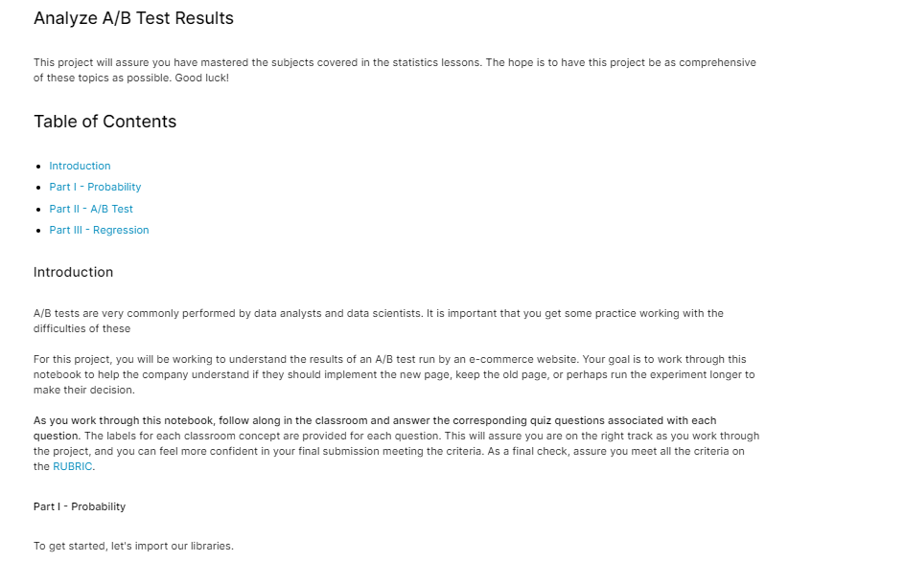

**IMPORT AND VIEW DATA**

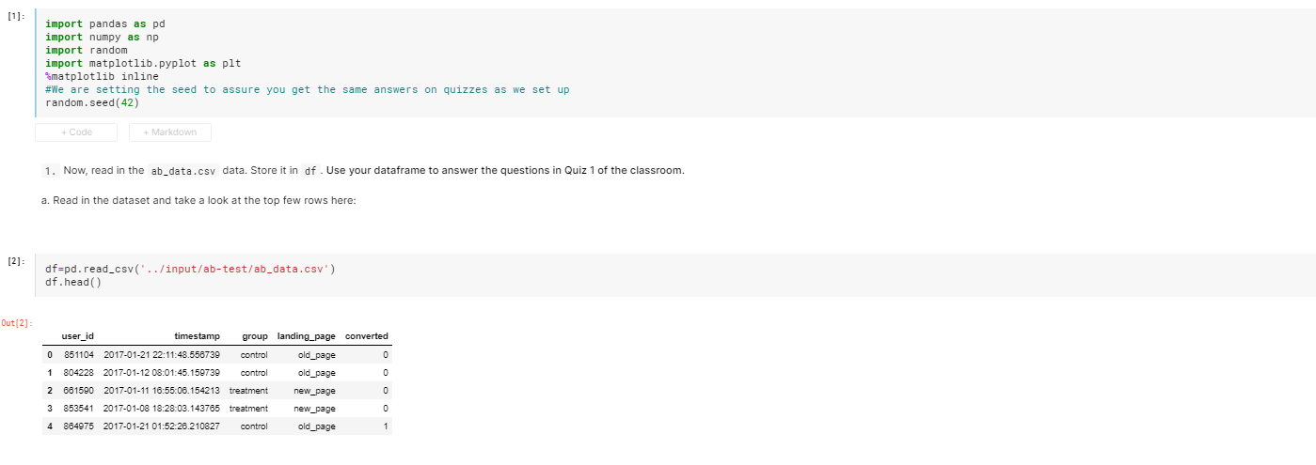

**CONTROL DATA – (MISSING ROWS, SHAPE ETC.)**

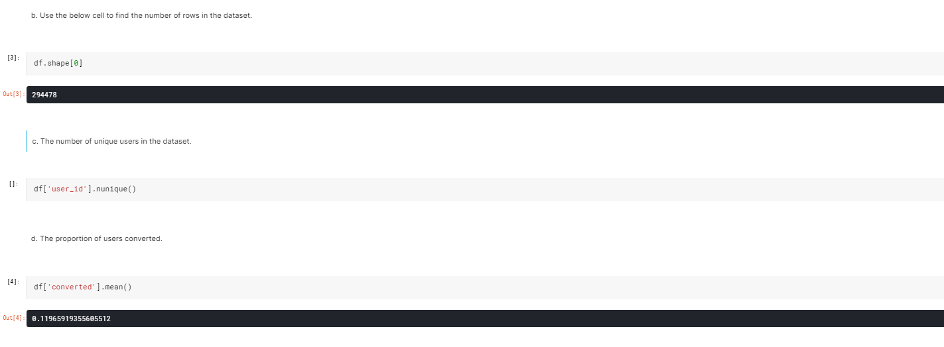

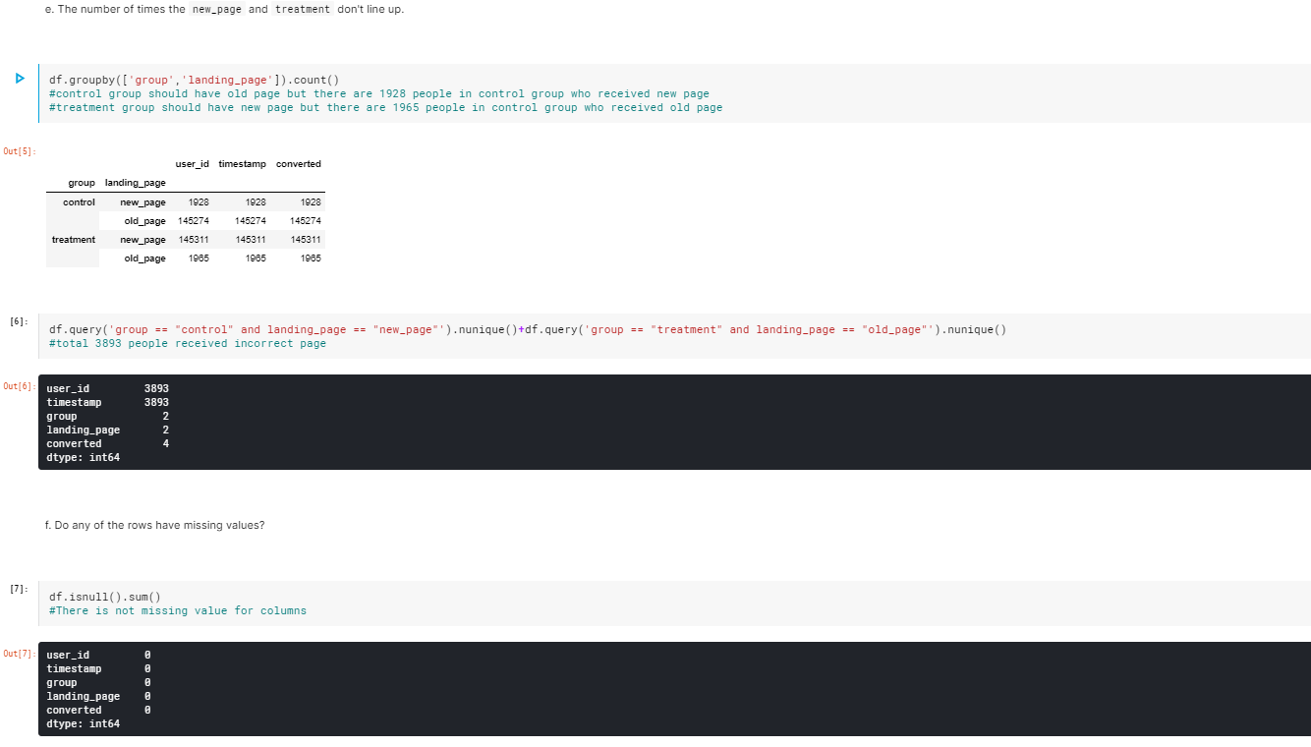

**CREATE DF2 WITH CORRECT VALUES**

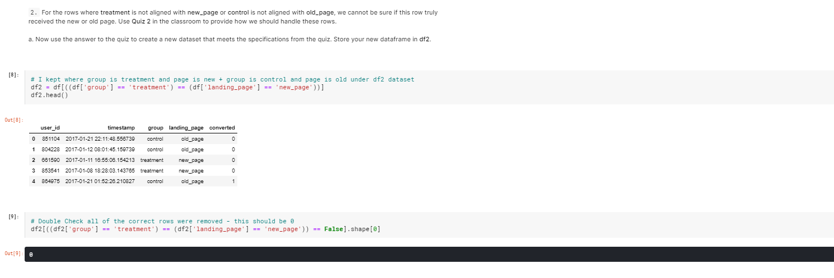

**FIND AND DELETE DUPLICATED ROWS**

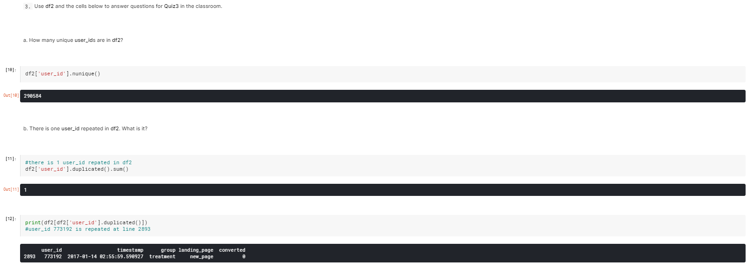

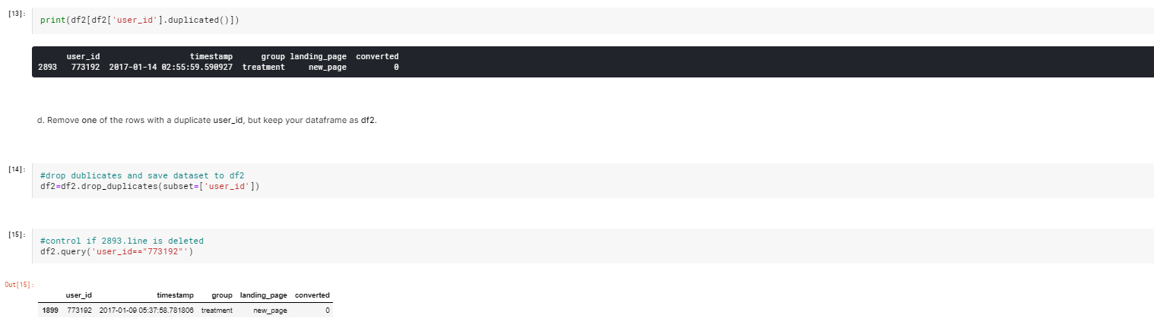

**CALCULATE CONVERSION RATES OF OVERALL, CONTROL GROUP AND TREATMENT GROUP**

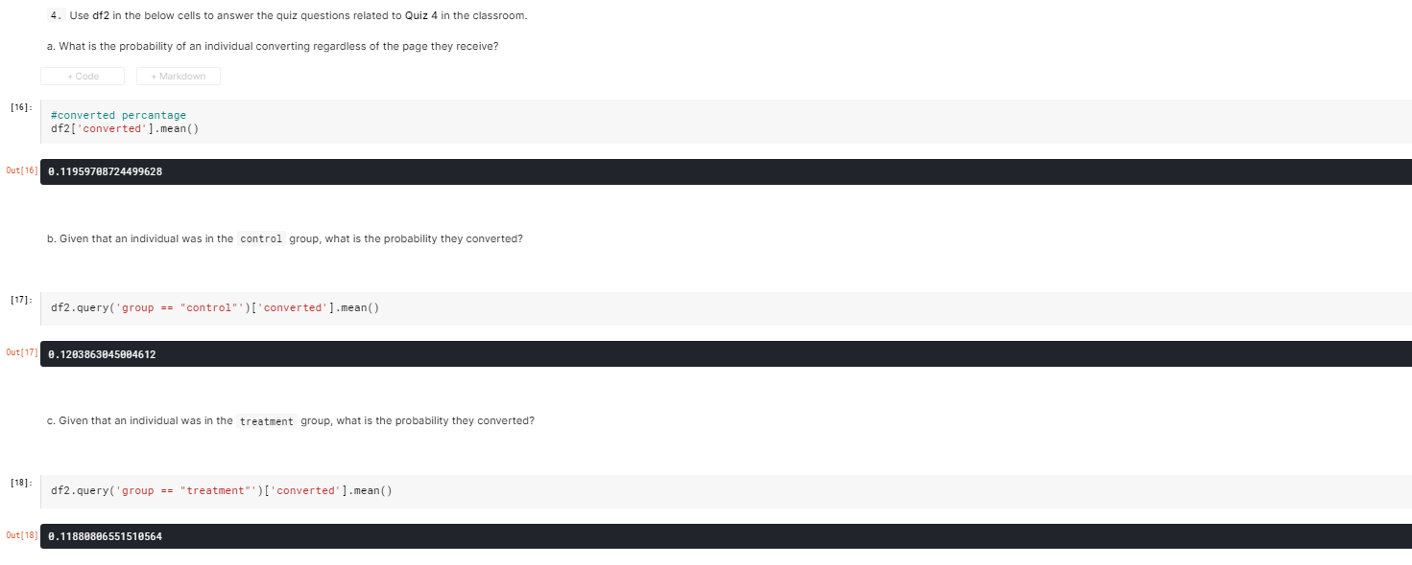

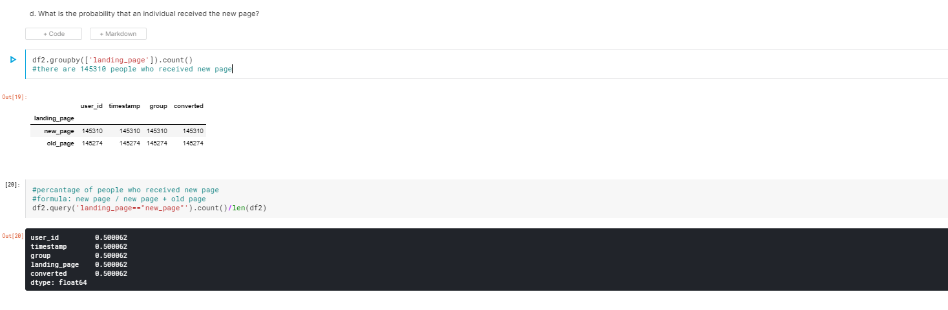

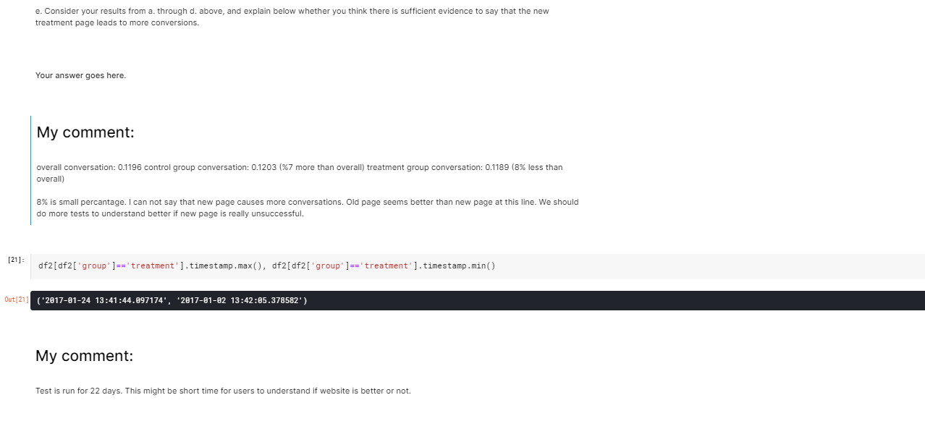

**DEFINE NULL AND ALTERNATIVE HYPOTHESES**

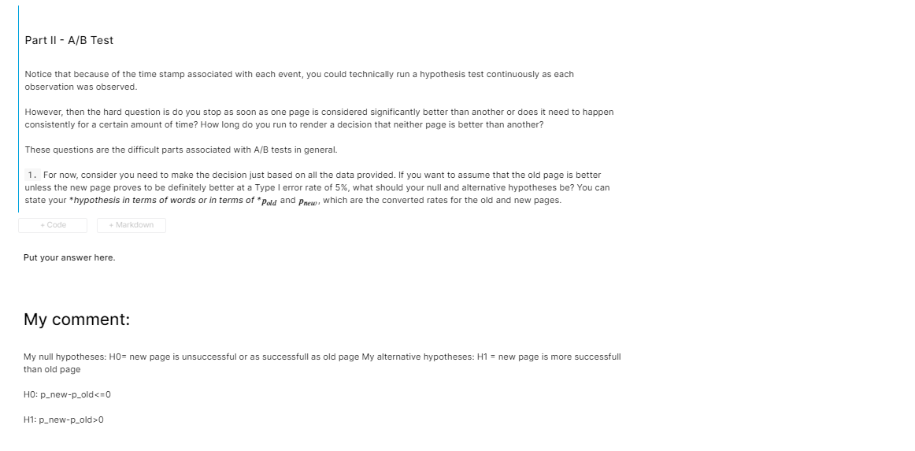

**CALCULATE SUCCESS RATES**

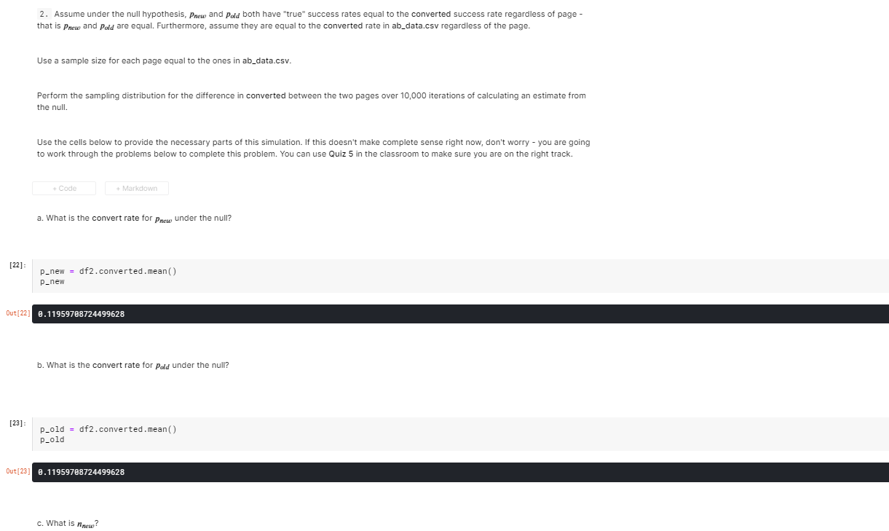

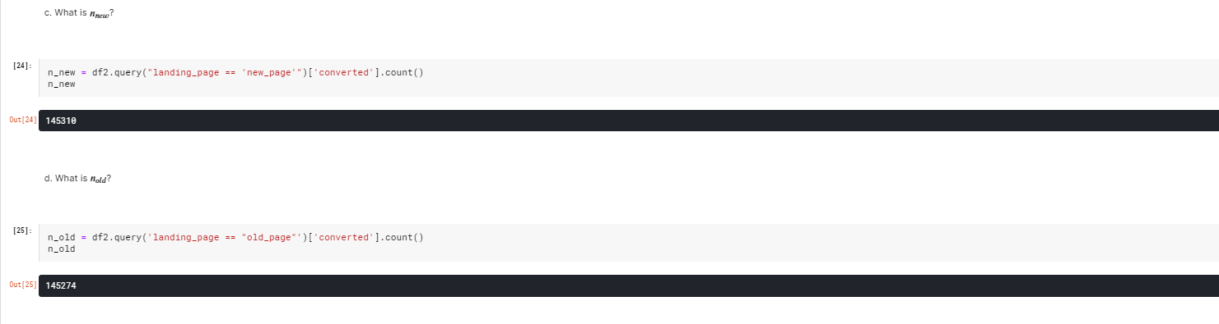

**SIMULATE SUCCESS RATES WITH BINOMIAL FUNCTION**

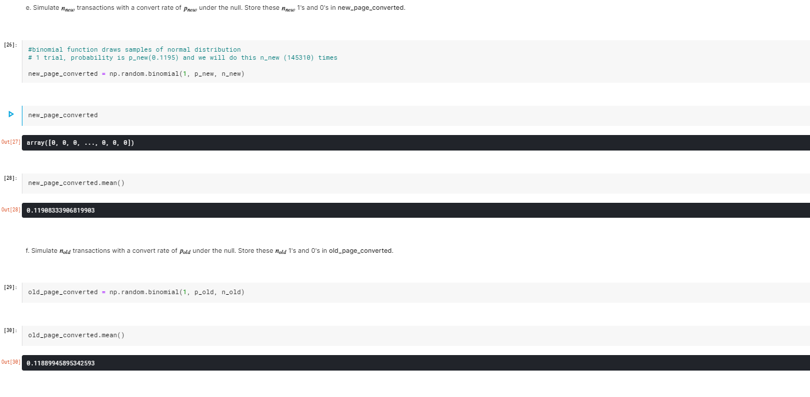

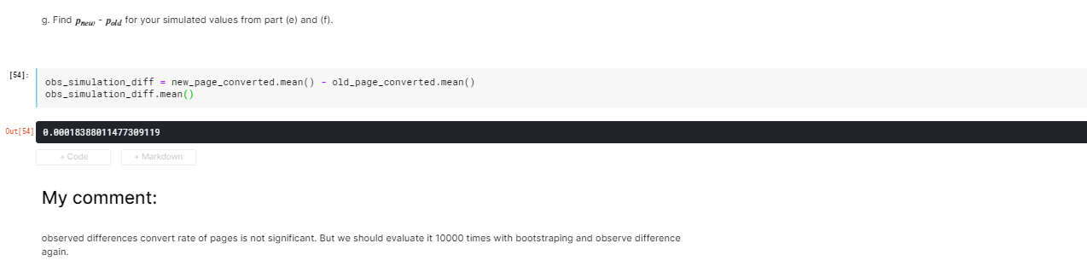

**CALCULATE SUCCESS RATES OF TREATMENT AND CONTROL GROUP**

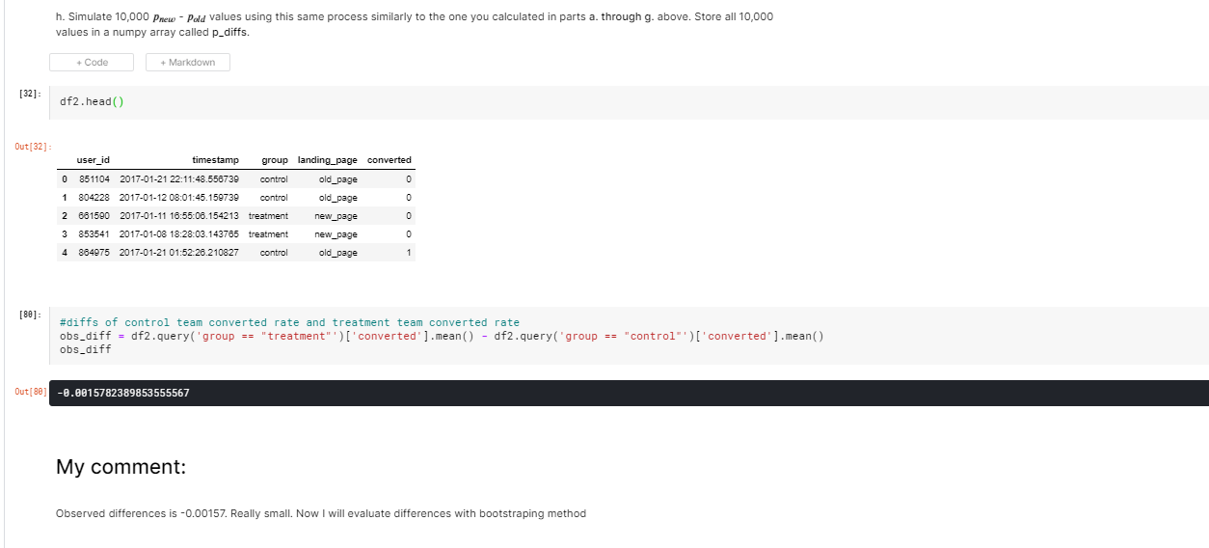

**SIMULATE SUCCESS RATES OF GROUPS WITH BOOTSTRAPING**

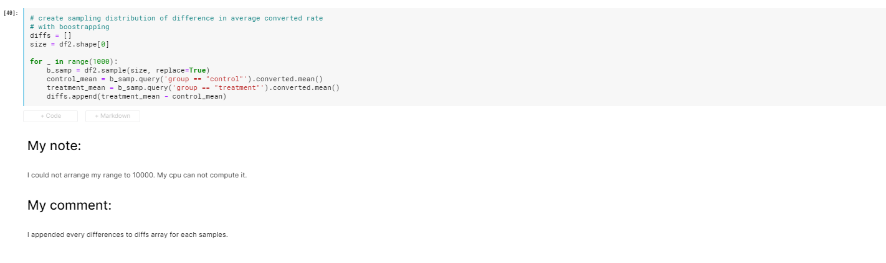

**DRAWING HISTOGRAM**

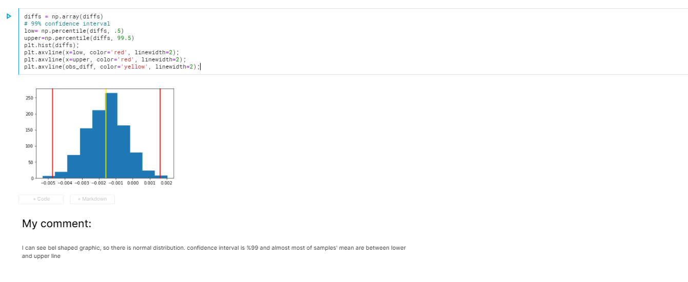

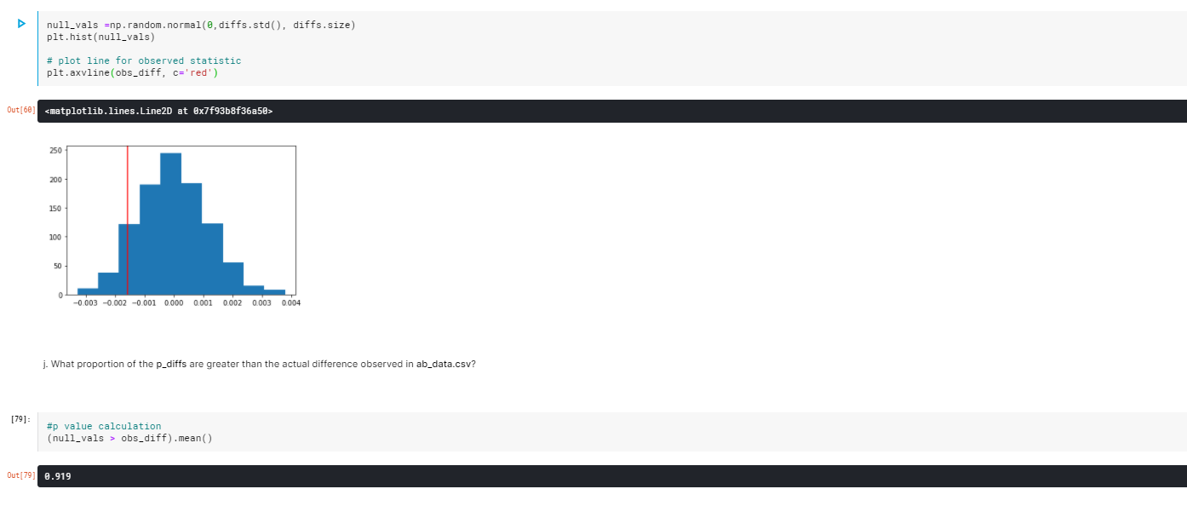

**COMMENT**

