Kognitiv – KLS Platform
Apache JMeter – User guide
Source - KLS_WS_0909_V2.jmx

KLS - Apache JMeter Best Practices
- Table of Contents
1. Installation of JMeter Software: 3
2. Pre-test execution steps 3
2.1 Installation of relevant JMeter Plugins 3
2.2 User Defined Variables: 3
2.3 Test Data – Parameter files 4
2.4 Jenkins Settings 4
3 Script pre-requisite settings: 5
3.1 WS-01 5
3.2 WS-03 & WS-04 6
4 JMeter - JDBC – SQL Query Testing 7

Installation of JMeter Software:

Download Apache JMeter 5.4.3 version from https://archive.apache.org/dist/jmeter/binaries/
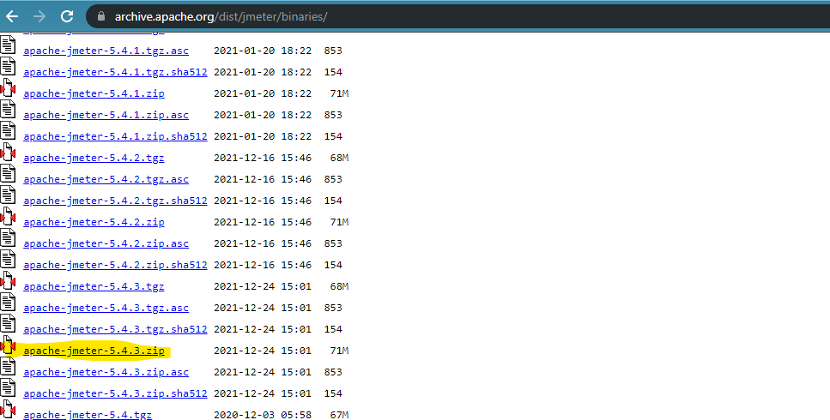

2. Pre-test execution steps

Installation of relevant JMeter Plugins
The plugins has to be downloaded from https://jmeter-plugins.org/ and to be placed in JMeter\lib\ext folder
jmeter.backendlistener.azure-0.2.8
JMeter-InfluxDB-Writer-plugin-1.2.2
jmeter-plugins-casutg-2.10
jmeter-plugins-graphs-additional-2.0
jmeter-plugins-graphs-basic-2.0
jmeter-plugins-graphs-composite-2.0
jmeter-plugins-manager-1.7
jmeter-plugins-perfmon-2.1

User Defined Variables:
Threads – Defines the number of users the Requests must be run with
Loop – Defines the number of times the subsequent requests have to be iterated. If the loop is defined at the Thread Group level, all the requests in the Thread Group would get looped that many number of times.
Currently in our script, Base_URL and Token are hard-coded. As need they could be parameterized.
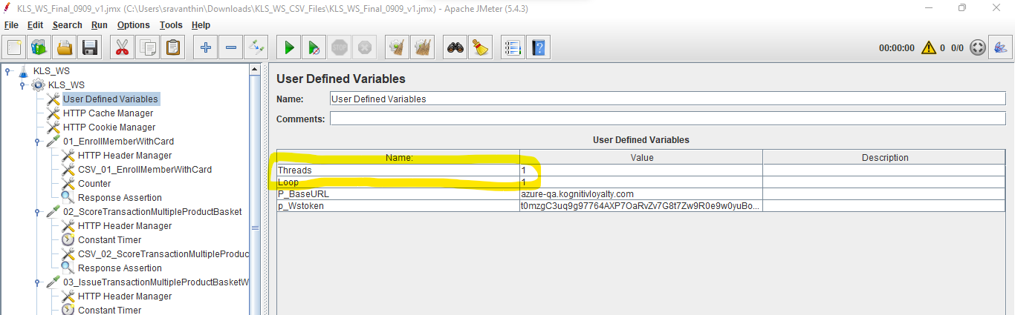

Test Data – Parameter files

See that the right path of the CSV Files is provided in the CSV Data Set Config Configuration Element
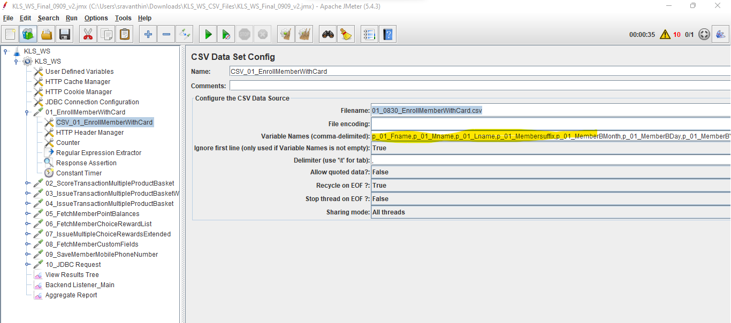

Note: The comma separated column names should be in the same sequence as in the excel test-data file

Jenkins Settings

The Test data files need to be uploaded to Github @
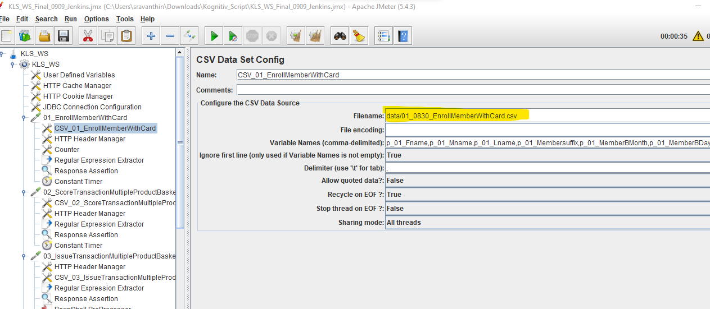

3 Script pre-requisite settings:

3.1 WS-01
- For the 01_EnrollMemberWithCard WS call – there is a counter which is assigned to generate a unique Card Number every single time. Just change the Counter_Start_Value in the User-defined variables
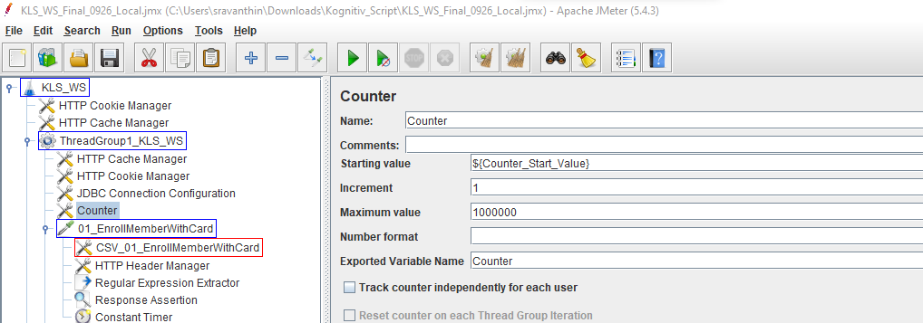
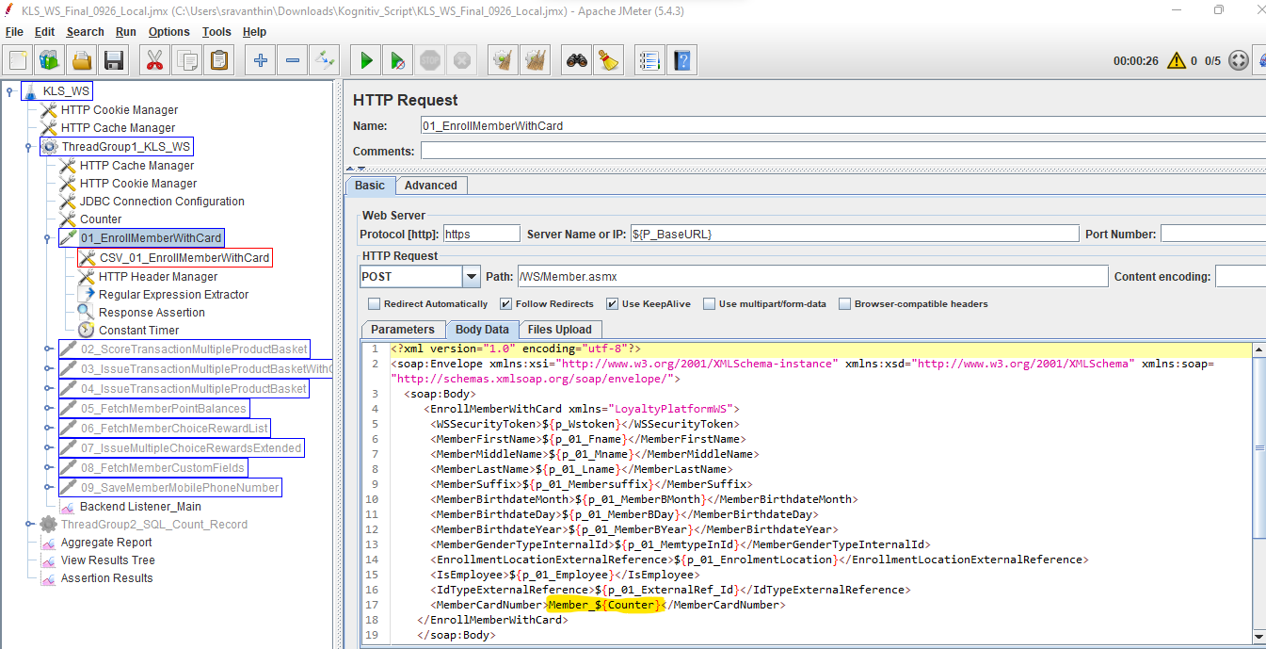

3.2 WS-03 & WS-04

In the WS-03 and 04 calls, there is a Bean Shell Pre-processor written to pass the custom fields of Transaction Basket and Custom Fields Storage values.

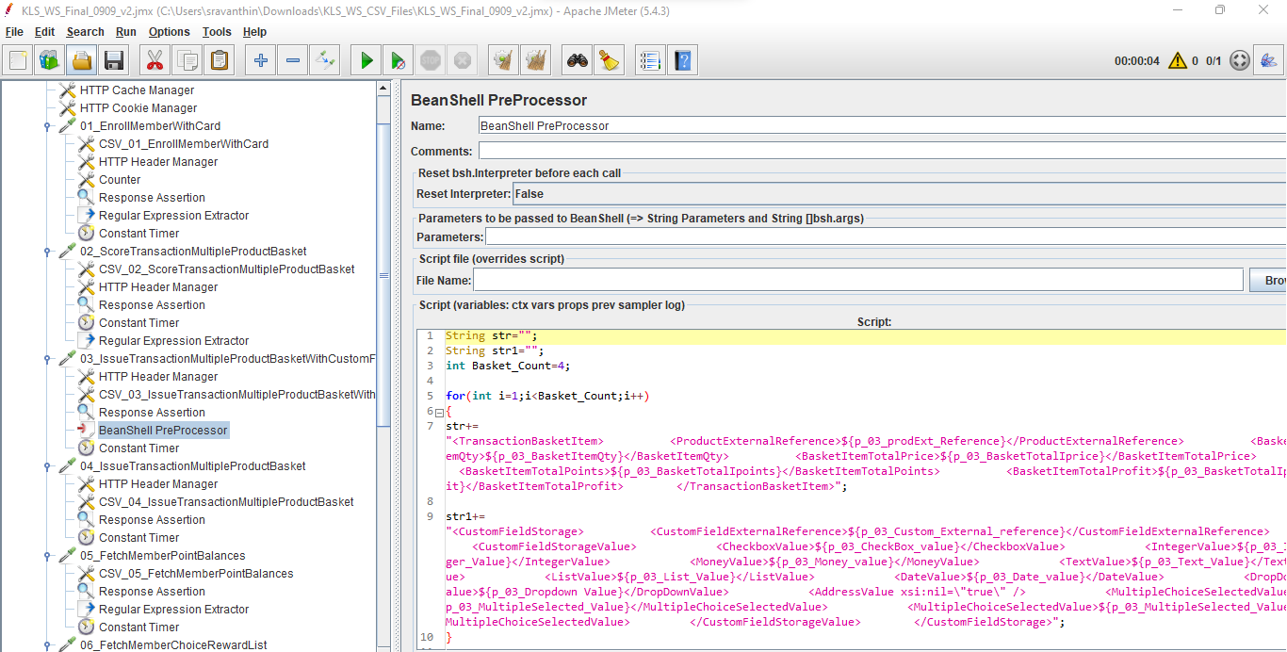

So, the Basket_Count value needs to be updated in the user-defined variables.
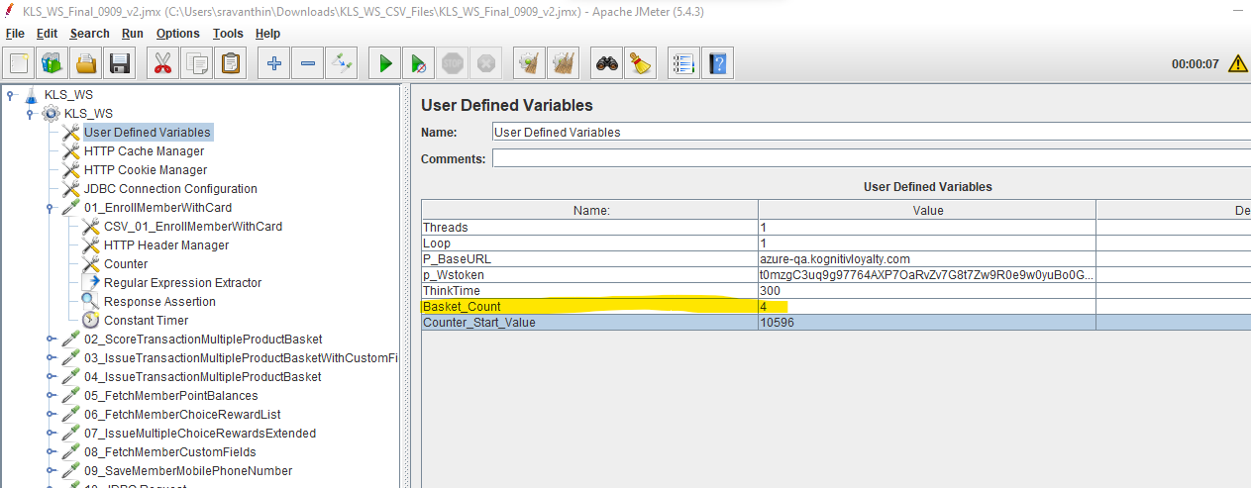
Q. How to stop a Thread based on a Sampler error?
A. Please check the option Stop Thread under Thread Group level
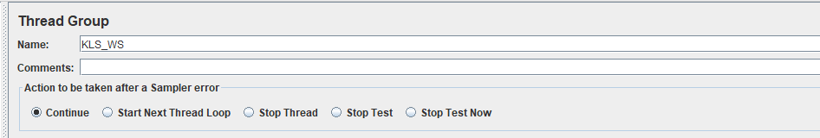

4 JMeter - JDBC – SQL Query Testing

Provide the Config element – JDBC Connection Configuration with the below settings:
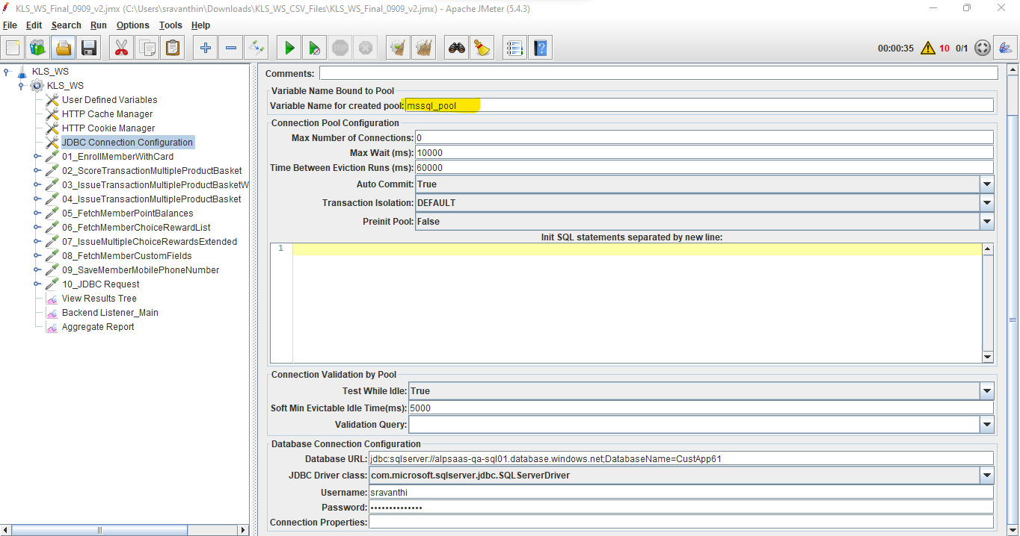
JDBC Request screenshot
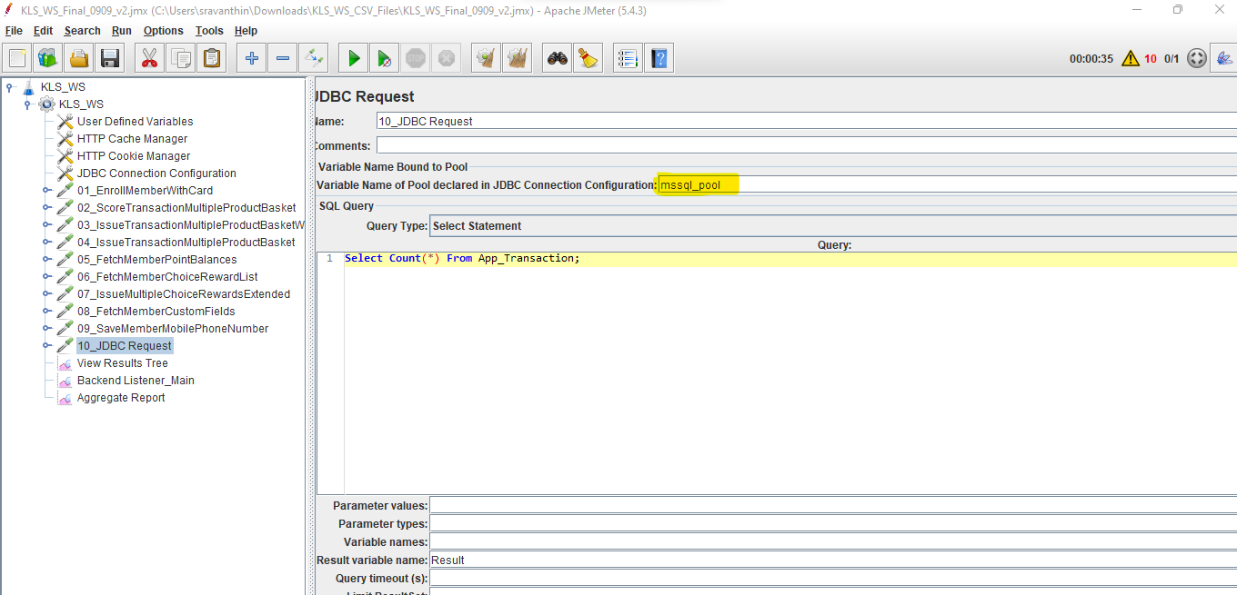

The variable name should match in both JDBC Connection Configuration and the JDBC request as shown above.

Also, the path of the JAR file must be specified in the Test Plan

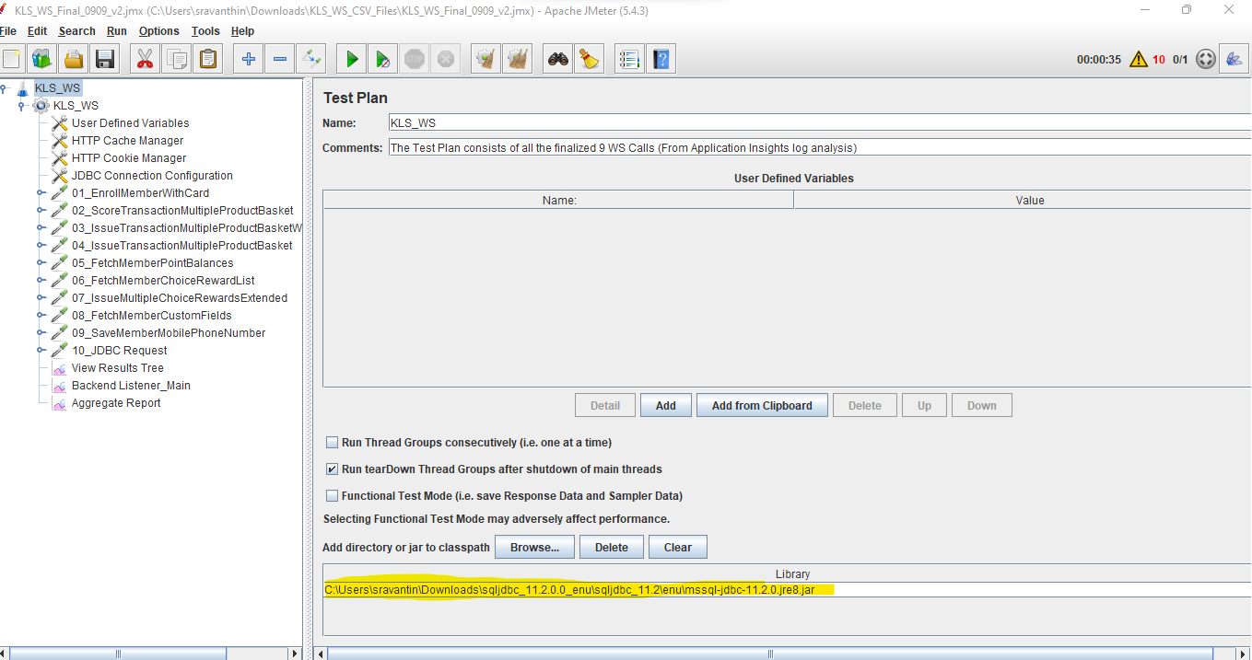

QnA:

- The SQL Thread Group should be executed only at the end of all 9 WS calls. Run Thread Groups consecutively (i.e. one at a time) should be checked to accomplish this.
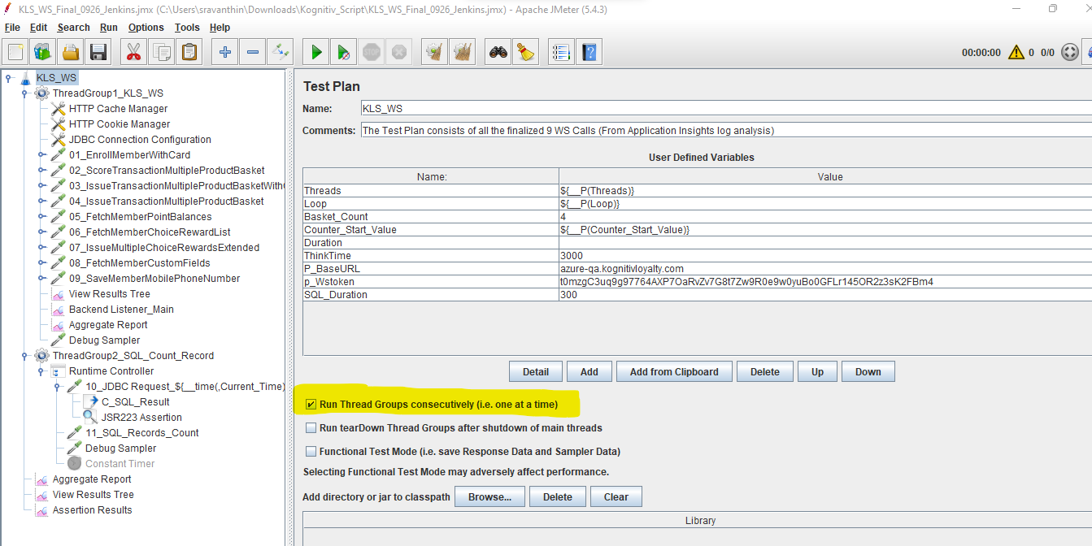
- The second SQL script should be executed by only one thread.
- The SQL Thread Group should start after 5 minutes of completion of Thread Group 1

- The SQL Request should execute for 5 minutes only.

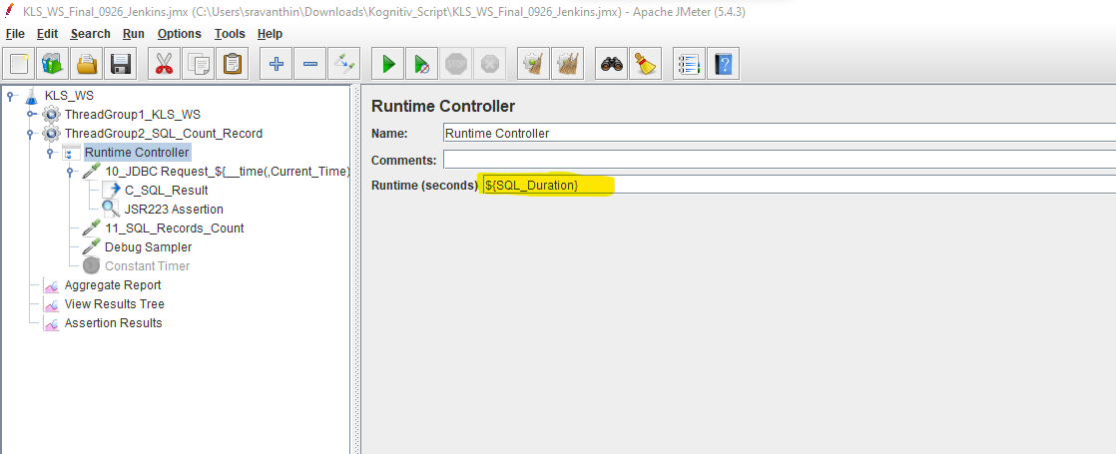

- The SQL Request should run every 5 seconds

Solution: A constant Think Timer of 5 seconds is provided in the script

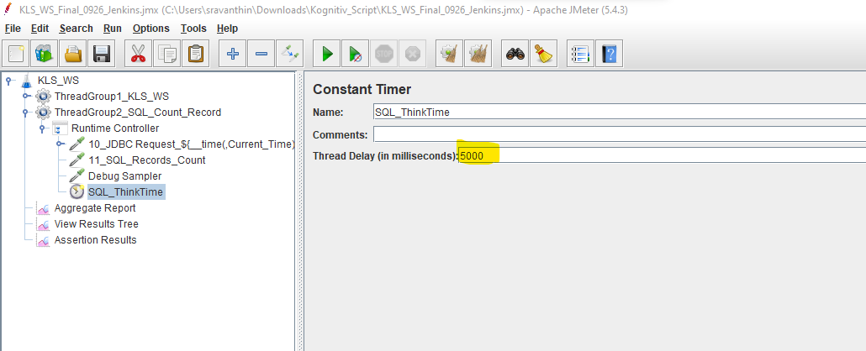

Miscellaneous Questions:

- Enroll Member with card – Executed 3 times with 3 different sets of data – FN1, FN2 and FN3 as shown below:

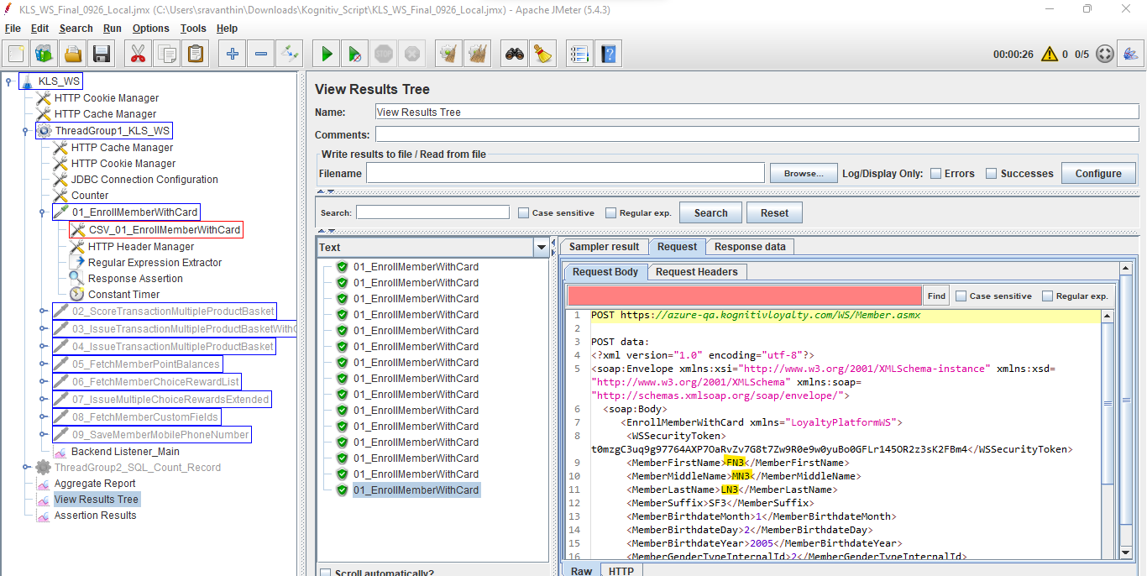

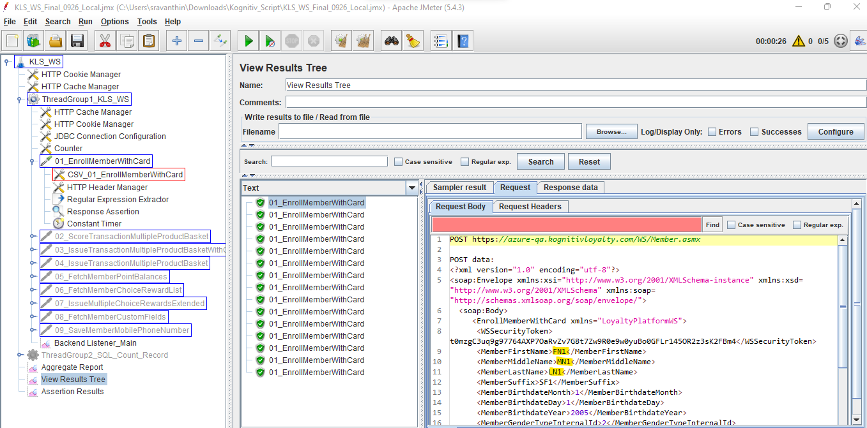

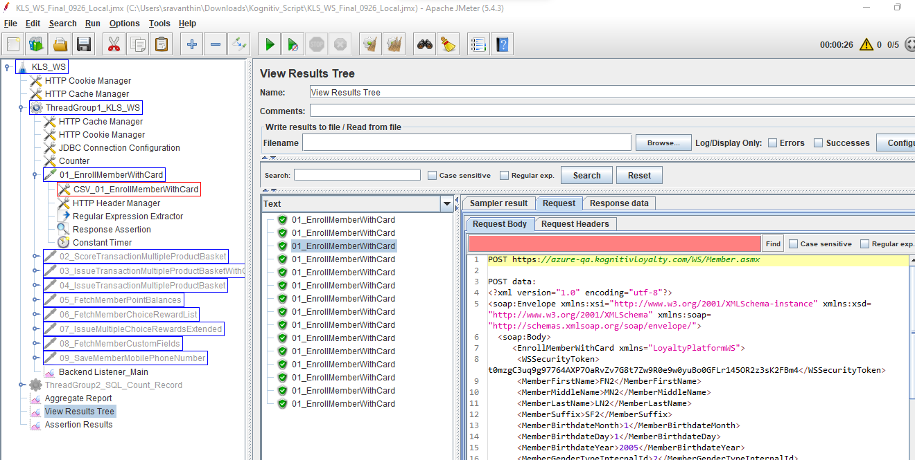

- How to parameterize the URL and Token?
Solution: Pass the value of the URL and Token in a CSV file.

