## Scenario

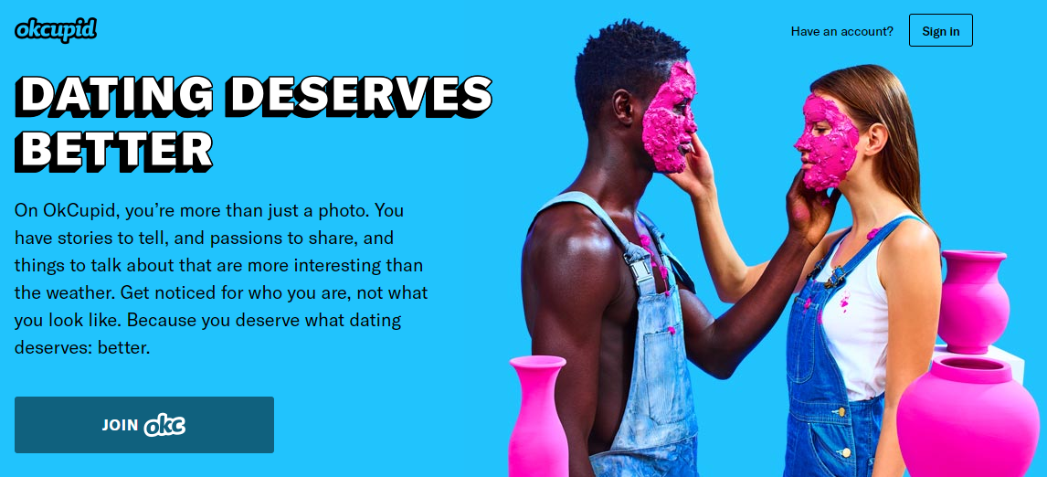

You are part of a business intelligence team at okcupid.com. The team has been asked to make an in-depth exploratory analysis of site users. The goal of the marketing team is to create micro segments and personas for future campaigns. Keep in mind, interesting data correlations may not be beneficial in a marketing context. For example, identifying 5 users with very specific attributes may be interesting but hardly a segment worth attracting.

**You are asked to examine the data, clean it, use supplemental data to enrich the data then identify 4 or more interesting insights from the user data. All relevant cleaning, enriching and EDA steps along with the 4 insightful data nuances should be organized into a presentation. You will present to the head of marketing who is looking for an “ah –ha” persona or previously unknown data relationship among two or more interactions. As the head of marketing, relevant information is consumed visually instead of in table form. Thus, your presentation should include visualizations when appropriate. You will need to turn in code and PowerPoint slides.**

## Data

Source:[~~https://www.researchgate.net/project/The-OKCupid-dataset-A-very-large-public-dataset-of-dating-site-users~~](https://www.researchgate.net/project/The-OKCupid-dataset-A-very-large-public-dataset-of-dating-site-users)[looks to be deprecated]

<https://www.kaggle.com/datasets/andrewmvd/okcupid-profiles>

This data set was scraped from user profiles. At the time, OKCupid did not authorize the data to be collected. After the data was released as part of academic literature, the data was authorized to be used by OKCupid.com .

***As a result, there is some moral ambiguity related to the use of the dataset.***

The data set your business analysis team is using has been authorized, cleaned and anonymized.

The original data, publication, code, and codebook was obtained here: <https://github.com/rudeboybert/JSE_OkCupid>”

To get the data run the following in your console *once you have set your working directory*:

## profiles <- read.csv('profiles.csv')

## Example *Abridged* Data

|  |  |  |  |  |  |  |  |  |
| --- | --- | --- | --- | --- | --- | --- | --- | --- |
| **age** | **body_type** | **diet** | **drinks** | **education** | **height** | **income** | **…** | **status** |
| 22 | a little extra | strictly anything | socially | working on college/university | 75 | *NA* | … | single |
| 35 | average | mostly other | often | working on space camp | 70 | 80000 | … | single |
| 38 | thin | anything | socially | graduated from masters program | 68 | *NA* | *…* | available |
| 23 | thin | vegetarian | socially | working on college/university | 71 | 20000 | … | single |
| 29 | athletic | *NA* | socially | graduated from college/university | 66 | *NA* | … | single |

## Course Scripting Supplemental

You will receive an initial script with code examples to get you started since this is the first case of the course.

## Criteria for Success

**Organization** – Was the presentation well organized?

**Delivery** – Was the content delivered clearly and persuasively with the audience in mind?

**Code Documentation** – Was the data mined to support the conclusion?

**Written Supplemental** – Is the information clear and supported in narration and code? Did the information satisfy the case problem? Were external and trustworthy sources used?

**Data Mining & Modeling Process** – Overall, as a complete portfolio of work, is the topic interesting, organized, researched, supported and delivered effectively? Was CRISP-DM, SEMMA, or a similar workflow followed to organize the work?

## Another resource may be a public R-Studio examination of the data

*Keep in mind this may not be helpful but code can be examined for additional ideas.*

[*https://rstudio-pubs-static.s3.amazonaws.com/209370_b62220c849b946088b463fdbec935848.html*](https://rstudio-pubs-static.s3.amazonaws.com/209370_b62220c849b946088b463fdbec935848.html)