## Get all products

GET localhost:8080/products/all

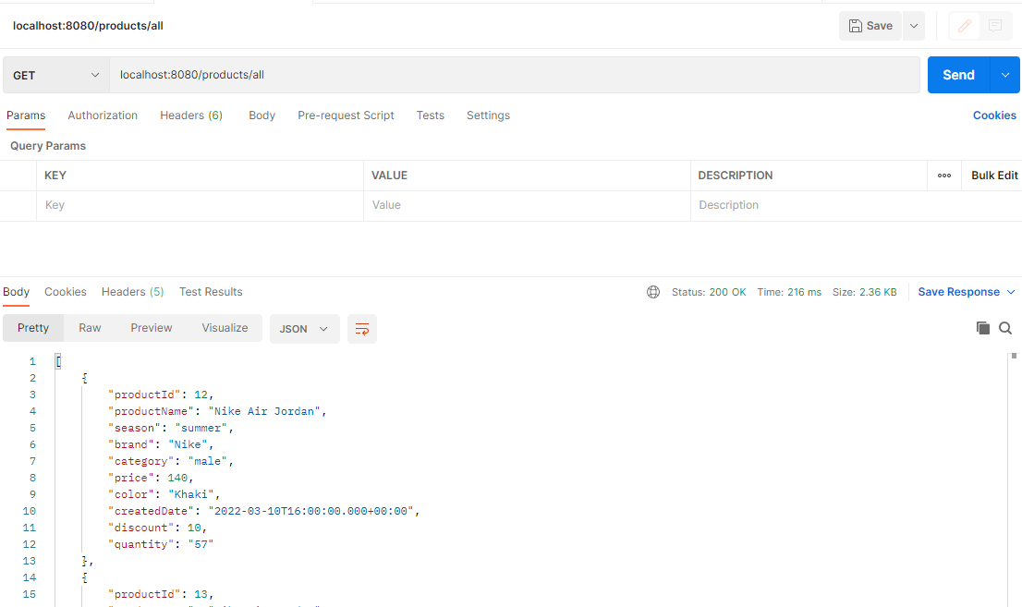

## Get product by productId

GET localhost:8080/products/product/12

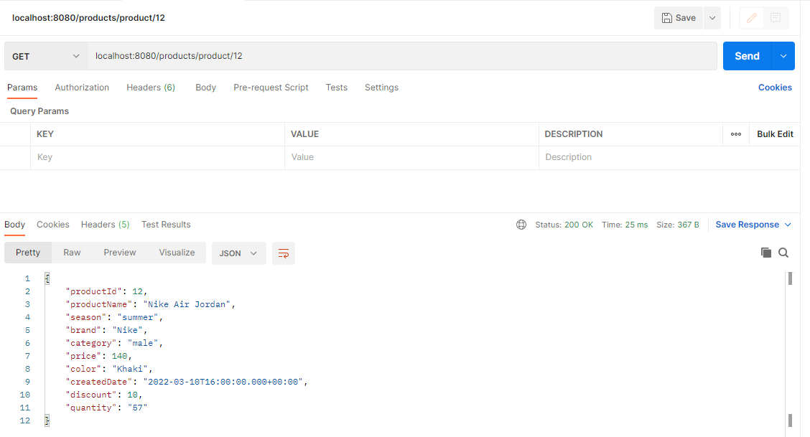

## Get all products by season

GET localhost:8080/products/season?season=summer

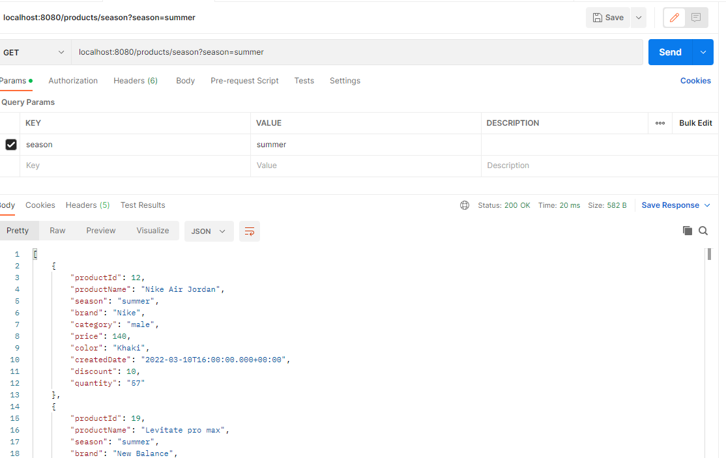

## Get all products by brand

GET localhost:8080/products/brand?brand=nike

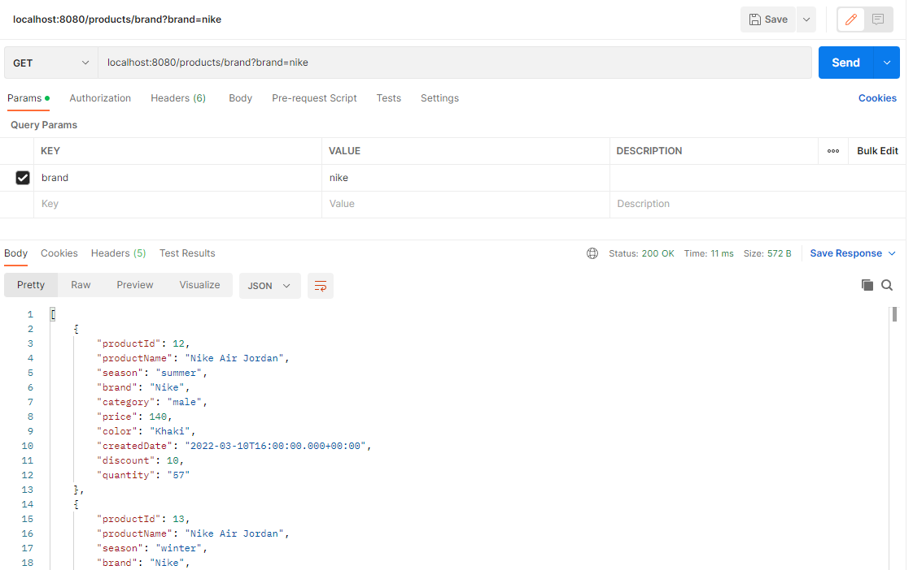

## Get all products by category

GET localhost:8080/products/category?category=male

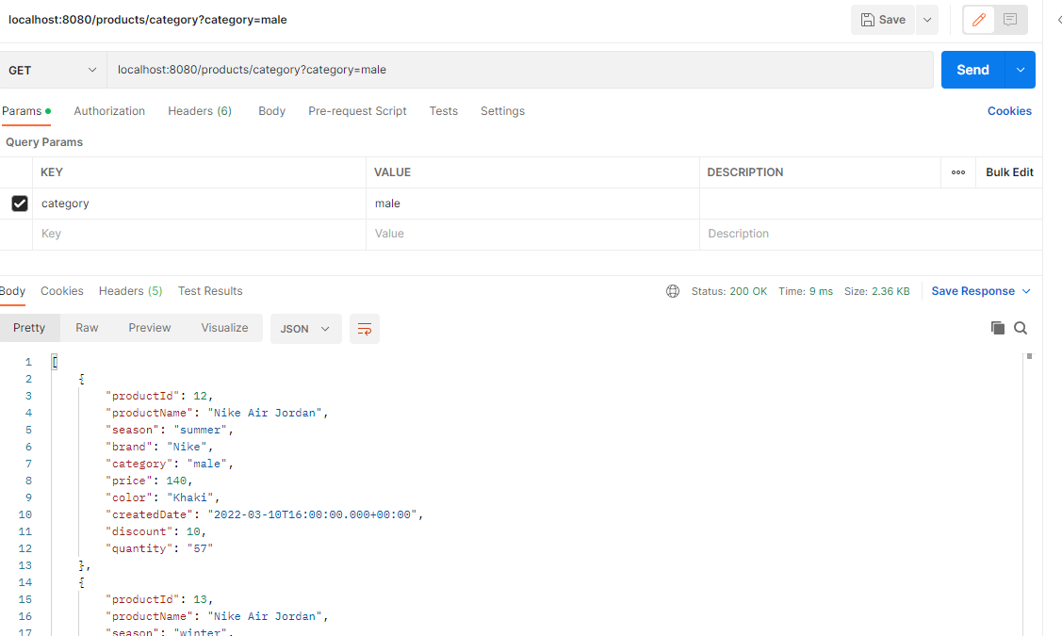

## Get all products by price

GET localhost:8080/products/price?price=190

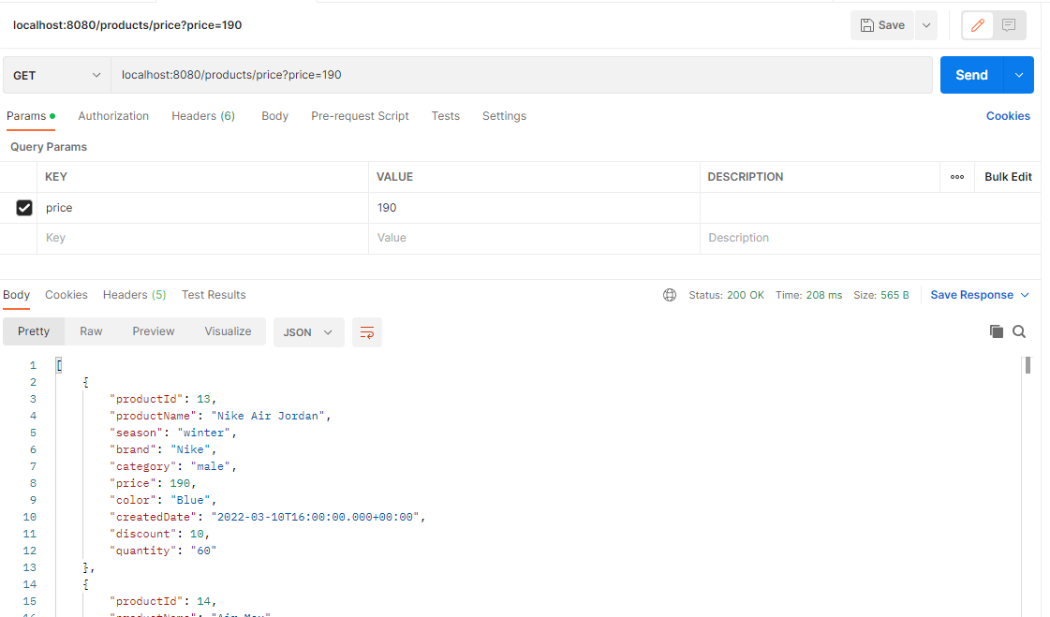

## Get all products by color

GET localhost:8080/products/color?color=blue

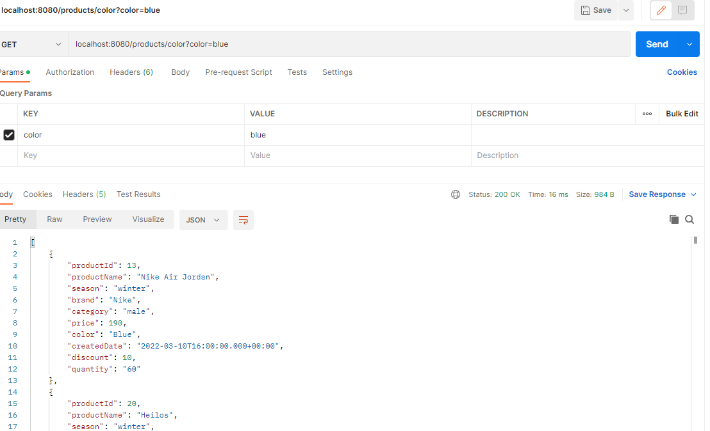

## Get all products by createdDate

GET localhost:8080/products/createdDate?createdDate=2022-03-11

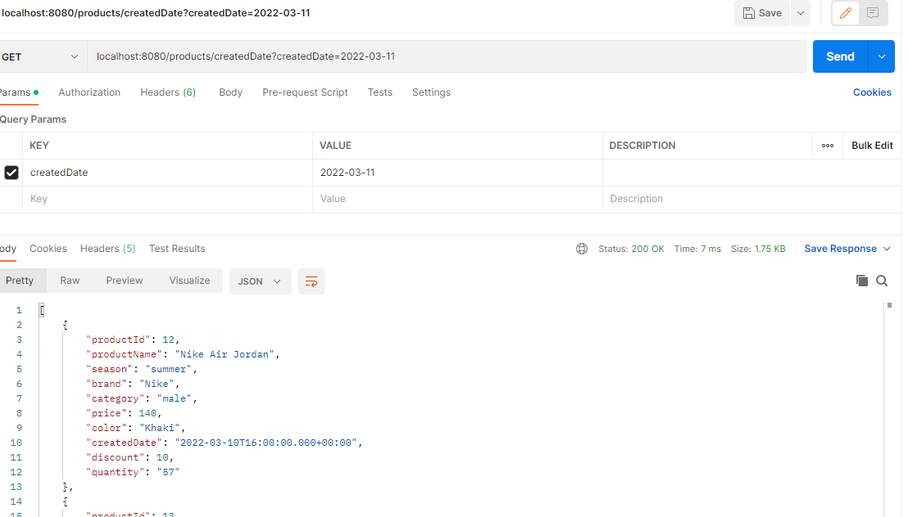

## Insert new product

POST localhost:8080/products/add

Body

{

        "productName": "Nike Air Lebron",

        "season": "summer",

        "brand": "Nike",

        "category": "male",

        "price": 340,

        "color": "Khaki",

        "createdDate": "2022-03-10T16:00:00.000+00:00",

        "discount": 10,

        "quantity": "20"

}

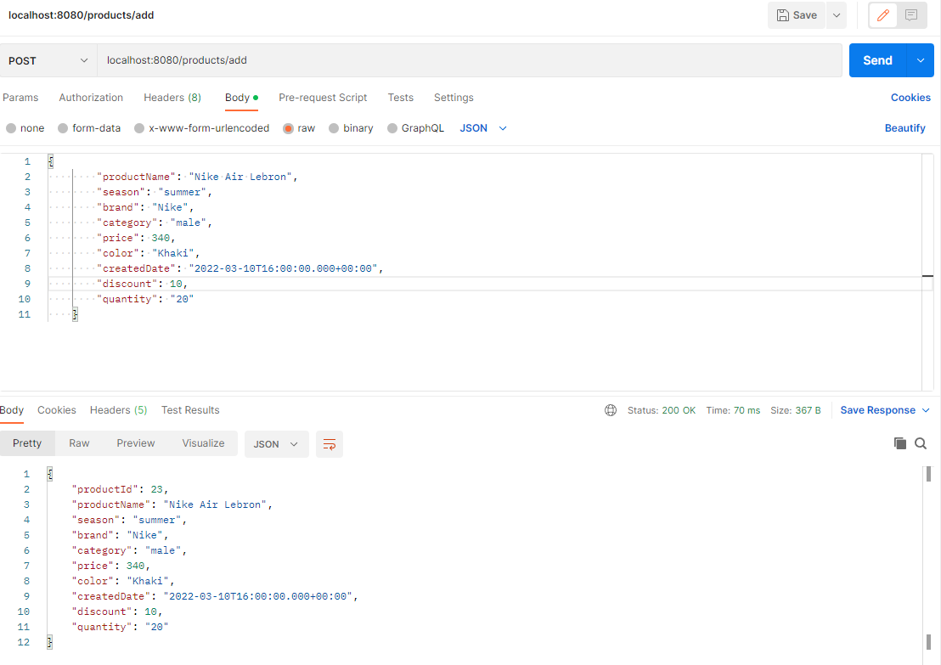

## Update existing product

PUT localhost:8080/products/update/23

{

        "productName": "Nike Air Lebron",

        "season": "summer",

        "brand": "Nike",

        "category": "male",

        "price": 350,

        "color": "Khaki",

        "createdDate": "2022-03-10T16:00:00.000+00:00",

        "discount": 10,

        "quantity": "20"

}

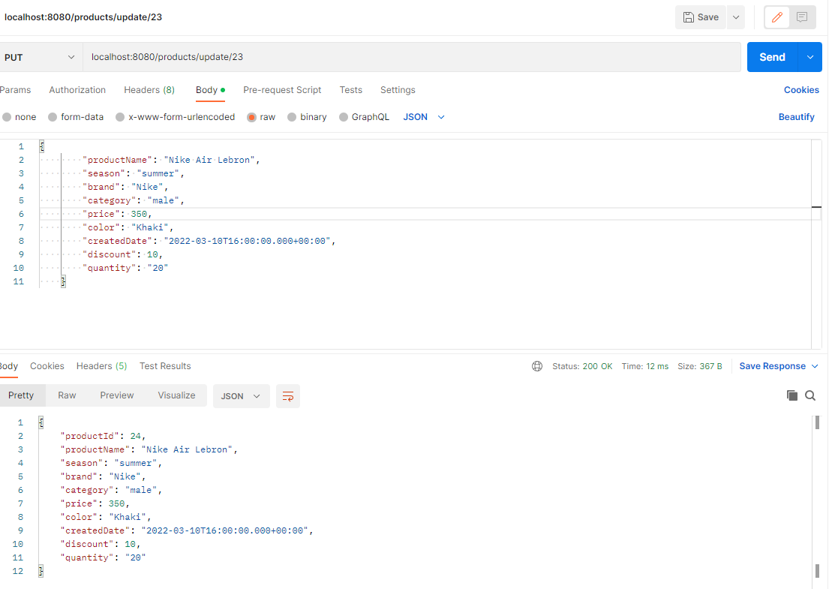

## Delete product by productid

localhost:8080/products/delete/23

## 

## Get all users

GET localhost:8080/users/all

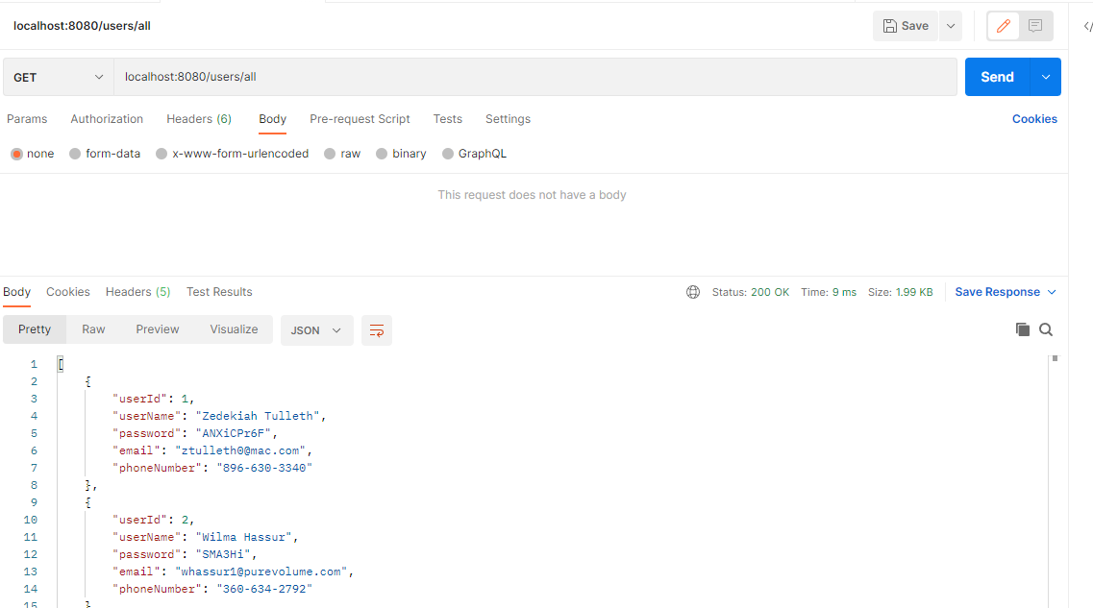

## Get products info from product_order table

GET localhost:8080/products/productDetail

