Systems Biology
Pragmatic Algorithms for Model Validation of Biological Systems
Chuan Hock Koh^{1,2}, Sucheechandra and Limsoon Wong²
¹NUS Graduate School for Integrative Sciences and Engineering, Singapore 117597
²School of Computing, National University of Singapore, Computing Drive, Singapore 117417
Received on XXXXX; revised on XXXXX; accepted on XXXXX

Associate Editor: XXXXXXX

abstract
Motivation: With the growing size and complexity of pathway models, model validation has become an indispensible step in building a reliable computational model. The stochastic nature of biological models makes it impractical to use classical numerical model checking approaches. Therefore, recently, several statistical model-checking procedures have been proposed. However, currently available model checking algorithms have flaws that make them not yet ideal for practical use.
Result: In this paper, we introduce two practical statistical model-checking algorithms that . We show that our algorithm overcomes the flaws of current state-of-the-art statistical model checking algorithms and makes them more suitable for use in practice. Finally, we demonstrate its feasibility using a model from the literature. It is important to note that the algorithms we present here are not limited to biological models but any stochastic discrete event systems that have large or infinite possible states, which renders classical numerical approach infeasible.
Contact: kohchuanhock@nus.edu.sg

introduction
Model checking is an automated process to formally verify a system's behavior with respect to a set of properties. It is a widely used technique for validating circuit designs (Biere et al., 2003). Recently, there are growing interest in applying this technique to the validation of biological models due the ever-increasing size and complexity of these computational models.
Hlavacek (2009) envisioned that in the future a library of model-checking queries that encodes key behavioral properties of different pathways would exist. Researchers could then use this library to test any new model to ensure its reliability. Before such library could materialize, apart from formulating those key behavioral properties, it would be important to have practical and reliable model-checking algorithms to validate the properties against the model.
Talk about what kind of properties can be checked and how?
There exist two dominating techniques in model checking of stochastic systems – numerical and statistical. Numerical approaches compute the exact probability of a property by running all possible executions of the state space generated by the system. Naturally, this would not scale up for large and complex systems with large or infinite possible states. Statistical approaches, on the other hand, use sampling and only require that the sample trace could be obtained. However, because of the sampling nature, statistical methods cannot guarantee the correct answer is always produced. Nevertheless, it is possible to control the probability of errors in statistical approaches.
Younes and Simmons (2002) introduce an algorithm that relax the standard hypothesis test of H₀: p ≥ θ vs. H₁: p < θ to H₀: p ≥ p₀ vs. H₁: p ≤ p₁ by introducing p₀ = θ + δ and p₁ = θ – δ so that α (type-I error rate) and β (type-II error rate) could be bounded independently. The region (p₁, p₀) is named the indifference region and δ, the half-width of the indifference region. There is a serious flaw in this algorithm in that errors are only bounded if the true probability of a property exists outside of the indifference region. Furthermore, the number of samples required is inversely proportional to δ². This makes the selection of δ critical. Too small, sample size required would be very large. Too large, the risk of having unbounded errors increase.
Younes recognizes and attempt to rectify this problem by developing a new procedure that allows undecided results (Younes 2006). The essence of this new algorithm is that if the true probability is likely to be inside the indifference region, the algorithm will return undecided as an answer to the property instead of true or false. Although this solves the problem of having unbounded error rates, but practically an undecided answer is almost equal to a wrong answer. Furthermore, the selection of δ remains crucial in this algorithm because it directly influences the number of samples required and number of indecisions.
It is worth noting that the ideal choice of δ would be δ = | p - θ |, so that the number of samples would be the minimum required to ensure the error rates are bounded. However, the true probability, p, would be unknown in realistic settings.
In this paper, we will propose an algorithm that outperforms the abovementioned algorithms and does not require the selection of difficult parameters. We will also demonstrate its usage in different realistic settings.
Online or on-the-fly model checking, on the other hand, carries out model checking during the simulation run. Thus, a full state graph need not be recorded and simulation runs are only executed for as long as a decision needs to be made. Jard and Jeron (1990) introduced on-the-fly model checking for finite state programs that can be represented by a finite state graph; and in 2007, Troncale et al. (2007) implemented a real-time model checker for Timed Hybrid Petri Nets (THPN). However, that model checker could only support THPN, which is a sub-class (reduced expressiveness) of Hybrid Functional Petri Nets (HFPNs) (Matsuno et al., 2000; Nagasaki et al., 2004).
In this paper, we present an efficient and reliable model checker. It has the advantages of the different approaches mentioned above, but without the limitations that weigh them down. We first propose a new algorithm for model checking, which always returns a definite result that is statistically backed. We define a new temporal logic, Probabilistic Linear Temporal Logic with Statistics (PLTLs), to be used with this algorithm. Finally, we develop a program, MIRACH 1.0, that implements our algorithm and PLTLs. MIRACH is integrated with the HFPNe simulation engine (Nagasaki et al., 2010) so as to deploy the efficient online checking approach.
To increase MIRACH 1.0's appeal to the Systems Biology Markup Language (SBML) community, a SBML2CSML (http://csmlpipeline.hgc.jp/) converter is included. Hence, MIRACH 1.0 could do checking for pathway models written in SBML (L2v1) (Hucka et al., 2003) and CSML formats (http://www.csml.org/).

Methods
To build a model checker, one of the first steps is defining a formalism to express the rules to be checked. We have chosen PLTLs for reasons that we will describe shortly in Section 2.1. Due to the stochastic and complex nature of biological systems, we have also chosen to use approximative model checking. In this approach, there are two approximations. First, only a finite subset of the model's behavior is sampled to estimate the probability of a property being true or false. Thus, statistical approaches should be deployed to measure the confidence of results. We propose a new algorithm to overcome current limitations in this area, which we will discuss in Section 2.2. The next approximation is that, since the simulation run is finite, we can only approximate the truth-value of a property's temporal logic statement from the given limited run results. Hence, to have a good approximation, it is best to run the simulation until a steady state or until the properties could be determined. Notably, the offline model checking approach is therefore not well suited as it does not carry out checking when the simulation is running. In Section 2.3, we will describe our online (on-the-fly) algorithm to check the validity of a property's temporal logic statement as the simulation runs. Finally, MIRACH’s implementation and its usage instructions can be found in its documentation.

Temporal Logics
Several different temporal logics have been proposed and used for model checking in biological pathway models. Troncale et al. (2007), proposed Continuous Time Evolution Logic (CTEL) for use with their Timed Hybrid Petri Nets (THPN). Clarke et al. (2008) presented Probabilistic Bounded Linear Temporal Logic for their BioLab algorithm. Donaldson and Gilbert (2008a) introduced Probabilistic Linear Temporal Logic with numeric constraints (PLTLc). It combines LTL in probabilistic settings (Baier, 1998) and LTL with numeric constraints (Fages and Rizk, 2007). In their implementation, free variables (or numeric constraints) are limited to the integer domain of 0 to positive infinity. Although having free variables allow for a richer way to sum up a set of properties, they are more complicated to write and interpret (Heiner et al., 2009). For MIRACH, we have decided to extend PLTL to PLTLs so that it will better suit our approach. We have chosen PLTL to build upon because it is sufficient for stochastic model checking in general and is easy to write and interpret.
The syntax of PLTLs is defined in Table 1 and it allows for the use of filter constructs. For a property in the form ϕ {AP}, ϕ will be checked from the state that AP is satisfied rather than from the default initial state. Note that PLTLs allows AP to contain temporal logic operators (X, F, G, R, U). We also allow the use of formulas without probabilistic operators (i.e. in pure LTL). This is useful when the model is deterministic.
The semantics of PLTLs is defined over the finite sets of finite paths through system's state space, obtained by repeated simulation runs of HFPN models. A property contains two components, the probabilistic operator and the linear temporal logic statement. For each simulation run, the temporal logic statement is evaluated to a boolean truth value, and the probability of the temporal logic statement holding true is decided based on the whole set of simulation runs performed using statistical approaches.
For the probability operator component, there are two distinct operators; P◊ is the inequality comparison of the probability of the property holding true and P_{=?} returns the value of the probability of the property holding true with a confidence interval. The semantics of the temporal logic operators are described in Table 2. Concentrations of biochemical species in the model are denoted by [variableName]. We also define a special variable, [time], to represent simulation time.
Furthermore, we provide the ability to define functions of two different natures: functions that return a real number and functions that return a boolean value. An example of the real number function is d([variableName]) which returns the subtracted value of [variableName] between time i and time i-1. By convention, the value of the d([variableName]) at time 0 is 0. One example of a boolean function is similarAbsolute(Value a, Value b, Value ε). This function returns true if |a – b| ≤ ε else it returns false. Please see MIRACH’s documentation for details and examples on usage of implemented functions.
Table 1. PLTLs Syntax
ψ ::＝ P_{◊Ω} (LTL) | P_{=?Θ} (LTL) | LTL
LTL ::＝ ϕ {AP} | ϕ
ϕ ::＝ X ϕ | G ϕ | F ϕ | ϕ U ϕ | ϕ R ϕ | ¬ ϕ | ϕ &&ϕ | ϕ || ϕ | ϕ => ϕ | AP
AP ::＝ AP||AP | AP&&AP | AP=>AP | Value comp Value | Value_{boolean}
Value ::＝ Value op Value | [variableName] | Function_{numeric} | Integer | Real
Value_{boolean} ::＝ true | false | Function_{boolean}
comp ::＝ == | != | >= | > | < | <=
op ::＝ + | - | * | / | ^
Ω ::＝ (θ, α, β, max) | (θ, δ, α, β, max) | (θ, δ, α, β, γ, max)
Θ ::＝ (confidence, max) | (confidence, CI, max)

with ◊ Є {<, <=, >, >=}, θ denotes the value to be compared against; δ denotes the half-width of the indifference region; α denotes the type-I error rate (false negative rate;, β denotes the type-II error rate (false positive rate); γ denotes the probability of an undecided results; max denotes the maximum number of simulation run;, confidence denotes the confidence level; CI denotes the confidence interval.
Table 2. Semantics of temporal operators
Operator | Explanation
X ϕ | ϕ must be true at the next time point.
G ϕ | ϕ must always be true.
F ϕ | ϕ must be true at least once.
ϕ ₁U ϕ ₂ | ϕ ₁ must be true until ϕ ₂ becomes true; ϕ ₂ must become true eventually.
ϕ ₁R ϕ ₂ | ϕ ₂ must be true until and including the time point ϕ ₁ becomes true; if ϕ ₁ never become true, ϕ ₂ must always be true.

Hypothesis Testing and Statistical Estimation
Clarke et al. (2008) implemented the SPRT (sequential probability ratio test) algorithm for hypothesis testing without undecided results to validate a probabilistic temporal logic statement statistically. The advantage of this approach is that it uses the minimum number of executions necessary to determine a given property. However, there are three limitations. Firstly, by using only hypothesis testing, it is not easy to handle the =? operator; that is, to estimate the percentage in which the temporal logic statement is true. In order to do that, one has to use statistical estimation. Another limitation in using this approach is that the user must define an indifference region (Fig. 1). The decision on the indifference region is crucial. The expected number of samples required is large if it is too small, since the complexity of the algorithm is inversely proportional to the width of the indifference region (Younes et al., 2006b). On the other hand, if the indifference region is chosen to be too large, the chance of the “true” distribution being in the indifference region increases; consequently, the error rate becomes unbounded (Younes et al., 2006b). Furthermore, without putting a limit on the number of samples, there is a chance of an extremely long running time if the required sample size is exorbitant--- i.e. indifference region set too low and/or very low error rate requested.
We design MIRACH 1.0 to be efficient and at the same time overcome the above limitations.
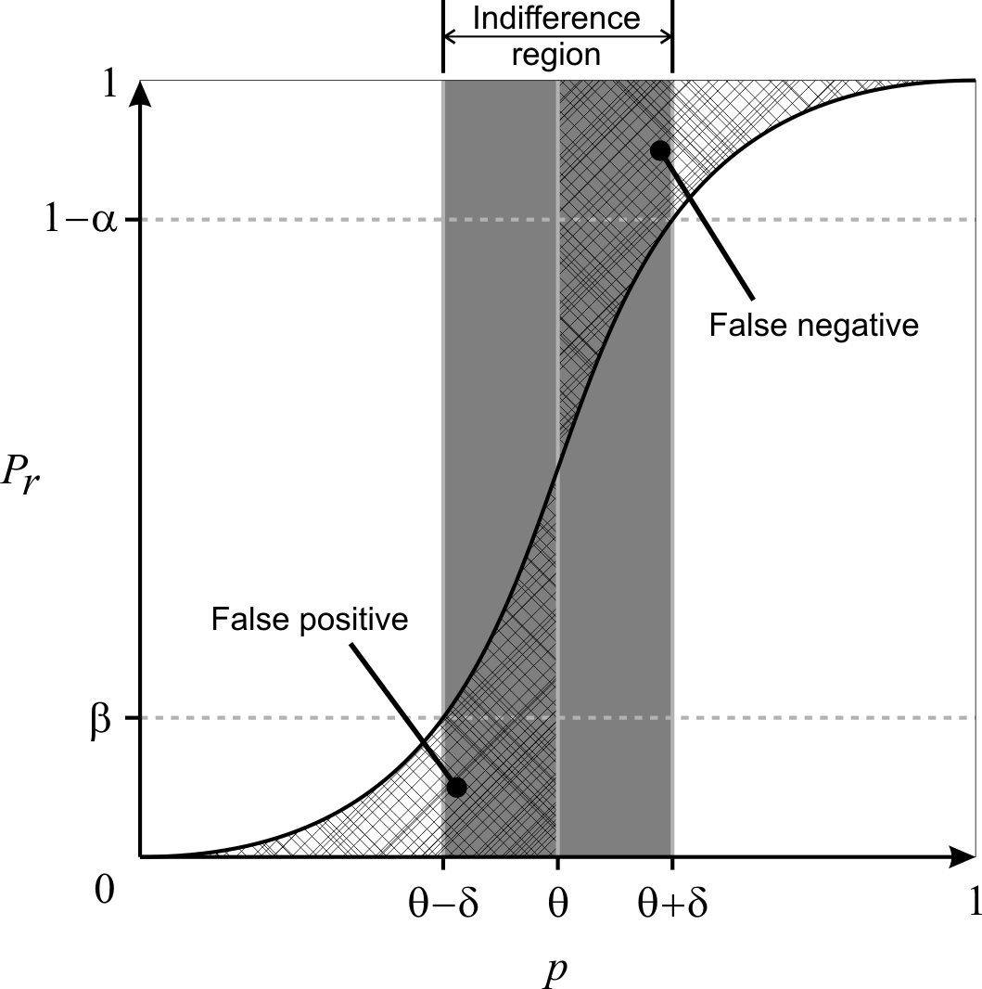
Fig. 1. Pr is the probability of accepting P_{≥θ}Φ as true whereas p is the actual probability of Φ holding true. Note that false positives and false negatives are not bounded when p is inside the indifference region.
2.2.1 The P_{=?} Operator
As mentioned earlier, in approximative model checking, we are only estimating the probability that the property holds in a stochastic model since we are only sampling a subset of the model's behavior. Therefore, we should give a confidence interval instead of just returning a single value. We have chosen to use Wilson interval (Wilson, 1927) to compute the confidence interval instead of the simpler normal approximation interval for two reasons. First, normal approximation is known to perform badly when the sample probability is close to 0 or 1 and fail completely when it is 0 or 1. Due to this, one cannot devise a sequential sampling algorithm that stops sampling once the confidence interval falls below a certain value, as the confidence interval will always be 0 if the current sample proportion is 0 or 1. Wilson interval (Equation 1) does not have these limitations and allows us to give more flexibility to our model checker.
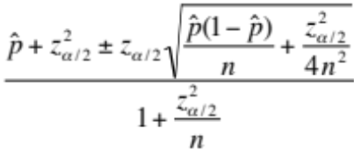
(1)

= No. of true samples / n, n = No. of samples, 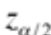 denotes the variate value from the standard normal distribution such that the area to the right of the value is
2.2.2 With and without undecided results
Younes et al. (2002) devised an approach based on statistical hypothesis testing to verify probabilistic properties in the form, P◊ Φ, where ◊ Є {<, <=, >, >=}, which Clarke et al., (2008) deployed in a systems biology context. In brief, they relaxed the standard hypothesis test of H₀: p ≥ θ vs. H₁: p < θ to H₀: p ≥ p₀ vs. H₁: p ≤ p₁ by introducing p₀ = θ + δ and p₁ = θ – δ so that α (type-I error rate) and β (type-II error rate) could be bounded independently. The region (p₁, p₀) is known as the indifference region and δ, the half-width of the indifference region. They further showed that by using Wald's sequential probability ratio test (Wald, 1945), they could determine after each sample whether another sample is required or a hypothesis could be accepted with the prescribed strength using available samples (Younes and Simmons, 2002; Younes et al., 2006a). The main limitation of this approach is that if |p - θ| < δ, then it gives no bound on the error rate (Fig. 1); i.e. p is inside the indifference region. It is worth noting that this approach does not give any likelihood as to whether p is inside or outside the indifference region. This implies that although the test promises to bound the error rate for p outside of the indifference region, there is no indication if p lies outside the indifference region.
In another publication, Younes (2006b) proposed another procedure that would bound the error rate whenever a definite result is given. This procedure could be seen as using two simultaneous acceptance tests as described above, H₀: p ≥ θ vs. H₁: p ≤ θ – δ with strength <α, γ> and H'₀: p ≥ θ + δ vs. H'₁: p ≤ θ with strength <γ, β>. γ represents the bound on the probability of an undecided result. A property, P_{≥θ} Φ is accepted as true only if both H₀ and H'₀ are accepted. Likewise, the property is accepted as false only if both H₁ and H'₁ are accepted. In other cases, the property is deemed as undetermined; e.g. H₀ is accepted but H'₀ is not accepted. This new procedure overcomes the limitation of unbounded error (if p is inside indifference region) in the previous approach. However, it comes at the expense of an increased sample size needed to make a decision, given the same α, β and δ (Younes, 2006b), and more importantly, the chance of an undecided result after resources have been used to do sampling.
In both methods proposed above, the selection of δ is critical. If δ is set too small, the sample size required will be very large as it is inversely proportional to δ². If δ is set too large, it will result in either an unbounded error rate (if the first approach is used) or an undecided result (if the second approach is used). Therefore, we propose an algorithm that does not require an indifference region to be predetermined by the user in the next sub-section.
2.2.4 Without a predetermined indifference region
We propose an algorithm that dynamically selects an indifference region by improving on the procedure described in the previous sub-section (Younes, 2006b). The algorithm is as follows; we first assume δ to be a sufficiently large value, currently set as 0.05. Then we proceed using two simultaneous acceptance-sampling tests. However, whenever an undecided result is given, we reduce δ by ½ and check if a definite result can be given or another sample is needed or a further reduced δ is required. We continue this process until a definite result is produced.
This algorithm has two advantages. Firstly, a predetermined δ is not required and hence the number of samples required will adjust to the difficulty of the problem; i.e. depending on how close p is to θ. Secondly, this algorithm always gives a definite result if sufficient samples are given, and that result is guaranteed to be error bounded.
However, to always provide a definite result with its error bounded has a drawback. That is, if p is very close to θ, δ needs to be reduced to a very small value such that δ < |p – θ|. As mentioned, if δ is very small, the sample size required to determine a result will be very large or in the worst case where p = θ, this algorithm will not terminate. Hence, in the next sub-section, we further improve on this proposed algorithm by allowing a limit on the sample size to be set; thus ensuring that the program completes in a user acceptable runtime.
2.2.5 Limiting the number of samples generated
By limiting the sample size, we can bound the runtime of the program but we might not be able to always bound the error rate. So we compute a p-value, which will serve as a measure of confidence of the result. The algorithm is as follows; as before, we first assume δ to be a large value, currently set as 0.05. Then we proceed using two simultaneous acceptance-sampling tests and whenever an undecided result is given, we reduce δ by ½ and check if a definite result can be given or another sample is needed or further reducing δ is required. We continue this process until a definite result is given or the sample size limit is reached. If a definite result is reached before the sample size limit, then the error rate is guaranteed to be bounded. Otherwise, if the sample size limit is reached, we compute the p-value for both hypothesis (H₀: p ≥ θ vs. H₁: p < θ) and accept the hypothesis with the lower p-value.
The method for computing the p-value is presented in Younes (2005) and is given as Equation 2 here. The p-value for H₀: p ≥ θ is 1 – F(d; n, θ) and the p-value for H₁: p < θ is F(d; n, θ) where d is the number of successes (or true) and n is the total number of samples.
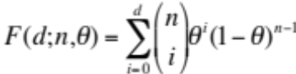 | (2)
The time complexity of approximative model checking depends on two main factors: sample size and time used for each sample. Now that we have demonstrated how to achieve the minimum sample size to satisfy user requirements, we will discuss in the next sub-section how simulation time of each simulation run can be reduced to further increase the efficiency of our model checker.

results
The two quantifiable contributions of this paper are the proposed algorithm, which can dynamically select an indifference region, and the implementation of the more efficient online approach in model checking. Therefore, in this section, we will demonstrate the performance of MIRACH 1.0 against previous works from these angles.

Probabilistic model checking
Clarke et al. (2008) implemented an approach, initially introduced by Younes et al. (2002), to probabilistic model checking for biological pathway models, where there is no undecided result (given sufficient samples) but the error rate is not always bounded. Another paper by Younes (2006b) proposed an algorithm that always bounds the error rate whenever a definite result is returned but this algorithm does not always return a definite result (even when sufficient samples are given). We name these two algorithms as Younes algorithm A (Younes et al., 2002) and Younes algorithm B (Younes, 2006b) for ease of reference. To compare our proposed algorithm against these two algorithms, we set up a simple experiment.
We use a uniform random generator that produces real numbers in the range of [0,1]. We attempt to validate P_{>=0.8} with p set to 0.7, 0.78 and 0.79 to represent three different levels of difficulty- easy, medium and hard, respectively. If a randomly generated value is lesser than p, then that sample is accepted as true, and false otherwise. Using this approach, we know the true probability, p, and can determine if a response from an algorithm is correct. Therefore, we can compare the performance of these algorithms under different scenarios. For each scenario, we repeat the experiment 10,000 times with α (type-I error rate) and β (type-II error rate) fixed at 0.0001. We expect the number of errors to be less than or equal to 0.0001 * 10,000 = 1 (or at least close to 1) if the error rate is to be bounded. We further limit the sample size used by our algorithm to 10,000, as we believe any realistic application should have a limit on the CPU resource. A total of three tables are obtained, one for each algorithm.
Table 3. Younes algorithm A (Younes et al., 2002)
 | p = 0.7 | p = 0.78 | p = 0.79
δ = 0.04
No. of Errors | 0 | 73 | 626
No. of Undecided | 0 | 0 | 0
Avg sample size | 181.2 | 820.7 | 1350.5
δ = 0.01
No. of Errors | 0 | 0 | 0
No. of Undecided | 0 | 0 | 0
Avg sample size | 737.5 | 3676.3 | 7311.4
δ = 0.001
No. of Errors | 0 | 0 | 0
No. of Undecided | 0 | 0 | 0
Avg sample size | 7377.5 | 36911.7 | 73715
No. of Errors show how many mistakes were made in the 10,000 experiments. No. of Undecided indicates how many experiments returned undecided results. Avg sample size compute the average samples used in each of the 10,000 experiments.

Table 3 clearly shows how crucial the selection of δ is for Younes algorithm A. If δ is too large, the error rate is not bounded (e.g. with p = 0.79 and δ = 0.04, error rate is at 6.26% instead of the requested 0.01%). On the other hand, if δ is too small, then the number of samples needed to make a decision grows rapidly (e.g. with p = 0.79 and δ = 0.001, the average number of samples needed is over 70,000). Indeed, if the correct δ is chosen, the error rate is bounded and minimum samples are used. However, it is rare for users to be able to choose the correct δ since we would need to know p, the true probability to do so; and if we actually knew that then there is really no need to do any hypothesis testing in the first place. It should be noted that Younes algorithm A does not provide information on when the error rate is bounded or not. This implies that the user may come to a false conclusion that the result is bounded with a certain error rate when it is actually not.
Table 4. Younes algorithm B (Younes, 2006b)
δ = 0.04 | p = 0.7 | p = 0.78 | p = 0.79
γ = 0.1
No. of Errors | 0 | 0 | 0
No. of Undecided | 0 | 7561 | 9913
Avg sample size | 487.8 | 2571.3 | 1191.2
γ = 0.01
No. of Errors | 0 | 0 | 0
No. of Undecided | 0 | 6211 | 9890
Avg sample size | 493.6 | 4738.9 | 2185.1
γ = 0.001
No. of Errors | 0 | 0 | 0
No. of Undecided | 0 | 5206 | 9900
Avg sample size | 491.1 | 7016.2 | 3168.3

From Table 4, we can see that Younes algorithm B does indeed always bound the error rate. However, it comes at the expense of a large number of undecided results. Over 50% were undecided results when p = 0.78 and it goes beyond 90% when p = 0.79. Note that this means the algorithm uses up computation resources and in the end returns an undecided result, which is undesirable. We should also note the introduction of a new parameter γ in this algorithm where it is meant to limit the probability of undecided results but it comes at the expense of higher sample size.
Table 5. Our Proposed Algorithm
 | p = 0.7 | p = 0.78 | p = 0.79
γ = 0.1
No. of Errors | 0 | 0 | 0
No. of Undecided | 0 | 0 | 0
Avg sample size | 422.6 | 6927.2 | 9814.4
No. decided by p-value | 0 | 2452 | 9435
Errors by p-value | 0 | 0 | 58
Avg p-value (wrong decision) | NA | NA | 0.3850
Avg p-value (correct decision) | NA | 0.0010 | 0.0387
γ = 0.01
No. of Errors | 0 | 0 | 0
No. of Undecided | 0 | 0 | 0
Avg sample size | 428.3 | 7290.3 | 9825.4
No. decided by p-value | 0 | 2814 | 9379
Errors by p-value | 0 | 0 | 77
Avg p-value (wrong decision) | NA | NA | 0.3744
Avg p-value (correct decision) | NA | 0.0008 | 0.0379
γ = 0.001
No. of Errors | 0 | 0 | 0
No. of Undecided | 0 | 0 | 0
Avg sample size | 428.3 | 7610.1 | 9852.0
No. decided by p-value | 0 | 3079 | 9521
Errors by p-value | 0 | 0 | 70
Avg p-value (wrong decision) | NA | NA | 0.3866
Avg p-value (correct decision) | NA | 0.0009 | 0.0389
No. decided by p-value shows how many experiments were decided by comparing p-values. Errors by p-value indicate the number of wrong decisions made by accepting the hypothesis with lower p-value when the sample size limit is reached. Avg p-value (wrong decision) computes the average p-value of those that we use p-value to decide and was wrong. Avg p-value (correct decision) computes the average p-value of those that we use p-value to decide and was right.

As shown in Table 5, our proposed algorithm always gives a definite result. When it is unable to bound the error rate of the result because the sample size limit has reached, it computes and accepts the hypothesis that has a lower p-value. It may seem that accepting a hypothesis based on p-value often results in mistakes. However, if we look at the average p-value where correct and wrong decisions are made, it is clear that wrong decisions are often made when the p-value is close to 0.4 and correct decisions are made when the p-value is below 0.04. Therefore, it is not difficult for humans to discern when to suspect or trust the result given a p-value.
Another feature of our algorithm is that the γ parameter is less influential as we do not have undecided results. Furthermore, γ is found to be optimal at 0.1 (Table 5). Hence, we set it to 0.1 as default in MIRACH so that users have one less parameter to worry about.

Conclusion
In this paper, we have presented a model checker, MIRACH 1.0, for biological pathway simulation models. First, we have proposed a new algorithm that automatically adjusts the sample size needed according to the difficulty of the problem and always gives a definite result which either guarantees a bounded error rate (decided by user) or, when that is not possible (due to sample size limit), gives a p-value as a measure of confidence to the user. With the option of setting a limit on the sample size, users need not worry about non-termination (when p is equal to θ) or an extremely long runtime (when p is extremely close to θ). Another major contribution is the implementation of the more efficient online approach that saves a significant amount of time. Furthermore, MIRACH is integrated with the HFPNe simulation engine, an expressive and powerful framework for defining biological pathway models (Troncale et al., 2006). For coverage, MIRACH supports commonly used formats such as CSML and SBML. Lastly, in an attempt to enable easy extension and contribution to MIRACH, we have uploaded its source along with documentation and examples so that other researchers can easily modify and improve MIRACH to suit their projects. With the community effort, we believe MIRACH will become a much better software than it already is.
We have on-going projects using MIRACH. Firstly, we are working to improve on an in-silico model that investigates cell fate determination of gustatory neurons of Caenorhabditis elegans (Saito et al., 2006) which we previously published by deriving properties from several recently published biological papers. Also, we are currently integrating MIRACH into our own framework, CSMLPipeline, for ease of use in our future projects. Lastly, we are working on a nice graphical user interface so that MIRACH will be even simpler and more appealing to use.
With increasingly large and complex pathway models such as the virtual human and virtual mouse models (Kitano, 2010) to be built, having an efficient and reliable model checker like MIRACH to verify the validity of these models will certainly bring about momentous impact.
acknowledgments
We are thankful to Sharene Lin for her help rendered in the manuscript preparation and proofreading of this manuscript. We would also like to thank Saito Ayumu, Li Chen, Masao Nagasaki and Hakan Younes for their many helpful discussions and suggestions.

Funding: Singapore National Research Foundation grant NRF-
G-CRP-2997-04-082(d) (to L.W. and C.H.K., in parts); National
University of Singapore NGS scholarship (to C.H.K., in parts).

Conflict of Interest: none declared.
References
Baier,C. (1998) On Algorithmic Verification Methods for Probabilistic Systems. Habilitation thesis, University of Mannheim.
Biere,A. et al. (2003) Bounded Model Checking. Advances in Computers, 53.
Clarke,EM. et al. (2008) Statistical Model Checking in BioLab: Applications to the Automated Analysis of T-Cell Receptor Signaling Pathway. In Proc. CSMB 2008, 231–250.
Donaldson,R. and Gilbert,D. (2008a) A Monte Carlo Model Checker for Probabilistic LTL with Numerical Constraints. Technical report, University of Glasgow, Department of Computing Science.
Donaldson,R. and Gilbert,D. (2008b) A Model Checking Approach to the Parameter Estimation of Biochemical Pathways. In Proc. CSMB 2008, 269–287.
Fages,F. And Rizk,A. On the Analysis of Numerical Data Time Series in Temporal Logic. In Proc. CMSB 2007, 48–63.
Heiner,M. et al. (2009) Extended Stochastic Petri Nets for Model-Based Design of Wetlab Experiments. In Proc. CMSB 2009, 138–163.
Hucka,M. et al. (2003) The systems biology markup language (SBML): a medium for representation and exchange of biochemical network models. Bioinformatics 19, 524–531.
Jard,C. and Jeron,T. (1990) On-Line Model-Checking for Finite Linear Temporal Logic Specifications. Lecture Notes in Computer Science, 407, 189–196.
Kitano,H. (2010) Grand challenges in systems physiology. Frontiers in Physiology, 1, 1–3
Levchenko, A. et al. (2000) Scaffold proteins may biphasically affect the levels of mitogen-activated protein kinase signaling and reduce its threshold properties. Proc Natl Acad Sci USA, 97(11), 5818–5823.
Matsuno,H. et al. (2000) Hybrid Petri net representation of gene regulatory network. Pacific Symposium on Biocomputing, 5, 341–352.
Nagasaki,M. et al. (2004) A versatile Petri net based architecture for modeling and simulation of complex biological processes. Genome Informatics, 15(1), 180–197.
Nagasaki,M. et al. (2010) Cell Illustrator 4.0: A computational platform for systems biology. In Silico Biology 10, 0002.
Saito,A. et al. (2006) Cell Fate Simulation Model of Gustatory Neurons with MicroRNAs Double-Negative Feedback Loop by Hybrid Functional Petri Net with Extension. Genome Informatics, 17(1), 100–111.
Troncale,S. et al. (2006) Modeling and simulation with hybrid functional petri nets of the role of interleukin-6 in haematopoiesis. In Proc PSB 2006.
Troncale,S. et al. (2007) Validation of Biological Models with Temporal Logic and Timed Hybrid Petri Nets. Conf Proc IEEE Eng Med Biol Soc, 2007, 4603-4608.
Wald,A. (1945) Sequential tests of statistical hypotheses. Annals of Mathematical Statistics 16(2), 117–186.
Wilson,E. (1927) Probable Inference, the Law of Succession, and Statistical Inference. Journal of the American Statistical Association, 22, 209–212.
Younes,H.L.S. and Simmons,R. (2002) Probabilistic Verification of Discrete Event Systems Using Acceptance Sampling. Lecture Notes in Computer Science, 2404, 223–235.
Younes,H.L.S. (2005) Probabilistic Verification for “Black-Box” Systems. Lecture Notes in Computer Science, 3576, 253–265.
Younes,H.L.S. et al. (2006a) Numerical vs statistical probabilistic model checking. International Journal on Software Tools for Technology Transfer, 8, 216–228.
Younes,H.L.S. (2006b) Error Control for Probabilistic Model Checking. Lecture Notes in Computer Science, 3855, 142–156.

*To whom correspondence should be addressed.

