Improving Risk Stratification in TaLG Bladder Cancer
Method
The UROMOL and Knowles datasets were filtered to only include samples with non-missing recurrence-free survival time values. A total of 178 and 28 samples were included in UROMOL and Knowles datasets respectively. Due to platform differences of RNAseq and microarray, a train-test split was conducted on the RNAseq data to conduct an internal validation of the classifier prior to validation with the Knowles cohort. Genes found in both microarray and RNAseq data were used for feature selection. Figure 1 shows the model workflow.
Weighted Gene Correlation Network Analysis (WGCNA) ¹ was conducted on the training split of the UROMOL dataset to reduce the dimensionality of the gene set. A soft threshold of 5 was used for module construction, yielding a total of 28 module eigengenes representing the expression data. Pearson correlation between the factorized recurrence outcomes labels and the module eigengenes was conducted and a correlation > 0.1 or < -0.1 was set, where five correlated modules were included in a random forest classifier with module eigengenes as input. Absolute SHAP importance values² were calculated from the model’s results, and the least important module was removed for the next step. Genes belonging to these modules were then used as features for a second random forest classifier and SHAP importance values were calculated.
Next, to ascertain genes that were important in recurrence classification, two main filtering steps were performed: 1) differential expression analysis with limma³, with significant differentially expressed genes (DEGs) defined with a threshold of p-value < 0.05 and log₂fold-change of > 0.58 or < -0.58 (corresponding to fold-change of 1.5 and 2) only protein-coding genes.
After these filters were applied, a total of 120 genes were included in in a second random forest model. SHAP importance features were evaluated on the model to determine genes to retain for the Cox proportional-hazards model. 52 genes accounting for up to 70% cumulative importance were retained. Finally, a Cox proportional-hazards model was fitted to the data to obtain its coefficients. Kaplan-Meier curves were constructed by first determining a risk of recurrence (ROR) score based on the sum of the expression multiplied by its coefficients, as in the approach taken in the PAM50 biomarker panel⁴. A precision-recall curve was used to calibrate an ROR threshold of approximately -1 corresponding to precision of 0.28 and recall of 0.63. ROR levels were then classified as high if it was above -1 and low otherwise. The final classifier predicted 36-month recurrence-free survival based on this binary ROR level.
Validation with the Knowles cohort was conducted by scaling the data with respect to the mean and standard deviation from UROMOL training data. caret and survival R packages were used for model construction and ggplot2 was used for graph plotting.

Performance
Figure 2 shows the Kaplan-Meier curves of the ROR levels. While the Kaplan-Meier curves seemed to separate the UROMOL training dataset well by ROR level, but not as much in the test dataset. Figure 3 shows the ROR classifier’s confusion matrix comparing predicted and actual 36-month recurrence-free survival in both datasets. Despite platform differences, the classifier performed well on Knowles cohort.
Clinical interpretation
This model can be used in clinics by testing the expression levels of this 52-gene set and converting it to a ROR score. Further reduction of number of genes, calibration, score normalization may encourage higher predictive power and higher model transparency in the future.
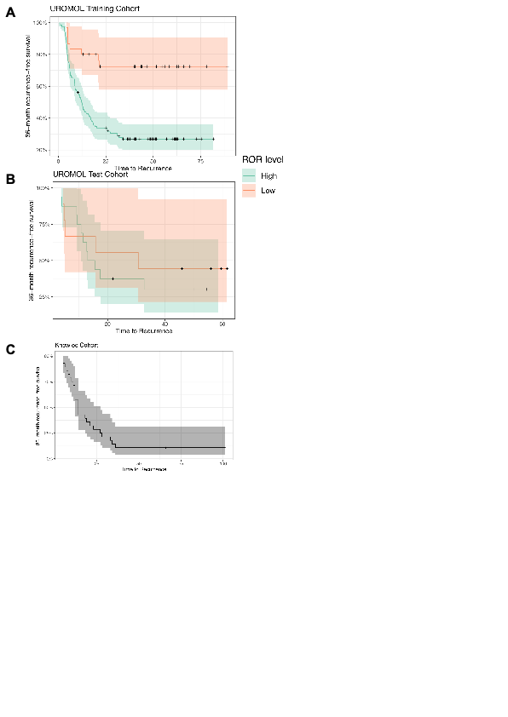
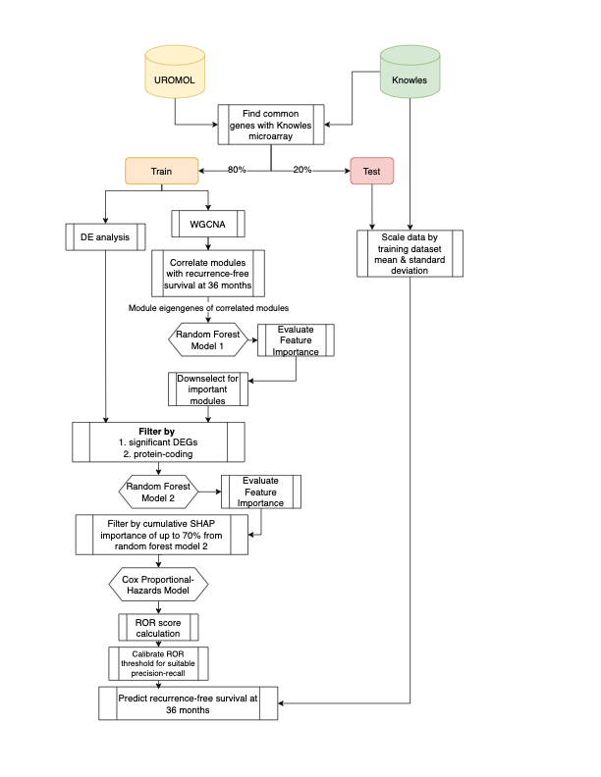
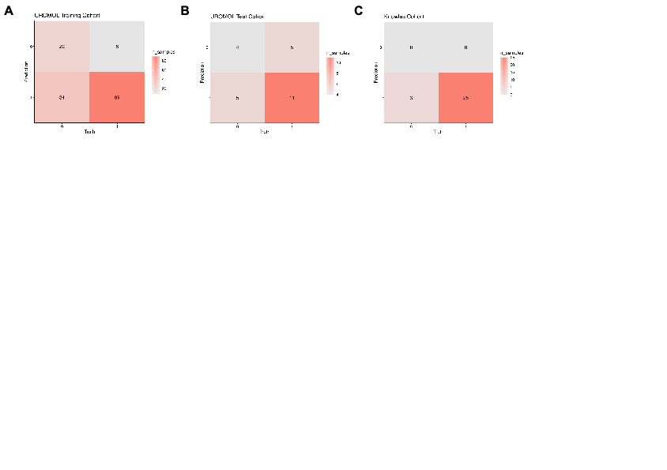
Figure 1. Model workflow. Colors represent data segment.
Figure 2. Kaplan-Meier curves of A) UROMOL training dataset, B) UROMOL testing dataset, C) Knowles dataset. Knowles dataset is uncolored as all samples were positive for recurrence at 36 months
Figure 3. Confusion matrices of A) UROMOL training dataset, B) UROMOL testing dataset, C) Knowles dataset.

Bibliography
1. Langfelder, P. & Horvath, S. WGCNA: an R package for weighted correlation network analysis. BMC Bioinformatics 9, 559 (2008).
2. Lundberg, S. M. & Lee, S.-I. A unified approach to interpreting model predictions. in Proceedings of the 31st International Conference on Neural Information Processing Systems 4768–4777 (Curran Associates Inc., Red Hook, NY, USA, 2017).
3. Ritchie, M. E. et al. limma powers differential expression analyses for RNA-sequencing and microarray studies. Nucleic Acids Res. 43, e47–e47 (2015).
4. Parker, J. S. et al. Supervised Risk Predictor of Breast Cancer Based on Intrinsic Subtypes. J. Clin. Oncol. 27, 1160–1167 (2009).

