|  |  |
| --- | --- |
|  | **Cognizant Academy**  **moviecruiser**  **SQL Specification Document**  **Version 1.0** |
| |  |  |  |  | | --- | --- | --- | --- | |  | **Prepared By / Last Updated By** | **Reviewed By** | **Approved By** | | **Name** | Ramamoorthy Selvam | Vimalathithan Krishnan | Ramadevanahalli Lingachar, Shashidhara Murthy | | **Role** | Learning Solution Designer | Learning Solution Architect | Learning Solution Lead | | **Signature** |  |  |  | | **Date** |  |  |  | |
|  |

Table of Contents

1.0 Introduction 3

1.1 Purpose of this document 3

1.2 Definitions & Acronyms 3

1.3 Project Overview 3

1.4 In Scope 3

1.5 Intended Audience 3

1.6 Hardware and Software Requirement 4

2.0 Database Design 4

2.1 ER Diagram 4

3.0 Schema creation and SQL 5

3.1 Create Schema 5

3.2 Queries for moviecruiser Use Cases 5

4.0 Submission 6

4.1 Code submission instructions 6

5.0 Change Log 6

# Introduction

## Purpose of this document

The purpose of this document is to define the database implementation of the moviecruiser application. The GenC’s has to create the schema for moviecruiser insert some test data and create queries for retrieving and saving data.

## Definitions & Acronyms

|  |  |
| --- | --- |
| Definition / Acronym | Description |
| GenC | Generation Cognizant – Refers to the fresh graduates whom had recently joined Cognizant |

## Project Overview

Refer Use Case specification document for understanding the functionality and features.



## In Scope

1. Creation of Schema
2. Write SQL queries to retrieve movie and favorite data
3. Write SQL queries to save movie details

## Intended Audience

* Product Owner
* Scrum Master
* Application Architect
* Project Manager
* Test Manager
* Development Team
* Testing Team

## Hardware and Software Requirement

1. Hardware Requirement:
   1. Developer PC with 4GB Ram
2. Software Requirement
   1. Git
   2. SQL Server 2014 Management Studio

# Database Design

## ER Diagram

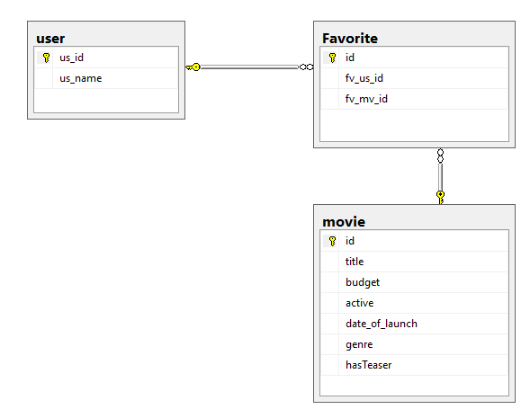

# Schema creation and SQL

## Create Schema

The script to create schema is available in the moviecruiser project.

Execute the script file moviecruiser/sql/moviecruiser-create-schema.sql to create the schema.

## Queries for moviecruiser Use Cases

Write select queries all use case of moviecruiser. Store all the SQL queries in the file mentioned below.

**File Name:** moviecruiser\sql\moviecruiser-data.sql

1. View Movie List Admin (EKUC001)
   1. Write insert scripts to add data into movie table. Refer View Movie List Admin screen shot from Web UI Specification for sample data.
   2. Write SQL query to get all moviess
2. View Movie List Customer (EKUC002)
   1. Write SQL query to get all moviess which are in stock and not expired
3. Edit Movie (EKUC003)
   1. Write SQL query to get a movies based on Movie Id
   2. Write update SQL movies table to update all the columns values based on Movie Id
4. Add to Favorite (EKUC004)
   1. Write insert scripts for adding data into user and favorite tables.In user table create two users. Once user will not have any entries in favorite, while the other will have at least 3 items in the favorite.
5. View Favorite (EKUC005)
   1. Write SQL query to get all moviess in a particular user’s favorite
   2. Write SQL query to get the total price of all moviess in a particular user’s favorite
6. Remove movie from Favorite (EKUC006)
   1. Write SQL query to remove a movie from Favorite based on User Id and Movie Id

# Submission

## Code submission instructions

Once your code is evaluated by the trainer and all the issues reported by the trainer are corrected, the code needs to be submitted to the remote repository. Follow the steps below to submit the code to remote repository.

1. In Windows Explorer go to the moviecruiser folder
2. Right click on the empty space in the right hand side of Windows Explorer and select “Git Bash here”
3. Execute the following commands

To display the added or modified files

git status

To stage the added or modified files

git add .

To display the staged files

git status

To save the code to local repository

git commit -m "sql"

To transfer the changes from local machine to server

git push origin master

1. Successful execution of the above commands will upload the files to the server repository.
2. Login into <https://code.cognizant.com>
3. Click on the project moviecruiser
4. Check if the files that are uploaded correctly with appropriate folder structure.

# Change Log

|  |  |  |  |  |
| --- | --- | --- | --- | --- |
|  | Changes Made | | | |
| V1.0.0 | Initial baseline created on 25-May-19 by Ramamoorthy Selvam | | | |
| Vx.y.z | <Please refer the configuration control tool / change item status form if the details of changes are maintained separately. If not, the template given below needs to be followed> | | | |
| **Section No.** | **Changed By** | **Effective Date** | **Changes Effected** |
|  |  |  |  |