|  |  |
| --- | --- |
|  | **Cognizant Academy**  **truYum**  **SQL Specification Document**  **Version 1.0** |
| |  |  |  |  | | --- | --- | --- | --- | |  | **Prepared By / Last Updated By** | **Reviewed By** | **Approved By** | | **Name** | Chandrasekaran Janardhanan | Vimalathithan Krishnan | Ramadevanahalli Lingachar, Shashidhara Murthy | | **Role** | Learning Solution Designer | Learning Solution Architect | Learning Solution Lead | | **Signature** |  |  |  | | **Date** | 23 May 2019 | 23 May 2019 | 17 Jun 2019 | |
|  |

Table of Contents

1.0 Introduction 3

1.1 Purpose of this document 3

1.2 Definitions & Acronyms 3

1.3 Project Overview 3

1.4 In Scope 3

1.5 Intended Audience 3

1.6 Hardware and Software Requirement 3

2.0 Database Design 4

2.1 ER Diagram 4

3.0 Schema creation and SQL 5

3.1 Create Schema 5

3.2 Queries for truYum Use Cases 5

4.0 Submission 6

4.1 Code submission instructions 6

5.0 Change Log 6

# Introduction

## Purpose of this document

The purpose of this document is to define the database implementation of the truYum application. The GenC’s has to create the schema for truYum insert some test data and create queries for retrieving and saving data.

## Definitions & Acronyms

|  |  |
| --- | --- |
| Definition / Acronym | Description |
| GenC | Generation Cognizant – Refers to the fresh graduates whom had recently joined Cognizant |

## Project Overview

Refer truYum-use-case-specification.docx for understanding the functionality and features.

## In Scope

1. Creation of Schema
2. Write SQL queries to retrieve menu item and cart data
3. Write SQL queries to save menu item details

## Intended Audience

* Product Owner
* Scrum Master
* Application Architect
* Project Manager
* Test Manager
* Development Team
* Testing Team

## Hardware and Software Requirement

1. Hardware Requirement:
   1. Developer PC with 4GB Ram
2. Software Requirement
   1. Git
   2. SQL server management studio 2012/2014
3. Reference application access steps
   1. Use the attached script files for the application



# Database Design

## ER Diagram

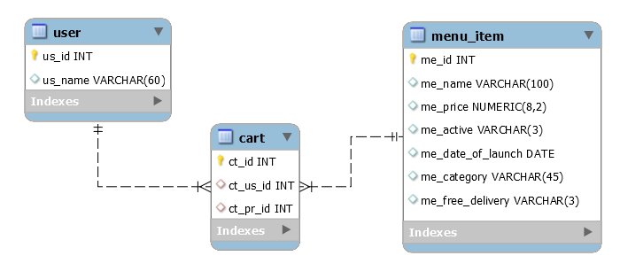

# Schema creation and SQL

## Create Schema

Use the attached script truyum-schema.sql to create the schema.

## Queries for truYum Use Cases

Frame select queries all use case of truYum. Store all the SQL queries in the file mentioned below.

**File Name:** truYumOnline\sql\data.sql

1. View Menu Item List Admin (TYUC001)
   1. Frame insert scripts to add data into menu_item table. Refer View Menu Item List Admin screen shot from Web UI Specification for sample data.
   2. Frame SQL query to get all menu items
2. View Menu Item List Customer (TYUC002)
   1. Frame SQL query to get all menu items which after launch date and is active.
3. Edit Menu Item (TYUC003)
   1. Frame SQL query to get a menu items based on Menu Item Id
   2. Frame update SQL menu_items table to update all the columns values based on Menu Item Id
4. Add to Cart (TYUC004)
   1. Frame insert scripts for adding data into user and cart tables.In user table create two users. Once user will not have any entries in cart, while the other will have at least 3 items in the cart.
5. View Cart (TYUC005)
   1. Frame SQL query to get all menu items in a particular user’s cart
   2. Frame SQL query to get the total price of all menu items in a particular user’s cart
6. Remove Item from Cart (TYUC006)
   1. Frame SQL query to remove a menu items from Cart based on User Id and Menu Item Id

# Submission

## Code submission instructions

Once your code is evaluated by the trainer and all the issues reported by the trainer are corrected, the code needs to be submitted to the remote repository. Follow the steps below to submit the code to remote repository.

1. In Windows Explorer go to the truYum folder
2. Right click on the empty space in the right hand side of Windows Explorer and select “Git Bash here”
3. Execute the following commands

To display the added or modified files

git status

To stage the added or modified files

git add .

To display the staged files

git status

To save the code to local repository

git commit -m "sql"

To transfer the changes from local machine to server

git push origin master

1. Successful execution of the above commands will upload the files to the server repository.
2. Login into <https://code.cognizant.com>
3. Click on the project truYum
4. Check if the files that are uploaded correctly with appropriate folder structure.

# Change Log

|  |  |  |  |  |
| --- | --- | --- | --- | --- |
|  | Changes Made | | | |
| V1.0.0 | Initial baseline created on <dd-Mon-yy> by <Name of Author> | | | |
| Vx.y.z | <Please refer the configuration control tool / change item status form if the details of changes are maintained separately. If not, the template given below needs to be followed> | | | |
| **Section No.** | **Changed By** | **Effective Date** | **Changes Effected** |
|  |  |  |  |