|  |  |
| --- | --- |
|  | **Cognizant Academy**  **truYum**  **Web Interface Specification Document**  **Version 1.0** |
| |  |  |  |  | | --- | --- | --- | --- | |  | **Prepared By / Last Updated By** | **Reviewed By** | **Approved By** | | **Name** | Ramamoorthy Selvam | Vimalathithan Krishnan | Ramadevanahalli Lingachar, Shashidhara Murthy | | **Role** | Learning Solution Designer | Learning Solution Architect | Learning Solution Lead | | **Signature** |  |  |  | | **Date** |  |  |  | |
|  |

Table of Contents

1.0 Introduction 3

1.1 Purpose of this document 3

1.2 Definitions & Acronyms 3

1.3 Project Overview 3

1.4 Scope 3

1.5 Intended Audience 3

1.6 Hardware and Software Requirement 4

2.0 Git Project Cloning 4

3.0 Screen Flow 5

4.0 View Menu Item List (TYUC001 & TYUC002) 7

4.1 Menu Item List Admin 7

4.2 Menu Item List Customer 8

5.0 Edit Menu Item (TYUC003) 9

5.1 Edit Menu Item 9

5.2 Edit Menu Item Status 10

6.0 Add to Cart (TYUC004) 11

6.1 Menu Item List Customer (Add to Cart success) 11

7.0 View Cart (TYUC005) 12

7.1 Cart 12

7.1 Cart Empty 13

8.0 Remove item from Cart (TYUC005) 14

8.1 Remove Cart 14

9.0 Standards and Guidelines 14

9.1 HTML 14

9.2 CSS 15

9.3 JavaScript 15

10.0 Submission 16

10.1 Code submission instructions 16

11.0 Change Log 17

# Introduction

## Purpose of this document

The purpose of this document is to define the user interface specification for truYum project.

## Definitions & Acronyms

|  |  |
| --- | --- |
| Definition / Acronym | Description |
| HTML | Hyper Text Markup Language |
| CSS | Cascading Style Sheet |

## Project Overview

Refer Use Case specification document for understanding the functionality and features.



## Scope

Develop static HTML web pages for truYum application.

## Intended Audience

* Product Owner
* Scrum Master
* Application Architect
* Project Manager
* Test Manager
* Development Team
* Testing Team

## Hardware and Software Requirement

1. Hardware Requirement:
   1. Developer Desktop PC with 4GB RAM
2. Software Requirement
   1. Notepad ++ for editing HTML and CSS
   2. Chrome Browser

# Git Project Cloning

Code for truYum project should be submitted to a Git server repository. This will enable the Facilitator to validate your code. The following paragraphs will give an overview about Git and the steps required to setup the folder structure before starting to code.

There is an existing project in GitLab server that contains the folder structure required for developing this application. Our first step is a create a copy of that project in your GitLab profile. Before starting the cloning steps, let us understand about GitLab.

**What is GitLab?**

GitLab is a software that can be installed in a centralized server to manage code from various developers. For the purpose of learning and collaboration within employees of Cognizant, a separate GitLab instance is available for use. This is hosted in the URL <https://code.cognizant.com>. Each employee in Cognizant has access to this repository and can login into this portal using Cognizant network credentials. Each employee can create upto 10 projects under his/her profile. The code for truYum has to be submitted in this server.

**How truYum project is organized in GitLab?**

There is an existing project in GitLab that contains the necessary folder structure for truYum project. You need to create a copy of this project in your profile before downloading the code from the server. The process of creating a copy of this project in your profile is called forking. Find the instructions befow to fork the project:

**Steps for Forking**

1. In browser, login with you network credentials at <https://code.cognizant.com>
2. Copy and paste the below URL in the browser after login.

[https://code.cognizant.com/125546/truYum](https://code.cognizant.com/125546/eKart)

1. Click fork
2. Click on your name
3. The above steps creates a new project in your profile. The content of the project will be the same as genc-dotnet-practice-check that is existing in the server.
4. If you click on GitLab link on the top left corner, you can find the project listed under your name in the “Your Projects” section. This means that you have successfully completed forking the project.
5. Click on the project and go through the folders and files in the project

**Steps for Cloning**

The steps done earlier had create copy of the project under your profile. Now, this project is only available in the server. We need to get a copy of this project in your local machine, so that you can start writing your code in the folder created locally. This process of creating a copy from the server to local PC is called cloning. The steps below will guide to clone the project.

1. Let us download the code from the server to D:
2. Open Windows Explorer and click on D:
3. Right click on the empty space in right hand side of the explorer window and select “Git Bash here” option
4. Execute the following commands. Replace content within angular brackets <> with appropriate values:

**git config --global user.name "<LastName>, <FirstName> (Cognizant)"**

**git config --global user.email "<CognizantEmailId>"**

**git clone** [**https://code.cognizant.com/<EmployeeId>/truYum.git**](https://code.cognizant.com/%3cEmployeeId%3e/eKart.git)

1. After completion of above steps you can find a new folder ‘truYum’ created in D:, which will contain few folders and files. The folder structure should be similar to the folders and files in the server.
2. Once the above steps are completed, you are ready for writing the code. Place the files as per the instructions provided in the following sections.

# Screen Flow

Flow of screens for Customer and Admin provided below. Blue boxes represent pages. Orange boxes represent the user role. The label in the lines denote the link in the page used to arrive from the specific page.

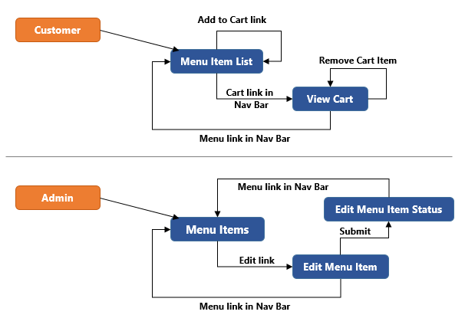

# View Menu Item List (TYUC001 & TYUC002)

## Menu Item List Admin

Displays the list of menu items. Each menu item will have option to edit a particular menu item

File: truYum/ truYumStoreWeb /MenuItemsListAdmin.html

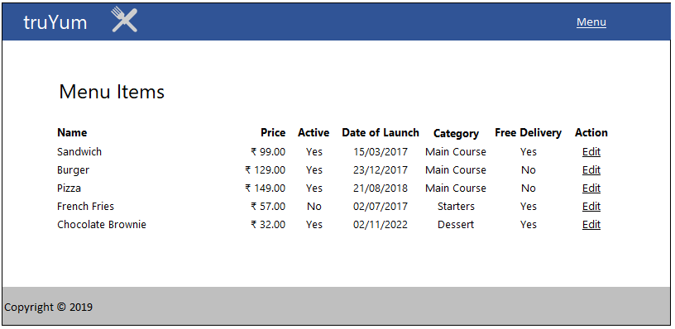

**Field Specification**

The menu items are listed in table kind of structure. Find below the specification for each column in the Menu Item List table.

|  |  |  |
| --- | --- | --- |
| **Field Name** | **Field Type** | **Description** |
| Name | Label | Displays the title of the menu item |
| Price | Label | Display the price of the menu item in currency format with two decimal places. Should include the currency symbol as well. |
| Active | Label | Display ‘Yes’ or ‘No’ based on whether the item is in stock or not |
| Date of Launch | Label | Display date of expiry in DD/MM/YYYY format |
| Category | Label | Displays the category of the menu item |
| Free Delivery | Label | Display ‘Yes’ or ‘No’ based the respective menu item delivery status |
| Action | Link | Display ‘Edit’ as a link that points to edit-MenuItem.html |

## Menu Item List Customer

Displays the list of menu items. Each menu item will have option to add the specific menu item to cart

File: truYum/TruYumStoreWeb/MenuItemListCustomer.html

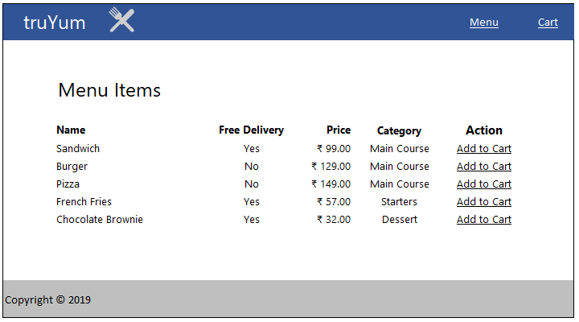

**Field Specification**

|  |  |  |
| --- | --- | --- |
| **Field Name** | **Field Type** | **Description** |
| Name | Label | Displays the title of the menu item |
| Price | Label | Display the price of the menu item in currency format with two decimal places. Should include the currency symbol as well. |
| Category | Label | Displays the category of the menu item |
| Free Delivery | Label | Display ‘Yes’ or ‘No’ based the respective menu item delivery status |
| Action | Link | Display ‘Add to Cart’ link, it displays the same page with notification message that the Menu Item is added into the cart or not |

# Edit Menu Item (TYUC003)

## Edit Menu Item

Screen with form fields to edit the menu item details. This page is arrived by clicking the Edit link in MenuItemListAdmin.html.

File: truYum/TruYumStoreWeb/EditMenuItem.html

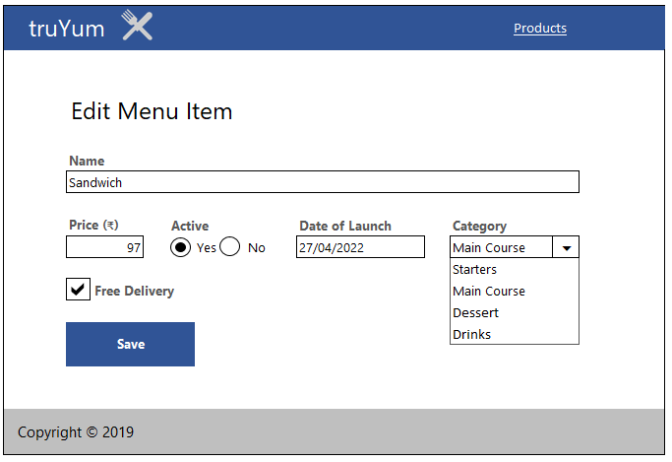

**Field Specification**

|  |  |  |  |
| --- | --- | --- | --- |
| **Field Name** | **Field Type** | **Name in HTML** | **Validation Message** |
| Title | Text Box | title | * Title is required. * Title should have 2 to 65 characters. |
| Price | Text Box | price | * Price is required. * Price has to be a number. |
| Date of Launch | Text Box | dateOfLaunch | * Date of Launch is required |
| Active | Radio Buttons | inStock |  |
| Category | Drop Down List | category | * Select one category |
| Free Delivery | Checkbox | freeDelivery |  |
| Save | Submit | submit | Button used by user to submit the form for saving a Menu Item. Above mentioned validations needs to be done on click of this button. The message needs to be displayed using JavaScript alert. |

## Edit Menu Item Status

Display the status of submission of edit menu item form. This page is arrived after clicking save in EditMenuItem.html.

File: truYum/TruYumStoreWeb/EditMenuItemStatus.html

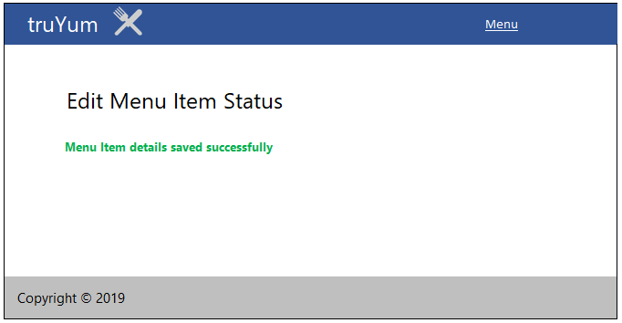

# Add to Cart (TYUC004)

## Menu Item List Customer (Add to Cart success)

Customer can add a menu item to Cart by clicking “Add to Cart” link in MenuItemListCustomer.html. On clicking this link a page similar to Menu Item List page is displayed with the message that the Menu Item has been added to the cart successfully.

File: truYum/TruYumStoreWeb/MenuItemListCustomerNotification.html

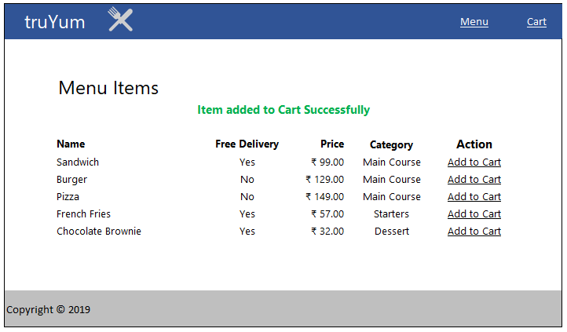

**Field Specification**

Refer Section 3.1

# View Cart (TYUC005)

## Cart

Displays the list of items added to the cart. This screen is arrived based on the navigation link in the top of the screen from MenuItemListCustomer.html.

File: truYum/TruYumStoreWeb/Cart.html

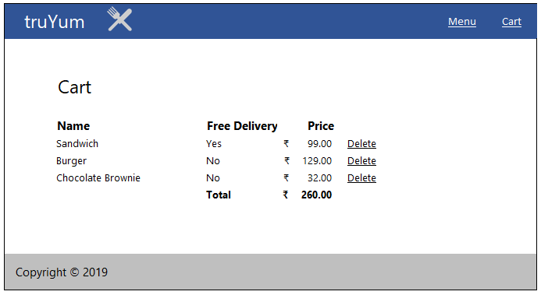

**Field Specification**

|  |  |  |
| --- | --- | --- |
| **Field Name** | **Field Type** | **Description** |
| Name | Label | Displays the title of the menu item |
| Free Delivery | Label | Display ‘Yes’ or ‘No’ based the respective menu item delivery status |
| Price | Label | Display the price of the menu item in currency format with two decimal places. Should include the currency symbol as well. |
| Delete | Link | Display ‘Delete’ link, which displays the same page with notification message that the item is deleted from the Cart successfully. |

## Cart Empty

Displays the view when there are no items in the cart. The Menu Item List link in the message should point to MenuItemListCustomer.html.

File: truYum/TruYumStoreWeb/CartEmpty.html

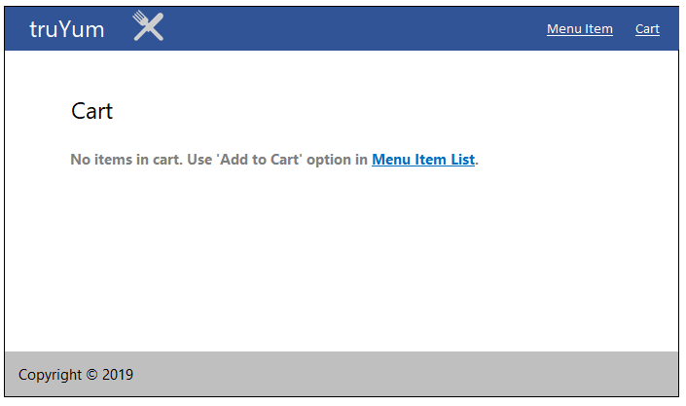

# Remove item from Cart (TYUC005)

## Remove Cart

When Customer click ‘Delete’ link in Cart.html, this page is displayed with the message that the item had been removed from the Cart successfully.

File: truYum/TruYumStoreWeb/CartNotification.html

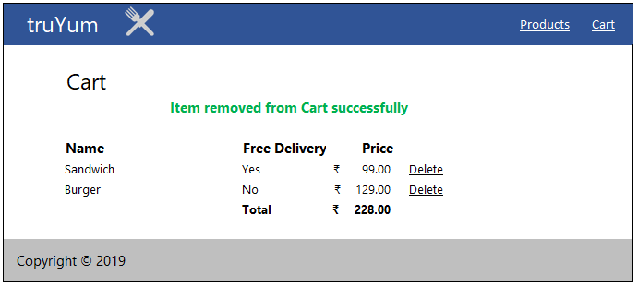

**Field Specification**

Refer section 6.1

# Standards and Guidelines

## HTML

1. Place all HTML files under TruYumStoreWeb folder.
2. HTML5 semantic tags has to be used wherever applicable. Avoid using div tags for header, footer, article and navigation bar.
3. Document Type should be defined as

<!DOCTYPE html>

1. Form fields must always include a <label> element with a "for" attribute matching the "id".

<label for="field-email">email</label>

<input type="email" id="field-email" name="email" value="" />

1. Each form field should have "name" attribute.
2. All tag names and attributes must be written in lowercase.
3. Inline style should be never used. Style should be in an external CSS and should be linked to the document.
4. Image files should be placed in TruYumStoreWeb/images folder.
5. Add one more tab on the next line after opening a tag
6. Reduce one tab on line when tag is closed

## CSS

1. CSS files names should be style.css
2. CSS files should be placed in TruYumStoreWeb/styles folder.
3. Feel free to change the Background Color, Font, Font Size and Font Color of the screen. But it should be applied consistently across screens using CSS. Following are the element in the screen that can be targeted for style change:
   1. Navigation Bar
   2. Page Heading
   3. Form Elements
   4. Messages
4. Reuse styles wherever applicable. Potential areas are Application Name, Page Title, Form Fields and Buttons
5. Selector names should be in lower case with words separated by hyphen.

.page-title {

margin: 20px;

}

1. Selector class names should be relevant to the purpose of the element where the style is applied. For example if common style needs to be applied for all text boxes in an application.
2. Properties should be followed by a colon and a space
3. Properties and values should be in lower case
4. Use hexadecimal code for color definition

Example:

.login-form {

background: #fdfdfd;

display: block;

margin: 0;

margin-left: 20px;

}

## JavaScript

1. JavaScript file name should **script.js**
2. JavaScript file should be placed in folder **TruYumStoreWeb/js**
3. Use camelCase for variables and functions.

var firstName = "John";

function alert() {

alert("This is an alert message.");

}

1. All variable names start with a letter.
2. Always put a space before and after an operator.

var profit = sellingPrice - buyingPrice;

1. Always end a statement with semicolon.
2. Open curly braces should be in the same line.
3. All lines following open curly braces should have one level of indent
4. Closing curly braces should be in next line with reduction of indent by one level

Example

if (time < 20) {

greeting = "Good day";

} else {

greeting = "Good evening";

}

# Submission

## Code submission instructions

Once your code is evaluated by the trainer and all the issues reported by the trainer are corrected, the code needs to be submitted to the remote repository. Follow the steps below to submit the code to remote repository.

1. In Windows Explorer go to the truYum folder
2. Right click on the empty space in the right hand side of Windows Explorer and select “Git Bash here”
3. Execute the following commands

To display the added or modified files

git status

To stage the added or modified files

git add .

To display the staged files

git status

To save the code to local repository

git commit -m "web module"

To transfer the changes from local machine to server

git push origin master

1. Successful execution of the above commands will upload the files to the server repository.
2. Login into <https://code.cognizant.com>
3. Click on the project truYum
4. Check if the files that are uploaded correctly with appropriate folder structure.

# Change Log

|  |  |  |  |  |
| --- | --- | --- | --- | --- |
|  | Changes Made | | | |
| V1.0.0 | Initial baseline created on 20-May-19 by Ramamoorthy Selvam | | | |
| Vx.y.z | <Please refer the configuration control tool / change item status form if the details of changes are maintained separately. If not, the template given below needs to be followed> | | | |
| **Section No.** | **Changed By** | **Effective Date** | **Changes Effected** |
|  |  |  |  |