1. Objective of the project 3

2. Features / Functionalities of the prototype 3

2.1 Tips 3

2.2 Greenhouse 3

2.3 Monthly Missions 3

2.4 General Missions 4

2.5 Weekly Missions 4

2.6 Update User Information 4

3 User manual with print screens from the prototype 5

3.1 Login 5

3.1.1 If it is user’s first time using the application 5

3.1.2 If it is not user’s first time using the application 7

3.1.3 Errors - invalid user input 8

3.2 Main Menu Page 10

3.3 Tips on saving Electricity and Water 11

3.4 Greenhouse 13

3.4.1 Greenhouse Menu page 13

3.4.2 Tree Gallery (Default) 14

3.4.3 Style Unlock 14

3.4.4 Tree Gallery (with colour selection) 15

3.4.5 Errors - invalid user input 16

3.5 Monthly Missions 18

3.5.1 Select month and year 18

3.5.2 Entering monthly data 19

3.5.3 Award points 19

3.5.4 Feedback for user 20

3.5.5 Errors - invalid user input 21

3.6 General Missions 22

3.6.1 First usage 22

3.6.2 Subsequent usage 24

3.6.3 Errors - invalid user input 25

3.7 Weekly Missions 26

3.7.1 First usage or seven days after completion of previous weekly mission 26

3.7.2 Previous user 27

3.7.3 Errors - invalid user input 27

3.8 Change user information 29

3.8.1 Errors - invalid user input 30

3.9 Help on the game 31

3.10 Update Household Information 32

3.10.1 Errors - invalid user input 32

4 References 33

# 

# 1. Objective of the project

This application aims to provide users with a fun and interactive way to save electricity and water at home through the gamification of our Python-based program.

Users will be able to grow trees and decorate their forest by completing various missions related to saving water and electricity. Users will learn more about their consumption habits and how they compare against the national average.

This encourages users to continue saving and become more conscious about their household consumption, all while creating their very own forest.

# 2. Features / Functionalities of the prototype

Data is saved by username, and the user’s previously saved data can be called or newly created upon entering the program. A main menu provides the user with all the features of the program. They include:

## 2.1 Tips

This feature provides electricity and water saving tips (randomly generated) for users to learn more about how they can save water and electricity at home. Their references can be found under *Section 4.*

## 2.2 Greenhouse

The greenhouse is where users enter to view their rewards. These rewards are in the form of trees and colour styles (font colour and tree background). Every user will receive a tree upon creating a new account. Afterwhich, users will receive a new tree by completing the weekly missions four times. Every four trees earn users a big tree. Points are awarded to users when they complete the general and monthly missions. Every 100 points can be exchanged for one colour style.

## 2.3 Monthly Missions

The monthly missions allow users to update their electricity and water usage. After entering the data, users will be provided feedback on their current electricity and water usage. The feedback will be based on comparison with users’ last-entered data and the national average. By providing feedback to users, it raises awareness about their water and electricity consumption, encouraging them to save more. Upon completion, users will also receive 30 points to unlock more colour styles in the Greenhouse.

## 

## 2.4 General Missions

The general missions allow users to enter basic information about their household appliances. Users will be prompted to key in their aircon and refrigerator green ticks, water heater wattage and toilet flush system. Upon successful entry, users will be awarded with 200 points to unlock colour styles in the Greenhouse. By entering the general missions page again, users can view a summary of their current inputs and choose to update the information. This ensures that our program has the most accurate and up-to-date user data.

## 2.5 Weekly Missions

The weekly missions can only be completed every seven days. First, there will be seven yes-no questions. The next part of the weekly mission will be asking questions specific to certain appliances and usage such as the water heater, aircon, shower, tap and washing machine. These questions could be yes-no questions or fill-in-the-blanks. After finishing their questionnaire, users will be rewarded with a score. If the score is above four, they pass the weekly mission for the week. After passing four weekly missions, they will be rewarded with a tree in the Greenhouse.

## 2.6 Update User Information

If needed, users can update some of their preliminary information. This includes their household members and household type. They can also choose to change user settings such as their name and password. However, users are not allowed to change their username as it is their unique identifier.

# 3 User manual with print screens from the prototype

## 3.1 Login

Upon activation of the program, the user will be introduced to the name of the program and asked to indicate if it is their first time using the application.

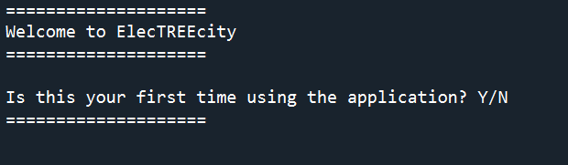

Figure 3.1: Welcome Page

### 3.1.1 If it is user’s first time using the application

The user will be introduced to the objective of the application. Then, he will be asked to input his new username. If user wants to return to the previous page (*Figure 3.1)*, he can input ‘e’.

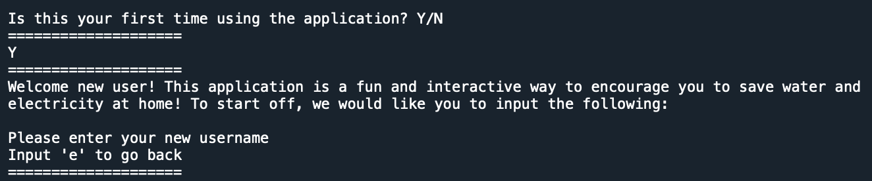

Figure 3.1.1a : Program’s Objective

After the user inputs his desired username, the system checks if the inputted username has already been taken in the stored data. For example, assuming the username “Python123” is already used, Figure 3.1.1b shows what happens if a new user tries to enter the existing username:

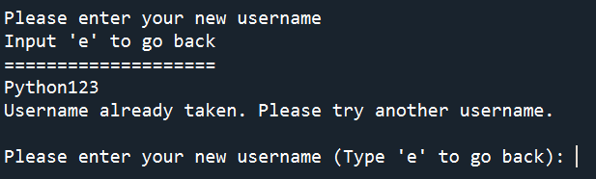

Figure 3.1.1b : When Username is Taken

Once the inputted username has passed through the check above, a password will be prompted from the user. The password requires at least 5 characters and can be alphanumeric.

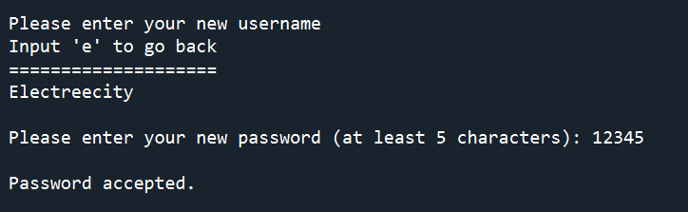

Figure 3.1.1c : Password Prompt

After a successful password has been added, some preliminary questions will be asked, such as the user’s name, household members and household type.

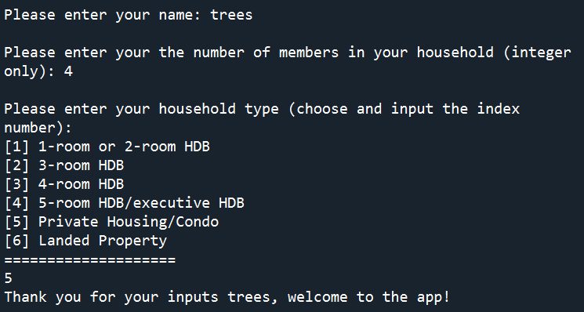

Figure 3.1.1d : Preliminary Questions

Since the user is new, the instructions on how the game is played will be displayed.

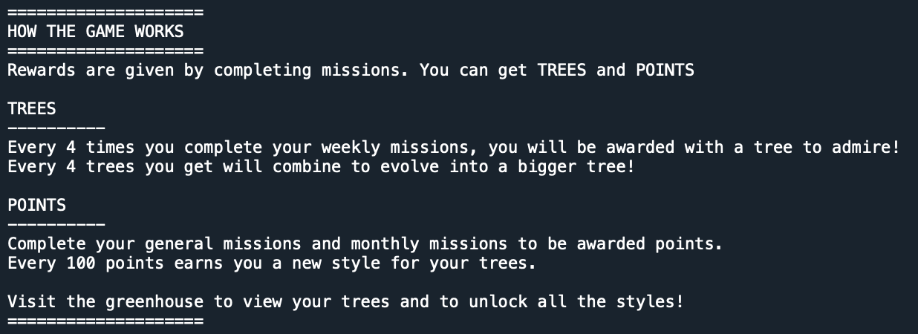

Figure 3.1.1e : Game Instruction

As a welcome gift, all new users will be given a tree to get them started



Figure 3.1.1e : Welcome Gift

The user can then press any key to continue into the main menu:



Figure 3.1.1e : Any Key Prompt

### 3.1.2 If it is not user’s first time using the application

The user will be prompted for his username. If keyed in successfully, he will be brought to the main menu page.

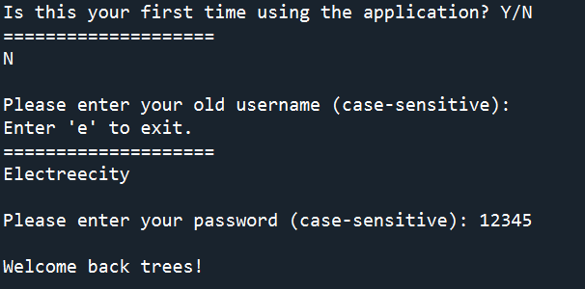

Figure 3.1.2: Existing User’s Login Page

### 3.1.3 Errors - invalid user input

When prompted Y or N, any invalid input will receive an error message:

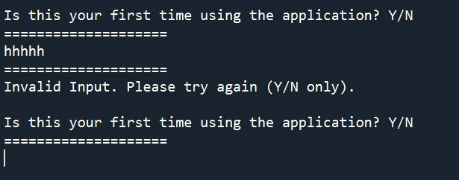

Figure 3.1.3a: Y/N Error Message

For new users, if the password is less than 5 characters, the user will receive an error message and be prompted to enter a longer password:

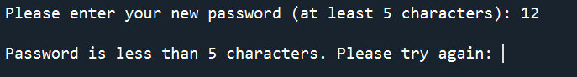

Figure 3.1.3b: New Password Error Message

For new users, when asked to input the household number, only integers greater than one are accepted because every household must consist of at least 1 person. An error message occurs if this criteria is not met:

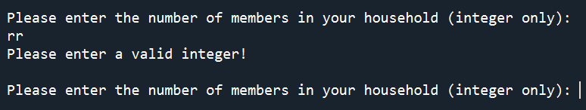

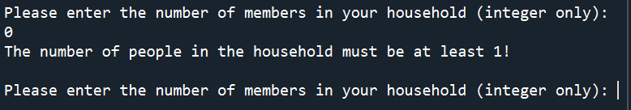

Figure 3.1.3c: Household Number Error Message

Additionally, for household type, if it is not part of the index number (from 1 to 6), an error message will occur:

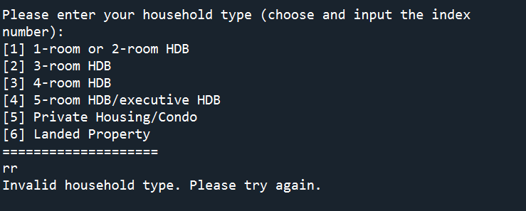

Figure 3.1.3d: Household Type Error Message

For old users, if the password is wrong, the user will again be prompted with an error and be requested to re-enter the correct password:

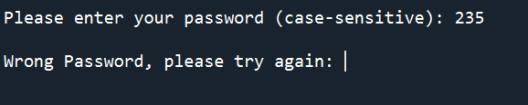

Figure 3.1.3b: Existing Password Error Message

## 3.2 Main Menu Page

After successful login, the user will be brought to the main menu where they are given a few options to choose from (Figure 3.2).

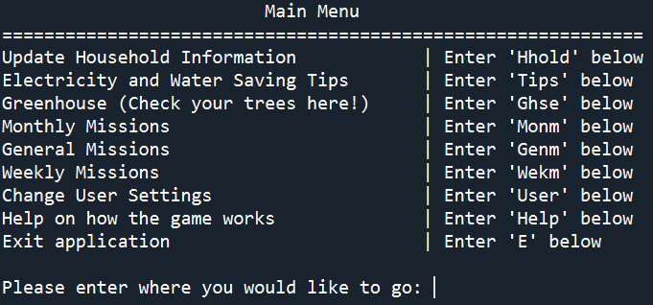

Figure 3.2a : Main Menu Page

To exit the application, the user can enter ‘E’.

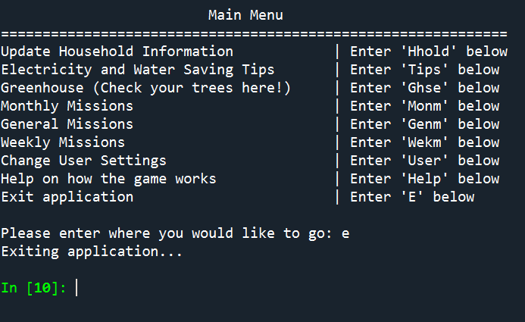

Figure 3.2b : Exiting Application

**3.2.1 Errors - invalid user input**

If the user enters any unrecognised input, an error message will appear:

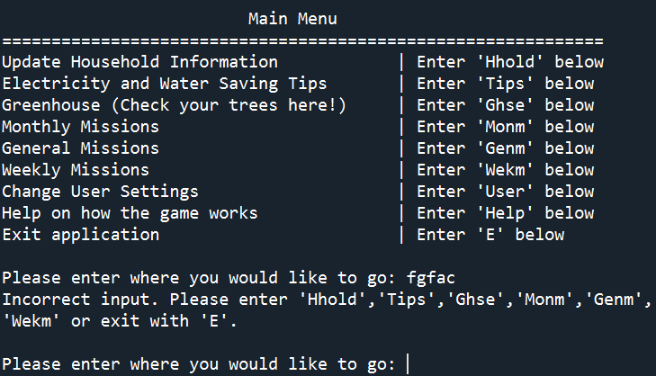

Figure 3.2.1 : Main Menu Error Message

## 3.3 Tips on saving Electricity and Water

To navigate to the Tips page, user will have to enter ‘ Tips’ .

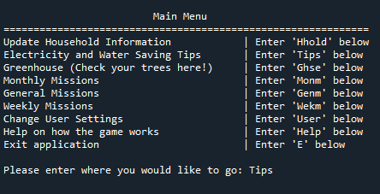

Figure 3.3a : Navigation to Tips Page

User will be provided a quick water-saving or electricity-saving tip. If the user wishes to generate more tips, he can continue inputting ‘Y’. Otherwise, he can input ‘N’ or return to the main menu.

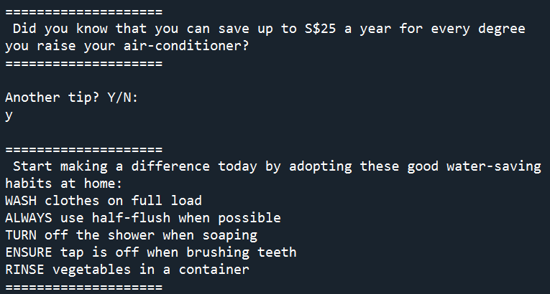

Figure 3.3b :Tips Page

**3.3.1 Errors - invalid user input**

Any input other than ‘Y’,’y’, ‘N’ or ‘n’ will display an error message and the user will be asked to input again:

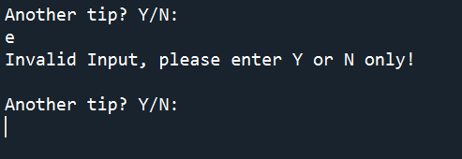

Figure 3.3.1 :Tips Page’s Error Message

## 3.4 Greenhouse

To navigate to the Greenhouse page, the user has to enter ‘Ghse’ in the main menu.

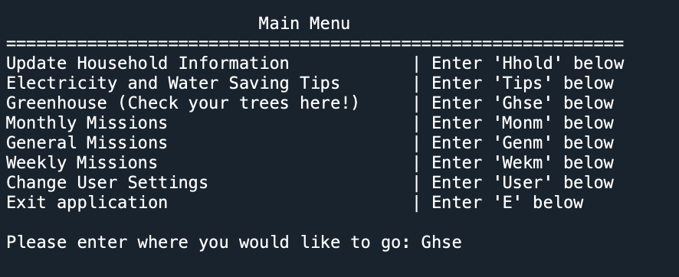

Figure 3.4 : Navigation to Greenhouse

### 3.4.1 Greenhouse Menu page

At the greenhouse menu page, the user would be able to either enter ‘Trees’ to view their trees or enter ‘Styles’ to unlock new styles for their trees.

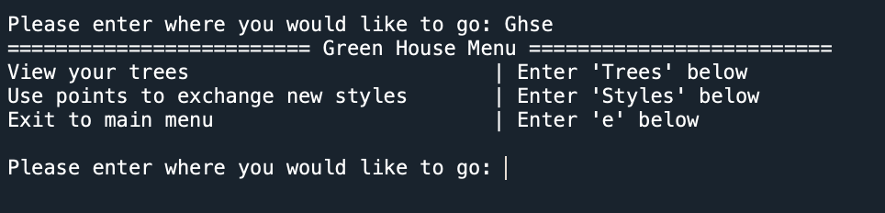

Figure 3.4 : Greenhouse Menu Page

### 3.4.2 Tree Gallery (Default)

The user is awarded 1 tree for every 4 weekly missions they complete. For every 4 trees the user obtains, the trees will join to become one big tree.

To view the trees he has, user can navigate to the trees gallery by entering ‘Trees’ in the Green House Menu.

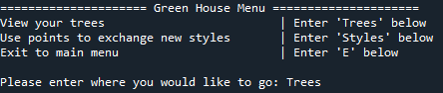

*Figure 3.4.2a: Navigation to Trees Gallery*

If the user has no styles unlocked for the trees, the trees will be printed out in default.

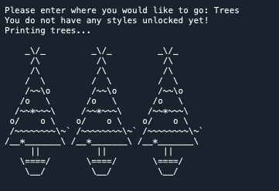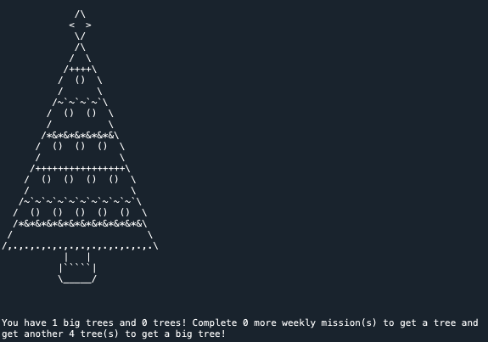

*Figure 3.4.2: Trees (Left: Small tree;Right: Large tree)*

### 3.4.3 Style Unlock

The user will earn 200 points for completing the general missions and 30 points every month for completing the monthly missions. These points can be used to unlock styles for the trees. The user has to enter ‘Styles’ at the greenhouse menu page to be navigated to the Styles Page.

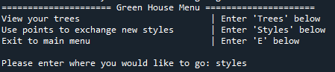

Figure 3.4.3a : Navigation to Styles Page

User will be informed of the total points collected. If the user has sufficient points, he will have a choice to unlock colours for the font or the background.

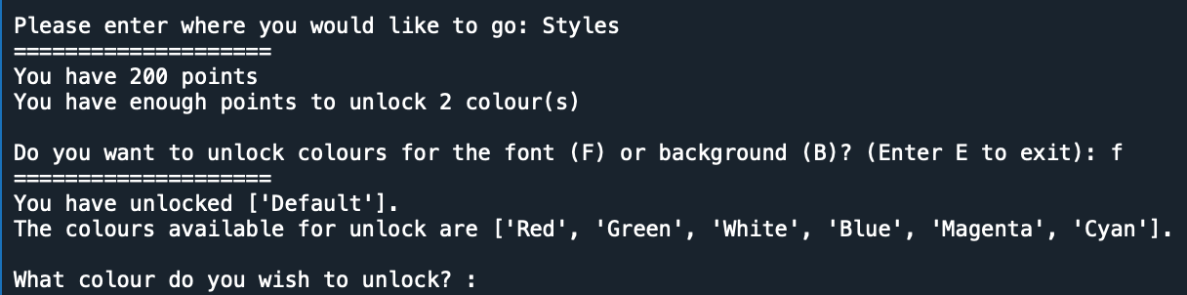

Figure 3.4.3b : Styles Page

Confirmation will be given to the user upon unlocking.

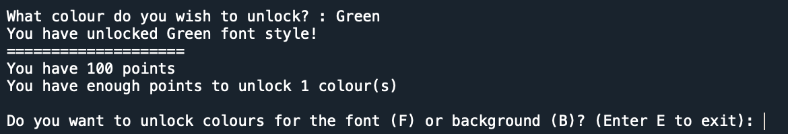

Figure 3.4.3c : Unlocking Styles

### 3.4.4 Tree Gallery (with colour selection)

Upon unlocking styles for the trees, users will be prompted to choose colours for the font and the background at the Tree Gallery. Users will also see the visual effect from the text.

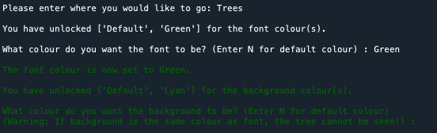

Figure 3.4.4a : Changing Styles

Upon choosing the colours, the trees will be printed with respect to the colours chosen. Text will reset to normal default colour after printing the trees:

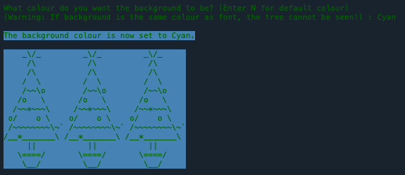

Figure 3.4.4b : Trees with different font and background colours

### 3.4.5 Errors - invalid user input

At the greenhouse menu page, users are only able to enter ‘Trees’, ‘Styles’, or ‘E’. If input is invalid, the user will be prompted again.

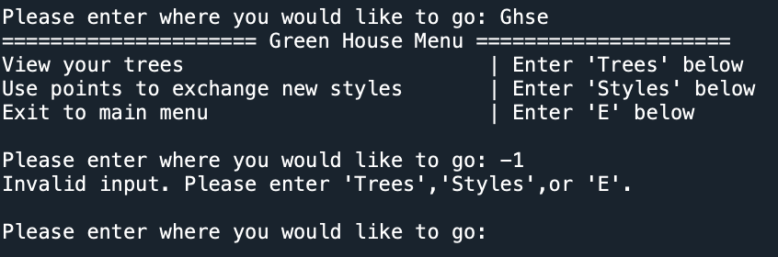

Figure 3.4.5a: Green house Menu Error Message

If the user enters a colour selection for a tree that is not unlocked (in the list) , user will be prompted to make a valid selection and will be reminded of the unlocked colours. This is the same for both font colour and background colour.

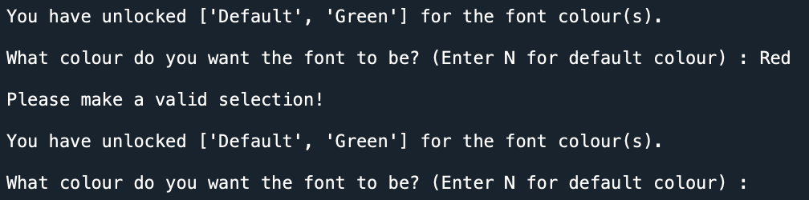

Figure 3.4.5b: Colour Selection Error Message

For style unlock, if the user does not enter ‘F’ for font, ’B’ for background’, or ‘E’ to exit, the user will be prompted to enter a valid selection.

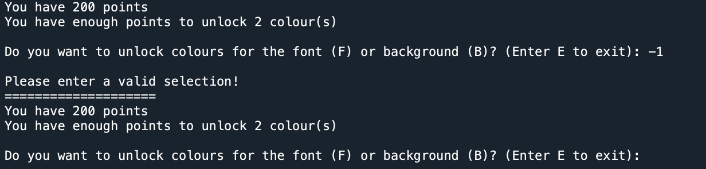

Figure 3.4.5c: Style Unlock Error Message 1

Similarly, if the user does not pick a colour to unlock within the colours available for unlocking, the user will be prompted to make a valid selection and reminded of the colours available. This is the same for both font and background unlocking.

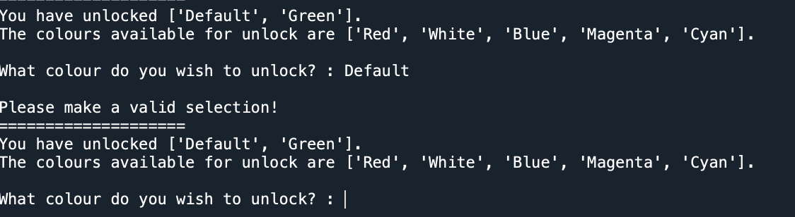

Figure 3.4.5c: Style Unlock Error Message 2

## 3.5 Monthly Missions

To navigate to the monthly mission page, the user has to enter ‘Monm’.

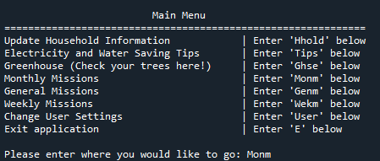

Figure 3.5: Navigation to Monthly Missions

### 3.5.1 Select month and year

The user will be asked to confirm the month and year. The program automatically selects the current month and year. If the user wishes to enter data for the current month and year, he has to enter ‘N’.



Figure 3.5.1a: Month, Year Confirmation 1

If the user wishes to select another month and year, he has to enter ‘Y’.



Figure 3.5.1b: Month, Year Confirmation 2

Afterwhich, he will be asked to enter the year and month no. he wants to enter the data for. The user will be presented with a table of months for reference. For example, if the user wishes to enter data for January, he has to enter ‘1’:

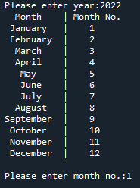

Figure 3.5.1c: Month, Year Input

If data for the selected month and year has been entered previously, the user will be redirected to the main menu page.



Figure 3.5.1d: Existing Data

### 3.5.2 Entering monthly data

After the confirmation of the month and year, the user will be asked to enter his electricity usage (kWh) and water usage (m3).



Figure 3.5.2a: Data Input

This data will be saved in the monthlydata.csv for further reference.



Figure 3.5.2b: monthlydata.csv file

### 

### 

### 3.5.3 Award points

Upon entering the data, the user will be awarded 30 points.

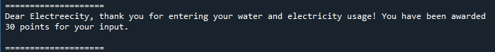

Figure 3.5.3: Points Allocation

### 3.5.4 Feedback for user

User will be provided a summary of his water and electricity usage based on the figures he entered. There are three parts to the feedback: comparison to the national average, comparison to previous month’s data and water billing rate.

**3.5.4.1 Comparison to the national average**

The user’s electricity usage will be compared against the national average electricity usage for his household type, while his daily water usage per household member (in litres) will be calculated and compared against the daily national average of 114 litres per person.

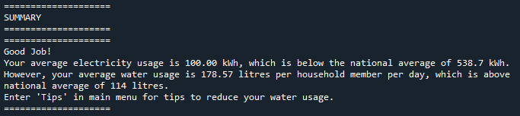

Figure 3.5.4.1: Feedback Based on Comparision to National Average

**3.5.4.2 Comparison to last-entered data**

For an existing user, the summary will include the comparison to the last entered data. This will help the user track his household water and electricity usage month-by-month. The immediate feedback encourages users to start saving electricity and water.

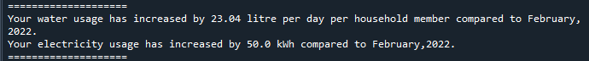

Figure 3.5.4.2: Feedback Based on Comparision to Last-entered Data

**3.5.4.3 Water billing rate**

If the user’s water usage for the month is above 40 m3 , the program will prompt the user about the higher water tariff he is paying.



Figure 3.5.4.3: Feedback on Water Billing Rate

### 3.5.5 Errors - invalid user input

Invalid Y/N: User can enter any key to try again or enter ‘E’ to return to the main menu page.



Figure 3.5.5a: Invalid Y/N Input Error Message

Invalid numerical input - user will be prompted to re-enter until they enter a numerical input.









Figure 3.5.5b: Invalid Numerical Input Error Message

## 3.6 General Missions

To navigate to general missions, the user will enter “Genm” in the main menu.

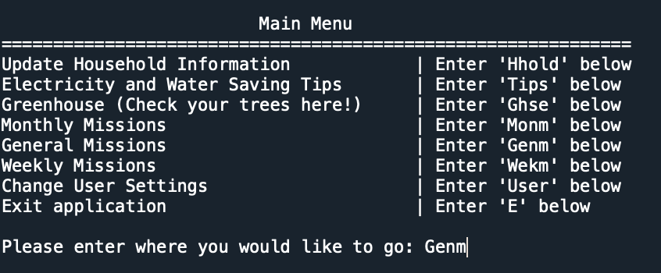

Figure 3.6: Navigation to General Mission

### 3.6.1 First usage

For first time users, the user will be prompted if he knows his aircon and refrigerator ticks (Y/N). If the user inputs “Y”, the user will enter the number of ticks for his aircon (between 2 and 5) and refrigerator (between 2 and 4).

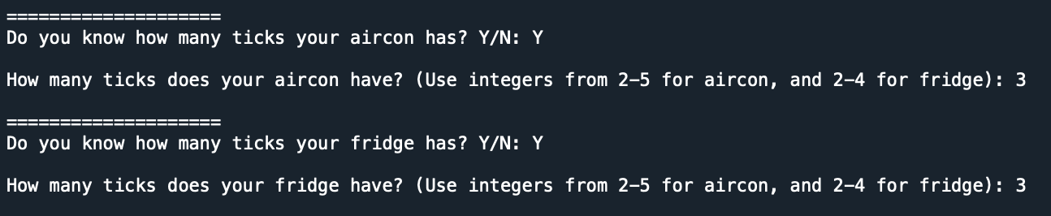

Figure 3.6.1a: Aircon Ticks Input (‘Y)

If the user inputs “N”, he will be asked to enter the appliance’s model number. If the model number is found in our database, the corresponding number of ticks will be extracted from the file and the number of ticks is shown to the user.

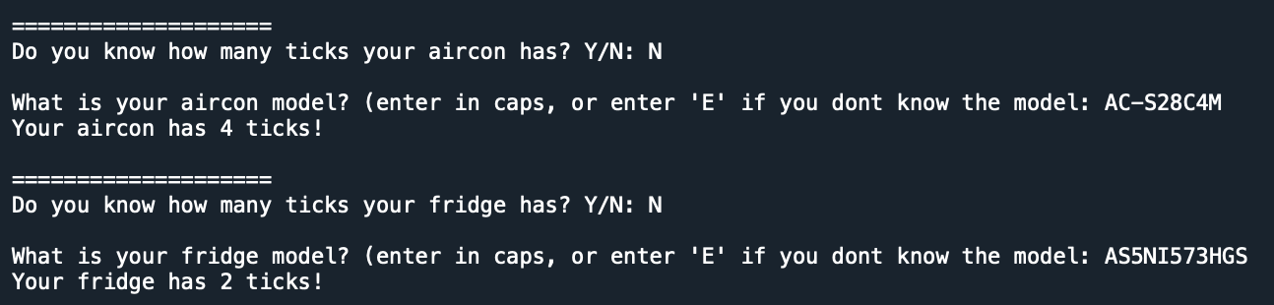

Figure 3.6.1b: Aircon Ticks Input (‘N)

However, if the model number is not found in our database or the user does not know the model number, the ticks will be set based on the national average (3 ticks).

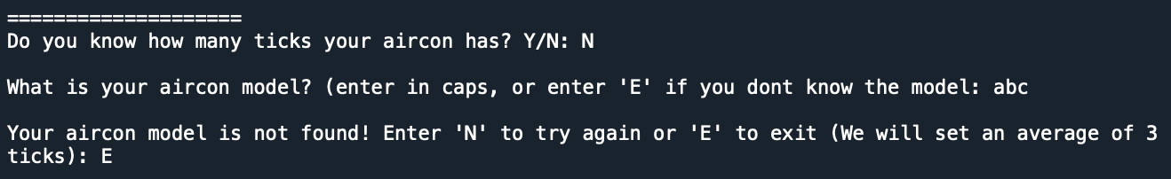

Figure 3.6.1c: Aircon Model Not Found in Database

Next, the user will be prompted if he knows the water heater wattage (Y/N). If the user inputs “Y”, the user enters the wattage and the data will be stored in the program.



Figure 3.6.1d: Water Heater Wattage Input (‘Y’)

If the user inputs “N”, the wattage will be set at national average (4500 watts).

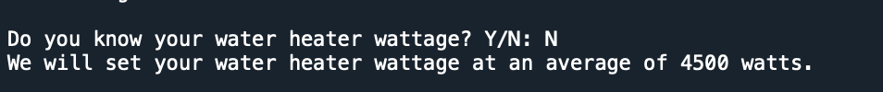

Figure 3.6.1e: Water Heater Wattage Input (‘N’)

Lastly, the user will enter information regarding their toilet flush system (S/D). If the user inputs “S”, the water usage will be set at 1.6 gallons per flush.

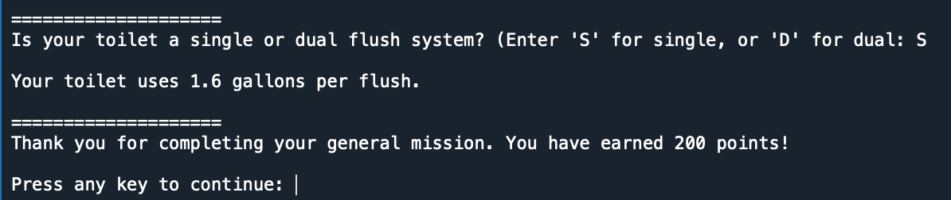

Figure 3.6.1f: Toilet Flush System Input (‘S’)

If the user inputs “D” instead, the water usage will be set at 0.8 gallons per flush.

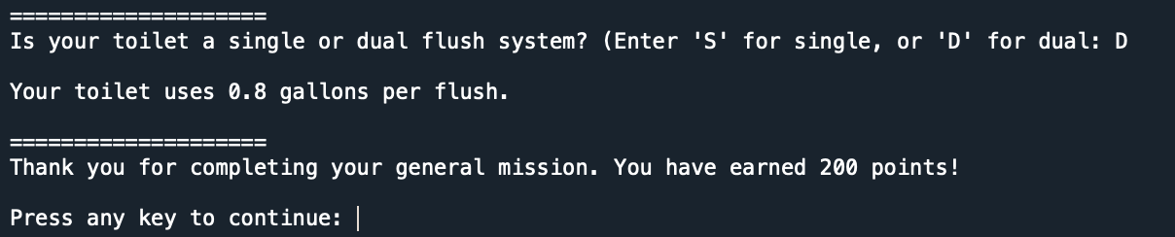

Figure 3.6.1g: Toilet Flush System Input (‘D’)

### 3.6.2 Subsequent usage

When the user enters ‘Genm’ in the main menu again, the user will be greeted with a summary page containing all his previous general missions inputs (aircon ticks, refrigerator ticks, water heater wattage, toilet flush system). The user can also check out a tip customised to his specific household usage.

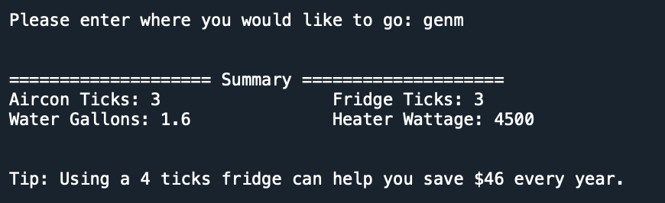

Figure 3.6.2a: General Mission Summary Page

After which, the user will be prompted if he wants to update the aircon ticks, refrigerator ticks, water heater wattage and toilet flush system (Y/N). If the user inputs “Y”, he will enter the updated information and overwrite the old data.

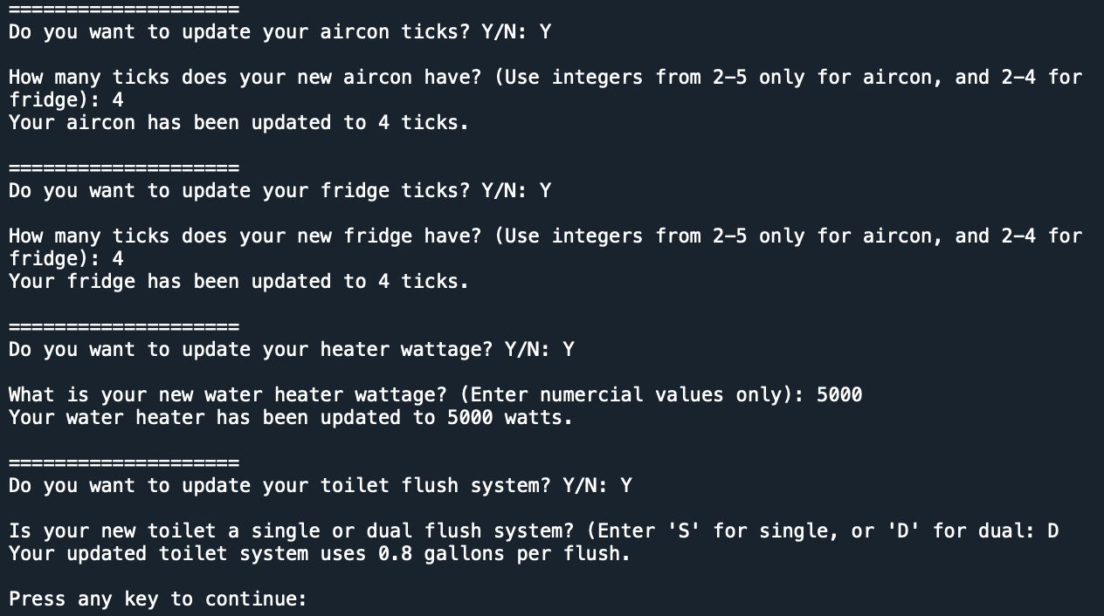

Figure 3.6.2b: General Mission Summary Page Update

If the user inputs “N”, the old data remains and the user exits the general missions.

### 

### 

### 

### 

### 

### 3.6.3 Errors - invalid user input

Invalid Y/N – user will be prompted to re-enter until they enter only “Y” or “N”.

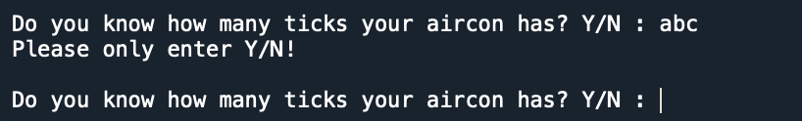

Figure 3.6.3a: Invalid Y/N Input Error Message

Invalid number of ticks – user will be prompted to re-enter an integer between 2 and 5 (for aircon), between 2 and 4 (for refrigerator).

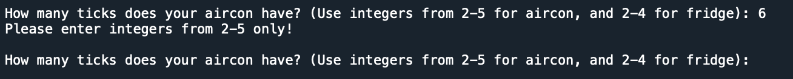

Figure 3.6.3b: Invalid Number of Ticks Input Error Message

Invalid aircon model – user can input “N” to re-enter the model number. If they are still unsure of the model number, the user can input “E” and the ticks will be set to an average number (3 ticks).

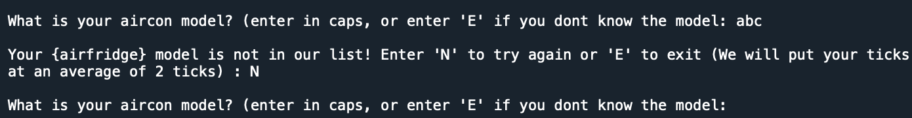

Figure 3.6.3C: Invalid Aircon Model Input Error Message

Invalid water heater wattage – user will be prompted to re-enter a positive integer.

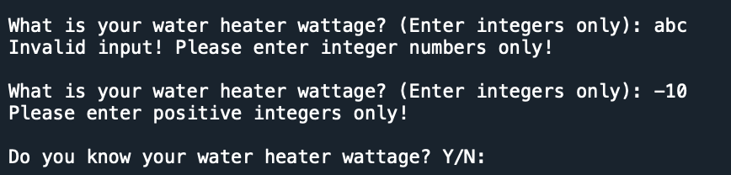

Figure 3.6.3d: Invalid Water Heater Wattage Input Error Message

Invalid toilet flush system – user will be prompted to re-enter until they enter only “S” or “D”.

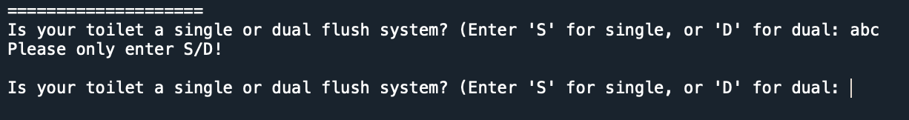

Figure 3.6.3e: Invalid Toilet Flush System Input Error Message

## 

## 3.7 Weekly Missions

The weekly missions can only be completed every seven days. User will obtain a tree once you have passed four weekly missions. You should input “Wekm” in the main menu when you are a new user or a previous user who has logged into the program after seven days of completing the previous weekly mission.

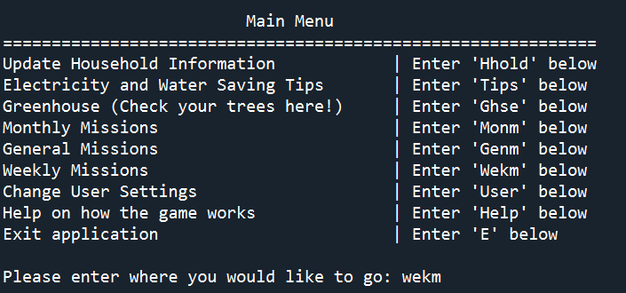

Figure 3.7: Navigation to Weekly Mission

### 3.7.1 First usage or seven days after completion of previous weekly mission

When you type “Wekm” in the input box in the main menu, it will bring you to the landing page.

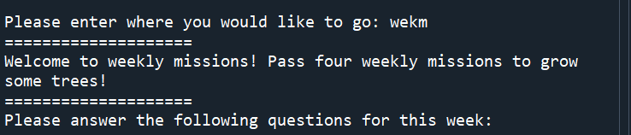

Figure 3.7.1a: Weekly Mission Landing Page

The weekly missions will consist of seven randomised yes-no questions from a question bank followed by randomised questions specific to one appliance. These appliances and usage include water heater, aircon, shower, tap, and washing machine. These randomised questions could be yes-no questions or fill-in-the-blanks.

For every yes in the seven yes-no questions, the user will gain one score. For the questions regarding the appliance and the usage, they will only gain one score when the answer is below the average usage for the appliance. The user will pass the weekly mission if they scored more than four.

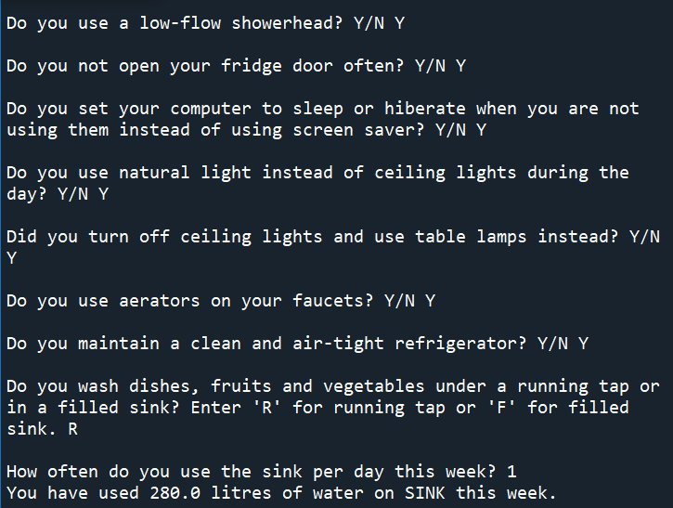

Figure 3.7.1b: Weekly Mission Questions

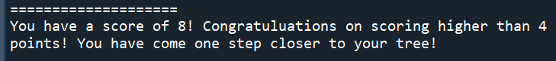

Figure 3.7.1c: Weekly Mission Score

### 3.7.2 Previous user

If you are a previous user who entered “Wekm” in the main menu before the seven days when the previous weekly mission was initiated, you will be prompted to come back with a countdown. The countdown will show the number of days left before your next weekly mission.

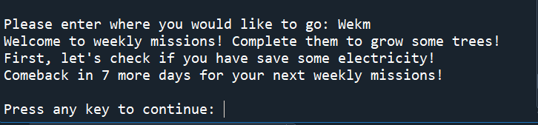

Figure 3.7.2: Weekly Mission Completion Mesage

### 

### 

### 

### 

### 3.7.3 Errors - invalid user input

Invalid Y/N – user will be prompted to re-enter until they enter only “Y” or “N”.

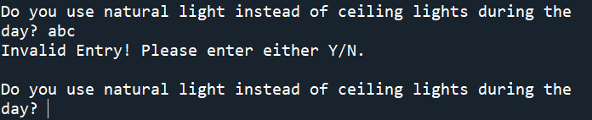

Figure 3.7.3a: Invalid Y/N Input Error Message

Invalid numerical input – user will be prompted to re-enter until they enter a numerical input.

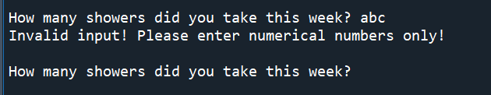

Figure 3.7.3b: Invalid Numerical Input Error Message

Invalid hour input – user will be prompted to re-enter until they enter a value between 0 to 24.

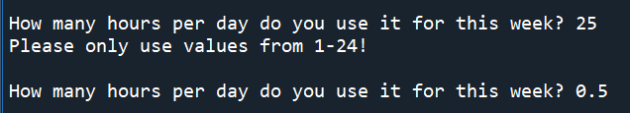

Figure 3.7.3c: Invalid Hour Input Error Message

Invalid tick input – user will be prompted to re-enter until they enter a value between 2-4.

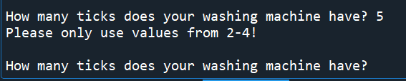

Figure 3.7.3a: Invalid Tick Input Error Message

## 3.8 Change user information

Changing of user information will bring the user to this landing page:

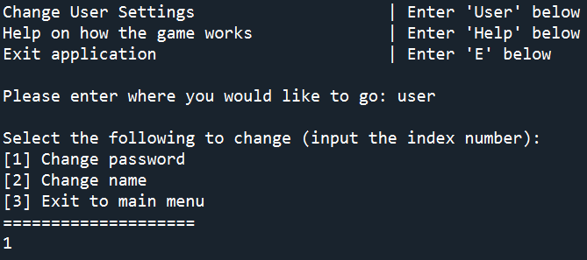

Figure 3.8a: Change User Information Landing Page

From this page, the user can once again change password and name by inputting ‘1’ or ‘2’ to change their password and name respectively. Alternatively, if the user changes their mind, they can press ‘3’ to return to the main menu.

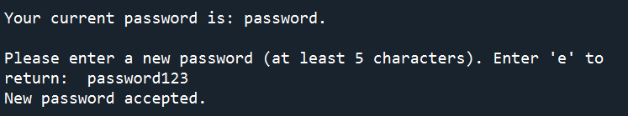

Figure 3.8.b: Change Password

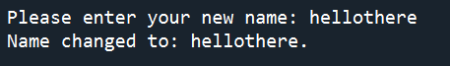

Figure 3.8 c: Change Name

### 3.8.1 Errors - invalid user input

An error message will appear asking the user to input again if they do not type a number:

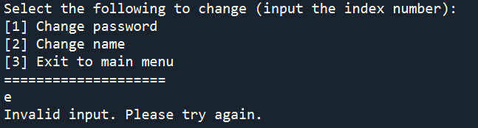

Figure 3.8.1a: Invalid Input Error Message for Landing Page

For the password, a minimum of 5 characters are allowed again. An error message will appear if it is too short:

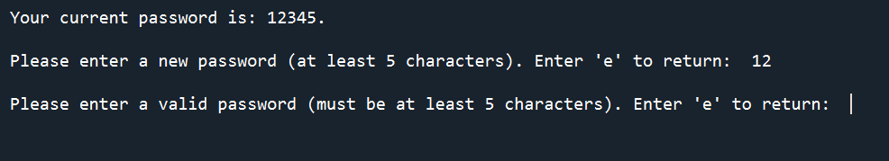

Figure 3.8.1b: Invalid Password Input Error Message

For the name, the user must enter some input. If the user tries to leave the name field empty, an error will appear:

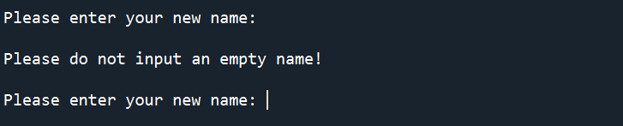

Figure 3.8.1c: Invalid Name Input Error Message

## 3.9 Help on the game

Entering ‘Help’ will pull out the instructions on how the game works. The user can then return to the main menu by pressing any button.

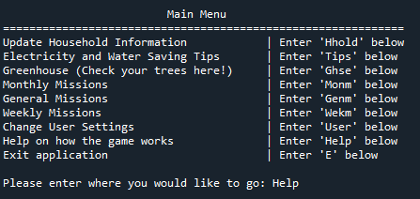

Figure 3.9a: Navigation to Help Page

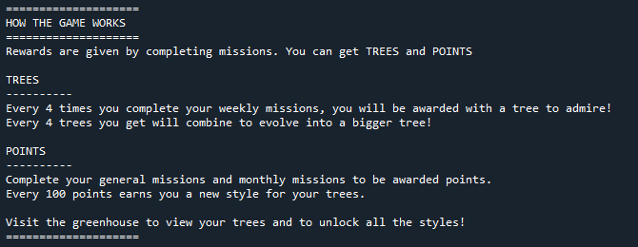

Figure 3.9b : Game Instructions

## 

## 3.10 Update Household Information

If the user enters ‘Hhold’ in the input box in the main menu, he will be brought to the landing page to update household information:

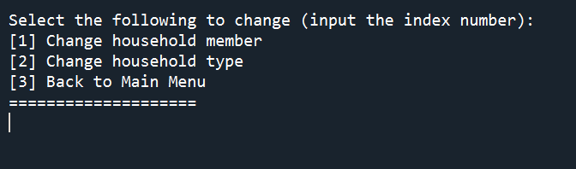

Figure 3.10 : Update Household Information Landing Page

Upon inputting the correct index number, the user can choose to change their household members, household type or return to the main menu (see *Section 3.1.1* for a demonstration of what you can change).

### 3.10.1 Errors - invalid user input

If the user does not input a valid index number, the following error message appears:

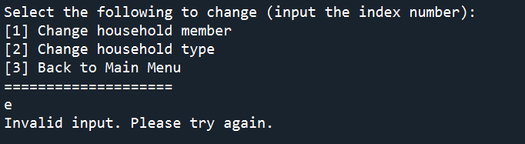

Figure 3.10.1 Invalid User Input Error Message

# 4 References

1. DBS. (2021, October 19). *5 tips on how to save electricity (and money)! | DBS Singapore*. https://www.dbs.com.sg/personal/articles/family/how-to-save-electricity-energy-tips-singapore
2. Eco Friendly Habits. (2021, June 30). *How to Conserve Energy: 31 Ways to save Electricity at Home*. https://www.ecofriendlyhabits.com/how-to-conserve-energy/
3. Hamm, T. (2020, November 18). *How Much Do You Really Save By Air-Drying Your Clothes?* The Simple Dollar. https://www.thesimpledollar.com/save-money/how-much-do-you-really-save-by-air-drying-your-clothes/?utm_source=feedburner&utm_medium=feed&utm_campaign=Feed%3A+thesimpledollar+%28The+Simple+Dollar%29
4. *Saving Water at Home*. (2022). PUB. https://www.pub.gov.sg/savewater/athome