**Amazon AUN (User Notifications)**

Amazon User notifications is a new service that enables you to centrally setup and view notifications from AWS services.

You can centrally set up and view notifications from AWS services, such as Amazon Simple Storage Service (Amazon S3) objects events, Amazon Elastic Compute Cloud (Amazon EC2) instance state changes, AWS Health Dashboard events, Amazon CloudWatch alarms, or AWS Support case updates in a consistent, human-friendly format.

You can also configure delivery channels—email, chat, and push notifications to the AWS console mobile app, where you can receive these notifications.

Notification hubs are the Regions your notifications are stored and processed in or replicated to. You are required to select at least one notification hub before you can create notification configurations. You can also edit notification hubs from Notification hubs in the navigation pane.

**Create Notification Configuration**

**Configure the Event rule**

You can choose any AWS Services and event type to notify you. Here I’m choosing EC2 Service and event type as State change notification – Terminated state.

So, Whenever Instance gets terminated in any region, you will be notified.

Optionally, you can choose Advanced filter to customize your event rules. For example, I’m choosing “production” tag. Now, you will get notification when the production tagged instance will shut down.

You can configure notifications priority

Finally, configure delivery channels where you want the notification to be sent, such as specific email addresses or chatbot and create a notification.

Once you verified your email address, you are ready to go and You can add more email addresses here.

I’m going to terminate the production and staging instances from Singapore region. As per custom event rules, you will get notification when the production instance shuts down.

You can check in your email

1. **You can configure to notify when some objects deleted in production S3 bucket**

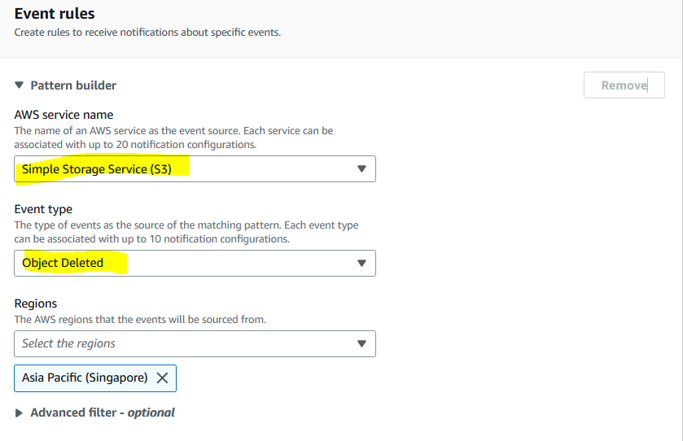

1. **You can configure to notify when Pull request state change in Code Commit**

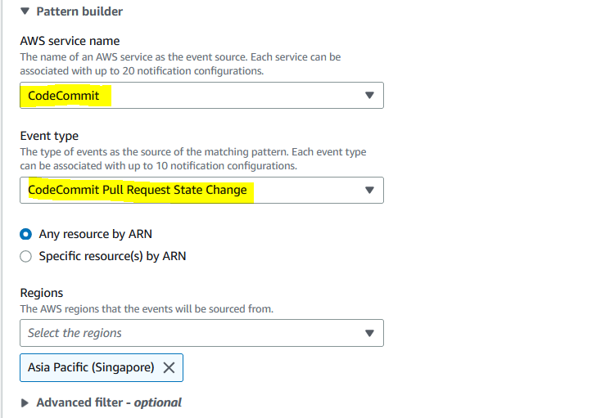

1. **You can configure to notify when Code build state is failed**

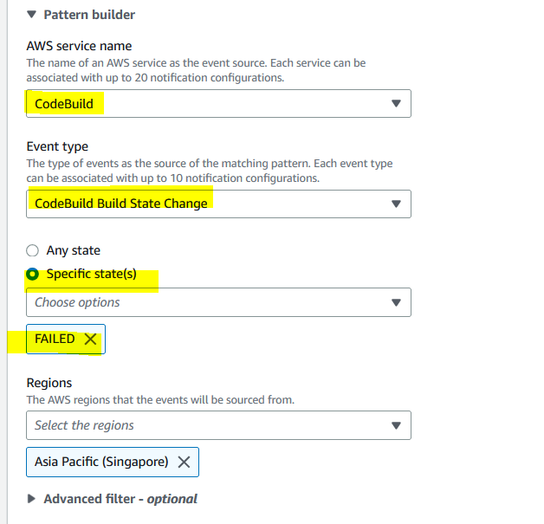

1. **You can configure to notify when Code deploy start**

1. **You can configure to notify when Elastic Beanstalk environment terminated**

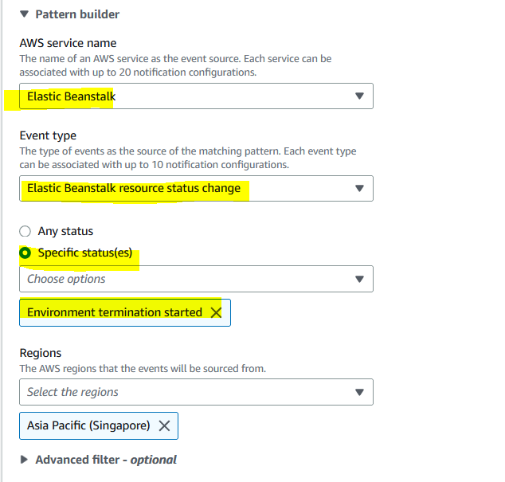

Like you can configure to all AWS Services to notify when specific state changes are occurring.

**Note:** It comes with no additional cost.