**AWS Private Access**

AWS Private Access is a security feature to control access to the AWS Management Console. Private Access is useful when you want to prevent users from signing in to unexpected AWS accounts from within your network. With this feature, you can limit access to the AWS Management Console only to a specified set of known AWS accounts when the traffic originates from within your network.

**Supported Regions**

US East (N. Virginia)

US East (Ohio)

US West (Oregon)

Europe (Ireland)

Asia Pacific (Singapore)

**Supported services**

[**https://docs.aws.amazon.com/awsconsolehelpdocs/latest/gsg/console-private-access.html**](https://docs.aws.amazon.com/awsconsolehelpdocs/latest/gsg/console-private-access.html)

**Test Setup with EC2 Instance**

Firstly, download the private access yaml file to deploy on stack. You can download a yaml file using below link

<https://github.com/kohlidevops/aws-privateaccess/blob/main/privateaccess.yml>

Navigate to AWS CloudFormation and change region as Singapore.

Create a new stack and upload a yaml file

Provide a stack name, assign key-pair and choose instance type

CIDR values are auto-populated by using yaml file

Next – Submit to create a stack.

Navigate to AWS System Manager once stack has been completed.

Select Fleet Manager to connect private access instance.

Connect with Remote Desktop

Provide credentials to connect EC2 instance

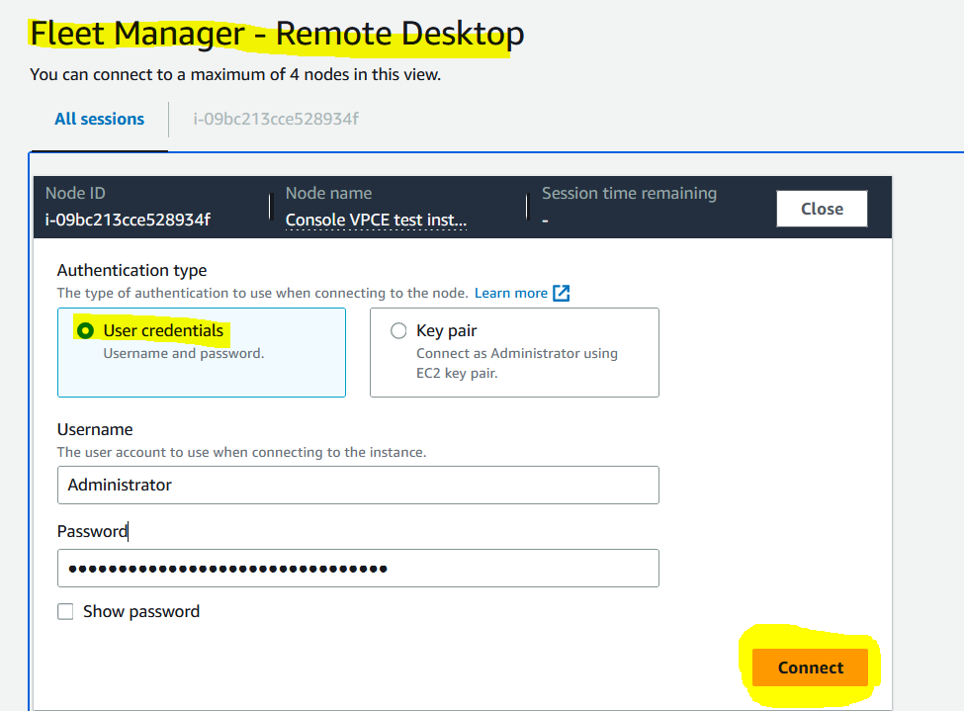

Open browser in Private access instance and sign-in to aws console  
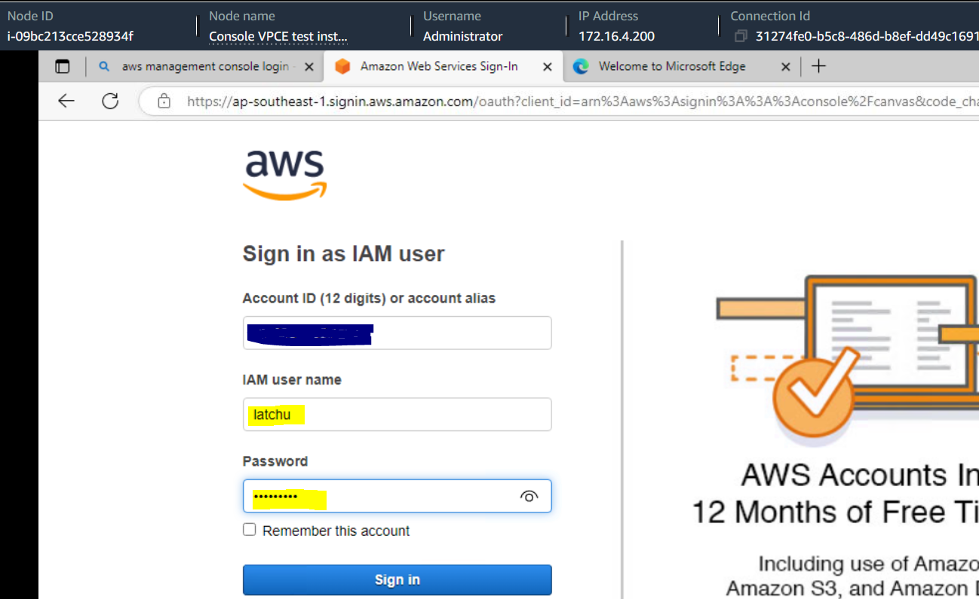

You can see the AWS Private access from AWS console.

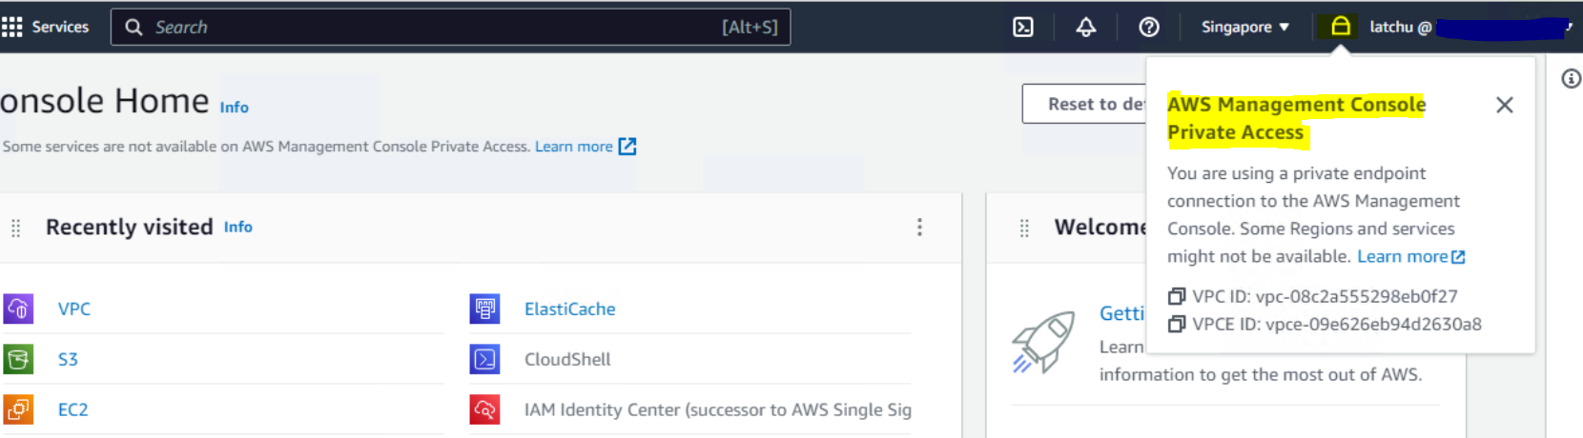

From here, I can be able to access the aws services (supported services) in Singapore region only. If I try to switch to other region (for example: Ohio), Private access won’t allow me to change.

So, you can access the specific region, where the stack has been implemented.