**How to Configure DNSSEC Signing and Validation process with AWS Route 53?**

1. **Enable DNSSEC Signing in hosted zone**

Navigate to hosted zone in Route53 and select Enable DNSSEC Signing

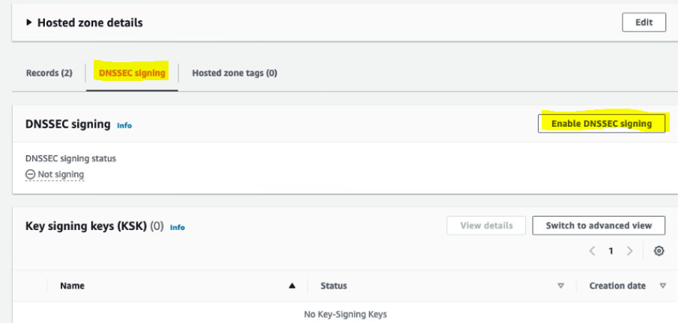

1. **Create Key Signing Key (KSK)**

Provide a KSK name and choose “Create Customer Managed CMK” and its key name

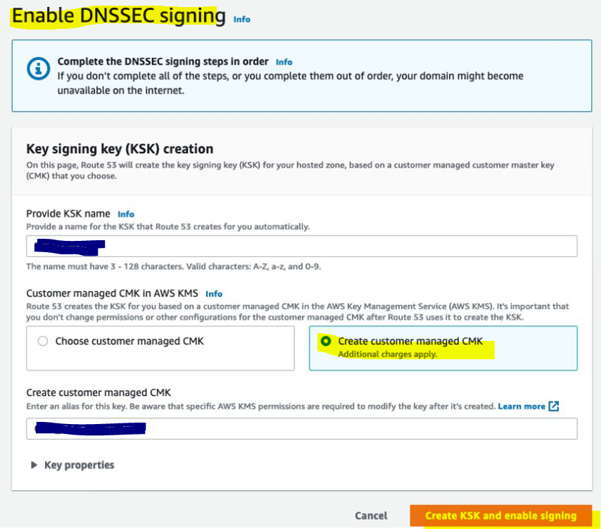

1. **To setup a Chain of Trust**

On the DNSSEC signing tab for your hosted zone, choose “View information to create DS record”. This page contains information about “establish the chain of trust” by updating DS record.

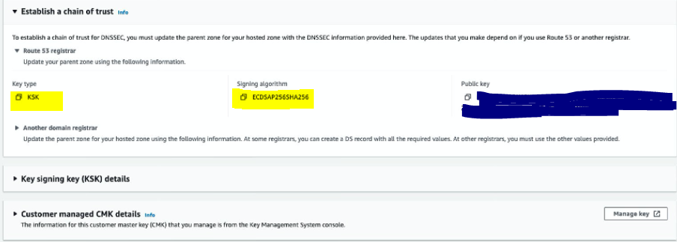

Copy the Public key for further configuration

1. **Configure KSK key in Registered domain**

Navigate to Registered domain and Select your domain name – under DNSSEC status, choose Manage keys

Key type as 257-KSK and paste the copied public key

Then Add this key, That’s it. Now DNSSEC enabled, So DNSSEC will use, when querying DNS records.