COMPLETE CI/CD GRADLE PROJECT DEVSECOPS

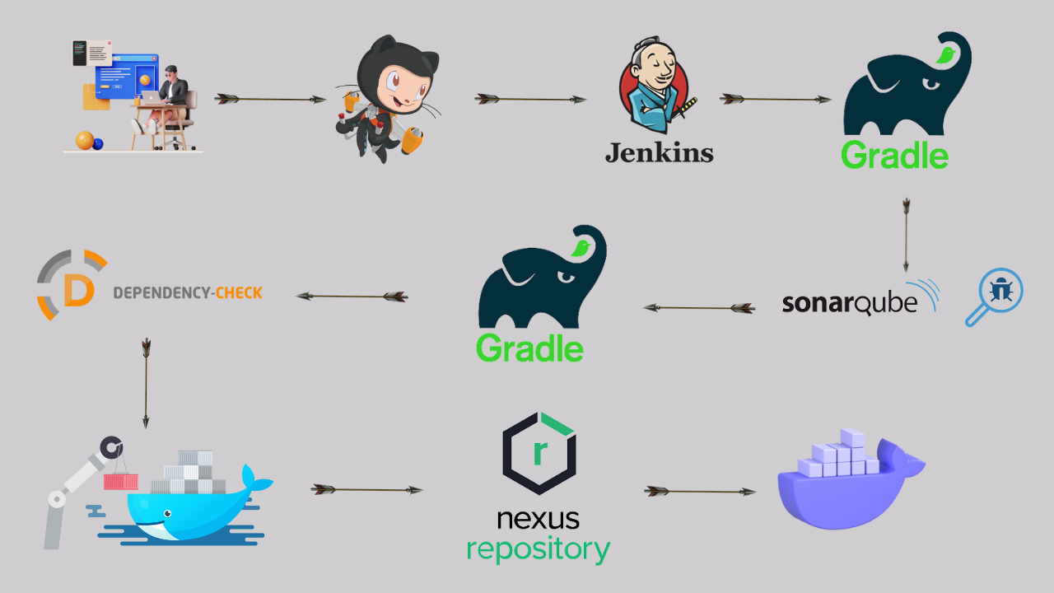

Hello friends, we will be deploying a Gradle Java Based Application. This is an everyday use case scenario used by several organizations. We will be using Jenkins as a CICD tool and deploying our application on Docker.

We will be deploying our application using Docker Container ,which docker image is stored in nexus repository.

**Steps:-**

Step 1 — Create an Ubuntu T2 Large Instance

Step 2 — Install Jenkins, Docker and Trivy. Create a Sonarqube Container using Docker.

Step 3 — Install Plugins like JDK, Sonarqube Scanner, Maven, OWASP Dependency Check,Gradle

Step 4 — Create a Pipeline Project in Jenkins using Declarative Pipeline

Step 5 — Install OWASP Dependency Check Plugins

Step 6 — launch t2medium instance for Nexus and setup

Step 7 — Docker Image Build and Push to nexus

Step 8 — Access the Real World Application

Step 9 — Terminate the AWS EC2 Instance

**References**

**Now, lets get started and dig deeper into each of these steps :-**

**Step 1** — Launch an AWS T2 Large Instance. Use the image as Ubuntu. You can create a new key pair or use an existing one. Enable HTTP and HTTPS settings in the Security Group.

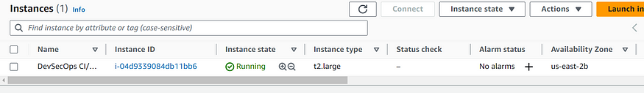

**Step 2** — Install Jenkins, Docker and Trivy

2A — To Install Jenkins

Connect to your console, and enter these commands to Install Jenkins

sudo apt-get update  
  
curl -fsSL https://pkg.jenkins.io/debian-stable/jenkins.io-2023.key | sudo tee \  
 /usr/share/keyrings/jenkins-keyring.asc > /dev/null  
echo deb [signed-by=/usr/share/keyrings/jenkins-keyring.asc] \  
 https://pkg.jenkins.io/debian-stable binary/ | sudo tee \  
 /etc/apt/sources.list.d/jenkins.list > /dev/null  
  
sudo apt update  
sudo apt install openjdk-17-jdk  
sudo apt install openjdk-17-jre  
  
sudo systemctl enable jenkins  
sudo systemctl start jenkins  
sudo systemctl status jenkins  
  
sudo cat /var/lib/jenkins/secrets/initialAdminPassword

Once Jenkins is installed, you will need to go to your AWS EC2 Security Group and open Inbound Port 8080, since Jenkins works on Port 8080.

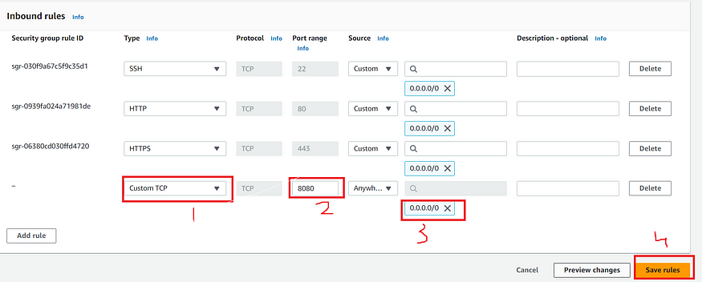

Now, grab your Public IP Address

<EC2 Public IP Address:8080>  
sudo cat /var/lib/jenkins/secrets/initialAdminPassword

Unlock Jenkins using an administrative password and install the required plugins.

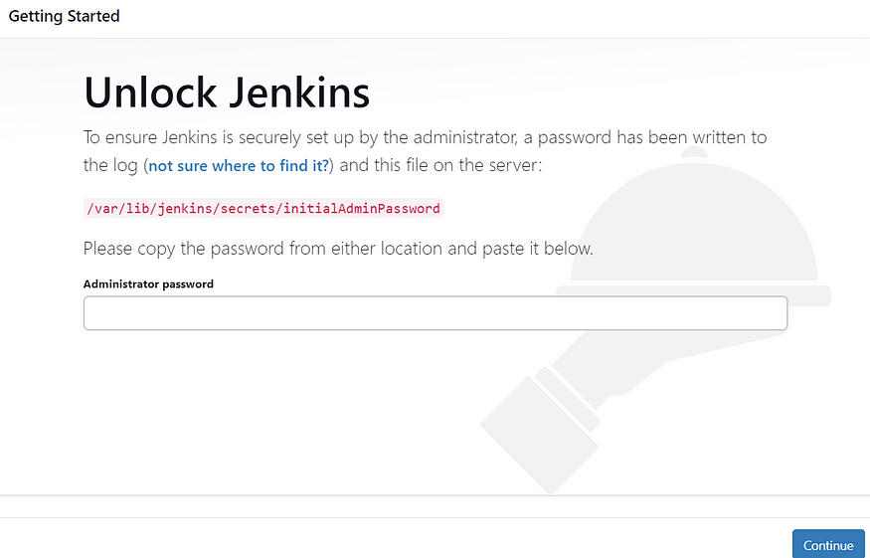

Jenkins will now get installed and install all the libraries.

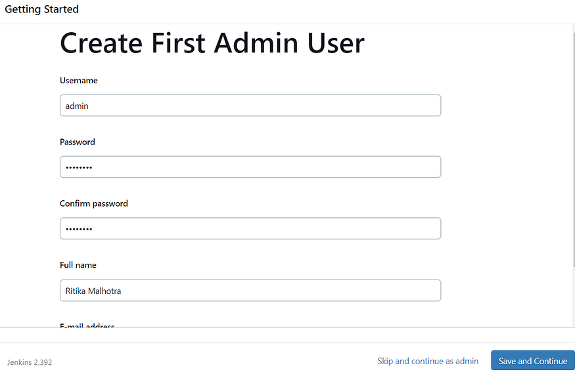

Jenkins Getting Started Screen

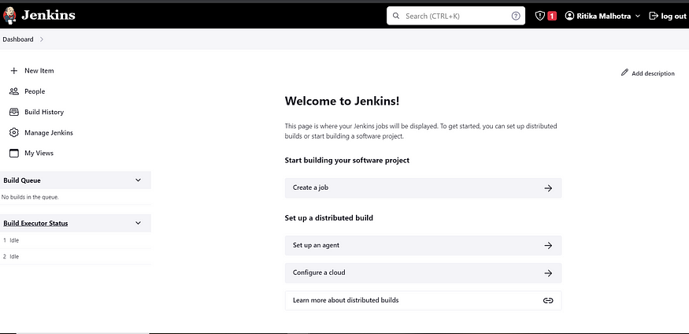

2B — Install Docker

sudo apt-get update  
sudo apt-get install docker.io -y  
sudo usermod -aG docker $USER  
sudo chmod 777 /var/run/docker.sock   
sudo docker ps

After the docker installation, we create a sonarqube container (Remember added 9000 port in the security group)

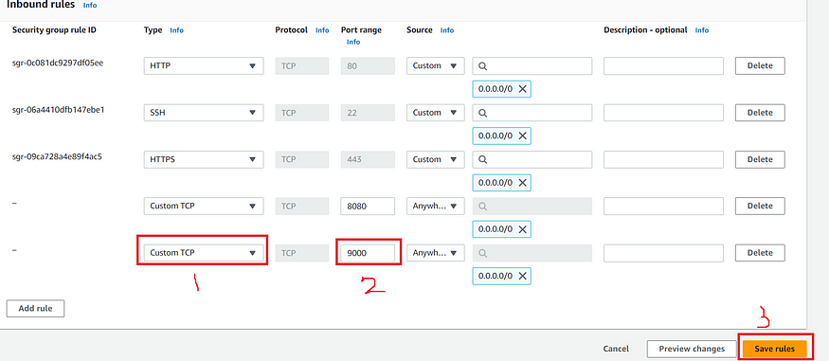

docker run -d --name sonar -p 9000:9000 sonarqube:lts-community

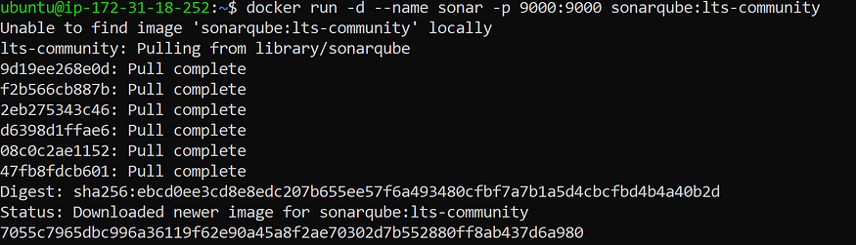

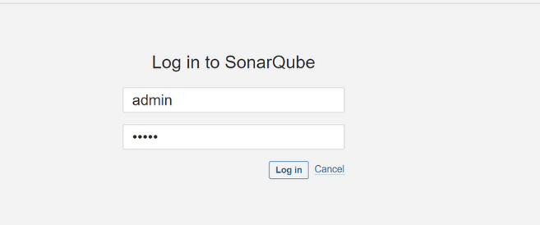

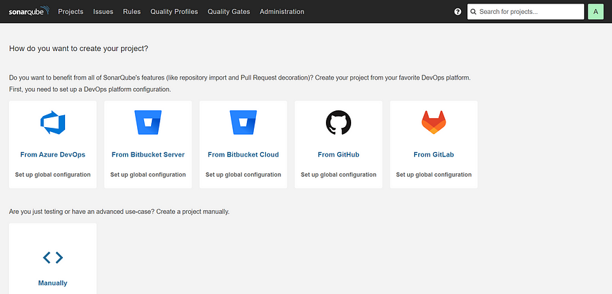

2C — Install Trivy

sudo apt-get install wget apt-transport-https gnupg lsb-release -y  
  
wget -qO - https://aquasecurity.github.io/trivy-repo/deb/public.key | gpg --dearmor | sudo tee /usr/share/keyrings/trivy.gpg > /dev/null  
  
echo "deb [signed-by=/usr/share/keyrings/trivy.gpg] https://aquasecurity.github.io/trivy-repo/deb $(lsb_release -sc) main" | sudo tee -a /etc/apt/sources.list.d/trivy.list  
  
sudo apt-get update  
  
sudo apt-get install trivy –y

Next, we will login to Jenkins and start to configure our Pipeline in Jenkins

**Step 3**— Install Plugins like JDK, Sonarqube Scanner, Maven, OWASP Dependency Check,

**3A — Install Plugin**

Goto Manage Jenkins →Plugins → Available Plugins →

Install below plugins

1 → Eclipse Temurin Installer (Install without restart)

2 → SonarQube Scanner (Install without restart)

**3B — Configure Java and Maven in Global Tool Configuration**

Goto Manage Jenkins → Tools → Install JDK and Gradle → Click on Apply and Save

**3C — Create a Job**

Label it as Gradle, click on Pipeline and Ok.

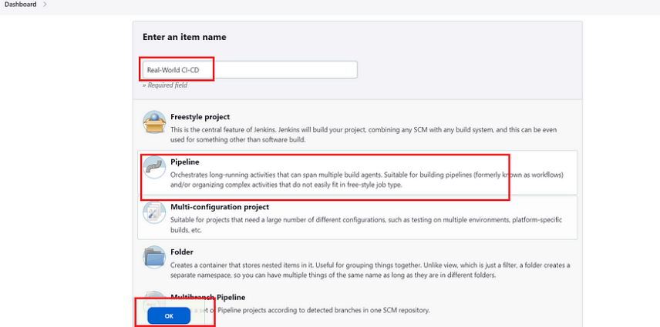

**Step 4 — Configure Sonar Server in Manage Jenkins**

Grab the Public IP Address of your EC2 Instance, Sonarqube works on Port 9000 , sp <Public IP>:9000. Goto your Sonarqube Server. Click on Administration → Security → Users → Click on Tokens and Update Token → Give it a name → and click on Generate Token

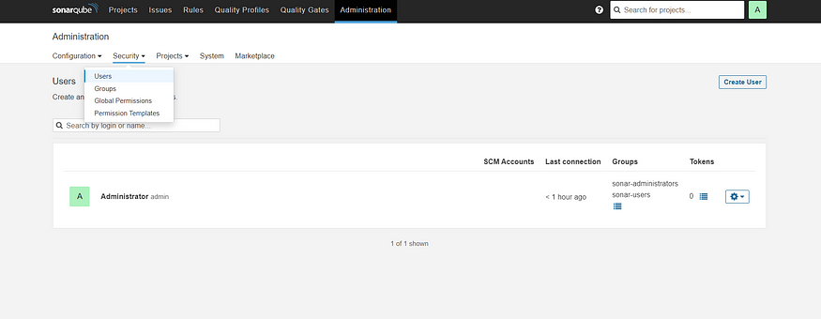

Click on Update Token

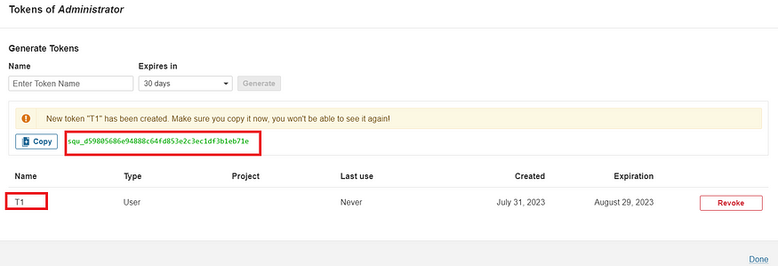

Copy this Token

Goto Dashboard → Manage Jenkins → Credentials → Add Secret Text. It should look like this

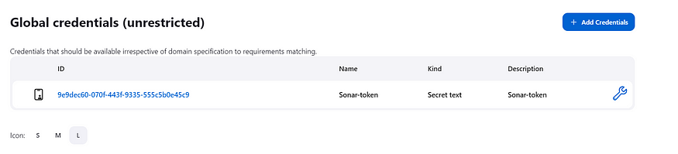

Now, goto Dashboard → Manage Jenkins → Configure System

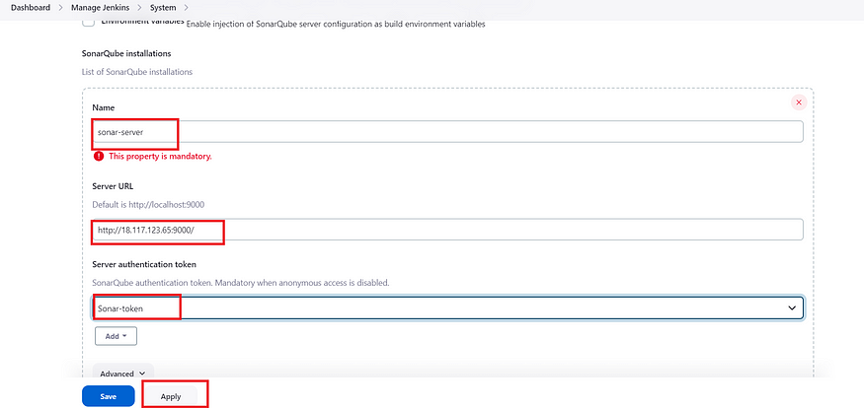

Click on Apply and Save

**Configure System option** is used in Jenkins to configure different server

**Global Tool Configuration** is used to configure different tools that we install using Plugins

We will install sonar-scanner in tools.

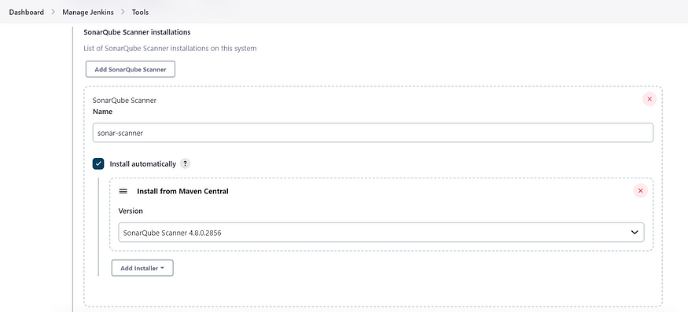

**Step 5**— Install OWASP Dependency Check Plugins

GotoDashboard → Manage Jenkins → Plugins → OWASP Dependency-Check. Click on it and install without restart.

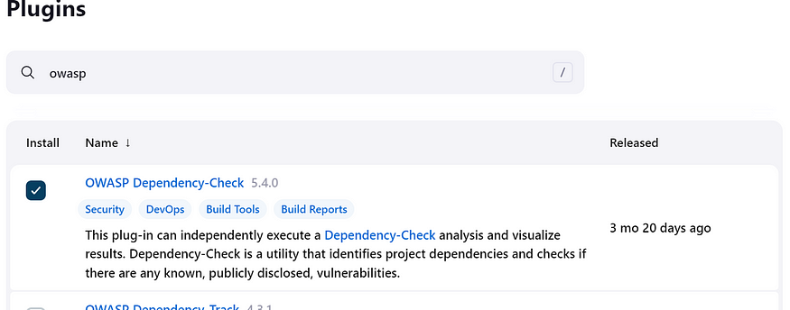

First, we configured Plugin and next we have to configure Tool

Goto Dashboard → Manage Jenkins → Tools →

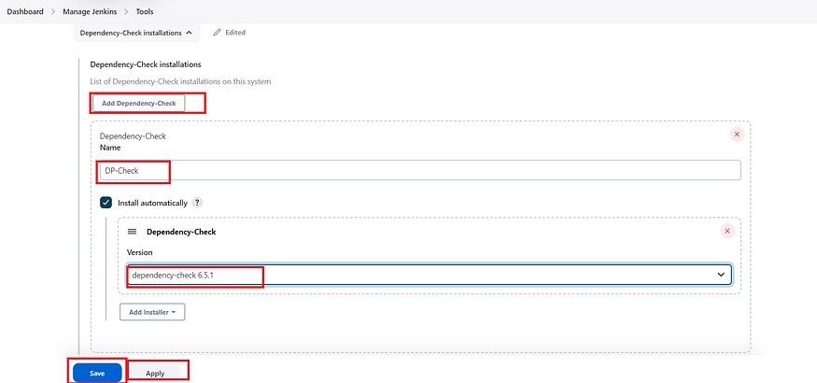

Click on apply and Save here.

**Step 6** — Nexus repo launch

Take an Ubuntu t2 medium instance and paste the below commands

Prequesites :

4 cpus max and min used 2 in this video

20 gb storage

java 8

Aws account

sudo apt update #update packages

Now, install the Java OpenJDK 8 via the apt command below. Input Y when asked to confirm the installation and press ENTER to proceed.

sudo apt install openjdk-8-jdk # install java8

Once Java is installed, verify the Java version on your system using the following command.

java -version

To install Nexus, you will need to create a new dedicated Linux user with a valid shell and

also need to set up the max open files for both hard and soft limits to '65536'.

Run the following command to create a new dedicated user for the Nexus with the name 'nexus'

sudo useradd -d /opt/nexus -s /bin/bash nexus

sudo passwd nexus

Add password

Next, set the ulimit to '65536' using the below command. This will only affect the system on the current system temporarily.

To make it permanent, you can create a new config file that you will do in the next step.

ulimit -n 65536

TO set up ulimit permanently, create a new config file '/etc/security/limits.d/nexus.conf' using nano editor.

sudo nano /etc/security/limits.d/nexus.conf

nexus - nofile 65536

ulimit -a

Download the Nexus Repository Manager package via the wget command as below. If the download process is finished,

you will see the file 'nexus-3.41.1-01-unix.tar.gz' on your current working directory.

sudo wget https://download.sonatype.com/nexus/3/nexus-3.41.1-01-unix.tar.gz

Now extract the file 'nexus-3.41.1-01-unix.tar.gz' via the tar command below. And you should get two directories, the 'nexus-3.41.1-01' and 'sonatype-work'.

The directory 'nexus-3.41.1-01' is the main directory for the Nexus package, and the directory 'sonatype-work' is the main working directory for Nexus.

sudo tar xzf nexus-3.41.1-01-unix.tar.gz

Next, move those extracted directories to '/opt' using the following command.

The Nexus package directory will be '/opt/nexus' and the Nexus working directory will be '/opt/sonatype-work'.

sudo mv nexus-3.41.1-01 /opt/nexus

sudo mv sonatype-work /opt/

Lastly, change the ownership of both directories to the user and group 'nexus' via the chown command below.

sudo chown -R nexus:nexus /opt/nexus /opt/sonatype-work

Next, you will set up your Nexus installation by editing some of the Nexus configuration files.

Open the file '/opt/nexus/bin/nexus.rc' using nano editor.

sudo nano /opt/nexus/bin/nexus.rc

Uncomment the option 'run_as_user' and change the value to 'nexus'. With this configuration, you will be running the Nexus application as the system user 'nexus'.

run_as_user='nexus'

Save the file and exit the editor when you are done.

Next, open the config file '/etc/nexus/bin/nexus.vmoptions' using the nano editor to set up the max heap memory for Nexus.

***********************************************************************************************

sudo vi /opt/nexus/bin/nexus.vmoptions

-Xms1024m

-Xmx1024m

-XX:MaxDirectMemorySize=1024m

-XX:LogFile=./sonatype-work/nexus3/log/jvm.log

-XX:-OmitStackTraceInFastThrow

-Djava.net.preferIPv4Stack=true

-Dkaraf.home=.

-Dkaraf.base=.

-Dkaraf.etc=etc/karaf

-Djava.util.logging.config.file=/etc/karaf/java.util.logging.properties

-Dkaraf.data=./sonatype-work/nexus3

-Dkaraf.log=./sonatype-work/nexus3/log

-Djava.io.tmpdir=./sonatype-work/nexus3/tmp

************************************************************************************************

To run nexus as service using Systemd

sudo nano /etc/systemd/system/nexus.service

************************************************************************************************

[Unit]

Description=nexus service

After=network.target

[Service]

Type=forking

LimitNOFILE=65536

ExecStart=/opt/nexus/bin/nexus start

ExecStop=/opt/nexus/bin/nexus stop

User=nexus

Restart=on-abort

[Install]

WantedBy=multi-user.target

***********************************************************************************************

sudo systemctl daemon-reload

sudo systemctl start nexus.service

sudo systemctl enable nexus.service

sudo systemctl status nexus.service

if the nexus service is not started, you can the nexus logs using below command

tail -f /opt/sonatype-work/nexus3/log/nexus.log

in ec2 instance add 8081 port for Nexus

sudo cat /opt/nexus/sonatype-work/nexus3/admin.password

**Step 7** – Docker build and push to docker

We need to install Docker tool in our system, Goto Dashboard → Manage Plugins → Available plugins → Search for Docker and install these plugins

Docker

Docker Commons

Docker Pipeline

Docker API

docker-build-step

and click on install without restart

Now, goto Dashboard → Manage Jenkins → Tools →

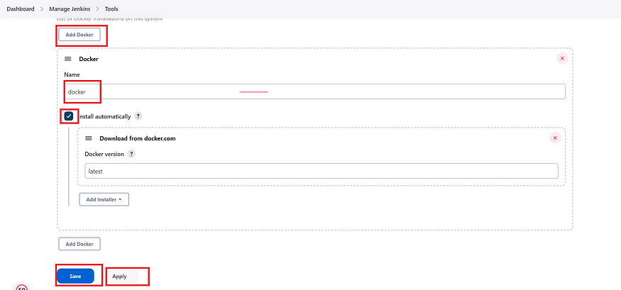

Add DockerHub Username and Password under Global Credentials

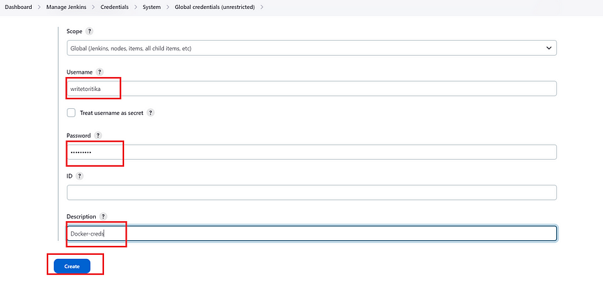

Initial setup

In nexus click on gear button --> click on repositories --> click on create repository ( below image can help in creating )

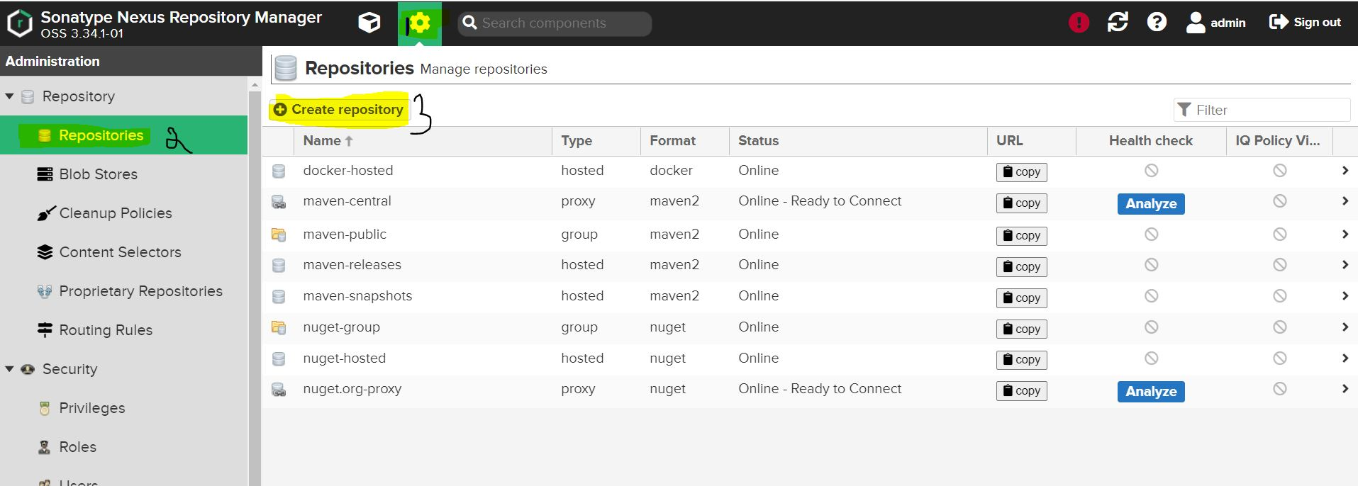

once we click on create repository ( types of repository will be listed ) --> click on docker(hosted)

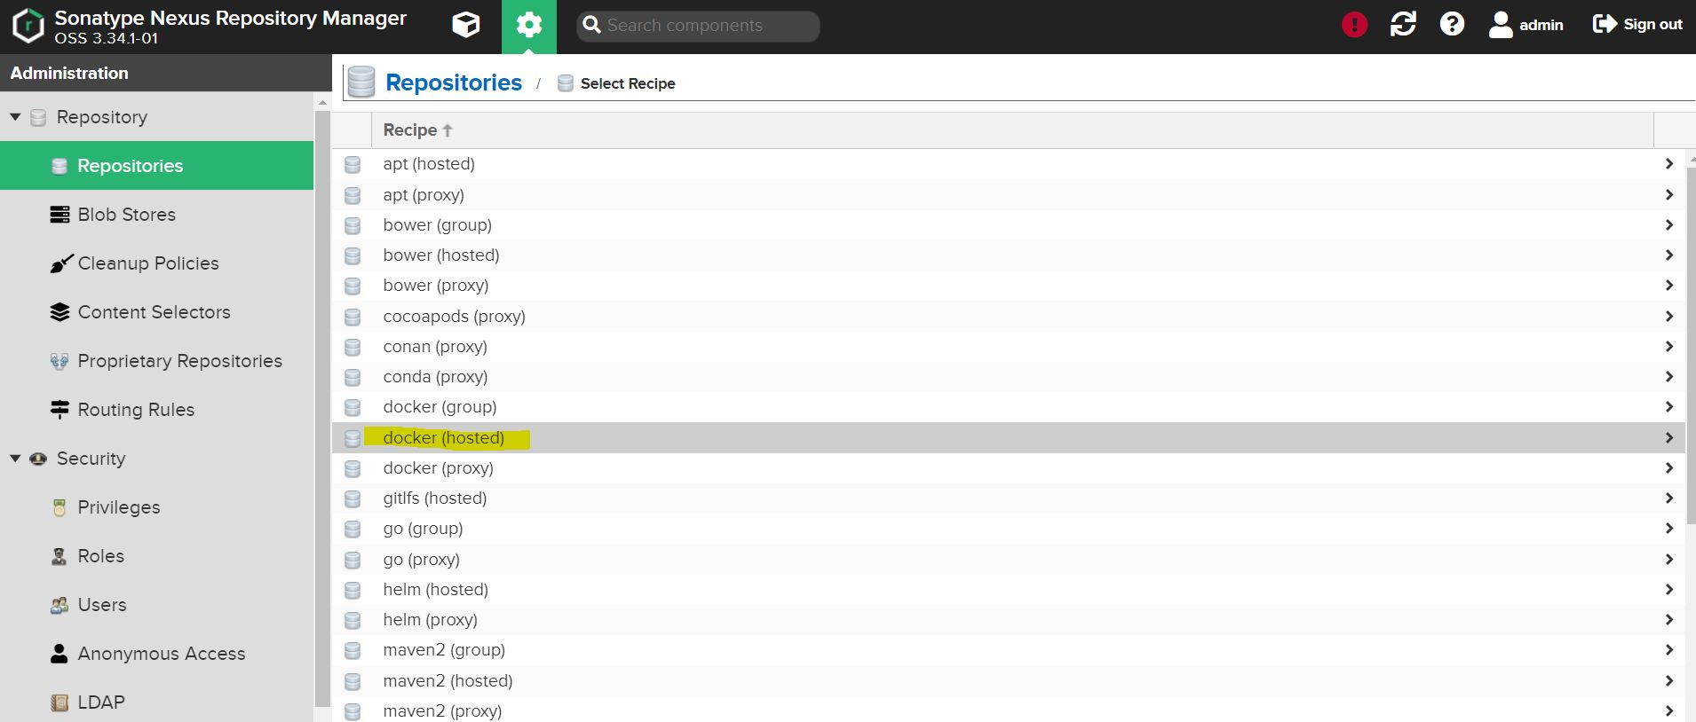

fill out the details in Name ( unique name ), enable checkbox beside to HTTP and enter a valid port ( preferred 8083 ) once that click on create repository

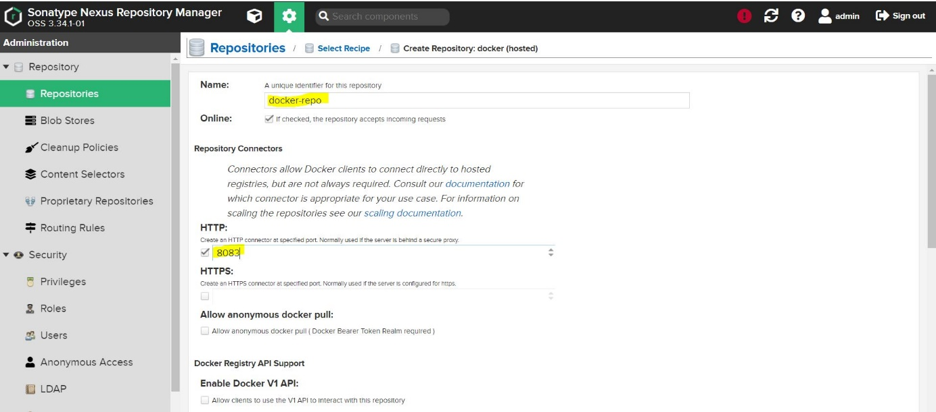 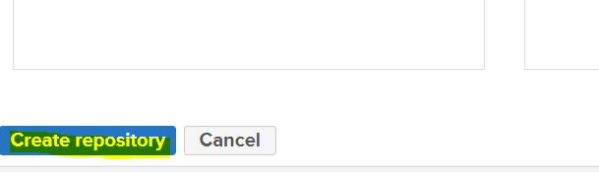

Once this set up is done in jenkins host we need to setup Insecure Registries. to do that we need to edit or if not present create a file /etc/docker/daemon.json in that file add details of nexus

{ "insecure-registries":["nexus_machine_ip:8083"] }

once that's done we need to execute systemctl restart docker this is to apply new changes, also we can verify whether registry is added or not by executing docker info

once this is done from jenkins host you can try

 docker login -u nexus_username -p nexus_pass nexus_ip:8083

        pipeline{

    agent any

    tools{

        jdk 'jdk11'

        gradle 'gradle'

    }

    stages{

        stage('Cleanws'){

            steps{

                cleanWs()

            }

        }

        stage('checkout from scm'){

            steps{

                git branch: 'main', url: 'https://github.com/Aj7Ay/Java_Gradle_Responsive_Website.git'

            }

        }

        stage('Gradle compile'){

            steps{

                sh 'chmod +x gradlew'

                sh './gradlew compileJava'

            }

        }

        stage('Test Gradle'){

            steps{

                sh 'chmod +x gradlew'

                sh './gradlew test'

            }

        }

        stage('sonarqube Analysis'){

            steps{

                script{

                      withSonarQubeEnv(credentialsId: 'Sonar-token') {

                        sh 'chmod +x gradlew'

                        sh './gradlew sonarqube'

                    }

                    //quality gate

                    timeout(time: 10, unit: 'MINUTES'){

                        def qg = waitForQualityGate()

                        if (qg.status != 'OK'){

                            error "pipeline is aborted due to qualitygate failure: ${qg.status}"

                        }

                    }

                }

            }

        }

        stage('build Gradle'){

            steps{

                sh 'chmod +x gradlew'

                sh './gradlew build'

            }

        }

        stage("OWASP Dependency Check"){

            steps{

                dependencyCheck additionalArguments: '--scan ./ --format HTML ', odcInstallation: 'DP-Check'

                dependencyCheckPublisher pattern: '**/dependency-check-report.html'

            }

        }

        stage('build and push to nexus'){

            steps{

                script{

                    withCredentials([string(credentialsId: 'docker_pass', variable: 'docker_password')]) {

                        sh '''

                         docker build -t 43.204.235.20:8083/gradle1:latest .

                         docker login -u admin -p $docker_password 43.204.235.20:8083

                         docker push 43.204.235.20:8083/gradle1:latest

                         '''

                    }

                }

            }

        }

        stage('deploy to container'){

            steps{

                script{

                    withCredentials([string(credentialsId: 'docker_pass', variable: 'docker_password')]) {

                        sh 'docker run -d --name g1 -p 8082:8080 43.204.235.20:8083/gradle1:latest'

                    }

                }

            }

        }

    }

}