**Continuous Integration and Continuous Deployment (CICD) from GitHub to EC2 instance with Node express Application using AWS Code Deploy and Pipeline**

1. **Clone the node express application from below GitHub link to local system**

<https://github.com/kohlidevops/nodeexpress-cicd-from-github-to-ec2/tree/main>

1. **Create IAM Role for EC2 instance**

With below permission

1. **Create IAM Role for Code Deploy**

With auto-populated permission to create a new role

1. **Create AMZ Linux EC2 Instance with IAM Role**

Navigate to AWS EC2 Instance – Amazon Linux2

Attach IAM Role for EC2 (which is created in step-2)

Then create EC2 instance. Open the port 80, 3000 to EC2 Security group.

Add the Code deploy agent installation script to User data to launch instance

1. **Create Code deploy Application**

Navigate to AWS Code Deploy – Application – Create a new application

1. **Create a Deployment group in Code Deploy Application**

Then attach the role for Code Deploy (which is created in step-3)

Deployment type should be In-place

Select your target EC2 instance

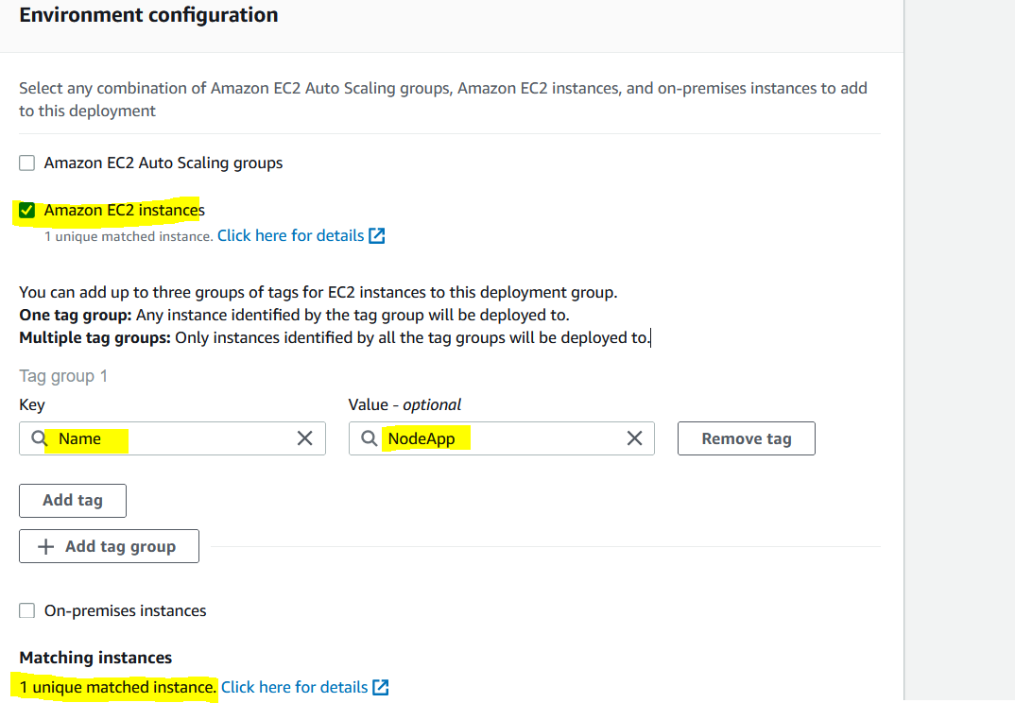

Disable the Load balancer

Deployment configuration should be CodeDeployDefault.AllAtOnce

Then create a deployment group

1. **Create a Code Pipeline Orchestration**

Navigate to AWS Code Pipeline – Create a pipeline

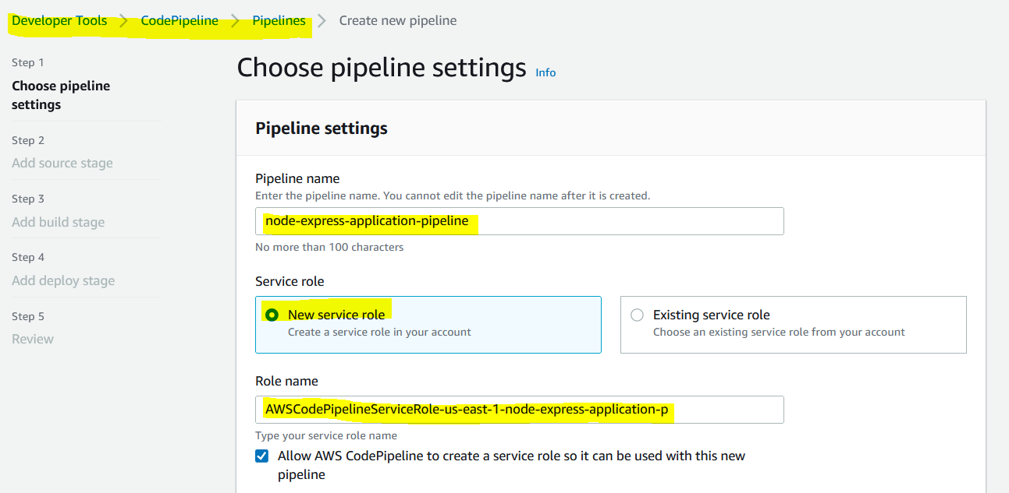

**Note:**

Code Pipeline needs an S3 bucket to hold the source code / package. You can choose a custom S3 bucket or Code pipeline create the default s3 location to store the codes.

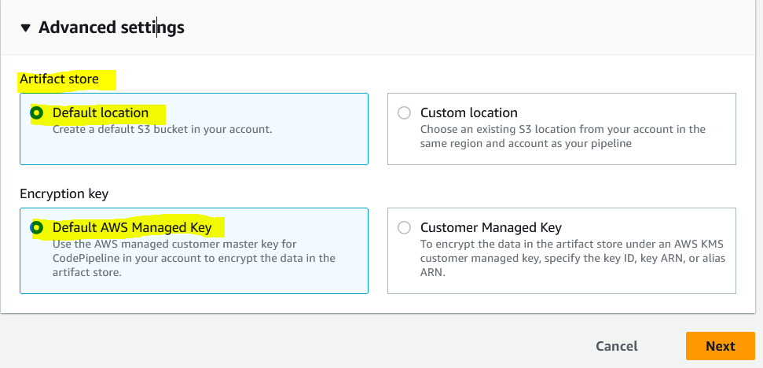

Add source stage

Connection name – meaningful name

Connect and install new app

Save and connect

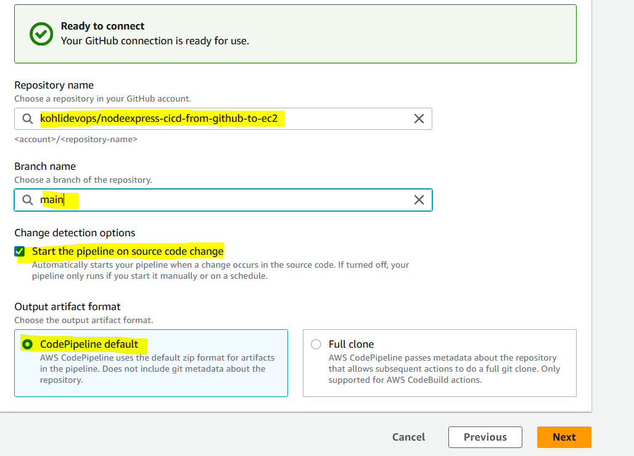

As of now, skip build stage

Provide the deployment details in Deploy stage

Next to create a Pipeline orchestration to complete this step

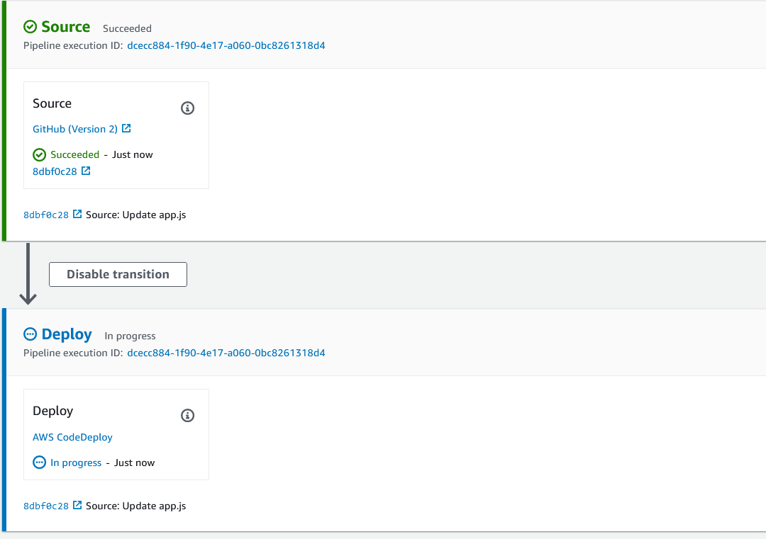

1. **Validate with EC2 IP address**

1. **Validate with Pipeline orchestration and it deploy stage events**

1. **Auto trigger – AWS Code Pipeline**

Do some changes in GitHub repository to ensure Pipeline orchestration is auto started.