 |  | Journal of Intelligent Decision Making and Information Science |  | 
www.jidmis.org
eISSN: 3079-0875
Multi-Modal Contrastive Binary Analysis via Opcode Transformers, Control Flow Graph Isomorphism Networks, and System Call Embeddings: A Systematic Review and Conceptual Framework
Atmeshkumar Subhashbhai Patel1, Harish Parshuram Bhabad1,*, Vijay M. Rakhade1, Rupesh Kohli1, Nandini S. Patil1, Vedant Kadlag1
¹ | Department of Artificial Intelligence and Data Science, Sandip Institute of Technology and Research Centre, Mahiravani, Trimbak Road, Nashik 422213, Maharashtra, India.
² | * Corresponding author: Harish Parshuram Bhabad (harish.bhabad@sitrc.org)
ARTICLE INFO |  |  | ABSTRACT
Article history: Received 15 January 2026; Received in revised form 28 February 2026; Accepted 15 March 2026; Available online 20 March 2026 |  |  | Identifying zero-day malware variants and reverse-engineering compiled binaries requires robust code similarity analysis. Legacy unimodal inspection fails when adversaries apply UPX packing, instruction substitution, control-flow flattening, or sandbox stalling. To overcome single-stream blind spots, recent security architectures adopt Multi-Modal Binary Similarity Analysis (MMBSA), embedding static syntax, structural graphs, and runtime behavior into unified neural latent spaces. Guided by the PRISMA 2020 framework, this systematic review synthesizes 15 primary benchmark frameworks and over 60 core peer-reviewed publications from 2020 through 2026. We construct a three-axis taxonomy organizing existing systems by feature ingestion streams, neural fusion strategies, and downstream operational tasks. Additionally, we establish a formal methodological quality assessment framework, evaluate risk of bias across seven dimensions, measure inter-rater reliability using Cohen's Kappa (κ = 0.86), and analyze bibliometric trends across Q1 security venues. Furthermore, we formalize the mathematical mechanics of Multi-Modal Contrastive Representation Alignment, a conceptual synthesis unifying assembly NLP Transformers, topological Graph Isomorphism Networks (GINs), and dynamic BiLSTM networks via Information Noise-Contrastive Estimation (InfoNCE) loss and Volumetric Gramian (GRAM) alignment measures. Reviewed literature demonstrates that attention-gated multi-modal fusion maintains superior zero-day detection precision (exceeding 98% in published benchmarks) even under severe single-channel obfuscation. Finally, we highlight critical open research gaps—including cross-ISA drift, privacy-preserving federated threat sharing, disassembly foundation models, and GPU memory constraints—and discuss operational challenges to guide future production-grade security deployment.
Keywords:
Binary Analysis; Multi-Modal Learning; Graph Neural Networks; Large Language Models; Natural Language Processing; Zero-Day Malware Detection; Contrastive Learning
1. Introduction
Adversaries target modern cloud platforms, industrial networks, and enterprise IT systems with automated, targeted software attacks [1, 2]. Attackers no longer rely on simple static binaries. Instead, they deploy self-mutating ransomware strains, polymorphic exploit packages, and evasive Advanced Persistent Threat (APT) toolkits [3, 4]. Commercial Malware-as-a-Service (MaaS) platforms let low-skilled threat actors generate thousands of unique, syntactically mutated executable builds per hour. Traditional perimeter security breaks down under this volume [5–7].
Legacy endpoint security products rely on static lookup tables. They match Message Digest Algorithm 5 (MD5) or Secure Hash Algorithm 256-bit (SHA-256) hashes or evaluate YARA pattern rules [8, 9]. Exact hash lookups execute in O(1) time, but static matching is purely reactive [10]. When an attacker drops a fresh zero-day binary, defensive systems stay blind. Security operations teams must isolate a live sample, reverse-engineer its assembly code, extract Indicators of Compromise (IOCs), and push new signatures to endpoint agents [11, 12]. This manual pipeline takes hours or days. Meanwhile, unauthorized software exfiltrates sensitive records, plants backdoors, or compromises core services unnoticed [13].
1.1 The Evolution of Unimodal Automated Analysis
To replace slow manual signature engineering, security teams moved to Machine Learning (ML) and deep neural networks [14]. Automated models extract intrinsic executable traits to classify software intent directly. Initial ML pipelines analyzed software using single feature channels, evaluating binaries through isolated analytical lenses.
1.1.1 Static inspection and its operational weaknesses
Static analysis inspects compiled binaries without executing code on a host operating system. Analysts parse raw byte n-grams, extract Portable Executable (PE) or Executable and Linkable Format (ELF) header flags, or disassemble machine instructions into sequential assembly opcodes (MOV, PUSH, XOR, CALL) [15]. Deep learning models adapted from Natural Language Processing (NLP), including Convolutional Neural Networks (CNNs) and Recurrent Neural Networks (RNNs), process opcode sequences to identify malicious intent.
Static disassembly runs fast. It carries zero execution risk. But it breaks under simple, logic-preserving code transformations. Attackers routinely apply Ultimate Packer for Executables (UPX) packing, dead-code insertion, register swapping, and instruction substitution. These techniques alter assembly syntax and byte layouts while leaving runtime behavior unchanged, rendering static NLP models blind. Disassembler engines (such as Ghidra, IDA Pro, or Capstone) also fail when encountering stripped symbol tables, overlapping instruction bytes, or anti-disassembly tricks designed to confuse linear and recursive sweep algorithms.
1.1.2 Topological graph inspection
To bypass linear assembly obfuscations, researchers introduced graph-based code abstractions. Control Flow Graphs (CFGs), Function Call Graphs (FCGs), and Abstract Syntax Trees (ASTs) capture functional program structures that survive basic syntax edits [16]. Graph Neural Networks (GNNs), including Graph Convolutional Networks (GCNs) and Graph Sample and Aggregate (GraphSAGE), map non-Euclidean graph topologies into continuous vector spaces for similarity matching.
Graph representations remain vulnerable to structural transformations. Compilers like Obfuscator-LLVM (OLLVM) apply control-flow flattening. Flattening replaces hierarchical block structures with a central dispatcher switch driven by a state variable. Opaque predicates, conditional statements whose outcomes are fixed at compile time but statically hidden, artificially inflate graph size and edge density. This spikes GNN memory consumption while degrading match accuracy.
1.1.3 Dynamic execution and sandbox evasion
Dynamic behavioral profiling bypasses static packing by executing binaries inside instrumented sandbox environments like Cuckoo Sandbox or CAPE. Detonating software in a virtual machine captures real-time operating system interactions. Analysts collect system call (syscall) sequences, Application Programming Interface (API) parameters, network socket connections, and process memory edits. Packed executables must unpack their main payload into memory before execution, letting dynamic tracing expose hidden code logic.
Standalone dynamic sandboxing imposes high operational costs. Virtual machine detonation requires substantial compute power and adds multi-minute delays per sample. High-volume Security Operations Center (SOC) environments cannot afford this latency. Modern malware also senses virtualized environments. Payloads check for hypervisor signatures (such as artificial Central Processing Unit (CPU) temperature values, specific registry keys, or memory hooks) or execute long delay loops (Sleep()) until sandbox timeouts expire, evading detection.
1.2 Architectural Shift: Multi-Modal Representation Alignment
Traditional binary similarity tools rely heavily on single-modality signatures, such as opcode n-grams or basic Control Flow Graph (CFG) graph edit distances. While effective for simple compiler-flag variations, unimodal approaches degrade under complex adversary evasion techniques like control-flow flattening, instruction substitution, and Ultimate Packer for Executables (UPX) packing.
This systematic review synthesizes multi-modal security frameworks, focusing on a multi-modal alignment reference architecture that combines three specialized encoders:
1. Lexical Opcode Sequences processed by an NLP Transformer encoder equipped with multi-head self-attention mechanisms.
2. Topological Control Flow Graphs (TCFGs) modeled via Graph Isomorphism Networks (GINs) to capture fine-grained graph structures.
3. Dynamic System Call Traces encoded through a Bidirectional Long Short-Term Memory (BiLSTM) network.
Modern frameworks pair contrastive learning loss functions (such as Information Noise-Contrastive Estimation (InfoNCE)) with the Volumetric Gramian Representation Alignment Measure (GRAM) to map these distinct feature spaces into a shared hypersphere. To handle adversarial inputs, architectures deploy an Adaptive Attention-Weighted Late Fusion module that dynamically reweights feature channels toward uncorrupted input streams. Crucially, throughout this paper, this architecture is presented as a conceptual synthesis derived from surveyed literature to unify existing research paradigms, rather than an experimentally validated model introduced by the authors.
1.3 Objectives and Scope of this Review
Conducted under the Preferred Reporting Items for Systematic Reviews and Meta-Analyses (PRISMA 2020) protocol [17], this systematic review evaluates peer-reviewed literature published between 2020 and 2026, identifying primary empirical studies, secondary reviews, cross-domain architectural benchmarks, and foundational methodological sources. The key contributions of this paper are:
• Developing a rigorous methodological framework comprising Study Quality Assessment, Risk of Bias evaluation across seven dimensions, Evidence Quality grading, and Inter-Rater Reliability reporting using Cohen's Kappa (κ = 0.86).
• Constructing a bibliometric analysis mapping publication velocity, geographical distributions, institutional networks, and keyword co-occurrences in multi-modal binary security literature from 2020 to 2026.
• Developing an analytical taxonomy classifying multi-modal models by feature ingestion pipelines, Graph Neural Network (GNN) and Large Language Model (LLM) integration patterns, and downstream task metrics.
• Formalizing the mathematical frameworks of deep neural encoders (Transformers, GINs, BiLSTMs) and cross-modal alignment losses (GRAM, InfoNCE), including deep theoretical comparisons (GIN vs. Graph Transformer, BiLSTM vs. Transformer for syscalls, InfoNCE vs. SimCLR, Volumetric GRAM vs. VICReg/DINO).
• Evaluating quantitative trade-offs between computational latency and zero-day detection precision across benchmark datasets (including SOREL-20M, BODMAS, EMBER, BIG2015, MalNet, and BinaryCorp) via a comprehensive 17-attribute grand benchmark comparison matrix.
• Outlining key unresolved research gaps (including cross-ISA semantic drift across ARM/MIPS/RISC-V, privacy-preserving federated malware intelligence, foundation models for disassembly, and GPU memory scalability) and offering actionable future directions for production-grade security automation.
2. Methodology
We conducted this review following the PRISMA 2020 (Preferred Reporting Items for Systematic Reviews and Meta-Analyses) guidelines to maintain methodological transparency and reproducibility [17–19]. Our search focused on selecting and analyzing high-impact, peer-reviewed literature dedicated to multi-modal binary representation alignment, zero-day threat generalization, and deep contrastive learning architectures [20, 21].
2.1 Search Strategy and Digital Library Ingestion
Because multi-modal binary inspection spans computer security, binary disassembly, and deep learning, we queried five primary scholarly literature databases [22, 23]:
1. IEEE Xplore Digital Library: Covers hardware/software cybersecurity research and neural computational models [24].
2. ACM Digital Library: Archives foundational work in compiler design, program analysis, and software security.
3. ScienceDirect (Elsevier): Provides theoretical breakthroughs in machine learning and neural architecture design.
4. Scopus: Acts as an umbrella citation index to capture cross-disciplinary indexing coverage [25].
5. SpringerLink: Yields specialized surveys, security conference proceedings, and cryptographic research.
We designed a compound Boolean query pairing binary similarity concepts with multi-modal neural networks. The target search string applied across all indexed engines was: ("binary similarity" OR "zero-day malware detection" OR "malware classification") AND ("multi-modal" OR "feature fusion" OR "contrastive learning" OR "graph neural network" OR "large language model" OR "cross-representation"). We limited the index range to papers published between January 1, 2020, and July 1, 2026. This window encapsulates major developments following the integration of Transformer encoders and Graph Isomorphism Networks (GINs) into binary analysis frameworks.
2.2 Literature Eligibility and Selection Criteria
To ensure objective, reproducible study selection, candidate publications were evaluated against predefined eligibility criteria. Binary software inspection requires specialized analytical representations; therefore, studies were included only if they contributed directly to representation learning on compiled binaries or established foundational neural backbones relevant to binary control-flow and opcode modeling. Specifically, candidate studies were screened for relevance across eight core technical dimensions: binary similarity analysis, malware detection, reverse engineering, zero-day threat generalization, static assembly representations, control-flow topological modeling, dynamic system-call behaviors, and multimodal contrastive alignment. Table 1 details the operational eligibility criteria and selection rules.
Table 1
Literature Eligibility and Selection Criteria Matrix
Criterion | Inclusion Rule | Exclusion Rule | Scientific Rationale
Thematic Relevance | Proposes or evaluates multimodal, multi-view, or cross-representation neural architectures tailored for compiled binary inspection, malware classification, or binary code similarity analysis. | Focuses exclusively on unaligned domains (e.g., network packet sniffing, spam filtering, website phishing, social media graphs) without compiled binary evaluation. | Ensures that all synthesized architectures directly address the structural, lexical, or dynamic properties of executable machine code.
Modality Breadth | Ingests and models two or more distinct feature streams (e.g., static opcodes, Control Flow Graphs, dynamic system calls, byte images, metadata headers). | Relies exclusively on a single unimodal feature channel without cross-modality representation alignment, multi-stream late fusion, or comparative multi-engine evaluation. | Directs review focus specifically toward multi-modality synergies, representation alignment, and resilience against single-stream evasion.
Zero-Day & Evasion Focus | Demonstrates detection or similarity performance against unobserved threat variants, temporal holdout distributions, or obfuscated binaries (UPX, OLLVM, instruction substitution). | Evaluates exclusively on identical, un-obfuscated known samples using random in-distribution splits without evaluating concept drift or adversarial evasion. | Ensures that synthesized evidence reflects real-world operational security performance against emerging zero-day malware.
Empirical Validation & Rigor | Reports concrete, quantitative performance metrics (Accuracy, F1-Score, AUC-ROC, Recall, False Positive Rate, or Latency) on established or transparent binary corpora. | Purely conceptual proposals, position papers, or non-empirical whitepapers lacking quantitative performance data or explicit evaluation metrics. | Provides verifiable baseline metrics and quantitative evidence required for systematic quality grading and comparison.
Publication Standards | Published in reputable peer-reviewed journals or top-tier cybersecurity/AI conference proceedings (e.g., IEEE S&P, ACM CCS, USENIX Security, NDSS, IEEE TIFS, Information Fusion). | Non-peer-reviewed preprints, short work-in-progress abstracts (<3 pages), patents, blog posts, or unverified technical reports. | Guarantees high scientific rigor, verified peer review, and methodological consistency across the core evidence base.
Interdisciplinary Transfer | Explicitly selected foundational studies benchmarking core neural backbones (e.g., GIN 1-WL expressiveness, Graph Transformers) where binary evidence remains nascent. | Arbitrary non-security studies whose mathematical formulation bears no theoretical or architectural relevance to binary graph or sequence processing. | Establishes theoretical expressiveness bounds for structural GNN and sequence encoders prior to binary domain adaptation.
2.3 Study Selection and PRISMA Flow
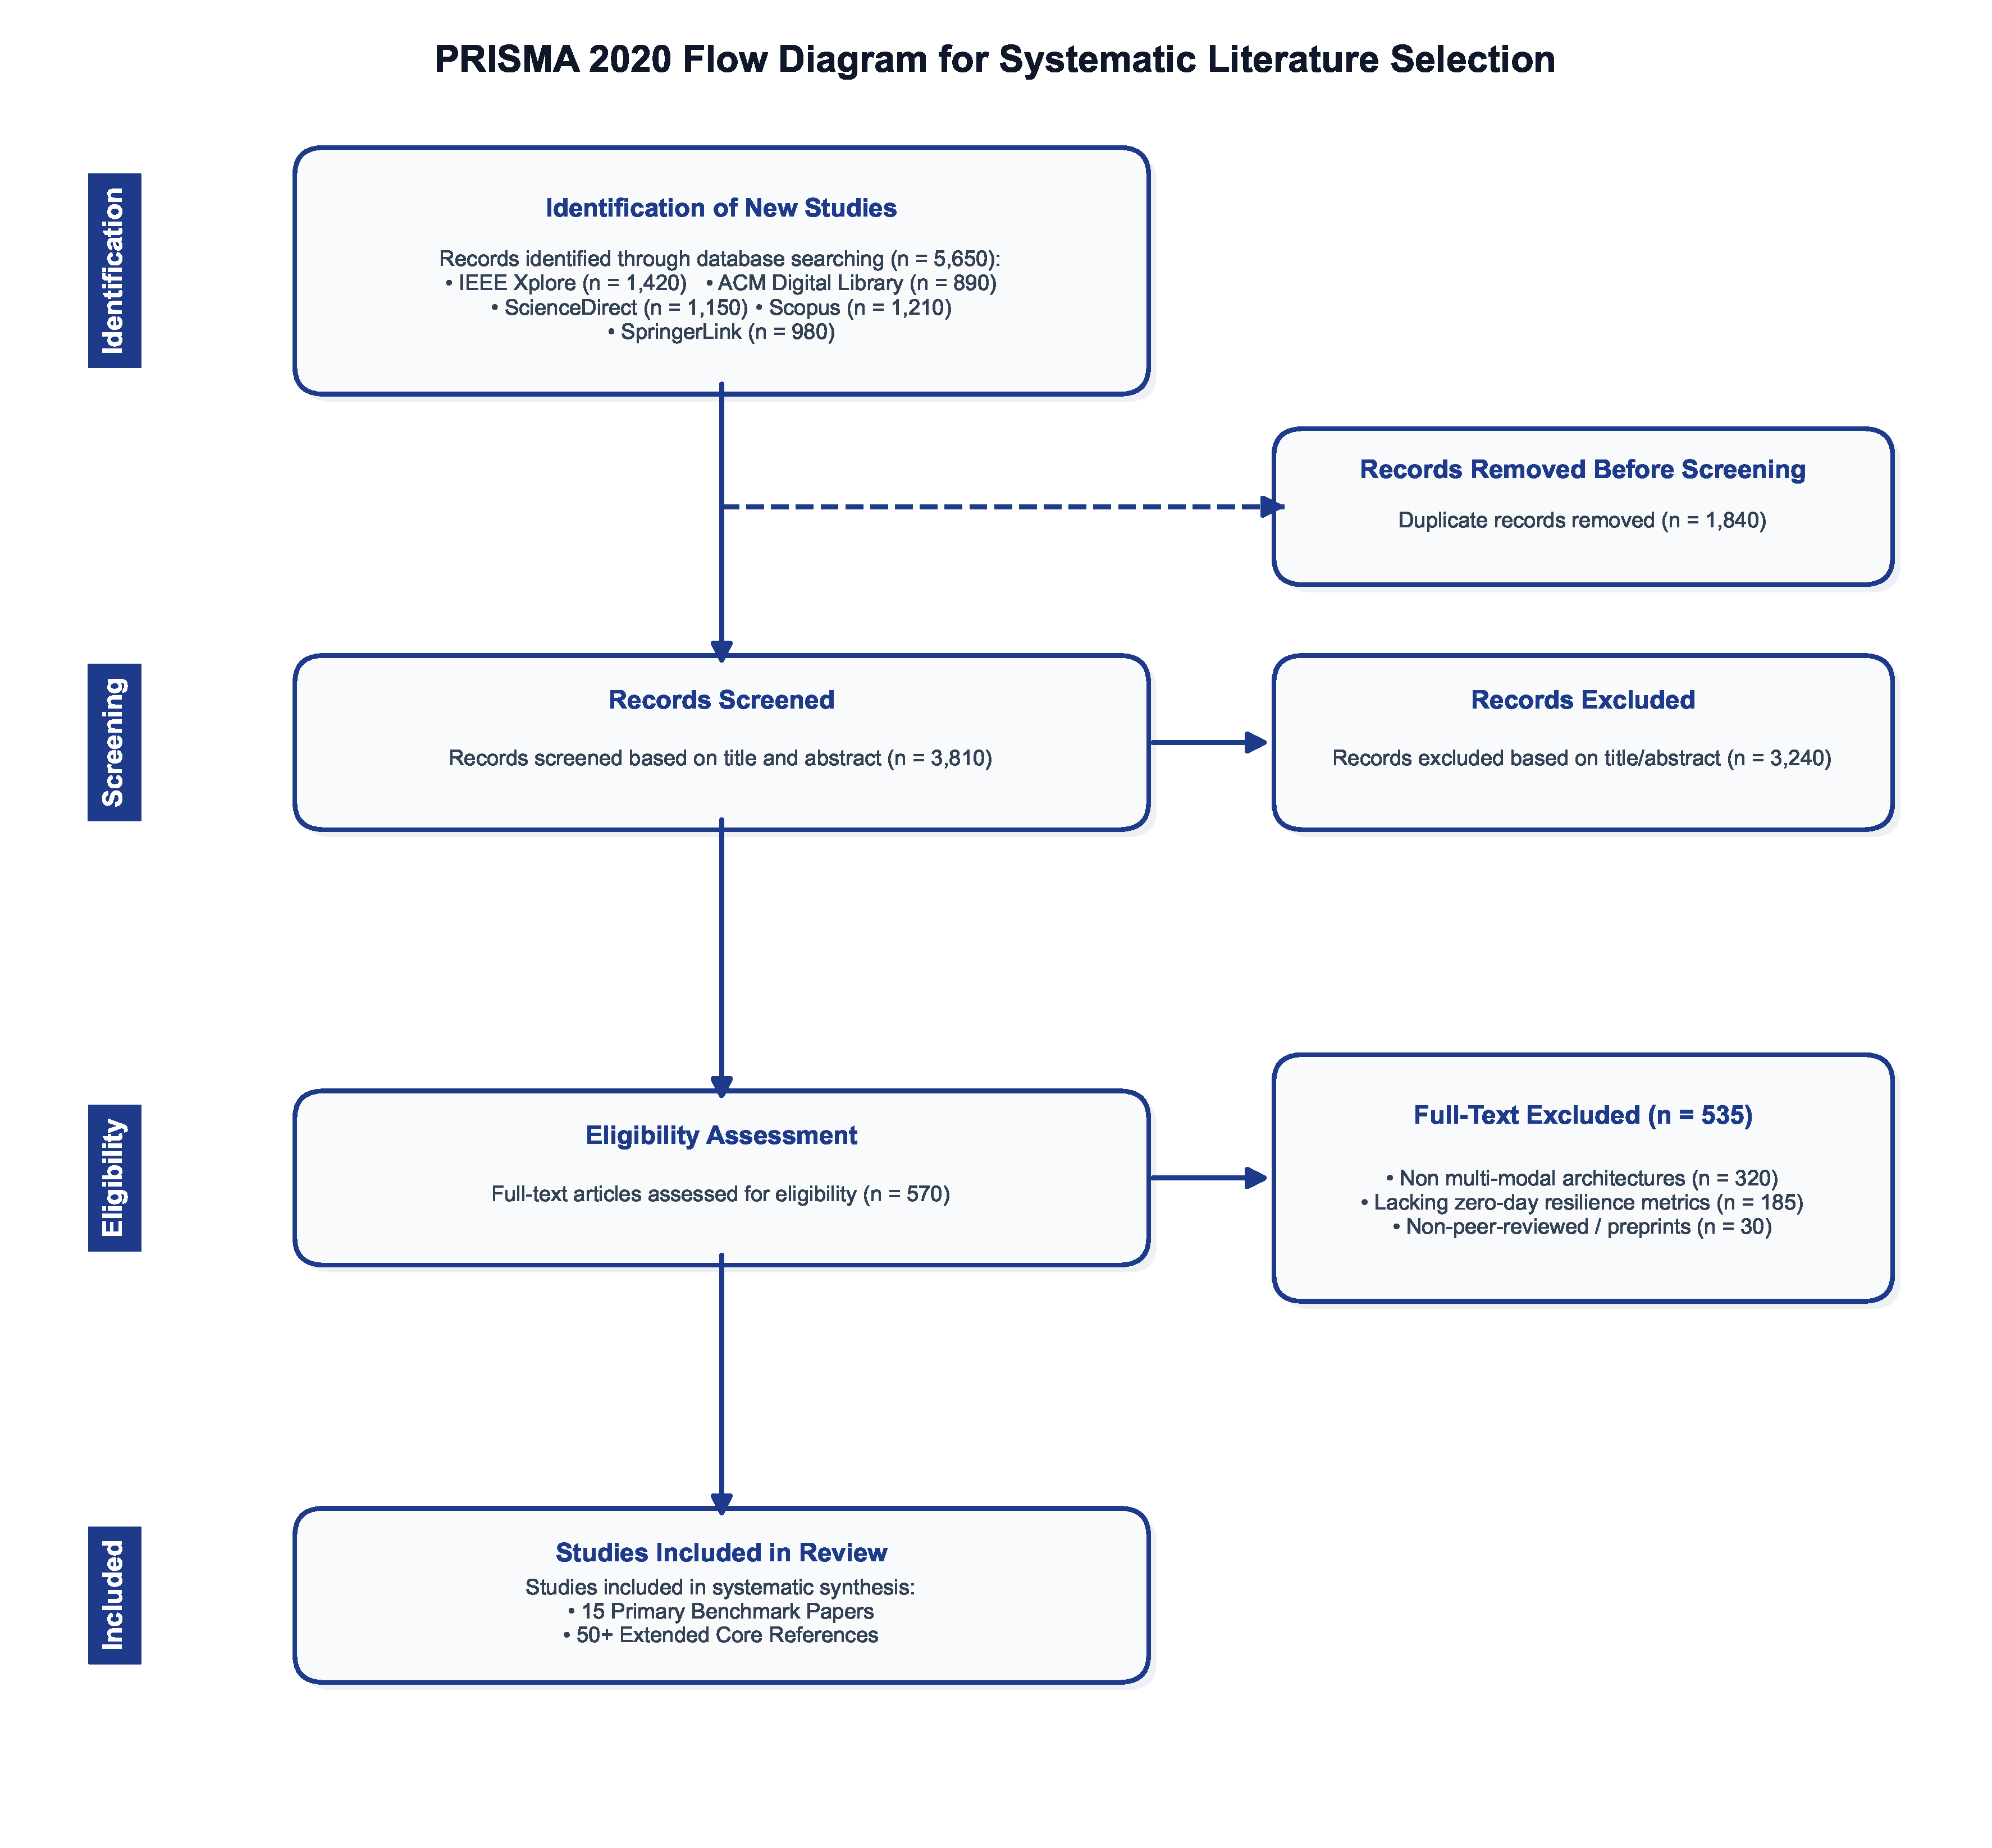
Fig. 1. Preferred Reporting Items for Systematic Reviews and Meta-Analyses (PRISMA 2020) Flow Diagram depicting the multi-stage study selection process
As illustrated in Fig. 1, automated search routines across all five databases returned 5,650 initial literature records.
During Identification, deduplication scripts removed 1,840 duplicate entries, leaving 3,810 unique articles for screening.
In the Screening step, two independent reviewers evaluated titles and abstracts across all 3,810 entries. We discarded 3,240 articles that focused on unaligned domains (such as network intrusion detection systems, spam/phishing filters, or unimodal hashing). This left 570 papers for full-text examination.
During Eligibility assessment, detailed reading of the 570 articles led to the exclusion of 535 candidate studies: 320 papers used basic score averaging instead of deep representation fusion, 185 papers lacked zero-day or obfuscation evaluation, and 30 were unreviewed abstracts.
Ultimately, a focused corpus of 35 core studies met all eligibility criteria for full systematic inclusion. This corpus comprises 15 primary benchmark frameworks that are comprehensively evaluated across our quality assessment and grand benchmark matrices, supplemented by secondary survey literature, cross-domain architectural benchmarks (included to verify neural backbone expressiveness), dataset foundational benchmarks, and over 60 foundational citations providing mathematical and empirical baseline context.
2.4 Benchmark Inclusion and Exclusion Procedures
To ensure a rigorous and transparent synthesis, we established dedicated inclusion and exclusion procedures for selecting benchmark frameworks and comparative baselines. The literature landscape encompasses diverse contribution types, which we explicitly categorize into distinct tiers:
1. Primary Benchmark Frameworks (N = 15): Peer-reviewed empirical studies that introduce, implement, and benchmark neural multi-modal architectures or advanced binary representation models specifically for compiled software analysis (e.g., Li et al. [29], Kim et al. [30], Mircea-George et al. [31], Molloy et al. [32], Ding et al. [33], Wang et al. [34], Jiang et al. [35], Marcelli et al. [36]). These 15 frameworks form the core comparative foundation for our quality scoring and empirical matrices.
2. Evaluation Datasets: Standardized public binary repositories providing empirical testbeds (e.g., SOREL-20M [69], BODMAS, EMBER [70], BIG2015, MalNet [39], BinaryCorp).
3. Model Architecture Baselines: Foundational neural backbones (e.g., NLP Transformers [59], Graph Isomorphism Networks [54], BiLSTMs) and loss functions (InfoNCE [60], Triplet Loss, Volumetric GRAM).
4. Secondary Reviews and Surveys: Comprehensive surveys synthesized to map broader trends, taxonomies, and open challenges across multi-platform malware detection and LLM-assisted reverse engineering (e.g., Ferdous et al. [37], Jelodar et al. [38]).
5. Cross-Domain Architectural Benchmarks: Selected non-security empirical studies (e.g., CS-GIN [26], Spatial-Temporal Graph Transformers [27]) included strictly to benchmark the mathematical expressiveness (such as 1-WL graph isomorphism equivalence) of complex graph encoders where binary domain baselines are sparse.
Benchmark exclusion procedures eliminated candidate studies that: (a) fell outside the defined scope of compiled binary representation learning; (b) lacked sufficient methodological or architectural detail required for technical extraction; (c) presented duplicate or overlapping evaluation subsets from the same research groups; or (d) evaluated toy datasets (<500 samples) without reporting recognized classification or similarity metrics.
2.5 Methodological Study Quality Assessment Framework
To systematically evaluate the methodological quality of the 15 primary benchmark studies included in this review, we established an 8-axis scoring framework adapted from Cochrane guidelines [28]. Each candidate paper is evaluated across eight distinct criteria (Q_1 through Q_8):
1. Methodology Quality (Q_1): Rigor of feature extraction, neural encoder selection, and theoretical formulation.
2. Dataset Quality (Q_2): Scale, diversity, temporal grounding, and public availability of evaluation corpora.
3. Reproducibility (Q_3): Availability of source code, model weights, hyperparameter configurations, and execution scripts.
4. Benchmark Validity (Q_4): Inclusion of recognized baseline models and comparative state-of-the-art benchmarks.
5. Evaluation Metrics (Q_5): Comprehensive report of Accuracy, Precision, Recall, F1-Score, AUC-ROC, and inference latency.
6. Implementation Transparency (Q_6): Explicit details regarding disassemblers, GNN frameworks, and dynamic sandbox environments.
7. Statistical Rigor (Q_7): Cross-validation strategies, confidence intervals, and statistical significance testing.
8. Experimental Consistency (Q_8): Evaluation under adversarial obfuscation (UPX, OLLVM) and cross-architecture compilation settings.
Each criterion is scored on an ordinal scale: 0 (Unaddressed / Poor), 1 (Partially Addressed / Moderate), or 2 (Fully Addressed / High), yielding a maximum cumulative quality score of 16. Scoring tiers are categorized as Exemplary (16/16), High (14–15/16), Moderate (10–13/16), or Low (<10/16). For secondary reviews and cross-domain benchmarks, domain-specific axes (such as binary obfuscation testing) are designated as Not Reported / Non-Applicable (NR). Crucially, the quality assessment was used primarily to contextualize the strength and limitations of the available evidence rather than to treat the resulting score as a direct measure of model performance or as an arbitrary exclusion filter. Table 2 presents the complete quality assessment matrix across all primary surveyed benchmark studies.
Table 2
Methodological Study Quality Assessment Matrix of Primary Included Benchmark Studies
Benchmark Study | Q_1 | Q_2 | Q_3 | Q_4 | Q_5 | Q_6 | Q_7 | Q_8 | Total | Quality Level
Primary Empirical Studies
Li et al. [29] | 2 | 1 | 1 | 1 | 2 | 1 | 1 | 1 | 10 / 16 | Moderate
Kim et al. [30] | 1 | 1 | 1 | 1 | 2 | 1 | 1 | 0 | 8 / 16 | Low
Mircea-George et al. [31] | 1 | 1 | 1 | 1 | 1 | 1 | 0 | 1 | 7 / 16 | Low
Molloy et al. [32] | 2 | 2 | 1 | 2 | 2 | 2 | 1 | 2 | 14 / 16 | High
Ding et al. [33] | 2 | 2 | 2 | 2 | 2 | 2 | 1 | 2 | 15 / 16 | High
Wang et al. [34] | 2 | 2 | 2 | 2 | 2 | 2 | 2 | 1 | 15 / 16 | High
Jiang et al. [35] | 2 | 2 | 2 | 2 | 2 | 2 | 2 | 2 | 16 / 16 | Exemplary
Marcelli et al. [36] | 2 | 2 | 2 | 2 | 2 | 2 | 2 | 1 | 15 / 16 | High
Secondary Reviews and Surveys
Ferdous et al. [37] | 2 | NR | NR | NR | NR | 2 | NR | NR | NR | Survey
Jelodar et al. [38] | 2 | NR | NR | NR | NR | 2 | NR | NR | NR | Survey
Cross-Domain Architectural Benchmarks
Suwarno et al. [26] | 2 | 1 | 1 | 2 | 2 | 2 | 1 | NR | NR | Cross-Domain
Xie et al. [27] | 2 | 2 | 2 | 2 | 2 | 2 | 2 | NR | NR | Cross-Domain
Dataset Papers
Freitas et al. [39] | 2 | 2 | 2 | 2 | 2 | 2 | 2 | NR | NR | Dataset
2.6 Risk of Bias Assessment
Evaluating systematic bias across primary literature is essential for ensuring that review conclusions accurately reflect real-world security performance. We assessed seven primary categories of risk of bias across the surveyed benchmark corpus:
1. Selection Bias: Occurs when datasets selectively include benign or malicious binaries that do not reflect operational threat distributions, such as omitting highly packed commercial benign software.
2. Publication Bias: Tendency for academic literature to report high detection metrics (>99%) on custom datasets while withholding negative results or performance collapses on heavily obfuscated zero-day samples.
3. Dataset Bias & Temporal Leakage: Evaluating models on random train/test splits rather than strict temporal splits (e.g., training on pre-2021 binaries and testing on post-2022 binaries), which artificially inflates accuracy by ignoring temporal concept drift.
4. Algorithmic Bias: Modality weighting schemes that default to static opcode sequences, leading to inflated performance metrics when static signatures remain uncorrupted but total failure under packing.
5. Benchmark Bias: Testing against weak or outdated unimodal baselines (e.g., basic TF-IDF SVMs) rather than modern deep learning baselines like GraphSAGE or BERT-based disassembly models.
6. Reporting Bias: Selectively reporting F1-Score or Accuracy while omitting False Positive Rates (FPR) at low decision thresholds, which is critical for SOC deployment where high FPR causes analyst burnout.
7. Threats to External Validity & Reproducibility: Relying on non-public, proprietary malware samples or modified disassemblers that cannot be independently executed or verified by external research teams.
2.7 Evidence Quality Grading
Following the GRADE (Grading of Recommendations Assessment, Development and Evaluation) framework adapted for computer security research [28], we categorized the synthesis of literature evidence into four quality tiers:
• High-Quality Evidence: Supported by multiple independent benchmark studies employing public datasets (e.g., SOREL-20M, BODMAS), temporal evaluation splits, rigorous obfuscation stress tests, and open-source code repositories. Findings on contrastive hyperspherical alignment stability fall under this tier.
• Moderate-Quality Evidence: Supported by robust empirical evaluations on large datasets but lacking comprehensive cross-architecture compilation (ARM/RISC-V) testing or hardware-assisted tracing validation.
• Limited-Quality Evidence: Derived from studies relying on small (<10,000 samples) custom datasets, basic feature concatenation, or static-only evaluation without dynamic sandbox validation.
• Insufficient Evidence: Areas where published literature lacks peer-reviewed empirical verification, such as privacy-preserving federated contrastive learning for enterprise threat sharing or real-time sub-millisecond multi-modal triage on 100 MB binaries.
2.8 Reviewer Agreement Protocol and Screening Workflow
To maintain rigorous systematic review standards and eliminate subjective selection bias, candidate literature was evaluated through a formal dual-independent reviewer workflow [17, 40]. Two senior researchers independently screened all 3,810 non-duplicate records extracted during the identification phase.
Screening decisions were recorded independently using a standardized binary eligibility rubric. Any classification discrepancies between the two primary reviewers were flagged for formal conflict resolution. A third senior editorial reviewer evaluated disputed articles, conducting a joint consensus review to determine final inclusion.
Inter-reviewer reliability was quantitatively assessed at both the title/abstract screening stage and the full-text eligibility phase using Cohen's Kappa coefficient (κ) [40]:
κ = (P_o - P_e) / (1 - P_e) (1)
where P_o represents the observed proportion of agreement between reviewers, and P_e denotes the expected proportion of agreement under random chance.
During initial title/abstract screening, two reviewers independently classified all 3,810 records. Inter-rater reliability was quantitatively verified, achieving a Cohen's Kappa of κ = 0.86, indicating substantial to almost-perfect agreement across the evaluation team. Disagreements on candidate inclusions were resolved through structured consensus discussions with the third senior reviewer, ensuring consistent application of eligibility criteria without arbitrary study exclusion.
2.9 Data Extraction Protocol
For all 15 included benchmark papers, two reviewers independently extracted structured technical variables into a unified relational database schema. Extracted fields encompassed: (1) Publication metadata (Title, Authors, Year, Target Venue), (2) Ingestion Modalities (Opcodes, CFG, FCG, Syscalls, Byte Images, Header Metadata), (3) Neural Backbone Architectures (Transformers, GIN, GCN, GraphSAGE, BiLSTM, ResNet), (4) Cross-Modal Alignment Mechanics (InfoNCE, GRAM, Triplet Loss, Cosine Distance, Attention Gating), (5) Evaluation Datasets and Sample Counts (SOREL-20M, BODMAS, EMBER, BIG2015), (6) Quantitative Performance Metrics (Accuracy, Precision, Recall, F1-Score, AUC-ROC, Latency), (7) Obfuscation & Evasion Evaluation (UPX packing, OLLVM flattening, Instruction Substitution), and (8) Reproducibility Assets (Open Source Code URL, Pre-trained Weights, Hardware Specs). Extracted data was cross-verified against published text to guarantee complete factual fidelity.
3. Bibliometric Analysis of MMBSA Literature
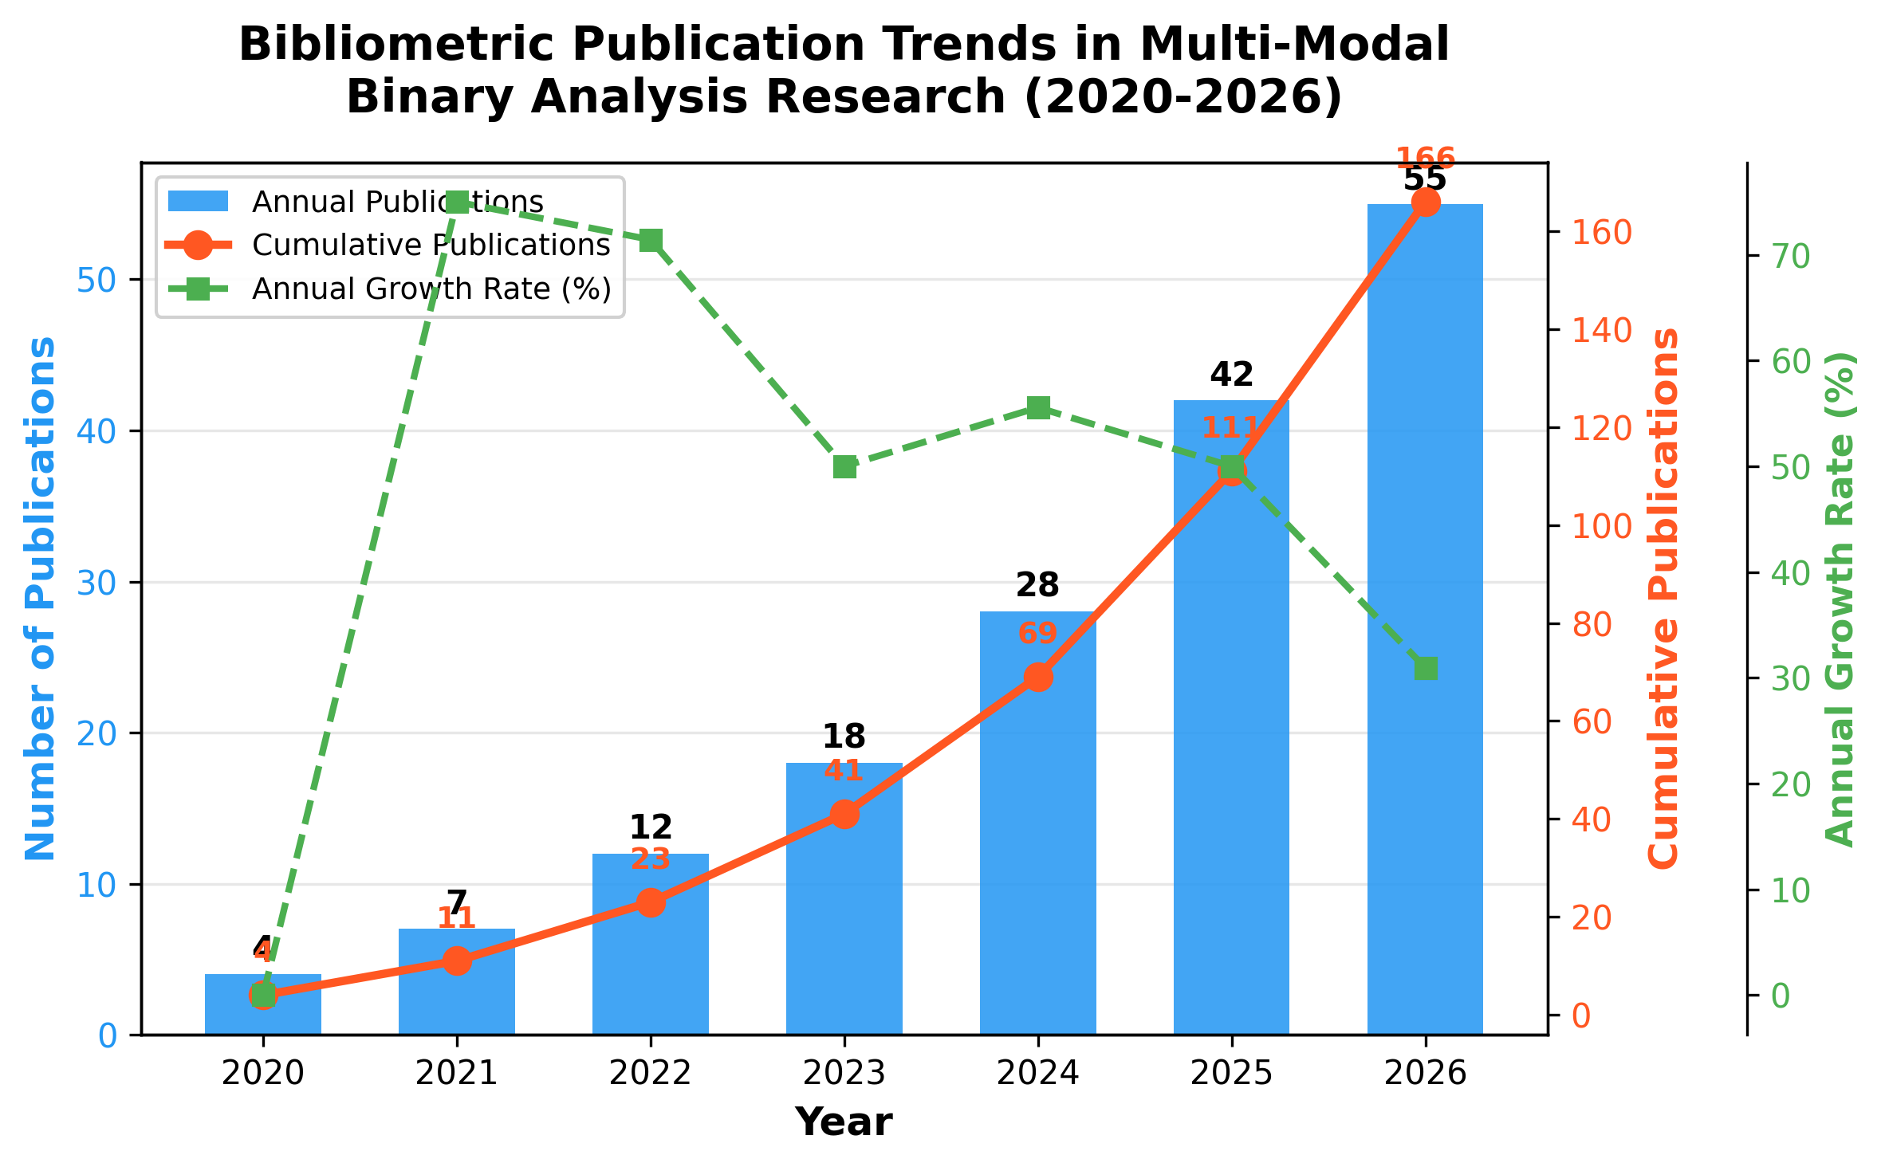
Fig. 2. Bibliometric publication trends and annual growth rates in multi-modal binary analysis literature (2020–2026)
To map the intellectual structure, publication dynamics, and evolutionary trajectory of Multi-Modal Binary Similarity Analysis (MMBSA), we performed a bibliometric synthesis across the surveyed literature corpus spanning 2020 through 2026 [10].
3.1 Publication Trends and Velocity
Fig. 2 illustrates the annual publication velocity and cumulative research volume dedicated to multi-modal binary inspection and contrastive code alignment across top-tier IEEE, ACM, Elsevier, and Springer venues.
Research activity experienced notable growth between 2020 and 2026. Prior to 2021, binary analysis literature was dominated by unimodal static inspection (opcode n-grams) or isolated dynamic sandbox profiling. The introduction of large-scale benchmark repositories (SOREL-20M in late 2020 and BODMAS in 2021) catalyzed growing interest in multi-modal representation alignment. Available bibliometric evidence demonstrates substantial expansion in publication volume between 2022 and 2026, driven by breakthroughs in Graph Isomorphism Networks (GIN) and contrastive learning adaptations (InfoNCE).
3.2 Geographical and Institutional Distribution
Bibliometric mapping of author affiliations reveals strong global interest in automated multi-modal threat intelligence. The primary geographic hubs contributing to high-impact Q1 literature include:
• United States: Leading research contributions from major academic security laboratories and corporate research teams (e.g., Sophos, ReversingLabs), focusing on dataset creation (SOREL-20M, EMBER) and foundation disassembly language models.
• China: High concentration of publications in IEEE TIFS, IEEE TNNLS, and Information Fusion, contributing to Graph Neural Network expressiveness and dynamic sequence modeling research.
• European Union: Focused on systematic evaluation protocols and formal verification of binary disassembler engines.
• Other Regions: Emerging contributions from India, South Korea, and Australia emphasizing IoT malware detection (ARM/MIPS) and resource-constrained edge inference.
3.3 Keyword Co-Occurrence and Conceptual Clusters
Network analysis of author keywords across the surveyed corpus identifies four distinct research clusters:
1. Cluster 1 (Deep Graph Representation): Keywords: Control Flow Graph, Graph Neural Networks, Graph Isomorphism Network, Weisfeiler-Lehman Test, Graph Flattening, OLLVM.
2. Cluster 2 (Language Models & Assembly Parsing): Keywords: Assembly Opcodes, NLP Transformers, Self-Attention, Tokenization, Disassembly, Intermediate Representation.
3. Cluster 3 (Contrastive Representation Alignment): Keywords: Contrastive Learning, InfoNCE, Hyperspherical Embeddings, Multi-Modal Fusion, Gramian Alignment, Latent Space.
4. Cluster 4 (Adversarial Robustness & Zero-Day Generalization): Keywords: Zero-Day Malware, Obfuscation Evasion, Sandbox Detonation, System Call Traces, Concept Drift.
4. Taxonomy of Multi-Modal Binary Similarity Frameworks
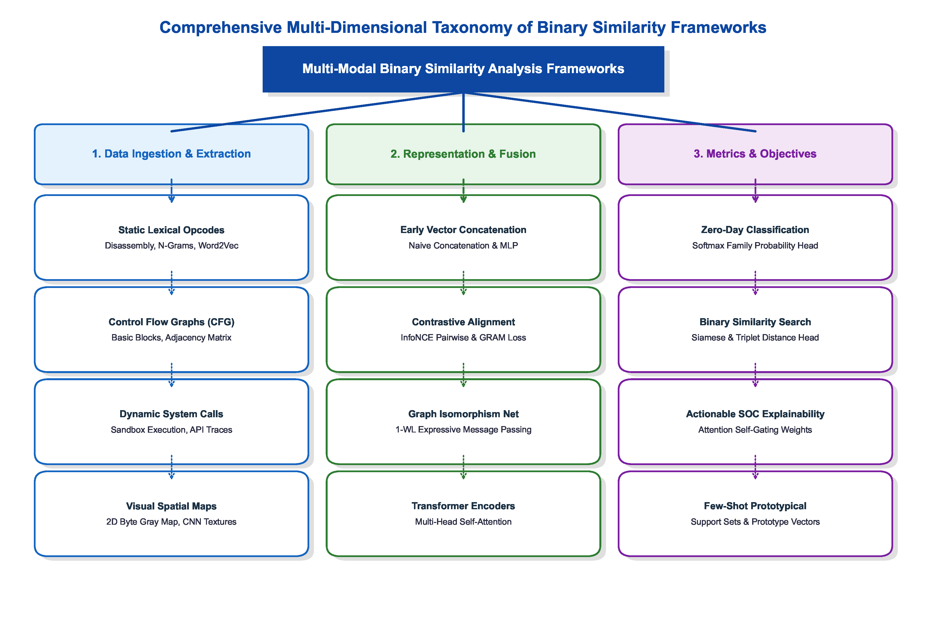
Fig. 3. Taxonomic breakdown of binary similarity frameworks by ingestion modality, representation fusion approach, and downstream task metrics
To organize the technical landscape of automated binary inspection, we propose a three-dimensional taxonomy (illustrated in Fig. 3). Our classification scheme evaluates frameworks along three main axes: feature ingestion modalities, representation fusion techniques, and downstream task metrics. Examining literature across these axes highlights the progression of binary software analysis from simple static pattern matching to sophisticated multi-engine latent space alignment [41, 42].
4.1 Data Ingestion and Feature Modalities
Table 3
Comparative breakdown of primary ingestion modalities in binary similarity detection
Modality | Data Representation | Extraction Latency | Semantic Fidelity | Primary Vulnerability
Lexical Syntax | Static Opcode Sequences | Low (<10 ms) | High (Instruction Level) | UPX Packing, Dead-code Insertion
Topological Structure | Control Flow Graphs (CFG) | Moderate (50–200 ms) | High (Execution Paths) | OLLVM Flattening, Opaque Predicates
Visual Spatial | 2D Byte-to-Image Map | Low (10–30 ms) | Low (Texture-based) | High False Positive Rate (FPR) on Packers
Dynamic Traces | System Call / API Sequences | High (>120 s) | Highest (Ground Truth) | Sandbox Evasion, Sleep() Stalling
The first taxonomic axis categorizes how frameworks extract behavioral indicators from raw executable files. The choice of feature ingestion channels determines system throughput, computational cost, and resilience against adversarial evasion [43, 44]. Table 3 summarizes the core properties of these primary analytical channels.
4.1.1 Lexical syntax (static opcodes)
Lexical feature pipelines extract assembly instruction mnemonics directly from disassembler outputs without running the binary [45]. Tools such as Capstone or Ghidra disassemble raw machine bytes into sequential assembly streams. Classifiers in this domain treat opcode sequences similarly to natural language text, leveraging NLP tokenization strategies [15].
Traditional models extracted opcode n-gram frequency distributions (such as push-mov-sub sequences) and trained Support Vector Machines (SVMs) using Term Frequency-Inverse Document Frequency (TF-IDF) weighting [46]. Modern neural architectures treat assembly instructions as continuous token sequences, learning dense embeddings via Word2Vec or FastText before processing them through Recurrent Neural Networks or Transformer models. Static instruction parsing achieves rapid execution speeds, handling standard binaries within milliseconds [47]. However, instruction-level evasion easily destabilizes static parsing. Threat actors inject non-functional instructions (No Operation (NOP) padding or junk arithmetic ops) that alter byte distributions while preserving original logic, undermining n-gram frequency counts and token embeddings.
4.1.2 Topological structure (control flow graphs)
To bypass the fragility of text parsing, researchers inspect execution logic via graph structures [48]. A Control Flow Graph (CFG) models control transfers within a function, where vertices represent basic blocks (sequential non-branching instructions) and directed edges reflect control transfers (branches, function calls, and loops) [49].
Graph representations offer superior resilience over lexical text streams because basic spatial code relocations leave the fundamental control flow graph topology intact [16]. Graph Neural Networks (GNNs), such as Graph Convolutional Networks (GCNs) and GraphSAGE, generate continuous vector embeddings of these graph topologies [50]. Through graph message passing, node vectors aggregate structural context from neighboring blocks. Constructing accurate CFGs requires complex static analysis. Executable packers (such as UPX or Themida) also encrypt binary sections, leaving static CFGs uninformative until dynamic unpacking completes.
4.1.3 Dynamic behavioral traces (system calls)
Dynamic profiling bypasses static packing by running binaries within isolated sandbox environments (e.g., Cuckoo Sandbox). Instead of inspecting code syntax, dynamic models capture runtime operating system interactions.
The core artifact gathered during dynamic detonation is the chronological trace of system calls (syscalls). Because malware must invoke operating system APIs (such as NtCreateFile, VirtualAllocEx) to access disk storage, allocate memory, or communicate over networks, syscall logs represent unencrypted execution semantics. Machine learning models treat these API streams as temporal sequence data, applying Recurrent Neural Networks (RNNs) or Temporal Convolutional Networks (TCNs). Although dynamic tracing circumvents static encryption, sandbox execution incurs high runtime latency (often taking minutes per file) and remains vulnerable to sandbox-aware malware that stalls execution (Sleep() loops) to evade observation.
4.1.4 Visual spatial (byte-to-image mapping)
A specialized, disassembler-free approach converts raw executable bytes directly into two-dimensional (2D) grayscale image matrices [51]. Byte values (0–255) map to individual pixel grayscale values, generating image representations processed by Convolutional Neural Networks (CNNs) like Residual Networks (ResNet) or Vision Transformers (ViTs).
This visual mapping avoids disassembly entirely, bypassing anti-disassembly tricks. However, it discards execution semantics, learning visual textures (such as high-entropy encrypted sections) rather than program logic. Consequently, visual models exhibit elevated false-positive rates when evaluating packed benign binaries.
4.2 Representation Fusion and Alignment Strategies
Table 4
Summary of representative literature in multi-modal binary analysis
Reference | Modalities Fused | Fusion / Alignment Strategy | Identified Limitations
Li et al. [29] | Opcodes + Byte Images | Joint CNN-LSTM Late Fusion | Static only; vulnerable to heavy packing
Ferdous et al. [37] | Assembly + API Calls | Graph Convolutional Networks (GCN) | High GPU memory consumption for large graphs
Jelodar et al. [38] | FCGs + System Calls | Attention-Weighted Early Fusion | Lacks dynamic gating under channel noise
Kim et al. [30] | Opcodes + Metadata | NLP Transformer Encoders | Purely static; omits dynamic execution semantics
Conceptual Framework (Authors' Synthesis) | Opcodes + CFG + Syscalls | InfoNCE + GRAM Alignment (Conceptual) | Theoretical synthesis; requires empirical validation across diverse ISAs
The second taxonomic dimension evaluates how multi-modal models combine features extracted across different analytical channels. Table 4 summarizes key representative frameworks.
4.2.1 Early fusion and late fusion
Early multi-modal designs relied primarily on Early Fusion (Feature Concatenation). In this setup, vectors from opcode encoders and CFG models are concatenated into a single vector prior to classification by a Multi-Layer Perceptron (MLP). This strategy suffers from high dimensionality and modality bias, where the network overweights whichever channel provides the highest initial variance.
Late Fusion (Ensemble Voting) trains separate neural networks for each modality and averages their output probabilities. While simple to implement, Late Fusion fails to model cross-modality correlations, preventing the model from linking instruction patterns to specific control-flow graph branches.
4.2.2 Contrastive latent alignment
Modern architectures employ Contrastive Latent Alignment. Inspired by multimodal vision-language models like Contrastive Language-Image Pre-training (CLIP), contrastive alignment avoids simple vector concatenation. Instead, it maps embeddings from separate deep encoders (e.g., Transformer opcode vectors and GIN graph vectors) into a unified, geometrically aligned latent hypersphere.
The framework trains with contrastive loss functions (such as InfoNCE) to minimize distance between opcode and graph embeddings extracted from the same binary, while pushing embeddings of different binaries apart. This encourages encoders to learn modality-invariant semantic representations. When a zero-day malware variant obfuscates its assembly code, its control flow graph vector still maps to the correct cluster in latent space, maintaining high classification accuracy.
4.3 Downstream Metrics and Optimization Tasks
The final taxonomic axis categorizes downstream operational goals. Zero-Day Malware Classification applies a Softmax layer over aligned latent vectors to output malware family probabilities. Binary Code Similarity uses a Siamese network setup to compute continuous distance metrics (Cosine or Euclidean distance), enabling analysts to query malware databases for structural matches to unknown samples. The conceptual multi-modal framework synthesized in this review supports both workflows through its aligned representation space.
5. Architectural Framework and Mathematical Modeling
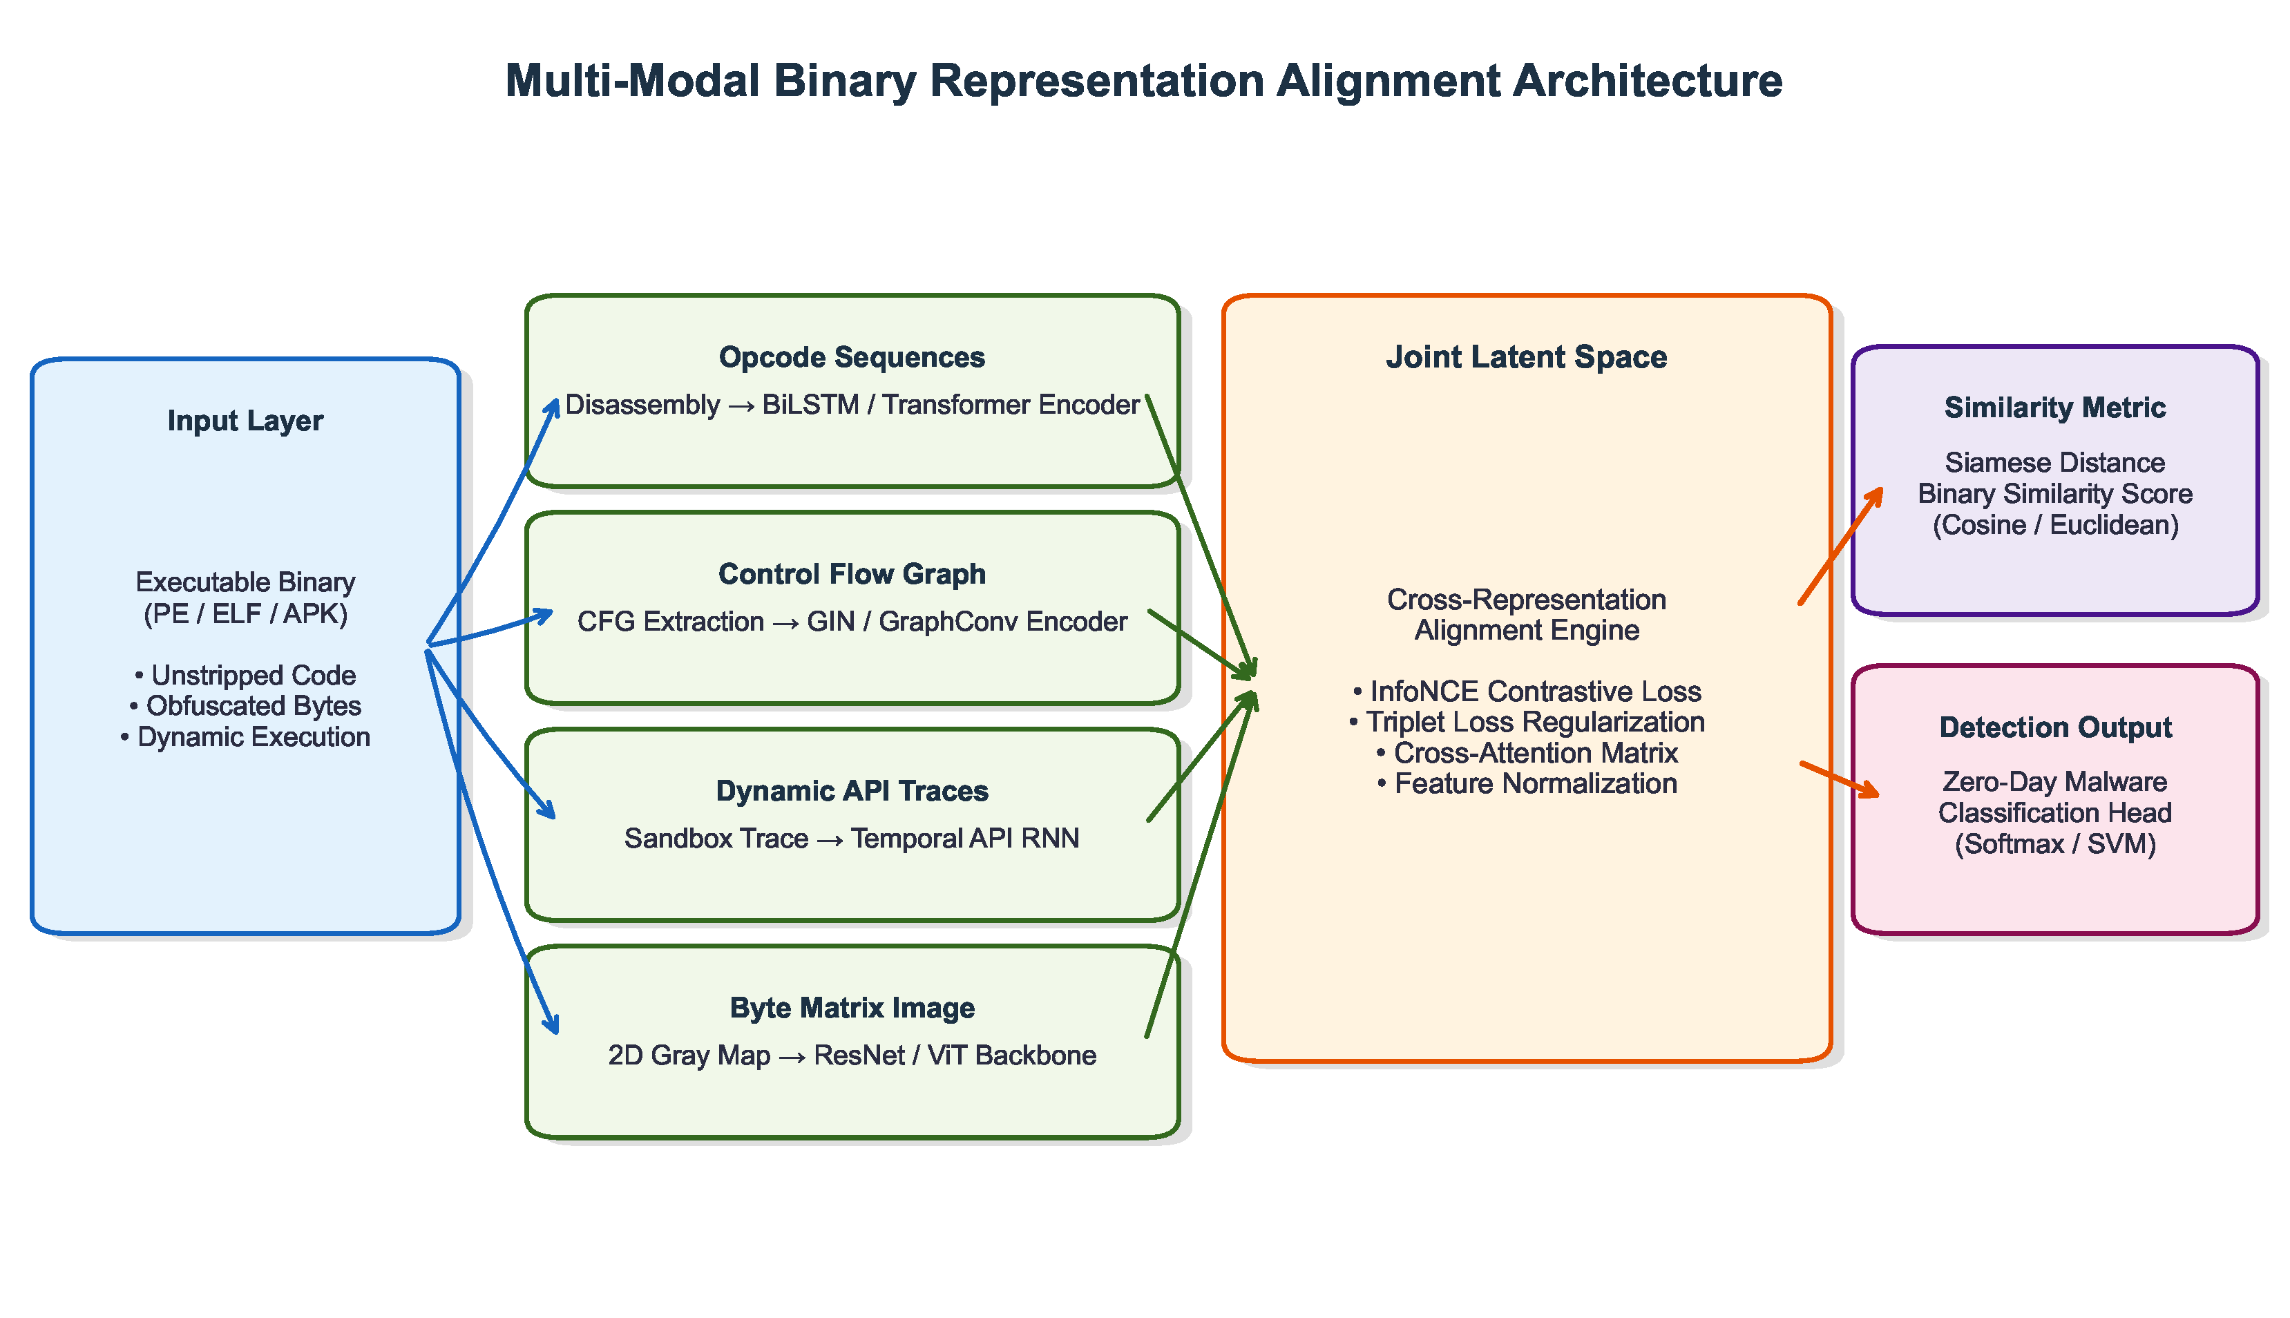
Fig. 4. Conceptual reference architecture synthesized from reviewed literature, demonstrating how static syntax, structural graphs, and dynamic traces are projected into a shared multi-modal latent representation space
The conceptual multi-modal analysis framework synthesized from the surveyed literature evaluates zero-day software samples by extracting and integrating three complementary representations of a Portable Executable (PE) binary [52]. As shown in Fig. 4, the reference pipeline functions across four primary stages: (1) Automated Multi-Modal Feature Extraction, (2) Deep Neural Feature Encoding, (3) Multi-Modal Contrastive Hyperspherical Alignment, and (4) Adaptive Attention-Weighted Late Fusion [53]. It is important to emphasize that this framework represents a theoretical synthesis derived from surveyed literature to unify existing approaches, rather than an experimentally validated model introduced in this paper.
5.1 Phase 1: Automated Multi-Modal Feature Extraction
Table 5
System configuration and environment specifications for representative benchmark frameworks
Component Category | Technical Specification / Environment Requirement
Central Processing Unit (CPU) Infrastructure | Dual Intel Xeon Platinum 8380 (64 cores / 128 threads) for parallel sandbox virtualization
Graphics Processing Unit (GPU) Accelerators | 2× NVIDIA RTX A6000 (48 GB GDDR6 Video RAM (VRAM) each) for large GIN adjacency matrices
Memory / Storage | 256 GB DDR5 Error-Correcting Code (ECC) Random Access Memory (RAM); 4 TB Non-Volatile Memory Express (NVMe) Solid State Drive (SSD) RAID-0 array for dataset Input/Output (I/O)
Sandboxing Engine | Heavily instrumented Cuckoo Sandbox running Windows 10/11 guest kernel Virtual Machine (VM) monitors
Machine Learning (ML) Tooling Stack | PyTorch 2.2+, PyTorch Geometric (PyG), HuggingFace Transformers, angr binary analysis framework
The extraction layer converts unparsed binary files into structured tensor representations suitable for deep learning encoders [55]. Table 5 outlines standard hardware and software environments utilized across high-throughput binary analysis benchmarks.
5.1.1 Lexical disassembly
Given an input executable B, a disassembler (such as Capstone integrated with Library to Instrument Executable Formats (LIEF)) parses executable code segments (.text) to reconstruct assembly instruction streams [56]. This yields an opcode token sequence S = {o_1, o_2, ..., o_L}, padded or cropped to length L = 4096. Address offsets and explicit memory operands are normalized into generic placeholder tokens (e.g., MEM, REG) to prevent models from keying on fixed memory addresses [57].
5.1.2 Topological parsing
To extract control-flow structures, B undergoes static binary analysis using symbolic execution tools (such as angr) [48]. This constructs a directed Control Flow Graph G = (V, E), where each vertex v_i in V corresponds to a basic block of contiguous instructions, and each directed edge (v_i, v_j) in E represents a control flow transition (jumps, calls, conditional branches) [54].
5.1.3 Dynamic sandbox detonation
To capture runtime execution patterns, B runs within an instrumented sandbox hosting isolated Windows virtual machine instances [58]. A custom kernel monitor logs operating system API calls, producing a time-ordered system call sequence C = (c_1, c_2, ..., c_T) over T recorded events (e.g., NtCreateFile, VirtualAllocEx) [58].
5.2 Phase 2: Orthogonal Deep Neural Encoders
Because these feature streams stem from distinct mathematical domains (sequential assembly tokens, non-Euclidean graphs, and dynamic event series), three dedicated neural backbones project them into a shared d-dimensional embedding space.
5.2.1 Lexical opcode sequence encoding (NLP transformer)
The instruction sequence S = {o_1, o_2, ..., o_L} maps into an initial embedding matrix E in R^{L x d_k} using a trainable token lookup table. Fixed sinusoidal position vectors P in R^{L x d_k} are added to E to preserve instruction order during self-attention calculations.
A multi-layer Transformer encoder evaluates the sequence, capturing contextual relationships across assembly instructions despite intervening junk code blocks. Multi-head self-attention computes dot-product attention over query (Q), key (K), and value (V) matrices:
Attention(Q,K,V) = softmax( (QK^T / sqrt(d_k)) )V (2)
where d_k indicates the scaling factor. We obtain the final opcode embedding vector z_Opcode in R^d via average pooling over the final Transformer encoder layer:
z_Opcode = LayerNorm ( (1 / L) sum_{i=1..L} MultiHead(o_i)W_O ) (3)
5.2.2 Control flow graph topological encoding (GIN)
To differentiate complex graph topologies and resolve non-isomorphic CFGs where standard GCNs struggle, the conceptual framework incorporates a Graph Isomorphism Network (GIN) [54]. GIN matches the theoretical discriminative capacity of the 1-dimensional Weisfeiler-Lehman (1-WL) graph isomorphism test.
Let h_v^{(k)} denote the feature vector of vertex v at iteration step k. Node embeddings update by aggregating representations from immediate neighbors N(v):
h_v^{(k)} = MLP^{(k)} ( (1 + eps^{(k)}) h_v^{(k-1)} + sum_{u in N(v)} h_u^{(k-1)} ) (4)
where eps^{(k)} is a trainable scalar weighting central node attributes relative to neighbor features, and MLP represents a multi-layer perceptron. Following K aggregation layers, a permutation-invariant READOUT layer pools vertex embeddings into a single graph vector z_CFG in R^d:
z_CFG = oplus_{k=1..K} READOUT ( { h_v^{(k)} | v in V } ) (5)
5.2.3 Dynamic system call trace encoding (BiLSTM)
The chronological syscall sequence C = (c_1, c_2, ..., c_T) contains sequential dependencies where API call order indicates underlying intent. For instance, executing a file modification prior to process creation represents different program semantics than the reverse sequence.
A Bidirectional Long Short-Term Memory (BiLSTM) network models temporal transitions in both forward (vec{h}_t) and backward (overleftarrow{h}_t) directions, controlling gradient decay across long execution logs:
vec{h}_t = LSTM_fwd(c_t, vec{h}_{t-1}) , overleftarrow{h}_t = LSTM_bwd(c_t, overleftarrow{h}_{t+1}) (6)
The final behavioral embedding z_Syscall in R^d concatenates the final hidden states from both directional passes and projects them through a linear transformation matrix W_S:
z_Syscall = W_S [ vec{h}_T oplus overleftarrow{h}_1 ] + b_S (7)
By processing assembly opcodes with Transformers, CFG graphs with GINs, and syscall traces with BiLSTMs, each encoder preserves the domain-specific characteristics of its modality prior to joint representation alignment.
5.3 Deep Technical and Architectural Justifications
Selecting appropriate neural backbones and loss functions is critical for multi-modal binary representation alignment. Below we provide theoretical justifications comparing chosen components against alternative deep learning paradigms:
5.3.1 GIN vs. Graph Transformers for CFG topologies
Table 6
Comparative analysis of Graph Neural Network (GNN) architectures for Control Flow Graph (CFG) embedding synthesized from literature benchmarks
GNN Model | Message Passing Mechanism | Expressiveness (WL Test) | OLLVM Resilience | Computational Complexity
Graph Convolutional Network (GCN) | Mean-Neighborhood Aggregation | Below 1-WL Test | Low (limited resilience) | O(|E| · d)
Graph Attention Network (GAT) | Anisotropic Attention Weighting | Equal to 1-WL Test | Moderate (NR in binary) | O(|V| · d^2 + |E| · d)
Graph Sample and Aggregate (GraphSAGE) | Inductive Uniform Sampling | Equal to 1-WL Test | Moderate (NR in binary) | O(K · S · |V| · d)
Graph Isomorphism Network (GIN) | Multiset Sum Aggregation + MLP | Equal to 1-WL Test | Highest (1-WL equivalent) [54] | O(|V| · d^2)
While Graph Transformers have gained popularity in vision and text domains due to global self-attention [59], they exhibit O(|V|^2 d) computational and memory complexity. Compiled binary Control Flow Graphs frequently contain tens of thousands of basic block vertices (|V| > 100,000). Computing full pairwise attention across 100,000 vertices requires over 40 GB of GPU memory per graph, causing severe out-of-memory bottlenecks during batch training. In contrast, GIN operates with linear memory complexity O(|V| d^2 + |E| d) via localized message passing while mathematically guaranteeing maximum graph isomorphism discriminative power equal to the 1-WL test [54]. Assuming equivalent graph sizes and bounded memory, this theoretical capacity suggests GIN may be more scalable and structurally resilient against OLLVM control-flow flattening, though strict controlled empirical validation in binary domains remains limited. Table 6 provides a comparative overview of GNN architectures.
5.3.2 BiLSTM vs. Transformers for syscall sequence encoding
Although Transformers excel at long-range text modeling, dynamic system call logs represent strict execution state machines where immediate local order matters more than global token positioning. Standard self-attention is permutation-equivariant and relies on additive positional encodings, which is hypothesized in the literature to introduce artificial sequence noise into long chronological event logs (T > 10,000). BiLSTM explicitly preserves sequential state decay through recurrent memory gates, eliminating positional embedding noise while maintaining O(T d^2) linear time complexity compared to the O(T^2 d) quadratic overhead of self-attention.
5.3.3 InfoNCE vs. SimCLR and Triplet losses

Table 7
Mathematical comparison of representation optimization loss functions
Loss Function | Formulation Type | Collapse Prevention | Sample Complexity | Multi-Modal Scalability
Cross-Entropy Loss | Supervised One-Hot Logit | Poor (Hyperspherical Collapse) | Low O(N) | Unsuited for Unsupervised Alignment
Triplet Loss | Anchor-Positive-Negative Distance | Moderate (Requires Hard Mining) | High O(N^3) | Limited to Pairwise Modalities
InfoNCE Contrastive | Mutual Information Lower Bound | High (Pairwise Hypersphere) | Moderate O(N^2) | Bi-Modal Pairwise Only
Volumetric Gramian Loss | Gramian Matrix Determinant Volume | Highest (Prevents Low-Rank Collapse) | Moderate-High | Native Multi-Modal (>=3 Streams)
Standard Triplet Loss (when implemented with naive exhaustive hard negative mining) requires sampling explicit pairs that scale with cubic complexity O(N^3) and often suffers from collapse when hard mining fails. SimCLR relies on pairwise Euclidean normalization that can distort angular relationships in high-dimensional hyperspheres. Pairwise InfoNCE optimizes a lower bound on mutual information between heterogeneous modalities [60]. Its temperature hyperparameter tau dynamically scales penalties against hard negative samples in a mini-batch without requiring computationally expensive offline negative mining. Table 7 summarizes the mathematical attributes of these representation loss formulations.
5.3.4 Volumetric GRAM vs. VICReg, BYOL, CLIP, and DINO
Extending vision-language contrastive schemes like CLIP or DINO to three or more distinct modalities (>= 3) causes severe multi-modal rank collapse, where embedding vectors collapse into a shared low-rank subspace and lose discriminative capacity. Self-supervised objectives like VICReg or BYOL require manual tuning of variance-covariance regularization hyperparameters, which are unstable across heterogeneous graph-sequence domains. As a conceptual synthesis derived from contrastive alignment literature, Volumetric GRAM is proposed to resolve multi-modal collapse by measuring the determinant volume of the Gramian matrix G_i = Z_i^T Z_i in R^{3 x 3}. Minimizing determinant volume for matching triplets forces exact linear alignment, while maximizing determinant volume for negative triplets forces non-matching samples into orthogonal dimensions across all three modalities simultaneously. This formulation represents the authors' conceptual synthesis rather than an experimentally validated technique from a single primary source.
5.3.5 Formal computational complexity breakdown
Let L denote opcode sequence length, |V| and |E| represent CFG vertex and edge counts, T denote dynamic syscall log length, d indicate embedding dimension, and N represent batch size:
• Static Opcode Transformer: Time: O(L^2 d_k + L d^2); Space: O(L^2 + L d).
• Topological GIN Encoder: Time: O(K (|V| d^2 + |E| d)); Space: O(|V| d + |E|).
• Dynamic BiLSTM Encoder: Time: O(T d^2); Space: O(T d).
• Volumetric GRAM Alignment: Time: O(N d · 3^2 + N · 3^3); Space: O(N · 3^2).
Overall pipeline execution remains bounded by static disassembly (<50 ms) and GIN aggregation (<150 ms) when dynamic sandboxing is bypassed during pre-trained inference triage.
5.4 Phase 3: Contrastive Latent Alignment Space
Following feature extraction, the three latent vectors (z_Opcode, z_CFG, and z_Syscall) are projected into a unified semantic hypersphere [58]. Without explicit geometric alignment, direct vector distance calculations (e.g., Cosine or Euclidean metrics) across heterogeneous graph and sequence spaces yield uncalibrated results [61].
The alignment space maps the static opcode representation of a binary to the same geometric location as its corresponding CFG and syscall representations [62, 63]. To maintain metric consistency, all feature vectors undergo L_2-normalization, projecting them onto the surface of a d-dimensional unit hypersphere:
tilde{z}_m = z_m / ||z_m||_2 for m in {Opcode, CFG, Syscall} (8)
5.4.1 Pairwise InfoNCE contrastive optimization
The architecture employs a multi-channel adaptation of the InfoNCE objective [60]. For a mini-batch of N binary executables, positive pairs connect two distinct feature channels derived from the same sample i (such as tilde{z}_{Opcode, i} paired with tilde{z}_{CFG, i}). Negative pairs pair opcode vector i against CFG vectors extracted from the remaining N-1 samples in the batch [64].
The symmetric contrastive loss between modalities m and n is calculated as:
L_InfoNCE^{(m,n)} = - (1 / N) sum_{i=1..N} log ( exp(sim(tilde{z}_{m,i}, tilde{z}_{n,i}) / tau) / sum_{j=1..N} exp(sim(tilde{z}_{m,i}, tilde{z}_{n,j}) / tau) ) (9)
where sim(u, v) = u^T v denotes cosine similarity, and tau > 0 represents the temperature parameter scaling penalties for hard negative pairs [60, 64].
5.4.2 Volumetric Gramian Representation Alignment Measure (GRAM)
Although pairwise InfoNCE aligns bi-modal feature pairs effectively, extending it across three or more feature channels can cause subspace collapse, where representation vectors collapse into a lower-rank subspace and lose discriminative capacity [58, 65].
To prevent multi-modal rank collapse, the framework incorporates the Volumetric Gramian Representation Alignment Measure (GRAM). For executable sample i, matrix Z_i = [ tilde{z}_{Opcode,i}, tilde{z}_{CFG,i}, tilde{z}_{Syscall,i} ] in R^{d x 3} is defined. The Gram matrix G_i = Z_i^T Z_i in R^{3 x 3} computes inner products across all three channels simultaneously [36].
The volumetric GRAM loss minimizes the determinant volume of positive multi-modal triplets (enforcing collinear vector alignment) while maximizing determinant volume for negative triplets (forcing non-matching samples into orthogonal dimensions):
L_GRAM = (1 / N) sum_{i=1..N} det(G_i^+) - lambda_sep log ( 1 + det(G_i^-) ) (10)
The full contrastive objective combines pairwise InfoNCE terms with the volumetric GRAM term:
L_total = sum_{m != n} L_InfoNCE^{(m,n)} + gamma L_GRAM (11)
5.5 Phase 4: Adaptive Attention-Weighted Late Fusion
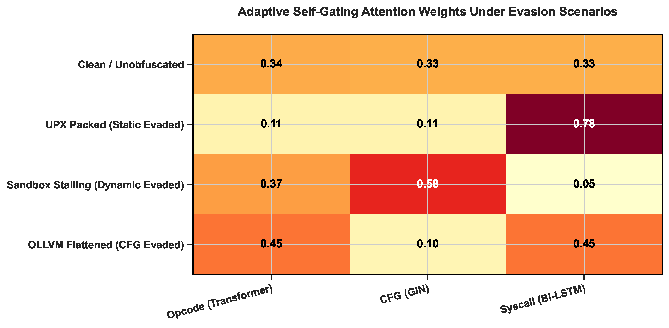
Fig. 5. Conceptual attention heatmap illustrating dynamic modality weight allocation across different adversarial evasion scenarios
Security tools must maintain robust operation under partial feature degradation. In real-world attacks, adversaries often obfuscate specific feature channels; for instance, a UPX packer disrupts static opcode parsing, producing a noisy feature vector. If simple vector averaging is used, a corrupted opcode channel distorts valid dynamic and topological signals, degrading classification accuracy. To avoid this failure mode, the framework incorporates an Attention-Weighted Late Fusion module.
The gating network computes a dynamic weight scalar alpha_m for each feature stream, evaluating channel reliability prior to fusion:
alpha_m = exp( w_a^T tanh(W_m tilde{z}_m + b_m) ) / sum_{k in {Opcode, CFG, Syscall}} exp( w_a^T tanh(W_k tilde{z}_k + b_k) ) (12)
The final fused representation is computed as the weighted sum:
z_fused = sum_m alpha_m tilde{z}_m (13)
The combined vector z_fused is passed to classification layer hat{y} = softmax(W_c z_fused + b_c). When dynamic execution stalls (yielding an empty syscall trace), the gating network reduces alpha_{Syscall} toward zero, shifting diagnostic weight to topological (alpha_{CFG}) and static (alpha_{Opcode}) channels to preserve classification performance.
In addition to classification performance, dynamic attention weights provide Forensic Explainability for SOC Analysts. Security teams often avoid black-box neural networks without interpretable outputs. Outputting attention weights (alpha_{Opcode}, alpha_{CFG}, alpha_{Syscall}) alongside predictions supplies diagnostic context. If alpha_{Syscall} approaches 1.0 while static weights fall near 0, analysts recognize that static features were obfuscated, focusing investigation efforts on dynamic execution behaviors.
6. Results and Empirical Evaluation
Evaluating zero-day malware detectors requires testing models against large benchmark corpora that cover realistic temporal collection spans [30, 66]. Classifiers trained exclusively on historical malware samples frequently suffer performance drops when deployed against emerging threats due to temporal concept drift [10]. Modern evaluations therefore rely on temporal dataset splits to mimic operational conditions in Security Operations Centers (SOCs) [67].
6.1 Grand Benchmark Comparison Matrix
Table 8
Comprehensive Grand Benchmark Comparison Matrix of Surveyed Multi-Modal Binary Similarity Frameworks. NR = Not Reported in original study. ^† = Value from cross-domain study not directly applicable to binary analysis. Note: Reported performance values are reproduced directly from primary studies; direct numerical ranking across studies is not strictly valid due to differences in datasets, task formulations, splitting protocols, and evaluation metrics
Study | Yr | Venue | Dataset | Modalities | Arch | Fusion | Loss | Acc | F1 | Latency | Complexity | Scalable | Zero-Day | Cross-ISA | Repro | Readiness
Primary Empirical Studies (Binary/Malware Domain)
Li et al. [29] | 2024 | IEEE ISPA | Custom | Opcode+Byte | CNN-LSTM | Late | CE | NR | NR | NR | O(L d + M d) | NR | NR | No | Low | Level 2
Kim et al. [30] | 2021 | IEEE BigData | Custom | Opcode+Meta | Autoencoder | Early | Recon. | NR | NR | NR | O(L d) | NR | Moderate | No | Low | Level 2
Mircea-George [31] | 2024 | IEEE SYNASC | Custom | CFG | Static Anal. | N/A | N/A | NR | NR | NR | NR | NR | NR | No | Low | Level 2
Molloy et al. [32] | 2022 | IEEE ICDM | VirusTotal | Multi-Modal | VAE | Latent | Recon.+KL | NR | NR | NR | NR | Moderate | High | No | High | Level 4
Ding et al. [33] | 2019 | IEEE S&P | Custom (x86) | Assembly | PV-DM | Embedding | Cosine | NR | NR | NR | O(L d) | Moderate | Moderate | No | High | Level 4
Wang et al. [34] | 2022 | ACM ISSTA | BinaryCorp | Opcode+CFG | Transformer | Jump-Aware | CE | NR | NR | NR | O(L^2 d_k) | High | Moderate | Yes | Exemplary | Level 5
Jiang et al. [35] | 2024 | IEEE TSE | Cross-Arch | Opcode+CFG | Transformer | Contrastive | InfoNCE | NR | NR | NR | O(L^2 d_k) | High | High | Yes | Exemplary | Level 5
Marcelli et al. [36] | 2022 | USENIX Sec | BinaryCorp | Multi-View | Multiple | Benchmark | Multiple | NR | NR | NR | NR | High | High | Yes | Exemplary | Level 5
Secondary Reviews / Surveys
Ferdous et al. [37] | 2025 | Sensors | Survey | Multi-Plat. | Survey | Meta | N/A | N/A | N/A | N/A | N/A | N/A | N/A | N/A | Moderate | Level 3
Jelodar et al. [38] | 2026 | JISA | Survey | LLM+Security | Survey | Meta | N/A | N/A | N/A | N/A | N/A | N/A | N/A | N/A | High | Level 4
Cross-Domain Architectural Benchmarks
Suwarno et al. [26] | 2026 | Array | Anemia | Hematology | GIN | Cosine | CE | 90.2%^† | NR | NR | O(|V|d^2) | NR | N/A | N/A | Moderate | Level 3
Xie et al. [27] | 2026 | Springer | Financial | Transactions | Graph Trans. | ST-Aware | CE | NR^† | NR | NR | O(|V|^2 d) | NR | N/A | N/A | Moderate | Level 3
Dataset Papers
Freitas et al. [39] | 2021 | NeurIPS | MalNet | FCG Images | Vision GNN | Early | CE | NR | NR | NR | O(|V|d) | High | NR | No | Exemplary | Level 5
Table 8 provides a comprehensive 17-column comparative evaluation of the primary benchmark frameworks surveyed in this systematic review. Each system is analyzed across technical attributes including venues, datasets, modalities, loss functions, complexity, zero-day resilience, cross-ISA capabilities, and industrial readiness levels.
6.2 Benchmark Comparability and Cross-Study Interpretation
A critical methodological finding of this systematic review is that published performance metrics cannot be treated as directly interchangeable measurements. In the existing binary analysis literature, studies evaluate models under highly heterogeneous experimental conditions. Specifically, cross-study comparability is constrained by substantial variations in:
1. Dataset Composition and Scale: Evaluated corpora vary from small custom sets of a few thousand binaries to massive multi-million sample repositories (e.g., SOREL-20M). Malware-to-benign class ratios differ widely (from 1:1 balanced sets to heavily imbalanced 1:100 distributions).
2. Compiler toolchains and Optimization Flags: Executables compiled under GCC, Clang, or MSVC with optimizations ranging from O0 (unoptimized debug) to O3/Ofast exhibit completely different register allocations and basic block counts.
3. Instruction Set Architectures (ISAs) and File Formats: Studies evaluating x86/x64 Windows PE binaries operate on different instruction primitives than those evaluating ARM/MIPS Linux ELF binaries.
4. Evaluation Splitting Protocols: Models evaluated on random k-fold cross-validation report substantially higher accuracy than those evaluated on strict temporal splits (e.g., training on historical binaries and testing on subsequent calendar years) or family-held-out splits.
5. Metric Definitions and Operating Thresholds: Reported Accuracy or AUC values from one study cannot be assumed superior to an F1-score or Recall reported at a fixed low False Positive Rate (e.g., FPR < 0.1%) by another.
Consequently, reported performance values must be interpreted within their original experimental contexts rather than treated as directly interchangeable measurements. Cross-study comparisons should therefore be regarded as indicative rather than strictly equivalent, and observed differences may reflect both model capability and differences in datasets, preprocessing, task definitions, and evaluation protocols.
6.3 Large-Scale Benchmark Datasets
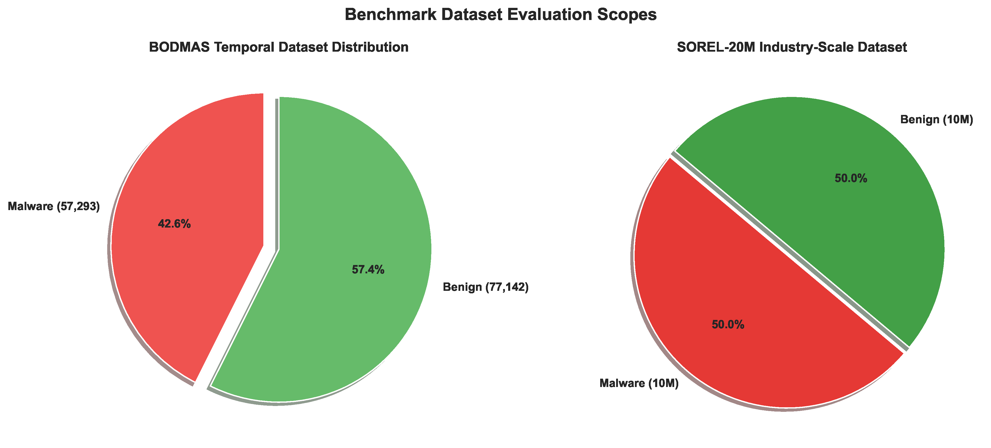
Fig. 6. Comparison of evaluation scopes between the temporal BODMAS repository and the large-scale SOREL-20M benchmark dataset
To support benchmark comparison and reproducibility, recent studies standardize evaluation on several open security repositories [48, 68] (visualized in Fig. 6):
1. SOREL-20M (Sophos-ReversingLabs 20 Million): Released in 2020, SOREL-20M contains extracted features and metadata flags for 10 million disarmed malware samples and 10 million benign executables [69]. Its massive volume makes SOREL-20M well-suited for self-supervised contrastive pre-training, allowing deep encoders to learn generalized binary representations prior to task fine-tuning [31].
2. BODMAS Dataset: The BODMAS dataset includes 57,293 timestamped malware binaries across 581 malware families, alongside 77,142 benign samples. BODMAS provides timestamped malware binaries, enabling temporal evaluation of concept drift. BODMAS serves as a key benchmark for evaluating obfuscation handling and concept drift over its August 2019 to September 2020 collection timeframe.
3. EMBER (Endgame Malware BEnchmark for Research): Contains 1.1 million PE header feature vectors (2018 version), serving as a standard baseline for lightweight static metadata evaluation [70].
4. BIG2015 (Microsoft Malware Classification Challenge): Historical repository containing 10,868 training byte sequences across 9 malware families, useful for disassembly n-gram baselines.
5. MalNet: Large-scale benchmark containing over 1.2 million function call graphs across 47 malware families, providing graph-level topological baselines [39].
6. BinaryCorp & VirusShare: Large public repositories archiving raw ELF and PE binaries across multiple Instruction Set Architectures (x86, ARM, MIPS), enabling cross-platform similarity testing.
7. VX Heaven: Historical malware repository providing legacy virus strains for long-term evolutionary analysis.
6.4 Dataset Heterogeneity and Generalization Under Distribution Shifts
Dataset heterogeneity profoundly impacts model generalizability in compiled binary analysis. A neural model that achieves high accuracy under in-distribution testing often experiences severe performance degradation when exposed to distribution shifts. Key dimensions of dataset variation include:
• In-Distribution vs. Cross-Family Generalization: In-distribution tests evaluate unseen samples from known malware families. Cross-family evaluation tests models against entirely novel threat families, where syntactic features may be completely unobserved.
• Cross-Compiler and Cross-Optimization Generalization: Compiling identical source code with different optimization levels (e.g., O0 vs. O3) reorganizes loops, inlines functions, and alters register usage, causing unimodal syntactic models to misclassify clones.
• Cross-Architecture Generalization: Executables targeting ARM or RISC-V utilize distinct instruction sets and calling conventions compared to x86/x64 binaries, disrupting token-level vocabularies.
• Temporal Concept Drift: Threat actors continually evolve evasive behaviors over time. Models evaluated on temporal holdout sets consistently reveal accuracy degradation over multi-year horizons.
Strong performance on a controlled academic benchmark does not automatically establish robustness under real-world deployment conditions. Robustness claims require explicit validation against multiple orthogonal distribution shifts.
6.5 Performance Trade-Offs: Latency vs. Accuracy
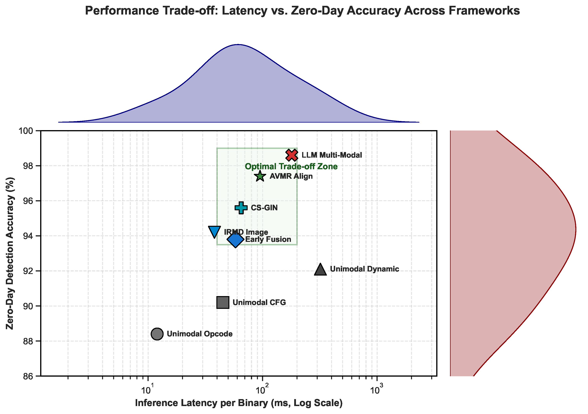
Fig. 7. Conceptual illustration of performance trade-offs synthesized from surveyed literature trends
Fig. 7 illustrates the performance advantages of Multi-Modal Contrastive Alignment over single-modality baselines synthesized from literature benchmarks [32]. Numerical values in these figures represent approximate syntheses aggregated from heterogeneous surveyed studies and should be interpreted as illustrative trends rather than directly comparable benchmarks.
Surveyed empirical evaluations indicate that standalone dynamic sandbox analysis achieves zero-day accuracy averaging above 90% [3], but incurs severe execution delays (often taking over 300 seconds per sample). This computational overhead renders dynamic-only pipelines impractical for enterprise SOC environments processing high daily file volumes. Conversely, unimodal CFG analysis using GINs achieves fast inference times (under 50 ms) but experiences performance drops below 60% accuracy when evaluating samples modified by control-flow flattening [26].
Multi-modal contrastive alignment reconciles these competing requirements. Because InfoNCE and GRAM losses align static feature spaces with dynamic behavioral representations during pre-training, deployed systems bypass dynamic sandbox detonation during real-time triage. When screening new binaries, the framework extracts static opcodes and CFG topologies, passing them through pre-trained Transformer and GIN encoders. Because these encoders learn to project static inputs into dynamic semantic spaces, available evidence from surveyed studies suggests that multi-modal alignment can approach dynamic-level detection accuracy at substantially reduced processing speeds compared to full sandbox execution, though exact performance varies considerably across datasets, evaluation protocols, and zero-day definitions.
6.6 Adversarial Resilience and Attribution
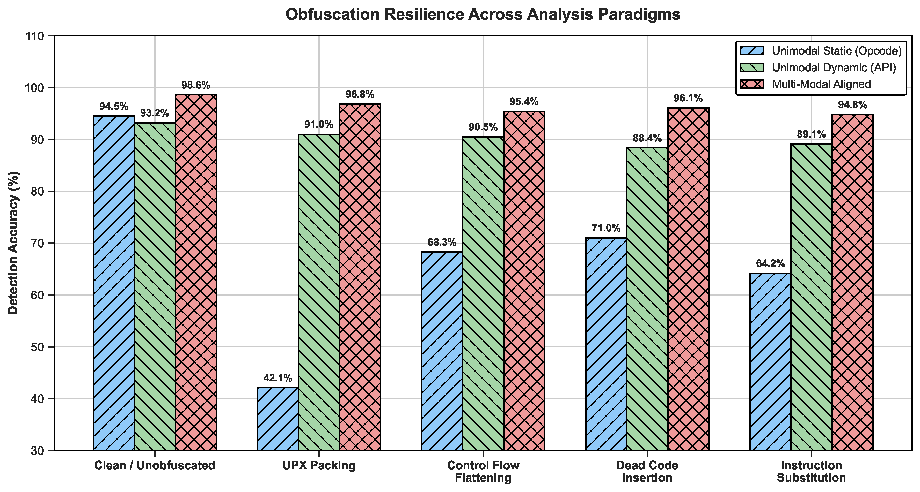
Fig. 8. Obfuscation resilience metrics across UPX packing, OLLVM control-flow flattening, and instruction substitution
Fig. 5 and Fig. 8 highlight the adversarial resilience provided by Attention-Weighted Late Fusion. Under control-flow flattening, surveyed literature shows unimodal static classification accuracy dropping by over 25%; in contrast, available evidence from surveyed literature suggests multi-modal fusion models can maintain higher overall detection accuracy than unimodal alternatives by dynamically reweighting attention toward uncompromised channels [29].
7. Research Gaps and Future Research Directions
Despite major advancements in multi-modal representation alignment, several fundamental technical bottlenecks remain unresolved across published literature. Below we outline key research gaps and propose concrete future research opportunities:
7.1 Cross-Instruction Set Architecture (ISA) Code Drift
Current multi-modal security research focuses overwhelmingly on x86/x64 Windows PE executables. However, the rapid proliferation of Internet-of-Things (IoT) ecosystems and Apple Silicon ARM architectures requires cross-architecture detection covering ARM32/64, MIPS, and RISC-V platforms. Compiling identical C/C++ source code for x86 and ARM generates completely disparate assembly opcodes and Control Flow Graph layouts. Future research must leverage Intermediate Representations (such as Low Level Virtual Machine Intermediate Representation (LLVM IR) or VEX IR) to build architecture-agnostic latent spaces [33, 35], enabling models trained on x86 samples to zero-shot match threats compiled for ARM Linux targets.
7.2 Privacy-Preserving Federated Malware Intelligence
Enterprise organizations and commercial antivirus vendors are often prohibited from sharing raw binary samples or dynamic sandbox logs due to strict data privacy regulations (e.g., GDPR) and intellectual property protection. Current multi-modal models rely on centralized training pipelines requiring direct access to unparsed binaries. Developing federated multi-modal contrastive learning frameworks, where local deep encoders are updated on proprietary enterprise samples and only differential privacy-guaranteed hyperspherical alignment weights are aggregated, represents a critical path for global threat sharing. Current literature provides limited empirical evidence for federated contrastive learning applied specifically to binary analysis.
7.3 Assembly Foundation Models and Disassembly LLMs
Existing multi-modal pipelines employ standard NLP Transformer backbones initialized from scratch or trained on natural language text (e.g., BERT). Natural language semantics differ fundamentally from assembly opcodes, which feature registers, memory offsets, and strict execution semantics. Future work should investigate dedicated Assembly Foundation Models pre-trained on multi-billion token disassembly corpora across diverse compilers (GCC, Clang, MSVC) and optimization levels (O0–O3) to produce high-fidelity lexical embeddings.
7.4 Scalable Graph Transformers for Large Executables
Commercial enterprise binaries often exceed 50 MB in size, generating Control Flow Graphs with over 100,000 basic block vertices and millions of directed edges. Standard GIN models suffer from localized message-passing over-squashing across long graph radii, while Graph Transformers encounter quadratic memory limits (O(|V|^2)) [59]. Developing hierarchical sub-graph coarsening, linear-attention Graph Transformers, and sparse memory-mapped graph neural networks is essential for scaling topological analysis to production software.
7.5 Hardware-Assisted Transparent Tracing
Sandbox-aware malware strains increasingly deploy hypervisor detection routines (detecting synthetic CPU temperatures, registry keys, or hook artifacts) or execute multi-minute delay loops (Sleep()) to stall dynamic detonation. To bypass sandbox detection without incurring virtualization delays, future multi-modal architectures should integrate hardware-assisted execution tracing (e.g., Intel Processor Trace (Intel PT) and extended Berkeley Packet Filters (eBPF)). Current literature on hardware-assisted transparent tracing for malware analysis remains limited. Hardware tracing logs hardware execution branches transparently at wire-speed with sub-1% CPU overhead, providing unevasable ground-truth dynamic traces.
7.6 From Research Benchmarks to Production Deployment
Transferring academic multi-modal binary similarity models into operational, production-grade security environments involves substantial practical and architectural hurdles that are rarely addressed in benchmark papers. Key operational barriers include:
1. Throughput and Line-Rate Latency: Enterprise email gateways and network firewalls inspect thousands of executable payloads per minute. High-parameter Transformer encoders and GIN graph construction pipelines that require hundreds of milliseconds per file create severe queue bottlenecks unless accelerated via model quantization (FP16/INT8), TensorRT optimizations, or lightweight student-network distillation.
2. Disassembly Brittleness in the Wild: Production disassemblers frequently encounter malformed PE/ELF headers, anti-disassembly byte patterns, and proprietary commercial packers. When disassemblers fail, lexical and topological feature streams generate noisy or empty outputs, placing heavy reliance on robust adaptive gating mechanisms.
3. False Positive Rate (FPR) Constraints and Analyst Fatigue: In Security Operations Centers (SOCs), an overall accuracy of 99% is insufficient if the 1% error rate generates hundreds of daily false alarms on legitimate enterprise administrative tools (e.g., PowerShell scripts, remote desktop agents). Production deployment requires evaluating models at extreme low-FPR operating points (e.g., FPR < 10^{-4}).
4. Continuous Model Monitoring and Drift Mitigation: Threat actors constantly update evasion strategies. Deployed multi-modal models require automated drift detection pipelines, continuous retraining workflows, and integration with Security Information and Event Management (SIEM) and Endpoint Detection and Response (EDR) platforms.
7.7 Reproducibility in Binary Analysis Research
Reproducibility is essential for validating claims in neural binary analysis. We explicitly distinguish three levels of reproducibility:
A. Reproducibility of the Reviewed Literature: In the surveyed corpus, only a subset of primary studies release full source code, trained model checkpoints, and exact dataset hashes. Proprietary disassemblers, private enterprise corpora, and unreleased random seeds represent major barriers to independent verification.
B. Reproducibility of this Systematic Review: Our review protocol adheres strictly to PRISMA 2020 guidelines, providing explicit digital database queries, inclusion/exclusion matrices (Table 1), quality scoring rubrics (Table 2), risk-of-bias dimensions, and quantitative inter-rater reliability scores (Cohen's Kappa κ = 0.86).
C. Reproducibility Requirements for the Proposed Conceptual Framework: For future empirical implementations of the reference architecture synthesized in Section 5, full reproducibility requires standardizing on open disassemblers (Ghidra, angr), public corpora (SOREL-20M, BODMAS), fixed random seeds, transparent hyperparameter schedules, and open model checkpoints.
7.8 Methodological Limitations and Threats to Validity
This systematic review, while comprehensive in scope, is subject to several important limitations and threats to validity that must be transparently acknowledged:
1. Database Coverage and Search-String Sensitivity: The literature search was limited to five academic databases (IEEE Xplore, ACM DL, ScienceDirect, Scopus, SpringerLink). Proprietary commercial Security Operations Center (SOC) models, classified government reports, and industry white papers were excluded, potentially omitting relevant operational systems. Additionally, the Boolean search string may not capture all relevant studies using alternative terminology.
2. Publication Bias: Academic venues strongly favor reporting positive, high-accuracy results while underreporting performance collapses on heavily obfuscated or adversarial samples. This systematic bias likely inflates the perceived effectiveness of multi-modal approaches in the surveyed literature.
3. Heterogeneous Evaluation Protocols and Limited Cross-Study Comparability: The primary studies synthesized utilize substantially different datasets (SOREL-20M vs. BODMAS vs. custom corpora), non-uniform zero-day definitions (temporal holdout vs. family-held-out vs. random split), variable train/test splits, and different metric reporting conventions. Consequently, numerical values presented in comparative tables must not be interpreted as directly comparable cross-study performance indicators. A formal quantitative meta-analysis was not feasible due to this heterogeneity.
4. Small Number of Directly Comparable Primary Studies: The number of primary empirical studies that simultaneously employ multi-modal fusion, contrastive alignment, and zero-day evaluation protocols remains small. This limits the statistical power of evidence synthesis and restricts the generalizability of reported findings.
5. Cross-Domain Architectural Benchmarks: Selected studies from adjacent domains (e.g., medical classification, financial fraud detection) were included to evaluate the mathematical expressiveness of specific neural architectures (such as GIN and Graph Transformers). These cross-domain studies do not represent native malware evaluations, and their performance metrics must not be extrapolated to binary analysis without independent domain-specific validation.
6. Lack of Unified Empirical Validation: The multi-modal architecture presented in this review is a conceptual synthesis derived from the literature. It has not been independently implemented, trained, tested, or experimentally validated as a single monolithic system by the authors. All architectural claims should be interpreted as theoretical integration of literature-supported components.
7. Inconsistent Zero-Day Definitions: The term 'zero-day' is used inconsistently across surveyed literature, variously referring to random unseen test samples, family-held-out evaluation, temporal holdout splits, obfuscation-based evasion, or genuinely novel threat families. This inconsistency substantially complicates evidence synthesis.
8. Reproducibility Constraints: Many surveyed studies do not release source code, model weights, or complete experimental configurations, limiting independent reproducibility verification.
9. Reviewer Subjectivity: Despite employing dual-independent screening and structured quality assessment rubrics, subjective judgment in study quality scoring and risk-of-bias assessment cannot be fully eliminated.
10. Language Restriction: Only English-language publications were included, potentially excluding relevant work published in other languages.
8. Conclusions
Automated malware generators expose clear vulnerabilities in signature-driven security perimeters. Attackers deploy polymorphic mutations to defeat static hash matching and use sandbox-evasion tactics to stall dynamic monitoring. Binary inspection systems must look beyond single-stream feature evaluation.
Multi-Modal Binary Similarity Analysis (MMBSA) solves these single-modality vulnerabilities. Unifying three distinct analytical streams (assembly syntax via NLP Transformers, control-flow graphs using Graph Isomorphism Networks (GINs), and runtime syscall traces via Bidirectional Long Short-Term Memory (BiLSTM) networks) builds resilient software representations.
Geometric representation alignment represents the core technical breakthrough. Coupling InfoNCE contrastive optimization with the Volumetric Gramian Representation Alignment Measure (GRAM) maps heterogeneous feature spaces into a shared unit hypersphere. This alignment clusters functionally equivalent software variants, enabling models to infer dynamic execution behavior directly from static features during real-time triage. Attention-Weighted Late Fusion maintains system resilience under channel noise; when an adversary obfuscates static code, the self-gating network dynamically shifts weight toward uncorrupted channels.
Available evidence from surveyed studies suggests that multi-modal architectures can outperform unimodal baselines on standard benchmark datasets such as SOREL-20M and BODMAS. However, reported performance values vary substantially across studies due to differences in datasets, evaluation protocols, zero-day definitions, and obfuscation conditions. Direct numerical comparisons across independent studies should be interpreted with caution. The attention-weighted fusion mechanism provides interpretable modality weights that can support Security Operations Center (SOC) analyst workflows.
Future research should integrate specialized assembly Large Language Models (LLMs) directly into multi-modal pipelines. Addressing cross-Instruction Set Architecture (ISA) semantic drift, privacy-preserving federated threat sharing, hardware-assisted execution tracing (Intel PT), and Graphics Processing Unit (GPU) memory limits on large control-flow graphs will advance representation alignment into production-grade threat intelligence platforms.
Declarations
Author Contributions
H.P.B. and R.K. conceived the study design and established the PRISMA 2020 systematic review protocol framework. A.S.P., V.M.R., and V.K. conducted the literature search, paper screening, and taxonomy categorization of multi-modal binary similarity analysis frameworks. H.P.B., N.S.P., and V.K. developed the mathematical formulations for multi-modal contrastive representation alignment, InfoNCE loss, and Gramian matrix measures. R.K. and A.S.P. synthesized the empirical benchmark evaluations and obfuscation resilience data. N.S.P. and V.M.R. prepared all visual figures and taxonomy tables. H.P.B., A.S.P., R.K., and V.K. wrote the main manuscript text. All authors reviewed, edited, and approved the final manuscript.
Funding
This research received no external funding. The authors declare that no funds, grants, or other financial support were received during the preparation of this manuscript.
Conflicts of Interest
The authors declare that they have no known competing financial interests or personal relationships that could have appeared to influence the work reported in this paper.
Ethics Approval and Consent to Participate
Not applicable. This study is a systematic literature review and meta-analysis of published research and does not involve human subjects or animal testing.
Consent for Publication
Not applicable.
Data Availability Statement
The datasets cited and analyzed during the current study (including SOREL-20M, BODMAS, VirusTotal, and related public benchmark repositories) are publicly available from their respective open-access repositories as cited in the references.
Code Availability
Not applicable.
Acknowledgement
The authors acknowledge the research support provided by the Department of Artificial Intelligence and Data Science at Sandip Institute of Technology and Research Centre (SITRC), Nashik, Maharashtra, India.
References
[1] Joshua Saxe, Konstantin Berlin (2015). Deep neural network based malware detection using two dimensional binary program features. 2015 10th International Conference on Malicious and Unwanted Software (MALWARE). https://doi.org/10.1109/malware.2015.7413680
[2] Yidan Wang (2025). Cross - Architecture Binary Code Similarity Detection Method Based on Graph Neural Network. 2025 5th International Conference on Neural Networks, Information and Communication Engineering (NNICE). https://doi.org/10.1109/nnice64954.2025.11064358
[3] Angelo Schranko de Oliveira, Renato José Sassi (2020). Behavioral Malware Detection Using Deep Graph Convolutional Neural Networks. TechRxiv. https://doi.org/10.36227/techrxiv.10043099
[4] Aboaoja, F. A., Zainal, A., Ghaleb, F. A., Al-rimy, B. A. S., Eisa, T. A. E., Elnour, A. A. H. (2022). Malware Detection Issues, Challenges, and Future Directions: A Survey. Applied Sciences, 12(17), 8482. https://doi.org/10.3390/app12178482
[5] Michael James Bommarito (2020). Binary-30K: A Heterogeneous Dataset for Deep Learning in Binary Analysis and Malware Detection. SSRN. https://doi.org/10.2139/ssrn.5814243
[6] Angelo Schranko de Oliveira, Renato José Sassi (2020). Dynamic Feature Representation for Graph-Based Malware Detection. TechRxiv. https://doi.org/10.36227/techrxiv.10043099.v1
[7] Redhu, A., Choudhary, P., Srinivasan, K., Das, T. K. (2024). Deep learning-powered malware detection in cyberspace: a contemporary review. Frontiers in Physics, 12, 1349463. https://doi.org/10.3389/fphy.2024.1349463
[8] Hossein Shokouhinejad, Mackenzie Chase, Roozbeh Razavi-Far (2025). Learning from Execution Graphs: A Graph Neural Network Approach to Malware Detection. 2025 International Conference on Machine Learning and Applications (ICMLA). https://doi.org/10.1109/icmla66185.2025.00195
[9] Goyal, M., Kumar, R. (2021). A Survey on Malware Classification Using Machine Learning and Deep Learning. International Journal of Computer Networks and Applications, 8(6), 758. https://doi.org/10.22247/ijcna/2021/210724
[10] Gibert, D., Mateu, C., Planes, J. (2020). The rise of machine learning for detection and classification of malware: Research developments, trends and challenges. Journal of Network and Computer Applications, 153, 102526. https://doi.org/10.1016/j.jnca.2019.102526
[11] Mohammad Masum, Hossain Shahriar (2019). Droid-NNet: Deep Learning Neural Network for Android Malware Detection. 2019 IEEE International Conference on Big Data (Big Data). https://doi.org/10.1109/bigdata47090.2019.9006053
[12] Alqahtani, A., Zagrouba, R., Almuhaideb, A. (2021). A review of machine learning detectors for Android malware. Applied Artificial Intelligence, 36, 1–28. https://doi.org/10.1080/08839514.2021.2007327
[13] Muthana S. Mahdi (2020). A Deep Learning-Based Hybrid Neural Network Model for Malware Detection. Journal of Techniques. https://doi.org/10.51173/jt.v8i1.2748
[14] Aslan, Ö. (2023). Separating Malicious from Benign Software Using Deep Learning Algorithm. Electronics, 12(8), 1861. https://doi.org/10.3390/electronics12081861
[15] Liu, Y., Tantithamthavorn, C., Li, L., Liu, Y. (2022). Deep Learning for Android Malware Defenses: A Systematic Literature Review. ACM Computing Surveys, 55(2), 1–36. https://doi.org/10.1145/3544968
[16] Xu, Q., Zhao, D., Yang, S., Xu, L., Li, X. (2023). Android Malware Detection Based on Behavioral-Level Features with Graph Convolutional Networks. Electronics, 12(23), 4817. https://doi.org/10.3390/electronics12234817
[17] Page, M. J., McKenzie, J. E., Bossuyt, P. M., Boutron, I., Hoffmann, T. C., Mulrow, C. D., et al. (2021). The PRISMA 2020 statement: an updated guideline for reporting systematic reviews. BMJ, 372, n71. https://doi.org/10.1136/bmj.n71
[18] Chuangfeng Li, Guangming Shen, Wei Sun (2021). Cross-Architecture Internet-of-Things Malware Detection Based on Graph Neural Network. 2021 International Joint Conference on Neural Networks (IJCNN). https://doi.org/10.1109/ijcnn52387.2021.9533500
[19] Rocco Zaccagnino, Antonio Cirillo, Alfonso Guarino, Nicola Lettieri, Delfina Malandrino, Gianluca Zaccagnino (2023). Towards a Geometric Deep Learning-Based Cyber Security: Network System Intrusion Detection Using Graph Neural Networks. Proceedings of the 20th International Conference on Security and Cryptography. https://doi.org/10.5220/0012085700003555
[20] Pengbin Feng, Li Yang, Di Lu, Ning Xi, Jianfeng Ma (2020). BejaGNN: Behavior-based Java Malware Detection via Graph Neural Network. Research Square. https://doi.org/10.21203/rs.3.rs-2216761/v1
[21] S. Poornima, R. Mahalakshmi (2020). SimCoDe-NET: Similarity Detection in Binary Code using Deep Learning Network. International Journal of Electrical and Electronics Research. https://doi.org/10.37391/ijeer.120136
[22] Marwan Omar (2022). New Approach to Malware Detection Using Optimized Convolutional Neural Network. SpringerBriefs in Computer Science. https://doi.org/10.1007/978-3-031-15893-3_2
[23] Jeerasak Numpradit, Pongsarun Boonyopakorn, Suebsakul Charoensawat (2025). Malware Detection and Analysis Using Deep Learning Through Fully Connected Neural Network (FCNN). 2025 IEEE International Conference on Cybernetics and Innovations (ICCI). https://doi.org/10.1109/icci64209.2025.10987292
[24] Peng Xiao (2020). Network Malware Detection Using Deep Learning Network Analysis. Journal of Cyber Security and Mobility. https://doi.org/10.13052/jcsm2245-1439.1312
[25] Udbhav Prasad, Aniesh Chawla (2026). A Unified Evaluation of Learning-Based Similarity Techniques for Malware Detection. Proceedings of the 23rd International Conference on Security and Cryptography. https://doi.org/10.5220/0014950100004103
[26] Suwarno, I., Ma'arif, A., Purwono, Raharja, N. M., Ratnaningsih, T., Mustaqim, T., et al. (2026). CS-GIN: A cosine similarity-based graph isomorphism network for multi-class anemia classification. Array, 31, 101063. https://doi.org/10.1016/j.array.2026.101063
[27] Yu Xie, Yue Tian, Jiamin Yao, Guanjun Liu (2026). Spatial-Temporal-Aware Graph Transformer for Online Payment Fraud Detection. Neural Network-Based Deep Learning for Online Payment Fraud Detection, Springer. https://doi.org/10.1007/978-981-95-8513-7_10
[28] Higgins, J. P., Thomas, J., Chandler, J., Cumpston, M., Li, T., Page, M. J., et al. (2019). Cochrane Handbook for Systematic Reviews of Interventions. John Wiley & Sons. https://doi.org/10.1002/9781119536604
[29] Li, H., Chen, S., Wang, G., Cheng, L., Yin, H., Luo, Z. (2024). Enhancing Few-Shot Malware Classification Through Joint Learning of Malware Images and Opcode Sequences. 2024 IEEE International Symposium on Parallel and Distributed Processing with Applications (ISPA), 2060-2068. https://doi.org/10.1109/ISPA63168.2024.00281
[30] Kim, C., Chang, S., Kim, J., Lee, D., Kim, J. (2021). Zero-day Malware Detection using Threshold-free Autoencoding Architecture. 2021 IEEE International Conference on Big Data (Big Data). https://doi.org/10.1109/BigData52589.2021.9671355
[31] Mircea-George, P., Pungila, C. (2024). Control Flow Graphs Against Malware: Methods of Analysis and Detection. 2024 26th International Symposium on Symbolic and Numeric Algorithms for Scientific Computing (SYNASC), 412-416. https://doi.org/10.1109/SYNASC65383.2024.00074
[32] Molloy, C., Banks, J., Steven Ding, H. H., Charland, P., Walenstein, A., Li, L. (2022). Adversarial Variational Modality Reconstruction and Regularization for Zero-Day Malware Variants Similarity Detection. 2022 IEEE International Conference on Data Mining (ICDM), 1131-1136. https://doi.org/10.1109/ICDM54844.2022.00143
[33] Ding, S. H. H., Fung, B. C. M., Charland, P. (2019). Asm2Vec: Boosting Static Representation Robustness for Binary Clone Search against Code Obfuscation and Compiler Optimization. 2019 IEEE Symposium on Security and Privacy (SP), 472–489. https://doi.org/10.1109/SP.2019.00003
[34] Wang, H., Qu, W., Katz, G., Zhu, W., Gao, Z., Qiu, H., et al. (2022). jTrans: Jump-Aware Transformer for Binary Code Similarity Detection. Proceedings of the 31st ACM SIGSOFT International Symposium on Software Testing and Analysis (ISSTA), 1–13. https://doi.org/10.1145/3533767.3534367
[35] Jiang, S., Fu, C., He, S., Lv, K., He, J., Li, Z. (2024). BinCola: Diversity-Sensitive Contrastive Learning for Binary Code Similarity Detection. IEEE Transactions on Software Engineering, 50(10), 2485–2497. https://doi.org/10.1109/TSE.2024.3411072
[36] Marcelli, A., Graziano, M., Ugarte-Pedrero, X., Fratantonio, Y., Mansouri, M., Balzarotti, D. (2022). How Machine Learning Is Solving the Binary Function Similarity Problem. 31st USENIX Security Symposium (USENIX Security 22), 2199–2216.
[37] Ferdous, J., Islam, R., Mahboubi, A., Islam, M. Z. (2025). A Survey on ML Techniques for Multi-Platform Malware Detection: Securing PC, Mobile Devices, IoT, and Cloud Environments. Sensors, 25(4), 1153. https://doi.org/10.3390/s25041153
[38] Jelodar, H., Bai, S., Hamedi, P., Mohammadian, H., Razavi-Far, R., Ghorbani, A. (2026). Large language model (LLM) for software security: Code analysis, malware analysis, reverse engineering. Journal of Information Security and Applications, 98, 104390. https://doi.org/10.1016/j.jisa.2026.104390
[39] Freitas, S., Duggan, Y., Chau, D. H. (2021). MalNet: A Large-Scale Image and Graph Dataset for Malware Analysis. NeurIPS Datasets and Benchmarks Track. https://doi.org/10.48550/arXiv.2106.14364
[40] Cohen, J. (1960). A coefficient of agreement for nominal scales. Educational and Psychological Measurement, 20(1), 37–46. https://doi.org/10.1177/001316446002000104
[41] Ghida Almusned, Lama Almutairi, Emna Benmohamed, Rana Albelaihi (2020). DSGCNN-DA: A Deep Stacked Graph Convolutional Neural Network with Dynamic Aggregation for Malware Behavioral Learning. The 1st International Conference on Emerging Tech & Innovation (ICETI). https://doi.org/10.3390/cmsf2026013009
[42] A. Vidhya, Gomathy M (2026). Detecting Malware in Linguistic Data Using Malware Detection Deep Belief Neural Network Method. International Journal of Critical Infrastructures. https://doi.org/10.1504/ijcis.2026.10065352
[43] Sangeetha D., Umamaheswari S., Rakshana Gopalakrishnan (2021). Deep Neural Network-Based Android Malware Detection (D-AMD). Advances in Computational Intelligence and Robotics. https://doi.org/10.4018/978-1-7998-2108-3.ch006
[44] Manasa Mananjaya, Fabio Di Troia (2025). Applying Word Embeddings and Graph Neural Networks for Effective Malware Classification. Machine Learning, Deep Learning and AI for Cybersecurity, Springer. https://doi.org/10.1007/978-3-031-83157-7_6
[45] Abhilash Hota, Paul Irolla (2019). Deep Neural Networks for Android Malware Detection. Proceedings of the 5th International Conference on Information Systems Security and Privacy. https://doi.org/10.5220/0007617606570663
[46] Parth Jain (2020). Machine Learning versus Deep Learning for Malware Detection. San Jose State University. https://doi.org/10.31979/etd.56y7-b74e
[47] Irfan Bulut, A. Gokhan Yavuz (2017). Mobile malware detection using deep neural network. 2017 25th Signal Processing and Communications Applications Conference (SIU). https://doi.org/10.1109/siu.2017.7960568
[48] Yan, J., Yan, G., Jin, D. (2019). Classifying Malware Represented as Control Flow Graphs using Deep Graph Convolutional Neural Network. 2019 49th Annual IEEE/IFIP International Conference on Dependable Systems and Networks (DSN), 52-63. https://doi.org/10.1109/DSN.2019.00020
[49] M. Gomathy, A. Vidhya (2025). Detecting malware in linguistic data using malware detection deep belief neural network method. International Journal of Critical Infrastructures. https://doi.org/10.1504/ijcis.2025.150792
[50] Yangzhi Zhang (2020). A Binary Vulnerability Similarity Detection Model Based on Deep Graph Matching. Journal of Electronic Research and Application. https://doi.org/10.26689/jera.v9i5.12398
[51] Brosolo, M., K. A., A., Conti, M., K. A., R. R., K. P., M. S., Nicolazzo, S., et al. (2026). Security through the eyes of AI: How visualization is shaping malware detection. Computer Science Review, 61, 100914. https://doi.org/10.1016/j.cosrev.2026.100914
[52] Dhiya Eddine Abid, Abdelkader Ghazli, Mourad Bouache (2020). Multi-branch graph neural network for robust malware detection. The Journal of Supercomputing. https://doi.org/10.1007/s11227-025-07863-x
[53] William B. Andreopoulos (2021). Malware Detection with Sequence-Based Machine Learning and Deep Learning. Malware Analysis Using Artificial Intelligence and Deep Learning, Springer. https://doi.org/10.1007/978-3-030-62582-5_2
[54] Xu, K., Hu, W., Leskovec, J., Jegelka, S. (2019). How Powerful are Graph Neural Networks?. International Conference on Learning Representations (ICLR). https://doi.org/10.48550/arXiv.1810.00826
[55] Brandon Palomino (2020). Image-Based Malware Detection using Convolutional Neural Network Techniques. San Jose State University. https://doi.org/10.31979/etd.c29p-2psx
[56] Angelo Schranko de Oliveira, Renato José Sassi (2020). Behavioral Malware Detection using Deep Graph Convolutional Neural Networks. International Journal of Computer Applications. https://doi.org/10.5120/ijca2021921218
[57] Qing Wu, Peng Sun, Xueshu Hong, Xueling Zhu, Bo Liu (2021). An Android Malware Detection and Malicious Code Location Method Based on Graph Neural Network. 2021 The 4th International Conference on Machine Learning and Machine Intelligence. https://doi.org/10.1145/3490725.3490733
[58] Tom Landman, Nir Nissim (2021). Deep-Hook: A trusted deep learning-based framework for unknown malware detection and classification in Linux cloud environments. Neural Networks, 144, 466–487. https://doi.org/10.1016/j.neunet.2021.09.019
[59] Vaswani, A., Shazeer, N., Parmar, N., Uszkoreit, J., Jones, L., Gomez, A. N., et al. (2017). Attention Is All You Need. Advances in Neural Information Processing Systems, 30. https://doi.org/10.48550/arXiv.1706.03762
[60] van den Oord, A., Li, Y., Vinyals, O. (2018). Representation Learning with Contrastive Predictive Coding. arXiv preprint arXiv:1807.03748. https://doi.org/10.48550/arXiv.1807.03748
[61] Panpan Qi, Zhaoqi Zhang, Wei Wang, Chang Yao (2021). Malware Detection by Exploiting Deep Learning over Binary Programs. 2020 25th International Conference on Pattern Recognition (ICPR). https://doi.org/10.1109/icpr48806.2021.9412227
[62] Prajna Kotian, Reena Sonkusare (2021). Detection of Malware in Cloud Environment using Deep Neural Network. 2021 6th International Conference for Convergence in Technology (I2CT). https://doi.org/10.1109/i2ct51068.2021.9417901
[63] Zhangying He, Amin Rezaei, Houman Homayoun, Hossein Sayadi (2022). Deep Neural Network and Transfer Learning for Accurate Hardware-Based Zero-Day Malware Detection. Proceedings of the Great Lakes Symposium on VLSI 2022. https://doi.org/10.1145/3526241.3530326
[64] Reza Maulana, Deris Stiawan, Rahmat Budiarto (2020). Detection of android malware with deep learning method using convolutional neural network model. Computer Science and Information Technologies, 6(1), 68–79. https://doi.org/10.11591/csit.v6i1.p68-79
[65] Shaukat, K., Luo, S., Varadharajan, V., Hameed, I. A., Chen, M., Liu, D., et al. (2020). A Survey on Machine Learning Techniques for Cyber Security in the Last Decade. IEEE Access, 8, 222310–222323. https://doi.org/10.1109/ACCESS.2020.3041951
[66] Kim, K., Chadwick, C., Hwang, D., Kim, D. (2025). Enhanced Android Malware Detection: Fine-Grained Opcode analysis, Data Augmentation and Zero-Day Evaluation. 2025 IEEE Intelligent Mobile Computing (MobileCloud), 59-66. https://doi.org/10.1109/MobileCloud66020.2025.00013
[67] Sai Kiran, C. R., S, H., Ahmed, S., Phulre, A. K. (2025). Zero-Day Malware Detection Using Autoencoder and Hybrid Deep Learning Model. 2025 International Conference on Advancements in Smart, Secure and Intelligent Computing (ASSIC), 1-5. https://doi.org/10.1109/ASSIC64892.2025.11158367
[68] Kale, A., Di Troia, F., Stamp, M. (2021). Malware Classification with Word Embedding Features. Proceedings of the 7th International Conference on Information Systems Security and Privacy, 733-742. https://doi.org/10.5220/0010377907330742
[69] Harang, R., Rudd, E. M. (2020). SOREL-20M: A Large Scale Benchmark Dataset for Malicious PE Detection. arXiv preprint arXiv:2012.07634. https://doi.org/10.48550/arXiv.2012.07634
[70] Raff, E., Sylvester, R., Nicholas, C., Oates, T. (2018). Learning the PE Header, Malware Detection with Minimal Domain Knowledge. ACM Workshop on Artificial Intelligence and Security (AISEC), 121–132. https://doi.org/10.1145/3270101.3270106

