<https://www.mysqltutorial.org/getting-started-with-mysql/mysql-sample-database/>

MySQL Sample Database

The MySQL sample database schema consists of the following tables:

* **customers**: stores customer’s data.
* **products**: stores a list of scale model cars.
* **productlines**: stores a list of product lines.
* **orders**: stores sales orders placed by customers.
* **orderdetails**: stores sales order line items for every sales order.
* **payments**: stores payments made by customers based on their accounts.
* **employees**: stores employee information and the organization structure such as who reports to whom.
* **offices**: stores sales office data.

The following picture illustrates the ER diagram of the sample database:

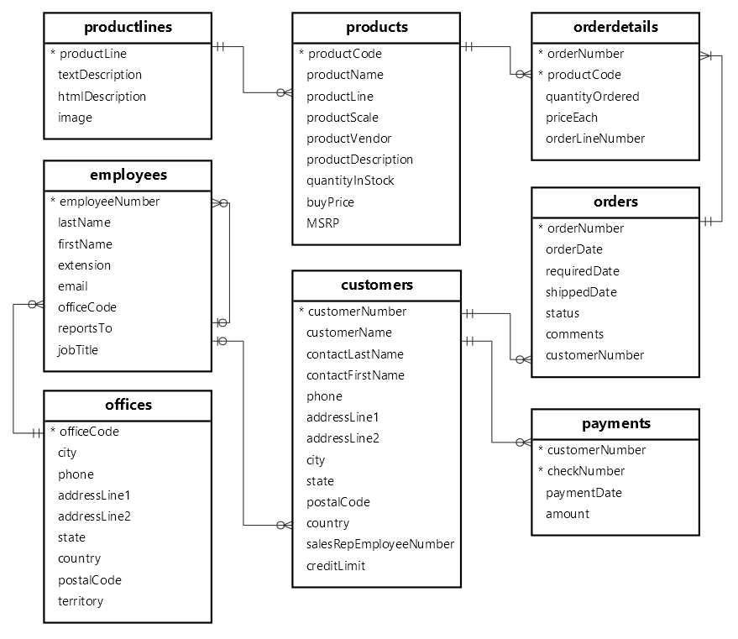

You can download the MySQL sample database ER diagram in PDF format from the following link:

[Download MySQL Sample Database Diagram PDF A4](https://www.mysqltutorial.org/wp-content/uploads/2018/04/MySQL-Sample-Database-Diagram-PDF-A4.pdf)