https://start.spring.io/

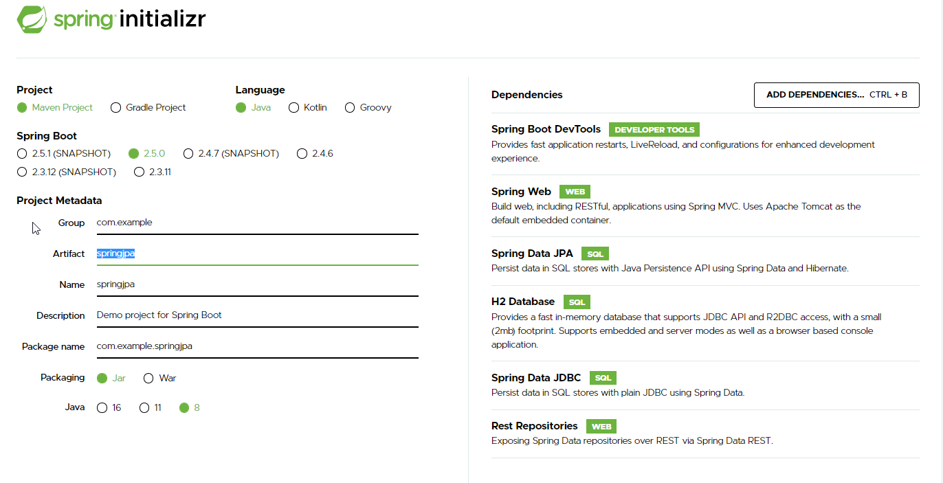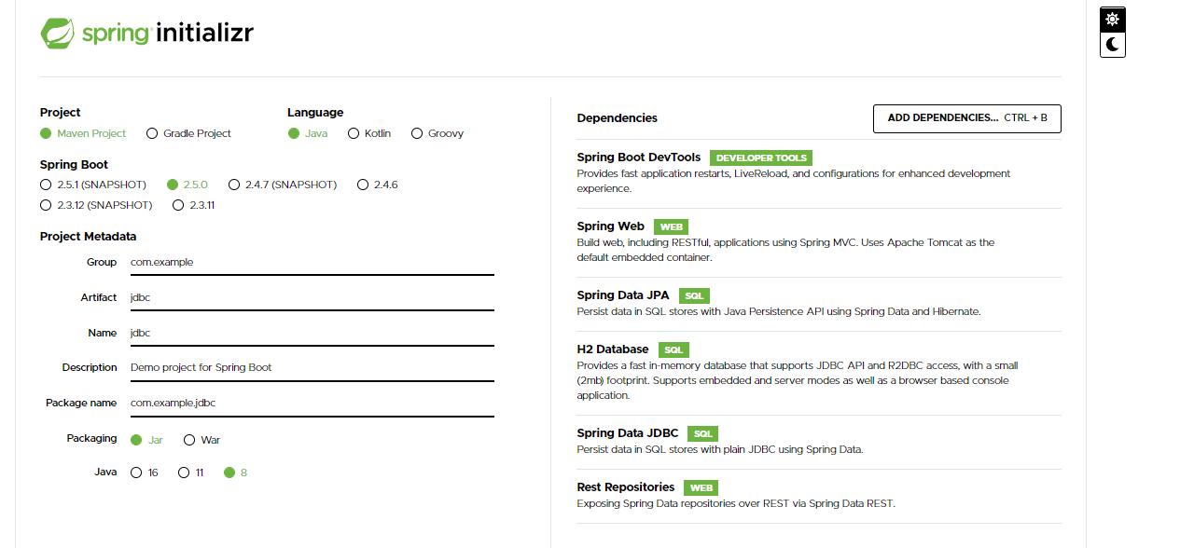

* **Spring Boot DevTools DEVELOPER TOOLS**Provides fast application restarts, LiveReload, and configurations for enhanced development experience.
* **Spring Web WEB**Build web, including RESTful, applications using Spring MVC. Uses Apache Tomcat as the default embedded container.
* **Spring Data JPA SQL**Persist data in SQL stores with Java Persistence API using Spring Data and Hibernate.
* **H2 Database SQL**Provides a fast in-memory database that supports JDBC API and R2DBC access, with a small (2mb) footprint. Supports embedded and server modes as well as a browser based console application.
* **Spring Data JDBC SQL**Persist data in SQL stores with plain JDBC using Spring Data.
* **Rest Repositories WEB**Exposing Spring Data repositories over REST via Spring Data REST.