ISO #####-#:####(X)
ISO TC ###/SC ##/WG #
Date: YYYY-MM-DD
Title (Introductory element — Main element — Part #: Part title)

WD/CD/DIS/FDIS stage

Warning for WDs and CDs
This document is not an ISO International Standard. It is distributed for review and comment. It is subject to change without notice and may not be referred to as an International Standard.
Recipients of this draft are invited to submit, with their comments, notification of any relevant patent rights of which they are aware and to provide supporting documentation.

A model manuscript of a draft International Standard (known as “The Rice Model”) is available at https://www.iso.org/iso/model_document-rice_model.pdf

© ISO 20XX
All rights reserved. Unless otherwise specified, or required in the context of its implementation, no part of this publication may be reproduced or utilized otherwise in any form or by any means, electronic or mechanical, including photocopying, or posting on the internet or an intranet, without prior written permission. Permission can be requested from either ISO at the address below or ISO’s member body in the country of the requester.
ISO copyright office
CP 401 • Ch. de Blandonnet 8
CH-1214 Vernier, Geneva
Phone: +41 22 749 01 11
Email: copyright@iso.org
Website: www.iso.org
Published in Switzerland
Contents
This template allows you to work with default MS Word functions and styles. You can use these if you want to maintain the Table of Contents automatically and apply auto-numbering.
To update the Table of Contents please select it and press "F9".
Foreword iv
Introduction v
1 Scope (mandatory) 1
2 Normative references (mandatory) 1
3 Terms and definitions (mandatory) 1
4 Clause title 2
5 Clause title 2
5.1 Subclause title (first level) 2
5.2 Subclause title (first level) 2
5.2.1 Subclause title (second level) 2
5.2.2 Subclause title (second level) 3
6 Clause title 3
7 Clause title 3
Annex A (informative) Annex title e.g. Example of a figure and a table 4
A.1 Clause title 4
A.1.1 Subclause title 4
A.1.2 Subclause title 4
A.1.2.1 Subclause title 4
A.1.2.2 Subclause title 4
A.2 Clause title 4
Bibliography 6

Foreword
ISO (the International Organization for Standardization) is a worldwide federation of national standards bodies (ISO member bodies). The work of preparing International Standards is normally carried out through ISO technical committees. Each member body interested in a subject for which a technical committee has been established has the right to be represented on that committee. International organizations, governmental and non-governmental, in liaison with ISO, also take part in the work. ISO collaborates closely with the International Electrotechnical Commission (IEC) on all matters of electrotechnical standardization.
The procedures used to develop this document and those intended for its further maintenance are described in the ISO/IEC Directives, Part 1. In particular, the different approval criteria needed for the different types of ISO documents should be noted. This document was drafted in accordance with the editorial rules of the ISO/IEC Directives, Part 2 (see www.iso.org/directives).
ISO draws attention to the possibility that the implementation of this document may involve the use of (a) patent(s). ISO takes no position concerning the evidence, validity or applicability of any claimed patent rights in respect thereof. As of the date of publication of this document, ISO [had/had not] received notice of (a) patent(s) which may be required to implement this document. However, implementers are cautioned that this may not represent the latest information, which may be obtained from the patent database available at www.iso.org/patents. ISO shall not be held responsible for identifying any or all such patent rights.
Any trade name used in this document is information given for the convenience of users and does not constitute an endorsement.
For an explanation of the voluntary nature of standards, the meaning of ISO specific terms and expressions related to conformity assessment, as well as information about ISO's adherence to the World Trade Organization (WTO) principles in the Technical Barriers to Trade (TBT), see www.iso.org/iso/foreword.html.
This document was prepared by Technical Committee [or Project Committee] ISO/TC [or ISO/PC] ###, [name of committee], Subcommittee SC ##, [name of subcommittee].
This second/third/… edition cancels and replaces the first/second/… edition (ISO #####:####), which has been technically revised.
The main changes are as follows:
— xxx xxxxxxx xxx xxxx
A list of all parts in the ISO ##### series can be found on the ISO website.
Any feedback or questions on this document should be directed to the user’s national standards body. A complete listing of these bodies can be found at www.iso.org/members.html.

Introduction
Type text.

Title (Introductory element — Main element — Part #: Part title)

Scope (mandatory)
Type text.

Normative references (mandatory)
Two options of text (remove the inappropriate option).
1) The normative references shall be introduced by the following wording.
The following documents are referred to in the text in such a way that some or all of their content constitutes requirements of this document. For dated references, only the edition cited applies. For undated references, the latest edition of the referenced document (including any amendments) applies.
ISO #####-#, General title — Part #: Title of part
ISO #####-##:20##, General title — Part ##: Title of part
2) If no references exist, include the following phrase below the clause title:
There are no normative references in this document.

Terms and definitions (mandatory)
Four options of text (remove the inappropriate options).
1) If all the specific terms and definitions are provided in Clause 3, use the following introductory text:
For the purposes of this document, the following terms and definitions apply.
2) If reference is given to an external document, use the following introductory text:
For the purposes of this document, the terms and definitions given in [external document reference xxx] apply.
3) If terms and definitions are provided in Clause 3, in addition to a reference to an external document, use the following introductory text:
For the purposes of this document, the terms and definitions given in [external document reference xxx] and the following apply.
4) If there are no terms and definitions provided, use the following introductory text:
No terms and definitions are listed in this document.
The text below is always included after each option:
ISO and IEC maintain terminology databases for use in standardization at the following addresses:
- ISO Online browsing platform: available at https://www.iso.org/obp
- IEC Electropedia: available at https://www.electropedia.org/
3.1
term
text of the definition
Note 1 to entry: Text of the note.
[SOURCE: …]
3.2
term
text of the definition

Clause title
Type text.
EXAMPLE Text of the example.
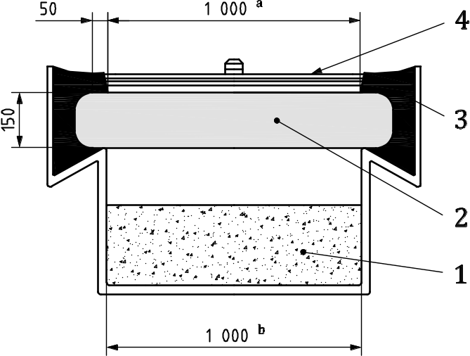
- Example

Clause title

Subclause title (first level)
Type text.
- List text.
NOTE Text of the note.
Use subclauses if required e.g. 5.1, 5.2, etc. or 5.1.1, 5.1.2, etc. For example:

Subclause title (first level)

Subclause title (second level)
There are two options for providing formulae: Equation Editor in MS Word, or MathType Equation.
Example of formula in MS Equation Editor:
$K_{2A}=10\log\left(1+\frac{4S}{A}\right)$ (1)
where
 | A | is the equivalent absorption area of the room, in square meters;
 | S | is the area in square meters of the measurement surface (in the case of this procedure, S is a sphere with a radius of 1 m, i.e. S = 4π).
The same formula in MathType Equation:
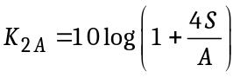 (2)

Subclause title (second level)
Type text.

Clause title
Example of codes:
<xs:complexType name="Route">
<xs:sequence>
<xs:element name="routeID" type="tdt:IntUnLoMB"/>
<xs:element name="routeListID" type="tdt:IntUnLoMB"/>
<xs:element name="listCount" type="tdt:IntUnLoMB"/>
</xs:sequence>
</xs:complexType>

Clause title
An example of a table is given in Table 1.
- Example
Type | No. series | Pressure | Length
A | 248-i | 50 | 216
B | 556-i | 100 ^{b} | 287
C | 43-ii | 200 | 300

- (informative)
Annex title e.g. Example of a figure and a table
  - Clause title
Use subclauses if required e.g. A.1.1, A.1.2, etc. or A.1.1.1, A.1.1.2, etc.. For example:
    - Subclause title
Type text.
    - Subclause title
      - Subclause title
Type text.
      - Subclause title
Type text.
  - Clause title
An example of a figure is given in Figure A.1.
Dimensions in millimetres
Key
1 | desiccant/aqueous saturated salt solution
2 | test specimen
3 | sealant
4 | template
NOTE Figure note.
ª | It is the upper exposed area.
^{b} | It is the lower exposed area.
- Example

An example of a table is given in Table A.1.
- Example
Type ª | No. series | Pressure | Length | Temperature
Type ª | No. series | p₁ | l₂ | T₁
Type ª | No. series | MPa | mm | °C
A | 248-i | 50 | 216 | 50
B | 556-i | 100 ^{b} | 287 | 60,5
C | 43-ii | 200 | 300 | 38
NOTE Table note.
ª Table footnote.
^{b} Second table footnote.

Bibliography
[1] ISO #####-#, General title — Part #: Title of part
[2] ISO #####-##:20##, General title — Part ##: Title of part

