Co-infetion

## R Markdown

This is an R Markdown document. Markdown is a simple formatting syntax for authoring HTML, PDF, and MS Word documents. For more details on using R Markdown see <http://rmarkdown.rstudio.com>.

When you click the **Knit** button a document will be generated that includes both content as well as the output of any embedded R code chunks within the document. You can embed an R code chunk like this:

library(ggplot2)  
library(reshape2)  
library(lme4)  
library(nlme)  
library(car)  
library(emmeans)  
library(cooccur)  
library(gmp)  
library(asnipe)  
library(Rmisc)  
library(multcomp)  
bcfrt <- read.csv("D:/Macquarie/PhD/Data/bacteria.csv", header = T, stringsAsFactors = F)  
bcfrt <- bcfrt[,-1]  
bcprv <- read.csv("D:/Macquarie/PhD/Data/subset/lizard.infection.csv", header = T, stringsAsFactors = F)  
bcprv <- bcprv[-c(25,26),]  
bcprv <- melt(bcprv, id=c("sex_code", "site_code", "Sampling.point", "ind.count"))  
colnames(bcprv) <- c("sex", "site", "frt", "sz", "strain", "lizard")  
bcfrt$Sampling.point <- as.factor(bcfrt$Sampling.point)  
bcprv$frt <- as.factor(bcprv$frt)

## Variation of infection

Lizards were swabbed every fortnight during their active season. The presence or absence of each bacterial strain was recorded. In the dataset, site A represented the location of “church”, while site B represented the location of “PhD”.

frt_mod1 <- lmer(Sequence.Type.Richness~site_code+sex_code+Sampling.point+site_code*sex_code+(1|Lizard), data = bcfrt, REML = F)   
Anova(frt_mod1)

## Analysis of Deviance Table (Type II Wald chisquare tests)  
##   
## Response: Sequence.Type.Richness  
## Chisq Df Pr(>Chisq)   
## site_code 5.0293 1 0.02492 *   
## sex_code 0.0292 1 0.86420   
## Sampling.point 342.8885 5 < 2e-16 ***  
## site_code:sex_code 1.5349 1 0.21538   
## ---  
## Signif. codes: 0 '***' 0.001 '**' 0.01 '*' 0.05 '.' 0.1 ' ' 1

#interaction was removed since not significant  
frt_mod2 <- lmer(Sequence.Type.Richness~site_code+Sampling.point+(1|Lizard)  
 , data = bcfrt, REML = F)  
summary(frt_mod2)

## Linear mixed model fit by maximum likelihood ['lmerMod']  
## Formula:   
## Sequence.Type.Richness ~ site_code + Sampling.point + (1 | Lizard)  
## Data: bcfrt  
##   
## AIC BIC logLik deviance df.resid   
## 2933.5 2970.8 -1457.8 2915.5 459   
##   
## Scaled residuals:   
## Min 1Q Median 3Q Max   
## -2.7688 -0.6448 0.0667 0.6772 3.3616   
##   
## Random effects:  
## Groups Name Variance Std.Dev.  
## Lizard (Intercept) 2.787 1.670   
## Residual 27.410 5.235   
## Number of obs: 468, groups: Lizard, 87  
##   
## Fixed effects:  
## Estimate Std. Error t value  
## (Intercept) 16.1781 0.7642 21.169  
## site_codeB 1.3343 0.6034 2.211  
## Sampling.point2 1.1820 0.9121 1.296  
## Sampling.point3 1.9679 0.8843 2.225  
## Sampling.point4 -1.7904 0.8893 -2.013  
## Sampling.point5 3.8022 0.8864 4.289  
## Sampling.point6 12.0443 0.8945 13.465  
##   
## Correlation of Fixed Effects:  
## (Intr) st_cdB Smpl.2 Smpl.3 Smpl.4 Smpl.5  
## site_codeB -0.400   
## Smplng.pnt2 -0.654 -0.009   
## Smplng.pnt3 -0.679 0.001 0.568   
## Smplng.pnt4 -0.673 -0.005 0.565 0.585   
## Smplng.pnt5 -0.681 0.009 0.566 0.585 0.582   
## Smplng.pnt6 -0.674 0.006 0.562 0.581 0.578 0.580

Anova(frt_mod2)

## Analysis of Deviance Table (Type II Wald chisquare tests)  
##   
## Response: Sequence.Type.Richness  
## Chisq Df Pr(>Chisq)   
## site_code 4.8902 1 0.02701 *   
## Sampling.point 343.0674 5 < 2e-16 ***  
## ---  
## Signif. codes: 0 '***' 0.001 '**' 0.01 '*' 0.05 '.' 0.1 ' ' 1

lsmeans(frt_mod2, ~site_code)

## site_code lsmean SE df lower.CL upper.CL  
## A 19.04579 0.4355147 89.54 18.1805 19.91108  
## B 20.38006 0.4303160 88.80 19.5250 21.23511  
##   
## Results are averaged over the levels of: Sampling.point   
## Degrees-of-freedom method: kenward-roger   
## Confidence level used: 0.95

#normality test  
resid.fm2 <- resid(frt_mod2)  
qqp(resid.fm2, "norm")

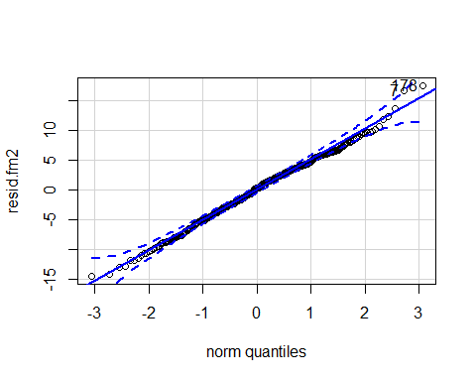

## [1] 178 7

shapiro.test(resid.fm2)

##   
## Shapiro-Wilk normality test  
##   
## data: resid.fm2  
## W = 0.99547, p-value = 0.1924

#auto-correlation test  
summary(lm(resid.fm2~bcfrt$Sampling.point))

##   
## Call:  
## lm(formula = resid.fm2 ~ bcfrt$Sampling.point)  
##   
## Residuals:  
## Min 1Q Median 3Q Max   
## -14.4959 -3.3758 0.3491 3.5457 17.5993   
##   
## Coefficients:  
## Estimate Std. Error t value Pr(>|t|)  
## (Intercept) -6.025e-14 6.522e-01 0 1  
## bcfrt$Sampling.point2 5.613e-14 8.809e-01 0 1  
## bcfrt$Sampling.point3 6.129e-14 8.548e-01 0 1  
## bcfrt$Sampling.point4 6.440e-14 8.591e-01 0 1  
## bcfrt$Sampling.point5 6.120e-14 8.569e-01 0 1  
## bcfrt$Sampling.point6 6.121e-14 8.635e-01 0 1  
##   
## Residual standard error: 5.094 on 462 degrees of freedom  
## Multiple R-squared: 1.718e-29, Adjusted R-squared: -0.01082   
## F-statistic: 1.587e-27 on 5 and 462 DF, p-value: 1

#homogeneity test  
leveneTest(resid.fm2~as.character(bcfrt$Sampling.point))

## Warning in leveneTest.default(y = y, group = group, ...): group coerced to  
## factor.

## Levene's Test for Homogeneity of Variance (center = median)  
## Df F value Pr(>F)   
## group 5 3.4589 0.004436 **  
## 462   
## ---  
## Signif. codes: 0 '***' 0.001 '**' 0.01 '*' 0.05 '.' 0.1 ' ' 1

#normalized residuals--------------------------  
frt_lme <- lme(Sequence.Type.Richness~site_code+Sampling.point,  
 data = bcfrt, method = "REML", random = ~1|Lizard)  
nresid.frt <- residuals(frt_lme, type = "normalized")  
qqp(nresid.frt,"norm")

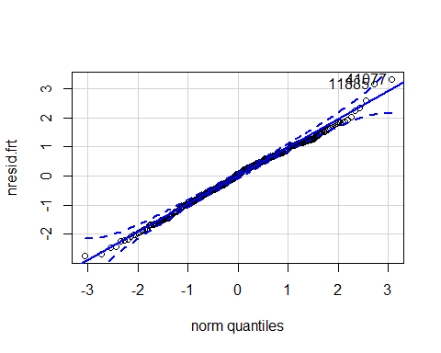

## 41077 11885   
## 178 7

shapiro.test(nresid.frt)

##   
## Shapiro-Wilk normality test  
##   
## data: nresid.frt  
## W = 0.99548, p-value = 0.1942

#homogeneity test  
plot(frt_lme)

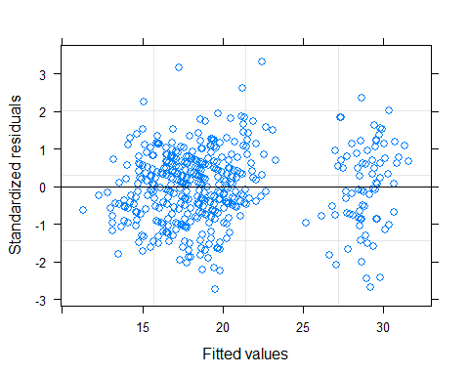

bartlett.test(nresid.frt~bcfrt$Sampling.point)

##   
## Bartlett test of homogeneity of variances  
##   
## data: nresid.frt by bcfrt$Sampling.point  
## Bartlett's K-squared = 17.431, df = 5, p-value = 0.00375

#autocorrelation test  
plot(nresid.frt~bcfrt$Sampling.point)

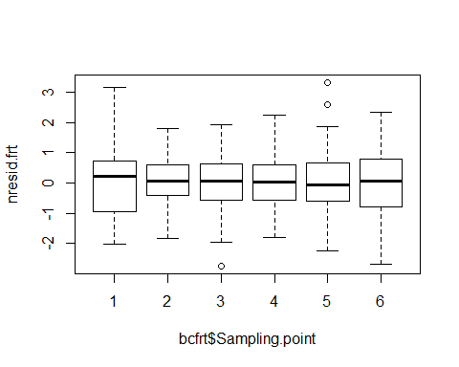

summary(lm(nresid.frt~bcfrt$Sampling.point))

##   
## Call:  
## lm(formula = nresid.frt ~ bcfrt$Sampling.point)  
##   
## Residuals:  
## Min 1Q Median 3Q Max   
## -2.7509 -0.6379 0.0615 0.6660 3.3302   
##   
## Coefficients:  
## Estimate Std. Error t value Pr(>|t|)  
## (Intercept) -1.302e-15 1.236e-01 0 1  
## bcfrt$Sampling.point2 -1.478e-15 1.669e-01 0 1  
## bcfrt$Sampling.point3 -6.724e-16 1.620e-01 0 1  
## bcfrt$Sampling.point4 2.284e-15 1.628e-01 0 1  
## bcfrt$Sampling.point5 -1.796e-15 1.624e-01 0 1  
## bcfrt$Sampling.point6 -1.487e-15 1.636e-01 0 1  
##   
## Residual standard error: 0.9653 on 462 degrees of freedom  
## Multiple R-squared: 2.498e-30, Adjusted R-squared: -0.01082   
## F-statistic: 2.308e-28 on 5 and 462 DF, p-value: 1

The model violated the assumption of homogeneity. Thus, we added varIdent to allow the model to have different variances.

frt_lme2 <- lme(data = bcfrt, Sequence.Type.Richness~site_code+Sampling.point, random = ~1|Lizard,   
 method = "REML")  
frt_lme2 <- update(frt_lme2, weights=varIdent(form = ~1|Sampling.point))  
summary(frt_lme2)

## Linear mixed-effects model fit by REML  
## Data: bcfrt   
## AIC BIC logLik  
## 2919.389 2977.257 -1445.695  
##   
## Random effects:  
## Formula: ~1 | Lizard  
## (Intercept) Residual  
## StdDev: 1.636341 5.52575  
##   
## Variance function:  
## Structure: Different standard deviations per stratum  
## Formula: ~1 | Sampling.point   
## Parameter estimates:  
## 1 2 3 4 5 6   
## 1.0000000 0.7414994 0.9008105 0.8103344 1.0827113 1.1372130   
## Fixed effects: Sequence.Type.Richness ~ site_code + Sampling.point   
## Value Std.Error DF t-value p-value  
## (Intercept) 16.135104 0.7923441 376 20.363759 0.0000  
## site_codeB 1.389346 0.5853600 85 2.373489 0.0199  
## Sampling.point2 1.180627 0.8596408 376 1.373396 0.1704  
## Sampling.point3 1.984595 0.8954136 376 2.216401 0.0273  
## Sampling.point4 -1.780642 0.8676542 376 -2.052248 0.0408  
## Sampling.point5 3.816339 0.9675395 376 3.944376 0.0001  
## Sampling.point6 12.062481 0.9998168 376 12.064691 0.0000  
## Correlation:   
## (Intr) st_cdB Smpl.2 Smpl.3 Smpl.4 Smpl.5  
## site_codeB -0.374   
## Sampling.point2 -0.743 -0.009   
## Sampling.point3 -0.718 0.000 0.661   
## Sampling.point4 -0.739 -0.005 0.683 0.657   
## Sampling.point5 -0.667 0.007 0.611 0.588 0.607   
## Sampling.point6 -0.646 0.005 0.592 0.570 0.588 0.528  
##   
## Standardized Within-Group Residuals:  
## Min Q1 Med Q3 Max   
## -2.83722406 -0.65729468 0.06708126 0.68183241 3.11135670   
##   
## Number of Observations: 468  
## Number of Groups: 87

hoc.frt <- summary(glht(frt_lme2, linfct = mcp("Sampling.point" = "Tukey")), test = adjusted("holm"))  
hoc.frt

##   
## Simultaneous Tests for General Linear Hypotheses  
##   
## Multiple Comparisons of Means: Tukey Contrasts  
##   
##   
## Fit: lme.formula(fixed = Sequence.Type.Richness ~ site_code + Sampling.point,   
## data = bcfrt, random = ~1 | Lizard, weights = varIdent(form = ~1 |   
## Sampling.point), method = "REML")  
##   
## Linear Hypotheses:  
## Estimate Std. Error z value Pr(>|z|)   
## 2 - 1 == 0 1.1806 0.8596 1.373 0.339259   
## 3 - 1 == 0 1.9846 0.8954 2.216 0.133320   
## 4 - 1 == 0 -1.7806 0.8677 -2.052 0.133320   
## 5 - 1 == 0 3.8163 0.9675 3.944 0.000560 ***  
## 6 - 1 == 0 12.0625 0.9998 12.065 < 2e-16 ***  
## 3 - 2 == 0 0.8040 0.7231 1.112 0.339259   
## 4 - 2 == 0 -2.9613 0.6882 -4.303 0.000135 ***  
## 5 - 2 == 0 2.6357 0.8112 3.249 0.006943 **   
## 6 - 2 == 0 10.8819 0.8488 12.821 < 2e-16 ***  
## 4 - 3 == 0 -3.7652 0.7305 -5.155 2.29e-06 ***  
## 5 - 3 == 0 1.8317 0.8479 2.160 0.133320   
## 6 - 3 == 0 10.0779 0.8838 11.403 < 2e-16 ***  
## 5 - 4 == 0 5.5970 0.8183 6.839 7.95e-11 ***  
## 6 - 4 == 0 13.8431 0.8555 16.182 < 2e-16 ***  
## 6 - 5 == 0 8.2461 0.9565 8.621 < 2e-16 ***  
## ---  
## Signif. codes: 0 '***' 0.001 '**' 0.01 '*' 0.05 '.' 0.1 ' ' 1  
## (Adjusted p values reported -- holm method)

nresid.frt2 <- residuals(frt_lme2, type = "normalized")  
qqp(nresid.frt2,"norm")

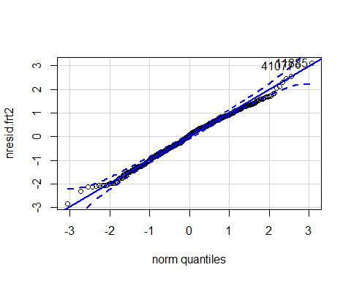

## 11885 41077   
## 7 178

shapiro.test(nresid.frt2)

##   
## Shapiro-Wilk normality test  
##   
## data: nresid.frt2  
## W = 0.99461, p-value = 0.09961

#homogeneity plot  
plot(frt_lme2)

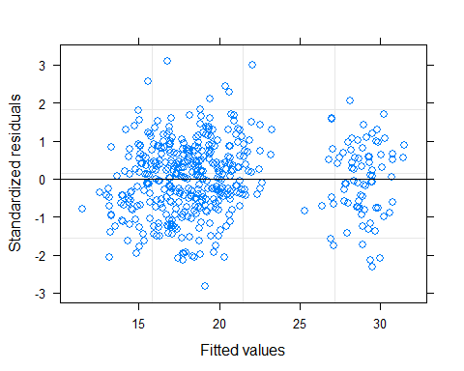

bartlett.test(nresid.frt2~bcfrt$Sampling.point)

##   
## Bartlett test of homogeneity of variances  
##   
## data: nresid.frt2 by bcfrt$Sampling.point  
## Bartlett's K-squared = 0.11617, df = 5, p-value = 0.9998

#autocorrelation test  
plot(nresid.frt2~bcfrt$Sampling.point)

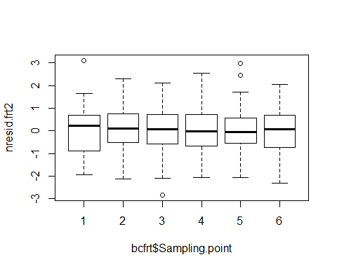

summary(lm(nresid.frt2~bcfrt$Sampling.point))

##   
## Call:  
## lm(formula = nresid.frt2 ~ bcfrt$Sampling.point)  
##   
## Residuals:  
## Min 1Q Median 3Q Max   
## -2.83722 -0.65729 0.06708 0.68183 3.11136   
##   
## Coefficients:  
## Estimate Std. Error t value Pr(>|t|)  
## (Intercept) 1.022e-15 1.236e-01 0 1  
## bcfrt$Sampling.point2 -6.828e-16 1.669e-01 0 1  
## bcfrt$Sampling.point3 -1.701e-15 1.620e-01 0 1  
## bcfrt$Sampling.point4 -2.177e-15 1.628e-01 0 1  
## bcfrt$Sampling.point5 7.074e-16 1.624e-01 0 1  
## bcfrt$Sampling.point6 -2.296e-15 1.636e-01 0 1  
##   
## Residual standard error: 0.9653 on 462 degrees of freedom  
## Multiple R-squared: 1.315e-30, Adjusted R-squared: -0.01082   
## F-statistic: 1.216e-28 on 5 and 462 DF, p-value: 1

#number of infeceted lizards  
il <- c(438,459,445,352,363,397,394,304,197,231,217,142,119,87,162,42,127,128,205,92,217,133,93,77,90,103,113,78,49,58,56,102,40,235,46,136,107,192,24,54,61,130,69,108,26,36,48,58,60,123,27,58,43,24,15,60,61,9,8,118,24,19,56,126,80,9,10,25,12,26,27,40,9,47,17,38,7,31,11,26,26,12,17,29,10,28,15,10,19,19,9,14,20,19,21,19,14,9,16,9,13,15,10,8,3,10,15,14,6,2,8,6,14,4,3,4,6,10,9,5,6,3,3,8,7,2,7,1,3,3,0,3,5,0,2,5,1,3,5,1,4,2,1,3,2,1,0,13,2,0,0,0,1,1,0,0  
 )  
quantile(il)

## 0% 25% 50% 75% 100%   
## 0 6 19 63 459

#remove strains infecting lizards less than the median. I assumed that they were less common strains.  
bcprv.s <- subset(bcprv, !strain %in% c("S094","S110","S156","S055","S116","S165","S192","S135","S145","S202","S243","S161","S714","S080","S109","S102","S075","S114","S120","S167","S190","S281","S059","S071","S089","S134","S146","S160","S284","S060","S171","S238","S372","S099","S379","S427","S212","S241","S269","S323","S303","S537","S561","S617","S252","S267","S667","S178","S266","S350","S363","S467","S484","S521","S583","S693","S225","S382","S554","S681","S694","S725","S458","S579","S661","S687","S705","S747","S749","S505","S539","S709","S731","S735","S745","S762","S772"  
))  
bcprv.s$frt <- as.factor(bcprv.s$frt)  
prv_mod <- lme(lizard~sex+site+frt+sz+sex*site, random = ~1|strain,  
 data = bcprv.s, method = "REML")  
#normality assumption was violated   
prv_mod2 <- lme(sqrt(lizard)~sex+site+frt+sz+sex*site, random = ~1|strain,  
 data = bcprv.s, method = "REML")  
summary(prv_mod2)

## Linear mixed-effects model fit by REML  
## Data: bcprv.s   
## AIC BIC logLik  
## 4487.346 4553.852 -2231.673  
##   
## Random effects:  
## Formula: ~1 | strain  
## (Intercept) Residual  
## StdDev: 1.024952 0.717297  
##   
## Fixed effects: sqrt(lizard) ~ sex + site + frt + sz + sex * site   
## Value Std.Error DF t-value p-value  
## (Intercept) 0.0715367 0.25912136 1808 0.276074 0.7825  
## sexM 0.0278143 0.05007578 1808 0.555445 0.5787  
## siteB 0.2440937 0.06447020 1808 3.786148 0.0002  
## frt2 0.0579985 0.07660794 1808 0.757082 0.4491  
## frt3 0.0800063 0.11027268 1808 0.725531 0.4682  
## frt4 -0.1394117 0.10362411 1808 -1.345359 0.1787  
## frt5 0.1925490 0.10692779 1808 1.800738 0.0719  
## frt6 0.6140035 0.09715713 1808 6.319696 0.0000  
## sz 0.0746098 0.01572652 1808 4.744206 0.0000  
## sexM:siteB -0.3037423 0.12383072 1808 -2.452884 0.0143  
## Correlation:   
## (Intr) sexM siteB frt2 frt3 frt4 frt5 frt6 sz   
## sexM 0.237   
## siteB -0.670 0.083   
## frt2 0.502 0.244 -0.461   
## frt3 0.692 0.314 -0.591 0.764   
## frt4 0.670 0.306 -0.577 0.762 0.857   
## frt5 0.681 0.310 -0.584 0.763 0.862 0.853   
## frt6 0.643 0.297 -0.559 0.759 0.845 0.837 0.841   
## sz -0.875 -0.366 0.691 -0.667 -0.856 -0.835 -0.846 -0.809   
## sexM:siteB 0.775 -0.040 -0.857 0.565 0.724 0.707 0.716 0.685 -0.847  
##   
## Standardized Within-Group Residuals:  
## Min Q1 Med Q3 Max   
## -3.56147181 -0.62186533 0.03643577 0.65584321 3.26083938   
##   
## Number of Observations: 1896  
## Number of Groups: 79

prv_mod2 <- update(prv_mod2, weights=varIdent(form = ~1|frt))  
#remove sex and interaction since not significant  
prv_mod3 <- lme(sqrt(lizard)~site+frt+sz, random = ~1|strain,  
 data = bcprv.s, method = "REML", weights=varIdent(form = ~1|frt))  
summary(prv_mod3)

## Linear mixed-effects model fit by REML  
## Data: bcprv.s   
## AIC BIC logLik  
## 4463.154 4546.303 -2216.577  
##   
## Random effects:  
## Formula: ~1 | strain  
## (Intercept) Residual  
## StdDev: 1.035347 0.8482748  
##   
## Variance function:  
## Structure: Different standard deviations per stratum  
## Formula: ~1 | frt   
## Parameter estimates:  
## 1 2 3 4 5 6   
## 1.0000000 0.8508709 0.8060242 0.7404431 0.7710762 0.8902138   
## Fixed effects: sqrt(lizard) ~ site + frt + sz   
## Value Std.Error DF t-value p-value  
## (Intercept) 0.5300887 0.15011541 1810 3.531208 0.0004  
## siteB 0.1165964 0.03249442 1810 3.588198 0.0003  
## frt2 0.1553561 0.06502046 1810 2.389342 0.0170  
## frt3 0.2597434 0.06917824 1810 3.754698 0.0002  
## frt4 0.0253473 0.06625943 1810 0.382547 0.7021  
## frt5 0.3647970 0.06764724 1810 5.392637 0.0000  
## frt6 0.7637844 0.06925577 1810 11.028459 0.0000  
## sz 0.0446537 0.00534665 1810 8.351711 0.0000  
## Correlation:   
## (Intr) siteB frt2 frt3 frt4 frt5 frt6   
## siteB -0.062   
## frt2 -0.091 0.023   
## frt3 0.028 0.039 0.630   
## frt4 0.008 0.037 0.647 0.703   
## frt5 0.018 0.038 0.639 0.697 0.710   
## frt6 -0.013 0.033 0.609 0.654 0.668 0.661   
## sz -0.534 -0.084 -0.267 -0.464 -0.444 -0.454 -0.386  
##   
## Standardized Within-Group Residuals:  
## Min Q1 Med Q3 Max   
## -3.2654812 -0.6364545 0.0197759 0.6615137 2.8120615   
##   
## Number of Observations: 1896  
## Number of Groups: 79

hoc.prv <- summary(glht(prv_mod3, linfct = mcp("frt" = "Tukey")), test = adjusted("holm"))  
hoc.prv

##   
## Simultaneous Tests for General Linear Hypotheses  
##   
## Multiple Comparisons of Means: Tukey Contrasts  
##   
##   
## Fit: lme.formula(fixed = sqrt(lizard) ~ site + frt + sz, data = bcprv.s,   
## random = ~1 | strain, weights = varIdent(form = ~1 | frt),   
## method = "REML")  
##   
## Linear Hypotheses:  
## Estimate Std. Error z value Pr(>|z|)   
## 2 - 1 == 0 0.15536 0.06502 2.389 0.08439 .   
## 3 - 1 == 0 0.25974 0.06918 3.755 0.00121 **   
## 4 - 1 == 0 0.02535 0.06626 0.383 0.70206   
## 5 - 1 == 0 0.36480 0.06765 5.393 6.25e-07 ***  
## 6 - 1 == 0 0.76378 0.06926 11.028 < 2e-16 ***  
## 3 - 2 == 0 0.10439 0.05783 1.805 0.14548   
## 4 - 2 == 0 -0.13001 0.05515 -2.357 0.08439 .   
## 5 - 2 == 0 0.20944 0.05640 3.713 0.00123 **   
## 6 - 2 == 0 0.60843 0.05950 10.225 < 2e-16 ***  
## 4 - 3 == 0 -0.23440 0.05230 -4.482 5.92e-05 ***  
## 5 - 3 == 0 0.10505 0.05325 1.973 0.14548   
## 6 - 3 == 0 0.50404 0.05755 8.758 < 2e-16 ***  
## 5 - 4 == 0 0.33945 0.05103 6.652 2.89e-10 ***  
## 6 - 4 == 0 0.73844 0.05532 13.349 < 2e-16 ***  
## 6 - 5 == 0 0.39899 0.05634 7.081 1.57e-11 ***  
## ---  
## Signif. codes: 0 '***' 0.001 '**' 0.01 '*' 0.05 '.' 0.1 ' ' 1  
## (Adjusted p values reported -- holm method)

# What’s the difference between auto-correlation test and leveneTest here

#residuals----  
#normality test  
resid.prv <- resid(prv_mod3)  
qqp(resid.prv, "norm")

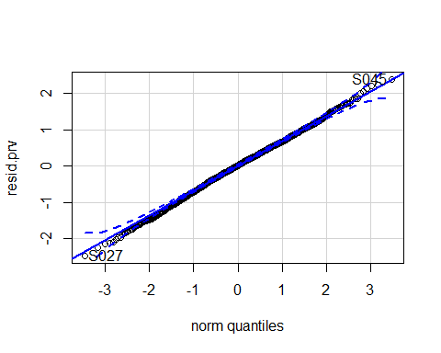

## S027 S045   
## 630 1069

shapiro.test(resid.prv)

##   
## Shapiro-Wilk normality test  
##   
## data: resid.prv  
## W = 0.99871, p-value = 0.1682

#auto-correlation test  
summary(lm(resid.prv~bcprv.s$frt))

##   
## Call:  
## lm(formula = resid.prv ~ bcprv.s$frt)  
##   
## Residuals:  
## Min 1Q Median 3Q Max   
## -2.46592 -0.44772 0.01404 0.47341 2.38540   
##   
## Coefficients:  
## Estimate Std. Error t value Pr(>|t|)  
## (Intercept) 9.641e-16 3.962e-02 0 1  
## bcprv.s$frt2 -2.968e-15 5.604e-02 0 1  
## bcprv.s$frt3 -2.984e-15 5.604e-02 0 1  
## bcprv.s$frt4 -9.275e-16 5.604e-02 0 1  
## bcprv.s$frt5 -1.675e-16 5.604e-02 0 1  
## bcprv.s$frt6 2.923e-15 5.604e-02 0 1  
##   
## Residual standard error: 0.7044 on 1890 degrees of freedom  
## Multiple R-squared: 7.764e-30, Adjusted R-squared: -0.002646   
## F-statistic: 2.935e-27 on 5 and 1890 DF, p-value: 1

#homogeneity test  
leveneTest(resid.prv~as.character(bcprv.s$frt))

## Warning in leveneTest.default(y = y, group = group, ...): group coerced to  
## factor.

## Levene's Test for Homogeneity of Variance (center = median)  
## Df F value Pr(>F)   
## group 5 6.146 1.172e-05 ***  
## 1890   
## ---  
## Signif. codes: 0 '***' 0.001 '**' 0.01 '*' 0.05 '.' 0.1 ' ' 1

#normalized residuals mod----  
nresid.prv <- residuals(prv_mod, type = "normalized")  
qqp(nresid.prv,"norm")

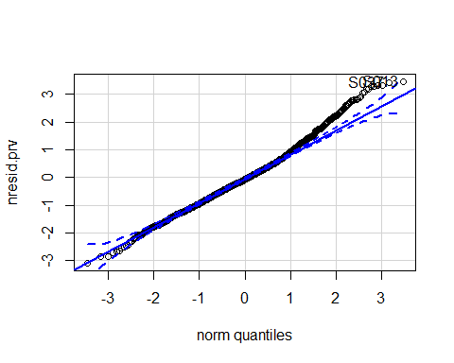

## S013 S037   
## 303 868

shapiro.test(nresid.prv)

##   
## Shapiro-Wilk normality test  
##   
## data: nresid.prv  
## W = 0.98805, p-value = 1.94e-11

hist(nresid.prv)

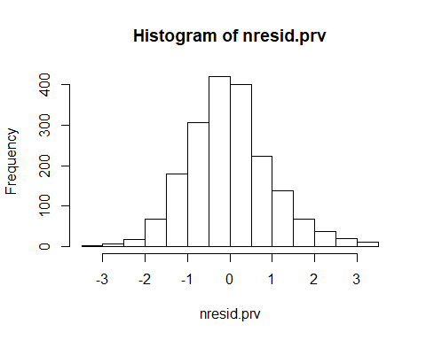

#normalized residuals mod2----  
nresid.prv2 <- residuals(prv_mod2, type = "normalized")  
qqp(nresid.prv2,"norm")

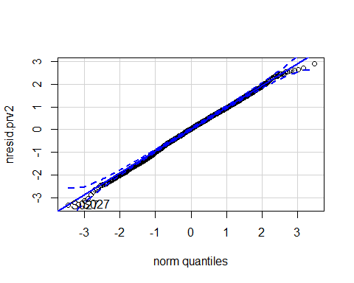

## S027 S027   
## 630 629

shapiro.test(nresid.prv2)

##   
## Shapiro-Wilk normality test  
##   
## data: nresid.prv2  
## W = 0.99832, p-value = 0.05228

hist(nresid.prv2)

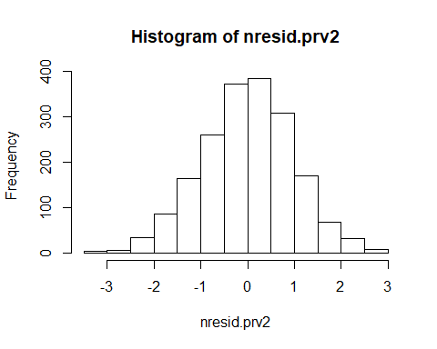

#homogeneity test  
plot(prv_mod2)

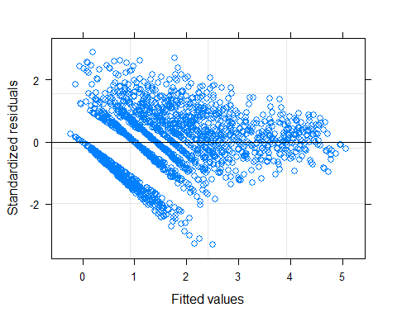

bartlett.test(nresid.prv2~bcprv.s$frt)

##   
## Bartlett test of homogeneity of variances  
##   
## data: nresid.prv2 by bcprv.s$frt  
## Bartlett's K-squared = 0.060273, df = 5, p-value = 1

#autocorrelation test  
plot(nresid.prv2~bcprv.s$frt)

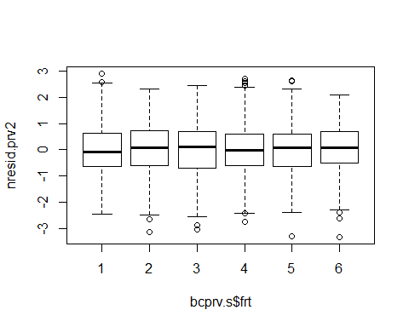

summary(lm(nresid.prv2~bcprv.s$frt))

##   
## Call:  
## lm(formula = nresid.prv2 ~ bcprv.s$frt)  
##   
## Residuals:  
## Min 1Q Median 3Q Max   
## -3.3169 -0.6252 0.0334 0.6672 2.8982   
##   
## Coefficients:  
## Estimate Std. Error t value Pr(>|t|)  
## (Intercept) -1.806e-15 5.504e-02 0 1  
## bcprv.s$frt2 1.003e-15 7.784e-02 0 1  
## bcprv.s$frt3 1.970e-15 7.784e-02 0 1  
## bcprv.s$frt4 4.049e-15 7.784e-02 0 1  
## bcprv.s$frt5 2.425e-15 7.784e-02 0 1  
## bcprv.s$frt6 2.853e-15 7.784e-02 0 1  
##   
## Residual standard error: 0.9785 on 1890 degrees of freedom  
## Multiple R-squared: 1.599e-30, Adjusted R-squared: -0.002646   
## F-statistic: 6.044e-28 on 5 and 1890 DF, p-value: 1

#normalized residuals mod3----  
nresid.prv3 <- residuals(prv_mod3, type = "normalized")  
qqp(nresid.prv3,"norm")

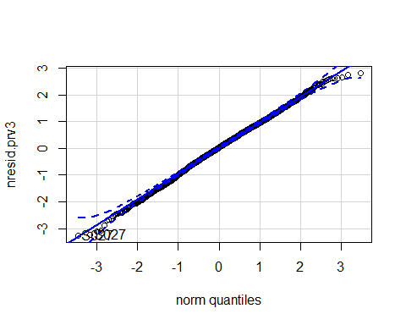

## S027 S027   
## 630 629

shapiro.test(nresid.prv3)

##   
## Shapiro-Wilk normality test  
##   
## data: nresid.prv3  
## W = 0.99829, p-value = 0.04783

#homogeneity test  
plot(prv_mod3)

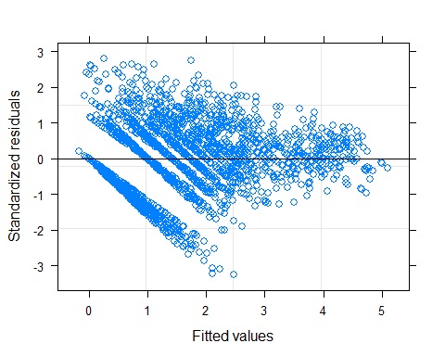

#autocorrelation test  
plot(nresid.prv3~bcprv.s$frt)

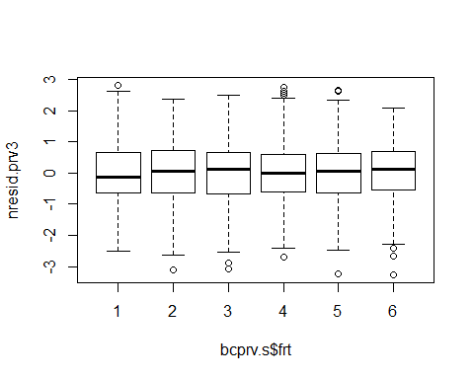

summary(lmer(nresid.prv3~frt+(1|strain),REML = F,data=bcprv.s))

## Linear mixed model fit by maximum likelihood ['lmerMod']  
## Formula: nresid.prv3 ~ frt + (1 | strain)  
## Data: bcprv.s  
##   
## AIC BIC logLik deviance df.resid   
## 5310.2 5354.5 -2647.1 5294.2 1888   
##   
## Scaled residuals:   
## Min 1Q Median 3Q Max   
## -3.3408 -0.6511 0.0202 0.6768 2.8769   
##   
## Random effects:  
## Groups Name Variance Std.Dev.  
## strain (Intercept) 0.0000 0.0000   
## Residual 0.9554 0.9775   
## Number of obs: 1896, groups: strain, 79  
##   
## Fixed effects:  
## Estimate Std. Error t value  
## (Intercept) 1.175e-15 5.499e-02 0  
## frt2 -3.840e-15 7.776e-02 0  
## frt3 -4.108e-15 7.776e-02 0  
## frt4 -1.137e-15 7.776e-02 0  
## frt5 -1.657e-16 7.776e-02 0  
## frt6 4.093e-15 7.776e-02 0  
##   
## Correlation of Fixed Effects:  
## (Intr) frt2 frt3 frt4 frt5   
## frt2 -0.707   
## frt3 -0.707 0.500   
## frt4 -0.707 0.500 0.500   
## frt5 -0.707 0.500 0.500 0.500   
## frt6 -0.707 0.500 0.500 0.500 0.500

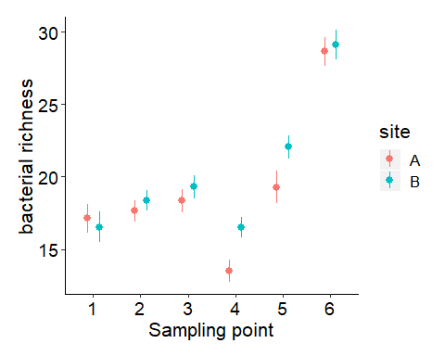

##   
## Simultaneous Tests for General Linear Hypotheses  
##   
## Multiple Comparisons of Means: Tukey Contrasts  
##   
##   
## Fit: lme.formula(fixed = Sequence.Type.Richness ~ site_code + Sampling.point,   
## data = bcfrt, random = ~1 | Lizard, weights = varIdent(form = ~1 |   
## Sampling.point), method = "REML")  
##   
## Linear Hypotheses:  
## Estimate Std. Error z value Pr(>|z|)   
## 2 - 1 == 0 1.1806 0.8596 1.373 0.339259   
## 3 - 1 == 0 1.9846 0.8954 2.216 0.133320   
## 4 - 1 == 0 -1.7806 0.8677 -2.052 0.133320   
## 5 - 1 == 0 3.8163 0.9675 3.944 0.000560 ***  
## 6 - 1 == 0 12.0625 0.9998 12.065 < 2e-16 ***  
## 3 - 2 == 0 0.8040 0.7231 1.112 0.339259   
## 4 - 2 == 0 -2.9613 0.6882 -4.303 0.000135 ***  
## 5 - 2 == 0 2.6357 0.8112 3.249 0.006943 **   
## 6 - 2 == 0 10.8819 0.8488 12.821 < 2e-16 ***  
## 4 - 3 == 0 -3.7652 0.7305 -5.155 2.29e-06 ***  
## 5 - 3 == 0 1.8317 0.8479 2.160 0.133320   
## 6 - 3 == 0 10.0779 0.8838 11.403 < 2e-16 ***  
## 5 - 4 == 0 5.5970 0.8183 6.839 7.95e-11 ***  
## 6 - 4 == 0 13.8431 0.8555 16.182 < 2e-16 ***  
## 6 - 5 == 0 8.2461 0.9565 8.621 < 2e-16 ***  
## ---  
## Signif. codes: 0 '***' 0.001 '**' 0.01 '*' 0.05 '.' 0.1 ' ' 1  
## (Adjusted p values reported -- holm method)

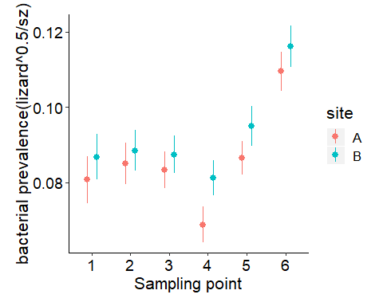

##   
## Simultaneous Tests for General Linear Hypotheses  
##   
## Multiple Comparisons of Means: Tukey Contrasts  
##   
##   
## Fit: lme.formula(fixed = sqrt(lizard) ~ site + frt + sz, data = bcprv.s,   
## random = ~1 | strain, weights = varIdent(form = ~1 | frt),   
## method = "REML")  
##   
## Linear Hypotheses:  
## Estimate Std. Error z value Pr(>|z|)   
## 2 - 1 == 0 0.15536 0.06502 2.389 0.08439 .   
## 3 - 1 == 0 0.25974 0.06918 3.755 0.00121 **   
## 4 - 1 == 0 0.02535 0.06626 0.383 0.70206   
## 5 - 1 == 0 0.36480 0.06765 5.393 6.25e-07 ***  
## 6 - 1 == 0 0.76378 0.06926 11.028 < 2e-16 ***  
## 3 - 2 == 0 0.10439 0.05783 1.805 0.14548   
## 4 - 2 == 0 -0.13001 0.05515 -2.357 0.08439 .   
## 5 - 2 == 0 0.20944 0.05640 3.713 0.00123 **   
## 6 - 2 == 0 0.60843 0.05950 10.225 < 2e-16 ***  
## 4 - 3 == 0 -0.23440 0.05230 -4.482 5.92e-05 ***  
## 5 - 3 == 0 0.10505 0.05325 1.973 0.14548   
## 6 - 3 == 0 0.50404 0.05755 8.758 < 2e-16 ***  
## 5 - 4 == 0 0.33945 0.05103 6.652 2.89e-10 ***  
## 6 - 4 == 0 0.73844 0.05532 13.349 < 2e-16 ***  
## 6 - 5 == 0 0.39899 0.05634 7.081 1.57e-11 ***  
## ---  
## Signif. codes: 0 '***' 0.001 '**' 0.01 '*' 0.05 '.' 0.1 ' ' 1  
## (Adjusted p values reported -- holm method)