**電通二乙微處理器實驗 實驗結報**

|  |  |  |  |
| --- | --- | --- | --- |
| **實驗名稱** | **走馬燈控制** | | |
| **組別** | **10** | **組員** | **柯鴻宇** |

1. **實驗目的**

**控制LED執行指令**

1. **實驗步驟**

**將LED正端插入Arduino上所指定之腳位，負端接GND，再燒入程式碼**

1. **程式碼**

**實驗1**

**const byte startPin=1;**

**const byte endPin=8;**

**void setup() {**

**for (byte i = startPin; i<= endPin; i++) {**

**pinMode(i, OUTPUT);**

**}**

**}**

**void loop() {**

**byte i;**

**byte lightPin = startPin;**

**for (i=startPin; i<= endPin; i++) {**

**digitalWrite(lightPin, HIGH);**

**if (lightPin < endPin) {**

**lightPin ++;**

**} else {**

**lightPin = startPin;**

**}**

**delay (100);**

**digitalWrite(i,LOW);**

**}**

**for (i=endPin;i>=startPin;i--) {**

**digitalWrite(i,LOW);**

**if (lightPin > startPin) {**

**lightPin --;**

**} else {**

**lightPin = endPin;**

**}**

**digitalWrite(lightPin, HIGH);**

**delay (100);**

**digitalWrite(i,LOW);**

**}**

**}**

**實驗2**

**const byte LEDs[] = {2,3,4,5,6,7,8,9};**

**const byte total = 8;**

**int i,j;**

**void setup() {**

**for (i=0;i<total;i++) {**

**pinMode(LEDs[i], OUTPUT);**

**digitalWrite (LEDs[i],LOW);**

**}**

**}**

**void loop() {**

**for(j=0;j<2;j++){**

**for(i=0;i<total;i++){**

**digitalWrite (LEDs[i],HIGH);**

**}**

**delay(250);**

**for(i=0;i<total;i++){**

**digitalWrite (LEDs[i],LOW);**

**}**

**delay(250);**

**}**

**for(i=0;i<total;i++){**

**digitalWrite(LEDs[i],HIGH);**

**delay(250);**

**digitalWrite(LEDs[i],LOW);**

**}**

**for(j=0;j<2;j++){**

**for(i=0;i<total;i++){**

**digitalWrite (LEDs[i],HIGH);**

**}**

**delay(250);**

**for(i=0;i<total;i++){**

**digitalWrite (LEDs[i],LOW);**

**}**

**delay(250);**

**}**

**for(i=total-1;i>=0;i--){**

**digitalWrite(LEDs[i],HIGH);**

**delay(250);**

**digitalWrite(LEDs[i],LOW);**

**}**

**}**

**實驗3**

**const byte LED[] ={2,3,4,5,6,7,8,9};**

**const byte SW = 10;**

**int i,j;**

**void setup(){**

**for(i=0;i<8;i++){**

**pinMode(LED[i],OUTPUT);**

**pinMode(SW, INPUT);**

**}**

**}**

**void loop(){**

**boolean val = digitalRead(10);**

**if(val){**

**for(i=0;i<8;i++){**

**digitalWrite(LED[i],HIGH);**

**delay(250);**

**digitalWrite(LED[i],LOW);**

**}**

**for(i=7;i>=0;i--){**

**digitalWrite(LED[i],HIGH);**

**delay(250);**

**digitalWrite(LED[i],LOW);**

**}**

**}else{**

**for(j=0;j<2;j++){**

**for(i=0;i<8;i++){**

**digitalWrite (LED[i],HIGH);**

**}**

**delay(250);**

**for(i=0;i<8;i++){**

**digitalWrite (LED[i],LOW);**

**}**

**delay(250);**

**}**

**for(i=0;i<8;i++){**

**digitalWrite(LED[i],HIGH);**

**delay(250);**

**digitalWrite(LED[i],LOW);**

**}**

**for(j=0;j<2;j++){**

**for(i=0;i<8;i++){**

**digitalWrite (LED[i],HIGH);**

**}**

**delay(250);**

**for(i=0;i<8;i++){**

**digitalWrite (LED[i],LOW);**

**}**

**delay(250);**

**}**

**for(i=7;i>=0;i--){**

**digitalWrite(LED[i],HIGH);**

**delay(250);**

**digitalWrite(LED[i],LOW);**

**}**

**}**

**}**

1. **實驗結果及分析**

**實驗1將會使LED向左及向右執行花色展示**

**實驗2將會使所有LED亮滅兩次，左移八次，所有LED亮滅兩次，右移八次**

**實驗3按下開關前會執行實驗1，按下後會執行實驗2**

1. **心得討論**

**一開始實驗1控制點亮LED的程式碼放錯位置，導致不會由左向右亮，經修正之後，實驗1 2 3的問題都解決，並完成題目之要求。**

1. **修正電路圖**

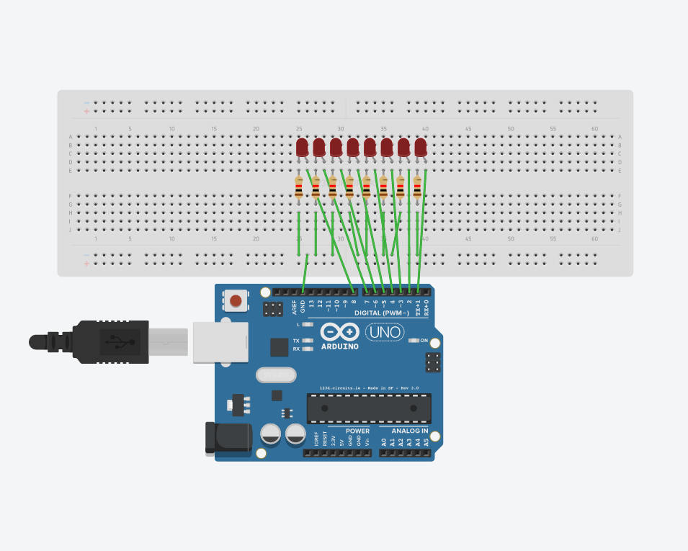

**實驗1之電路圖**

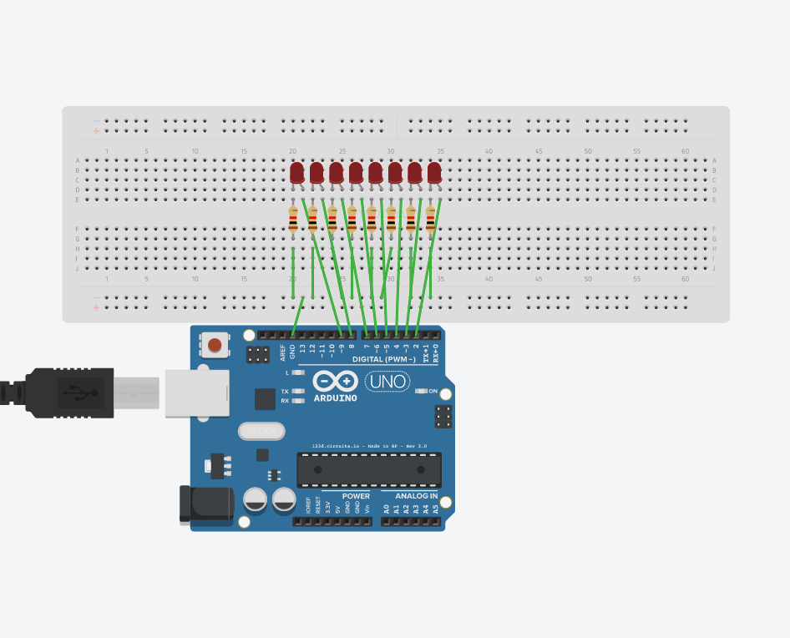

**實驗2之電路圖**

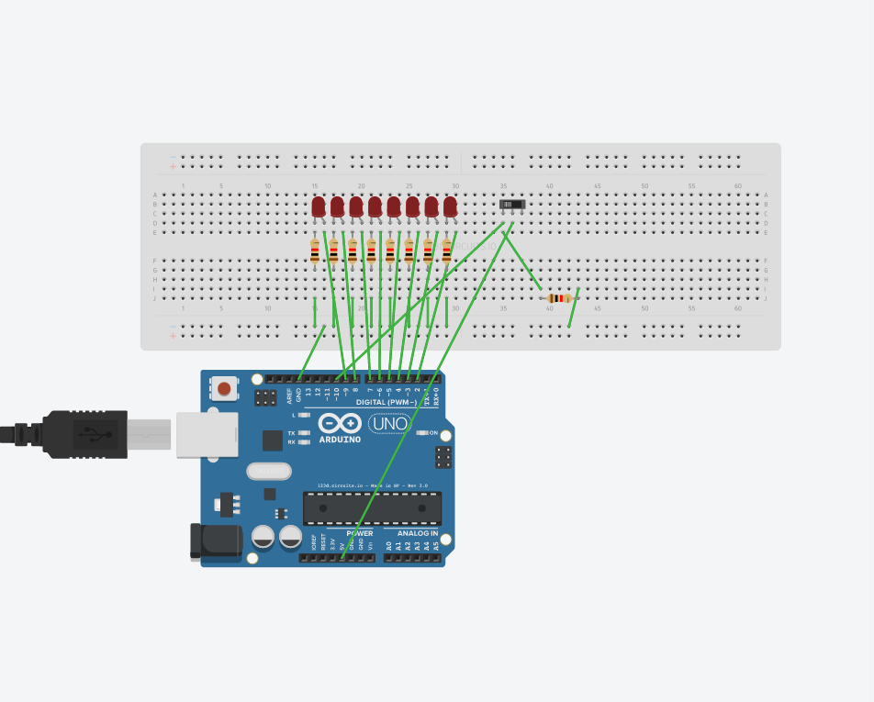

**實驗3之電路圖**

1. **修正程式碼**

**實驗1**

**const byte startPin=1;**

**const byte endPin=8;**

**void setup() {**

**for (byte i = startPin; i<= endPin; i++) {**

**pinMode(i, OUTPUT);**

**}**

**}**

**void loop() {**

**byte i;**

**byte lightPin = startPin;**

**for (i=startPin; i<= endPin; i++) {**

**digitalWrite(lightPin, HIGH);**

**if (lightPin < endPin) {**

**lightPin ++;**

**} else {**

**lightPin = startPin;**

**}**

**delay (100);**

**digitalWrite(i,LOW);**

**}**

**for (i=endPin;i>=startPin;i--) {**

**digitalWrite(i,LOW);**

**if (lightPin > startPin) {**

**lightPin --;**

**} else {**

**lightPin = endPin;**

**}**

**digitalWrite(lightPin, HIGH);**

**delay (100);**

**digitalWrite(i,LOW);**

**}**

**}**

**實驗2**

**const byte LEDs[] = {2,3,4,5,6,7,8,9};**

**const byte total = 8;**

**int i,j;**

**void setup() {**

**for (i=0;i<total;i++) {**

**pinMode(LEDs[i], OUTPUT);**

**digitalWrite (LEDs[i],LOW);**

**}**

**}**

**void loop() {**

**for(j=0;j<2;j++){**

**for(i=0;i<total;i++){**

**digitalWrite (LEDs[i],HIGH);**

**}**

**delay(250);**

**for(i=0;i<total;i++){**

**digitalWrite (LEDs[i],LOW);**

**}**

**delay(250);**

**}**

**for(i=0;i<total;i++){**

**digitalWrite(LEDs[i],HIGH);**

**delay(250);**

**digitalWrite(LEDs[i],LOW);**

**}**

**for(j=0;j<2;j++){**

**for(i=0;i<total;i++){**

**digitalWrite (LEDs[i],HIGH);**

**}**

**delay(250);**

**for(i=0;i<total;i++){**

**digitalWrite (LEDs[i],LOW);**

**}**

**delay(250);**

**}**

**for(i=total-1;i>=0;i--){**

**digitalWrite(LEDs[i],HIGH);**

**delay(250);**

**digitalWrite(LEDs[i],LOW);**

**}**

**}**

**實驗3**

**const byte LED[] ={2,3,4,5,6,7,8,9};**

**const byte SW = 10;**

**int i,j;**

**void setup(){**

**for(i=0;i<8;i++){**

**pinMode(LED[i],OUTPUT);**

**pinMode(SW, INPUT);**

**}**

**}**

**void loop(){**

**boolean val = digitalRead(10);**

**if(val){**

**for(i=0;i<8;i++){**

**digitalWrite(LED[i],HIGH);**

**delay(250);**

**digitalWrite(LED[i],LOW);**

**}**

**for(i=7;i>=0;i--){**

**digitalWrite(LED[i],HIGH);**

**delay(250);**

**digitalWrite(LED[i],LOW);**

**}**

**}else{**

**for(j=0;j<2;j++){**

**for(i=0;i<8;i++){**

**digitalWrite (LED[i],HIGH);**

**}**

**delay(250);**

**for(i=0;i<8;i++){**

**digitalWrite (LED[i],LOW);**

**}**

**delay(250);**

**}**

**for(i=0;i<8;i++){**

**digitalWrite(LED[i],HIGH);**

**delay(250);**

**digitalWrite(LED[i],LOW);**

**}**

**for(j=0;j<2;j++){**

**for(i=0;i<8;i++){**

**digitalWrite (LED[i],HIGH);**

**}**

**delay(250);**

**for(i=0;i<8;i++){**

**digitalWrite (LED[i],LOW);**

**}**

**delay(250);**

**}**

**for(i=7;i>=0;i--){**

**digitalWrite(LED[i],HIGH);**

**delay(250);**

**digitalWrite(LED[i],LOW);**

**}**

**}**

**}**