Special Topics in Mechano-Informatics II

2018/05/30

37-176839 Koichiro Tamura

1. What are the two important properties of heuristics for A\* search?

- It is more efficient and quick than Dijkstra’s algorithm in terms of computation.

- It can find one of the most optimal paths if you use admissible heuristic.

2. The pseudo code of the A\* search in the slides might miss the optimal solution if used with inconsistent heuristic. Fix it.

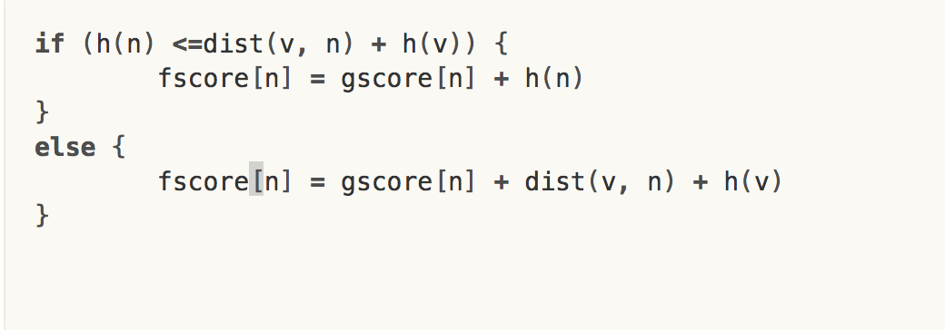

3. Give an Example of a graph search problem which is not mentioned today (e.g. Go, sliding puzzles, 2D grid shortest path). Discuss pros/cons of A\* search, Monte Carlo Tree search or other search algorithms for solving the problem. - A research problem is better.

Example: Go computer game

* A\* search:
  + Pros: Easy to make a simple heuristics function. Then you can enjoy the game with quick response.
  + Cons: Computation efficiency depends on the quality of heuristics function.
* MCTS:
  + Pros: Needless to engineer the heuristics function.
  + Cons: Might iterate the same path or take a lot of computational cost for a far destination.