**Visual Recognition using Machine Learning**

2018/06/20

37-176839 Koichiro Tamura

1. Read one article in CVPR2017, CVPR2018 or ICCV2017, and summarize it in one A4 paper.

paper: Squeeze-and-Excitation Networks

arxiv: <https://arxiv.org/abs/1709.01507>

This paper supposed the new module “Squeeze-and-Excitation (SE) block” for machine image recognition. SE block can extract informative features by fusing spatial and channel-wise information together within local receptive fields as follows.

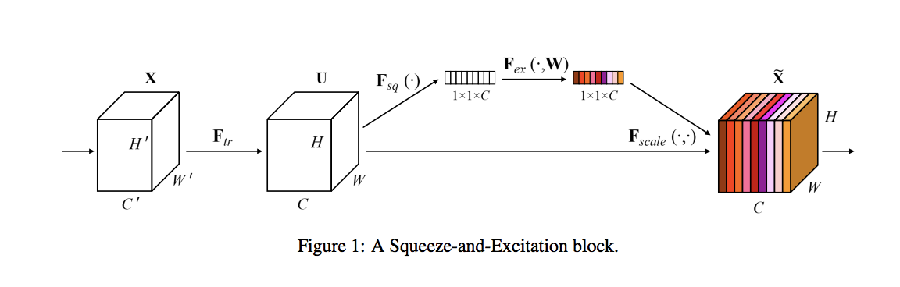

SENets formed the foundation of our ILSVRC 2017 classification submission which won first place and significantly reduced the top-5 error to 2.251%, achieving a ~25% relative improvement over the winning entry of 2016.

And I summarized this paper and related works @ <http://deeplearning.jp/english-squeeze-and-excitation-networks/> .

Please read. (Japanese only)