REQUEST FOR TESTING FOR SIMILARITY INDEX

Research Title: TEST
Researcher(s): Alther John P. Esteban, Daxton Jersield D. Tabuan, Bren Webster R. Lorenzo
Contact No.: 09123456789
Email Address: djdtabuan@gmail.com
Type of Research: ☐ Social ☑ Technical

Ma’am/ Sir may I request for the plagiarism check of the abovementioned research. I am entrusting the softcopy of the research to be used for this purpose only. I hereby certify that the information given are true and correct and the research conducted is authentic. I further signify my commitment to revise the paper as per evaluation results.
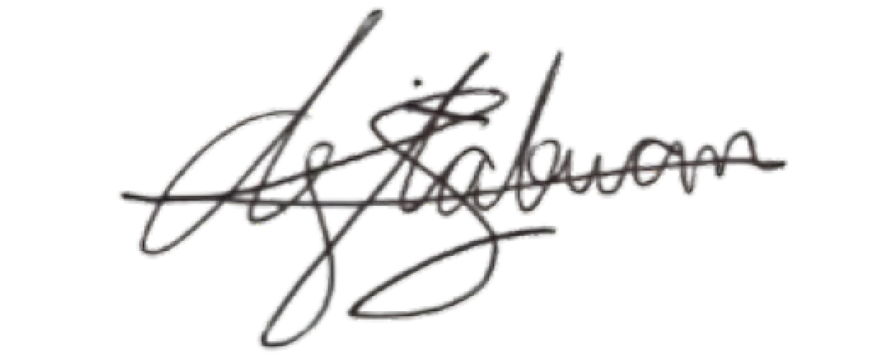
Daxton Jersield D. Tabuan
May 19, 2026
_____________________________ ______________________
Requestor Date
(Signature over Printed Name)

Received by:

_____________________________ ______________________
DRD Staff/Turnitin Instructor Date
(Signature over Printed Name)

Application Number: ________ Official Receipt Number: ________

