REQUEST FOR TESTING FOR SIMILARITY INDEX

Research Title: The Collaborative Thesis Capstone System for Undergraduate Students with AI Support
Researcher(s): Bren Webster Lorenzo, Alther John Esteban
Contact No.: 03123456789
Email Address: example@gmail.com
Type of Research: ☐ Social ☑ Technical

Ma’am/ Sir may I request for the plagiarism check of the abovementioned research. I am entrusting the softcopy of the research to be used for this purpose only. I hereby certify that the information given are true and correct and the research conducted is authentic. I further signify my commitment to revise the paper as per evaluation results.
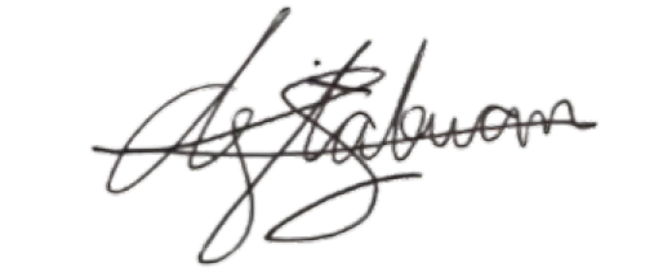
Bren Webster Lorenzo
June 08, 2026
_____________________________ ______________________
Requestor Date
(Signature over Printed Name)

Received by:

_____________________________ ______________________
DRD Staff/Turnitin Instructor Date
(Signature over Printed Name)

Application Number: ________ Official Receipt Number: ________

