**The University of Northampton**

**Web Development 1 Assignment**

**Submitted by:**

Name: Mandeep Koirala

UN ID: 16418511

Submission date: 7th April 2017

GitHub Live URL: <https://123una975.github.io/work_web_mk>

**Contents Page**

1. Introduction 1

2. Designs 2

2.1 Sketches 2

2.2 Wireframes 5

2.2.1 Desktop Wireframes 5

2.2.2 Mobile Wireframes 7

2.3 Pages 11

2.3.1 Desktop Pages 11

2.3.2 Design Structure 13

3. Work progress 14

3.1 Progression 14

3.2 Good practices 16

3.3 Collaboration 16

4. Testing 17

5. Conclusion 18

6. References 19

**1. Introduction**

This is a project for my portfolio. I researched on different portfolio sites before designing one for mine. Also I researched on good practices and some mark-up codes to make my portfolio simple yet attractive. I took a look at <https://www.w3schools.com> and learned to enhance the design of pages while putting the contents properly in pages as in <https://joel.sh/about>.

**2. Designs**

Before developing actual pages, I first drew sketches of designs in copy. I made sketches for both the desktop and mobile pages which helped me in creating responsive pages easily and effectively. Then I designed wireframes from those sketches. With the wireframes, finally I developed the pages of my portfolio.

**2.1 Sketches**

All the sketches I made are shown below.

This is my sketch for home page

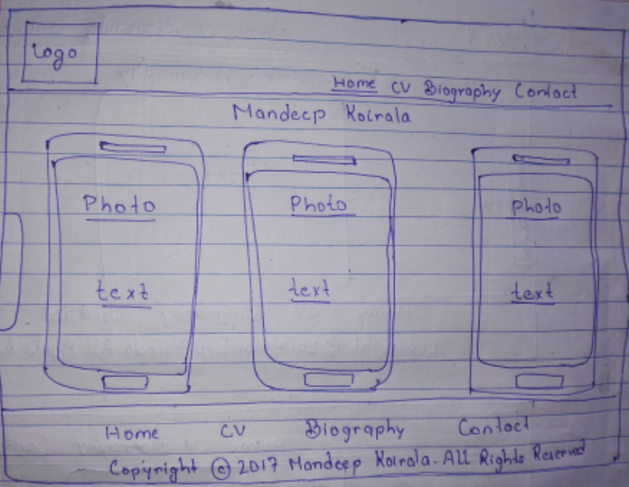

This is the sketch for my CV page

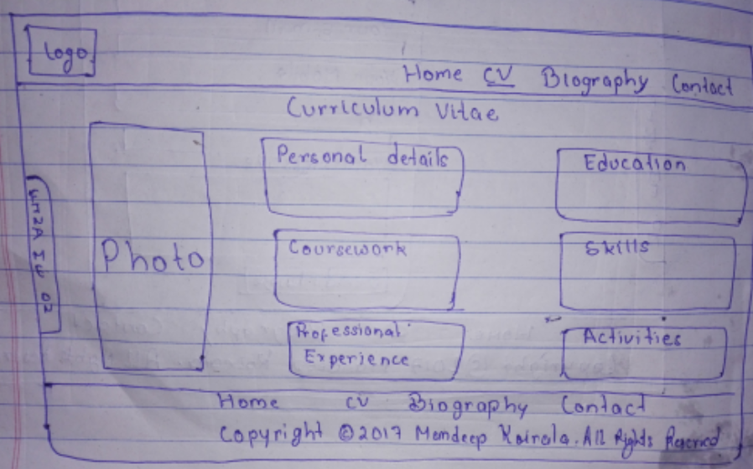

This is the sketch for my Bio page

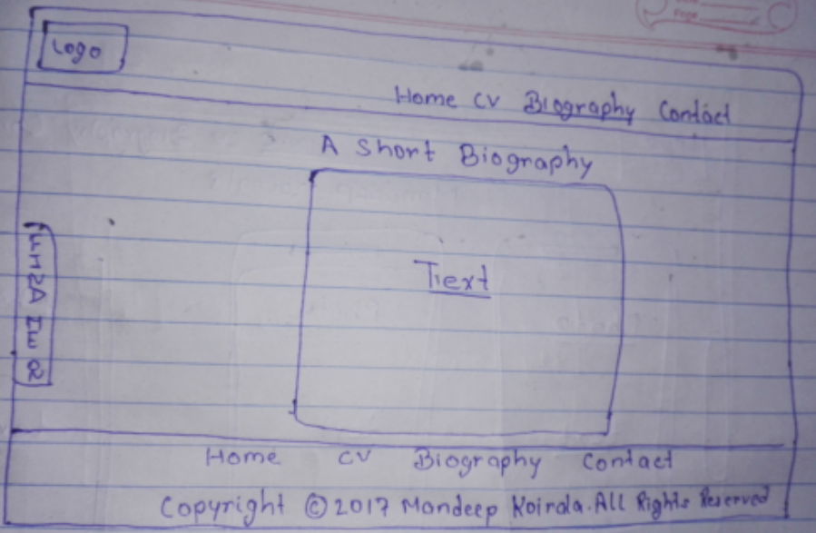

This is the sketch for Contact page

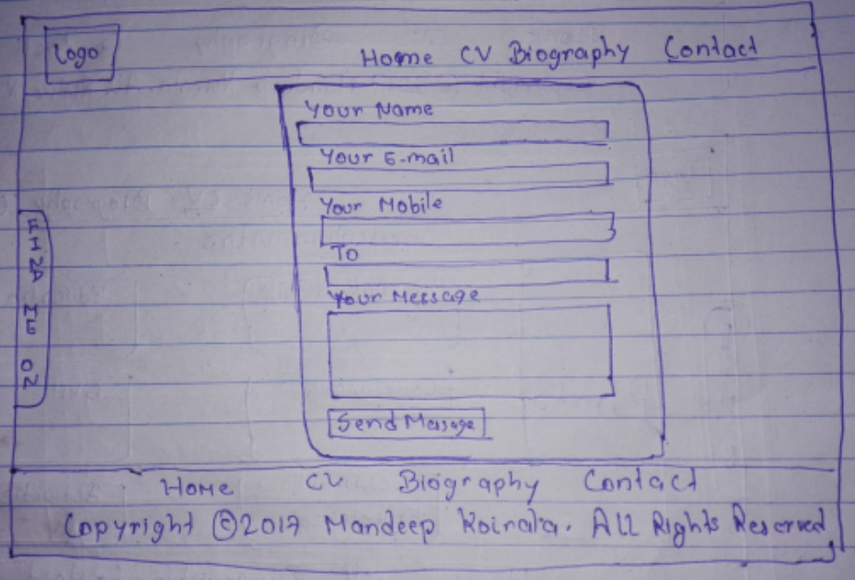

**2.2 Wireframes**

**2.2.1 Desktop Wireframes**

This is the wireframe for homepage

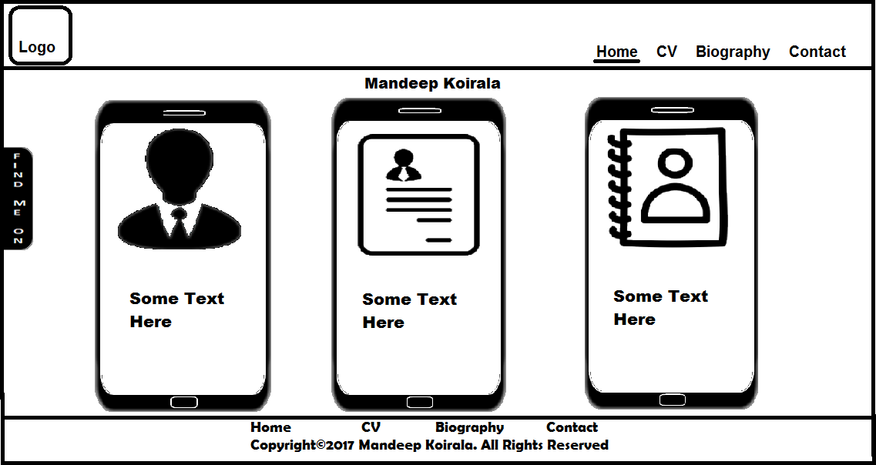

This is the wireframe for CV page

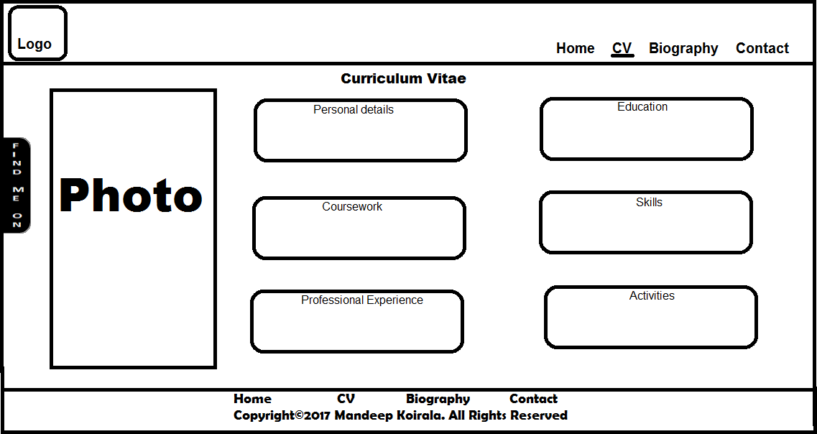

This is the wireframe of Bio page

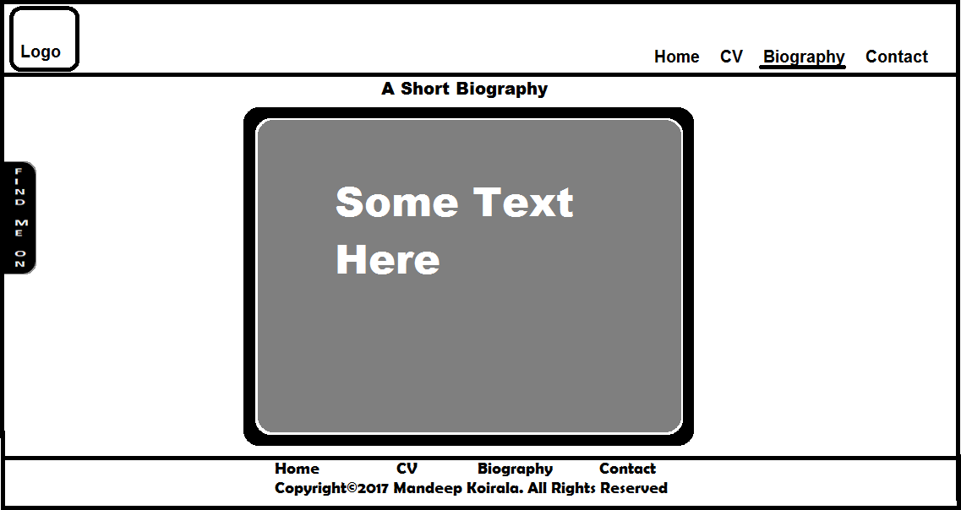

This is the mobile sketch of Contact page

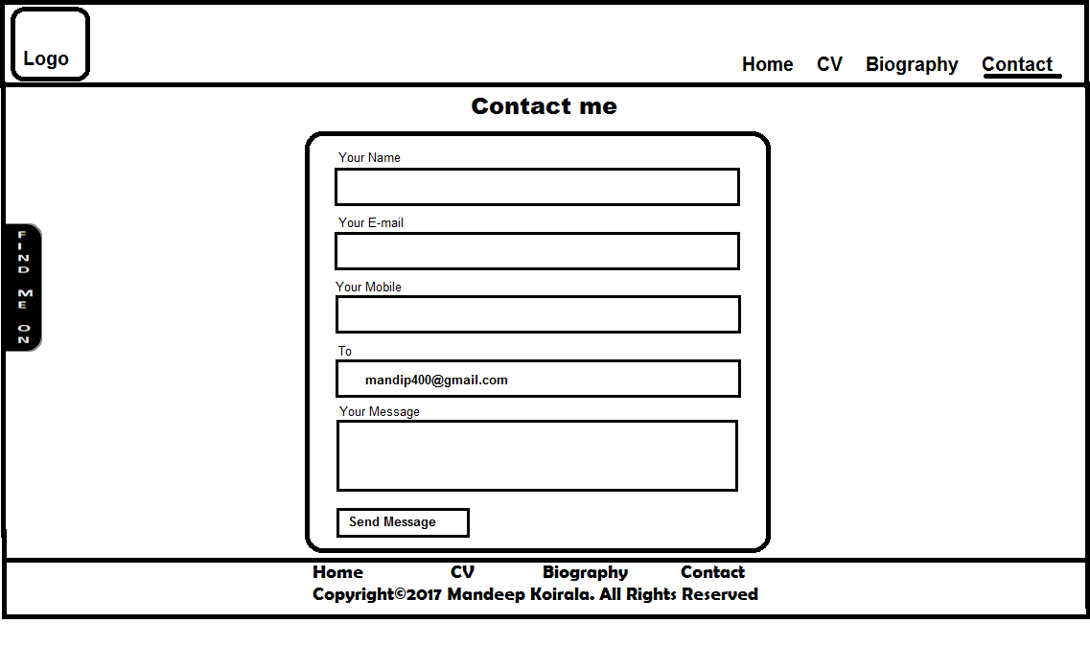

**2.2.2 Mobile Wireframes**

This is the mobile wireframe of home page

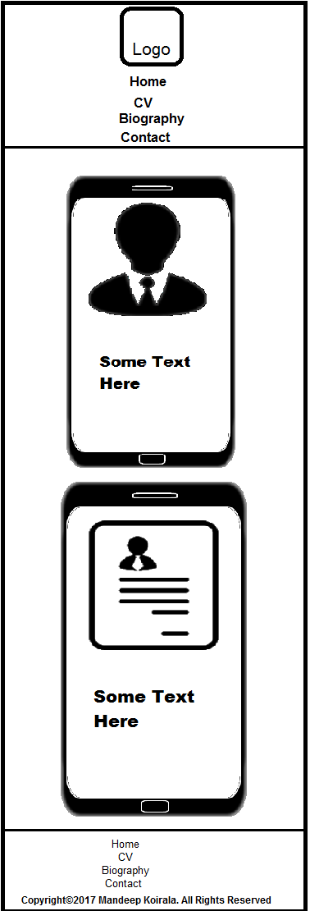

This is the mobile wireframe of CV page

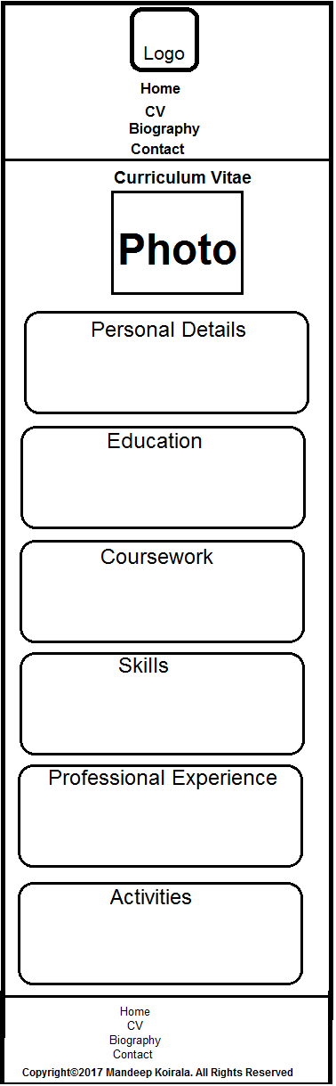

This is the mobile wireframe of Bio page

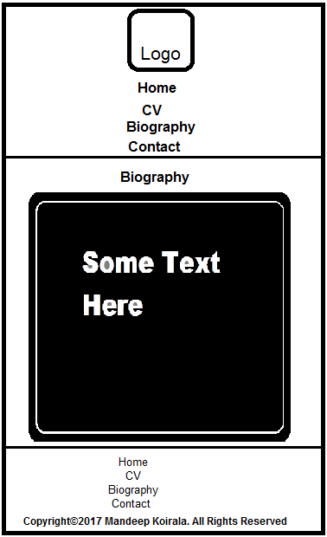

This is the mobile wireframe of Contact page

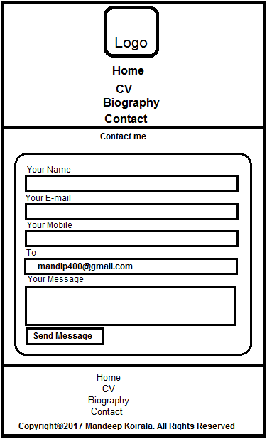

**2.3 Pages**

After different researches and after constructing sketches and wireframes, I developed the pages for my portfolio. I also researched on themes for the pages and finally applied dark theme for the portfolio. The combination of black and grey colour is used

Header and footer of all pages are same. Header contains logo for my portfolio pages and navigation menus. The background colour of menus changes on hover to make pages more user-interactive. Footer also contains navigation menus and copyright text. Moreover, social media link is one common feature in all the pages. The block containing links to my social media profiles shows up on hover. Header and footer have black background while the main section of the pages has a shade of grey colour.

**2.3.1 Desktop Pages**

Below is the page for home page. It contains my name and a photo in a block. Other blocks contain links to my CV and biography pages. All the blocks are styled to create mobile-shaped designs.

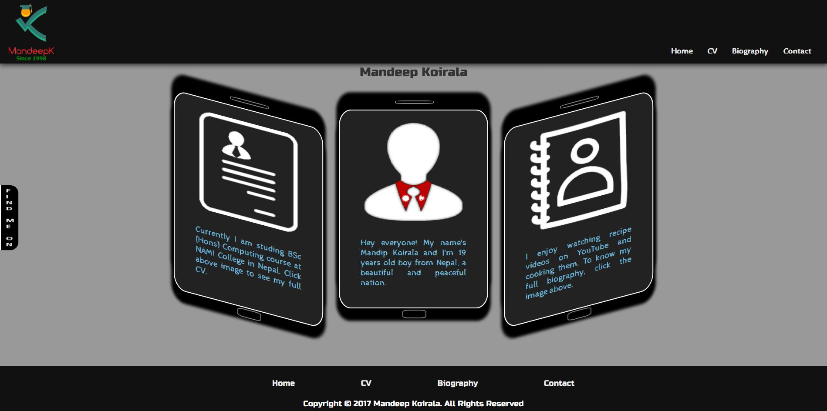

Below is the page for CV page. It contains my picture and CV details. CV details are separated in different blocks for specific details. I also added icons for each title for enhancing user-interaction.

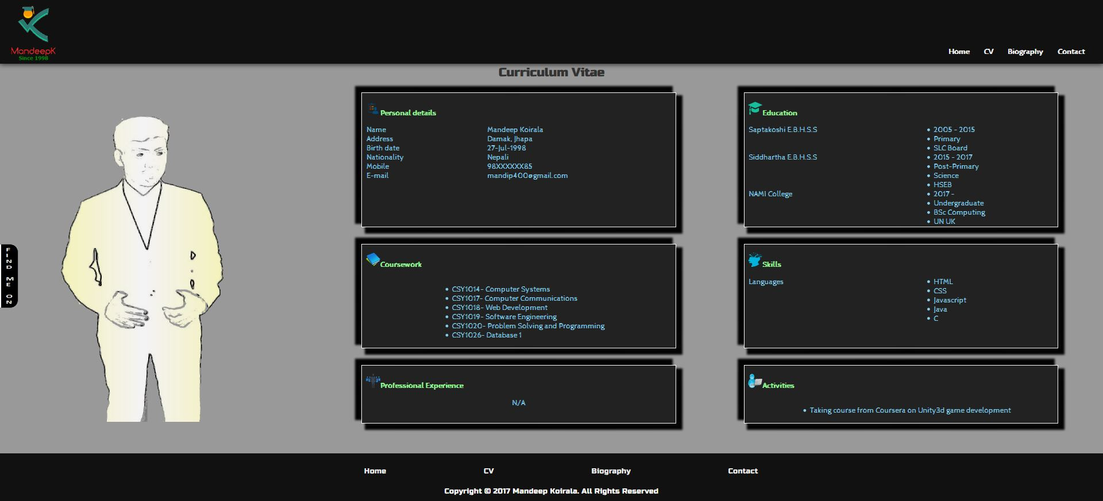

Below is the page for biography page. It contains my short biography. I placed the biography inside a box and applied shadow and border to the box for better look.

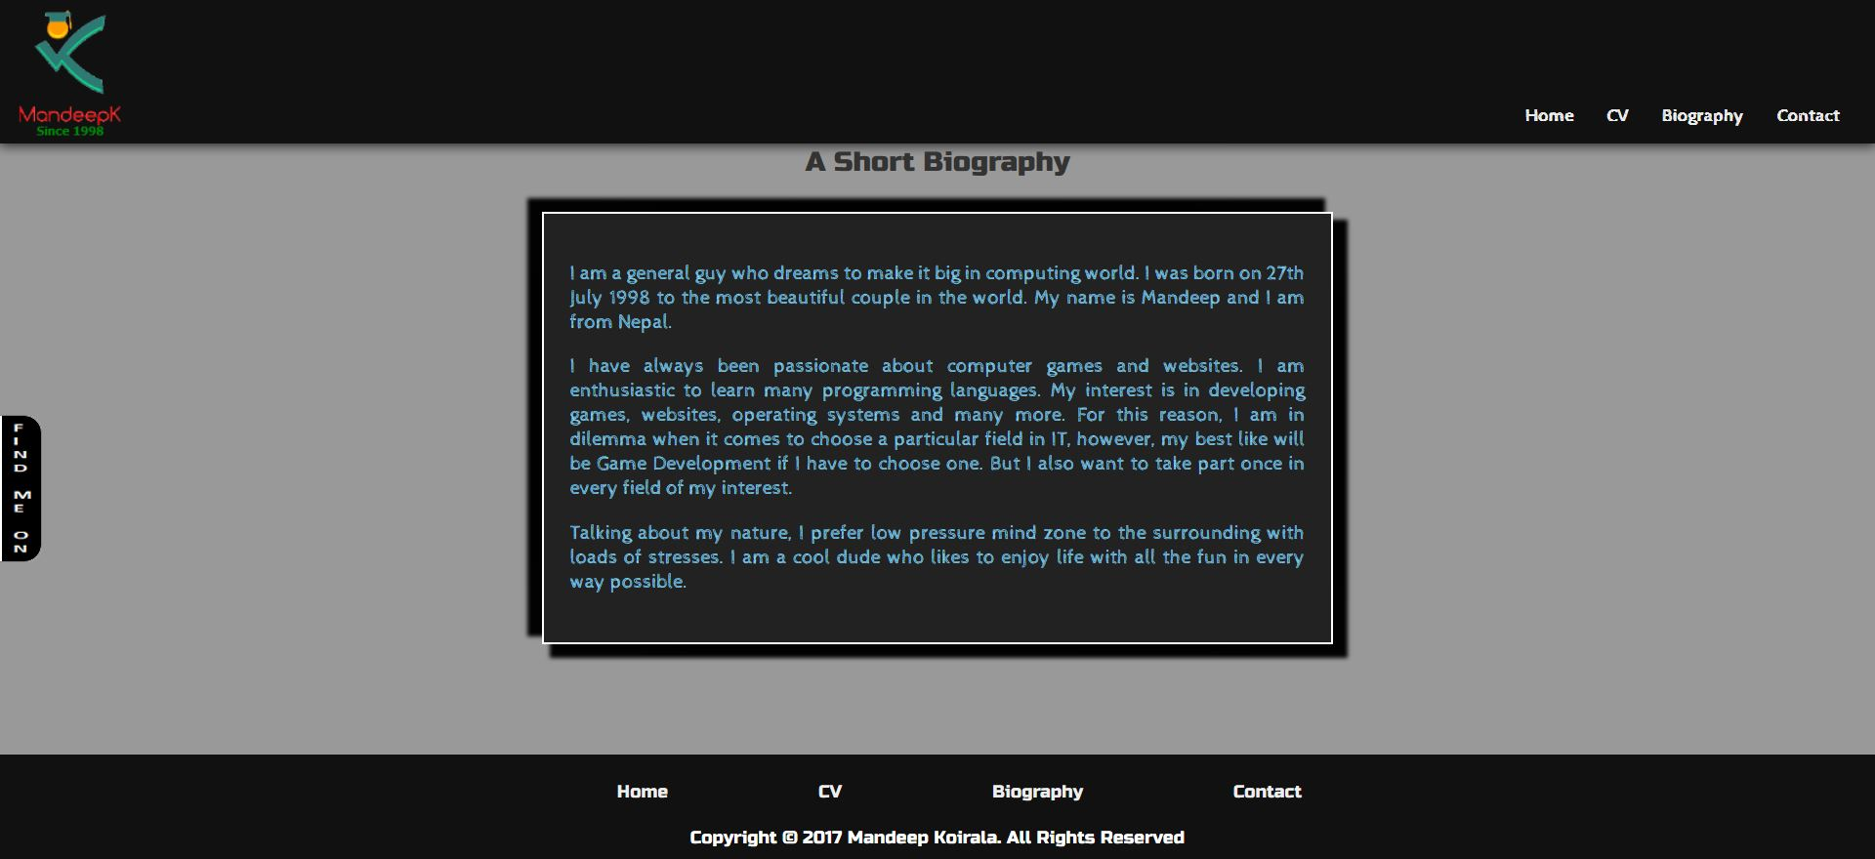

Below is the page for contact page. Contact form is included in this page. Name, contact number, email and message of a person can be entered. The form is static and nothing happens on clicking the submit button.

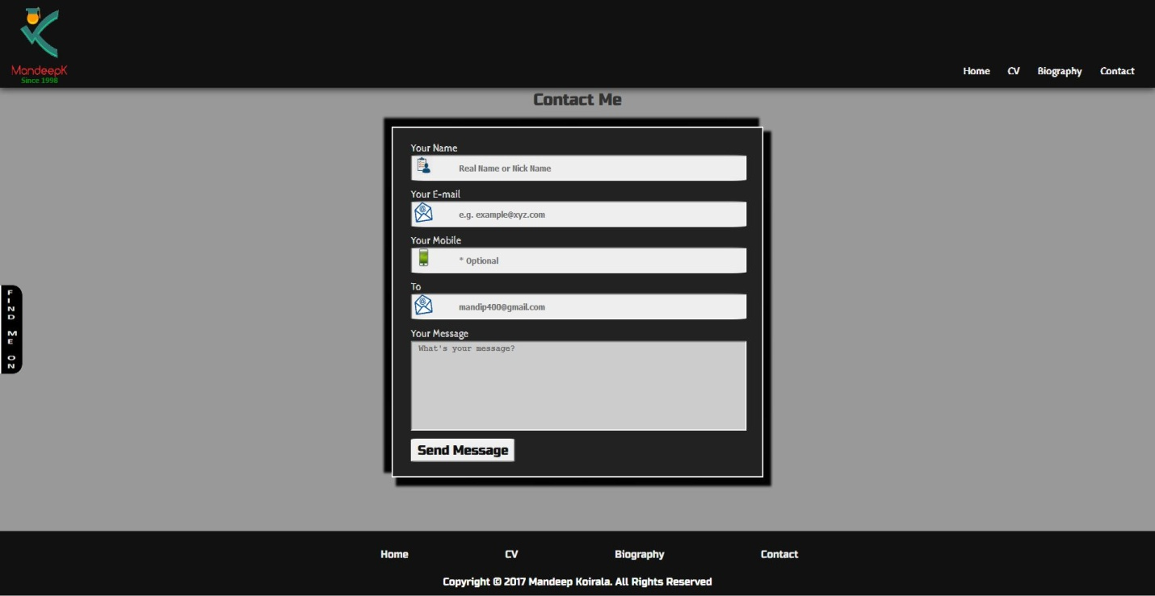

**2.3.2 Design Structure**

For the entire project, I have used flex structure in designs. Flex structure makes it easy to place contents in a page. It is easy to centre or align contents in a page using flex structure. There are several other structures that can be used in styling pages but with some disadvantages and hard to maintain than flex. Float structure needs to be cleared. Tabular data can exceed cell margin and is hard to maintain. Because of its easiness and advantages, I have used flex for the project.

**3. Work Progress**

**3.1 Progression**

The project took around 8 weeks to complete. During this time, I changed the designs of the pages for many times. I changed the colour combination of pages and style of some blocks to make a completely different look of the project. After many amendments and revisions, I finally chose a design for the portfolio shown in above images.

Home pages of some of my amendments are shown below:

This is the home page of the first design I made.

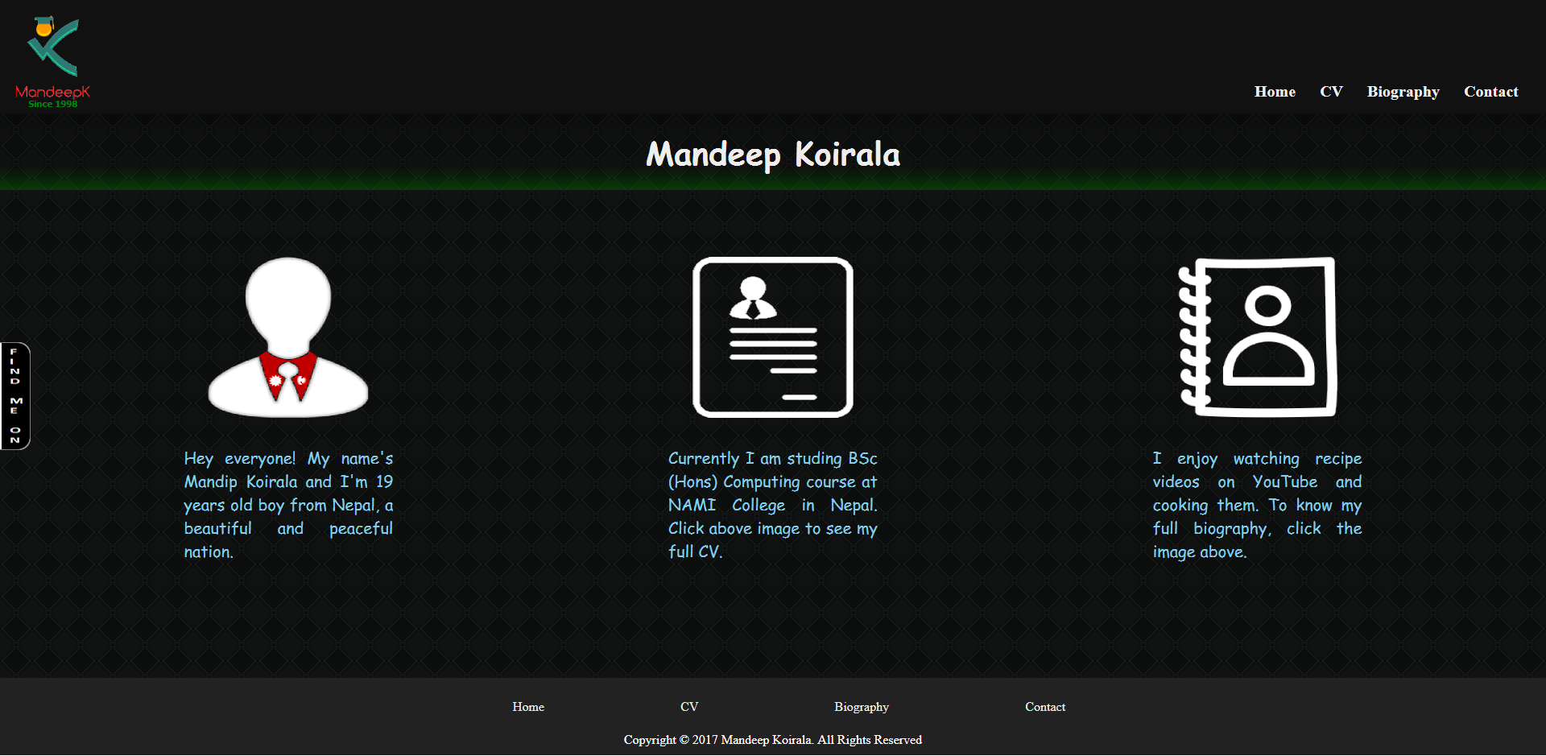

This is the home page of second design I made.

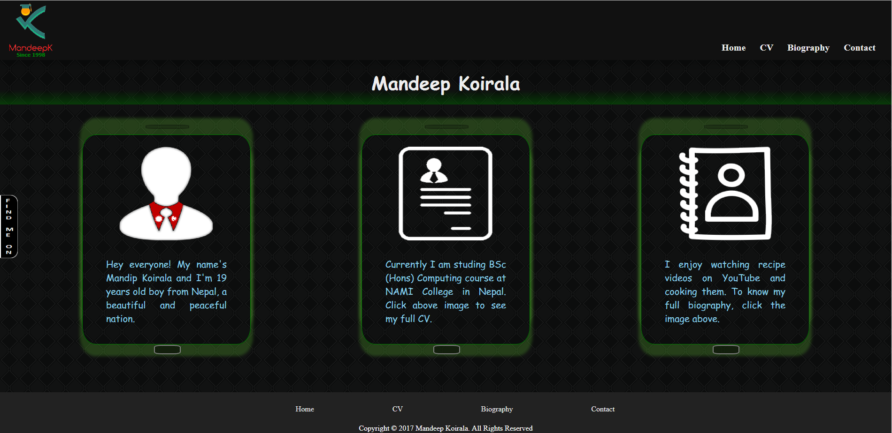

This is the home page of the third design made by me.

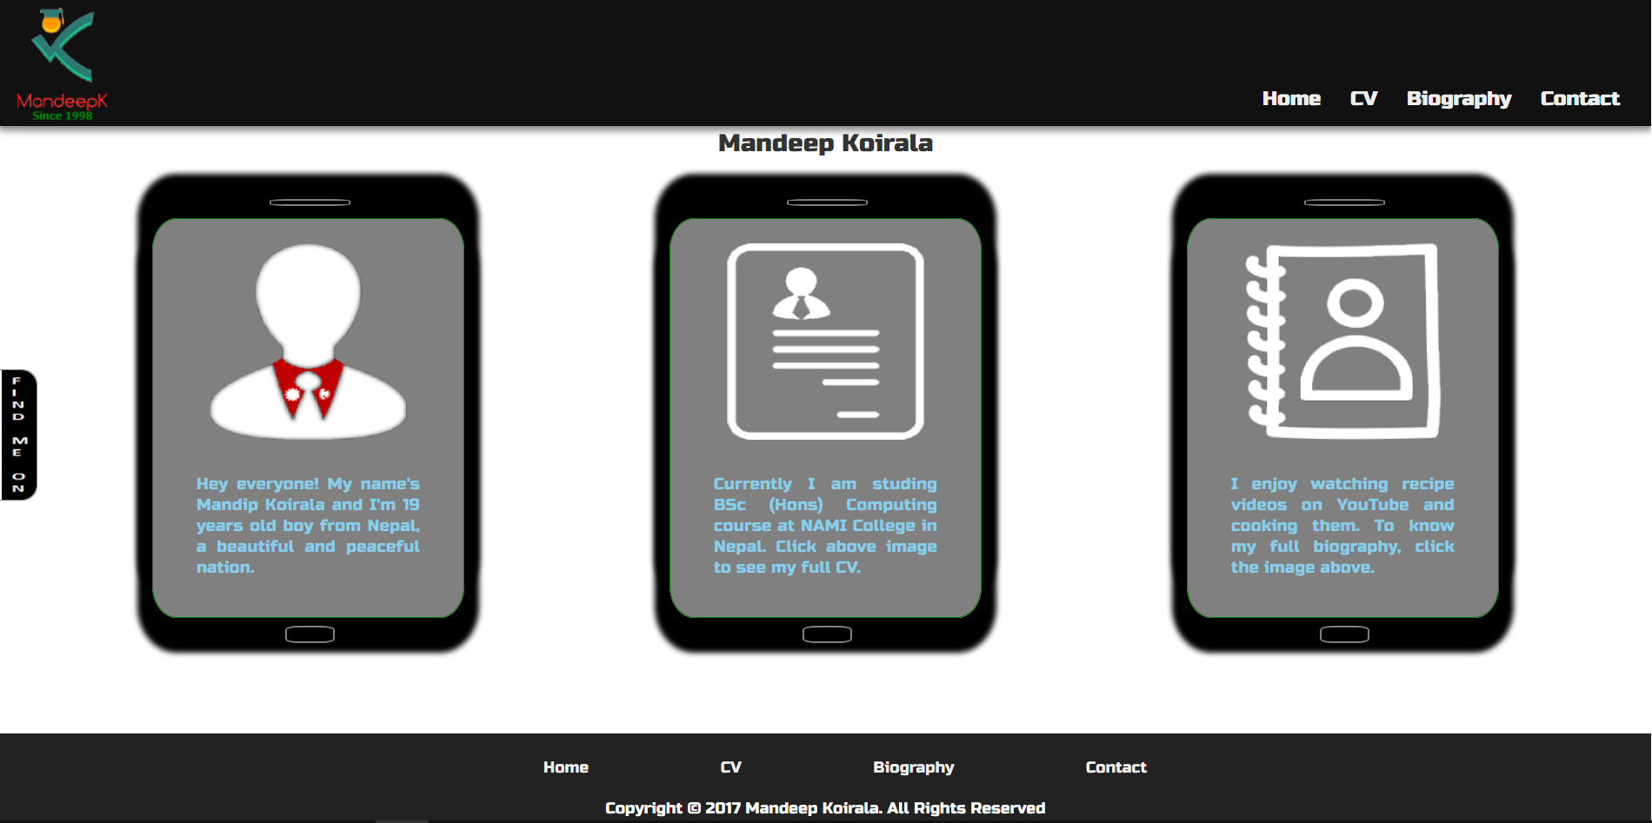

And this is the fourth design before I finalized the design as shown in section 2.3.

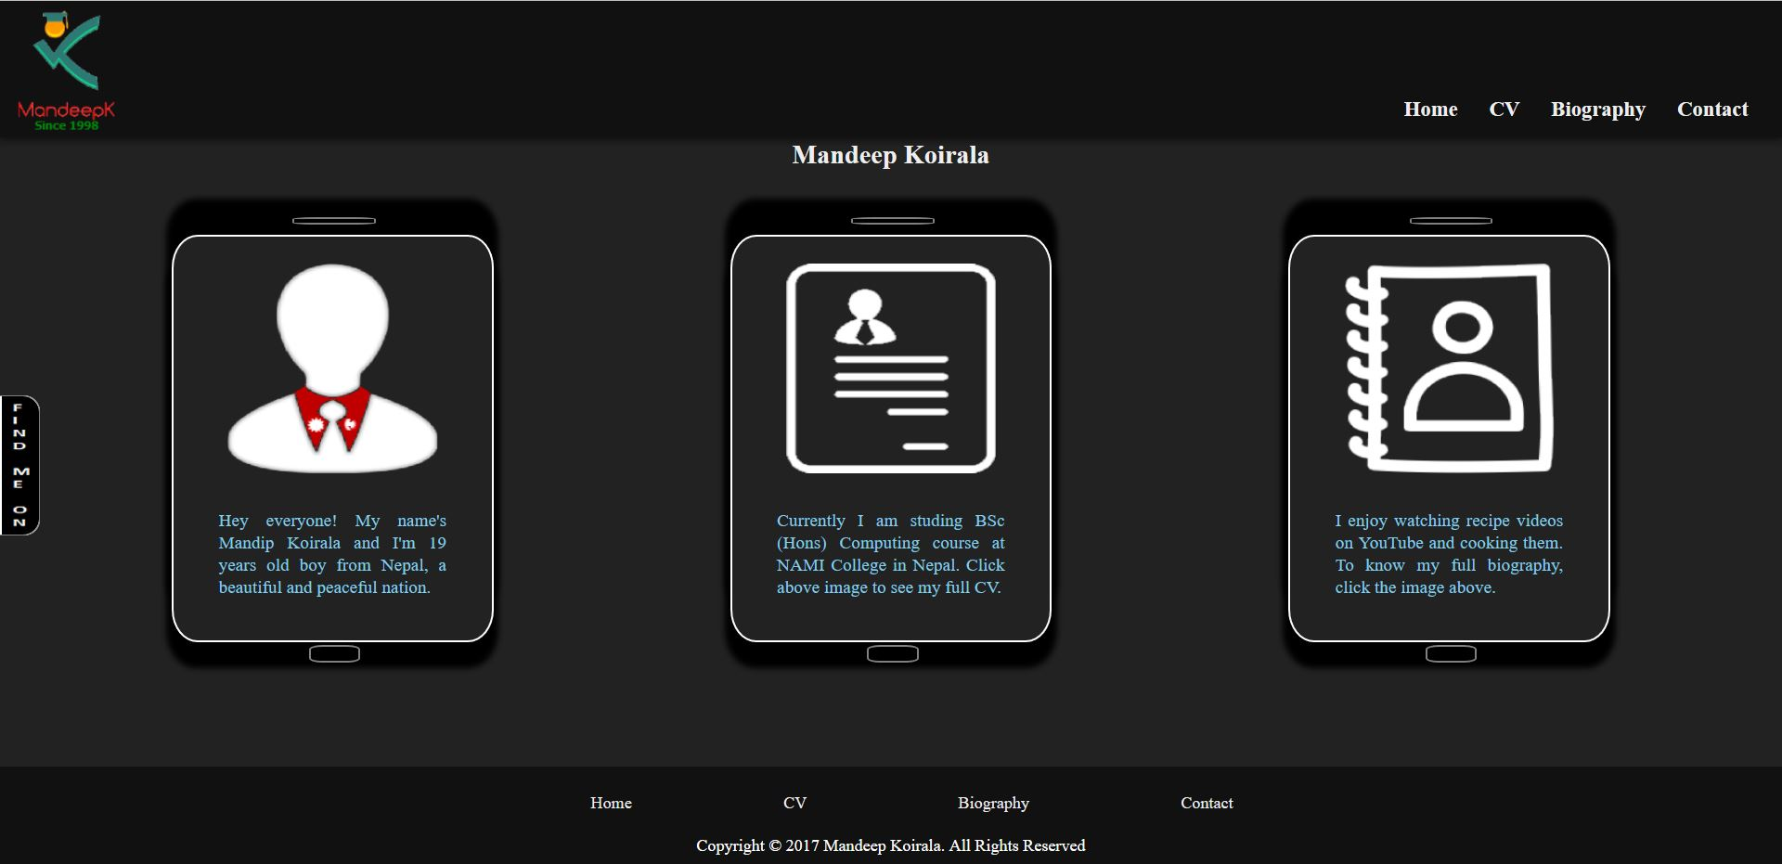

**3.2 Good Practices**

This project is developed keeping in mind some of the good practices. The practises used are listed below:

1. Titles of pages are clearly mentioned and images are optimised to speed up the loading time.

2. Indentation of source codes is properly managed for better readability to other developers and the pages are made responsive.

3. Different blocks are separated by certain margins and borders usage and other styling are done for better readability by users.

**3.3 Collaboration**

During this project development, I learned from different sites about good designs and also collaborated with friends to share ideas. I mostly collaborated with Punam Dahal during the development. Her UN ID is 16418511. We shared our researched ideas on designing good user-interactive system and applied individually in our projects.

**4. Testing**

The pages and CSS files are validated for HTML5 and CSS3.

Validation of home page

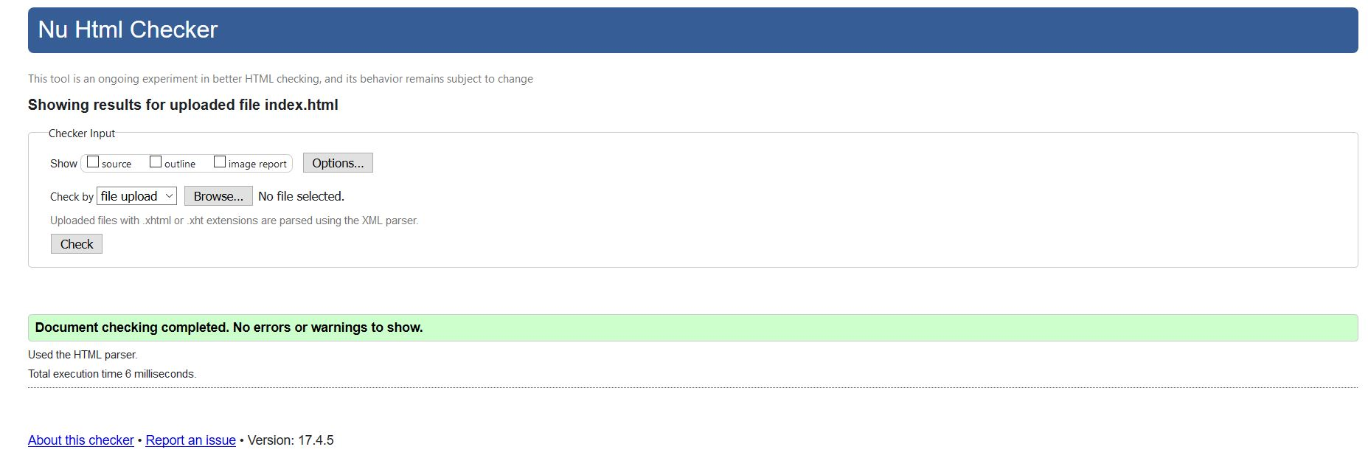

Validation of common.css

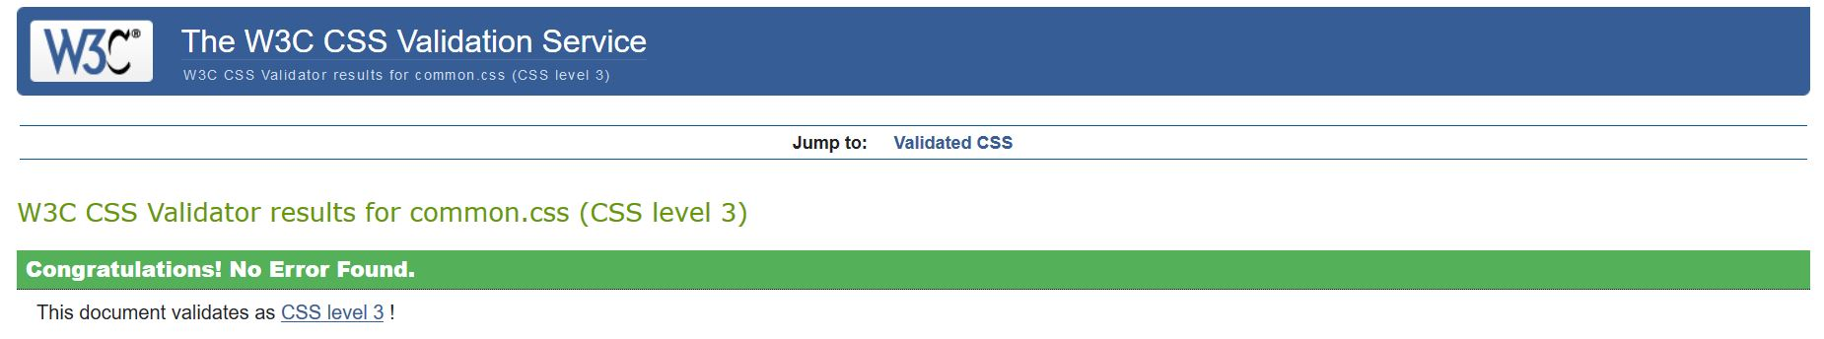

Other files are also error free.

**5. Conclusion**

After different researches on designs, I finally developed the portfolio pages. I drew sketches and wireframes to support the design of actual pages for the project. Several changes were made to the design and finally a design is chosen. This project is an outcome of 8 weeks’ researches and works.

**6. References**

For developing this project, I took a look at some other sites to gather information and ideas on proper design techniques.

I visited the below mentioned site and implemented the technique of attractive use of photo in my CV page.

Joel (2015) About Joel. [online]. Available from: <https://joel.sh/about> [Accessed 18 March 2017].

I also looked at w3schools website to learn some html5 and css3 properties to implement in my pages for better look and feel of the project.

W3schools (1999) HTML. [online]. Available from: <https://www.w3schools.com> [Accessed 10 March 2017].