
EDMA3 Resource Manager
User Guide

IMPORTANT NOTICE

Texas Instruments Incorporated and its subsidiaries (TI) reserve the right to make corrections, modifications, enhancements, improvements, and other changes to its products and services at any time and to discontinue any product or service without notice. Customers should obtain the latest relevant information before placing orders and should verify that such information is current and complete.

TI assumes no liability for applications assistance or customer product design. Customers are responsible for their products and applications using TI components. To minimize the risks associated with customer products and applications, customers should provide adequate design and operating safeguards.

TI does not warrant or represent that any license, either express or implied, is granted under any TI patent right, copyright, mask work right, or other TI intellectual property right relating to any combination, machine, or process in which TI products or services are used. Information published by TI regarding third-party products or services does not constitute a license from TI to use such products or services or a warranty or endorsement thereof. Use of such information may require a license from a third party under the patents or other intellectual property of the third party, or a license from TI under the patents or other intellectual property of TI

Mailing Address:
Texas Instruments
Post Office Box 655303, Dallas, Texas 75265

Copyright © 2009, Texas Instruments Incorporated

LICENSE

This work is licensed under the Creative Commons Attribution-Share Alike 3.0 United States License. To view a copy of this license, visit http://creativecommons.org/licenses/by-sa/3.0/us/ or send a letter to Creative Commons, 171 Second Street, Suite 300, San Francisco, California, 94105, USA.

Preface
Read This First
About This Manual
This User’s Manual serves as a software programmer’s handbook for working with the EDMA3 Resource Manager Version 02.12.xx.xx. This manual provides necessary information regarding how to effectively install, build and use EDMA3 Resource Manager in user systems and applications.
This manual provides details regarding how the EDMA3 Resource Manager is Architected, its composition, its functionality, the requirements it places on the hardware and software environment where it can be deployed, how to customize/ configure it to specific requirements, how to leverage the supported run-time interfaces in user’s own application etc.,
This manual also provides supplementary information regarding steps to be followed for proper installation/ un-installation of the EDMA3 Resource Manager. Also included are appendix sections on related Glossary, Web sites and Pointers for gathering further information on the EDMA3 Resource Manager.
Terms and Abbreviations

Term/Abbreviation | Description
EDMA | Enhanced Direct Memory Access
EDMA3 Controller | Consists of the EDMA3 channel controller (EDMA3CC) and EDMA3 transfer memory access controller(s) (EDMA3TC). Is referred to as EDMA3 in this document.
DMA | Direct Memory Access
QDMA | Quick DMA
TCC | Transfer Completion Code (basically Interrupt Channel)
ISR | Interrupt Service Routine
CC | Channel Controller
TC | Transfer Controller
RM | Resource Manager
TR | Transfer Request.  A command for data movement that is issued from the EDMA3CC to the EDMA3TC. A TR includes source and destination addresses, counts, indexes, options, etc.
Notations
Explain any special notations or typefaces used (such as for API guides, special typefaces for functions, variables, etc.)
Information about Cautions and Warnings
This book may contain cautions and warnings.

This is an example of a caution statement.

A caution statement describes a situation that could potentially damage your software or equipment.


This is an example of a warning statement.

A warning statement describes a situation that could potentially cause harm to you.

The information in a caution or a warning is provided for your protection. Please read each caution and warning carefully.

Related Documentation
Internal
      - EDMA3 Channel Controller (TPCC), version 3.0.2 (Available at PDS)
      - EDMA3 Transfer Controller (TPTC), version 3.0.1 (Available at PDS)
Trademarks
The TI logo design is a trademark of Texas Instruments Incorporated. All other brand and product names may be trademarks of their respective companies.
Revision History

Date | Author | Revision History |  | Version
October 16, 2008 | Anuj Aggarwal | First release supporting platform DA830 on BIOS 6. |  | 02.00.00.XX
June 3, 2009 | Anuj Aggarwal | Patch release for DA830 platform on BIOS 6. |  | 02.00.01.XX
December 7, 2009 | Anuj Aggarwal | a) Migration to new BSD license  b) Added support for TCI6498 platform.  See release notes for more details. |  | 02.10.00.XX
April 9,2010 | Imtiaz SMA | Added support for the C6748 and OMAPL138 platforms. See release notes for more details. |  | 02.10.01.XX
May 12, 2010 | Vinay K Nooji | Added support for the OMAPL138 ARM platform. See release notes for more details. |  | 02.10.02.XX
Sep 6, 2010 | Sundaram Raju | Support for the TI816X Simulator & platform, C6472 & TCI6486 platform and TI814X platform have been added. |  | 02.10.03.XX
Oct 12, 2010 | Sundaram Raju | Support for C66x(ELF) in Generic library of Resource Manager and bug fixes |  | 02.10.04.XX
Feb 02, 2011 | Sundaram Raju | Support for Make based build for all the libraries and sample applications |  | 02.11.00.XX
Feb 15, 2011 | Raghu Nambiath  Sundaram Raju | Additional support for C66x platforms TCI6608/TCI6616/C6670/C6678 |  | 02.11.01.XX
Apr 8, 2011 | Prasad Konnur | Addition of TI816x-m3vpss and TI816x-m3video platform to EDMA3LLD |  | 02.11.02.XX
Nov 15, 2011 | Prasad Konnur | Addition of M3 support for TI814X and A8 support for TI816X and bug fixes |  | 02.11.03.XX
Jan 27, 2012 | Murtaza Gaadiwala | Addition of Appleton (TCI6614) support |  | 02.11.04.XX
Mar 9, 2012 | Prasad | Addition of TI811X platform support |  | 02.11.05.01
Aug 10, 2012 | Prasad Konnur | Bug Fixes |  | 02.11.06.01
May 13, 2013 | Prasad Konnur | Addition of TDA2XX support |  | 02.11.07.03
May 17, 2013 | Murtaza Gaadiwala | Addition of TCI6638K2K support |  | 02.11.07.04
July 12, 2013 | Prasad Konnur | TDA2XX return region number at runtime based on core and Bug fix |  | 02.11.08.XX
July 18, 2013 | Murtaza Gaadiwala | Addition of TCI6636K2H support |  | 02.11.09.XX
Sept 23, 2013 | Sivaraj R | Addition of GCC Compiler build for A8 for Centaurus and bug fix |  | 02.11.10.XX
Dec 20, 2013 | Arvind S | Ported EDMA lld to EVE core to access EVE internal EDMA instance. |  | 02.11.11.XX
Dec 24, 2013 | Arvind S | Bug fixes |  | 02.11.11.XX
Jan 7, 2014 | Arvind S | Removed warnings and bug fix |  | 02.11.11.XX
Feb 19, 2014 | Ivan P | Merged in user space support for Keystone 2 devices |  | 02.11.11.XX
May 30, 2014 | Prasad Konnur | Addition of tda3xx and dra72x platform support. |  | 02.11.12.XX
June 30, 2014 | Prasad Konnur | Bug Fixes |  | 02.11.14.XX
August 25,  2014 | Sunil  MS | Added tda3xx and dra72x which were missing in package.xs file of RM. |  | 02.11.14.XX
November 4,  2014 | Sunil  MS | Misra C Compliance of edma3lld and bug fixes. |  | 02.12.00.XX
August 10,  2015 | Hongmei Gou | Addition of AM335x and AM437x suppor | 02.12.01.XX

Contents
Read This First iii
About This Manual iii
Terms and Abbreviations iv
Notations v
Information about Cautions and Warnings v
Related Documentation v
Internal v
Trademarks vi
Revision History vii
Contents ix
Tables xi
EDMA3 Resource Manager Introduction 1-1
1.1 Overview 1-2
1.1.1 System Partitioning 1-2
1.1.2 Supported Services 1-3
Installation Guide 1-2-1
2.1 Component Folder 2-2-2
2.2 Development Tools Environment(s) 3-2-4
2.2.1 Development Tools 4-2-4
2.3 Installation Guide 5-2-5
2.3.1 Installation and Usage Procedure 6-2-5
2.3.2 Un-installation 7-2-5
2.4 Integration Guide 8-2-6
2.4.1 Building EDMA3 Libraries 9-2-6
2.4.2 Build Options 10-2-8
Run-Time Interfaces/Integration Guide 11-1
3.1 Symbolic Constants and Enumerated Data types 12-2
3.2 Data Structures 13-12
3.2.1 RM Global Error Callback 14-12
3.2.2 EDMA3_RM_GblErrCallbackParams 15-12
3.2.3 EDMA3_RM_GblConfigParams 16-12
3.2.4 EDMA3_RM_InstanceInitConfig 17-14
3.2.5 EDMA3_RM_Param 18-17
3.2.6 EDMA3_RM_MiscParam 19-17
3.2.7 EDMA3_RM_GblXbarToChanConfigParams 20-17
3.2.8 EDMA3_RM_ResDesc 21-18
3.3 API Specification 22-21
3.4 API Usage Example 23-22
EDMA3 Resource Manager Porting 24-31
4.1 Getting Started 25-32
4.2 Step-by-Step procedure for porting 26-34
4.2.1 edma3_<PLATFORM_NAME>_cfg.c: 27-34
4.2.2 Make file for the Resource Manager 28-35

Tables
Table 1: Development Tools/components 29-2-4
Table 2: Build Options 30-2-8
Table 3: Symbolic Constants and Enumerated Data types Table for common header file edma3_common.h 31-2
Table 4: Symbolic Constants and Enumerated Data types Table for EDMA3 Resource Manager Header file edma3_rm.h 32-4

EDMA3 Resource Manager Introduction
This chapter introduces the EDMA3 Resource Manager to the user by providing a brief overview of the purpose and construction of the EDMA3 Resource Manager along with hardware and software environment specifics in the context of EDMA3 Resource Manager Deployment.

  - Overview
This section describes the functional scope of the EDMA3 Resource Manager and its feature set.
A brief definition of the component is provided at this point – its main characteristics and purpose.
    - System Partitioning
EDMA3 peripheral supports data transfers between two memory mapped devices. It supports EDMA as well as QDMA channels for data transfer. This peripheral IP is being re-used in different SoCs with only a few configuration changes like number of DMA and QDMA channels supported, number of PARAM sets available etc.
The EDMA3 peripheral is used by other peripherals for their DMA needs thus the EDMA3 driver needs to cater to the requirements of device drivers of these peripherals as well as other application software that may need to use the 3rd party DMA services.
The EDMA3 Resource Manager comprises of the following two parts:
      - Physical Resource Manager: This component is responsible for the management of several resources within the EDMA3 peripheral like TCC codes, PARAM entry, DMA and QDMA channels, all global EDMA3 registers, queues etc.
      - Interrupt Manager: This component handles EDMA3 interrupts, which are registered with the underlying OS interrupt handling mechanism by the user. Since interrupts are associated with TCC codes in EDMA3 module, this module provides the functionality of accepting application registration callbacks for TCC codes and calls the callback functions upon receipt of the given interrupt (TCC). Note that the application/driver using the EDMA3 Resource Manager has to register/unregister the Interrupt Handlers with the underlying operating system. The Resource Manager does not do this by itself.
    - Supported Services
Following are the services provided by the Physical Resource Manager:
      - Allocation/de-allocation of EDMA3 resources: It provides interfaces that allow applications to allocate and free EDMA3 resources:
        - EDMA channels
        - QDMA channels
        - PARAM Entries
        - TCC
These resources shall be provided to the instance of the resource manager at run time.
      - Global EDMA3 settings configuration: It provides an interface that can be used by applications to configure global EDMA3 settings. For e.g. number of resources (DMA/QDMA channels, TCCs, PaRAM sets) available, number of Transfer controllers, queue priorities etc.
      - Binding of specific EDMA3 resources: It provides an interface that can be used by applications to bind specific EDMA3 resources like EDMA or QDMA channel with PaRAM Set entries.
      - Multiple RM Instances Support: It supports multiple instances of the Resource Manager, running on the same processor, but managing same/different sets of resources and tied to same/different shadow regions.
      - Read/Write a specific CC register: It provides APIs to read as well as write on a specific Channel Controller Register.
      - Non-RTSC Environment Support: Resource Manager module should gets built in non-RTSC environment also. All the CCS PJT files should come for non-RTSC environment too.
      - IOCTL interface support: EDMA3 Resource Manager shall provide an IOCTL interface for toggling the option whether PaRAM Sets should be cleared during allocation or not. This interface could also be extended in future for other misc requirements.
      - Provides Poll mode support: It also provides APIs which could be used by users, working in Poll Mode. These users don’t rely upon the trasnfer completion interrupts generated by the Channel controller, and instead, Poll the IPR/IPRH register for the transfer completion interrupt bit.
      - Big Endian platforms support: EDMA3 Resource Manager can also be used for big endian platforms.

Following are the services provided by the Interrupt Manager:
      - Error Interrupts Handling: It also handles error interrupts and depending upon the nature of error, either calls a global application callback or TCC callback with the appropriate error status. It provides APIs to register/unregister these error interrupt handlers.
      - Registration and Un-registration of TCC callbacks: It provides an interface that can be called by applications to register/un-register for TCC callbacks. It handles EDMA3 interrupts and calls the respective TCC callback function with appropriate status.
      - Map Cross bar events to the DMA channels: It provides and interface than can be used to map the cross bar mapped events to the specific DMA channel.

Installation Guide
This chapter discusses the EDMA3 Resource Manager installation, how and what software and hardware components to be availed in order to complete a successful installation of EDMA3 Resource Manager.

  - Component Folder
Upon installing the EDMA3 Resource Manager User's Guide, the following directory structure is found in the main directory.
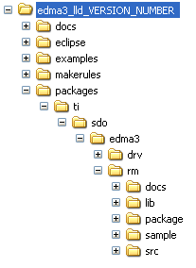
Figure 1: EDMA3 Resource Manager User's Guide Directory Structure

The sections below describe the folder contents:
edma3_lld_<<version_number>>
Top level installation directory. Contains the source code, examples and the documents.
docs
Contains release notes for EDMA3 Driver and Resource Manager.
eclipse
Contains eclipse related files for CCSv4.
examples
Contains the stand-alone applications for EDMA3 Driver (for all the supported platforms) and the DAT example.

makerules
Contains the common makerules required to build the libraries and the sample applications.
packages
All components (Driver, Resource Manager, sample OS-abstraction layers etc) fall under packages/ti/sdo/edma3 directory, under their individual directories. For e.g., EDMA3 Resource Manager lies under packages/ti/sdo/edma3/rm folder, sample initialization library for EDMA3 Resource Manager lies under packages/ti/sdo/edma3/rm/sample folder etc.
- rm -> Top level folder for the Resource Manager
- rm\docs -> User guide, datasheet etc.
- rm\lib -> Resource Manager libraries for all the supported platforms.
- rm\package -> XDC related meta files for the module RM
- rm\sample -> Sample code for how to use the Resource Manager, along-with the pre-built libraries for the same.
- rm\src -> Source files for Resource Manager.
Just to clarify, the sample folder inside the edma3/rm folder DOESN’T contain the sample applications. It provides the:
- Sample initialization code to properly configure the EDMA3 hardware, and,
- Sample OS abstraction layer to provide the OS-specific hooks to the EDMA3 package.
This sample code is provided for reference purpose only. To start with, the user is advised to use the sample code/library as it is, and later modify/create his/her own initialization code, as per the requirements.
The stand-alone applications are provided in the top level examples folder as mentioned above. Please note that these examples use the above mentioned sample initialization/OS abstraction libraries and the EDMA3 Driver libraries.
  - Development Tools Environment(s)
This section describes the development tools environment(s) for software development with EDMA3 Resource Manager. It describes the tools used and their setup, for each supported environment.
    - Development Tools

Describe here the tools that need to be installed, the installation order and specific configuration. Including: 3rd party components/ libraries, Operating system and auxiliary Tools.

Table 1: Development Tools/components

Development tool/ component | Version | Comments
Code Composer Studio (CCS) | 5.5.0 | IDE
C6x Code Gen Tools | 7.4.4 | Code generation utilities
TMS470 Code Gen Tools | 5.1.5 | Code generation utilities
ARP32 Code Gen Tools | 1.0.2 | Code generation utilities
DSP BIOS | 6.40.03.39 | Operating System
XDC tool chain | 3.30.04.52 | XDC tools
TCI6608/TCI6616 Simulator | 1.0.0 | Simulator

  - Installation Guide
This section describes the EDMA3 LLD installation and un-installation.
    - Installation and Usage Procedure
- Install the products mentioned in the development tools requirements section, as per instructions provided along with the products.
- Install the EDMA3 package by untarring the tar.gz file into preferred drive/folder.
- After untarring, create an environment variable “EDMA3LLD_BIOS6_INSTALLDIR” with its value as the current EDMA3 installation directory. This environment variable can be used by other users of EDMA3 package for e.g. BIOS PSP drivers package.
    - Un-installation
- Uninstall the EDMA3 package by simply deleting the install directory.
- Un-install the products mentioned in the development tools requirements section as per the instructions provided with the product.
  - Integration Guide
This section describes the EDMA3 LLD package usage. The package provides pre-built libraries for all the different components: Resource Manager along with their sample initialization libraries etc. Moreover, demo applications are also provided to check the basic functionality for the supported components.
    - Building EDMA3 Libraries
The EDMA3 package contains pre-built libraries for all EDMA3 components. But user can also build them by following the below mentioned steps in case of source code modification or some other specific use cases described below.
- Install the products mentioned in the development tools requirements section (section 2.2), as per instructions provided along with the products.
- Change the variables in the makerules\env.mk as follows
  - INTERNAL_SW_ROOT: to the path where EDMA3LLD is installed
  - EXTERNAL_SW_ROOT: to the path of the top level directory where all the tools mentioned in section 2.2 are installed. It is required that all the tools are located within a single top level directory as all tools are accessed using relative paths from this variable. Else each variable used for the location of each tool has to be updated with its absolute path in makerules\env.mk
  - UTILS_INSTALL_DIR: to the path where any utility that has the make binary is installed. It can be Cygwin/any utility that has the make compiled for win32 or it can be xdc tools itself as it has make binary as gmake inside it. All illustrations provided here after are for the gmake binary in xdc tools. One can simply use any other utility also by pointing this variable to the install directory of that utility.
  - Always be sure not to have any spaces in the values populated for these variables. If the file/folder name has spaces in between, then use the non-8dot3 file names.
- Set the variables PATH and ROOTDIR in command prompt to the location where make binary is available and EDMA3LLD is installed respectively, like
Z:\edma3_lld_<<version_number>>\packages> set PATH=C:/PROGRA~1/TEXASI~1/xdctools_x_xx_xx_xx
Z:\edma3_lld_<<version_number>>\packages> set ROOTDIR=C:/PROGRA~1/TEXASI~1/edma3_lld_02_11_xx_xx
- Build the required libraries using the gmake command at the command prompt:
Example:
Z:\edma3_lld_<<version_number>>\packages> gmake libs FORMAT=ELF
Z:\edma3_lld_<<version_number>>\packages> gmake libs FORMAT=COFF
This command builds both the DRV and Resource Manager Libraries for all the platforms mentioned in the top level make file.
- In case of C66x based devices including TCI6608/TCI6616/C6670/C6678/TCI6614/C6657/TCI6638K2K following make command could be used to build. This will limit building binaries only for C66x target
gmake -f makefile_c66x libs FORMAT=ELF

- All EDMA3 public APIs provide a mechanism to disable input parameter checking. This is intended to reduce the number of CPU cycles spent in the parameter checking and hence provide more efficient libraries. To do that, user has to modify the “make” file, found in the component base folder itself, and re-build the libraries. By default, the parameter checking is enabled for all the public APIs.
For e.g., following code snippet in the edma3\rm\make file is used to create the EDMA3 Resource Manager libraries:
CFLAGS_LOCAL_COMMON = -mi10
By default, parameter checking is enabled in both Debug and Release modes for all the public APIs. If user wants to disable the same in Release mode (for example), he has to modify the above code as:
CFLAGS_LOCAL_COMMON = -mi10 -DEDMA3_RM_PARAM_CHECK_DISABLE
The Release mode library generated now will have input parameter check disabled for all the public APIs. User is advised to use this configuration option with caution.
- All EDMA3 private functions use the standard C assert mechanism to enable/disable input parameter checking. This is intended to reduce the number of CPU cycles spent in the parameter checking and hence provide more efficient libraries. To do that, user has to modify the “make” file, found in the component base folder itself, and re-build the libraries. By default, the parameter checking is enabled for all the private functions.
For e.g., following code snippet in the edma3\drv\make file is used to create the EDMA3 Driver libraries:
CFLAGS_LOCAL_COMMON = -mi10
By default, parameter checking is enabled in both Debug and Release modes for all the private functions. If user wants to disable the same in Release mode (for example), he has to modify the above code as:
CFLAGS_LOCAL_COMMON = -mi10 -DNDEBUG
The Release mode library generated now will have input parameter check disabled for all the private functions. User is advised to use this configuration option with caution.
    - Build Options
This section enumerates and describes alongside each of the allowed build options. It also tells the default configurations available.

Build option Reference | Default Configuration | Description
EDMA3_INSTRUMENTATION_ENABLED | Instrumentation disabled | To enable/disable Real Time Instrumentation support.
EDMA3_RM_PARAM_CHECK_DISABLE | Parameter checking enabled (public APIs) | Disable parameter checking for public APIs, if required. See note 1 below.
NDEBUG | Parameter checking enabled (private functions) | Disable parameter checking for private functions, if required. See note 2 below.
_BIG_ENDIAN | NA | Used while building libraries for Big Endian platforms.

Table 2: Build Options

Note 1: All EDMA3 public APIs provide a mechanism to disable input parameter checking. This is intended to reduce the number of CPU cycles spent in the parameter checking and hence provide more efficient libraries. To do that, user has to modify the build environment (for e.g. the make file), and re-build the libraries. By default, the parameter checking is enabled for all the public APIs.

Note 2: All EDMA3 private functions use the standard C assert mechanism to enable/disable input parameter checking. This is intended to reduce the number of CPU cycles spent in the parameter checking and hence provide more efficient libraries. To do that, user has to modify the build environment (for e.g. the make file), and re-build the libraries. By default, the parameter checking is enabled for all the private functions.

Run-Time Interfaces/Integration Guide
This chapter discusses the EDMA3 Resource Manager run-time interfaces that comprise the API specification & usage scenarios, in association with its data types and structure definitions.
  - Symbolic Constants and Enumerated Data types
This section summarizes all the symbolic constants specified as either #define macros and/or enumerated C data types. Described alongside the macro or enumeration is the semantics or interpretation of the same in terms of what value it stands for and what it means.

Table 3: Symbolic Constants and Enumerated Data types Table for common header file edma3_common.h

Group or Enumeration Class | Symbolic Constant Name | Description or Evaluation
RM Global Defines | EDMA3_RM_DEBUG | This define is used to enable/disable EDMA3 Driver debug messages
 | EDMA3_RM_PRINTF | If EDMA3_RM_DEBUG is defined, EDMA3_RM_PRINTF will be used to print the debug messages on the user specified output.
 | EDMA3_RM_SOK | EDMA3 Driver Result OK
 | EDMA3_OSSEM_NO_TIMEOUT | This define is used to specify a blocking call without timeout while requesting a semaphore.
Defines used to support the maximum resources supported by the EDMA3 controller. These are used to allocate the maximum memory for different data structures of the EDMA3 Driver and Resource Manager. | EDMA3_MAX_  EDMA3_INSTANCES | Maximum EDMA3 Controllers on the SoC
 | EDMA3_MAX_DMA_CH | Maximum DMA channels supported by the EDMA3 Controller
 | EDMA3_MAX_QDMA_CH | Maximum QDMA channels supported by the EDMA3 Controller
 | EDMA3_MAX_PARAM_SETS | Maximum PaRAM Sets supported by the EDMA3 Controller
 | EDMA3_MAX_LOGICAL_CH | Maximum Logical channels supported by the EDMA3 Package
 | EDMA3_MAX_TCC | Maximum TCCs (Interrupt Channels) supported by the EDMA3 Controller
 | EDMA3_MAX_EVT_QUE | Maximum Event Queues supported by the EDMA3 Controller
 | EDMA3_MAX_TC | Maximum Transfer Controllers supported by the EDMA3 Controller
 | EDMA3_MAX_REGIONS | Maximum Shadow Regions supported by the EDMA3 Controller
 | EDMA3_MAX_DMA_CHAN_DWRDS | Maximum Words (4-bytes region) required for the book-keeping information specific to the maximum possible DMA channels.
 | EDMA3_MAX_QDMA_CHAN_DWRDS | Maximum Words (4-bytes region) required for the book-keeping information specific to the maximum possible QDMA channels.
 | EDMA3_MAX_PARAM_DWRDS | Maximum Words (4-bytes region) required for the book-keeping information specific to the maximum possible PaRAM Sets.
 | EDMA3_MAX_TCC_DWRDS | Maximum Words (4-bytes region) required for the book-keeping information specific to the maximum possible TCCs.
Defines for the level of OS protection needed when calling edma3OsProtectXXX() | EDMA3_OS_PROTECT_INTERRUPT | Protection from All Interrupts required
 | EDMA3_OS_PROTECT_SCHEDULER | Protection from scheduling required
 | EDMA3_OS_PROTECT_INTERRUPT_XFER_COMPLETION | Protection from EDMA3 Transfer Completion Interrupt required
 | EDMA3_OS_PROTECT_INTERRUPT_CC_ERROR | Protection from EDMA3 CC Error Interrupt required
 | EDMA3_OS_PROTECT_INTERRUPT_TC_ERROR | Protection from EDMA3 TC Error Interrupt required

Table 4: Symbolic Constants and Enumerated Data types Table for EDMA3 Resource Manager Header file edma3_rm.h

Group or Enumeration Class | Symbolic Constant Name | Description or Evaluation
Enum EDMA3_RM_TccStatus | EDMA3_RM_XFER_COMPLETE | DMA Transfer successfully completed (true completion mode) or submitted to the TC (early completion mode).
 | EDMA3_RM_E_CC_DMA_EVT_MISS | EDMA3 Channel Controller has reported an error for DMA missed event. It gets latched in the DMA event missed register (EMR/EMRH).
 | EDMA3_RM_E_CC_QDMA_EVT_MISS | EDMA3 Channel Controller has reported an error for QDMA missed event. It gets latched in the QDMA event missed register (QEMR).
Enum EDMA3_RM_GlobalError | EDMA3_RM_E_CC_QUE_THRES_EXCEED | The EDMA3CC error register (CCERR) indicates whether or not at any instant of time the number of  events queued up in a particular event queue exceeds or equals the threshold/watermark value that is set in the queue watermark threshold register (QWMTHRA) for that particular queue.
 | EDMA3_RM_E_CC_TCC | The EDMA3CC error register (CCERR) indicates when the number of outstanding TRs (Transfer Requests) that have been programmed to return transfer completion code (TRs which have the TCINTEN or TCCHEN bit in OPT set to 1) to the EDMA3CC has exceeded the maximum allowed value of 63.
 | EDMA3_RM_E_TC_MEM_LOCATION_READ_ERROR | Transfer Controller has reported a Read error signaled by the source or destination address.
 | EDMA3_RM_E_TC_MEM_LOCATION_WRITE_ERROR | Transfer Controller has reported a Write error signaled by the source or destination address.
 | EDMA3_RM_E_TC_INVALID_ADDR | Transfer Controller has reported an attempt to read or write to an invalid address in the configuration memory map.
 | EDMA3_RM_E_TC_TR_ERROR | Transfer Controller has reported that a Transfer Request has been detected that violates FIFO mode transfer (SAM or DAM is set to 1) alignment rules (the source/destination addresses and source/destination indexes must be aligned to 32 bytes) OR has ACNT or  BCNT == 0.
Resource Manager Error Codes | EDMA3_RM_E_OBJ_NOT_DELETED | Before a Resource Manager Object could be created, it must be in the ‘Deleted’ state. Since it is not yet ‘Deleted’, it cannot be created.
 | EDMA3_RM_E_OBJ_NOT_CLOSED | Before a Resource Manager Object could be deleted, it must be in the ‘Closed’ state. Since it is not yet ‘Closed’, it cannot be deleted.
 | EDMA3_RM_E_OBJ_NOT_OPENED | Before a Resource Manager Object could be closed, it must be in the ‘Opened’ state. Since it is not yet ‘Opened’, it cannot be closed.
 | EDMA3_RM_E_INVALID_PARAM | Invalid Parameter passed to Resource Manager API.
 | EDMA3_RM_E_RES_ALREADY_FREE | Specific resource requested for freeing is already free.
 | EDMA3_RM_E_RES_NOT_OWNED | Resource requested for allocation/freeing is not owned by the Resource Manager Instance.
 | EDMA3_RM_E_SPECIFIED_RES_NOT_AVAILABLE | Specific resource requested for allocation is not available.
 | EDMA3_RM_E_ALL_RES_NOT_AVAILABLE | No resource of the specified type is available.
 | EDMA3_RM_E_INVALID_STATE | Resource Manager Object is in an invalid state. For e.g., if number of RM instances opened is more than 0 and less than the maximum allowed, then RM Object state should be ‘Opened’. If not, this error is returned.
 | EDMA3_RM_E_MAX_RM_INST_OPENED | There could be a maximum of EDMA3_RM_NUM_MAX_INSTANCES instances per EDMA3 Controller. If maximum number of RM Instances are already Opened, this error is returned.
 | EDMA3_RM_E_RM_MASTER_ALREADY_EXISTS | A Master Resource Manager Instance is ONLY allowed to program the global EDMA3 registers like Event Queues Priority, Watermark threshold etc. More than ONE Master Resource Manager Instance is NOT supported.
 | EDMA3_RM_E_CALLBACK_ALREADY_REGISTERED | Callback function already registered with the specified TCC.
 | EDMA3_RM_E_FEATURE_UNSUPPORTED | Hardware feature NOT supported
 | EDMA3_RM_E_RES_NOT_ALLOCATED | EDMA3 Resource NOT allocated
 | EDMA3_RM_E_SEMAPHORE | Semaphore related error
 | EDMA3_RM_E_FEATURE_UNSUPPORTED | Hardware feature NOT supported
 | EDMA3_RM_E_RES_NOT_ALLOCATED | EDMA3 Resource NOT allocated
Resource Manager Global Defines | EDMA3_RM_RES_ANY | It is used to specify any available resource Id (EDMA3_RM_ResDesc.resId) for the specific type (EDMA3_RM_ResDesc.type), while requesting a resource.
 | EDMA3_RM_DMA_CHANNEL_ANY | Used to specify any available DMA Channel while requesting one. Used in the API EDMA3_RM_allocLogicalChannel (). DMA channel from the pool of (owned && non_reserved && available_right_now) DMA channels will be chosen and returned.
 | EDMA3_RM_QDMA_CHANNEL_ANY | Used to specify any available QDMA Channel while requesting one. Used in the API EDMA3_RM_allocLogicalChannel(). QDMA channel from the pool of (owned && non_reserved && available_right_now) QDMA channels will be chosen and returned.
 | EDMA3_RM_TCC_ANY | Used to specify any available TCC while requesting one. Used in the API EDMA3_RM_allocLogicalChannel(), for both DMA and QDMA channels. TCC from the pool of (owned && non_reserved && available_right_now) TCCs will be chosen and returned.
 | EDMA3_RM_PARAM_ANY | Used to specify any available PaRAM Set while requesting one. Used in the API EDMA3_RM_allocLogicalChannel(), for both DMA/QDMA and Link channels. PaRAM Set from the pool of (owned && non_reserved && available_right_now) PaRAM Sets will be chosen and returned.
 | EDMA3_RM_CH_NO_PARAM_MAP | This define is used to specify that a DMA channel is NOT tied to any PaRAM Set and hence any available PaRAM Set could be used for that DMA channel. It could be used in dmaChannelPaRAMMap [EDMA3_MAX_DMA_CH], in global configuration structure EDMA3_RM_GblConfigParams.  This value should mandatorily be used to mark DMA channels with no initial mapping to specific PaRAM Sets.
 | EDMA3_RM_CH_NO_TCC_MAP | This define is used to specify that the DMA/QDMA channel is not tied to any TCC and hence any available TCC could be used for that DMA/QDMA channel. It could be used in dmaChannelTccMap [EDMA3_MAX_DMA_CH], in global configuration structure EDMA3_RM_GblConfigParams.  This value should mandatorily be used to mark DMA channels with no initial mapping to specific TCCs.
Enum EDMA3_RM_HW_CHANNEL_EVENT | EDMA3_RM_HW_CHANNEL_EVENT_0 = 0,  EDMA3_RM_HW_CHANNEL_EVENT_1,  EDMA3_RM_HW_CHANNEL_EVENT_2,  .  .  .  . | DMA Channels assigned to different Hardware Events. They should be used while requesting a specific DMA channel.  One possible usage is to maintain a SoC specific file, which will contain the mapping of these hardware events to the respective peripherals for better understanding and lesser probability of errors. Also, if any event associated with a particular peripheral gets changed, only that SoC specific file needs to be changed.
Enum EDMA3_RM_ResType | EDMA3_RM_RES_DMA_CHANNEL | EDMA3 DMA Channel resource type.
 | EDMA3_RM_RES_QDMA_CHANNEL | EDMA3 QDMA Channel resource type.
 | EDMA3_RM_RES_TCC | EDMA3 TCC resource type.
 | EDMA3_RM_RES_PARAM_SET | EDMA3 PaRAM Set resource type.
Enum EDMA3_RM_QdmaTrigWord | EDMA3_RM_QDMA_TRIG_OPT | Used to set the OPT field (Offset Address 0h Bytes) of the PaRAM Set as the QDMA trigger word.
 | EDMA3_RM_QDMA_TRIG_SRC | Used to set the Source Address field (Offset Address 4h Bytes) of the PaRAM Set as the QDMA trigger word.
 | EDMA3_RM_QDMA_TRIG_ACNT_BCNT | Used to set the (ACNT+BCNT) field (Offset Address 8h Bytes) of the PaRAM Set as the QDMA trigger word.
 | EDMA3_RM_QDMA_TRIG_DST | Used to set the Destination Address field (Offset Address Ch Bytes) of the PaRAM Set as the QDMA trigger word.
 | EDMA3_RM_QDMA_TRIG_SRC_DST_BIDX | Used to set the (SRCBIDX+DSTBIDX) field (Offset Address 10h Bytes) of the PaRAM Set as the QDMA trigger word.
 | EDMA3_RM_QDMA_TRIG_LINK_BCNTRLD | Used to set the (LINK+BCNTRLD) field (Offset Address 14h Bytes) of the PaRAM Set as the QDMA trigger word.
 | EDMA3_RM_QDMA_TRIG_SRC_DST_CIDX | Used to set the (SRCCIDX+DSTCIDX) field (Offset Address 18h Bytes) of the PaRAM Set as the QDMA trigger word.
 | EDMA3_RM_QDMA_TRIG_CCNT | Used to set the CCNT field (Offset Address 1Ch Bytes) of the PaRAM Set as the QDMA trigger word.
 | EDMA3_RM_QDMA_TRIG_DEFAULT | Used to set the CCNT field (Offset Address 1Ch Bytes) of the PaRAM Set as the default QDMA trigger word.
Enum EDMA3_RM_Cntrlr_PhyAddr  Use this enum to get the physical address of the Channel Controller or the Transfer Controller. The address returned could be used by the advanced users to set/get some specific registers directly. | EDMA3_RM_CC_PHY_ADDR | Channel Controller Physical Address
 | EDMA3_RM_TC0_PHY_ADDR | Transfer Controller 0 Physical Address
 | EDMA3_RM_TC0_PHY_ADDR | Transfer Controller 1 Physical Address
 | EDMA3_RM_TC0_PHY_ADDR | Transfer Controller 2 Physical Address
 | EDMA3_RM_TC0_PHY_ADDR | Transfer Controller 3 Physical Address
 | EDMA3_RM_TC0_PHY_ADDR | Transfer Controller 4 Physical Address
 | EDMA3_RM_TC0_PHY_ADDR | Transfer Controller 5 Physical Address
 | EDMA3_RM_TC0_PHY_ADDR | Transfer Controller 6 Physical Address
 | EDMA3_RM_TC0_PHY_ADDR | Transfer Controller 7 Physical Address
Enum EDMA3_RM_IoctlCmd | EDMA3_RM_IOCTL_MIN_IOCTL | EDMA3 Resource Manager IOCTL commands. Min IOCTL.
 | EDMA3_RM_IOCTL_SET_PARAM_CLEAR_OPTION | PaRAM Sets will be cleared OR will not be cleared during allocation, depending upon this option.  For e.g., To clear the PaRAM Sets during allocation,  cmdArg = (void *)1;  To NOT clear the PaRAM Sets during allocation,  cmdArg = (void *)0;  For all other values, it will return error.  By default, PaRAM Sets will be cleared during allocation.  Note: Since this enum can change the behavior how the resources are initialized during their allocation, user is advised to not use this command while allocating the resources. User should first change the behavior of resources' initialization and then should use start allocating resources.
 | EDMA3_RM_IOCTL_GET_PARAM_CLEAR_OPTION | To check whether PaRAM Sets will be cleared or not during allocation.  If the value read is '1', it means that PaRAM Sets are getting cleared during allocation.  If the value read is '0', it means that PaRAM Sets are NOT getting cleared during allocation.  For e.g.,  unsigned short isParamClearingDone;  cmdArg = &paramClearingRequired;
 | EDMA3_RM_IOCTL_SET_GBL_REG_MODIFY_OPTION | Global EDMA3 registers (DCHMAP/QCHMAP) and PaRAM Sets will be modified OR will not be modified during EDMA3_RM_allocLogicalChannel (), depending upon this option.  For e.g.,  To modify the Registers or PaRAM Sets during allocation,  cmdArg = (void *)1;  To NOT modify the Registers or PaRAM Sets during allocation,  cmdArg = (void *)0;  For all other values, it will return error.  By default, Registers or PaRAM Sets will be programmed during allocation.  Note: Since this enum can change the behavior how the resources are initialized during their allocation, user is advised to not use this command while allocating the resources. User should first change the behavior of resources' initialization and then should use start allocating resources.
 | EDMA3_RM_IOCTL_GET_GBL_REG_MODIFY_OPTION | To check whether Global EDMA3 registers (DCHMAP/QCHMAP) and PaRAM Sets will be programmed or not during allocation (EDMA3_RM_allocLogicalChannel ()).  If the value read is '1', it means that the registers/PaRAMs are getting programmed during allocation.  If the value read is '0', it means that the registers/PaRAMs are NOT getting programmed during allocation.  For e.g.,  unsigned int *isParamClearingDone = (unsigned int *)cmdArg;  (*isParamClearingDone) = paramClearingRequired;
 | EDMA3_RM_IOCTL_MAX_IOCTL | Max IOCTL.

  - Data Structures
This section summarizes the entire user visible data structure elements pertaining to the EDMA3 Resource Manager run-time interfaces.
    - RM Global Error Callback
It caters to module events like bus error, queue threshold exceeded etc which are not channel specific. gblerrData is application provided data when opening the Resource Manager Instance. It runs in the ISR context.
    - EDMA3_RM_GblErrCallbackParams
It consists of the Global Error Callback function and the data to be passed to it.
    - EDMA3_RM_GblConfigParams
This configuration structure is used to specify the EDMA3 Resource Manager global settings, specific to the SoC. For e.g. number of DMA/QDMA channels, number of PaRAM sets, TCCs, event queues, transfer controllers, base addresses of CC global registers and TC registers, interrupt number for EDMA3 transfer completion, CC error, event queues’ priority, watermark threshold level etc.
This configuration information is SoC specific and could be provided by the user at run-time while creating the EDMA3 Driver Object. In case user doesn’t provide it, this information could be taken from the SoC specific configuration file edma3_<SOC_NAME>_cfg.c, in case it is available.

Member | Description
numDmaChannels | Number of DMA Channels supported by the underlying EDMA3 Controller
numQdmaChannels | Number of QDMA Channels supported by the underlying EDMA3 Controller
numTccs | Number of Interrupt Channels supported by the underlying EDMA3 Controller
numPaRAMSets | Number of PaRAM Sets supported by the underlying EDMA3 Controller
numEvtQueue | Number of Event Queues in the underlying EDMA3 Controller
numTcs | Number of Transfer Controllers (TCs) in the underlying EDMA3 Controller
numRegions | Number of Regions in the underlying EDMA3 controller
dmaChPaRAMMapExists | Channel mapping existence:  A value of 0 (No channel mapping) implies that there is fixed association between a DMA channel and a PaRAM Set or, in other words, DMA channel n can ONLY use PaRAM Set n (No availability of DCHMAP registers) for transfers to happen.  A value of 1 implies the presence of DCHMAP registers for the DMA channels and hence the flexibility of associating any DMA channel to any PaRAM Set. In other words, ANY PaRAM Set can be used for ANY DMA channel (like QDMA Channels).
memProtectionExists | Existence of memory protection feature
globalRegs | Base address of EDMA3 CC memory mapped registers.
tcRegs[EDMA3_MAX_TC] | Base address of EDMA3 TCs memory mapped registers.
xferCompleteInt | EDMA3 transfer completion interrupt line (could be different for ARM and DSP)
ccError | EDMA3 CC error interrupt line (could be different for ARM and DSP)
tcError[EDMA3_MAX_TC] | EDMA3 TCs error interrupt line (could be different for ARM and DSP)
evtQPri [EDMA3_MAX_EVT_QUE] | User can program the priority of the Event Queues at a system-wide level. This means that the user can set the priority of an IO initiated by either of the TCs (Transfer Controllers) relative to IO initiated by the other bus masters on the device (ARM, DSP, USB, etc).
evtQueueWaterMarkLvl [EDMA3_MAX_EVT_QUE] | To Configure the Threshold level of number of events that can be queued up in the Event queues. EDMA3CC error register (CCERR) will indicate whether or not at any instant of time the number of events queued up in any of the event queues exceeds or equals the threshold/watermark value that is set in the queue watermark threshold register (QWMTHRA).
tcDefaultBurstSize[EDMA3_MAX_TC] | To Configure the Default Burst Size (DBS) of TCs. An optimally-sized command is defined by the transfer controller default burst size (DBS). Different TCs can have different DBS values. It is defined in Bytes.
dmaChannelPaRAMMap [EDMA3_MAX_DMA_CH] | If channel mapping exists (DCHMAP registers are present), this array stores the respective PaRAM Set for each DMA channel. User can initialize each array member with a specific PaRAM Set or with EDMA3_RM_CH_NO_PARAM_MAP.  If channel mapping doesn’t exist, it is of no use as the EDMA3 driver automatically uses the right PaRAM Set for that DMA channel.
dmaChannelTccMap [EDMA3_MAX_DMA_CH] | This array stores the respective TCC (interrupt channel) for each DMA channel. User can initialize each array member with a specific TCC or with EDMA3_RM_CH_NO_TCC_MAP. This specific TCC code will be returned when the transfer is completed on the mapped DMA channel.
dmaChannelHwEvtMap [EDMA3_MAX_DMA_CHAN_DWRDS] | Each bit in this array corresponds to one DMA channel and tells whether this DMA channel is tied to any peripheral. That is whether any peripheral can send the synch event on this DMA channel or not.  1 means the channel is tied to some peripheral; 0 means it is not.  DMA channels which are tied to some peripheral are RESERVED for that peripheral only. They are not allocated when user asks for ‘ANY’ DMA channel.  All channels need not be mapped, some can be free also.

    - EDMA3_RM_InstanceInitConfig
This configuration structure is used to specify which EDMA3 resources are owned and reserved by the EDMA3 driver instance. This configuration structure is shadow region specific and will be provided by the user at run-time while calling EDMA3_RM_open ().
Owned resources:
EDMA3 Driver Instances are tied to different shadow regions and hence different masters. Regions could be:
- ARM,
- DSP,
- IMCOP (Imaging Co-processor) etc.
User can assign each EDMA3 resource to a shadow region using this structure. In this way, user specifies which resources are owned by the specific EDMA3 Driver Instance.
This assignment should also ensure that the same resource is not assigned to more than one shadow regions (unless desired in that way). Any assignment not following the above mentioned approach may have catastrophic consequences.
Reserved resources:
During EDMA3 driver initialization, user can reserve some of the EDMA3 resources for future use, by specifying which resources to reserve in the configuration data structure. These (critical) resources are reserved in advance so that they should not be allocated to someone else and thus could be used in future for some specific purpose.
User can request different EDMA3 resources using two methods:
- by passing the resource type and the actual resource id,
- by passing the resource type and ANY as resource id
For e.g. to request DMA channel 31, user will pass 31 as the resource id. But to request ANY available DMA channel (mainly used for memory-to-memory data transfer operations), user will pass EDMA3_RM_DMA_CHANNEL_ANY as the resource id.
During initialization, user may have reserved some of the DMA channels for some specific purpose (mainly for peripherals using EDMA). These reserved DMA channels then will not be returned when user requests ANY as the resource id.
Same logic applies for QDMA channels and TCCs.
For PaRAM Set, there is one difference. If the DMA channels are one-to-one tied to their respective PaRAM Sets (i.e. user cannot ‘choose’ the PaRAM Set for a particular DMA channel), EDMA3 Driver automatically reserves all those PaRAM Sets which are tied to the DMA channels. Then those PaRAM Sets would not be returned when user requests for ANY PaRAM Set (specifically for linking purpose). This is done in order to avoid allocating the PaRAM Set, tied to a particular DMA channel, for linking purpose. If this constraint is not there, that DMA channel thus could not be used at all, because of the unavailability of the desired PaRAM Set.

Member | Description
ownPaRAMSets [EDMA3_MAX_PARAM_DWRDS] | PaRAM Sets owned by the EDMA3 Driver Instance.
ownDmaChannels [EDMA3_MAX_DMA_CHAN_DWRDS] | DMA channels owned by the EDMA3 Driver Instance.
ownQdmaChannels [EDMA3_MAX_QDMA_CHAN_DWRDS] | QDMA channels owned by the EDMA3 Driver Instance.
ownTccs [EDMA3_MAX_TCC_DWRDS] | TCCs owned by the EDMA3 Driver Instance.
resvdPaRAMSets [EDMA3_MAX_PARAM_DWRDS] | PaRAM Sets reserved during initialization for future use. These will not be given when user requests for ANY available PaRAM Set using 'EDMA3_RM_LINK_CHANNEL' as resource/channel id.
resvdDmaChannels [EDMA3_MAX_DMA_CHAN_DWRDS] | DMA channels reserved during initialization for future use. These will not be given when user requests for ANY available DMA channel using 'EDMA3_RM_DMA_CHANNEL_ANY' as resource/channel id.
resvdQdmaChannels [EDMA3_MAX_QDMA_CHAN_DWRDS] | QDMA channels reserved during initialization for future use. These will not be given when user requests for ANY available QDMA channel using 'EDMA3_RM_QDMA_CHANNEL_ANY' as resource/channel id.
resvdTccs [EDMA3_MAX_TCC_DWRDS] | TCCs reserved during initialization for future use. These will not be given when user requests for ANY available TCC using 'EDMA3_RM_TCC_ANY' as resource/TCC id.

    - EDMA3_RM_Param
This configuration structure is used to initialize the Resource Manager Instance (Master or Slave). It consists of the Instance (shadow region) specific configuration, like resources owned and reserved by this Instance, region id, global error callback parameters, instance specific semaphore handle, whether this instance is master or not etc. Only the master instance will receive the interrupts from the EDMA3 controller, if interrupts are enabled.
    - EDMA3_RM_MiscParam
This configuration structure is used to specify some miscellaneous options while creating the Resource Manager object. New options may also be added into this structure in future.

Member | Description
isSlave | In a multi-master system (for e.g. ARM + DSP), this option is used to distinguish between Master and Slave. Only the Master is allowed to program the global EDMA3 registers (like Queue priority, Queue water-mark level, error registers etc).
param | For future use
    - EDMA3_RM_GblXbarToChanConfigParams
This configuration structure is used to map the cross bar events to DMA channels. This setting is done at initialization time. For the cross bar event if the DMA channel is to be mapped then DMA channel number is stored in the event array location, otherwise -1 is written.

    - EDMA3_RM_ResDesc
This structure is used to specify an EDMA3 resource object i.e. the resource type (DMA / QDMA / PaRAM Set / TCC) and the resource Id. The handle of this object is used while allocating/freeing the resources.
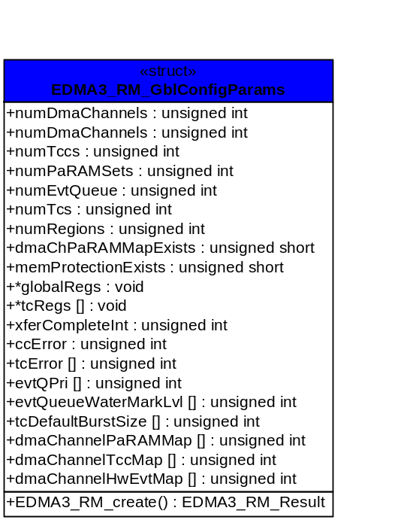
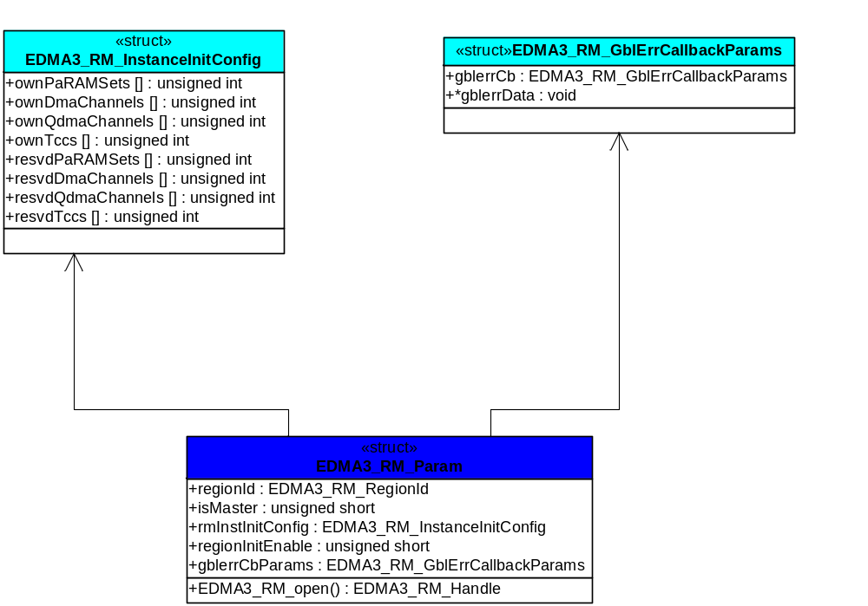

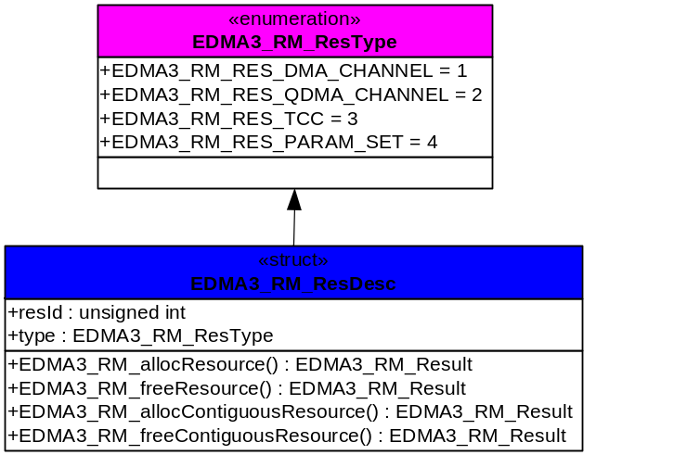

  - API Specification
The application programming interface (API) for the EDMA3 Resource Manager can be found at:
EDMA3_Resource_Manager.chm
  - API Usage Example

Below is a flow-chart describing the steps required to create the Resource Manager Object and then initialize a region specific Resource Manager Instance.
After the successful opening, the RM instance can be used to call other RM APIs.
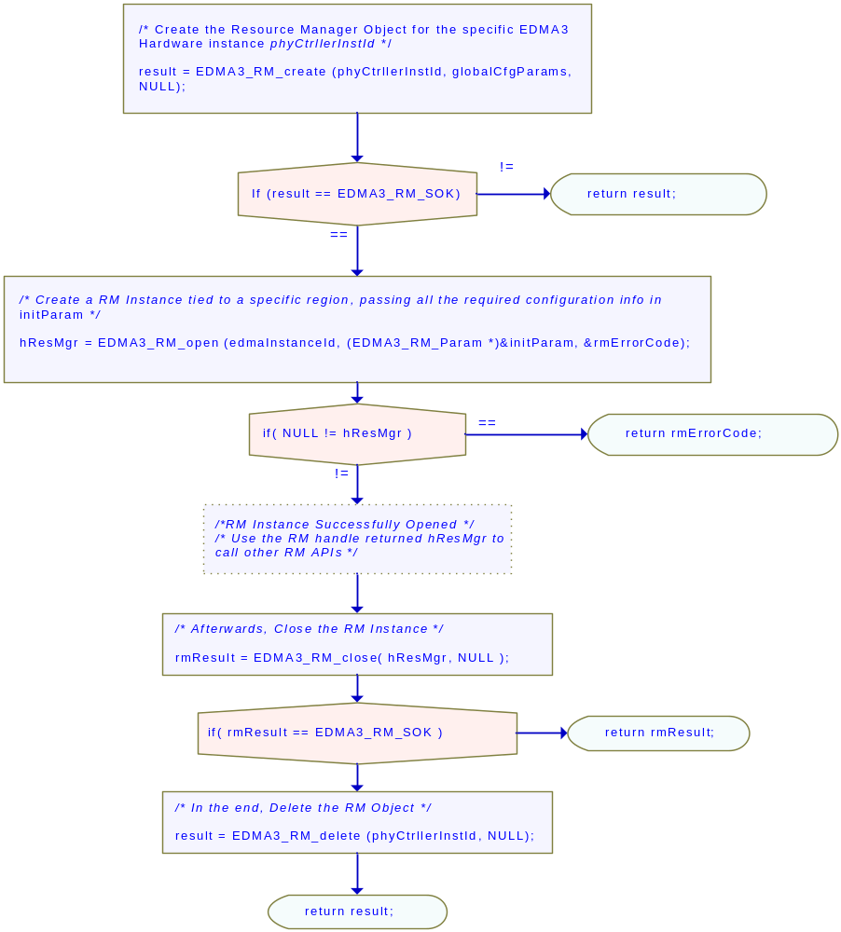

Below is the sample configuration of the Resource Manager Object, tied to a specific EDMA3 hardware. This configuration information is EDMA3 controller specific and needs to be passed while calling the API EDMA3_RM_create (). Also, sample configuration for Resource Manager Instance is also provided which could be passed in EDMA3_RM_open ().

/* Driver Object Initialization Configuration */

EDMA3_RM_GblConfigParams globalCfgParams =
{
/** Total number of DMA Channels supported by the EDMA3 Controller */
32u,
/** Total number of QDMA Channels supported by the EDMA3 Controller */
8u,
/** Total number of TCCs supported by the EDMA3 Controller */
32u,
/** Total number of PaRAM Sets supported by the EDMA3 Controller */
128u,
/** Total number of Event Queues in the EDMA3 Controller */
2u,
/** Total number of Transfer Controllers (TCs) in the EDMA3 Controller */
2u,
/** Number of Regions on this EDMA3 controller */
4u,

/**
* \brief Channel mapping existence
* A value of 0 (No channel mapping) implies that there is fixed association
* for a channel number to a parameter entry number or, in other words,
* PaRAM entry n corresponds to channel n.
*/
0u,
/** Existence of memory protection feature */
0u,

/** Global Register Region of CC Registers */
(void *)0x01C00000u,
/** Transfer Controller (TC) Registers */
{
(void *)0x01C10000u,
(void *)0x01C10400u,
(void *)NULL,
(void *)NULL,
(void *)NULL,
(void *)NULL,
(void *)NULL,
(void *)NULL
},

/** Interrupt no. for Transfer Completion */
8u,

/** Interrupt no. for CC Error */
56u,

/** Interrupt no. for TCs Error */
{
57u,
58u,
0u,
0u,
0u,
0u,
0u,
0u,
},

/**
* \brief EDMA3 TC priority setting
*
* User can program the priority of the Event Queues
* at a system-wide level. This means that the user can set the
* priority of an IO initiated by either of the TCs (Transfer Controllers)
* relative to IO initiated by the other bus masters on the
* device (ARM, DSP, USB, etc)
*/
{
0u,
1u,
0u,
0u,
0u,
0u,
0u,
0u
},
/**
* \brief To Configure the Threshold level of number of events that can be queued up in the Event queues. EDMA3CC error register (CCERR) will indicate whether or not at any instant of time the number of events queued up in any of the event queues exceeds or equals the threshold/watermark value that is set in the queue watermark threshold register (QWMTHRA).
*/
{
16u,
16u,
0u,
0u,
0u,
0u,
0u,
0u
},
/**
* \brief To Configure the Default Burst Size (DBS) of TCs.
* An optimally-sized command is defined by the transfer controller
* default burst size (DBS). Different TCs can have different
* DBS values. It is defined in Bytes.
*/
{
16u,
16u,
0u,
0u,
0u,
0u,
0u,
0u
},
/**
* \brief Mapping from each DMA channel to a Parameter RAM set,
* if it exists, otherwise of no use.
*/
{
0u, 1u, 2u, 3u,
4u, 5u, 6u, 7u,
8u, 9u, 10u, 11u,
12u, 13u, 14u, 15u,
16u, 17u, 18u, 19u,
20u, 21u, 22u, 23u,
24u, 25u, 26u, 27u,
28u, 29u, 30u, 31u,

/* DMA channels 32-63 DOES NOT exist in DA830. */
EDMA3_MAX_PARAM_SETS, EDMA3_MAX_PARAM_SETS,
EDMA3_MAX_PARAM_SETS, EDMA3_MAX_PARAM_SETS,
EDMA3_MAX_PARAM_SETS, EDMA3_MAX_PARAM_SETS,
EDMA3_MAX_PARAM_SETS, EDMA3_MAX_PARAM_SETS,
EDMA3_MAX_PARAM_SETS, EDMA3_MAX_PARAM_SETS,
EDMA3_MAX_PARAM_SETS, EDMA3_MAX_PARAM_SETS,
EDMA3_MAX_PARAM_SETS, EDMA3_MAX_PARAM_SETS,
EDMA3_MAX_PARAM_SETS, EDMA3_MAX_PARAM_SETS,
EDMA3_MAX_PARAM_SETS, EDMA3_MAX_PARAM_SETS,
EDMA3_MAX_PARAM_SETS, EDMA3_MAX_PARAM_SETS,
EDMA3_MAX_PARAM_SETS, EDMA3_MAX_PARAM_SETS,
EDMA3_MAX_PARAM_SETS, EDMA3_MAX_PARAM_SETS,
EDMA3_MAX_PARAM_SETS, EDMA3_MAX_PARAM_SETS,
EDMA3_MAX_PARAM_SETS, EDMA3_MAX_PARAM_SETS,
EDMA3_MAX_PARAM_SETS, EDMA3_MAX_PARAM_SETS,
EDMA3_MAX_PARAM_SETS, EDMA3_MAX_PARAM_SETS
},

/**
* \brief Mapping from each DMA channel to a TCC. This specific
* TCC code will be returned when the transfer is completed
* on the mapped channel.
*/
{
0u, 1u, 2u, 3u,
4u, 5u, 6u, 7u,
8u, 9u, 10u, 11u,
12u, 13u, 14u, 15u,
16u, 17u, 18u, 19u,
20u, 21u, EDMA3_RM_CH_NO_TCC_MAP, EDMA3_RM_CH_NO_TCC_MAP,
24u, 25u, 26u, 27u,
EDMA3_RM_CH_NO_TCC_MAP, EDMA3_RM_CH_NO_TCC_MAP, 30, 31,
/* DMA channels 32-63 DOES NOT exist in DA830. */
EDMA3_MAX_TCC, EDMA3_MAX_TCC, EDMA3_MAX_TCC, EDMA3_MAX_TCC,
EDMA3_MAX_TCC, EDMA3_MAX_TCC, EDMA3_MAX_TCC, EDMA3_MAX_TCC,
EDMA3_MAX_TCC, EDMA3_MAX_TCC, EDMA3_MAX_TCC, EDMA3_MAX_TCC,
EDMA3_MAX_TCC, EDMA3_MAX_TCC, EDMA3_MAX_TCC, EDMA3_MAX_TCC,
EDMA3_MAX_TCC, EDMA3_MAX_TCC, EDMA3_MAX_TCC, EDMA3_MAX_TCC,
EDMA3_MAX_TCC, EDMA3_MAX_TCC, EDMA3_MAX_TCC, EDMA3_MAX_TCC,
EDMA3_MAX_TCC, EDMA3_MAX_TCC, EDMA3_MAX_TCC, EDMA3_MAX_TCC,
EDMA3_MAX_TCC, EDMA3_MAX_TCC, EDMA3_MAX_TCC, EDMA3_MAX_TCC
},

/**
* \brief Mapping of DMA channels to Hardware Events from
* various peripherals, which use EDMA for data transfer.
* All channels need not be mapped, some can be free also.
*/
{
0xCF3FFFFFu,
0x0u
}
};
/* Driver Instance Initialization Configuration */
EDMA3_RM_InstanceInitConfig sampleInstInitConfig =
{
/* Resources owned by Region 1 */
/* ownPaRAMSets */
/* 31 0 63 32 95 64 127 96 */
{0xFFFFFFFFu, 0xFFFFFFFFu, 0xFFFFFFFFu, 0xFFFFFFFFu,
/* 159 128 191 160 223 192 255 224 */
0x00000000u, 0x00000000u, 0x00000000u, 0x00000000u,
/* 287 256 319 288 351 320 383 352 */
0x00000000u, 0x00000000u, 0x00000000u, 0x00000000u,
/* 415 384 447 416 479 448 511 480 */
0x00000000u, 0x00000000u, 0x00000000u, 0x00000000u,},

/* ownDmaChannels */
/* 31 0 63 32 */
{0xFFFFFFFFu, 0x00000000u},

/* ownQdmaChannels */
/* 31 0 */
{0x000000FFu},

/* ownTccs */
/* 31 0 63 32 */
{0xFFFFFFFFu, 0x00000000u},

/* Resources reserved by Region 1 */
/* resvdPaRAMSets */
/* 31 0 63 32 95 64 127 96 */
{0xFFFFFFFFu, 0x00000000u, 0x00000000u, 0x00000000u,
/* 159 128 191 160 223 192 255 224 */
0x00000000u, 0x00000000u, 0x00000000u, 0x00000000u,
/* 287 256 319 288 351 320 383 352 */
0x00000000u, 0x00000000u, 0x00000000u, 0x00000000u,
/* 415 384 447 416 479 448 511 480 */
0x00000000u, 0x00000000u, 0x00000000u, 0x00000000u,},

/* resvdDmaChannels */
/* 31 0 */
{EDMA3_DMA_CHANNEL_TO_EVENT_MAPPING_0,
/* 63 32 */
EDMA3_DMA_CHANNEL_TO_EVENT_MAPPING_0},

/* resvdQdmaChannels */
/* 31 0 */
{0x00000000u},

/* resvdTccs */
/* 31 0 */
{EDMA3_DMA_CHANNEL_TO_EVENT_MAPPING_0,
/* 63 32 */
EDMA3_DMA_CHANNEL_TO_EVENT_MAPPING_0},
};

EDMA3_DRV_GblXbarToChanConfigParams sampleXbarChanInitConfig=
/* Event to channel map for region 0 */
{
-1, -1, -1, -1, -1, -1, -1, -1,
-1, -1, -1, -1, -1, -1, -1, -1,
-1, -1, -1, -1, -1, -1, -1, -1,
-1, -1, -1, -1, -1, -1, -1
}

/* End of File */
Below is the sample configuration of the Resource Manager instance, operating on shadow region 1 as a slave. So this Resource Manager instance will not receive any interrupts from the EDMA3 controller. To receive the interrupts on a specific region (or Master), one has to open the Resource Manager instance as Master (only ONCE), i.e. set isMaster as TRUE.

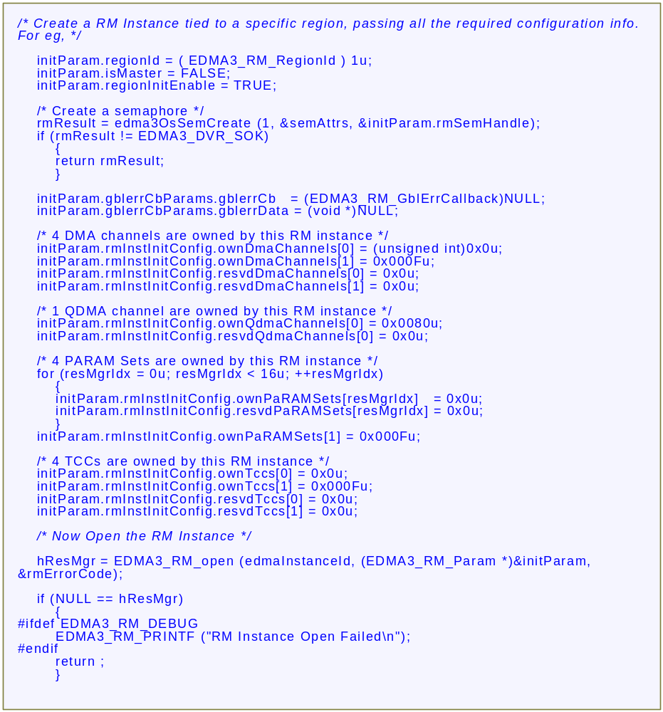

EDMA3 Resource Manager Porting
This chapter discusses how to port EDMA3 Resource Manager to other supported target platforms.

  - Getting Started
The EDMA3 Resource Manager is based upon PSP Framework architecture making portability and re-usability as prime requirements. Based upon the architecture, the EDMA3 Resource Manager is made like it can be ported to another platform very easily. EDMA3 Resource Manager itself is completely platform independent. So for its proper functioning, user has to provide the platform specific configuration, which the Resource Manager will use for managing all the resources.
The platform specific configuration can be provided in two ways:
- Provide the configuration during init time only while calling the APIs: EDMA3_RM_create () (for providing the global hardware specific configuration) and EDMA3_RM_open () (for providing the shadow regions specific configuration), OR,
- Create the platform specific configuration file “edma3_<PLATFORM_NAME>_cfg.c” in “edma3_lld_<VERSION_NUMBER>\packages\ti\sdo\edma3\rm\src\configs” folder, if it is not already there. Use this configuration file as input and generate the required platform specific library.
Support is already provided for multiple platforms. To port to a new platform, user is advised to look the existing files.
Also, the EDMA3 Resource Manager module is completely OS-agnostic, for make it’s porting to a different OS completely hassle-free. It is designed in such a way that the OS dependent part has to be provided by the user for its proper functioning. This is done in order to make the it OS independent.
The following OS dependent part of the EDMA3 Package has to be provided by the user:
- Critical section entry and exit functions: They should be implemented by the application for proper linking with the EDMA3 RM. It uses these functions for proper sharing of resources (among various users) and for other purposes and assumes the implementation of these functions to be provided by the application. Without the definitions being provided, the image won’t get linked properly.
/** Entry to critical section */
extern void edma3OsProtectEntry (unsigned int edma3InstanceId, int level, unsigned int *intState);
/** Exit from critical section */
extern void edma3OsProtectExit (unsigned int edma3InstanceId, int level, unsigned int intState);
These APIs should be mandatorily implemented once by the global initialization routine or by the user itself, for proper linking.
- Semaphore related functions: They should be implemented by the application for proper linking with Resource Manager. The EDMA3 Resource Manager uses these functions for proper sharing of resources (among various users) and assumes the implementation of these functions to be provided by the application. Without the definitions being provided, the image won’t get linked properly.
/** EDMA3 OS Semaphore Take */
extern EDMA3_RM_Result edma3OsSemTake (EDMA3_OS_Sem_Handle hSem, int mSecTimeout);
/** EDMA3 OS Semaphore Give */
extern EDMA3_RM_Result edma3OsSemGive (EDMA3_OS_Sem_Handle hSem);
- Interrupts registration and un-registration: It is not done by the Resource Manager. The application which is using it should register the various Interrupt Handlers (ISRs in Resource Manager) with the underlying OS on which it is running. Similarly, the application should un-register the previously registered Interrupt Handlers when the Resource Manager instance is no more required.
Public header file “edma3_lld_<VERSION_NUMBER>\packages\ti\sdo\edma3\rm\edma3_common.h” contains all the OS dependent part which needs to be provided by the user application.
Sample initialization libraries are already provided for multiple platforms which provide the DSP/BIOS 6 side OS adaptation layer implementation and platform specific configuration for proper functioning of the EDMA3 Resource Manager. User is encouraged to look at them and use them in the porting activity.

  - Step-by-Step procedure for porting
This section provides illustrative description on how to port the EDMA3 Resource Manager to the selected platform and the OS.
    - edma3_<PLATFORM_NAME>_cfg.c:
EDMA3_RM_GblConfigParams is the initialization structure which is used to specify the EDMA3 Hardware specific global settings, specific to the SoC. For e.g. number of DMA/QDMA channels, number of PaRAM sets, TCCs, event queues, transfer controllers, base addresses of CC global registers and TC registers, interrupt number for EDMA3 transfer completion, CC error, event queues’ priority, watermark threshold level etc. This configuration information is SoC specific and could be provided by the user at run-time also while creating the EDMA3 Resource Manager object. In case user doesn’t provide it, this information will be taken from the configuration file, in case it is available for the specific SoC.
Similarly, EDMA3_RM_InstanceInitConfig is the initialization structure which is used to specify the EDMA3 Resource Manager Region specific settings. For e.g. resources (DMA/QDMA channels, PaRAM sets, TCCs) owned and reserved by this EDMA3 driver instance. This configuration information is shadow region (or master) specific and could be provided by the user at run-time while creating the EDMA3 Resource Manager instance. In case user doesn’t provide it, this information will be taken from the configuration file, in case it is available for the specific SoC for the specific shadow region.
To summarize, this file contains the global and region specific configuration information for EDMA3 for the specific platform. User can create this file by adding the desired information for the new SoC, or he/she can provide this info at init-time.
User can find the sample configuration files for different platforms at: “edma3_lld_<VERSION_NUMBER>\packages\ti\sdo\edma3\rm\src\configs”. On the same lines, user can create different configuration file for another platform.

    - Make file for the Resource Manager
Platform specific EDMA3 configuration file will be included as a source file in the make file. The make file has many variables which will be used to generate the platform specific Resource Manager libraries.
User can find the make file at “edma3_lld_<VERSION_NUMBER>\packages\ti\sdo\edma3\rm\” and modify it appropriately to add support for the desired platform.
User will also be required to modify the files in the makerules directory in the EDMA3_LLD_INSTALLDIR to add complete support to that particular platform.

