Table of Contents

Document Version 2

1. Purpose 3

1.1. Intended Audience 3

1.2. Intended Use 3

1.3. Scope 3

1.4. Definitions and Acronyms 3

2. Overall System Description 4

2.1. Use Case Diagrams 4

2.2. System Architecture 5

2.3. Functional Requirements 5

2.3.1. Mobile App Interface 5

2.3.2. Start Up Main Menu (In-store) 6

2.3.3. Product Scanning (In-store) 7

[2.3.4.](https://docs.google.com/document/d/1KI1t0F_MUq326-t64G1bKelGiXduWvid/edit?pli=1#heading=h.26in1rg) Payment (In-store)8

2.4. Non-Functional Requirements 10

2.4.1. Idle Mode (In-store) 10

3. Software Architecture 12

3.1. Static Software Architecture 12

# Document Version

| No | Update | Name | Date | Version |
| --- | --- | --- | --- | --- |
| 1. | Initial version | Justin | 29/12/2023 | 1.0 |
| 2. | Added Software Architecture | Han Ni | 31/12/2023 | 1.1 |
| 3. | Replaced product scanning using RFID with Camera | Justin | 2/1/2024 | 1.2 |

# Purpose

## Intended Audience

This SRS document describes the System Requirements and Software Design for a Supermarket Self-Checkout System and the target audience are System and Software Engineers working on the development of this project.

## Intended Use

The SRS defines the overall System Architecture and Requirements as well as the Software Architecture and Design. This document also contains the definition of the System Requirements which shall be used as the input for System Test cases and Software Unit Test cases.

## Scope

The customer requires an automated system for customers to self-checkout their purchases, as well as order items online.

The following are the hardware components required as per the customer requirements:

| Component | Input/Output | Purpose | Customer’s requirements |
| --- | --- | --- | --- |
| Ultrasonic Sensor | Input | To detect customer presence | - |
| Camera | Input | To scan products to fetch product attributes | Read product barcode to fetch product prices and other attributes |
| RFID Reader | Input | To read customer’s credit card | Read customer’s credit card for “PayWave” support |
| Keypad | Input | To allow customers to interact with the system (i.e confirm total price, payment choice, ATM PIN) | Allow customer to enter ATM PIN code for payment |
| LED | Output | To show system state | - |
| Buzzer | Output | To provide information/alerts to customer | - |
| LCD | Output | To provide information to customer | Display product name, price, cumulative total |

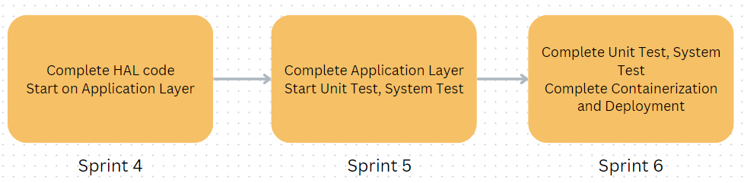

## Definitions and Acronyms

| **Acronym** | **Description** |
| --- | --- |
| LED | Light Emitting Diode |
| LCD | Liquid Crystal Display |
| QR | Quick Read (Code) |
| RFID | Radio Frequency Identification |
| SW | Software |
| HW | Hardware |

# Overall System Description

## Use Case Diagrams

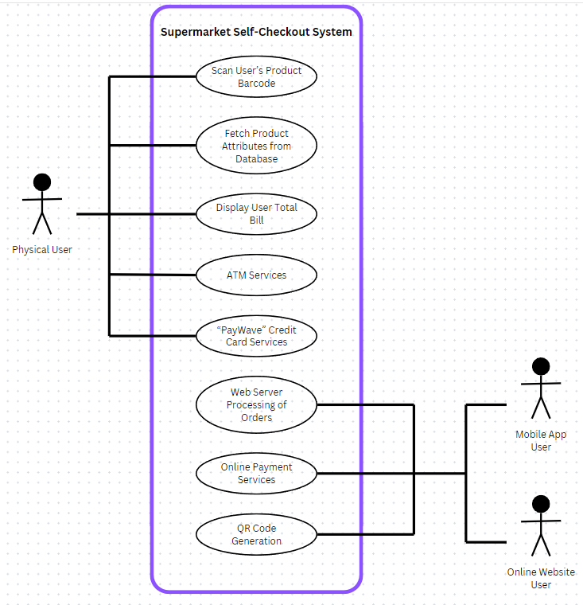

## System Architecture

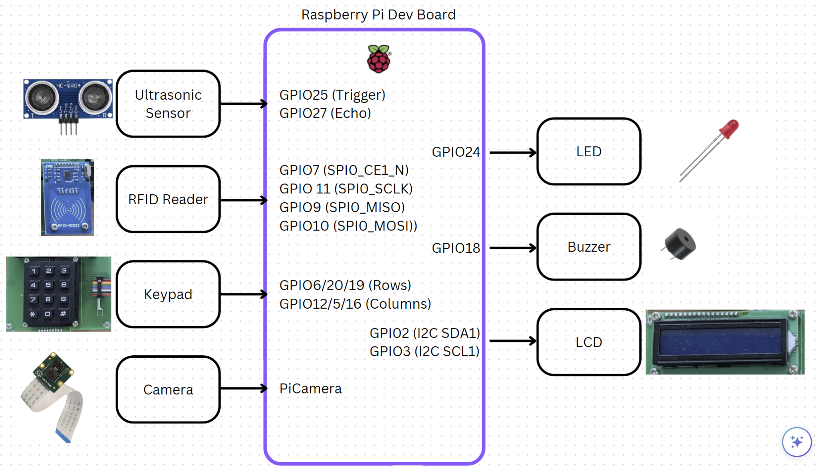

## Functional Requirements

### Online Interface

The Supermarket Self-Checkout System supports an online store for customers to order items and either self-collect by showing a QR Code or deliver to the customer’s home for an additional charge.

| **REQ_ID** | **Requirement** |
| --- | --- |
| REQ-01 | When the website is first accessed, display the Home Page (Product Page) containing all products in the database, which contains the following details:   * Price * Quantity selector * Add to Cart button   Pressing Add to Cart will save the product to the user’s cart, which can be accessed in REQ-03 |
| REQ-02 | In the Footer Menu, the following buttons leading to pages will be shown:   * Products * Cart * QR Codes |
| REQ-03 | In the Cart page, show all products that the user saved in the cart. The following actions shall be displayed per product in the cart:   * Change quantity * Remove product   A checkout button shall be found at the bottom of the page, which will lead to REQ-04 |
| REQ-04 | In the Checkout page, the following delivery options shall be shown   * Self collect at any store * Deliver to home   If the user selects Deliver to home, an additional $4 shall be added to the total cost.  The total price shall be displayed at the bottom of the page, together with a Confirm Payment button. A QR Code will be generated if Self Collect is selected by user, and saved to the QR Codes page defined in REQ-05, accessible via the bottom navigation bar as defined in REQ-02 |
| REQ-05 | In the QR Codes page, all QR Codes tied to previous purchases will be shown in a vertical list. The following details will be shown together with each QR Code:   * Purchase date * Total product quantity * Total amount paid   Tapping the QR Code will enlarge the QR Code for easier scanning by supermarket staff.  Once the QR Code is scanned by the supermarket, it will be marked invalid in the app. |

### Start Up Main Menu (In-store)

The Supermarket Self-Checkout System allows customers to scan their products and checkout on their own, using cashless payment methods

| **REQ_ID** | **Requirement** |
| --- | --- |
| REQ-06 | When the self-checkout system is first powered ON, the main menu with the text below shall be displayed on the LCD Screen   * Line 1: “1. Start self-checkout” * Line 2: “2. Enter Idle Mode” |
| REQ-07 | In the main menu defined in REQ-06, if the option “1. Start self-checkout” is selected on the keypad, then the menu in REQ-09 shall be shown |
| REQ-08 | In the main menu defined in REQ-06, if the option “2. Enter Idle Mode” is selected, the LCD should display the following text for 2 seconds and then turn off the LCD display and back light and enter into the Idle Mode state defined in the State Machine in REQ-36  Line 1 = “Entering Idle Mode”   * Line 2 = *(blank)* |

### 

### Product Scanning (In-store)

| **REQ_ID** | **Requirement** |
| --- | --- |
| REQ-09 | When Start self-checkout is selected in REQ-06, the following text shall be displayed on the LCD Screen:   * Line 1: “Hold your items” * Line 2: “at reader one by one”   The following flowchart defined in Figure 1 shall be implemented. |

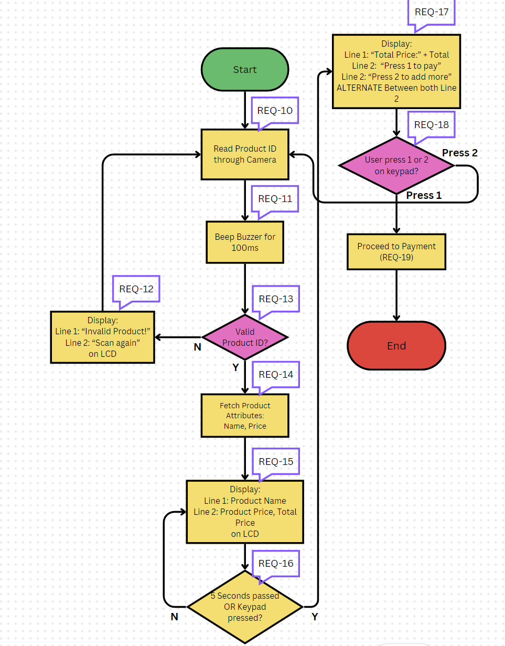

**Figure 1**

### Payment (In-store)

The Supermarket Self-Checkout System supports ATM PIN payment as well as “PayWave” credit card

| **REQ_ID** | **Requirement** |
| --- | --- |
| REQ-19 | When Payment is initiated by customer after REQ-18, the following shall be implemented:  Display the following lines on the LCD   * Line 1: “Payment Method?” * Line 2: “1. ATM, 2. PayWave”   The following flowchart defined in Figure 2 shall be implemented. |

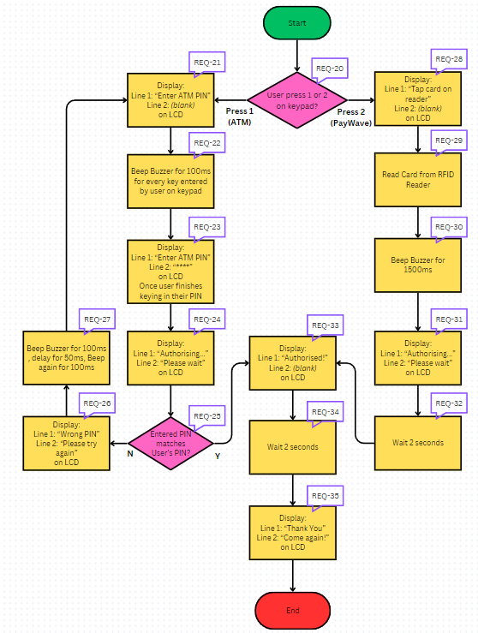

**Figure 2**

## Non-Functional Requirements

### Idle Mode (In-store)

The In-store Self Checkout system has 2 Power Modes as defined in the State Machine Diagram in Figure 3 below. The transitions between the Idle Mode and Ready Mode are triggered by the events labelled “evEnterIdle” and “evResume”. Conditions for triggering the events are defined in the requirements below.

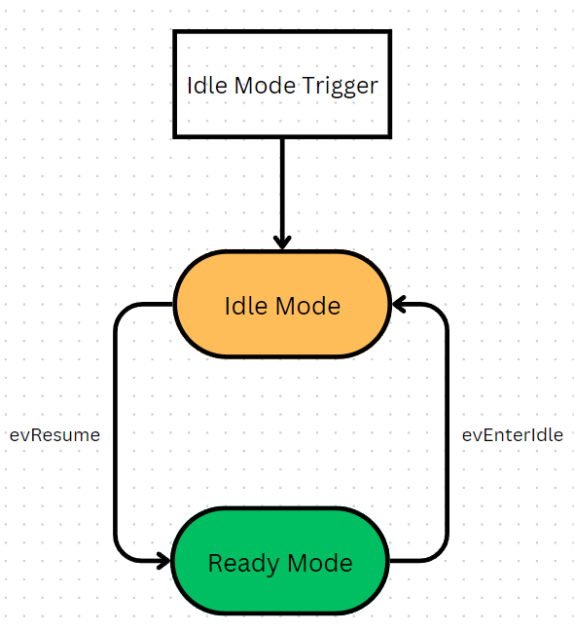

**Figure 3**

| **REQ_ID** | **Requirement** |
| --- | --- |
| REQ-36 | **“evEnterIdle” Trigger Condition 1**   * When the option “2. Enter Idle Mode” is selected in the main menu |
| REQ-37 | **“evEnterIdle” Trigger Condition 2**   * When no interaction with keypad has been detected for at least 5 minutes |
| REQ-38 | **“evEnterIdle” Trigger Condition 3**   * When no movement from Ultrasonic sensor has been detected for at least 3 minutes |
| REQ-39 | **“evResume” Trigger Condition 1**   * When a key is pressed on the keypad |
| REQ-40 | **“evResume” Trigger Condition 2**   * When movement is detected from Ultrasonic sensor |
| REQ-41 | **Idle Mode Function 1**  LCD shall be cleared and empty while in Idle Mode |
| REQ-42 | **Idle Mode Function 2**  LED shall blink based on the following timing diagram |

# Software Architecture

## Static Software Architecture

The Software Architecture defines the various Software Components that are developed to realize the implementation of the system requirements.

