Tidyverse and Tidymodels packages

Koji Mizumura

December 22nd,2018 - 2019-01-25

Table of Contents

# Broom

## [Broom by blog post by David Robinson](http://varianceexplained.org/r/broom-intro/)

The concept of “tidy data” offers a powerful framework for data manipulation, analysis and visualization. Popular packages like dplyr, tidyr and ggplot2 take greate advantage of this framework. Please explore several recent posts by others.

But there is an important step in a tidy data workflow that so far has been missing: the **output** of R statistical modeling functions isn’t tidy, meaning it’s difficult to manipulate and recombine in downstream analyses and visualizations. Hadley’s paper makes a convincing statement of this problem.

While model inputs usually require tidy inputs, such attention to detail doesn’t carry over to model outputs. Outputs such as predictions and estimated coefficients aren’t always tidy. This makes it more difficult to combine results from multiple models. For example, in R, the default representation of model coefficients is not tidy because it does not have an explicit variable that records the variable name for each estimate, they are instead recorded as row names. In R, row names must be unique, so combining coefficients from many models (e.g., from bootstrap resamples, or subgroups) requires workarounds to avoid losing important information. This knocks you out of the flow of analysis and makes it harder to combine the results from multiple models. I’m not currently aware of any packages that resolve this problem.

In this [new paper](https://arxiv.org/abs/1412.3565) I introduce the broom package available on CRAN, which bridges the gap from untidy outputs of predictions and estimations to the tidy data we want to work with. It takes the messy output of built-in statistical functions in R, such as lm, nls, kmeans, or t.test as well as popular third-party packages, like gam, glmnet, survival or lme4, and turns them into tidy data frames. This allows the results to be handed to other tidy packages for downstream analysis: they can be recombined using dplyr or visualized using ggplot2.

### Example: linear regression

As a simple example, consider alinear regression on the built-in mtcars dataset:

fit <- lm(mpg~wt+qsec, data=mtcars)  
summary(fit)  
##   
## Call:  
## lm(formula = mpg ~ wt + qsec, data = mtcars)  
##   
## Residuals:  
## Min 1Q Median 3Q Max   
## -4.3962 -2.1431 -0.2129 1.4915 5.7486   
##   
## Coefficients:  
## Estimate Std. Error t value Pr(>|t|)   
## (Intercept) 19.7462 5.2521 3.760 0.000765 ***  
## wt -5.0480 0.4840 -10.430 2.52e-11 ***  
## qsec 0.9292 0.2650 3.506 0.001500 **   
## ---  
## Signif. codes: 0 '***' 0.001 '**' 0.01 '*' 0.05 '.' 0.1 ' ' 1  
##   
## Residual standard error: 2.596 on 29 degrees of freedom  
## Multiple R-squared: 0.8264, Adjusted R-squared: 0.8144   
## F-statistic: 69.03 on 2 and 29 DF, p-value: 9.395e-12

This summary shows many kinds of statistics describing the regression: coefficient estimates and p-values, information about the residuals, and model statistics like $R^{2}$ and the F-statistics. But, this format isn’t convenient if you want to combine and compare multiple models, or plot it using ggplot2: you need to turn it into a data frame.

The broom package provides three tidying methods for turning the contents of this object into a data frame, depending on the level of statistics you’re interested in. If you want statistics about each of the coefficients fit by the model, use the tidy() method:

broom::tidy(fit)  
## # A tibble: 3 x 5  
## term estimate std.error statistic p.value  
## <chr> <dbl> <dbl> <dbl> <dbl>  
## 1 (Intercept) 19.7 5.25 3.76 7.65e- 4  
## 2 wt -5.05 0.484 -10.4 2.52e-11  
## 3 qsec 0.929 0.265 3.51 1.50e- 3

Note that the rownames are now added as a column, term, meaning that the data can be combined with other models. Note also that the columns have been given names like std_error and p.value that are more easily accessed than std_error and Pr(>|t|). This is true of all data frames broom returns: they’re designed so they can be processed in additional steps.

If you are interested in extracting **per-observation information**, such as fitted values and residuals, use the argument method, which adds these to the original data.

fit %>%   
 broom::augment()  
## # A tibble: 32 x 11  
## .rownames mpg wt qsec .fitted .se.fit .resid .hat .sigma  
## * <chr> <dbl> <dbl> <dbl> <dbl> <dbl> <dbl> <dbl> <dbl>  
## 1 Mazda RX4 21 2.62 16.5 21.8 0.683 -0.815 0.0693 2.64  
## 2 Mazda RX~ 21 2.88 17.0 21.0 0.547 -0.0482 0.0444 2.64  
## 3 Datsun 7~ 22.8 2.32 18.6 25.3 0.640 -2.53 0.0607 2.60  
## 4 Hornet 4~ 21.4 3.22 19.4 21.6 0.623 -0.181 0.0576 2.64  
## 5 Hornet S~ 18.7 3.44 17.0 18.2 0.512 0.504 0.0389 2.64  
## 6 Valiant 18.1 3.46 20.2 21.1 0.803 -2.97 0.0957 2.58  
## 7 Duster 3~ 14.3 3.57 15.8 16.4 0.701 -2.14 0.0729 2.61  
## 8 Merc 240D 24.4 3.19 20 22.2 0.730 2.17 0.0791 2.61  
## 9 Merc 230 22.8 3.15 22.9 25.1 1.41 -2.32 0.295 2.59  
## 10 Merc 280 19.2 3.44 18.3 19.4 0.491 -0.185 0.0358 2.64  
## # ... with 22 more rows, and 2 more variables: .cooksd <dbl>,  
## # .std.resid <dbl>

Finally, glance() computes per-model statistics such as $R^{2}$, AIC, BIC:

fit %>%   
 glance()  
## # A tibble: 1 x 11  
## r.squared adj.r.squared sigma statistic p.value df logLik AIC BIC  
## * <dbl> <dbl> <dbl> <dbl> <dbl> <int> <dbl> <dbl> <dbl>  
## 1 0.826 0.814 2.60 69.0 9.39e-12 3 -74.4 157. 163.  
## # ... with 2 more variables: deviance <dbl>, df.residual <int>

The tidy method makes it easy to construct coefficient plots using **ggplot2**:

library(ggplot2)  
  
td <- fit %>%   
 broom::tidy(conf.int=TRUE)  
  
td %>% head()  
## # A tibble: 3 x 7  
## term estimate std.error statistic p.value conf.low conf.high  
## <chr> <dbl> <dbl> <dbl> <dbl> <dbl> <dbl>  
## 1 (Intercept) 19.7 5.25 3.76 7.65e- 4 9.00 30.5   
## 2 wt -5.05 0.484 -10.4 2.52e-11 -6.04 -4.06  
## 3 qsec 0.929 0.265 3.51 1.50e- 3 0.387 1.47  
  
ggplot(td, aes(estimate, term, color = term)) +  
 geom_point() +  
 geom_errorbarh(aes(xmin = conf.low, xmax = conf.high)) +  
 geom_vline(xintercept = 0)

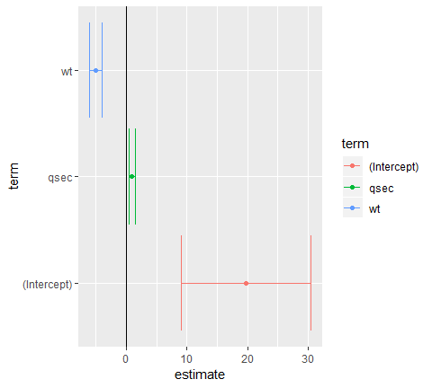

When combined with dplyr’s group_by and do, **broom** also lets you perform regression within groups, such as within automatic and manual cars separately;

library(dplyr)  
  
mtcars %>%   
 group_by(am) %>%   
 do(broom::tidy(lm(mpg ~ wt, .)))  
## # A tibble: 4 x 6  
## # Groups: am [2]  
## am term estimate std.error statistic p.value  
## <dbl> <chr> <dbl> <dbl> <dbl> <dbl>  
## 1 0 (Intercept) 31.4 2.95 10.7 0.00000000601  
## 2 0 wt -3.79 0.767 -4.94 0.000125   
## 3 1 (Intercept) 46.3 3.12 14.8 0.0000000128   
## 4 1 wt -9.08 1.26 -7.23 0.0000169

This is useful for performing regressions or other analyses within each gene, country, or any other kind of division in your tidy dataset.

### Using tidiers for visualization with ggplot2

The broom package provides tidying methods for many otherp packages as well. These tidiers serve to connect various statistical models seamlessly with packages like dplyr and ggplot2 . For instance, we could create a LASSO regression with the glmenet package.

library(glmnet)  
set.seed(03-19-2015)  
  
# generate data with 5 real variables and 45 null, on 100 observations  
  
nobs <- 100  
nvar <- 50  
real <- 5  
x <- matrix(rnorm(nobs*nvar), nobs)  
beta <- c(rnorm(real, 0,1), rep(0, nvar - real))  
y <- c(t(beta) %*% t(x)) + rnorm(nvar, sd=3)  
  
glmnet_fit <- cv.glmnet(x,y)

Then, we tidy it with broom and plot it using ggplot2:

tidied_cv <- glmnet_fit %>% broom::tidy()  
glance_cv <- glmnet_fit %>% broom::tidy()  
  
tidied_cv %>% ggplot(aes(lambda, estimate))+  
 geom_line(color="red")+  
 geom_ribbon(aes(ymin = conf.low, ymax = conf.high, alpha = .2))+  
 scale_x_log10()

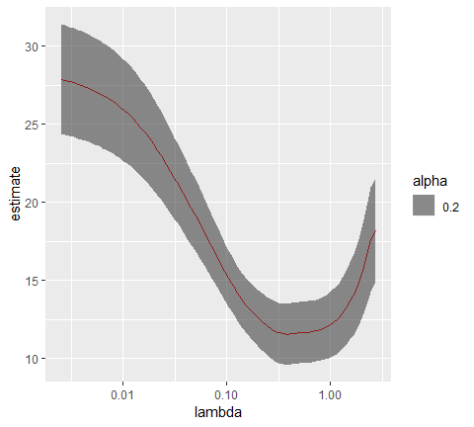

# geom_vline(xintercept = glance_cv$lambda.min) +  
 # geom_vline(xintercept = glance_cv$lambda.1se, lty = 2)

By plotting with ggplot2, rather than relying on glmnet’s built in plotting methods, we gain access to all the tools and framework of the package. This allows us to customize or add attributes, or even to cmplare multiple LASSO cross-validations in the same plot.

The same is true of the [survivial](https://cran.r-project.org/web/packages/survival/index.html) package.

library(survival)  
  
surv_fit <- survfit(coxph(Surv(time, status) ~ age + sex, lung))  
td <- broom::tidy(surv_fit)  
ggplot(td, aes(time, estimate))+ geom_line()+  
 geom_ribbon(aes(ymin=conf.low, ymax=conf.high),alpha=.2)

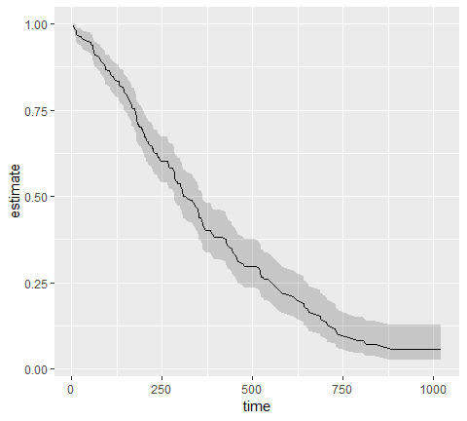

Others have explored how broom can help visualize [random effects estimated with lme4](https://rstudio-pubs-static.s3.amazonaws.com/38628_54b19baf70b64eb5936a3f1f84beb7da.html). Other packages for which tidiers are implemented include gam, zoo, lfe, and multcomp.

The vignettes for the broom package offer other useful examples, including one on [combining broom and dplyr](https://cran.r-project.org/web/packages/broom/vignettes/broom_and_dplyr.html), a demonstration of [bootstrapping with broom](https://cran.r-project.org/web/packages/broom/vignettes/bootstrapping.html), and a simulation of [k-means clustering](https://cran.r-project.org/web/packages/broom/vignettes/kmeans.html). The broom manuscript offers still more examples.

Tidying model outputs is not an exact science, and it is based on a judgment of the kinds of values a data scientist typically wants out of a tidy analysis (for instance, estimates, test statistics, and p-values). It is my hope that data scientists will propose and contribute their own features feature requests are welcome!) to help expand the universe of tidy analysis tools.

## Visualizing Imer model random effects

I will be exploring the differences between three models:

library(lme4)  
subj_intercepts_mod <- lmer(rt ~ A + (1|Subject))  
subjA_intercepts_mod <- lmer(rt ~ 1 + (1|Subject:A))  
subj_slopes_mod <- lmer(rt ~ A + (A|Subject))

Granted, the second model is rarely encounted in practice. More common would be a nested structure (see this [crossvalidated post](https://stats.stackexchange.com/questions/121504/how-many-random-effects-to-specify-in-lmer))

lmer(rt ~ 1 + (1|Subject) + (1|Subject:A))  
## the above random effects structure is often written as `(1|Subject/A)` the   
## same way `y ~ A + B + A:B` is usually written as `y ~ A * B`.

Even though the non-nested (1|)

I will work with a modified version of the sleepstudy dataset from lme4.

library(lme4)  
library(ggplot2)  
library(reshape2)  
library(dplyr)  
library(broom)  
library(stringr)

head(sleepstudy)  
## Reaction Days Subject  
## 1 249.5600 0 308  
## 2 258.7047 1 308  
## 3 250.8006 2 308  
## 4 321.4398 3 308  
## 5 356.8519 4 308  
## 6 414.6901 5 308  
  
example <- sleepstudy %>%   
 mutate(A = ifelse(Days<5, -0.5, 0.5)) %>%   
 select(Subject, A, Reaction)  
  
example %>% head(n=11)  
## Subject A Reaction  
## 1 308 -0.5 249.5600  
## 2 308 -0.5 258.7047  
## 3 308 -0.5 250.8006  
## 4 308 -0.5 321.4398  
## 5 308 -0.5 356.8519  
## 6 308 0.5 414.6901  
## 7 308 0.5 382.2038  
## 8 308 0.5 290.1486  
## 9 308 0.5 430.5853  
## 10 308 0.5 466.3535  
## 11 309 -0.5 222.7339

Let’s plot means using ggplot and stat_summary functions.

base_plot <- ggplot(example, aes(x=A, y=Reaction))+  
 stat_summary(aes(fill=factor(A)), fun.y=mean, geom="bar")+  
 scale_fill_manual(values=c("#66c2a5", "#8da0cb"))+ #colorbrewer2.rog  
 theme(legend.position = "above")  
  
base_plot

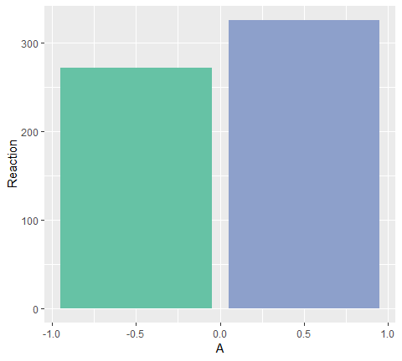

### Part1: subj_intercepts_mod

First, I will fit an lmer model that allows the intercept to vary across subjects.

subj_intercepts_mod <- lmer(Reaction ~ A + (1|Subject), data=example)  
# broom::tidy turns fixef(subj_intercepts_mod)` into a data.frame  
  
fixed_params <- subj_intercepts_mod %>%   
 broom::tidy(effects="fixed") %>%   
 select(term, estimate)  
  
fixed_params  
## # A tibble: 2 x 2  
## term estimate  
## <chr> <dbl>  
## 1 (Intercept) 299.   
## 2 A 53.8

Although its sometimes helpful to think about model parameters (and you can draw them easily with ggplot::geom_abline()), I find it more beneficial in a simple design like this to deal in estimates. I will write a little function to speed up this conversion that seems like overkill now but it will come in handy later.

# converts parameters of a `Reaction ~ (Intercept) + A` model into estimates,  
# assumes A is a 0-centered, unit-weighted, dichotomous variable  
  
convert_parameters_to_estimates <- function(tidy_frame,id_var="."){  
 tidy_frame %>%   
 dcast(as.formula(paste(id_var, "term", sep="~")), value.var = "estimate") %>%   
 mutate(`-0.5` = `(Intercept)` - A/2, `0.5` = `(Intercept)` + A/2) %>%  
 select(-`(Intercept)`, -A) %>%  
 melt(idvars = id_var, measure.vars = c("-0.5", "0.5"),  
 variable.name = "A", value.name = "Reaction") %>%  
 mutate(A = as.numeric(as.character(A)))  
}  
  
fixed_estimates <- convert_parameters_to_estimates(fixed_params)[,c("A","Reaction")]  
  
fixed_estimates  
## A Reaction  
## 1 -0.5 271.6302  
## 2 0.5 325.3856

#sanity check  
example %>%   
 group_by(A) %>%   
 summarise(Reaction = mean(Reaction)) %>%   
 merge(., fixed_estimates, by="A", suffixes = c("_mean", "_model"))  
## A Reaction_mean Reaction_model  
## 1 -0.5 271.6302 271.6302  
## 2 0.5 325.3856 325.3856

It is possible to turn parameters from the model into estimates that make sense; now let’s do the same thing with random effects. How will the model’s random effect parameters, when converted to estimates, compare to the average for each subject that we can calculate by hand?

random_params <- broom::tidy(subj_intercepts_mod, effect = "random")  
random_estimates <- convert_parameters_to_estimates(random_params, id_var = "level")  
  
fixed_slopes_plot <- base_plot +   
 geom_point(data = random_estimates, shape = 17, size = 3) +  
 geom_line(aes(group = level), data = random_estimates)  
fixed_slopes_plot

fixed_slopes_plot +  
 stat_summary(aes(group = Subject), fun.y = mean, # means from raw data  
 geom = "point", shape = 19, size = 4, color = "#fc8d62", alpha = 0.6)

Of course, the reason the two sets of points don’t line up is because we are only allowing the subject’s overall Reaction to vary, not the subject’s overall Reaction in each condition. Applying the same slope to each subject, this is the best we can do to account for variance.

base_plot+  
 geom_line(aes(group = level), data = random_estimates)+  
 ## calculate mean Reaction by subject using `stat_summary`  
 stat_summary(aes(x=0.0, y=Reaction, group=level), data = random_estimates, fun.y = mean, geom = "point", shape = 17, size = 3) +  
 stat_summary(aes(x=0.0, group=Subject), fun.y = mean,  
 geom = "point", shape = 19, size = 4, color = "#fc8d62", alpha = 0.6)

A model that allows intercepts to vary across subjects does just that: it does a great job of estimating overall Reaction for each subject, but it is limited in estimating the effect of A on Reaction.

### Part2: subjA_intercepts_mod

We are looking for a way to capture the fact that all of the following by-subject lines don’t have the same slope.

subj_means_plot <- base_plot +  
 stat_summary(aes(group = Subject), fun.y = mean, geom = "point", shape =19, size =4, color = "#fc8d62")+  
 stat_summary(aes(group = Subject), fun.y = mean, geom = "line", size = 1.2, color = "#fc8d62")

One way to give the model some flexibility would be to “serve the connection” between the measurements on the left bar from those in the right bar.

example$SubAject <- with(example, paste(Subject, A, sep = ":"))  
subjA_intercepts_mod <- lmer(Reaction ~ 1 + (1|SubAject), data = example)

Why make a new, hideously-named variable SubAject? Because if the model can’t understand the relationship between Subject and A, I shouldn’t be able to either! We’ve severed the connection between scores on the left and scores on the right, and given the model more flexibility to estimate the effects.

Of course, nothing is preventing

## [broom and dplyr](https://broom.tidyverse.org/articles/broom_and_dplyr.html)

While broom is useful for summarizing the result of a single analysis in a consistent format, it is really designed for high-throughput applications, where you must combine results from multiple analyses. These could be subgrouped of data, analyses using different models, bootstrap replicates, permutations, and so on. In particular, it plays well with the nest/unnest functions in tidyr and the map function in purrr.

For purrr package, please refer this [RStudio tutorial](https://www.rstudio.com/resources/videos/happy-r-users-purrr-tutorial/).

Let’s try this on a simple dataset, the built-in Orange. We start by coercing Orange to a tibble. This gives a nicer method that will especially useful later on when we start working with list-columns.

library(broom)  
library(tibble)  
  
data("Orange")  
  
  
Orange <- as_tibble(Orange)  
Orange  
## # A tibble: 35 x 3  
## Tree age circumference  
## * <ord> <dbl> <dbl>  
## 1 1 118 30  
## 2 1 484 58  
## 3 1 664 87  
## 4 1 1004 115  
## 5 1 1231 120  
## 6 1 1372 142  
## 7 1 1582 145  
## 8 2 118 33  
## 9 2 484 69  
## 10 2 664 111  
## # ... with 25 more rows

This contains 35 observations of three variables: Tree, age and circumference. Tree is a factor with five levels describing five trees. As might be expected, age and circumference are correlated:

cor(Orange$age, Orange$circumference)  
## [1] 0.9135189  
  
ggplot2::ggplot(Orange,  
 aes(age, circumference, color=Tree))+  
 geom_line(size=1)+  
 theme_minimal()

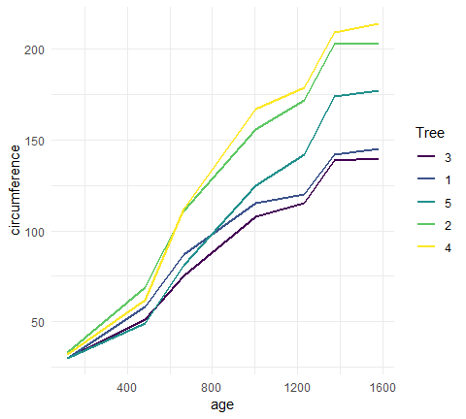

Suppose you want to test for correlations individually within each tree. You can do this with dplyr’s group_by:

library(dplyr)  
  
Orange %>%   
 group_by(Tree) %>%   
 summarise(correlations=cor(age,circumference))  
## # A tibble: 5 x 2  
## Tree correlations  
## <ord> <dbl>  
## 1 3 0.988  
## 2 1 0.985  
## 3 5 0.988  
## 4 2 0.987  
## 5 4 0.984

Note that the correlations are much higher than the aggregated one, and furthermore we can now see it is similar across trees. Suppose that instead of simply estimating a correlation, we want to perform a hypothesis test with cor.test:

ct <- cor.test(Orange$age, Orange$circumference)  
ct  
##   
## Pearson's product-moment correlation  
##   
## data: Orange$age and Orange$circumference  
## t = 12.9, df = 33, p-value = 1.931e-14  
## alternative hypothesis: true correlation is not equal to 0  
## 95 percent confidence interval:  
## 0.8342364 0.9557955  
## sample estimates:  
## cor   
## 0.9135189

This contains multiple values we could want in our output. Some are vectors of length 1, such as the p-value and the estimate, and some are longer, such as the confidence interval. We can get this into a nicely organized tibble using the tidy function:

ct %>% broom::tidy()  
## # A tibble: 1 x 8  
## estimate statistic p.value parameter conf.low conf.high method  
## <dbl> <dbl> <dbl> <int> <dbl> <dbl> <chr>   
## 1 0.914 12.9 1.93e-14 33 0.834 0.956 Pears~  
## # ... with 1 more variable: alternative <chr>

Often, we want to perform multiple tests or fit multiple models, each on different part of the data. In this case, we recommend a nest-map-unnest workflow. For example, suppose we want to perform correlation tests for each different tree. We start by nest ing our data based on the group of interest.

library(tidymodels)  
library(tidyverse)  
  
nested <- Orange %>%   
 nest(-Tree)  
  
nested   
## # A tibble: 5 x 2  
## Tree data   
## <ord> <list>   
## 1 1 <tibble [7 x 2]>  
## 2 2 <tibble [7 x 2]>  
## 3 3 <tibble [7 x 2]>  
## 4 4 <tibble [7 x 2]>  
## 5 5 <tibble [7 x 2]>

Then we run a correlation test for each nested tibble using purrr::map:

nested %>%   
 mutate(test = map(data, ~ cor.test(.x$age, .x$circumference)))  
## # A tibble: 5 x 3  
## Tree data test   
## <ord> <list> <list>   
## 1 1 <tibble [7 x 2]> <S3: htest>  
## 2 2 <tibble [7 x 2]> <S3: htest>  
## 3 3 <tibble [7 x 2]> <S3: htest>  
## 4 4 <tibble [7 x 2]> <S3: htest>  
## 5 5 <tibble [7 x 2]> <S3: htest>  
  
# i come up with this formula - does this work as well?  
nested %>%   
 mutate(test = map(data, ~ cor.test(.$age, .$circumference)))  
## # A tibble: 5 x 3  
## Tree data test   
## <ord> <list> <list>   
## 1 1 <tibble [7 x 2]> <S3: htest>  
## 2 2 <tibble [7 x 2]> <S3: htest>  
## 3 3 <tibble [7 x 2]> <S3: htest>  
## 4 4 <tibble [7 x 2]> <S3: htest>  
## 5 5 <tibble [7 x 2]> <S3: htest>

This results in a list-column of S3 objects. We want to tidy each of the objects, which we can also do with map.

nested %>%   
 mutate(  
 test = map(data, ~ cor.test(.x$age, .x$circumference)), # S3 list-col  
 tidied = map(test, broom::tidy)  
 ) %>%   
 select(Tree, tidied) %>%   
 unnest()  
## # A tibble: 5 x 9  
## Tree estimate statistic p.value parameter conf.low conf.high method  
## <ord> <dbl> <dbl> <dbl> <int> <dbl> <dbl> <chr>   
## 1 1 0.985 13.0 4.85e-5 5 0.901 0.998 Pears~  
## 2 2 0.987 13.9 3.43e-5 5 0.914 0.998 Pears~  
## 3 3 0.988 14.4 2.90e-5 5 0.919 0.998 Pears~  
## 4 4 0.984 12.5 5.73e-5 5 0.895 0.998 Pears~  
## 5 5 0.988 14.1 3.18e-5 5 0.916 0.998 Pears~  
## # ... with 1 more variable: alternative <chr>  
  
nested2 <- nested %>%   
 mutate(  
 test = map(data, ~ cor.test(.x$age, .x$circumference)), # S3 list-col  
 tidied = map(test, broom::tidy)  
 )  
   
nested2 %>%   
 select(Tree, tidied) %>%   
 unnest()  
## # A tibble: 5 x 9  
## Tree estimate statistic p.value parameter conf.low conf.high method  
## <ord> <dbl> <dbl> <dbl> <int> <dbl> <dbl> <chr>   
## 1 1 0.985 13.0 4.85e-5 5 0.901 0.998 Pears~  
## 2 2 0.987 13.9 3.43e-5 5 0.914 0.998 Pears~  
## 3 3 0.988 14.4 2.90e-5 5 0.919 0.998 Pears~  
## 4 4 0.984 12.5 5.73e-5 5 0.895 0.998 Pears~  
## 5 5 0.988 14.1 3.18e-5 5 0.916 0.998 Pears~  
## # ... with 1 more variable: alternative <chr>

Finally, we want to unnest the tidied data frames so we can see the results in a flat tibble. All together, this looks like:

Orange %>%   
 nest(-Tree) %>%   
 mutate(  
 test = map(data, ~ cor.test(.x$age, .x$circumference)), # S3 list-col  
 tidied = map(test, broom::tidy)  
 ) %>%   
 unnest(tidied, .drop = TRUE)  
## # A tibble: 5 x 9  
## Tree estimate statistic p.value parameter conf.low conf.high method  
## <ord> <dbl> <dbl> <dbl> <int> <dbl> <dbl> <chr>   
## 1 1 0.985 13.0 4.85e-5 5 0.901 0.998 Pears~  
## 2 2 0.987 13.9 3.43e-5 5 0.914 0.998 Pears~  
## 3 3 0.988 14.4 2.90e-5 5 0.919 0.998 Pears~  
## 4 4 0.984 12.5 5.73e-5 5 0.895 0.998 Pears~  
## 5 5 0.988 14.1 3.18e-5 5 0.916 0.998 Pears~  
## # ... with 1 more variable: alternative <chr>

Note that the .drop argument to tidyr::unnest is often useful. This workflow becomes even more useful when applied to regression. Untidy output for a regression looks like:

lm_fit <- lm(age ~ circumference, data=Orange)  
summary(lm_fit)  
##   
## Call:  
## lm(formula = age ~ circumference, data = Orange)  
##   
## Residuals:  
## Min 1Q Median 3Q Max   
## -317.88 -140.90 -17.20 96.54 471.16   
##   
## Coefficients:  
## Estimate Std. Error t value Pr(>|t|)   
## (Intercept) 16.6036 78.1406 0.212 0.833   
## circumference 7.8160 0.6059 12.900 1.93e-14 ***  
## ---  
## Signif. codes: 0 '***' 0.001 '**' 0.01 '*' 0.05 '.' 0.1 ' ' 1  
##   
## Residual standard error: 203.1 on 33 degrees of freedom  
## Multiple R-squared: 0.8345, Adjusted R-squared: 0.8295   
## F-statistic: 166.4 on 1 and 33 DF, p-value: 1.931e-14  
  
Orange %>%   
 ggplot()+  
 geom_point(aes(x=circumference, y=age))+  
 geom_abline(xintercept=lm_fit$coefficients[[1]], slope=lm_fit$coefficients[[2]])

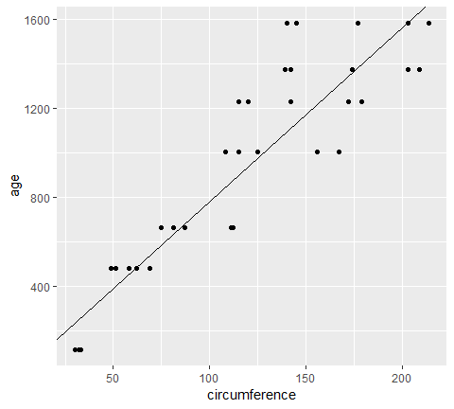

where we tidy these results, we get multiple rows of output for each model:

broom::tidy(lm_fit)  
## # A tibble: 2 x 5  
## term estimate std.error statistic p.value  
## <chr> <dbl> <dbl> <dbl> <dbl>  
## 1 (Intercept) 16.6 78.1 0.212 8.33e- 1  
## 2 circumference 7.82 0.606 12.9 1.93e-14

Now we can handle multiple regressions at once using exactly the same workflow as before:

Orange %>%   
 nest(-Tree) %>%   
 mutate(  
 fit = map(data, ~ lm(age~circumference, data=.x)),  
 tidied = map(fit, broom::tidy)  
 ) %>%   
 unnest(tidied)  
## # A tibble: 10 x 6  
## Tree term estimate std.error statistic p.value  
## <ord> <chr> <dbl> <dbl> <dbl> <dbl>  
## 1 1 (Intercept) -265. 98.6 -2.68 0.0436   
## 2 1 circumference 11.9 0.919 13.0 0.0000485  
## 3 2 (Intercept) -132. 83.1 -1.59 0.172   
## 4 2 circumference 7.80 0.560 13.9 0.0000343  
## 5 3 (Intercept) -210. 85.3 -2.46 0.0574   
## 6 3 circumference 12.0 0.835 14.4 0.0000290  
## 7 4 (Intercept) -76.5 88.3 -0.867 0.426   
## 8 4 circumference 7.17 0.572 12.5 0.0000573  
## 9 5 (Intercept) -54.5 76.9 -0.709 0.510   
## 10 5 circumference 8.79 0.621 14.1 0.0000318

You can just as easily use multiple predictors in the regressions, as shown here on the mtcars dataset. We nest the data into automatic and manual cars (the am column), then peform the regression within each nested tibble.

data("mtcars")  
mtcars <- as_tibble(mtcars) # to play nicely with list-cols  
mtcars  
## # A tibble: 32 x 11  
## mpg cyl disp hp drat wt qsec vs am gear carb  
## * <dbl> <dbl> <dbl> <dbl> <dbl> <dbl> <dbl> <dbl> <dbl> <dbl> <dbl>  
## 1 21 6 160 110 3.9 2.62 16.5 0 1 4 4  
## 2 21 6 160 110 3.9 2.88 17.0 0 1 4 4  
## 3 22.8 4 108 93 3.85 2.32 18.6 1 1 4 1  
## 4 21.4 6 258 110 3.08 3.22 19.4 1 0 3 1  
## 5 18.7 8 360 175 3.15 3.44 17.0 0 0 3 2  
## 6 18.1 6 225 105 2.76 3.46 20.2 1 0 3 1  
## 7 14.3 8 360 245 3.21 3.57 15.8 0 0 3 4  
## 8 24.4 4 147. 62 3.69 3.19 20 1 0 4 2  
## 9 22.8 4 141. 95 3.92 3.15 22.9 1 0 4 2  
## 10 19.2 6 168. 123 3.92 3.44 18.3 1 0 4 4  
## # ... with 22 more rows

mtcars %>%   
 nest(-am) %>%   
 mutate(  
 fit = map(data, ~ lm(wt ~ mpg + qsec + gear, data=.x)),  
 tidied = map(fit, broom::tidy)  
 ) %>%   
 unnest(tidied)  
## # A tibble: 8 x 6  
## am term estimate std.error statistic p.value  
## <dbl> <chr> <dbl> <dbl> <dbl> <dbl>  
## 1 1 (Intercept) 4.28 3.46 1.24 0.247   
## 2 1 mpg -0.101 0.0294 -3.43 0.00750   
## 3 1 qsec 0.0398 0.151 0.264 0.798   
## 4 1 gear -0.0229 0.349 -0.0656 0.949   
## 5 0 (Intercept) 4.92 1.40 3.52 0.00309   
## 6 0 mpg -0.192 0.0443 -4.33 0.000591  
## 7 0 qsec 0.0919 0.0983 0.935 0.365   
## 8 0 gear 0.147 0.368 0.398 0.696

What if you want not just the tidy output, but the argument and glance outputs as well, while still performing each regression only once? Since we are using list-columns, we can just fit the model once and use multiple list-columns to store the tidied, glanced and augmented outputs.

regressions <- mtcars %>%   
 nest(-am) %>%   
 mutate(  
 fit = map(data, ~ lm(wt ~ mpg + qsec + gear, data = .x)),  
 tidied = map(fit, broom::tidy),  
 glanced = map(fit, glance),  
 augumented = map(fit, augment)  
 )  
  
regressions %>%   
 unnest(tidied)  
## # A tibble: 8 x 6  
## am term estimate std.error statistic p.value  
## <dbl> <chr> <dbl> <dbl> <dbl> <dbl>  
## 1 1 (Intercept) 4.28 3.46 1.24 0.247   
## 2 1 mpg -0.101 0.0294 -3.43 0.00750   
## 3 1 qsec 0.0398 0.151 0.264 0.798   
## 4 1 gear -0.0229 0.349 -0.0656 0.949   
## 5 0 (Intercept) 4.92 1.40 3.52 0.00309   
## 6 0 mpg -0.192 0.0443 -4.33 0.000591  
## 7 0 qsec 0.0919 0.0983 0.935 0.365   
## 8 0 gear 0.147 0.368 0.398 0.696

regressions %>%   
 unnest(glanced, .drop=T)  
## # A tibble: 2 x 12  
## am r.squared adj.r.squared sigma statistic p.value df logLik  
## <dbl> <dbl> <dbl> <dbl> <dbl> <dbl> <int> <dbl>  
## 1 1 0.833 0.778 0.291 15.0 7.59e-4 4 -5.80e-3  
## 2 0 0.625 0.550 0.522 8.32 1.70e-3 4 -1.24e+1  
## # ... with 4 more variables: AIC <dbl>, BIC <dbl>, deviance <dbl>,  
## # df.residual <int>

regressions %>%   
 unnest(augumented)  
## # A tibble: 32 x 12  
## am wt mpg qsec gear .fitted .se.fit .resid .hat .sigma  
## <dbl> <dbl> <dbl> <dbl> <dbl> <dbl> <dbl> <dbl> <dbl> <dbl>  
## 1 1 2.62 21 16.5 4 2.73 0.209 -0.107 0.517 0.304  
## 2 1 2.88 21 17.0 4 2.75 0.152 0.126 0.273 0.304  
## 3 1 2.32 22.8 18.6 4 2.63 0.163 -0.310 0.312 0.279  
## 4 1 2.2 32.4 19.5 4 1.70 0.137 0.505 0.223 0.233  
## 5 1 1.62 30.4 18.5 4 1.86 0.151 -0.244 0.269 0.292  
## 6 1 1.84 33.9 19.9 4 1.56 0.156 0.274 0.286 0.286  
## 7 1 1.94 27.3 18.9 4 2.19 0.113 -0.253 0.151 0.293  
## 8 1 2.14 26 16.7 5 2.21 0.153 -0.0683 0.277 0.307  
## 9 1 1.51 30.4 16.9 5 1.77 0.191 -0.259 0.430 0.284  
## 10 1 3.17 15.8 14.5 5 3.15 0.157 0.0193 0.292 0.308  
## # ... with 22 more rows, and 2 more variables: .cooksd <dbl>,  
## # .std.resid <dbl>  
  
regressions %>%   
 unnest(augumented) %>%   
 ggplot(aes(x=wt, y=.fitted))+  
 geom_point()

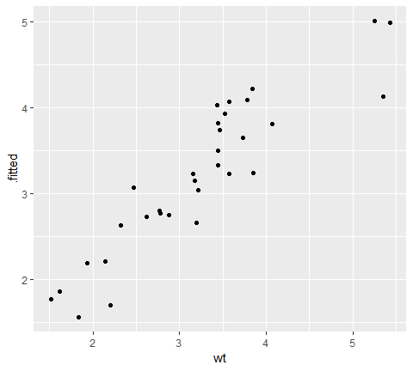

By combining the estimates and p-values across all groups into the same tidy data frame (instead of a list of output model objects), a new class of analyses and visualizations becomes straightforward. This includes

* Sorting by p-value or estimate to find the most significant terms across all tests
* P-value histograms
* Volcano plots comparing p-values to effect size estimates

In each of these cases, we can easily filter, facet, or distinguish based on the term column. In short, this makes the tools of tidy data analysis available for the results of data analysis and models, not just the inputs.

## [Tidy bootstrapping](https://cran.r-project.org/web/packages/broom/vignettes/bootstrapping.html)

Another place where combining model fits in a tidy way becomes useful is when performing bootstrapping or permutation tests. These approach have been explored, for instance, by [Andrew MacDonald here](http://rstudio-pubs-static.s3.amazonaws.com/19698_a4c472606e3c43e4b94720506e49bb7b.html), and [Hadley has explored efficient support for bootstrapping](https://github.com/hadley/dplyr/issues/269) as a potential enhancement to dplyr. broom fits naturally with dplyr in performing these analyses.

Bootstrapping consists of randomly sampling a dataset with replacement, then performing the analysis individually on each bootstrapped replicate. The variation in the resulting estimate is then a reasonable approximation of the variance in our estimate.

Let’s say we want to fit a nonlinear model to the weight/mileage relationship in the mtcars dataset.

library(ggplot2)  
ggplot(mtcars, aes(mpg, wt)) +   
 geom_point()

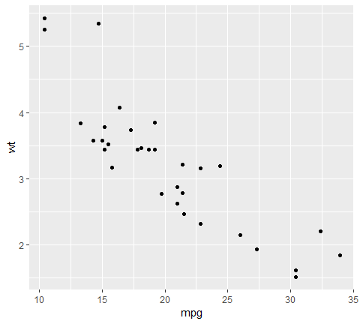

We might use the method of nonlinear least squares (via the nls function) to fit a model.

nlsfit <- nls(mpg~k/wt+b,  
 data = mtcars,  
 start = list(k=1, b=0))  
  
summary(nlsfit)  
##   
## Formula: mpg ~ k/wt + b  
##   
## Parameters:  
## Estimate Std. Error t value Pr(>|t|)   
## k 45.829 4.249 10.786 7.64e-12 ***  
## b 4.386 1.536 2.855 0.00774 **   
## ---  
## Signif. codes: 0 '***' 0.001 '**' 0.01 '*' 0.05 '.' 0.1 ' ' 1  
##   
## Residual standard error: 2.774 on 30 degrees of freedom  
##   
## Number of iterations to convergence: 1   
## Achieved convergence tolerance: 2.877e-08  
  
ggplot(mtcars, aes(wt,mpg))+  
 geom_point()+  
 geom_line(aes(y=predict(nlsfit)))

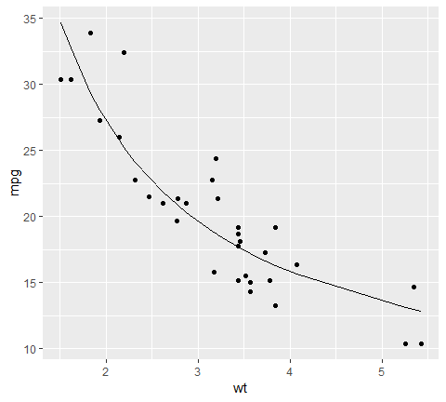

While this does provide a p-value and confidence intervals for the parameters, these are based on model assumptions that may not hold in real data. Bootstrapping is a popular method for providing confidence intervals and predictions that are more robust to the nature of the data.

We cna use the bootstraps function in the rsample package to sample bootstrap replications. First, we construct 100 bootstrap replications of the data, each of which as been randomly sampled with replacement. The resulting object is an rset, which is a dataframe with a column of rsplit objects.

an rsplit object has two main components: an analysis dataset and an assessment dataset, accessible via analysis(rsplit) and asessement(rsplit) respectively. For bootstrap samples, the analysis dataset is the bootstrap sample itself, and the assessment dataset consists of all the out of bag samples.

library(dplyr)  
library(rsample)  
library(broom)  
library(purrr)

set.seed(27)  
boots <- rsample::bootstraps(mtcars, times = 100)  
  
boots %>% head()  
## # A tibble: 6 x 2  
## splits id   
## * <list> <chr>   
## 1 <split [32/12]> Bootstrap001  
## 2 <split [32/15]> Bootstrap002  
## 3 <split [32/10]> Bootstrap003  
## 4 <split [32/10]> Bootstrap004  
## 5 <split [32/12]> Bootstrap005  
## 6 <split [32/12]> Bootstrap006  
boots$splits[[1]]  
## <32/12/32>

We create a helper function to fit an nls model on each bootstrap sample, and then use purrr::map to apply this to function to all the bootstrap samples at once. Similarly, we create an column of tidy coefficient information by unnesting.

fit_nls_on_bootstrap <- function(split) {  
 nls(mpg ~ k / wt + b, analysis(split), start = list(k = 1, b = 0))  
}  
  
boot_models <- boots %>%   
 mutate(model = map(splits, fit_nls_on_bootstrap),  
 coef_info = map(model, broom::tidy))  
  
boot_coefs <- boot_models %>%   
 unnest(coef_info)

The unnested coefficient information contains a summary of each replication combined in a single data frame:

boot_coefs  
## # A tibble: 200 x 6  
## id term estimate std.error statistic p.value  
## <chr> <chr> <dbl> <dbl> <dbl> <dbl>  
## 1 Bootstrap001 k 42.1 3.76 11.2 2.99e-12  
## 2 Bootstrap001 b 5.76 1.43 4.02 3.60e- 4  
## 3 Bootstrap002 k 46.3 3.72 12.4 2.26e-13  
## 4 Bootstrap002 b 4.10 1.43 2.87 7.38e- 3  
## 5 Bootstrap003 k 56.1 3.80 14.7 2.77e-15  
## 6 Bootstrap003 b 0.935 1.31 0.713 4.82e- 1  
## 7 Bootstrap004 k 43.5 3.39 12.8 1.06e-13  
## 8 Bootstrap004 b 4.83 1.33 3.62 1.06e- 3  
## 9 Bootstrap005 k 41.3 3.74 11.0 4.26e-12  
## 10 Bootstrap005 b 5.37 1.31 4.11 2.81e- 4  
## # ... with 190 more rows

We can then calculate confidence intervals (using what is called the [percentile method](https://www.uvm.edu/~dhowell/StatPages/Randomization%20Tests/ResamplingWithR/BootstMeans/bootstrapping_means.html))

alpha <- .05  
boot_coefs %>%   
 group_by(term) %>%   
 summarise(  
 low = quantile(estimate, alpha /2),  
 high = quantile(estimate, 1-alpha/2)  
 )  
## # A tibble: 2 x 3  
## term low high  
## <chr> <dbl> <dbl>  
## 1 b -0.695 7.40  
## 2 k 38.7 62.3

or we can use histograms to get a more detailed idea of the uncertainty in each estimate:

ggplot(boot_coefs, aes(estimate))+  
 geom_histogram(binwidth = 2)+  
 facet_wrap(~term, scales = "free")

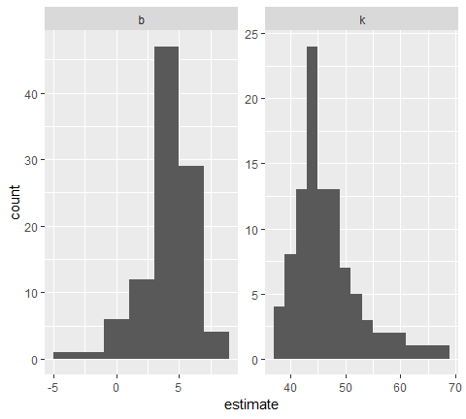

or we can use augment to visualize the uncertainty in the curve.

boot_aug <- boot_models %>%   
 mutate(augmented = map(model,augment)) %>%   
 unnest(augmented)  
  
boot_aug  
## # A tibble: 3,200 x 5  
## id mpg wt .fitted .resid  
## <chr> <dbl> <dbl> <dbl> <dbl>  
## 1 Bootstrap001 21.4 2.78 20.9 0.484  
## 2 Bootstrap001 22.8 2.32 23.9 -1.12   
## 3 Bootstrap001 30.4 1.51 33.6 -3.20   
## 4 Bootstrap001 17.8 3.44 18.0 -0.209  
## 5 Bootstrap001 24.4 3.19 19.0 5.43   
## 6 Bootstrap001 17.3 3.73 17.1 0.243  
## 7 Bootstrap001 22.8 2.32 23.9 -1.12   
## 8 Bootstrap001 21 2.62 21.8 -0.841  
## 9 Bootstrap001 18.7 3.44 18.0 0.691  
## 10 Bootstrap001 14.3 3.57 17.6 -3.26   
## # ... with 3,190 more rows

ggplot(boot_aug, aes(wt, mpg))+  
 geom_point()+  
 geom_line(aes(y=.fitted,group=id),alpha=.2)

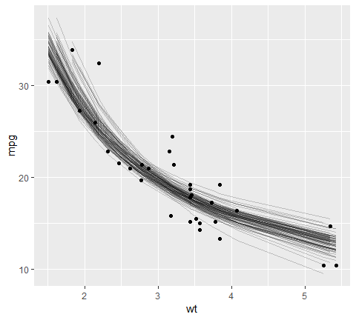

With only a few small changes, we could easily perform bootstrapping with other kinds of predictive or hypothetical tesing models, since the tidy functions work for many statistical outputs. As another example, we could use smooth.spline which fits a cubic smoothing spline to data:

fit_spline_on_bootstrap <- function(split){  
 data <- analysis(split)  
 smooth.spline(data$wt, data$mpg, df=4)  
}  
  
boot_splines <- boots %>%   
 mutate(spline = map(splits, fit_spline_on_bootstrap),  
 aug_train = map(spline, augment))  
  
splines_aug <- boot_splines %>%   
 unnest(aug_train)  
  
ggplot(splines_aug, aes(x,y,))+  
 geom_point()+  
 geom_line(aes(y = .fitted,group = id), alpha = .2)

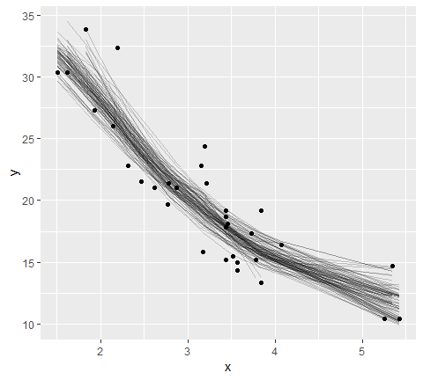

## [kmeans with dplyr and broom](https://cran.r-project.org/web/packages/broom/vignettes/kmeans.html)

### Tidy k-means clustering

K-means clustering serves as a very useful example of tidy data, and especially the distinction between the three tidying functions: tidy, agument and glance.

Let’s start by generating some random two-dimensional data with three clusters. Data in each cluster will come from a multivariate gaussian distribution with different means for each cluster:

library(dplyr)  
library(ggplot2)  
library(purrr)  
library(tibble)  
library(tidyr)

set.seed(27)  
  
centers <- tibble(  
 cluster = factor(1:3),  
 num_points = c(100, 150, 50), # the number in each cluster  
 x1 = c(5, 0, -3), # x1 coordinate of cluster center  
 x2 = c(-1, 1, -2) # x2 coordinate of cluster center  
)  
  
labeled_points <- centers %>%   
 mutate(  
 x1 = map2(num_points, x1, rnorm),  
 x2 = map2(num_points, x2, rnorm)  
 ) %>%   
 select(-num_points) %>%   
 unnest(x1, x2)  
  
ggplot(labeled_points, aes(x1, x2, color=cluster))+  
 geom_point()

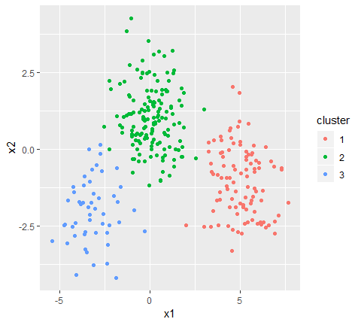

This is an ideal case for k-means clustering. We’ll use the built-in kmeans function, which accepts a data frame with all numeric columns as its prinary argument.

points <- labeled_points %>%   
 select(-cluster)  
  
points %>% head()  
## # A tibble: 6 x 2  
## x1 x2  
## <dbl> <dbl>  
## 1 6.91 -2.74   
## 2 6.14 -2.45   
## 3 4.24 -0.946  
## 4 3.54 0.287  
## 5 3.91 0.408  
## 6 5.30 -1.58  
  
kclust <- kmeans(points, centers = 3)  
kclust  
## K-means clustering with 3 clusters of sizes 51, 101, 148  
##   
## Cluster means:  
## x1 x2  
## 1 -3.14292460 -2.000043  
## 2 5.00401249 -1.045811  
## 3 0.08853475 1.045461  
##   
## Clustering vector:  
## [1] 2 2 2 2 2 2 2 2 2 2 2 2 2 2 2 2 2 2 2 2 2 2 2 2 2 2 2 2 2 2 2 2 2 2 2  
## [36] 2 2 2 2 2 2 2 2 2 2 2 2 2 2 2 2 2 2 2 2 2 2 2 2 2 2 2 2 2 2 2 2 2 2 2  
## [71] 2 2 2 2 2 2 2 2 2 2 2 2 2 2 2 2 2 2 2 2 2 2 2 2 2 2 2 2 2 2 3 3 3 3 3  
## [106] 3 3 3 3 3 3 3 3 3 3 3 3 3 3 3 3 3 3 3 3 3 3 3 3 3 3 3 3 3 3 3 3 3 3 3  
## [141] 3 3 3 3 3 3 3 3 3 3 3 3 3 3 3 3 3 3 3 3 3 3 3 3 3 3 3 3 3 3 3 3 3 3 3  
## [176] 3 3 3 3 3 3 3 3 3 3 3 3 3 3 3 3 3 3 3 3 3 3 3 2 3 3 3 3 3 3 3 3 3 3 3  
## [211] 3 3 3 3 3 3 3 3 3 3 3 3 3 3 3 3 3 3 3 3 3 3 3 3 3 3 3 3 3 3 3 3 3 1 3  
## [246] 3 3 3 3 3 1 1 1 1 1 1 1 1 1 1 1 1 1 1 1 1 1 1 1 1 1 1 1 1 1 1 1 1 1 1  
## [281] 1 1 1 1 1 1 1 1 1 1 1 1 1 1 1 1 1 1 1 1  
##   
## Within cluster sum of squares by cluster:  
## [1] 108.8112 243.2092 298.9415  
## (between_SS / total_SS = 82.5 %)  
##   
## Available components:  
##   
## [1] "cluster" "centers" "totss" "withinss"   
## [5] "tot.withinss" "betweenss" "size" "iter"   
## [9] "ifault"  
  
summary(kclust)  
## Length Class Mode   
## cluster 300 -none- numeric  
## centers 6 -none- numeric  
## totss 1 -none- numeric  
## withinss 3 -none- numeric  
## tot.withinss 1 -none- numeric  
## betweenss 1 -none- numeric  
## size 3 -none- numeric  
## iter 1 -none- numeric  
## ifault 1 -none- numeric

The output is a list of vectors, where each component has a different length. There’s one of length 300: the same as our original dataset. There are number of elements of length 3: withiness, tot.withiness and betweeness and centers is a matrix with 3 rows. And then there are the elements of length 1: totss, tot.withiness, betweenss and iter.

These differing lengths have a deeper meaning when we want to tidy our dataset: they signify that each type of component communicates a *different kind* of information.

* cluster (300 values) contains information about each *point*
* centers, withinss and size (3 values) contain information about each *cluster*
* totss, tot.withinss, betweenss, and iter (1 value) contain information about the *full clustering*

Which of these do we want to extract? There is no right answer: each of them may be interesting to an analyst. Because they communicate entirely different information (not to mention there is no straightfoward way to combine them), they are extracted by separate functions. augment adds the point classifications to the original dataset:

library(broom)  
broom::augment(kclust, points)  
## # A tibble: 300 x 3  
## x1 x2 .cluster  
## <dbl> <dbl> <fct>   
## 1 6.91 -2.74 2   
## 2 6.14 -2.45 2   
## 3 4.24 -0.946 2   
## 4 3.54 0.287 2   
## 5 3.91 0.408 2   
## 6 5.30 -1.58 2   
## 7 5.01 -1.77 2   
## 8 6.16 -1.68 2   
## 9 7.13 -2.17 2   
## 10 5.24 -2.42 2   
## # ... with 290 more rows

The tidy function summarizes on a per-cluster level:

broom::tidy(kclust)  
## # A tibble: 3 x 5  
## x1 x2 size withinss cluster  
## * <dbl> <dbl> <int> <dbl> <fct>   
## 1 -3.14 -2.00 51 109. 1   
## 2 5.00 -1.05 101 243. 2   
## 3 0.0885 1.05 148 299. 3

And as it always does, the glance function extracts a single-row summary:

glance(kclust)  
## # A tibble: 1 x 4  
## totss tot.withinss betweenss iter  
## <dbl> <dbl> <dbl> <int>  
## 1 3724. 651. 3073. 2

### broom and dplyr for exploratory clustering

While these summaries are useful, they would not have been too difficult to extract out from the dataset yourself. The real power comes from combining these analyses with dplyr.

Let’s say we want to explore theeffects of different choices of k, from 1 to 9, on this clustering. First, cluster the data 9 times, each using a different value of k, then create columns containing the tidied, glanced and augmented data:

kclusts <- tibble(k = 1:9) %>%  
 mutate(  
 kclust = map(k, ~kmeans(points, .x)),  
 tidied = map(kclust, broom::tidy),  
 glanced = map(kclust, glance),  
 augmented = map(kclust, augment, points)  
 )  
  
kclusts  
## # A tibble: 9 x 5  
## k kclust tidied glanced augmented   
## <int> <list> <list> <list> <list>   
## 1 1 <S3: kmeans> <tibble [1 x 5]> <tibble [1 x 4]> <tibble [300 x 3]>  
## 2 2 <S3: kmeans> <tibble [2 x 5]> <tibble [1 x 4]> <tibble [300 x 3]>  
## 3 3 <S3: kmeans> <tibble [3 x 5]> <tibble [1 x 4]> <tibble [300 x 3]>  
## 4 4 <S3: kmeans> <tibble [4 x 5]> <tibble [1 x 4]> <tibble [300 x 3]>  
## 5 5 <S3: kmeans> <tibble [5 x 5]> <tibble [1 x 4]> <tibble [300 x 3]>  
## 6 6 <S3: kmeans> <tibble [6 x 5]> <tibble [1 x 4]> <tibble [300 x 3]>  
## 7 7 <S3: kmeans> <tibble [7 x 5]> <tibble [1 x 4]> <tibble [300 x 3]>  
## 8 8 <S3: kmeans> <tibble [8 x 5]> <tibble [1 x 4]> <tibble [300 x 3]>  
## 9 9 <S3: kmeans> <tibble [9 x 5]> <tibble [1 x 4]> <tibble [300 x 3]>

We can turn these into three separate datasets each representing a different type of data: Then tidy the clusterings three ways: using tidy, using augment, and using glance. Each of these goes into a separate dataset as they represent different types of data.

clusters <- kclusts %>%  
 unnest(tidied)  
  
assignments <- kclusts %>%   
 unnest(augmented)  
  
clusterings <- kclusts %>%   
 unnest(glanced, .drop=TRUE)

Now we can plot the original points, with each point colored according to the predicted cluster.

p1 <- ggplot(assignments, aes(x1, x2))+  
 geom_point(aes(color=.cluster))+  
 facet_wrap(~k)  
  
p1

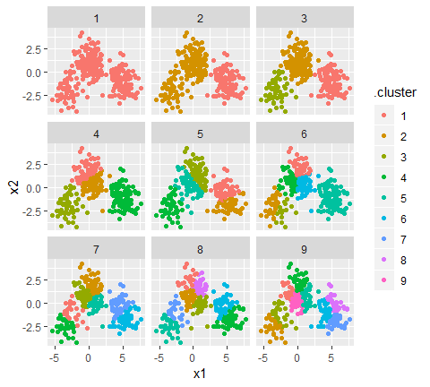

Already we get a good sense of the proper number of clusters (3), and how the k-means algorithm functions when k is too high or too low. We can then add the centers using the data from tidy:

p2 <- p1 + geom_point(data=clusters, size=3, shape="X")  
p2

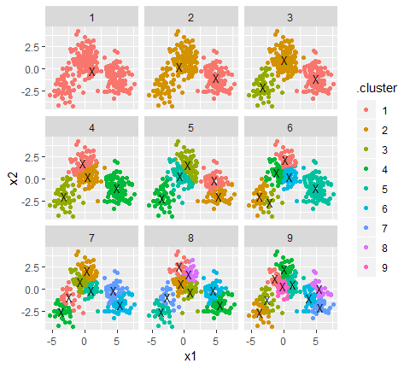

The data from glance fits a diffrent but equally important purpose: it lets you view trends of some summary statistics across values of k. Of particular interest is the total within sum of squares, saved in the tot.withinss column.

ggplot(clusterings, aes(k, tot.withinss))+  
 geom_line()

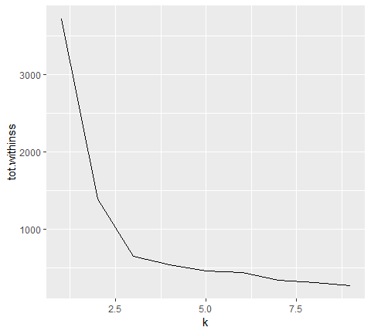

This represents the variance within clusters. It decreases as k increases, but one can notice a bed (or elborw) right at k=3. This bend indicates that additional clusters beyond the third little value. (See [here](http://web.stanford.edu/~hastie/Papers/gap.pdf) for a more mathematically rigorous interpretation and implementation of this method). Thus, all three methods of tidying data provided by broom are useful for summarizing clustering output.

## Rererence

[Broom Vignette](https://broom.tidyverse.org/)

# rsample

rsample contains a set of functions that can create different types of resamples and corresponding classses for their analysis. The goal is to have modular set of methods that can be used across different R packages for:

* traditional resampling techniques for estimating the sampling distribution of a statistic and
* estimating model performance using a holdout set

The scope of rsample is to provide the basic building blocks for creating and analyzing resamples of a data set but does not include for modeling or calculating statistics. The “Workking with Resample Sets” vignette gives demonstrations of how rsample tools can be used.

install.packages("rsample")  
  
# for the devel version::  
require(devtools)  
devtools::install_github("tidymodels/rsample")

Note that resampled data sets created by rsample are directly accessible ina resampling object but do not contain much overhead in memory. Since the original data is not modified, R does not make an automatic copy.

For example, creating 50 bootstraps of a data set does not create an object that is 50-fold larger inmemory.

library(rsample)  
library(mlbench)  
library(pryr)  
  
data(LetterRecognition)  
object_size(LetterRecognition)  
## 2.64 MB  
  
set.seed(35222)  
boots <- rsample::bootstraps(LetterRecognition, times=50)  
  
object_size(boots)  
## 6.69 MB  
  
# object size per resample  
object_size(boots)/nrow(boots)  
## 134 kB  
  
# Fold increase is <<< 50  
as.numeric(object_size(boots)/object_size(LetterRecognition))  
## [1] 2.529808

## Nested resampling

(A version of this article was originally published in the [*Applied Predictive Modeling* blog](http://appliedpredictivemodeling.com/blog/2017/9/2/njdc83d01pzysvvlgik02t5qnaljnd))

A typical scheme for splitting the data when developing a predictive model is to create an initial split of the data into a training and test set. If resampling is used, it is executed on the training set. A series of binary splits is created. In rsample, we use the term *analysis set* for the data that are used to fit the model and *assessment set* is used to compute performance

A common method for tuning models is grid search where a candidate set of tuning parameters is created. The full set of models for every combination of the tuning parameter grid and the resamples is created. Each time, the assessment data are used to measure performance and the average value is determined for each tuning parameter.

The potential problem is, once we pick the tuning parameter associated with the bet performance, this performance value is usually quoted as the performance of the model. There is a serious potential for *optimization bias* since we uses the same data to tune the model and quote performance. This would result in an optimistinc estimate of performance.

Nested resampling does an additional layer of resampling that separates the tuning activities from the process used to estimate the efficacy of the model. An *outer* resampling scheme is used and, for every split in the outer resample, another full set of resampling splits are created on the original analysis set. For example, if 10-fold cross-validation is used on the outside and 5-fold cross-validation on the inside, a total of 500 models will be fit. The parameter tuning will be conducted 10 times and thebest parameters are determined from the average of the 5 assessment sets. This process occurs 10 times.

We will simulate some regression data to illustrate the methods. The mlbench function mlbench::mlbench.friedman1 can simulate a complex regression data structure from the [original MARS publication](https://scholar.google.com/scholar?hl=en&q=%22Multivariate+adaptive+regression+splines%22&btnG=&as_sdt=1%2C7&as_sdtp=). A training set size of 100 data points are generated as well as a large set that will be used to characterize how well the resampling procedure performed.

library(mlbench)  
sim_data <- function(n){  
 tmp <- mlbench.friedman1(n, sd=1)  
 tmp <- cbind(tmp$x, tmp$y)  
 tmp <- as.data.frame(tmp)  
 names(tmp)[ncol(tmp)] <- "y"  
 tmp  
}  
  
set.seed(9815)  
train_dat <- sim_data(100)  
large_dat <- sim_data(10^5)  
  
train_dat %>% head()  
## V1 V2 V3 V4 V5 V6 V7  
## 1 0.1945697 0.6418371 0.9530617 0.7961244 0.2175547 0.9341119 0.1990057  
## 2 0.2281191 0.1046035 0.8010136 0.6872665 0.7132849 0.5495135 0.4451621  
## 3 0.0237278 0.0983911 0.5911238 0.2729825 0.3486822 0.5970778 0.9879835  
## 4 0.7073537 0.8550995 0.8232934 0.5859757 0.5678440 0.1095951 0.6397121  
## 5 0.7844861 0.2843560 0.3885567 0.1277830 0.6481253 0.8126577 0.3983826  
## 6 0.5669030 0.9980239 0.7295834 0.1901266 0.5859250 0.2845121 0.7643961  
## V8 V9 V10 y  
## 1 0.2106022 0.57407261 0.1958863 16.36389  
## 2 0.7320519 0.08607139 0.3788550 12.90426  
## 3 0.6377623 0.56391894 0.9798512 4.12934  
## 4 0.9254958 0.79069775 0.3709754 21.72215  
## 5 0.5251866 0.62025157 0.1792105 11.59917  
## 6 0.2775036 0.82434996 0.1619205 14.79745  
train_dat %>% dim()  
## [1] 100 11

To get started, the types of resampling methods need to be specified. This isn’t a large data set, so 5 repeates of 10-fold cross validation will be used as the *outer* resampling method that will be used to generate the estimate of overall performance. To tune the model, it would be good to have precise estimates for each of the values of the tuning parameter so 25 iterations of the bootstrap will be used. fit This means that there will eventually be 5 * 10 * 25 = 1250 models that are fit to the data per tuning parameter. These will be discarded once the performance of the model has been quantified.

library(rsample)   
results <- nested_cv(train_dat,   
 outside = vfold_cv(repeats = 5),   
 inside = bootstraps(times = 25))  
results  
## [1] "nested_cv" "vfold_cv" "rset" "tbl_df" "tbl"   
## [6] "data.frame"  
## # Nested resampling:  
## # outer: 10-fold cross-validation repeated 5 times  
## # inner: Bootstrap sampling  
## # A tibble: 50 x 4  
## splits id id2 inner_resamples   
## <list> <chr> <chr> <list>   
## 1 <split [90/10]> Repeat1 Fold01 <tibble [25 x 2]>  
## 2 <split [90/10]> Repeat1 Fold02 <tibble [25 x 2]>  
## 3 <split [90/10]> Repeat1 Fold03 <tibble [25 x 2]>  
## 4 <split [90/10]> Repeat1 Fold04 <tibble [25 x 2]>  
## 5 <split [90/10]> Repeat1 Fold05 <tibble [25 x 2]>  
## 6 <split [90/10]> Repeat1 Fold06 <tibble [25 x 2]>  
## 7 <split [90/10]> Repeat1 Fold07 <tibble [25 x 2]>  
## 8 <split [90/10]> Repeat1 Fold08 <tibble [25 x 2]>  
## 9 <split [90/10]> Repeat1 Fold09 <tibble [25 x 2]>  
## 10 <split [90/10]> Repeat1 Fold10 <tibble [25 x 2]>  
## # ... with 40 more rows

The splitting information for each resample is contained in the split objects. Focusing on the second fold of the first repeat:

results$splits[[2]]  
## <90/10/100>

<90/10/100> indicates the number of data in the analysis set, assessment set, and the original data.

Each element of inner_resamples has its own tibble with the bootstrapping splits.

results$inner_resamples[[5]]  
## # Bootstrap sampling   
## # A tibble: 25 x 2  
## splits id   
## <list> <chr>   
## 1 <split [90/37]> Bootstrap01  
## 2 <split [90/31]> Bootstrap02  
## 3 <split [90/28]> Bootstrap03  
## 4 <split [90/37]> Bootstrap04  
## 5 <split [90/32]> Bootstrap05  
## 6 <split [90/34]> Bootstrap06  
## 7 <split [90/32]> Bootstrap07  
## 8 <split [90/30]> Bootstrap08  
## 9 <split [90/35]> Bootstrap09  
## 10 <split [90/41]> Bootstrap10  
## # ... with 15 more rows

These are self-contained, meaning that the bootstrap sample is aware that it is a sample of a specific 90% of the data:

results$inner_resamples[[5]]$splits[[1]]  
## <90/37/90>

To start, we need to define how the model will be created and measured. For our example, a **radial basis support vector machine** model will be created using the function kernlab::ksvm. This model is generally thought of as having *two* tuning parameters: the SVM cost value and the kernel parameter sigma. For illustration, only the cost value will be tuned and the function kernlab::sigest will be used to estimate sigma during each model fit. This is automatically done by ksvm.

After the model is fit to the analysis set, the root-mean squared error (RMSE) is computed on the assessment set. One important note: for this model, it is critical to center and scale the predictors before computing dot products. We don’t do this operation here because mlbench.friedman1 simulates all of the predictors to be standard uniform random variables.

Our function to fit the model and compute the RMSE is:

library(kernlab)  
  
# `object` will be an `rsplit` object from our `results` tibble  
# `cost` is the tuning parameter  
svm_rmse <- function(object, cost = 1) {  
 y_col <- ncol(object$data)  
 mod <- ksvm(y ~ ., data = analysis(object), C = cost)  
 holdout_pred <- predict(mod, assessment(object)[-y_col])  
 rmse <- sqrt(mean((assessment(object)$y - holdout_pred) ^ 2, na.rm = TRUE))  
 rmse  
}  
  
# In some case, we want to parameterize the function over the tuning parameter:  
rmse_wrapper <- function(cost, object) svm_rmse(object, cost)

For the nested resampling, a model needs to be fit for each tuning parameter and each bootstrap split. To do this, a wrapper can be created:

library(purrr)  
library(dplyr)  
  
# `object` will be an `rsplit` object for the bootstrap samples  
tune_over_cost <- function(object) {  
 results <- tibble(cost = 2 ^ seq(-2, 8, by = 1))  
 results$RMSE <- map_dbl(results$cost,   
 rmse_wrapper,  
 object = object)  
 results  
}

Since this will be called across the set of outer cross-validation splits, another wrapper is required:

# `object` is an `rsplit` object in `results$inner_resamples`   
summarize_tune_results <- function(object) {  
 # Return row-bound tibble that has the 25 bootstrap results  
 map_df(object$splits, tune_over_cost) %>%  
 # For each value of the tuning parameter, compute the   
 # average RMSE which is the inner bootstrap estimate.   
 group_by(cost) %>%  
 summarize(mean_RMSE = mean(RMSE, na.rm = TRUE),  
 n = length(RMSE))  
}

Now that those functions are defined, we can execute all the inner resampling loops:

tuning_results <- map(results$inner_resamples, summarize_tune_results)

tuning_results is a list of data frames for each of the 50 outer resamples.

Let’s make a plot of the averaged results to see what the relationship is between the RMSE and the tuning parameters for each of the inner bootstrapping operations:

library(ggplot2)  
library(scales)  
  
pooled_inner <- tuning_results %>% bind_rows  
  
best_cost <- function(dat) dat[which.min(dat$mean_RMSE),]  
  
p <- ggplot(pooled_inner, aes(x=cost, y=mean_RMSE))+  
 scale_x_continuous(trans="log2")+  
 xlab("SVM Cost")+ylab("Inner RMSE")  
  
for (i in 1:length(tuning_results)){  
 p <- p +   
 geom_line(data=tuning_results[[i]], alpha=.2)+  
 geom_point(data=best_cost(tuning_results[[i]]), pch = 16)  
}  
  
p <- p+geom_smooth(data=pooled_inner, se=FALSE)  
p

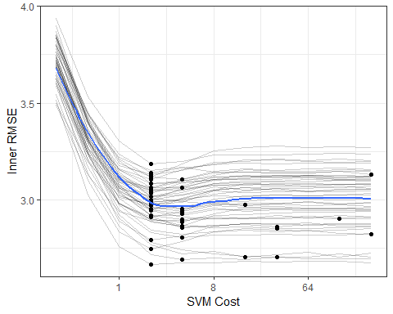

Each grey line is a separate bootstrap resampling curve created from a different 90% of the data. The blue line is a loess smooth of all the results pooled together.

To determine the best parameter estimate for each of the outer resampling iterations:

cost_vals <- tuning_results %>%   
 map_df(best_cost) %>%   
 select(cost)  
  
results <- bind_cols(results, cost_vals)  
results$cost <- factor(results$cost, levels=paste(2^seq(-2,8,by=1)))  
  
ggplot(results, aes(x=cost))+  
 geom_bar()+  
 xlab("SVM Cost")+  
 scale_x_discrete(drop=FALSE)

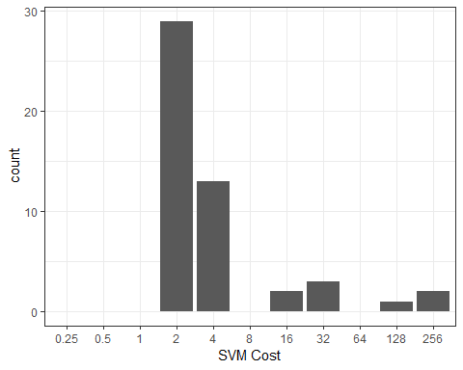

Most of the resampling produced and optimal cost values of 2.0 but the distribution is right-skewed due to the flat trend in the resampling profile once the cost value becomes 10 or larger.

Now that we have these estimates, we can compute the outer resampling results for each of the 50 splits using the corresponding tuning parameter value:

results$RMSE <- map2_dbl(results$splits, results$cost, svm_rmse)  
summary(results$RMSE)  
## Min. 1st Qu. Median Mean 3rd Qu. Max.   
## 1.095 2.099 2.636 2.682 3.093 4.177

What is the RMSE estimate for non-nested procedure when only the outer resampling method is used? For each cost value in the tuning grid, 50 SVM models are fit and their RMSE values are averaged. The table of cost values and mean RMSE estimates is used to determine the best cost value. The associated RMSE is the biased estimate.

not_nested <- map(results$splits, tune_over_cost) %>%   
 bind_rows  
  
outer_summary <- not_nested %>%   
 group_by(cost) %>%   
 summarise(outer_RMSE = mean(RMSE),  
 n = length(RMSE))  
outer_summary  
## # A tibble: 11 x 3  
## cost outer_RMSE n  
## <dbl> <dbl> <int>  
## 1 0.25 3.57 50  
## 2 0.5 3.12 50  
## 3 1 2.78 50  
## 4 2 2.61 50  
## 5 4 2.64 50  
## 6 8 2.76 50  
## 7 16 2.83 50  
## 8 32 2.84 50  
## 9 64 2.83 50  
## 10 128 2.83 50  
## 11 256 2.84 50  
  
ggplot(outer_summary, aes(x = cost, y = outer_RMSE))+  
 geom_point()+  
 geom_line()+  
 scale_x_continuous(trans="log2")+  
 xlab("SVM cost")+ylab("RMSE")

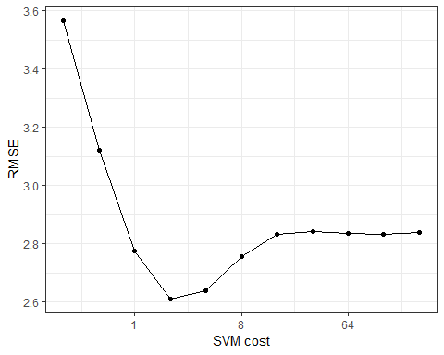

The non-nested procedure estimates the RMSE to be 2.61. Both estimates are fairly close.

finalModel <- kernlab::ksvm(y~., data=train_dat, C = 2)  
large_pred <- predict(finalModel, large_dat[, -ncol(large_dat)])  
sqrt(mean((large_dat$y - large_pred)^2, na.rm=TRUE))  
## [1] 2.696096

The nested procedure produces a closer estimate to the approximate truth but the non-nested estimate is very similar.

## Recipes with rsample

library(rsample)  
library(recipes)  
library(purrr)

The [recipes](https://topepo.github.io/recipes/) package contains a data preprocessor that can be used to avoid the potentially expensive formula methods as well as providing a richer set of data manipulation tools than base R can provide. This document uses version 0.1.4 of recipes.

In many cases, the preprocessing steps might contain quantities that require statistical estimation of parameters, such as

* signal extraction using principal component analysis
* imputation of missing values
* transformations of individual variables (e.g., Box-Cox transformations)

It is critical that any complex preprocessing steps be contained *inside* of resampling so that the model performance estimates take into account the variability of these steps. Before discussing how rsample can use recipes, let’s look at an example recipe for the Ames housing data.

### An example recipe

For illustration, the Ames housing data will be used. There are sale prices of homes along with various other descriptions for the property:

library(AmesHousing)  
ames <- make_ames()  
names(ames)  
## [1] "MS_SubClass" "MS_Zoning" "Lot_Frontage"   
## [4] "Lot_Area" "Street" "Alley"   
## [7] "Lot_Shape" "Land_Contour" "Utilities"   
## [10] "Lot_Config" "Land_Slope" "Neighborhood"   
## [13] "Condition_1" "Condition_2" "Bldg_Type"   
## [16] "House_Style" "Overall_Qual" "Overall_Cond"   
## [19] "Year_Built" "Year_Remod_Add" "Roof_Style"   
## [22] "Roof_Matl" "Exterior_1st" "Exterior_2nd"   
## [25] "Mas_Vnr_Type" "Mas_Vnr_Area" "Exter_Qual"   
## [28] "Exter_Cond" "Foundation" "Bsmt_Qual"   
## [31] "Bsmt_Cond" "Bsmt_Exposure" "BsmtFin_Type_1"   
## [34] "BsmtFin_SF_1" "BsmtFin_Type_2" "BsmtFin_SF_2"   
## [37] "Bsmt_Unf_SF" "Total_Bsmt_SF" "Heating"   
## [40] "Heating_QC" "Central_Air" "Electrical"   
## [43] "First_Flr_SF" "Second_Flr_SF" "Low_Qual_Fin_SF"   
## [46] "Gr_Liv_Area" "Bsmt_Full_Bath" "Bsmt_Half_Bath"   
## [49] "Full_Bath" "Half_Bath" "Bedroom_AbvGr"   
## [52] "Kitchen_AbvGr" "Kitchen_Qual" "TotRms_AbvGrd"   
## [55] "Functional" "Fireplaces" "Fireplace_Qu"   
## [58] "Garage_Type" "Garage_Finish" "Garage_Cars"   
## [61] "Garage_Area" "Garage_Qual" "Garage_Cond"   
## [64] "Paved_Drive" "Wood_Deck_SF" "Open_Porch_SF"   
## [67] "Enclosed_Porch" "Three_season_porch" "Screen_Porch"   
## [70] "Pool_Area" "Pool_QC" "Fence"   
## [73] "Misc_Feature" "Misc_Val" "Mo_Sold"   
## [76] "Year_Sold" "Sale_Type" "Sale_Condition"   
## [79] "Sale_Price" "Longitude" "Latitude"

Suppose that we will again fit a simple regression model with the formula:

log10(Sale_Price)~Neighborhood+House_Style+Year_Sold+Lot_Area

The distribution of the lot size is right-skewed:

library(ggplot2)  
theme_set(theme_bw())  
ggplot(ames, aes(x=Lot_Area))+  
 geom_histogram(binwidth = 5000, col = "red", fill = "red", alpha = .5)

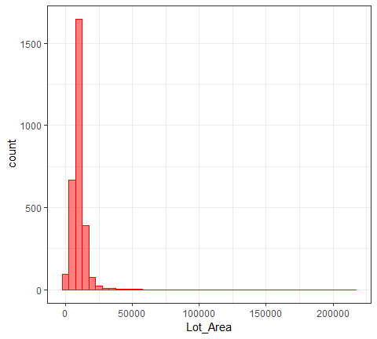

It might benefit the model if we estimate a transformation of the data using the Box-Cox procedure. Also, note that the frequencies of the neighborhoods can vary:

ggplot(ames, aes(x = Neighborhood))+  
 geom_bar()+  
 coord_flip()+  
 xlab("")

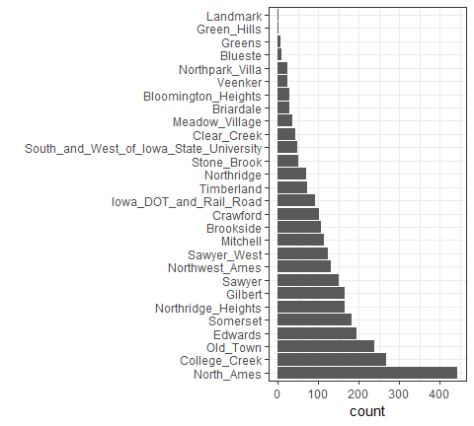

When these are resampled, some neighborhood will not be included in the test set and this will result in a column of dummy variables with zero entires. The same is true for the House_Style variable. We might want to collapse rarely occuring values into other categories.

To define the design matrix, an initial recipe is created:

library(recipes)  
  
rec <- recipe(Sale_Price ~ Neighborhood + House_Style + Year_Sold + Lot_Area,  
 data = ames) %>%   
 # log the outcome  
 step_log(Sale_Price, base = 10) %>%   
 # Collapse rarely occuring jobs into "other"  
 step_other(Neighborhood, House_Style, threshold = 0.05) %>%   
 # dummy variables on the qualitative predictors  
 step_dummy(all_nominal()) %>%   
 # Unskew a predictor  
 step_BoxCox(Lot_Area) %>%   
 # Normalize   
 step_center(all_predictors()) %>%   
 step_scale(all_predictors())  
  
rec  
## Data Recipe  
##   
## Inputs:  
##   
## role #variables  
## outcome 1  
## predictor 4  
##   
## Operations:  
##   
## Log transformation on Sale_Price  
## Collapsing factor levels for Neighborhood, House_Style  
## Dummy variables from all_nominal()  
## Box-Cox transformation on Lot_Area  
## Centering for all_predictors()  
## Scaling for all_predictors()

This recreates the work that the fomula method traditionally uses with the additional steps. While the original data object ames is used in the call, it is only used to define the variables and their characteristics so a single recipe is valid across all resampled versions of the data. The recipe can be estimated on the analysis component of the resample.

If we execute the recipe on the entire data set:

rec_training_set <- prep(rec, training=ames)  
rec_training_set  
## Data Recipe  
##   
## Inputs:  
##   
## role #variables  
## outcome 1  
## predictor 4  
##   
## Training data contained 2930 data points and no missing data.  
##   
## Operations:  
##   
## Log transformation on Sale_Price [trained]  
## Collapsing factor levels for Neighborhood, House_Style [trained]  
## Dummy variables from Neighborhood, House_Style [trained]  
## Box-Cox transformation on Lot_Area [trained]  
## Centering for Year_Sold, ... [trained]  
## Scaling for Year_Sold, ... [trained]

To get the values of the data, the bake function can be used:

# By default, the selector `everything` is used to  
# return all the variables. Other selectors can be used too.  
rec_training_set %>%   
 bake(new_data = ames[1:20,])  
## # A tibble: 20 x 14  
## Lot_Area Year_Sold Sale_Price Neighborhood_Co~ Neighborhood_Ol~  
## <dbl> <dbl> <dbl> <dbl> <dbl>  
## 1 2.70 1.68 5.33 -0.317 -0.298  
## 2 0.506 1.68 5.02 -0.317 -0.298  
## 3 0.930 1.68 5.24 -0.317 -0.298  
## 4 0.423 1.68 5.39 -0.317 -0.298  
## 5 0.865 1.68 5.28 -0.317 -0.298  
## 6 0.197 1.68 5.29 -0.317 -0.298  
## 7 -1.16 1.68 5.33 -0.317 -0.298  
## 8 -1.12 1.68 5.28 -0.317 -0.298  
## 9 -0.988 1.68 5.37 -0.317 -0.298  
## 10 -0.364 1.68 5.28 -0.317 -0.298  
## 11 0.202 1.68 5.25 -0.317 -0.298  
## 12 -0.244 1.68 5.27 -0.317 -0.298  
## 13 -0.143 1.68 5.26 -0.317 -0.298  
## 14 0.237 1.68 5.23 -0.317 -0.298  
## 15 -0.546 1.68 5.33 -0.317 -0.298  
## 16 3.95 1.68 5.73 -0.317 -0.298  
## 17 0.594 1.68 5.21 -0.317 -0.298  
## 18 0.465 1.68 5.60 -0.317 -0.298  
## 19 1.56 1.68 5.15 -0.317 -0.298  
## 20 0.764 1.68 5.32 -0.317 -0.298  
## # ... with 9 more variables: Neighborhood_Edwards <dbl>,  
## # Neighborhood_Somerset <dbl>, Neighborhood_Northridge_Heights <dbl>,  
## # Neighborhood_Gilbert <dbl>, Neighborhood_Sawyer <dbl>,  
## # Neighborhood_other <dbl>, House_Style_One_Story <dbl>,  
## # House_Style_Two_Story <dbl>, House_Style_other <dbl>

Note that there are fewer dummy variables for Neighborhood and House_Style than in the data. Also, the above code using prep benefits from the default argument of retain=TRUE, which keeps the processed version of the data set so that we don’t have to reapply the steps to extract the processed values. For the data used to train the recipe, we would have used:

rec_training_set %>%   
 juice() %>%   
 head()  
## # A tibble: 6 x 14  
## Year_Sold Lot_Area Sale_Price Neighborhood_Co~ Neighborhood_Ol~  
## <dbl> <dbl> <dbl> <dbl> <dbl>  
## 1 1.68 2.70 5.33 -0.317 -0.298  
## 2 1.68 0.506 5.02 -0.317 -0.298  
## 3 1.68 0.930 5.24 -0.317 -0.298  
## 4 1.68 0.423 5.39 -0.317 -0.298  
## 5 1.68 0.865 5.28 -0.317 -0.298  
## 6 1.68 0.197 5.29 -0.317 -0.298  
## # ... with 9 more variables: Neighborhood_Edwards <dbl>,  
## # Neighborhood_Somerset <dbl>, Neighborhood_Northridge_Heights <dbl>,  
## # Neighborhood_Gilbert <dbl>, Neighborhood_Sawyer <dbl>,  
## # Neighborhood_other <dbl>, House_Style_One_Story <dbl>,  
## # House_Style_Two_Story <dbl>, House_Style_other <dbl>

The next section will explore recipes and bootstrap resampling for modeling:

library(rsample)  
set.seed(7712)  
bt_samples <- bootstraps(ames)  
bt_samples  
## # Bootstrap sampling   
## # A tibble: 25 x 2  
## splits id   
## <list> <chr>   
## 1 <split [2.9K/1.1K]> Bootstrap01  
## 2 <split [2.9K/1.1K]> Bootstrap02  
## 3 <split [2.9K/1.1K]> Bootstrap03  
## 4 <split [2.9K/1K]> Bootstrap04  
## 5 <split [2.9K/1.1K]> Bootstrap05  
## 6 <split [2.9K/1.1K]> Bootstrap06  
## 7 <split [2.9K/1.1K]> Bootstrap07  
## 8 <split [2.9K/1K]> Bootstrap08  
## 9 <split [2.9K/1.1K]> Bootstrap09  
## 10 <split [2.9K/1.1K]> Bootstrap10  
## # ... with 15 more rows  
bt_samples$splits[[1]]  
## <2930/1076/2930>

### Working with Rsamples

We can add a recipe column to the tibble. recipes has a connivence function called prepper that can be used to call prep but has the split object as the first argument (for easier purring):

library(purrr)  
  
bt_samples$recipes <- map(bt_samples$splits, prepper, recipe=rec)  
bt_samples  
## # Bootstrap sampling   
## # A tibble: 25 x 3  
## splits id recipes   
## <list> <chr> <list>   
## 1 <split [2.9K/1.1K]> Bootstrap01 <S3: recipe>  
## 2 <split [2.9K/1.1K]> Bootstrap02 <S3: recipe>  
## 3 <split [2.9K/1.1K]> Bootstrap03 <S3: recipe>  
## 4 <split [2.9K/1K]> Bootstrap04 <S3: recipe>  
## 5 <split [2.9K/1.1K]> Bootstrap05 <S3: recipe>  
## 6 <split [2.9K/1.1K]> Bootstrap06 <S3: recipe>  
## 7 <split [2.9K/1.1K]> Bootstrap07 <S3: recipe>  
## 8 <split [2.9K/1K]> Bootstrap08 <S3: recipe>  
## 9 <split [2.9K/1.1K]> Bootstrap09 <S3: recipe>  
## 10 <split [2.9K/1.1K]> Bootstrap10 <S3: recipe>  
## # ... with 15 more rows  
bt_samples$recipes[[1]]  
## Data Recipe  
##   
## Inputs:  
##   
## role #variables  
## outcome 1  
## predictor 4  
##   
## Training data contained 2930 data points and no missing data.  
##   
## Operations:  
##   
## Log transformation on Sale_Price [trained]  
## Collapsing factor levels for Neighborhood, House_Style [trained]  
## Dummy variables from Neighborhood, House_Style [trained]  
## Box-Cox transformation on Lot_Area [trained]  
## Centering for Year_Sold, ... [trained]  
## Scaling for Year_Sold, ... [trained]

Now to fit the model, the fit function only needs the recipe as input. This is because the above code implicitly used the retain=TRUE option in prep. Otherwise, the split objects would also be needed to bake the recipe (as it will in the prediction function below).

fit_lm <- function(rec_obj, ...){  
 lm(..., data = juice(rec_obj, everything()))  
}  
  
bt_samples$lm_mod <-   
 map(bt_samples$recipes,  
 fit_lm,  
 Sale_Price ~.  
 )  
  
  
bt_samples  
## # Bootstrap sampling   
## # A tibble: 25 x 4  
## splits id recipes lm_mod   
## <list> <chr> <list> <list>   
## 1 <split [2.9K/1.1K]> Bootstrap01 <S3: recipe> <S3: lm>  
## 2 <split [2.9K/1.1K]> Bootstrap02 <S3: recipe> <S3: lm>  
## 3 <split [2.9K/1.1K]> Bootstrap03 <S3: recipe> <S3: lm>  
## 4 <split [2.9K/1K]> Bootstrap04 <S3: recipe> <S3: lm>  
## 5 <split [2.9K/1.1K]> Bootstrap05 <S3: recipe> <S3: lm>  
## 6 <split [2.9K/1.1K]> Bootstrap06 <S3: recipe> <S3: lm>  
## 7 <split [2.9K/1.1K]> Bootstrap07 <S3: recipe> <S3: lm>  
## 8 <split [2.9K/1K]> Bootstrap08 <S3: recipe> <S3: lm>  
## 9 <split [2.9K/1.1K]> Bootstrap09 <S3: recipe> <S3: lm>  
## 10 <split [2.9K/1.1K]> Bootstrap10 <S3: recipe> <S3: lm>  
## # ... with 15 more rows  
bt_samples$lm_mod[[1]] %>% broom::tidy()  
## # A tibble: 15 x 5  
## term estimate std.error statistic p.value  
## <chr> <dbl> <dbl> <dbl> <dbl>  
## 1 (Intercept) 5.22 0.00230 2275. 0.   
## 2 Year_Sold -0.00242 0.00230 -1.05 2.92e- 1  
## 3 Lot_Area 0.0723 0.00239 30.3 2.81e-175  
## 4 Neighborhood_College_Creek 0.0374 0.00281 13.3 2.91e- 39  
## 5 Neighborhood_Old_Town -0.0176 0.00285 -6.18 7.52e- 10  
## 6 Neighborhood_Edwards -0.00900 0.00270 -3.34 8.54e- 4  
## 7 Neighborhood_Somerset 0.0504 0.00271 18.6 2.90e- 73  
## 8 Neighborhood_Northridge_Heights 0.0734 0.00266 27.6 6.55e-149  
## 9 Neighborhood_Gilbert 0.0164 0.00276 5.96 2.90e- 9  
## 10 Neighborhood_Sawyer -0.00647 0.00260 -2.48 1.30e- 2  
## 11 Neighborhood_Northwest_Ames 0.0156 0.00261 5.96 2.88e- 9  
## 12 Neighborhood_other 0.0416 0.00349 11.9 5.70e- 32  
## 13 House_Style_One_Story 0.0162 0.00396 4.10 4.18e- 5  
## 14 House_Style_Two_Story 0.0427 0.00385 11.1 4.93e- 28  
## 15 House_Style_other 0.00950 0.00296 3.21 1.33e- 3

To get predictions, the function needs three arguments: the splits (to get the assessment data), the recipe (to process them), and the model. To iterate over these, the function purrr: pmap is used:

pred_lm <- function(split_obj, rec_obj, model_obj, ...){  
 mod_data <- bake(  
 rec_obj,  
 new_data = assessment(split_obj),  
 all_predictors(),  
 all_outcomes()  
 )  
   
 out <- mod_data %>% select(Sale_Price)  
 out$predicted <- predict(model_obj, newdata = mod_data %>% select(-Sale_Price))  
 out  
}  
  
bt_samples$pred <-   
 pmap(  
 list( #lst  
 split_obj = bt_samples$splits,  
 rec_obj = bt_samples$recipes,  
 model_obj = bt_samples$lm_mod  
 ),  
 pred_lm  
 )  
bt_samples  
## # Bootstrap sampling   
## # A tibble: 25 x 5  
## splits id recipes lm_mod pred   
## <list> <chr> <list> <list> <list>   
## 1 <split [2.9K/1.1K]> Bootstrap01 <S3: recipe> <S3: l~ <tibble [1,076 x ~  
## 2 <split [2.9K/1.1K]> Bootstrap02 <S3: recipe> <S3: l~ <tibble [1,105 x ~  
## 3 <split [2.9K/1.1K]> Bootstrap03 <S3: recipe> <S3: l~ <tibble [1,102 x ~  
## 4 <split [2.9K/1K]> Bootstrap04 <S3: recipe> <S3: l~ <tibble [1,015 x ~  
## 5 <split [2.9K/1.1K]> Bootstrap05 <S3: recipe> <S3: l~ <tibble [1,070 x ~  
## 6 <split [2.9K/1.1K]> Bootstrap06 <S3: recipe> <S3: l~ <tibble [1,058 x ~  
## 7 <split [2.9K/1.1K]> Bootstrap07 <S3: recipe> <S3: l~ <tibble [1,081 x ~  
## 8 <split [2.9K/1K]> Bootstrap08 <S3: recipe> <S3: l~ <tibble [1,048 x ~  
## 9 <split [2.9K/1.1K]> Bootstrap09 <S3: recipe> <S3: l~ <tibble [1,090 x ~  
## 10 <split [2.9K/1.1K]> Bootstrap10 <S3: recipe> <S3: l~ <tibble [1,072 x ~  
## # ... with 15 more rows

bt_samples$pred[[1]] %>%   
 ggplot(aes(Sale_Price, predicted))+  
 geom_point()+  
 geom_abline(col="blue")

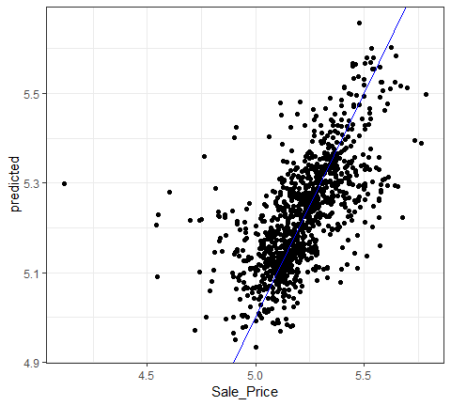

Calculating the RMSE:

library(yardstick)  
  
results <- map_dfr(bt_samples$pred, rmse, Sale_Price, predicted)  
results   
## # A tibble: 25 x 3  
## .metric .estimator .estimate  
## <chr> <chr> <dbl>  
## 1 rmse standard 0.135  
## 2 rmse standard 0.137  
## 3 rmse standard 0.133  
## 4 rmse standard 0.127  
## 5 rmse standard 0.130  
## 6 rmse standard 0.126  
## 7 rmse standard 0.126  
## 8 rmse standard 0.136  
## 9 rmse standard 0.131  
## 10 rmse standard 0.140  
## # ... with 15 more rows  
mean(results$.estimate)  
## [1] 0.1297649

## [Grid search tuning of Keras Models](https://github.com/tidymodels/rsample/blob/master/vignettes/Applications/Keras.Rmd).

Here we demonstrate a single grid search to optimize a tuning parameter of a [keras](https://keras.rstudio.com/index.html) neural network.

The AmesHousing data is used to demonstrate, and there are a number of predictors for these data, but for simplicity, we will see how far we can get by just using the geocodes for the properties as predictors of price. The outcome will be modeled on the log10 scale.

library(AmesHousing)  
library(dplyr)  
ames <- make_ames() %>%   
 select(Sale_Price, Longitude, Latitude)

To be consistent with other analysis of thes data, a training/test split is made. However, this article focuses on the training set.

Normally, feature preprocessing should be estimated **within the resampling process** to get generalizable estimates of performance. Here, the two predictors are simply centered and scaled beforehand to avoid complexity in this analysis. However, this is generally a bad idea and the article on [recipe](ttps://topepo.github.io/rsample/articles/Applications/Recipes_and_rsample.html) describes a proper methodology for preprocessing the data.

library(rsample)  
library(dplyr)  
set.seed(4595)  
  
data_split <- initial_split(ames,strata = "Sale_Price")  
  
ames_train <-   
 training(data_split) %>%   
 mutate(  
 Sale_Price = log10(Sale_Price),  
 Longitude = scale(Longitude, center = TRUE),  
 Latitude = scale(Latitude, center = TRUE)  
 )

To resample the model, simple 10-fold cross-validation is done such that the splits use the outcome as a stratification variable. On average, there should be rfloor(nrow(ames_train)*.1 properties in the assessment set and this should be enough to obtain good estimate of the model RMSE.

set.seed(2453)  
cv_splits <- vfold_cv(ames_train, v = 10, strata = "Sale_Price")

A single layer feed-foward neural network with 10 hidden units will be used to model these data. There are a great many tuning parameters for these models including those for structural aspects (e.g., number of hidden unites, activation type, number of layers), the optimization (momentum dropout rate, etc.) and so on. For simplicity, this article will optimize the number of training epochs (i.e., iterations); basically this is testing for stopping.

A function is needed to compute the model on the analysis set, predict the assessment set, and compute the holdout root mean squared error (in log10 units). The function below constructs the model sequentially and takes the number of epochs as a parameter. The argument split will be used to pass a single elment of cv_splits$splits. This object will contain the two splits of the data for a single resample. The ellipses (...) will be used to pass arbitrary arguments to keras::fit.

In this function, the seed is set. A few of the model components, such as initializer_glorot_uniform and layer_dropout, use random numbers and their specific seeds are set from the session’s seed. This helps with reproducibility.

library(keras)  
library(yardstick)  
library(purrr)  
  
mlp_rmse <- function(epoch, split, ...){  
 # set the seed to get reproducible starting values and dropouts  
 set.seed(4109)  
   
 # cleaning the session after the computations have finished  
 # clears memory used by the last trial in preparation for the next iteration  
 on.exit(keras::backend()$clear_session())  
 # define a single layer MLP with dropout and ReLUs  
 model <- keras_model_sequential()  
 model %>%   
 layer_dense(  
 units = 10,  
 activation = "relu",  
 input_shape = 2,  
 kernel_initializer = initializer_glorot_uniform()  
 ) %>%   
 layer_dropout(rate = 0.4) %>%   
 layer_dense(units = 1, activation = "linear")  
   
 model %>% compile(  
 loss = "mean_squared_error",  
 optimizer = optimizer_rmsprop(),  
 metrics = "mean_squared_error"  
 )  
   
 # the data used for modeling (aka the analysis set)  
 geocode <-   
 analysis(split) %>%   
 select(-Sale_Price) %>%   
 as.matrix()  
   
 model %>% fit(  
 x = geocode,  
 y = analysis(split)[["Sale_Price"]],  
 epochs = epoch,  
 ...  
 )  
   
 # Now obtain the holdout set for prediction  
 holdout <- assessment(split)  
 pred_geocode <-   
 holdout %>%   
 select(-Sale_Price) %>%   
 as.matrix()  
   
 # get predicted values and compute RMSE  
 holdout %>%   
 mutate(predicted = predict(model, pred_geocode)[,1]) %>%   
 rmse(truth = Sale_Price, estimate = predicted) %>%   
 pull(.estimate)  
}

Let&s execute the function on the first fold of the data using a batch size of 128 and disable the print/plotting of the optimization:

cv_splits$splits[[1]]  
  
mlp_rmse(  
 epoch = 100,  
 cv_splits$splits[[1]],  
 # options to keras::fit  
 batch_size = 128,  
 verbose = 0  
)

## [Time series](https://github.com/tidymodels/rsample/blob/master/vignettes/Applications/Time_Series.Rmd)

“[Demo Week: Tidy Forecasting with sweep](http://www.business-science.io/code-tools/2017/10/25/demo_week_sweep.html)” is an excellent article that uses tidy methods with time series. This article uses their analysis with rsample to get performance estimates for future observations using [rolling forecast origin resampling](https://robjhyndman.com/hyndsight/crossvalidation/).

The data are sales of alcholic beverages originally from [the Federal Reserve Bank of St. Louis website](https://fred.stlouisfed.org/series/S4248SM144NCEN).

library(tidymodels)  
data("drinks")  
str(drinks, give.att=FALSE)  
## Classes 'tbl_df', 'tbl' and 'data.frame': 309 obs. of 2 variables:  
## $ date : Date, format: "1992-01-01" "1992-02-01" ...  
## $ S4248SM144NCEN: num 3459 3458 4002 4564 4221 ...

Each row is a month of sales (in millions of US dolloars). Suppose that predictions for one year ahead were needed and the model should use the most recent data from the last 20 years. To setup this resampling scheme:

roll_rs <- rolling_origin(  
 drinks,  
 initial = 12*20,  
 assess = 12,  
 cumulative = FALSE  
)  
  
nrow(roll_rs)  
## [1] 58  
roll_rs  
## # Rolling origin forecast resampling   
## # A tibble: 58 x 2  
## splits id   
## <list> <chr>   
## 1 <split [240/12]> Slice01  
## 2 <split [240/12]> Slice02  
## 3 <split [240/12]> Slice03  
## 4 <split [240/12]> Slice04  
## 5 <split [240/12]> Slice05  
## 6 <split [240/12]> Slice06  
## 7 <split [240/12]> Slice07  
## 8 <split [240/12]> Slice08  
## 9 <split [240/12]> Slice09  
## 10 <split [240/12]> Slice10  
## # ... with 48 more rows

Each split element contains the information about the resample:

roll_rs$splits[[1]]  
## <240/12/309>

For plotting, let’s index each split by the first day of the assessment set:

get_date <- function(x)  
 min(assessment(x)$date)  
  
start_date <- map(roll_rs$splits, get_date)  
roll_rs$start_date <- do.call("c", start_date)  
head(roll_rs$start_date)  
## [1] "2012-01-01" "2012-02-01" "2012-03-01" "2012-04-01" "2012-05-01"  
## [6] "2012-06-01"

This resampling scheme has 58 splits of the data so that there will be 58 ARIMA models that are fit. To create the models, the auto.arima function from the forecast package is used. The function analysis and assessment return the data frame, so another step converts the data into a ts object called mod_dat using a function in the timetk package.

library(forecast) # for `auto.arima`  
library(timetk) # for `tk_ts`   
library(zoo) # for `as.yearmon`  
  
fit_model <- function(x, ...){  
 # suggested by Matt Dancho:  
 x %>%   
 analysis() %>%   
 # since the first day changes over resamples, adjust it  
 # based on the first date value in the data frame  
 tk_ts(start = .$date[[1]] %>% as.yearmon(),  
 freq = 12,  
 silent = TRUE) %>%   
 auto.arima(...)  
}

Each model is saved in a new column:

roll_rs$arima <- map(roll_rs$splits, fit_model)  
  
# for example:  
roll_rs$arima[[1]] %>% broom::tidy()  
## # A tibble: 7 x 3  
## term estimate std.error  
## <fct> <dbl> <dbl>  
## 1 ar1 -0.994 0.106   
## 2 ar2 -0.502 0.0810  
## 3 ma1 0.0243 0.111   
## 4 ma2 -0.414 0.125   
## 5 sar1 0.404 0.100   
## 6 sar2 -0.334 0.0759  
## 7 sma1 -0.554 0.0834

(There are some warnings produced by these first regarding extra columns in the data that can be ignored)

Using the model fits, performance will be measured in two ways:

* *interpolation* error will measure how well the model fits to the data that were used to create the model. This is most likely optimistic since no holdout method is used.
* *extrapolation* or *forecast* error evaluates the efficacy of the model on the data from the following year (that were not used in the model fit).

In each case, the mean absolute percent error (MAPE) is the statistic used to characterize the model fits. The interpolation error can be computed from the Arima object. to make things easy, the sweep package’s sw_glance function is used:

library(sweep)  
  
roll_rs$interpolation <- map_dbl(  
 roll_rs$arima,  
 function(x)  
 sw_glance(x)[["MAPE"]]  
)  
summary(roll_rs$interpolation)  
## Min. 1st Qu. Median Mean 3rd Qu. Max.   
## 2.84 2.89 2.92 2.93 2.95 3.13

For the extrapolation error, the model and split objects are required. Using these:

get_extrap <- function(split, mod){  
 n <- nrow(assessment(split))  
 # get asessment data  
 pred_dat <- assessment(split) %>%   
 mutate(  
 pred = as.vector(forecast(mod, h = n)$mean),  
 pct_error = ( S4248SM144NCEN - pred ) / S4248SM144NCEN * 100  
 )  
 mean(abs(pred_dat$pct_error))  
}  
  
roll_rs$extrapolation <-   
 map2_dbl(roll_rs$splits, roll_rs$arima, get_extrap)  
  
summary(roll_rs$extrapolation)  
## Min. 1st Qu. Median Mean 3rd Qu. Max.   
## 2.37 3.19 3.56 3.65 4.16 5.45

What do these error estimates look like over time?

roll_rs %>%  
 select(interpolation, extrapolation, start_date) %>%  
 as.data.frame %>%  
 gather(error, MAPE, -start_date) %>%  
 ggplot(aes(x = start_date, y = MAPE, col = error)) +   
 geom_point() +   
 geom_line() +   
 theme_bw() +   
 theme(legend.position = "top")

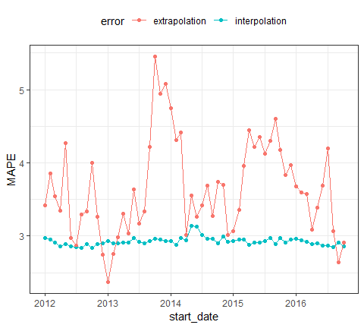

It is likely that interpolration error is an underestimate to some degree.

It is also worth noting that rolling_origin() can be used over calendar periods, rather than just over a fixed window size. This is especially useful for irregular series where a fixed window size might not make sense because of missing data points, or because of calender features like different months having a different number of days.

The example below demonstrates this idea by splitting drinks into a nested set of 26 years, and rolling over years rather than months. Note that the end result accomplishes a different task than the original example, in this case, each slice moves forward an entire year, rather than just one month.

# The idea is to nest by the period to roll over,  
# which in this case is the year.  
  
roll_rs_annual <- drinks %>%  
 mutate(year = as.POSIXlt(date)$year + 1900) %>%  
 nest(-year) %>%  
 rolling_origin(  
 initial = 20,   
 assess = 1,   
 cumulative = FALSE  
 )  
  
analysis(roll_rs_annual$splits[[1]])  
## # A tibble: 20 x 2  
## year data   
## <dbl> <list>   
## 1 1992 <tibble [12 x 2]>  
## 2 1993 <tibble [12 x 2]>  
## 3 1994 <tibble [12 x 2]>  
## 4 1995 <tibble [12 x 2]>  
## 5 1996 <tibble [12 x 2]>  
## 6 1997 <tibble [12 x 2]>  
## 7 1998 <tibble [12 x 2]>  
## 8 1999 <tibble [12 x 2]>  
## 9 2000 <tibble [12 x 2]>  
## 10 2001 <tibble [12 x 2]>  
## 11 2002 <tibble [12 x 2]>  
## 12 2003 <tibble [12 x 2]>  
## 13 2004 <tibble [12 x 2]>  
## 14 2005 <tibble [12 x 2]>  
## 15 2006 <tibble [12 x 2]>  
## 16 2007 <tibble [12 x 2]>  
## 17 2008 <tibble [12 x 2]>  
## 18 2009 <tibble [12 x 2]>  
## 19 2010 <tibble [12 x 2]>  
## 20 2011 <tibble [12 x 2]>

The workflow to access these calender slices is to use bind_rows() to join each analysis set together.

mutate(  
 roll_rs_annual,  
 extracted_slice = map(splits, ~ bind_rows(analysis(.x)$data))  
)

## Survival analysis

options(digits = 3)  
library(survival)  
library(purrr)  
library(rsample)  
library(dplyr)  
library(tidyposterior)  
library(ggplot2)  
library(tidyr)

In this article, a parameteric analysis of censored daa is conducted and rsample is used to measure the importance of predictors in the model. The data will be used is the NCCTG lung cancer data contained in the survival package:

library(survival)  
str(lung)  
## 'data.frame': 228 obs. of 10 variables:  
## $ inst : num 3 3 3 5 1 12 7 11 1 7 ...  
## $ time : num 306 455 1010 210 883 ...  
## $ status : num 2 2 1 2 2 1 2 2 2 2 ...  
## $ age : num 74 68 56 57 60 74 68 71 53 61 ...  
## $ sex : num 1 1 1 1 1 1 2 2 1 1 ...  
## $ ph.ecog : num 1 0 0 1 0 1 2 2 1 2 ...  
## $ ph.karno : num 90 90 90 90 100 50 70 60 70 70 ...  
## $ pat.karno: num 100 90 90 60 90 80 60 80 80 70 ...  
## $ meal.cal : num 1175 1225 NA 1150 NA ...  
## $ wt.loss : num NA 15 15 11 0 0 10 1 16 34 ...  
skimr::skim(lung)  
## Skim summary statistics  
## n obs: 228   
## n variables: 10   
##   
## -- Variable type:numeric --------------------------------------------------------------------  
## variable missing complete n mean sd p0 p25 p50 p75  
## age 0 228 228 62.45 9.07 39 56 63 69   
## inst 1 227 228 11.09 8.3 1 3 11 16   
## meal.cal 47 181 228 928.78 402.17 96 635 975 1150   
## pat.karno 3 225 228 79.96 14.62 30 70 80 90   
## ph.ecog 1 227 228 0.95 0.72 0 0 1 1   
## ph.karno 1 227 228 81.94 12.33 50 75 80 90   
## sex 0 228 228 1.39 0.49 1 1 1 2   
## status 0 228 228 1.72 0.45 1 1 2 2   
## time 0 228 228 305.23 210.65 5 166.75 255.5 396.5   
## wt.loss 14 214 228 9.83 13.14 -24 0 7 15.75  
## p100 hist  
## 82 <U+2582><U+2582><U+2585><U+2587><U+2586><U+2587><U+2585><U+2581>  
## 33 <U+2587><U+2582><U+2587><U+2582><U+2582><U+2582><U+2581><U+2581>  
## 2600 <U+2582><U+2585><U+2587><U+2586><U+2581><U+2581><U+2581><U+2581>  
## 100 <U+2581><U+2581><U+2581><U+2583><U+2586><U+2587><U+2587><U+2585>  
## 3 <U+2585><U+2581><U+2587><U+2581><U+2581><U+2583><U+2581><U+2581>  
## 100 <U+2581><U+2582><U+2581><U+2583><U+2587><U+2581><U+2587><U+2583>  
## 2 <U+2587><U+2581><U+2581><U+2581><U+2581><U+2581><U+2581><U+2585>  
## 2 <U+2583><U+2581><U+2581><U+2581><U+2581><U+2581><U+2581><U+2587>  
## 1022 <U+2585><U+2587><U+2586><U+2582><U+2582><U+2582><U+2581><U+2581>  
## 68 <U+2581><U+2582><U+2587><U+2583><U+2582><U+2581><U+2581><U+2581>

status is an indicator for which patients are censored (status=1) or an actual event (status=2). The help file ?survreg has the following model fit:

lung_mod <- survreg(Surv(time,status)~ ph.ecog + age + strata(sex), data = lung)  
  
#   
summary(lung_mod)  
##   
## Call:  
## survreg(formula = Surv(time, status) ~ ph.ecog + age + strata(sex),   
## data = lung)  
## Value Std. Error z p  
## (Intercept) 6.73235 0.42396 15.88 < 2e-16  
## ph.ecog -0.32443 0.08649 -3.75 0.00018  
## age -0.00581 0.00693 -0.84 0.40193  
## sex=1 -0.24408 0.07920 -3.08 0.00206  
## sex=2 -0.42345 0.10669 -3.97 7.2e-05  
##   
## Scale:  
## sex=1 sex=2   
## 0.783 0.655   
##   
## Weibull distribution  
## Loglik(model)= -1137 Loglik(intercept only)= -1146  
## Chisq= 17.8 on 2 degrees of freedom, p= 0.00014   
## Number of Newton-Raphson Iterations: 5   
## n=227 (1 observation deleted due to missingness)  
  
# coefficient plot  
lung_mod %>%   
 broom::tidy() %>%   
 ggplot(aes(x=term, y=estimate))+geom_point()

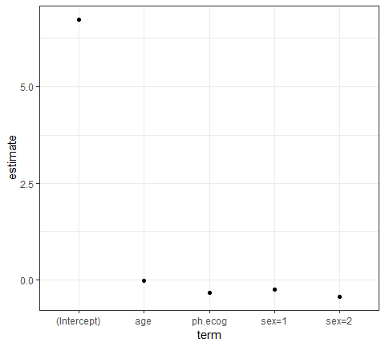

Note that the stratification on gender only affects the scale parameter: the estimates above are from a log-linear model for the scale parameter even though they are listed with the regression variables for the other parameter. coef gives results that are more clear:

coef(lung_mod) %>% broom::tidy()  
## # A tibble: 3 x 2  
## names x  
## <chr> <dbl>  
## 1 (Intercept) 6.73   
## 2 ph.ecog -0.324   
## 3 age -0.00581  
# coefplot::coefplot(lung_mod)

To resample these data, it would a good idea to try to maintain the same censoring rate across the splits. To do this, stratified resampling can be used where each analysis/assessment split is conducted within each value of the status indicator. To demonstrate, Monte CArol resampling is used where 75% of the data are in the analysis set. A total of 100 splits are created.

library(rsample)  
set.seed(9666)  
mc_samp <- mc_cv(lung, strata="status", times=100)  
  
library(purrr)  
cens_rate <- function(x) mean(analysis(x)$status==1)  
  
map_dbl(mc_samp$splits, cens_rate) %>%   
 summary()  
## Min. 1st Qu. Median Mean 3rd Qu. Max.   
## 0.279 0.279 0.279 0.279 0.279 0.279

To demonstrate the use of resampling with censored data, the parametric model shown above will be fit with different variable sets:

three_fact <- as.formula(Surv(time, status) ~ ph.ecog + age + strata(sex))  
rm_ph.ecog <- as.formula(Surv(time, status) ~ age + strata(sex))  
rm_age <- as.formula(Surv(time, status) ~ ph.ecog + strata(sex))  
rm_sex <- as.formula(Surv(time, status) ~ ph.ecog + age )

The model fitting function will take the formula as an argument:

mod_fit <- function(x, form, ...){  
 survreg(form, data = analysis(x), ...)  
}

To calculate the efficacy of the model, the concordance statistic is used (see ?survconcordance):

get_concord <- function(split, mod, ...){  
 pred_dat <- assessment(split)  
 pred_dat$pred <- predict(mod, newdata = pred_dat)  
 survConcordance(Surv(time, status) ~ pred, pred_dat, ...)$concordance  
}

With these functions, a series of models are created for each variable set.

mc_samp$mod_full <- purrr::map(mc_samp$splits, mod_fit, form = three_fact)  
mc_samp$mod_ph.ecog <- purrr::map(mc_samp$splits, mod_fit, form = rm_ph.ecog)  
mc_samp$mod_age <- purrr::map(mc_samp$splits, mod_fit, form = rm_age)  
mc_samp$mod_sex <- purrr::map(mc_samp$splits, mod_fit, form = rm_sex)

Simiarly, the concordance values are computed for each model:

mc_samp$full <- map2_dbl(mc_samp$splits, mc_samp$mod_full, get_concord)  
mc_samp$ph.ecog <- map2_dbl(mc_samp$splits, mc_samp$mod_ph.ecog, get_concord)  
mc_samp$age <- map2_dbl(mc_samp$splits, mc_samp$mod_age, get_concord)  
mc_samp$sex <- map2_dbl(mc_samp$splits, mc_samp$mod_sex, get_concord)  
  
# lets extract a sample model results  
mc_samp$mod_full[[1]] %>% broom::tidy()  
## # A tibble: 5 x 7  
## term estimate std.error statistic p.value conf.low conf.high  
## <chr> <dbl> <dbl> <dbl> <dbl> <dbl> <dbl>  
## 1 (Intercept) 6.55 0.498 13.2 1.65e-39 5.57 7.52   
## 2 ph.ecog -0.331 0.0948 -3.49 4.78e- 4 -0.517 -0.145   
## 3 age -0.00305 0.00808 -0.378 7.06e- 1 -0.0189 0.0128  
## 4 sex=1 -0.276 0.0910 -3.04 2.39e- 3 NA NA   
## 5 sex=2 -0.443 0.130 -3.42 6.32e- 4 NA NA

The distirubitions of the resampling estimates

library(dplyr)  
# select variables  
concord_est <- mc_samp %>%   
 select(-matches("^mod"))  
  
concord_est %>% colnames()  
## [1] "splits" "id" "full" "ph.ecog" "age" "sex"  
concord_est %>% head()  
## # A tibble: 6 x 6  
## splits id full ph.ecog age sex  
## * <list> <chr> <dbl> <dbl> <dbl> <dbl>  
## 1 <split [172/56]> Resample001 0.388 0.424 0.405 0.388  
## 2 <split [172/56]> Resample002 0.429 0.529 0.400 0.425  
## 3 <split [172/56]> Resample003 0.389 0.441 0.400 0.389  
## 4 <split [172/56]> Resample004 0.424 0.554 0.392 0.427  
## 5 <split [172/56]> Resample005 0.396 0.355 0.381 0.396  
## 6 <split [172/56]> Resample006 0.368 0.404 0.389 0.368  
  
concord_est %>%  
 select(-splits) %>%  
 gather()  
## id model statistic  
## 1 Resample001 full 0.388  
## 2 Resample002 full 0.429  
## 3 Resample003 full 0.389  
## 4 Resample004 full 0.424  
## 5 Resample005 full 0.396  
## 6 Resample006 full 0.368  
## 7 Resample007 full 0.381  
## 8 Resample008 full 0.353  
## 9 Resample009 full 0.361  
## 10 Resample010 full 0.491  
## 11 Resample011 full 0.339  
## 12 Resample012 full 0.331  
## 13 Resample013 full 0.367  
## 14 Resample014 full 0.354  
## 15 Resample015 full 0.466  
## 16 Resample016 full 0.303  
## 17 Resample017 full 0.462  
## 18 Resample018 full 0.441  
## 19 Resample019 full 0.468  
## 20 Resample020 full 0.370  
## 21 Resample021 full 0.364  
## 22 Resample022 full 0.449  
## 23 Resample023 full 0.457  
## 24 Resample024 full 0.477  
## 25 Resample025 full 0.384  
## 26 Resample026 full 0.406  
## 27 Resample027 full 0.299  
## 28 Resample028 full 0.367  
## 29 Resample029 full 0.294  
## 30 Resample030 full 0.398  
## 31 Resample031 full 0.347  
## 32 Resample032 full 0.334  
## 33 Resample033 full 0.399  
## 34 Resample034 full 0.403  
## 35 Resample035 full 0.405  
## 36 Resample036 full 0.361  
## 37 Resample037 full 0.339  
## 38 Resample038 full 0.433  
## 39 Resample039 full 0.408  
## 40 Resample040 full 0.383  
## 41 Resample041 full 0.363  
## 42 Resample042 full 0.424  
## 43 Resample043 full 0.349  
## 44 Resample044 full 0.486  
## 45 Resample045 full 0.314  
## 46 Resample046 full 0.406  
## 47 Resample047 full 0.374  
## 48 Resample048 full 0.423  
## 49 Resample049 full 0.448  
## 50 Resample050 full 0.446  
## 51 Resample051 full 0.369  
## 52 Resample052 full 0.436  
## 53 Resample053 full 0.423  
## 54 Resample054 full 0.458  
## 55 Resample055 full 0.408  
## 56 Resample056 full 0.467  
## 57 Resample057 full 0.433  
## 58 Resample058 full 0.319  
## 59 Resample059 full 0.345  
## 60 Resample060 full 0.366  
## 61 Resample061 full 0.419  
## 62 Resample062 full 0.444  
## 63 Resample063 full 0.413  
## 64 Resample064 full 0.376  
## 65 Resample065 full 0.502  
## 66 Resample066 full 0.385  
## 67 Resample067 full 0.476  
## 68 Resample068 full 0.428  
## 69 Resample069 full 0.499  
## 70 Resample070 full 0.410  
## 71 Resample071 full 0.394  
## 72 Resample072 full 0.479  
## 73 Resample073 full 0.341  
## 74 Resample074 full 0.314  
## 75 Resample075 full 0.335  
## 76 Resample076 full 0.397  
## 77 Resample077 full 0.443  
## 78 Resample078 full 0.445  
## 79 Resample079 full 0.354  
## 80 Resample080 full 0.448  
## 81 Resample081 full 0.321  
## 82 Resample082 full 0.463  
## 83 Resample083 full 0.345  
## 84 Resample084 full 0.437  
## 85 Resample085 full 0.433  
## 86 Resample086 full 0.391  
## 87 Resample087 full 0.370  
## 88 Resample088 full 0.398  
## 89 Resample089 full 0.418  
## 90 Resample090 full 0.390  
## 91 Resample091 full 0.430  
## 92 Resample092 full 0.345  
## 93 Resample093 full 0.371  
## 94 Resample094 full 0.484  
## 95 Resample095 full 0.491  
## 96 Resample096 full 0.438  
## 97 Resample097 full 0.392  
## 98 Resample098 full 0.382  
## 99 Resample099 full 0.441  
## 100 Resample100 full 0.378  
## 101 Resample001 ph.ecog 0.424  
## 102 Resample002 ph.ecog 0.529  
## 103 Resample003 ph.ecog 0.441  
## 104 Resample004 ph.ecog 0.554  
## 105 Resample005 ph.ecog 0.355  
## 106 Resample006 ph.ecog 0.404  
## 107 Resample007 ph.ecog 0.407  
## 108 Resample008 ph.ecog 0.393  
## 109 Resample009 ph.ecog 0.411  
## 110 Resample010 ph.ecog 0.433  
## 111 Resample011 ph.ecog 0.410  
## 112 Resample012 ph.ecog 0.464  
## 113 Resample013 ph.ecog 0.454  
## 114 Resample014 ph.ecog 0.493  
## 115 Resample015 ph.ecog 0.361  
## 116 Resample016 ph.ecog 0.432  
## 117 Resample017 ph.ecog 0.409  
## 118 Resample018 ph.ecog 0.387  
## 119 Resample019 ph.ecog 0.466  
## 120 Resample020 ph.ecog 0.403  
## 121 Resample021 ph.ecog 0.362  
## 122 Resample022 ph.ecog 0.445  
## 123 Resample023 ph.ecog 0.451  
## 124 Resample024 ph.ecog 0.446  
## 125 Resample025 ph.ecog 0.463  
## 126 Resample026 ph.ecog 0.466  
## 127 Resample027 ph.ecog 0.384  
## 128 Resample028 ph.ecog 0.394  
## 129 Resample029 ph.ecog 0.345  
## 130 Resample030 ph.ecog 0.510  
## 131 Resample031 ph.ecog 0.447  
## 132 Resample032 ph.ecog 0.391  
## 133 Resample033 ph.ecog 0.444  
## 134 Resample034 ph.ecog 0.488  
## 135 Resample035 ph.ecog 0.403  
## 136 Resample036 ph.ecog 0.453  
## 137 Resample037 ph.ecog 0.430  
## 138 Resample038 ph.ecog 0.432  
## 139 Resample039 ph.ecog 0.429  
## 140 Resample040 ph.ecog 0.457  
## 141 Resample041 ph.ecog 0.438  
## 142 Resample042 ph.ecog 0.449  
## 143 Resample043 ph.ecog 0.512  
## 144 Resample044 ph.ecog 0.543  
## 145 Resample045 ph.ecog 0.415  
## 146 Resample046 ph.ecog 0.447  
## 147 Resample047 ph.ecog 0.423  
## 148 Resample048 ph.ecog 0.438  
## 149 Resample049 ph.ecog 0.520  
## 150 Resample050 ph.ecog 0.479  
## 151 Resample051 ph.ecog 0.449  
## 152 Resample052 ph.ecog 0.397  
## 153 Resample053 ph.ecog 0.430  
## 154 Resample054 ph.ecog 0.446  
## 155 Resample055 ph.ecog 0.458  
## 156 Resample056 ph.ecog 0.499  
## 157 Resample057 ph.ecog 0.463  
## 158 Resample058 ph.ecog 0.432  
## 159 Resample059 ph.ecog 0.349  
## 160 Resample060 ph.ecog 0.389  
## 161 Resample061 ph.ecog 0.421  
## 162 Resample062 ph.ecog 0.401  
## 163 Resample063 ph.ecog 0.450  
## 164 Resample064 ph.ecog 0.420  
## 165 Resample065 ph.ecog 0.687  
## 166 Resample066 ph.ecog 0.430  
## 167 Resample067 ph.ecog 0.442  
## 168 Resample068 ph.ecog 0.508  
## 169 Resample069 ph.ecog 0.532  
## 170 Resample070 ph.ecog 0.525  
## 171 Resample071 ph.ecog 0.453  
## 172 Resample072 ph.ecog 0.384  
## 173 Resample073 ph.ecog 0.394  
## 174 Resample074 ph.ecog 0.386  
## 175 Resample075 ph.ecog 0.443  
## 176 Resample076 ph.ecog 0.397  
## 177 Resample077 ph.ecog 0.432  
## 178 Resample078 ph.ecog 0.423  
## 179 Resample079 ph.ecog 0.458  
## 180 Resample080 ph.ecog 0.463  
## 181 Resample081 ph.ecog 0.384  
## 182 Resample082 ph.ecog 0.483  
## 183 Resample083 ph.ecog 0.418  
## 184 Resample084 ph.ecog 0.455  
## 185 Resample085 ph.ecog 0.411  
## 186 Resample086 ph.ecog 0.470  
## 187 Resample087 ph.ecog 0.419  
## 188 Resample088 ph.ecog 0.466  
## 189 Resample089 ph.ecog 0.454  
## 190 Resample090 ph.ecog 0.436  
## 191 Resample091 ph.ecog 0.439  
## 192 Resample092 ph.ecog 0.453  
## 193 Resample093 ph.ecog 0.408  
## 194 Resample094 ph.ecog 0.462  
## 195 Resample095 ph.ecog 0.341  
## 196 Resample096 ph.ecog 0.485  
## 197 Resample097 ph.ecog 0.454  
## 198 Resample098 ph.ecog 0.438  
## 199 Resample099 ph.ecog 0.459  
## 200 Resample100 ph.ecog 0.443  
## 201 Resample001 age 0.405  
## 202 Resample002 age 0.400  
## 203 Resample003 age 0.400  
## 204 Resample004 age 0.392  
## 205 Resample005 age 0.381  
## 206 Resample006 age 0.389  
## 207 Resample007 age 0.405  
## 208 Resample008 age 0.365  
## 209 Resample009 age 0.371  
## 210 Resample010 age 0.499  
## 211 Resample011 age 0.344  
## 212 Resample012 age 0.325  
## 213 Resample013 age 0.375  
## 214 Resample014 age 0.348  
## 215 Resample015 age 0.431  
## 216 Resample016 age 0.302  
## 217 Resample017 age 0.426  
## 218 Resample018 age 0.464  
## 219 Resample019 age 0.462  
## 220 Resample020 age 0.390  
## 221 Resample021 age 0.407  
## 222 Resample022 age 0.456  
## 223 Resample023 age 0.460  
## 224 Resample024 age 0.489  
## 225 Resample025 age 0.381  
## 226 Resample026 age 0.411  
## 227 Resample027 age 0.308  
## 228 Resample028 age 0.392  
## 229 Resample029 age 0.313  
## 230 Resample030 age 0.369  
## 231 Resample031 age 0.351  
## 232 Resample032 age 0.373  
## 233 Resample033 age 0.407  
## 234 Resample034 age 0.398  
## 235 Resample035 age 0.427  
## 236 Resample036 age 0.372  
## 237 Resample037 age 0.342  
## 238 Resample038 age 0.420  
## 239 Resample039 age 0.420  
## 240 Resample040 age 0.398  
## 241 Resample041 age 0.379  
## 242 Resample042 age 0.423  
## 243 Resample043 age 0.346  
## 244 Resample044 age 0.458  
## 245 Resample045 age 0.328  
## 246 Resample046 age 0.414  
## 247 Resample047 age 0.376  
## 248 Resample048 age 0.434  
## 249 Resample049 age 0.426  
## 250 Resample050 age 0.438  
## 251 Resample051 age 0.373  
## 252 Resample052 age 0.409  
## 253 Resample053 age 0.434  
## 254 Resample054 age 0.455  
## 255 Resample055 age 0.432  
## 256 Resample056 age 0.447  
## 257 Resample057 age 0.418  
## 258 Resample058 age 0.338  
## 259 Resample059 age 0.372  
## 260 Resample060 age 0.355  
## 261 Resample061 age 0.421  
## 262 Resample062 age 0.416  
## 263 Resample063 age 0.423  
## 264 Resample064 age 0.396  
## 265 Resample065 age 0.439  
## 266 Resample066 age 0.369  
## 267 Resample067 age 0.475  
## 268 Resample068 age 0.413  
## 269 Resample069 age 0.464  
## 270 Resample070 age 0.387  
## 271 Resample071 age 0.409  
## 272 Resample072 age 0.442  
## 273 Resample073 age 0.380  
## 274 Resample074 age 0.342  
## 275 Resample075 age 0.342  
## 276 Resample076 age 0.412  
## 277 Resample077 age 0.428  
## 278 Resample078 age 0.440  
## 279 Resample079 age 0.351  
## 280 Resample080 age 0.458  
## 281 Resample081 age 0.344  
## 282 Resample082 age 0.432  
## 283 Resample083 age 0.352  
## 284 Resample084 age 0.440  
## 285 Resample085 age 0.410  
## 286 Resample086 age 0.401  
## 287 Resample087 age 0.385  
## 288 Resample088 age 0.411  
## 289 Resample089 age 0.423  
## 290 Resample090 age 0.393  
## 291 Resample091 age 0.456  
## 292 Resample092 age 0.334  
## 293 Resample093 age 0.391  
## 294 Resample094 age 0.499  
## 295 Resample095 age 0.439  
## 296 Resample096 age 0.424  
## 297 Resample097 age 0.397  
## 298 Resample098 age 0.383  
## 299 Resample099 age 0.452  
## 300 Resample100 age 0.384  
## 301 Resample001 sex 0.388  
## 302 Resample002 sex 0.425  
## 303 Resample003 sex 0.389  
## 304 Resample004 sex 0.427  
## 305 Resample005 sex 0.396  
## 306 Resample006 sex 0.368  
## 307 Resample007 sex 0.381  
## 308 Resample008 sex 0.353  
## 309 Resample009 sex 0.361  
## 310 Resample010 sex 0.491  
## 311 Resample011 sex 0.340  
## 312 Resample012 sex 0.331  
## 313 Resample013 sex 0.367  
## 314 Resample014 sex 0.354  
## 315 Resample015 sex 0.466  
## 316 Resample016 sex 0.303  
## 317 Resample017 sex 0.390  
## 318 Resample018 sex 0.441  
## 319 Resample019 sex 0.468  
## 320 Resample020 sex 0.370  
## 321 Resample021 sex 0.364  
## 322 Resample022 sex 0.449  
## 323 Resample023 sex 0.457  
## 324 Resample024 sex 0.477  
## 325 Resample025 sex 0.385  
## 326 Resample026 sex 0.406  
## 327 Resample027 sex 0.299  
## 328 Resample028 sex 0.367  
## 329 Resample029 sex 0.294  
## 330 Resample030 sex 0.404  
## 331 Resample031 sex 0.346  
## 332 Resample032 sex 0.334  
## 333 Resample033 sex 0.399  
## 334 Resample034 sex 0.403  
## 335 Resample035 sex 0.405  
## 336 Resample036 sex 0.361  
## 337 Resample037 sex 0.339  
## 338 Resample038 sex 0.408  
## 339 Resample039 sex 0.408  
## 340 Resample040 sex 0.383  
## 341 Resample041 sex 0.362  
## 342 Resample042 sex 0.423  
## 343 Resample043 sex 0.352  
## 344 Resample044 sex 0.486  
## 345 Resample045 sex 0.314  
## 346 Resample046 sex 0.407  
## 347 Resample047 sex 0.374  
## 348 Resample048 sex 0.423  
## 349 Resample049 sex 0.449  
## 350 Resample050 sex 0.444  
## 351 Resample051 sex 0.369  
## 352 Resample052 sex 0.382  
## 353 Resample053 sex 0.423  
## 354 Resample054 sex 0.458  
## 355 Resample055 sex 0.408  
## 356 Resample056 sex 0.467  
## 357 Resample057 sex 0.433  
## 358 Resample058 sex 0.319  
## 359 Resample059 sex 0.345  
## 360 Resample060 sex 0.344  
## 361 Resample061 sex 0.419  
## 362 Resample062 sex 0.387  
## 363 Resample063 sex 0.413  
## 364 Resample064 sex 0.376  
## 365 Resample065 sex 0.501  
## 366 Resample066 sex 0.353  
## 367 Resample067 sex 0.476  
## 368 Resample068 sex 0.428  
## 369 Resample069 sex 0.493  
## 370 Resample070 sex 0.410  
## 371 Resample071 sex 0.394  
## 372 Resample072 sex 0.479  
## 373 Resample073 sex 0.341  
## 374 Resample074 sex 0.314  
## 375 Resample075 sex 0.335  
## 376 Resample076 sex 0.397  
## 377 Resample077 sex 0.443  
## 378 Resample078 sex 0.445  
## 379 Resample079 sex 0.354  
## 380 Resample080 sex 0.448  
## 381 Resample081 sex 0.321  
## 382 Resample082 sex 0.464  
## 383 Resample083 sex 0.345  
## 384 Resample084 sex 0.437  
## 385 Resample085 sex 0.387  
## 386 Resample086 sex 0.391  
## 387 Resample087 sex 0.370  
## 388 Resample088 sex 0.398  
## 389 Resample089 sex 0.417  
## 390 Resample090 sex 0.390  
## 391 Resample091 sex 0.430  
## 392 Resample092 sex 0.349  
## 393 Resample093 sex 0.371  
## 394 Resample094 sex 0.484  
## 395 Resample095 sex 0.491  
## 396 Resample096 sex 0.438  
## 397 Resample097 sex 0.392  
## 398 Resample098 sex 0.382  
## 399 Resample099 sex 0.441  
## 400 Resample100 sex 0.376  
  
library(tidyr)  
library(ggplot2)  
concord_est %>%   
 select(-splits) %>%   
 gather() %>%   
 ggplot(aes(x = statistic, col = model))+  
 geom_line(stat = "density")+  
 theme_bw()+  
 theme(legend.position = "top")

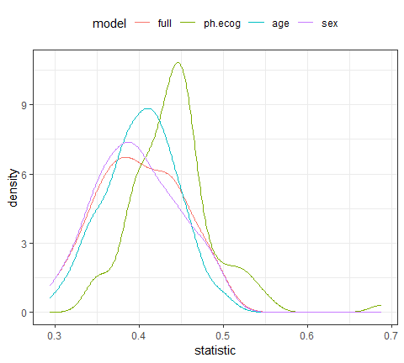

It looks as though the model missing ph.ecog has large concordance values than the other models. as one might expect, the full model and the model absent sex are very similar: the difference in these models should only be the scale parameters estimates.

To more formally test this, the tidyposterior package to create a Bayesian model for the concordance statsitics.

library(tidyposterior)  
concord_est <- perf_mod(concord_est, seed=6507, iter=5000)  
##   
## SAMPLING FOR MODEL 'continuous' NOW (CHAIN 1).  
## Chain 1:   
## Chain 1: Gradient evaluation took 0.001 seconds  
## Chain 1: 1000 transitions using 10 leapfrog steps per transition would take 10 seconds.  
## Chain 1: Adjust your expectations accordingly!  
## Chain 1:   
## Chain 1:   
## Chain 1: Iteration: 1 / 5000 [ 0%] (Warmup)  
## Chain 1: Iteration: 500 / 5000 [ 10%] (Warmup)  
## Chain 1: Iteration: 1000 / 5000 [ 20%] (Warmup)  
## Chain 1: Iteration: 1500 / 5000 [ 30%] (Warmup)  
## Chain 1: Iteration: 2000 / 5000 [ 40%] (Warmup)  
## Chain 1: Iteration: 2500 / 5000 [ 50%] (Warmup)  
## Chain 1: Iteration: 2501 / 5000 [ 50%] (Sampling)  
## Chain 1: Iteration: 3000 / 5000 [ 60%] (Sampling)  
## Chain 1: Iteration: 3500 / 5000 [ 70%] (Sampling)  
## Chain 1: Iteration: 4000 / 5000 [ 80%] (Sampling)  
## Chain 1: Iteration: 4500 / 5000 [ 90%] (Sampling)  
## Chain 1: Iteration: 5000 / 5000 [100%] (Sampling)  
## Chain 1:   
## Chain 1: Elapsed Time: 11.739 seconds (Warm-up)  
## Chain 1: 6.257 seconds (Sampling)  
## Chain 1: 17.996 seconds (Total)  
## Chain 1:   
##   
## SAMPLING FOR MODEL 'continuous' NOW (CHAIN 2).  
## Chain 2:   
## Chain 2: Gradient evaluation took 0 seconds  
## Chain 2: 1000 transitions using 10 leapfrog steps per transition would take 0 seconds.  
## Chain 2: Adjust your expectations accordingly!  
## Chain 2:   
## Chain 2:   
## Chain 2: Iteration: 1 / 5000 [ 0%] (Warmup)  
## Chain 2: Iteration: 500 / 5000 [ 10%] (Warmup)  
## Chain 2: Iteration: 1000 / 5000 [ 20%] (Warmup)  
## Chain 2: Iteration: 1500 / 5000 [ 30%] (Warmup)  
## Chain 2: Iteration: 2000 / 5000 [ 40%] (Warmup)  
## Chain 2: Iteration: 2500 / 5000 [ 50%] (Warmup)  
## Chain 2: Iteration: 2501 / 5000 [ 50%] (Sampling)  
## Chain 2: Iteration: 3000 / 5000 [ 60%] (Sampling)  
## Chain 2: Iteration: 3500 / 5000 [ 70%] (Sampling)  
## Chain 2: Iteration: 4000 / 5000 [ 80%] (Sampling)  
## Chain 2: Iteration: 4500 / 5000 [ 90%] (Sampling)  
## Chain 2: Iteration: 5000 / 5000 [100%] (Sampling)  
## Chain 2:   
## Chain 2: Elapsed Time: 12.071 seconds (Warm-up)  
## Chain 2: 2.693 seconds (Sampling)  
## Chain 2: 14.764 seconds (Total)  
## Chain 2:   
##   
## SAMPLING FOR MODEL 'continuous' NOW (CHAIN 3).  
## Chain 3:   
## Chain 3: Gradient evaluation took 0.001 seconds  
## Chain 3: 1000 transitions using 10 leapfrog steps per transition would take 10 seconds.  
## Chain 3: Adjust your expectations accordingly!  
## Chain 3:   
## Chain 3:   
## Chain 3: Iteration: 1 / 5000 [ 0%] (Warmup)  
## Chain 3: Iteration: 500 / 5000 [ 10%] (Warmup)  
## Chain 3: Iteration: 1000 / 5000 [ 20%] (Warmup)  
## Chain 3: Iteration: 1500 / 5000 [ 30%] (Warmup)  
## Chain 3: Iteration: 2000 / 5000 [ 40%] (Warmup)  
## Chain 3: Iteration: 2500 / 5000 [ 50%] (Warmup)  
## Chain 3: Iteration: 2501 / 5000 [ 50%] (Sampling)  
## Chain 3: Iteration: 3000 / 5000 [ 60%] (Sampling)  
## Chain 3: Iteration: 3500 / 5000 [ 70%] (Sampling)  
## Chain 3: Iteration: 4000 / 5000 [ 80%] (Sampling)  
## Chain 3: Iteration: 4500 / 5000 [ 90%] (Sampling)  
## Chain 3: Iteration: 5000 / 5000 [100%] (Sampling)  
## Chain 3:   
## Chain 3: Elapsed Time: 13.648 seconds (Warm-up)  
## Chain 3: 3.678 seconds (Sampling)  
## Chain 3: 17.326 seconds (Total)  
## Chain 3:   
##   
## SAMPLING FOR MODEL 'continuous' NOW (CHAIN 4).  
## Chain 4:   
## Chain 4: Gradient evaluation took 0 seconds  
## Chain 4: 1000 transitions using 10 leapfrog steps per transition would take 0 seconds.  
## Chain 4: Adjust your expectations accordingly!  
## Chain 4:   
## Chain 4:   
## Chain 4: Iteration: 1 / 5000 [ 0%] (Warmup)  
## Chain 4: Iteration: 500 / 5000 [ 10%] (Warmup)  
## Chain 4: Iteration: 1000 / 5000 [ 20%] (Warmup)  
## Chain 4: Iteration: 1500 / 5000 [ 30%] (Warmup)  
## Chain 4: Iteration: 2000 / 5000 [ 40%] (Warmup)  
## Chain 4: Iteration: 2500 / 5000 [ 50%] (Warmup)  
## Chain 4: Iteration: 2501 / 5000 [ 50%] (Sampling)  
## Chain 4: Iteration: 3000 / 5000 [ 60%] (Sampling)  
## Chain 4: Iteration: 3500 / 5000 [ 70%] (Sampling)  
## Chain 4: Iteration: 4000 / 5000 [ 80%] (Sampling)  
## Chain 4: Iteration: 4500 / 5000 [ 90%] (Sampling)  
## Chain 4: Iteration: 5000 / 5000 [100%] (Sampling)  
## Chain 4:   
## Chain 4: Elapsed Time: 14.115 seconds (Warm-up)  
## Chain 4: 4.032 seconds (Sampling)  
## Chain 4: 18.147 seconds (Total)  
## Chain 4:  
concord_est$stan  
## stan_glmer  
## family: gaussian [identity]  
## formula: statistic ~ model + (1 | id)  
## observations: 400  
## ------  
## Median MAD_SD  
## (Intercept) 0.4 0.0   
## modelph.ecog 0.0 0.0   
## modelage 0.0 0.0   
## modelsex 0.0 0.0   
##   
## Auxiliary parameter(s):  
## Median MAD_SD  
## sigma 0.0 0.0   
##   
## Error terms:  
## Groups Name Std.Dev.  
## id (Intercept) 0.038   
## Residual 0.029   
## Num. levels: id 100   
##   
## Sample avg. posterior predictive distribution of y:  
## Median MAD_SD  
## mean_PPD 0.4 0.0   
##   
## ------  
## * For help interpreting the printed output see ?print.stanreg  
## * For info on the priors used see ?prior_summary.stanreg

To summarize the posteriors for each model:

ggplot(broom::tidy(concord_est))+  
 theme_bw()

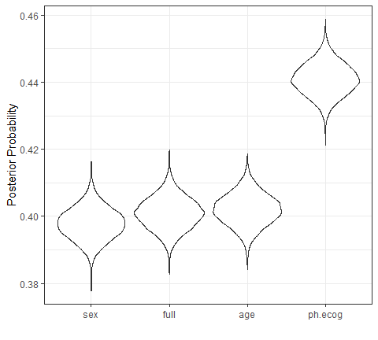

While this seems clear-cut, let’s assume that a difference in the concordance statistic of 0.1 is a real effect. To compute the posteriors for the difference in models, the full model will be contrasted with the others:

comparisons <- contrast_models(  
 concord_est,  
 list_1 = rep("full",3),  
 list_2 = c("ph.ecog", "age", "sex"),  
 seed = 4654  
)

The posterior distributions show that, statistically, ph.ecog has real importance ot the model. However, since these distributions are mostly with +/- 0.05, they are unlikely to be real differences.

ggplot(comparisons, size = 0.05) +   
 theme_bw()

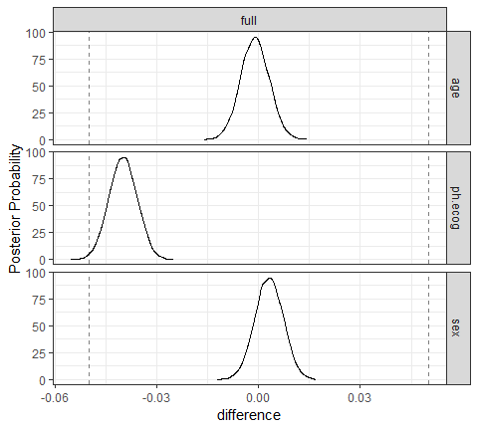

The ROPE statistics quantify the practical effects:

summary(comparisons, size = 0.05) %>%  
 select(contrast, starts_with("pract"))  
## # A tibble: 3 x 4  
## contrast pract_neg pract_equiv pract_pos  
## <chr> <dbl> <dbl> <dbl>  
## 1 full vs age 0 1 0  
## 2 full vs ph.ecog 0.0068 0.993 0  
## 3 full vs sex 0 1 0

## Reference

[Vignettes](https://github.com/tidymodels/rsample/tree/master/vignettes)

# [recipes](https://github.com/tidymodels/recipes)

## Introduction

The recipes package is an alternative method for creating and preprocessing design matrics that can be used for modeling or visualization.

In statistics, a **desgin matrix** (also known as regressor matrix or model matrix) is a matrix of values of explnatory variables of a set of objects, often denoted by X. Each row represents and individual object, with the successive columns corresponding to the variables and their specifc values for that object.

While R already has long-standing methods for creating these matrices (e.g. [formulas](https://www.rstudio.com/rviews/2017/02/01/the-r-formula-method-the-good-parts) and model.matrix), there are some [limitations to what the existing infrastructure can do](https://rviews.rstudio.com/2017/03/01/the-r-formula-method-the-bad-parts/).

The idea of the recipes package is to define a recipe or blue print that can be used to sequentially define the encodings and preprocessing of the data (i.e., “feature engineering”). For example to create a simple recipe containing only an outcome and predictors and have the predictors centered and scaled:

library(recipes)  
library(mlbench)  
data(Sonar)  
  
Sonar %>% head()  
## V1 V2 V3 V4 V5 V6 V7 V8 V9 V10  
## 1 0.0200 0.0371 0.0428 0.0207 0.0954 0.0986 0.154 0.160 0.3109 0.211  
## 2 0.0453 0.0523 0.0843 0.0689 0.1183 0.2583 0.216 0.348 0.3337 0.287  
## 3 0.0262 0.0582 0.1099 0.1083 0.0974 0.2280 0.243 0.377 0.5598 0.619  
## 4 0.0100 0.0171 0.0623 0.0205 0.0205 0.0368 0.110 0.128 0.0598 0.126  
## 5 0.0762 0.0666 0.0481 0.0394 0.0590 0.0649 0.121 0.247 0.3564 0.446  
## 6 0.0286 0.0453 0.0277 0.0174 0.0384 0.0990 0.120 0.183 0.2105 0.304  
## V11 V12 V13 V14 V15 V16 V17 V18 V19 V20 V21  
## 1 0.1609 0.158 0.2238 0.0645 0.066 0.227 0.3100 0.300 0.508 0.480 0.578  
## 2 0.4918 0.655 0.6919 0.7797 0.746 0.944 1.0000 0.887 0.802 0.782 0.521  
## 3 0.6333 0.706 0.5544 0.5320 0.648 0.693 0.6759 0.755 0.893 0.862 0.797  
## 4 0.0881 0.199 0.0184 0.2261 0.173 0.213 0.0693 0.228 0.406 0.397 0.274  
## 5 0.4152 0.395 0.4256 0.4135 0.453 0.533 0.7306 0.619 0.203 0.464 0.415  
## 6 0.2988 0.425 0.6343 0.8198 1.000 0.999 0.9508 0.902 0.723 0.512 0.207  
## V22 V23 V24 V25 V26 V27 V28 V29 V30 V31 V32 V33  
## 1 0.507 0.433 0.555 0.671 0.641 0.710 0.808 0.679 0.386 0.131 0.260 0.512  
## 2 0.405 0.396 0.391 0.325 0.320 0.327 0.277 0.442 0.203 0.379 0.295 0.198  
## 3 0.674 0.429 0.365 0.533 0.241 0.507 0.853 0.604 0.851 0.851 0.504 0.186  
## 4 0.369 0.556 0.485 0.314 0.533 0.526 0.252 0.209 0.356 0.626 0.734 0.612  
## 5 0.429 0.573 0.540 0.316 0.229 0.700 1.000 0.726 0.472 0.510 0.546 0.288  
## 6 0.399 0.589 0.287 0.204 0.578 0.539 0.375 0.341 0.507 0.558 0.478 0.330  
## V34 V35 V36 V37 V38 V39 V40 V41 V42 V43 V44  
## 1 0.7547 0.854 0.851 0.669 0.610 0.494 0.274 0.051 0.2834 0.2825 0.4256  
## 2 0.2341 0.131 0.418 0.384 0.106 0.184 0.197 0.167 0.0583 0.1401 0.1628  
## 3 0.2709 0.423 0.304 0.612 0.676 0.537 0.472 0.465 0.2587 0.2129 0.2222  
## 4 0.3497 0.395 0.301 0.541 0.881 0.986 0.917 0.612 0.5006 0.3210 0.3202  
## 5 0.0981 0.195 0.418 0.460 0.322 0.283 0.243 0.198 0.2444 0.1847 0.0841  
## 6 0.2198 0.141 0.286 0.381 0.416 0.405 0.330 0.271 0.2650 0.0723 0.1238  
## V45 V46 V47 V48 V49 V50 V51 V52 V53 V54  
## 1 0.2641 0.1386 0.1051 0.1343 0.0383 0.0324 0.0232 0.0027 0.0065 0.0159  
## 2 0.0621 0.0203 0.0530 0.0742 0.0409 0.0061 0.0125 0.0084 0.0089 0.0048  
## 3 0.2111 0.0176 0.1348 0.0744 0.0130 0.0106 0.0033 0.0232 0.0166 0.0095  
## 4 0.4295 0.3654 0.2655 0.1576 0.0681 0.0294 0.0241 0.0121 0.0036 0.0150  
## 5 0.0692 0.0528 0.0357 0.0085 0.0230 0.0046 0.0156 0.0031 0.0054 0.0105  
## 6 0.1192 0.1089 0.0623 0.0494 0.0264 0.0081 0.0104 0.0045 0.0014 0.0038  
## V55 V56 V57 V58 V59 V60 Class  
## 1 0.0072 0.0167 0.0180 0.0084 0.0090 0.0032 R  
## 2 0.0094 0.0191 0.0140 0.0049 0.0052 0.0044 R  
## 3 0.0180 0.0244 0.0316 0.0164 0.0095 0.0078 R  
## 4 0.0085 0.0073 0.0050 0.0044 0.0040 0.0117 R  
## 5 0.0110 0.0015 0.0072 0.0048 0.0107 0.0094 R  
## 6 0.0013 0.0089 0.0057 0.0027 0.0051 0.0062 R  
Sonar %>% dim()  
## [1] 208 61  
  
sonar_rec <- recipe(Class ~., data = Sonar) %>%   
 step_center(all_predictors()) %>%   
 step_scale(all_predictors)

To install it, use:

install.packages("recipes")  
  
## for development version:  
require("devtools")  
install_github("tidymodels/recipes")

## [Dummy steps](https://github.com/tidymodels/recipes/blob/master/vignettes/Custom_Steps.Rmd)

The recipes package contains a number of different operations:

library(recipes)  
ls("package:recipes", pattern="^step_")  
## [1] "step_arrange" "step_bagimpute" "step_bin2factor"   
## [4] "step_BoxCox" "step_bs" "step_center"   
## [7] "step_classdist" "step_corr" "step_count"   
## [10] "step_date" "step_depth" "step_discretize"   
## [13] "step_downsample" "step_dummy" "step_factor2string"  
## [16] "step_filter" "step_geodist" "step_holiday"   
## [19] "step_hyperbolic" "step_ica" "step_integer"   
## [22] "step_interact" "step_intercept" "step_inverse"   
## [25] "step_invlogit" "step_isomap" "step_knnimpute"   
## [28] "step_kpca" "step_lag" "step_lincomb"   
## [31] "step_log" "step_logit" "step_lowerimpute"   
## [34] "step_meanimpute" "step_medianimpute" "step_modeimpute"   
## [37] "step_mutate" "step_naomit" "step_nnmf"   
## [40] "step_novel" "step_ns" "step_num2factor"   
## [43] "step_nzv" "step_ordinalscore" "step_other"   
## [46] "step_pca" "step_pls" "step_poly"   
## [49] "step_profile" "step_range" "step_ratio"   
## [52] "step_regex" "step_relu" "step_rm"   
## [55] "step_rollimpute" "step_sample" "step_scale"   
## [58] "step_shuffle" "step_slice" "step_spatialsign"   
## [61] "step_sqrt" "step_string2factor" "step_unorder"   
## [64] "step_upsample" "step_window" "step_YeoJohnson"   
## [67] "step_zv"

You might need to define your own iperations, this page describes how to do that. I f you are looking for good examples of existing steps, I would suggest looking at the code for [centering](https://github.com/tidymodels/recipes/blob/master/R/center.R) or [PCA](https://github.com/tidymodels/recipes/blob/master/R/pca.R) to start.

For checks, the process is very similar. notes on this are given at the end of this document.

### A new step definition

As an example, let’s create a step that replaces the value of a viable with its percentile from the training set. The data that I will use is from the recipes package:

# [Parsnip](https://tidymodels.github.io/parsnip/))

## introduction

One issue with different functions available in R that *do the same thing* is that they can have different interfaces and arguments. For example, to fit a random forest classification model, we might have:

# From random forest  
rf_1 <- randomForest::randomForest(x,y,mtry=12, ntrees=2000, importance=TRUE)  
  
# From ranger  
library(ranger)  
rf_2 <- ranger(  
 y~.,   
 data = dat,   
 mtry = !2,  
 num.trees = 2000,  
 importance = "impurity"  
)  
  
# From sparklyr  
rf_3 <- ml_random_forest(  
 dat,  
 intercept = FALSE,  
 response = "y",  
 features = names(dat)[names(dat) 1= "y"],  
 col.sample.rate =12,  
 num.trees = 2000  
)

Note that the model syntax is very different and that the argument names (and formals) are also different. This is pain if you go between implementations.

In this example: - the **type** of model is “random forest” - the **mode** of the model is “classification” (as opposed to regression, etc) - the computational **engine** is the name of the R package

The idea of parsnip is to: - separate the definition of a model from its evaluation. - Decouple the model specification from the implementation (whether the implementation is in R, spark or something else). For example, the user would call rand_forest instead of ranger::ranger or other specific packages. - Harmonize the argument names (e.g., n.trees, ntrees, trees) so that users can remember a single name. This will help across model types too so that trees will be the same argument across random forest as well as boosting or bagging.

Using the example above, the parsnip approach would be:

library(parsnip)  
parsnip::rand_forest(  
 mtry = 12,  
 trees = 2000  
) %>%   
 set_engine("ranger", importance = "impurity") %>%   
 fit (y ~., data=dat)

The engine can be easily changed and the mode can be determined when fit is called. to use Spark, the change is simple:

rand_forest(  
 mtry = 12,  
 trees = 2000  
) %>%   
 set_engine("spark") %>%   
 fit(y ~ ., data = dat)

### Model list

parsnip contains wrappers for a number of models. For example, the parsnip function rand_forest() can be used to create a random forest model. The **mode** of a model is realted to its goal. Examples would be regression and classification.

[Ths list of models](https://tidymodels.github.io/parsnip/articles/articles/Models.html) accessible via parsnip is :

* classification: boost_tree(), decision_tree(), logistic_reg(), mars(), mlp(), multinomial_reg(), nearest_neighbor(), rand_forest(), svm_poly(), svm_rbf()
* regression: boost_tree(), decision_tree(), linear_reg(), mars(), mlp(), nerarest_neighbor(), rand_forest(), surv_reg(), svm_reg(), svm_poly(), svm_rbf().

How the model is created is related to the *engine*. In many cases, this is an R modeling package. In others, it may be a connection to an externam system (such as SparkorTensorflow).

## Regression example

The Ames housing data will be used

## [Regression](https://github.com/tidymodels/parsnip/blob/master/vignettes/articles/Regression.Rmd)