USAGE DECLARATION
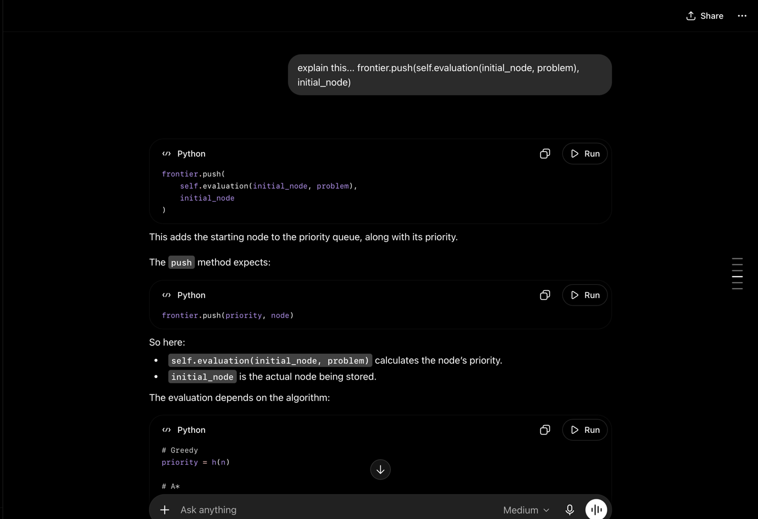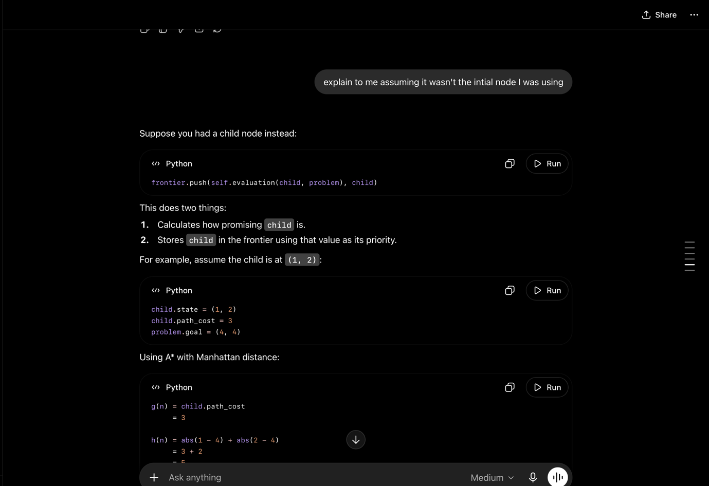
These were prompts used to understand how the push function works and how self.evaluation is a valid argument.
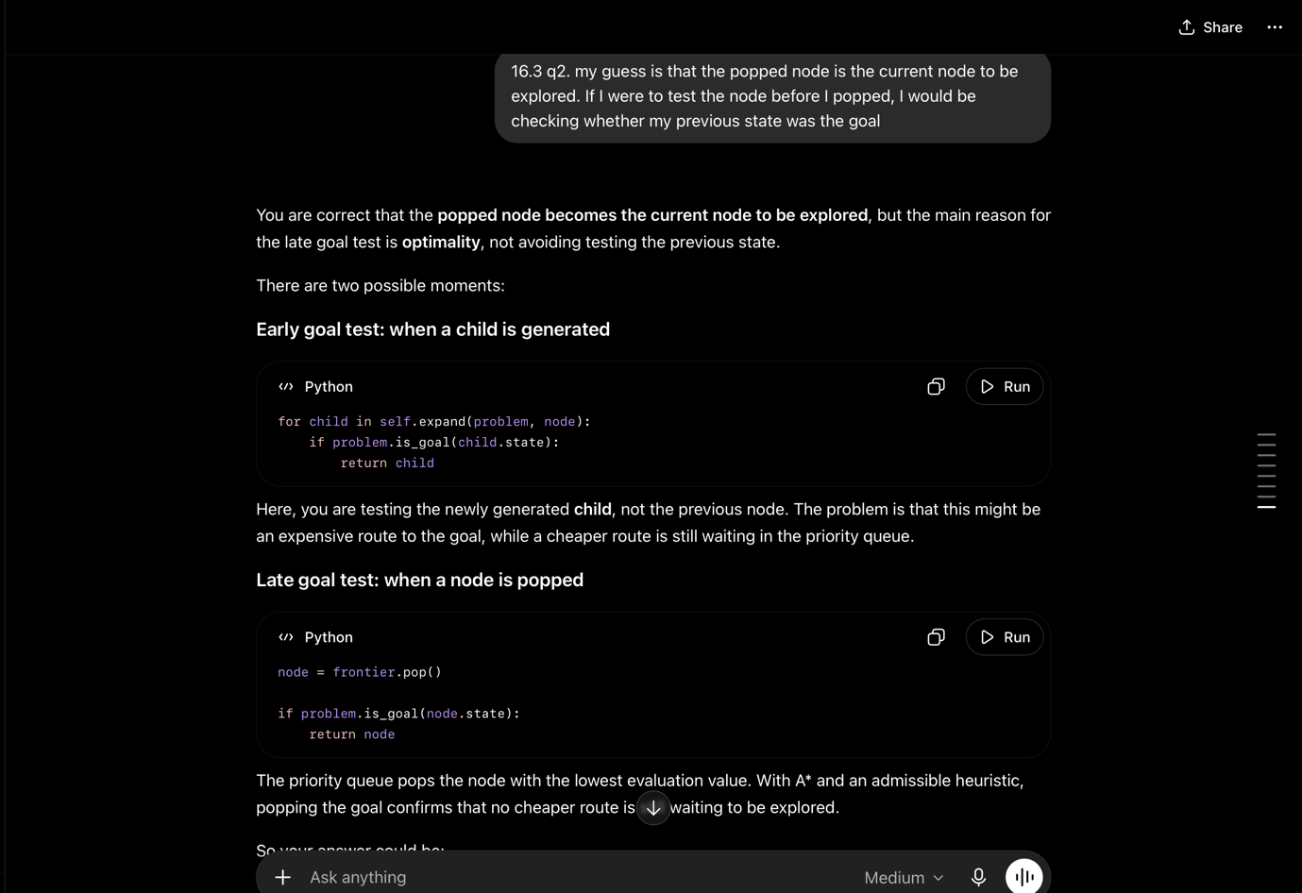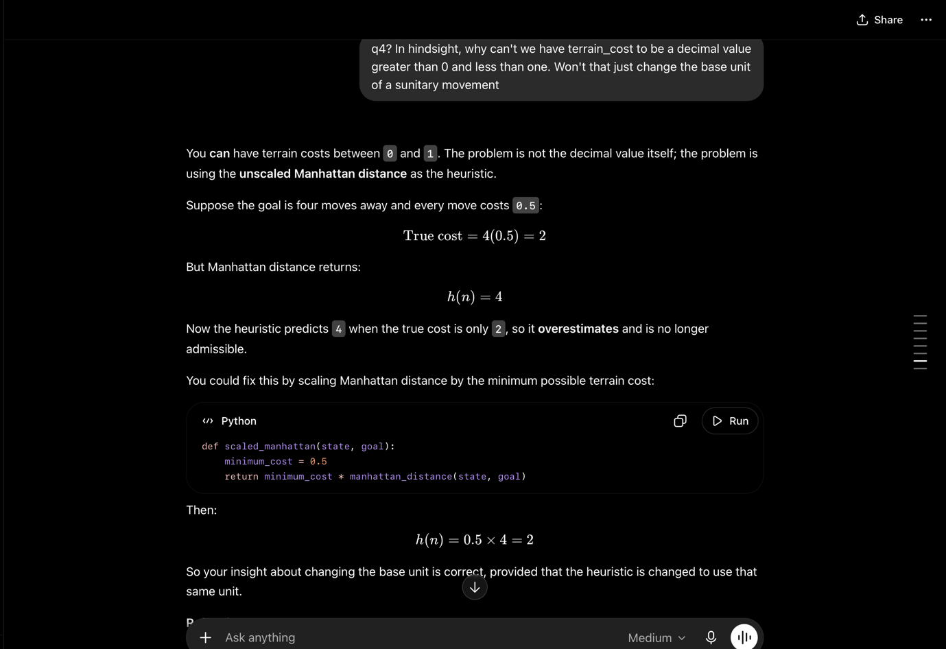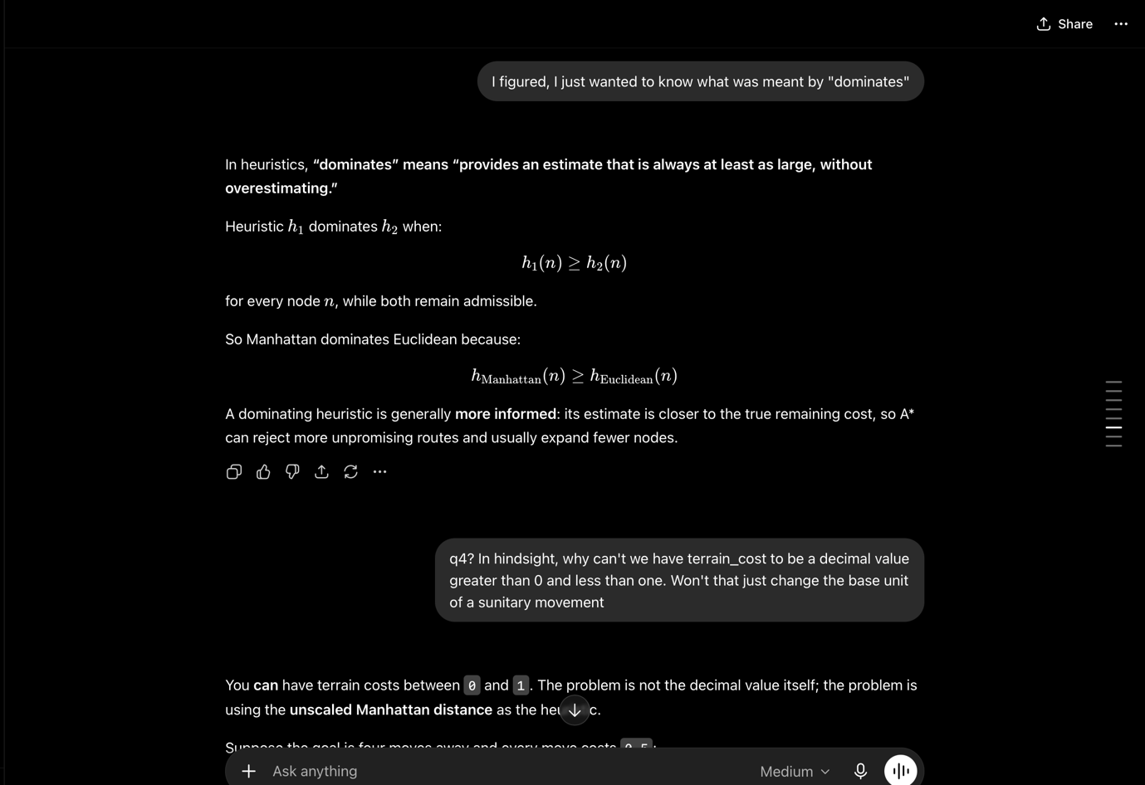
The above show me verifying my answers.

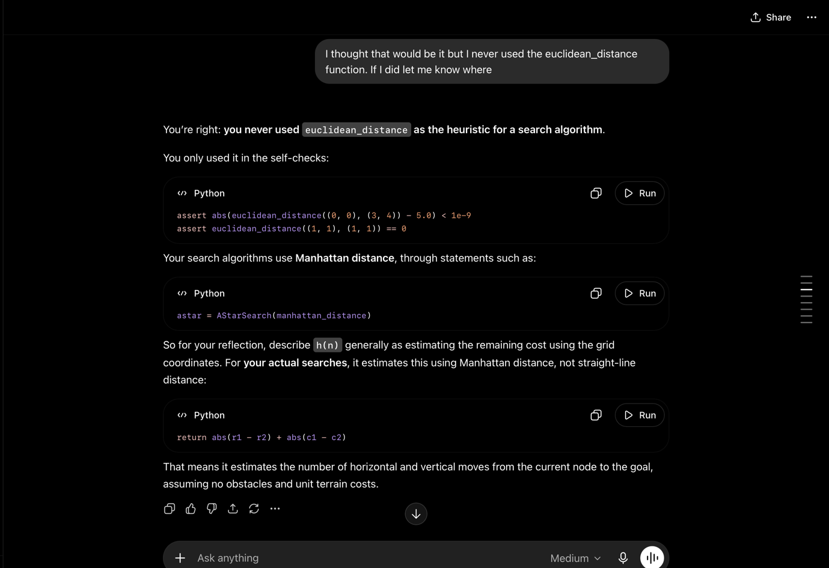

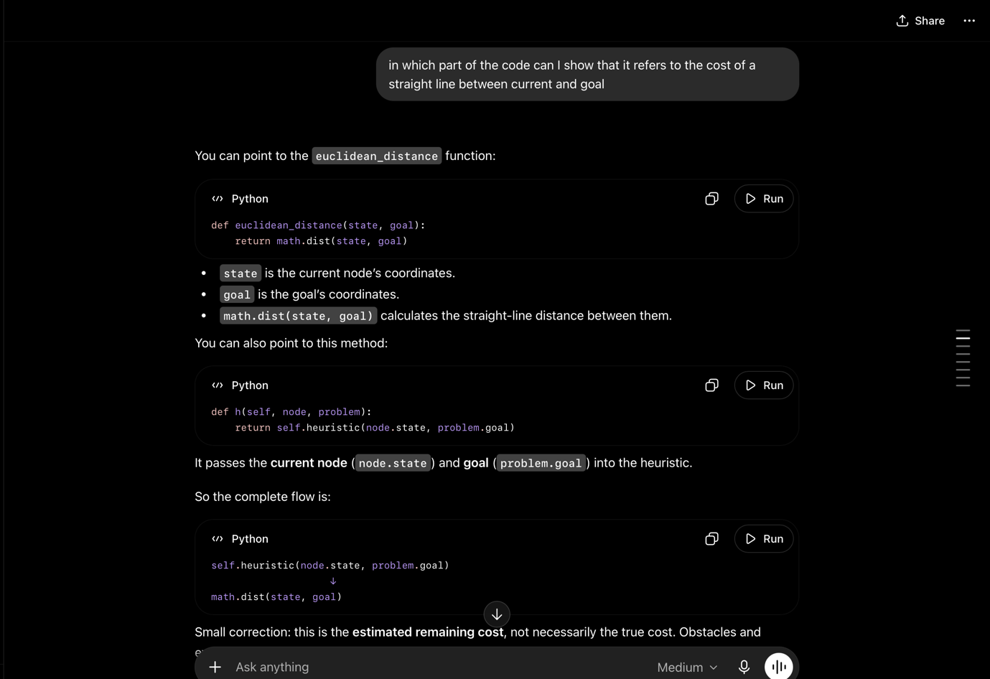
These show me getting clarification on how Euclidean and Manhattan distances were used and their relevance.
NB: My source code was fed into the ai model to make the process of understanding changes more easy.

