Setup DHCP Role – Server 2016

How to setup DHCP server role on Server 2016

* From Server Manager Dashboard, click on **Add roles and features**.  
  [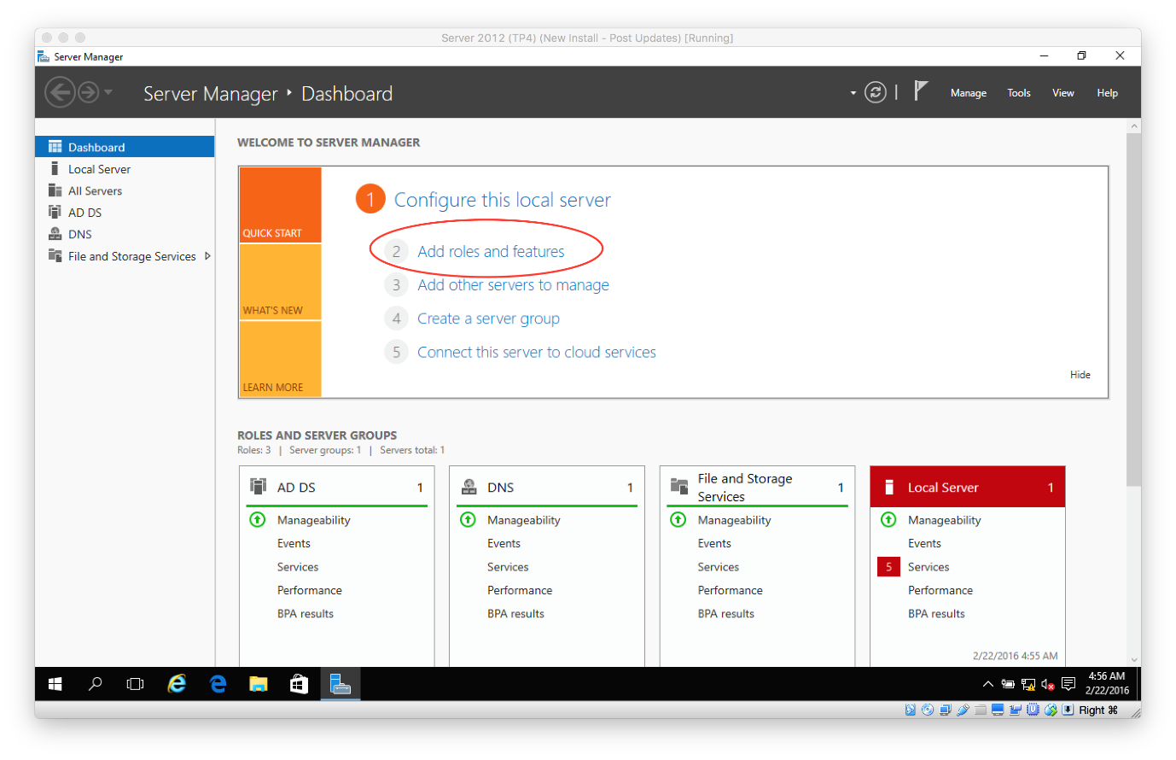](https://secureservercdn.net/198.71.233.195/dbd.2d9.myftpupload.com/wp-content/uploads/2016/02/Server-Basics-2016-DHCP_1.png)
* Select **Role-based or feature-based installation** and click **Next**.  
  [[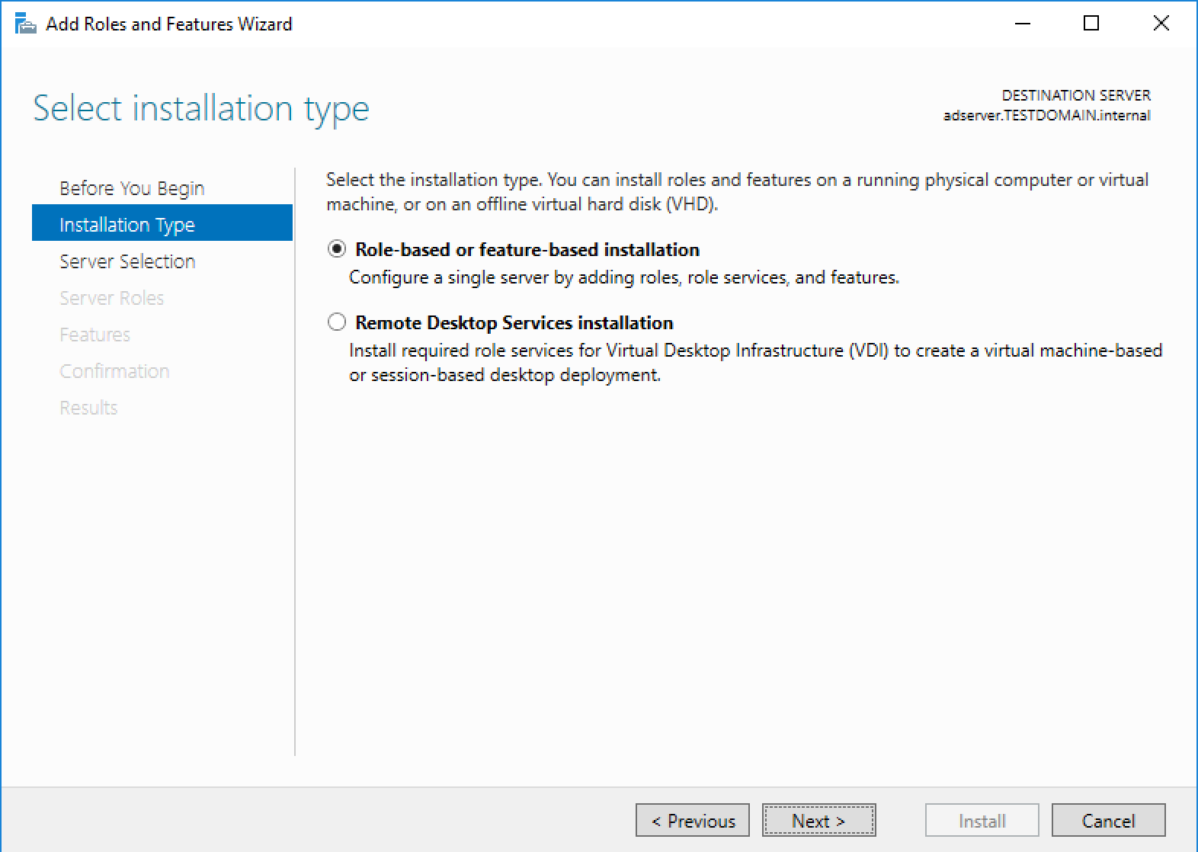](https://secureservercdn.net/198.71.233.195/dbd.2d9.myftpupload.com/wp-content/uploads/2016/02/Server-Basics-2016-DHCP_2.png)](https://secureservercdn.net/198.71.233.195/dbd.2d9.myftpupload.com/wp-content/uploads/2016/02/Server-Basics-2016-DHCP_2.png)
* Select the server, then click **Next**.  
  [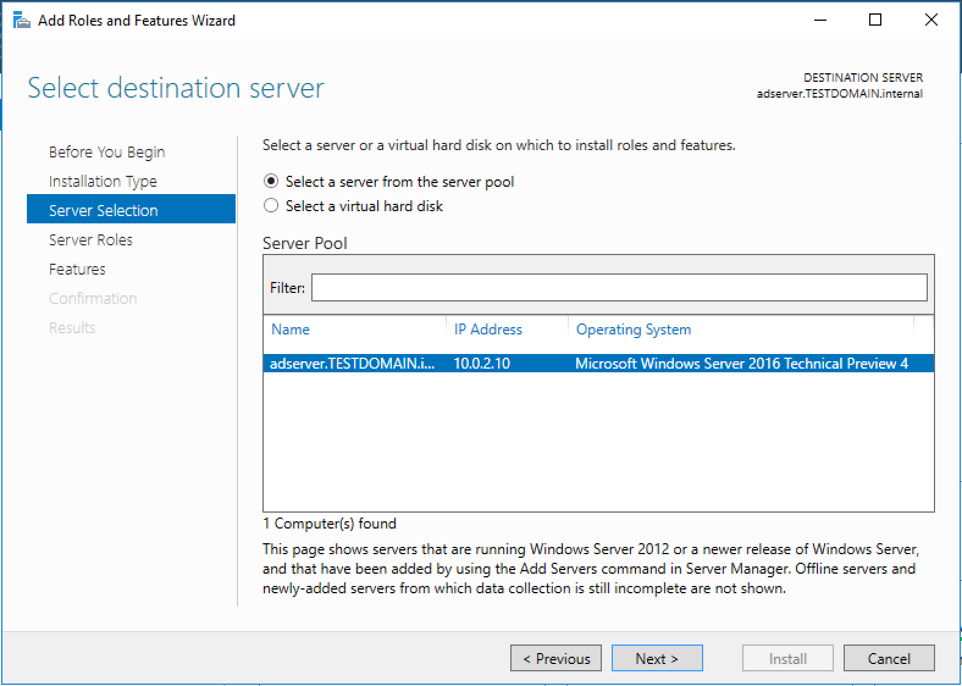](https://secureservercdn.net/198.71.233.195/dbd.2d9.myftpupload.com/wp-content/uploads/2016/02/Server-Basics-2016-DHCP_3.png)
* Select **DHCP Server**, then click **Next**.  
  [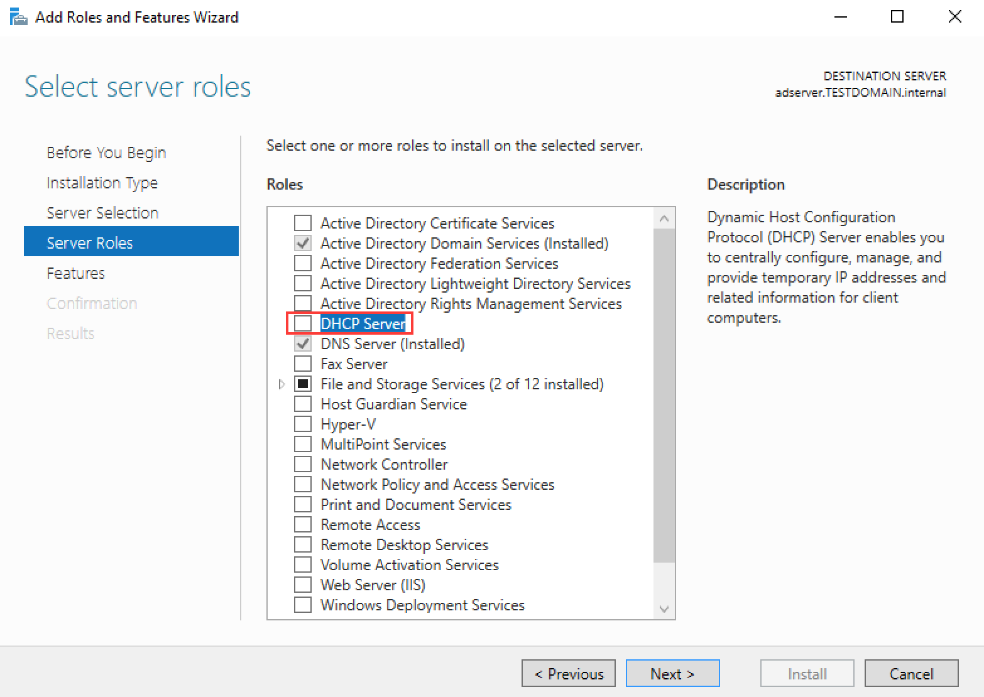](https://secureservercdn.net/198.71.233.195/dbd.2d9.myftpupload.com/wp-content/uploads/2016/02/Server-Basics-2016-DHCP_4.png)
* Click **Add Features**. [[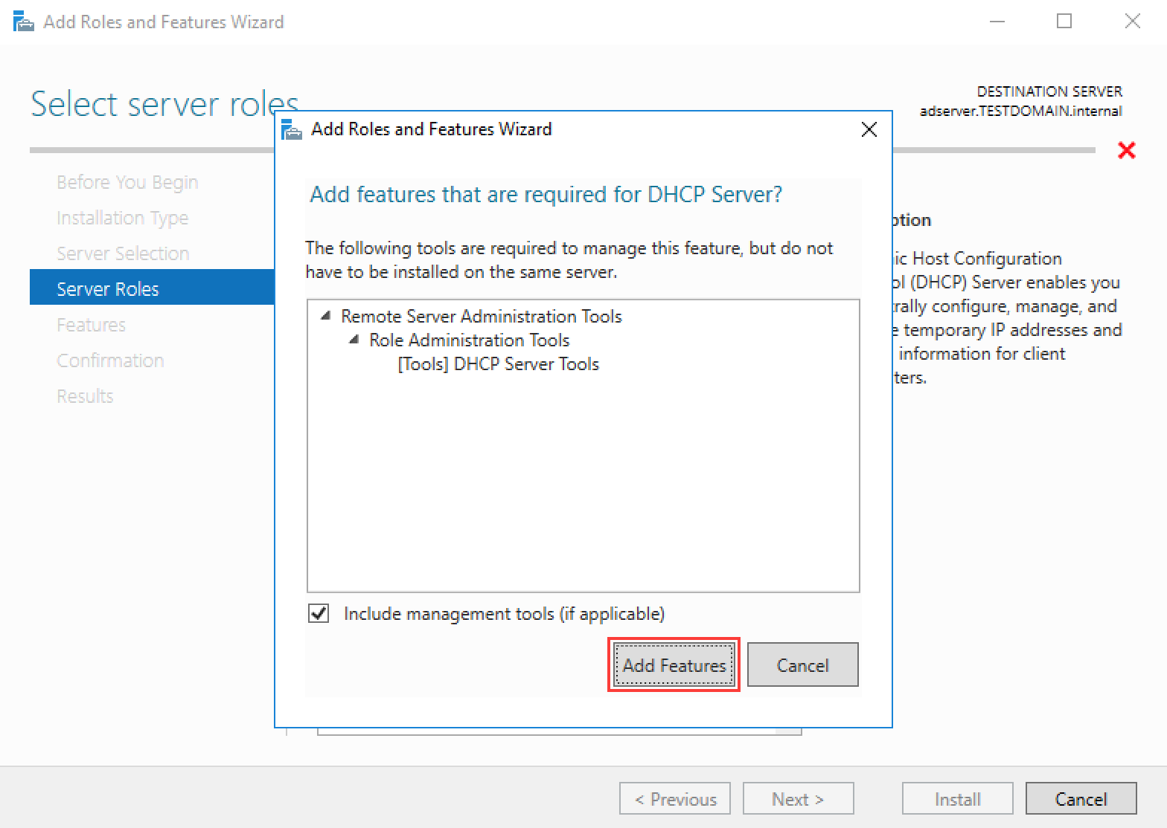](https://secureservercdn.net/198.71.233.195/dbd.2d9.myftpupload.com/wp-content/uploads/2016/02/Server-Basics-2016-DHCP_5.png)](https://secureservercdn.net/198.71.233.195/dbd.2d9.myftpupload.com/wp-content/uploads/2016/02/Server-Basics-2016-DHCP_5.png)
* Click **Next**.  
  [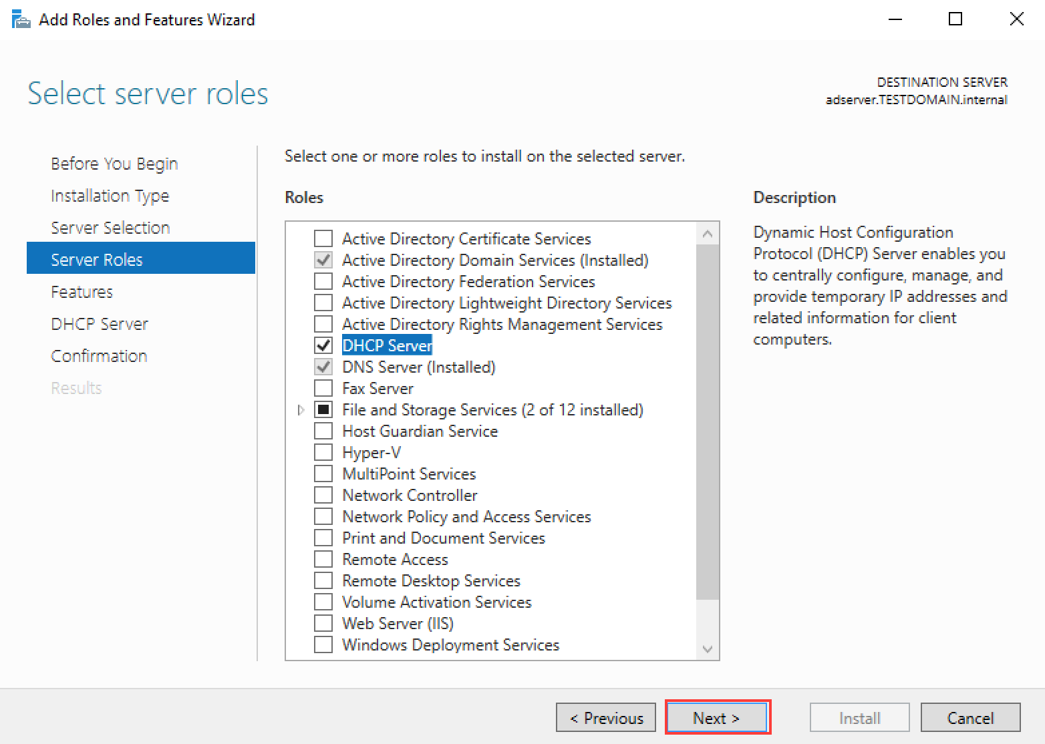](https://secureservercdn.net/198.71.233.195/dbd.2d9.myftpupload.com/wp-content/uploads/2016/02/Server-Basics-2016-DHCP_6.png)
* Click **Next**.  
  [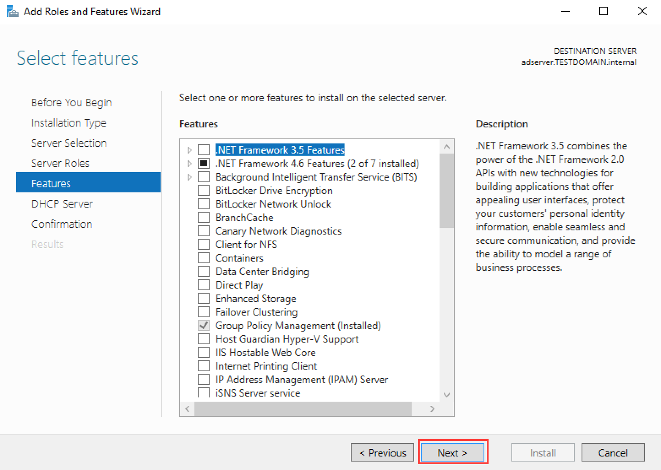](https://secureservercdn.net/198.71.233.195/dbd.2d9.myftpupload.com/wp-content/uploads/2016/02/Server-Basics-2016-DHCP_7.png)
* Click **Next**.  
  [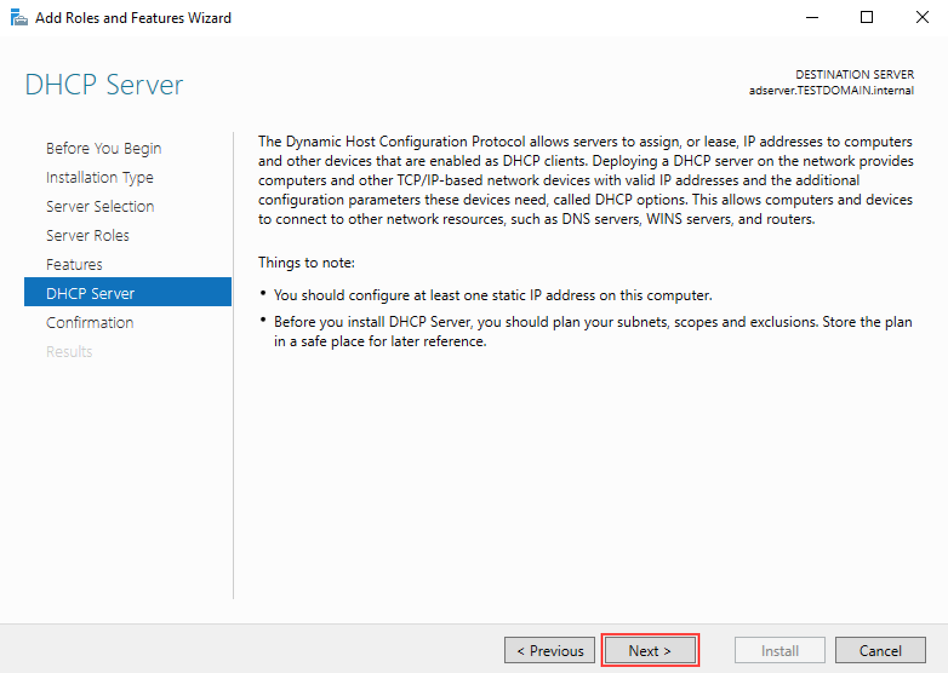](https://secureservercdn.net/198.71.233.195/dbd.2d9.myftpupload.com/wp-content/uploads/2016/02/Server-Basics-2016-DHCP_8.png)
* Check the **Restart the destination server automatically if required**, then click **Install**.  
  [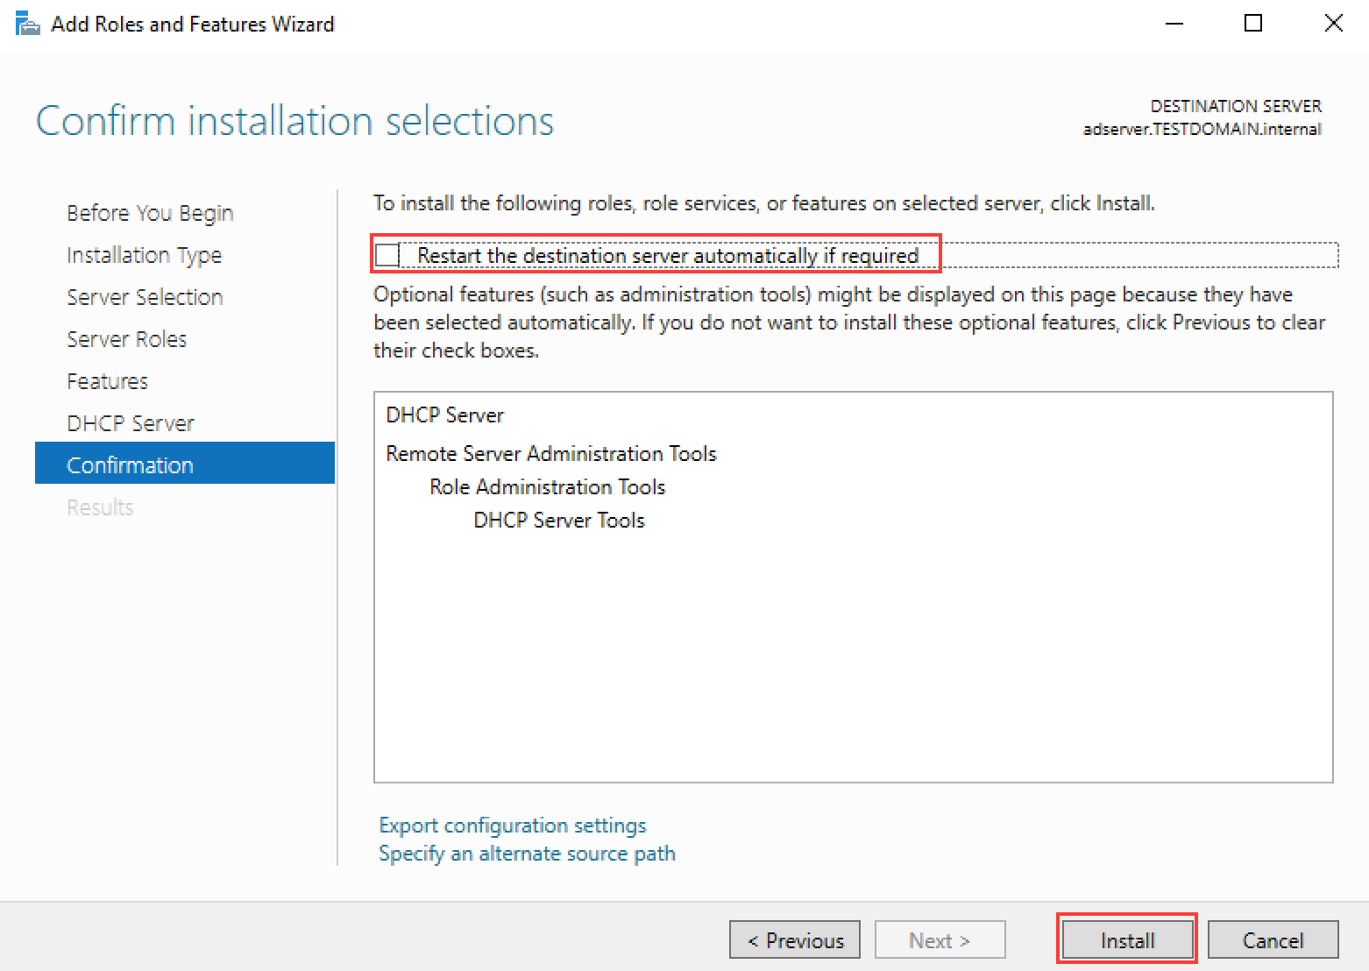](https://secureservercdn.net/198.71.233.195/dbd.2d9.myftpupload.com/wp-content/uploads/2016/02/Server-Basics-2016-DHCP_9.png)
* When installation is complete, click **Close**.  
  [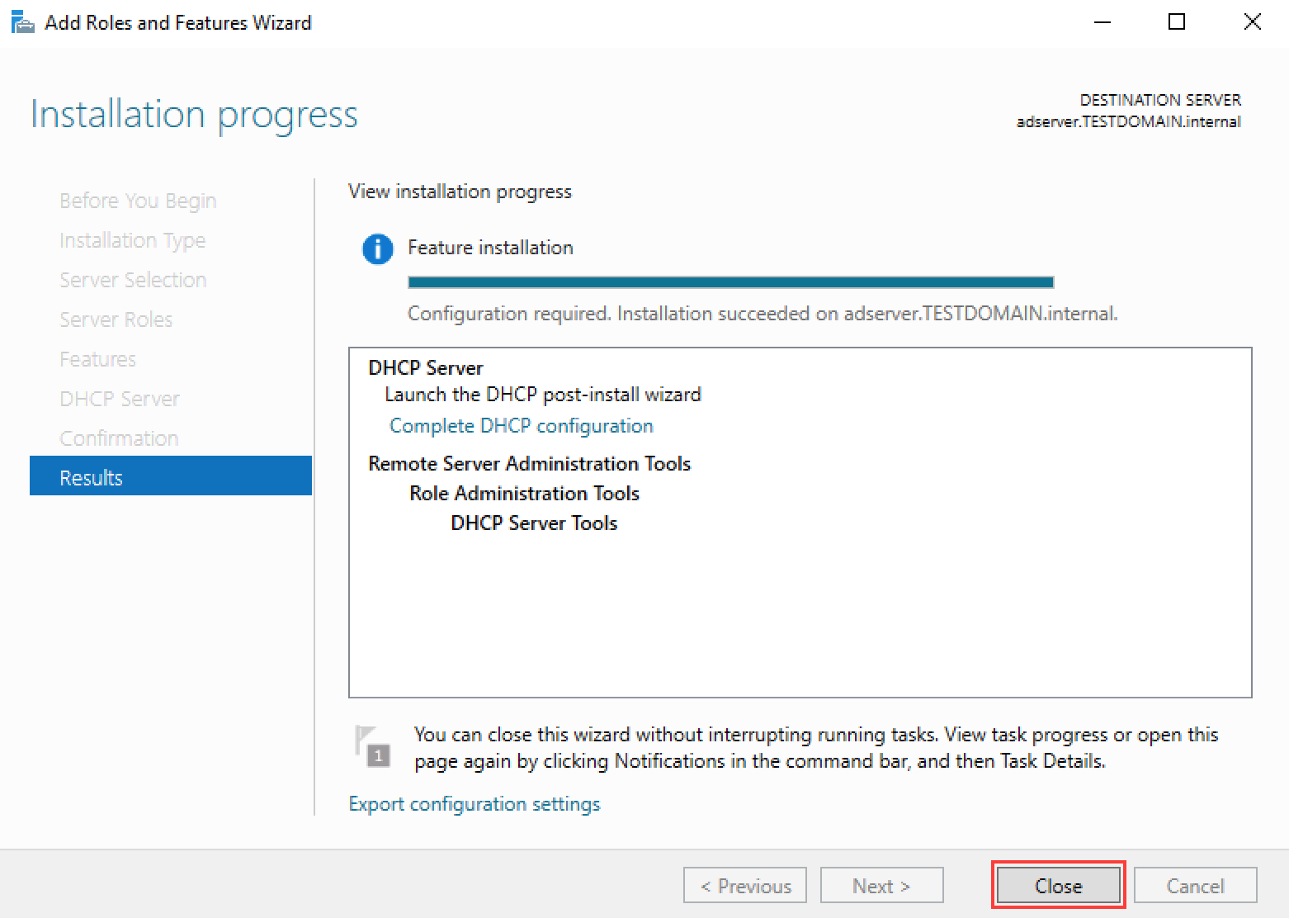](https://secureservercdn.net/198.71.233.195/dbd.2d9.myftpupload.com/wp-content/uploads/2016/02/Server-Basics-2016-DHCP_10.png)
* From Server Manager Dashboard, click the **yellow exclamation mark triangle**, then click **Complete DHCP configuration**. [[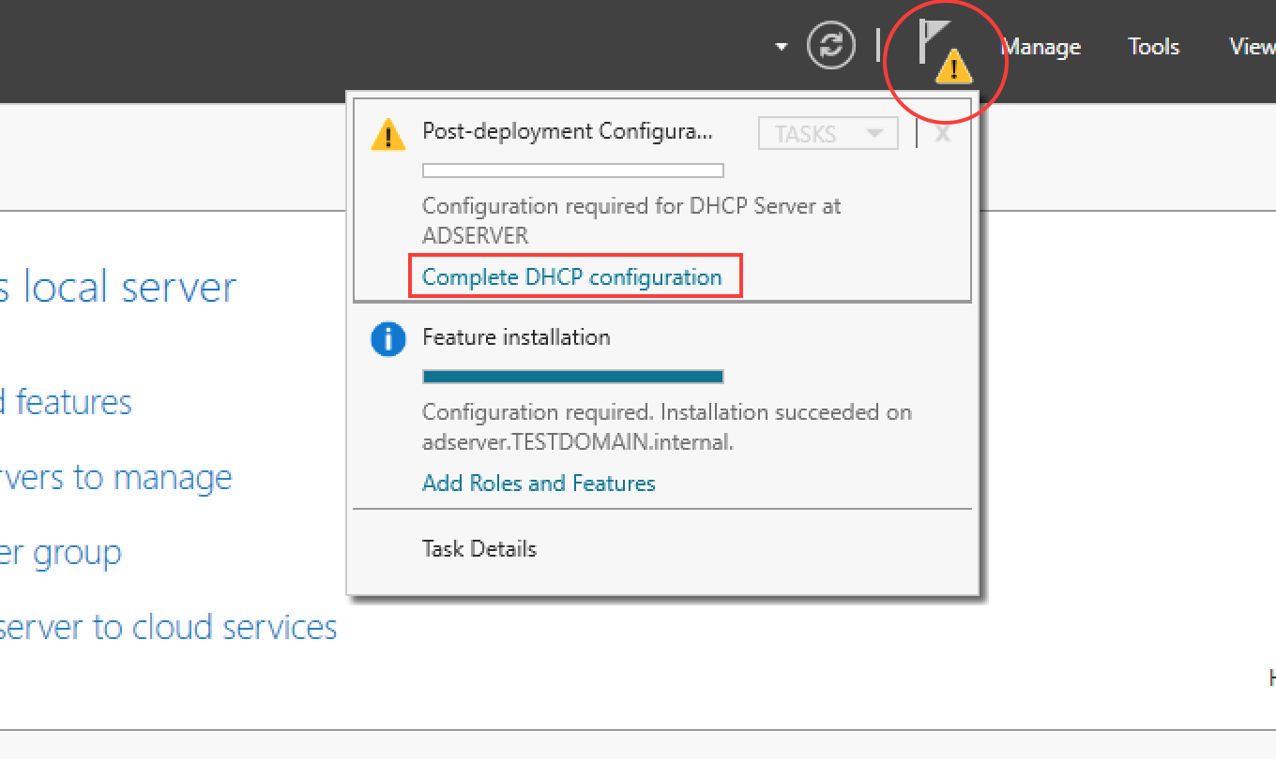](https://secureservercdn.net/198.71.233.195/dbd.2d9.myftpupload.com/wp-content/uploads/2016/02/Server-Basics-2016-DHCP_11.png)](https://secureservercdn.net/198.71.233.195/dbd.2d9.myftpupload.com/wp-content/uploads/2016/02/Server-Basics-2016-DHCP_11.png)
* Click **Next**.  
  [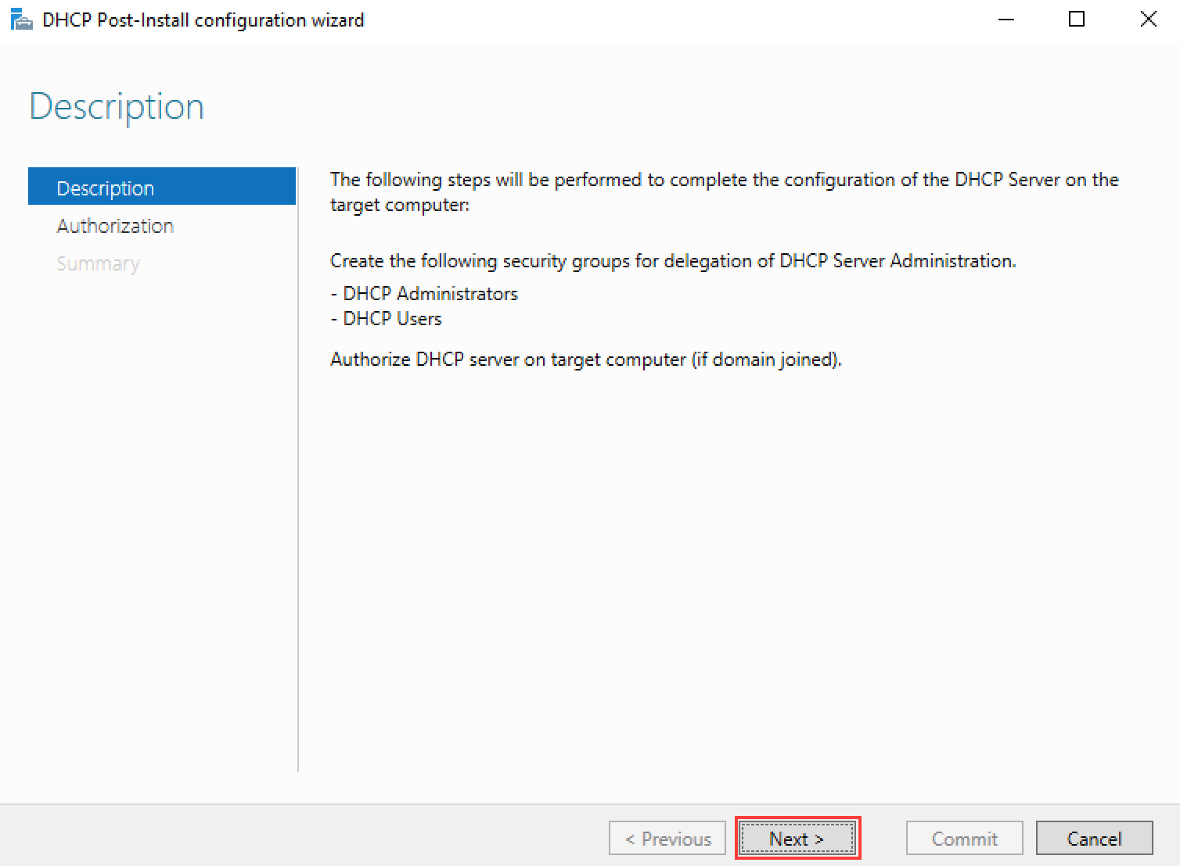](https://secureservercdn.net/198.71.233.195/dbd.2d9.myftpupload.com/wp-content/uploads/2016/02/Server-Basics-2016-DHCP_12.png)
* Click **Commit**. [[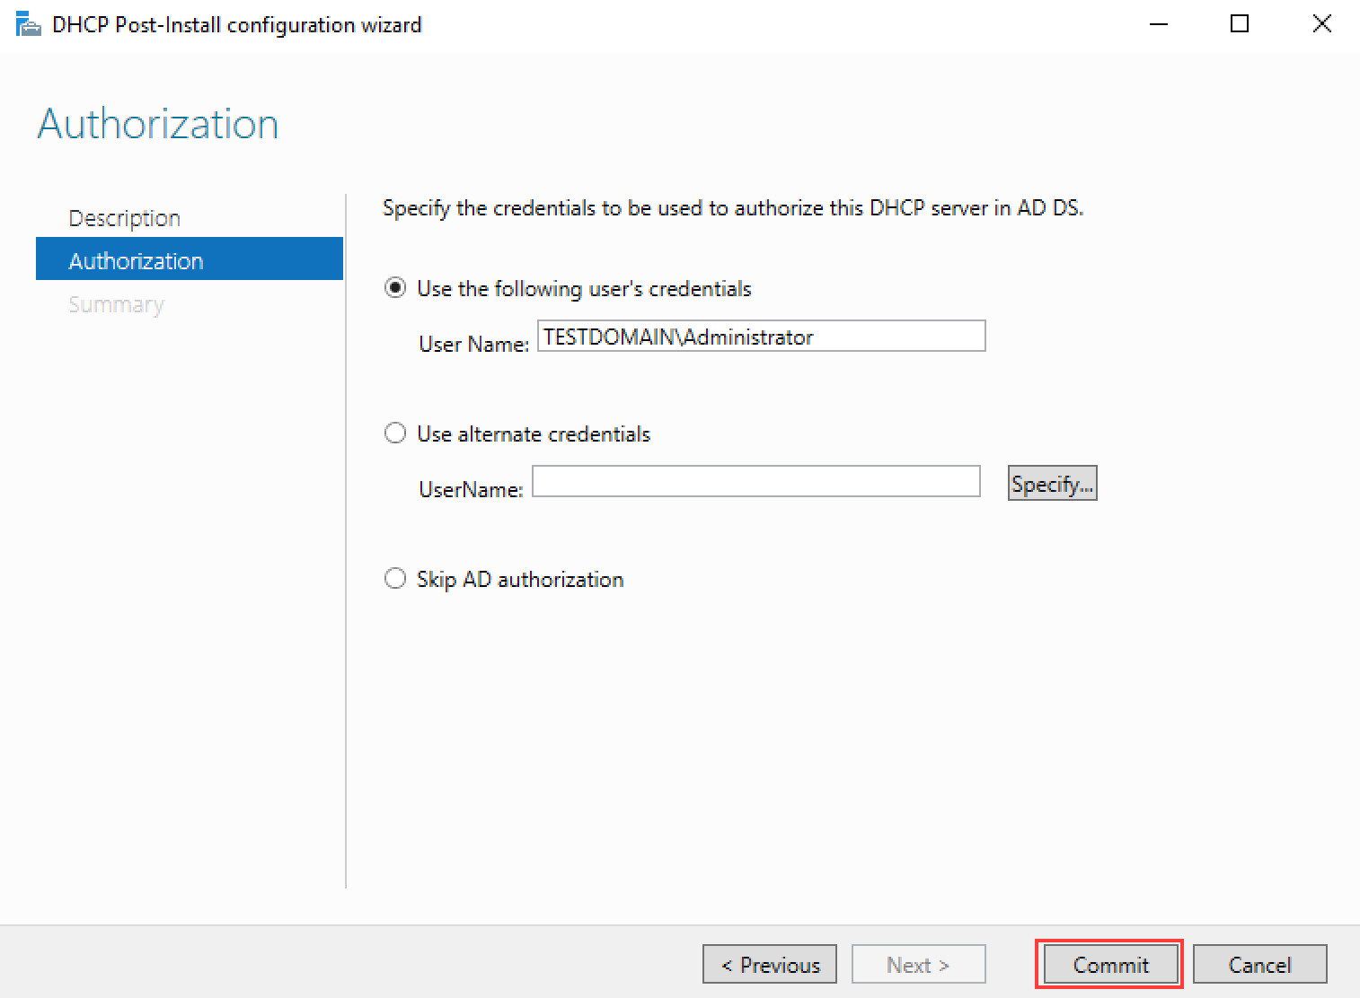](https://secureservercdn.net/198.71.233.195/dbd.2d9.myftpupload.com/wp-content/uploads/2016/02/Server-Basics-2016-DHCP_13.png)](https://secureservercdn.net/198.71.233.195/dbd.2d9.myftpupload.com/wp-content/uploads/2016/02/Server-Basics-2016-DHCP_13.png)
* From **Server Manager Dashboard**, click on **Tools** in the upper-right, then **DHCP** to launch the DHCP MMC.
* Expand **DHCP** | <**servername**>**.**<**domain name**> | **IPv4**.
* Right-click **Server Options** and click **Configure Options**. [[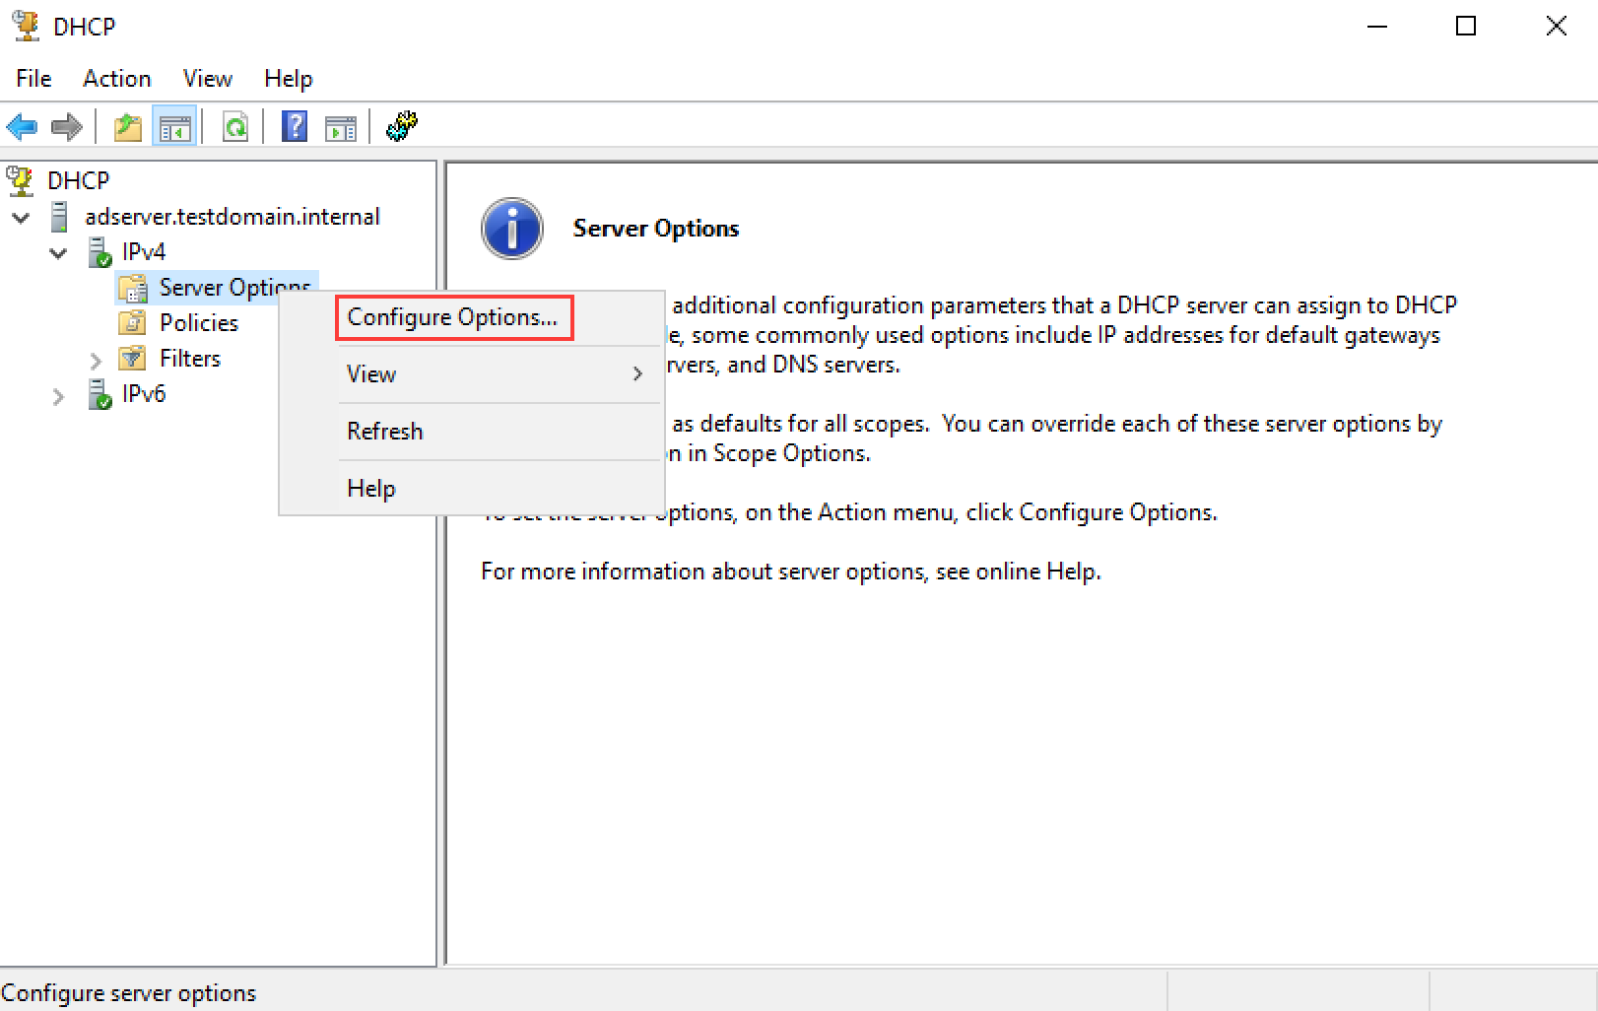](https://secureservercdn.net/198.71.233.195/dbd.2d9.myftpupload.com/wp-content/uploads/2016/02/Server-Basics-2016-DHCP_14.png)](https://secureservercdn.net/198.71.233.195/dbd.2d9.myftpupload.com/wp-content/uploads/2016/02/Server-Basics-2016-DHCP_14.png)
* Check **003 Router** and type the **router’s IP address** in the IP address field, click Add. (For me, since I am using NAT Network within Virtualbox, this IP address would be the IP address of my server’s gateway that we setup a few videos ago.)  
  [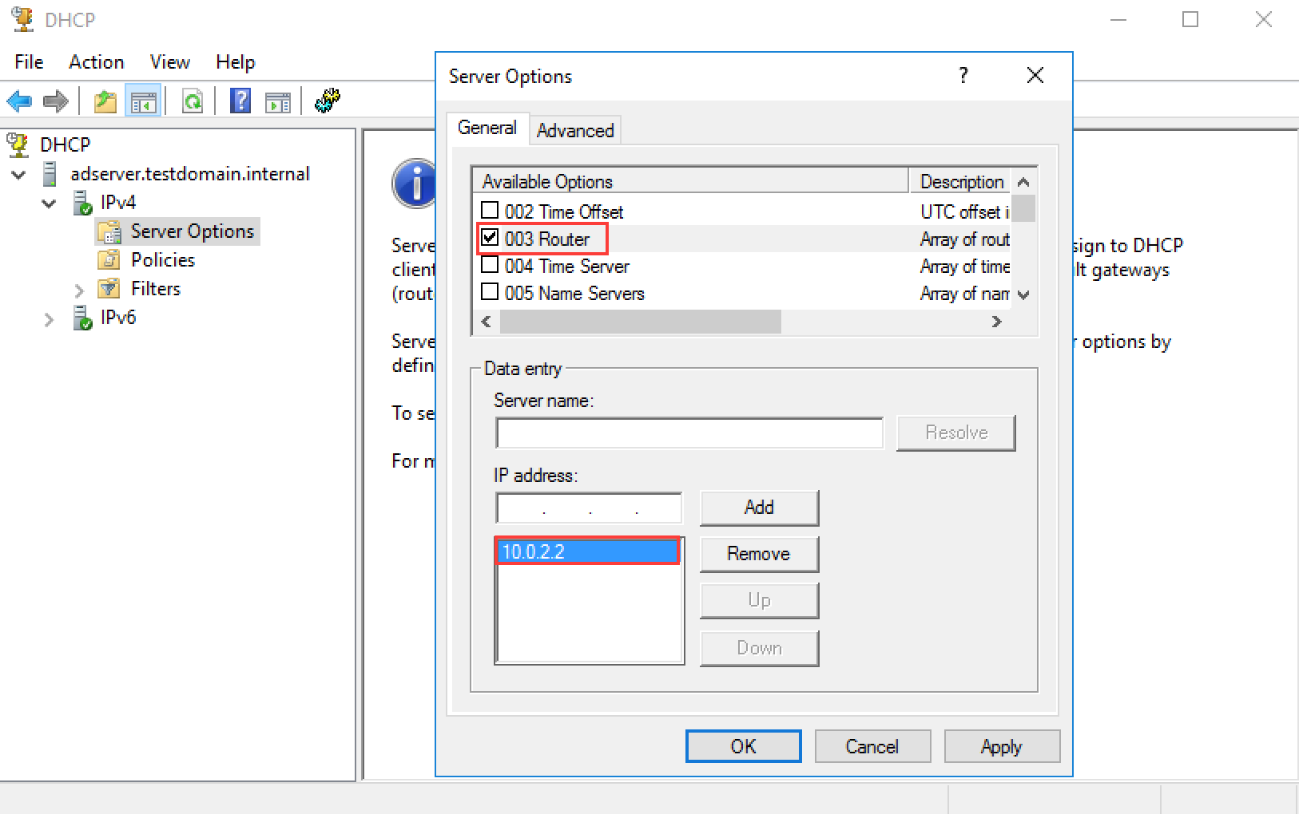](https://secureservercdn.net/198.71.233.195/dbd.2d9.myftpupload.com/wp-content/uploads/2016/02/Server-Basics-2016-DHCP_15.png)
* Check **006 DNS Servers** and type the **server’s IP address** in the IP address field, then click **Add**.
* Click **OK**. [[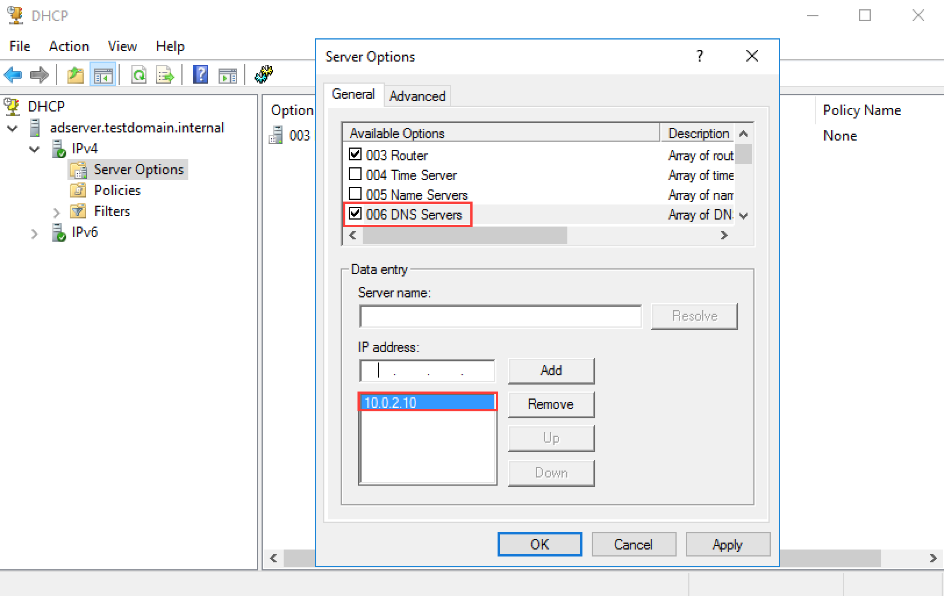](https://secureservercdn.net/198.71.233.195/dbd.2d9.myftpupload.com/wp-content/uploads/2016/02/Server-Basics-2016-DHCP_16.png)](https://secureservercdn.net/198.71.233.195/dbd.2d9.myftpupload.com/wp-content/uploads/2016/02/Server-Basics-2016-DHCP_16.png)
* Right-click **IPv4** then select **New Scope**. [[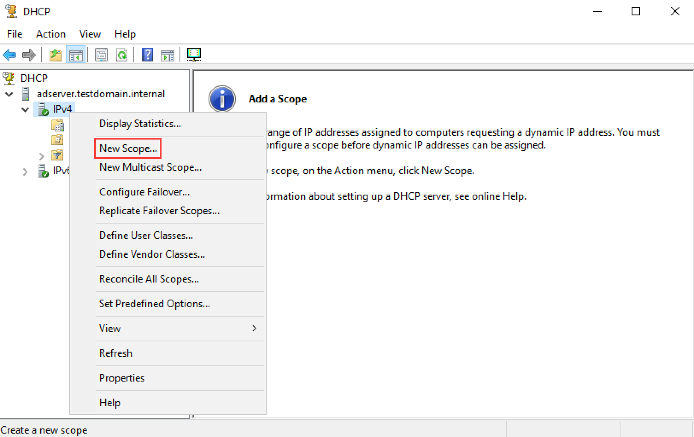](https://secureservercdn.net/198.71.233.195/dbd.2d9.myftpupload.com/wp-content/uploads/2016/02/Server-Basics-2016-DHCP_17.png)](https://secureservercdn.net/198.71.233.195/dbd.2d9.myftpupload.com/wp-content/uploads/2016/02/Server-Basics-2016-DHCP_17.png)
* **Type in a name** for the new scope, then click **Next**.  
  [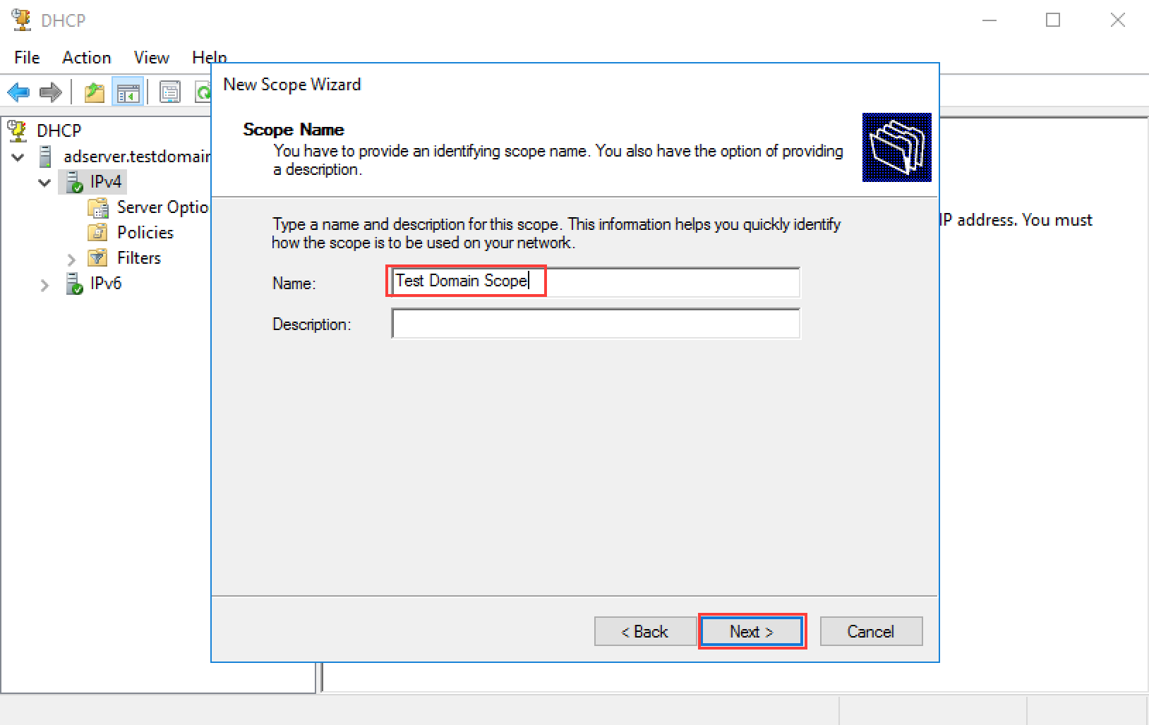](https://secureservercdn.net/198.71.233.195/dbd.2d9.myftpupload.com/wp-content/uploads/2016/02/Server-Basics-2016-DHCP_18.png)
* Enter the **IP Address Range** (**start** and **end**) and the correct **Subnet mask**, then click Next. This is the range of IP addresses the server will hand out to DHCP clients that come up on the network. [[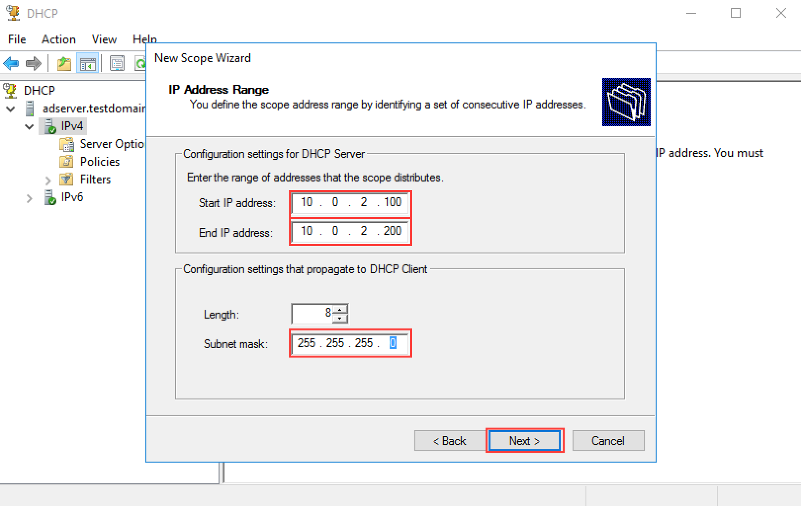](https://secureservercdn.net/198.71.233.195/dbd.2d9.myftpupload.com/wp-content/uploads/2016/02/Server-Basics-2016-DHCP_19.png)](https://secureservercdn.net/198.71.233.195/dbd.2d9.myftpupload.com/wp-content/uploads/2016/02/Server-Basics-2016-DHCP_19.png)
* Leave **Exclusions and Delay** empty, then click **Next**. [[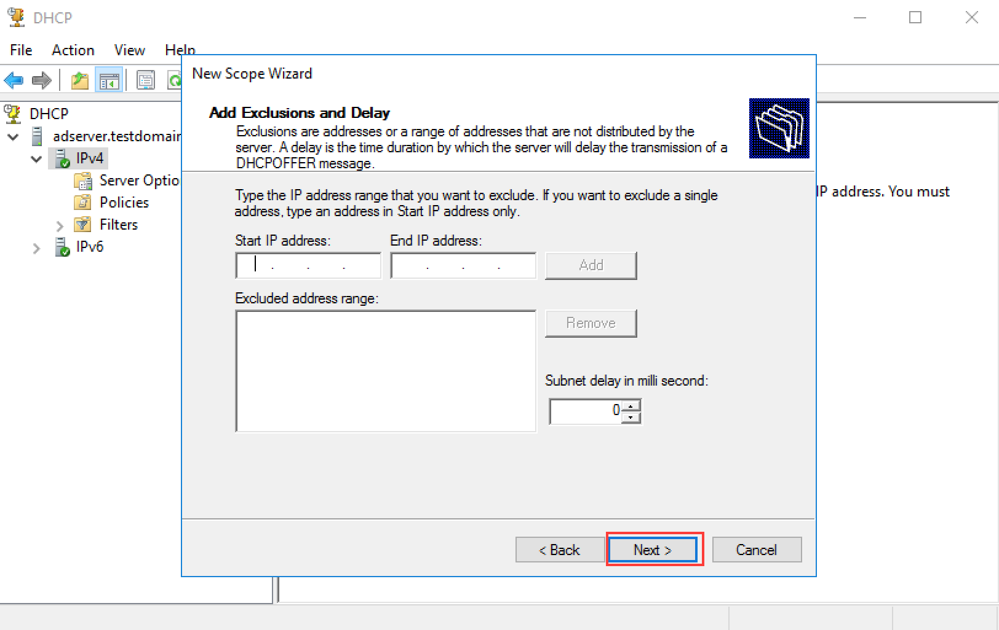](https://secureservercdn.net/198.71.233.195/dbd.2d9.myftpupload.com/wp-content/uploads/2016/02/Server-Basics-2016-DHCP_20.png)](https://secureservercdn.net/198.71.233.195/dbd.2d9.myftpupload.com/wp-content/uploads/2016/02/Server-Basics-2016-DHCP_20.png)
* Click **Next** for **Lease Duration**. [[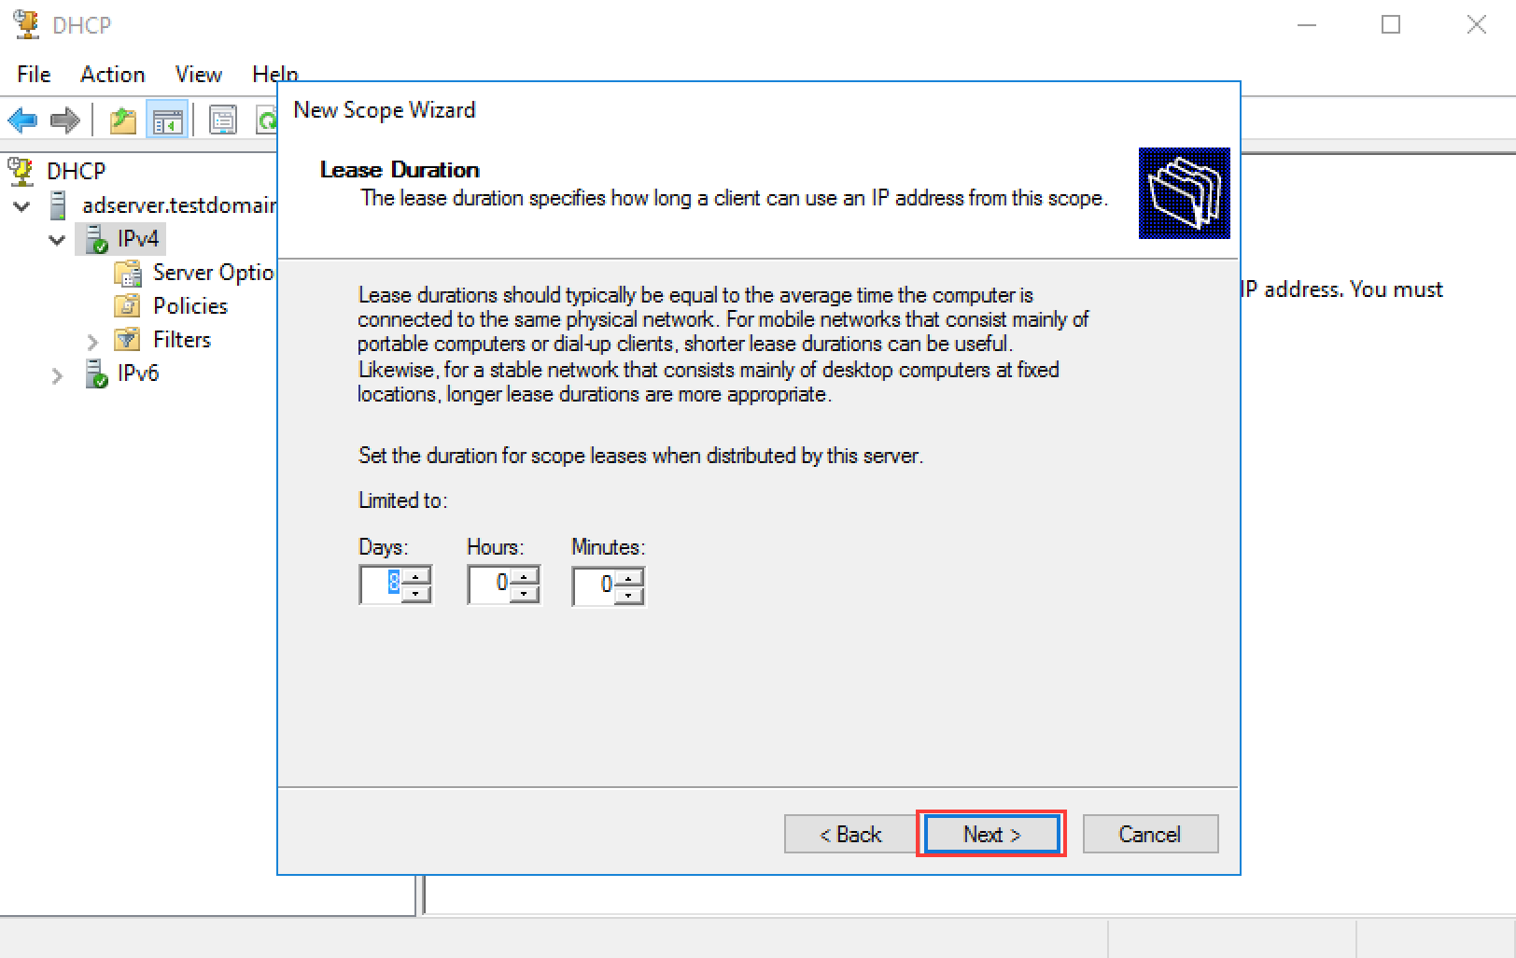](https://secureservercdn.net/198.71.233.195/dbd.2d9.myftpupload.com/wp-content/uploads/2016/02/Server-Basics-2016-DHCP_21.png)](https://secureservercdn.net/198.71.233.195/dbd.2d9.myftpupload.com/wp-content/uploads/2016/02/Server-Basics-2016-DHCP_21.png)
* Select **Yes, I want to configure these options now**, then click **Next**. [[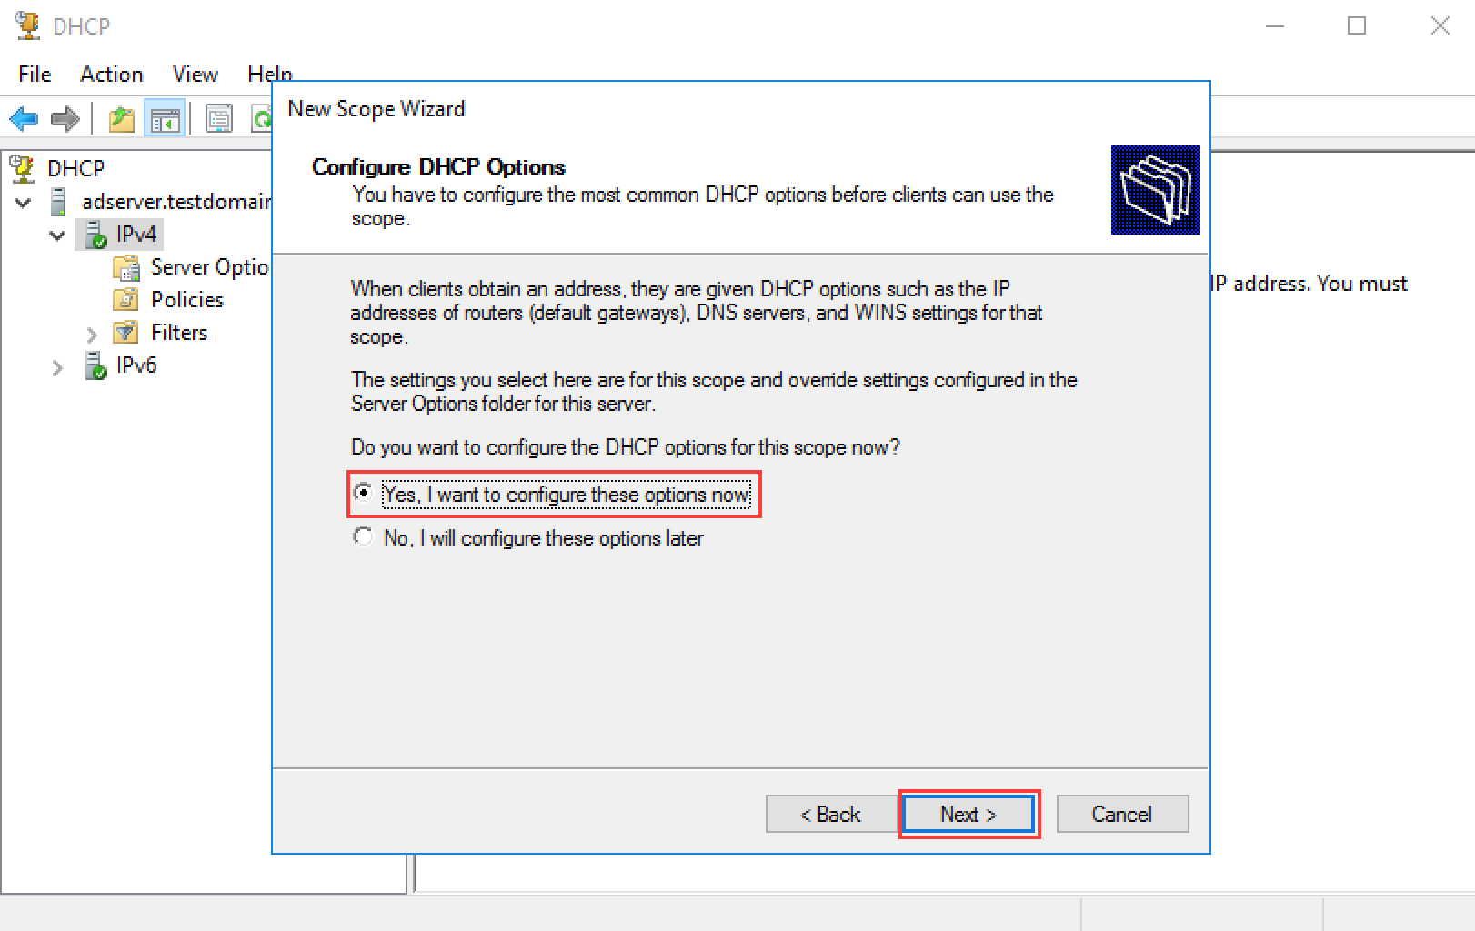](https://secureservercdn.net/198.71.233.195/dbd.2d9.myftpupload.com/wp-content/uploads/2016/02/Server-Basics-2016-DHCP_22.png)](https://secureservercdn.net/198.71.233.195/dbd.2d9.myftpupload.com/wp-content/uploads/2016/02/Server-Basics-2016-DHCP_22.png)
* Enter the **router’s IP** again (remember, this is the same as the server’s current gateway address), then click **Next**.  
  [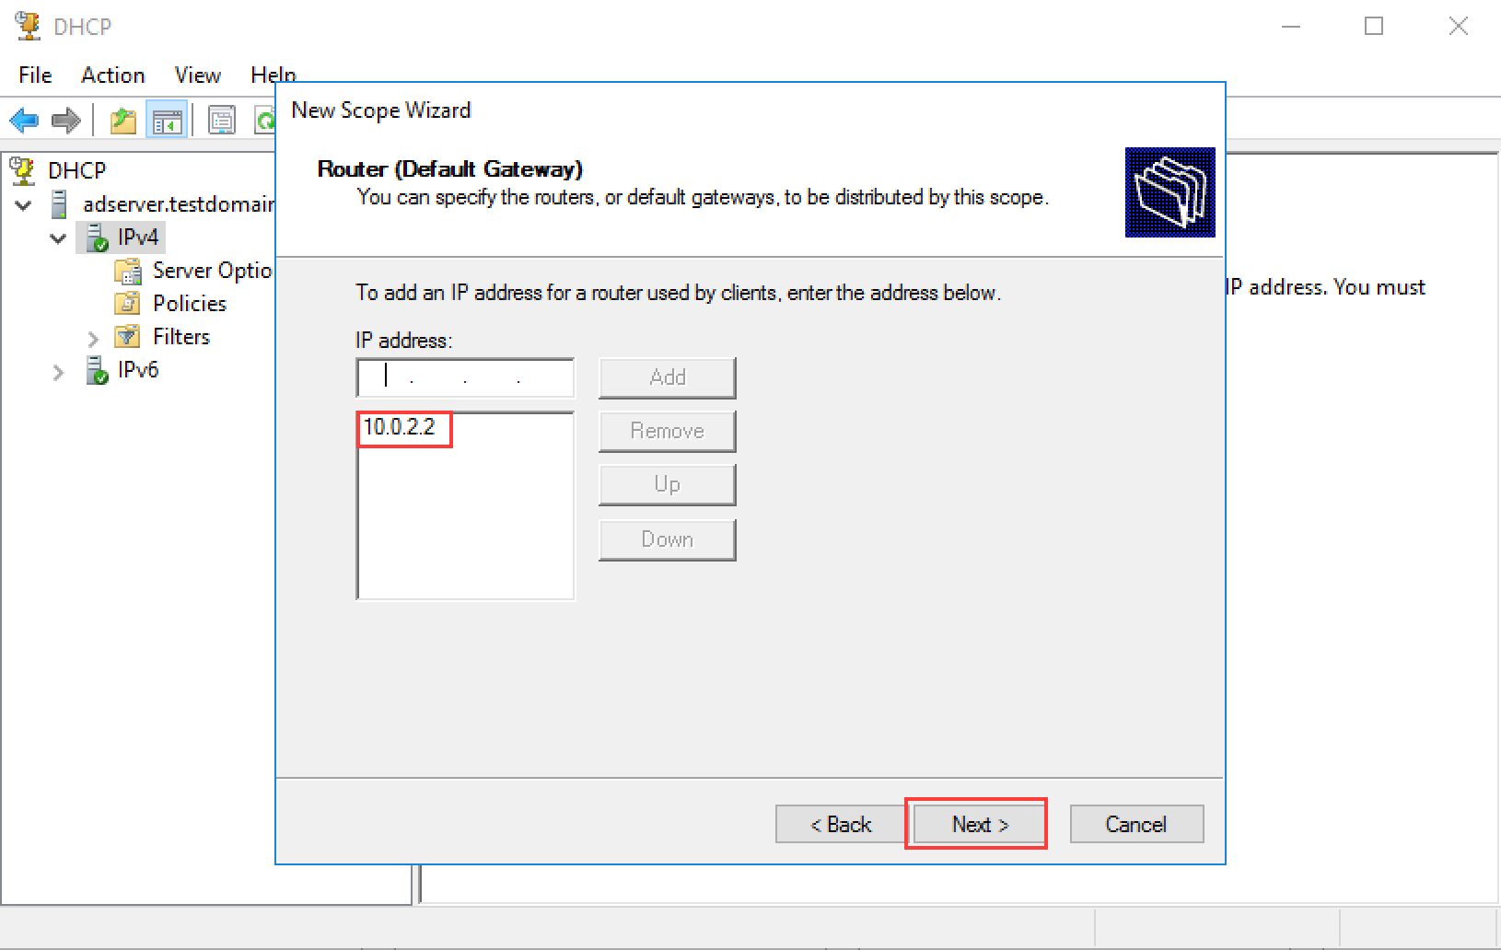](https://secureservercdn.net/198.71.233.195/dbd.2d9.myftpupload.com/wp-content/uploads/2016/02/Server-Basics-2016-DHCP_23.png)
* The DNS server IP should already be filled in, click **Next**. [[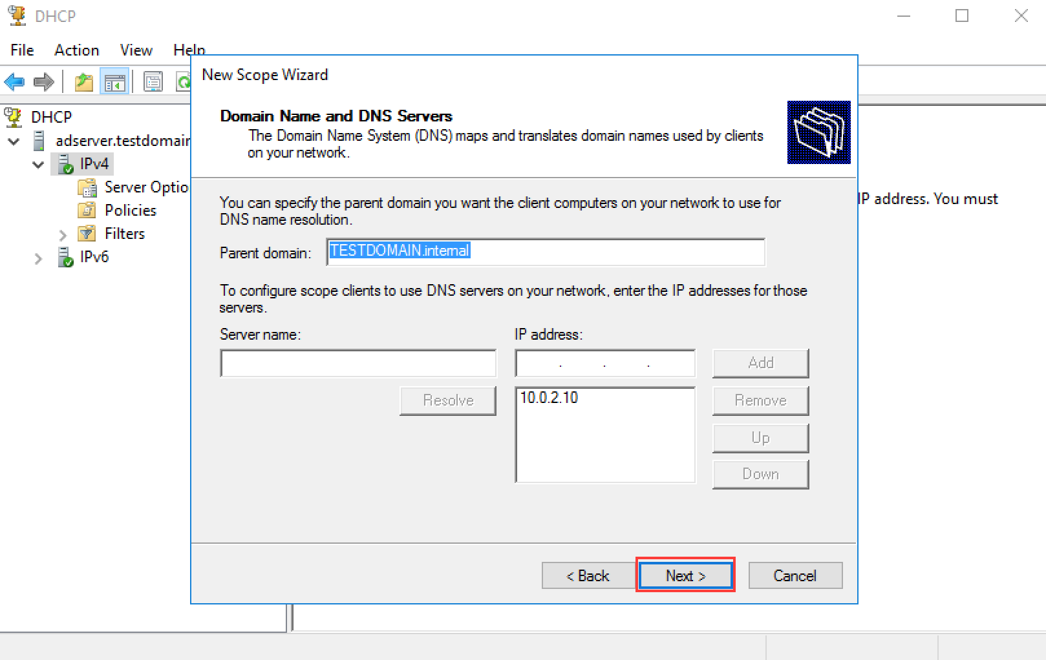](https://secureservercdn.net/198.71.233.195/dbd.2d9.myftpupload.com/wp-content/uploads/2016/02/Server-Basics-2016-DHCP_24.png)](https://secureservercdn.net/198.71.233.195/dbd.2d9.myftpupload.com/wp-content/uploads/2016/02/Server-Basics-2016-DHCP_24.png)
* For now, we are not planning on using WINS, click **Next**. [[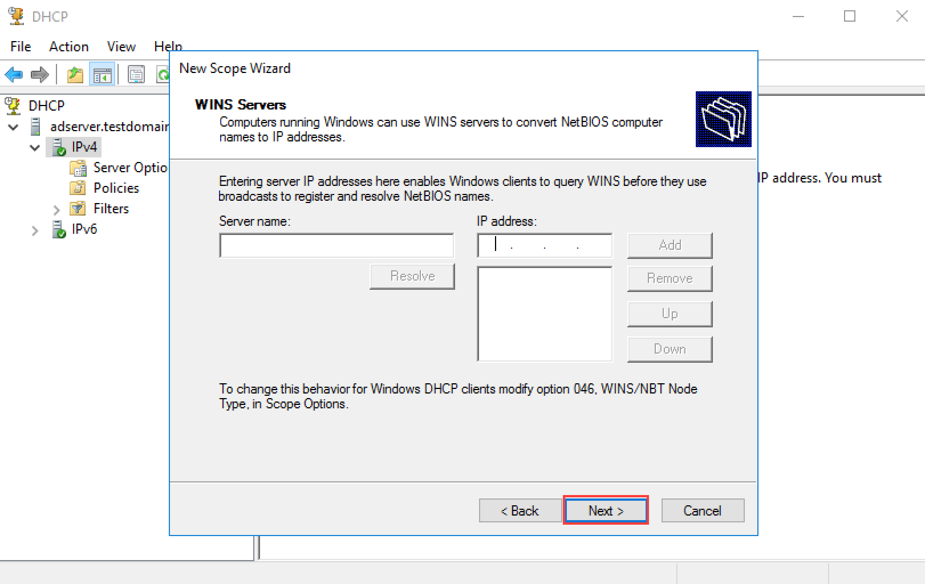](https://secureservercdn.net/198.71.233.195/dbd.2d9.myftpupload.com/wp-content/uploads/2016/02/Server-Basics-2016-DHCP_25.png)](https://secureservercdn.net/198.71.233.195/dbd.2d9.myftpupload.com/wp-content/uploads/2016/02/Server-Basics-2016-DHCP_25.png)
* Select **Yes, I want to activate this scope now**, then click **Next**.  
  [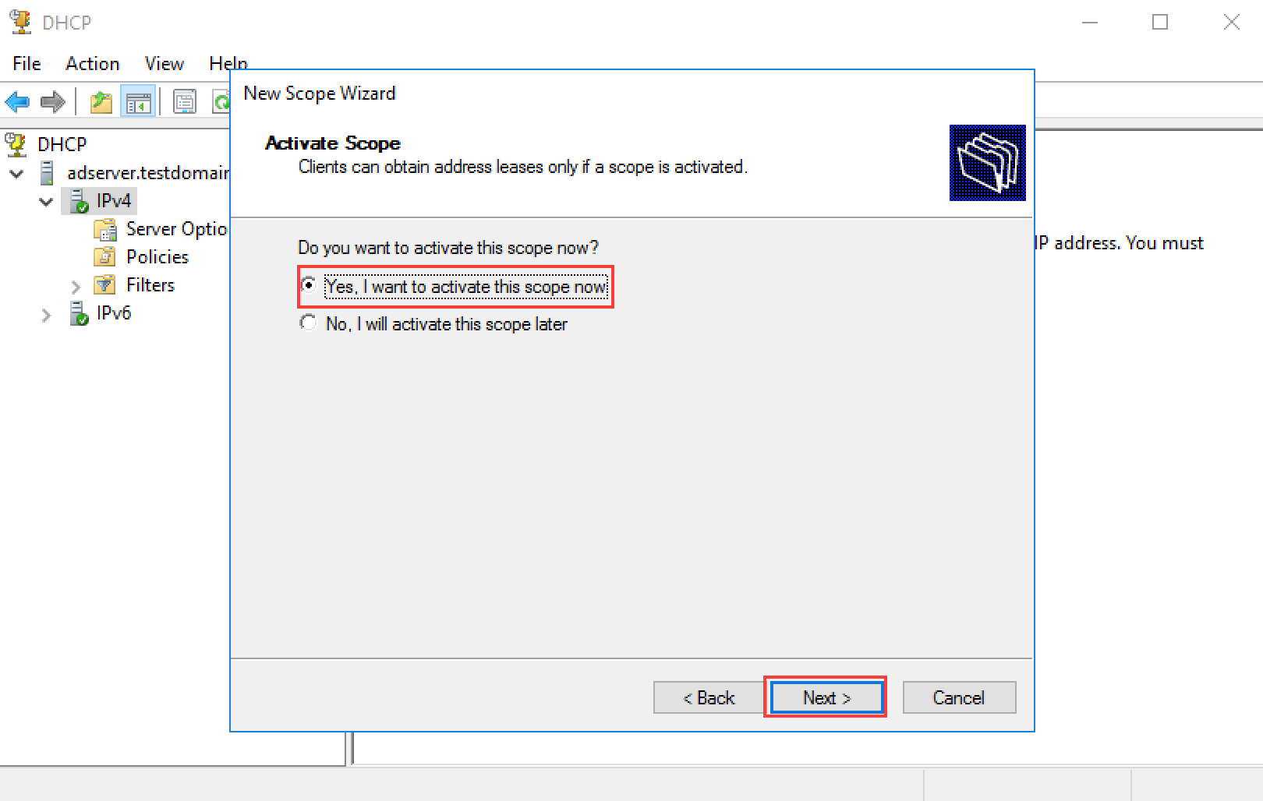](https://secureservercdn.net/198.71.233.195/dbd.2d9.myftpupload.com/wp-content/uploads/2016/02/Server-Basics-2016-DHCP_26.png)
* Your scope is configured and activated. [[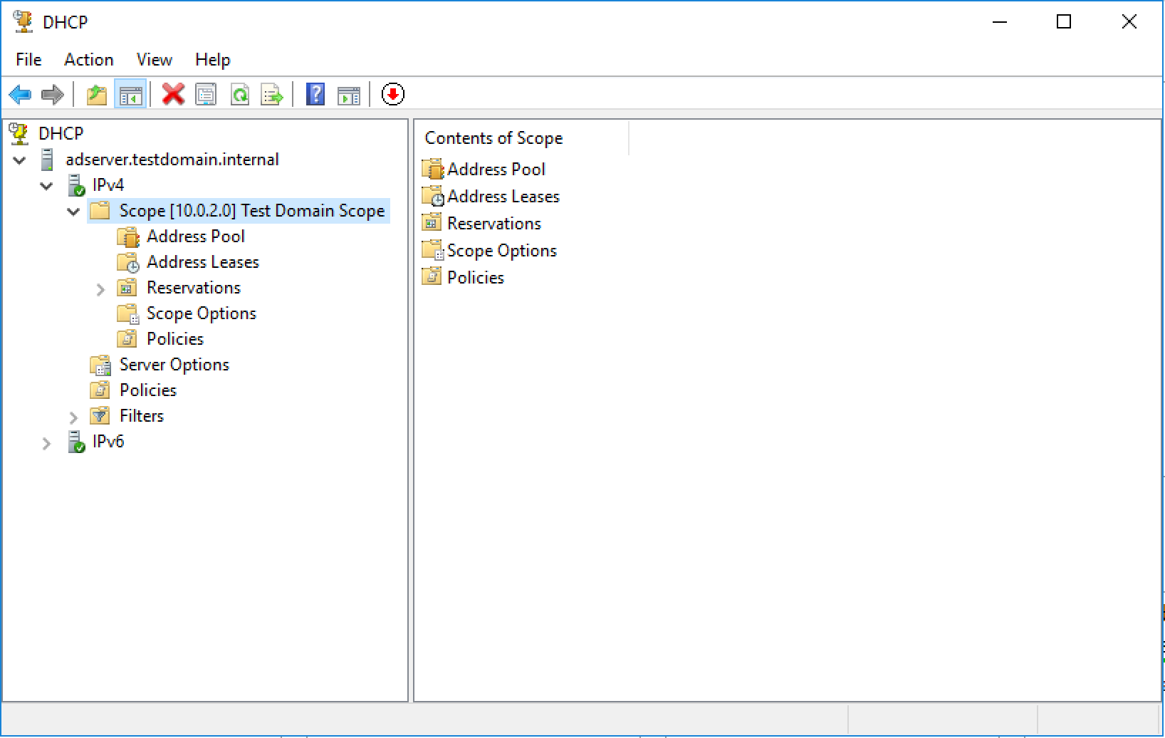](https://secureservercdn.net/198.71.233.195/dbd.2d9.myftpupload.com/wp-content/uploads/2016/02/Server-Basics-2016-DHCP_27.png)](https://secureservercdn.net/198.71.233.195/dbd.2d9.myftpupload.com/wp-content/uploads/2016/02/Server-Basics-2016-DHCP_27.png)

That’s it! DHCP is configured on your brand new server and ready to be used.