# 更新

## ？

压缩包没用？

整包输出半包输出啥时用？

大版本更新？

之前标准的流程？

## 运行流程

FirstScene🡪Patcher.cs🡪Patcher.lu🡪Hotupdate(Scene)🡪 UIPanelHotUpdateFSFirm

🡪不需要更新Hotupdate还是会通过下面流程加载…

Main.lua🡪 SDKInitFinish🡪 RunGame🡪 UI.Show("UIPanelLoadingFSFirm",Enum.UISort.Peek5);

🡪 SPLASH_FILM_DONE🡪 Hotupdate(Scene)

1.拉取MAX_VERSION.txt服务器最新版本

2.对比版本信息确认是否需要热更或者强更

3.需要版本热更的话 拉取FULL_VERSIONS.json 做进一步检查具体版本 IOS 是FULL_VERSION_IOS.json

4.下载地址会是cdn的patch目录下的android_1.8.1.zip 或者ios_1.8.1.zip

### Patcher.lua 版本一致

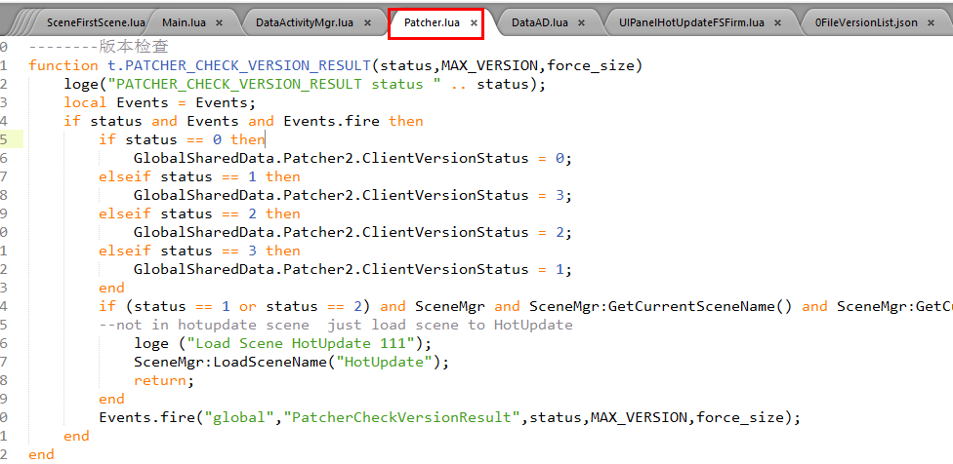

🡪



🡺

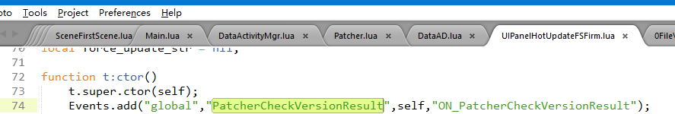

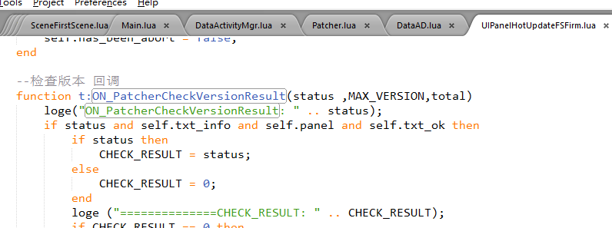

🡺校验

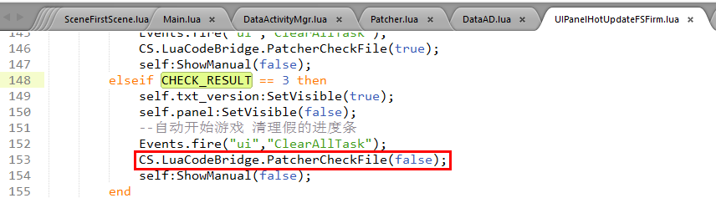

### 热更

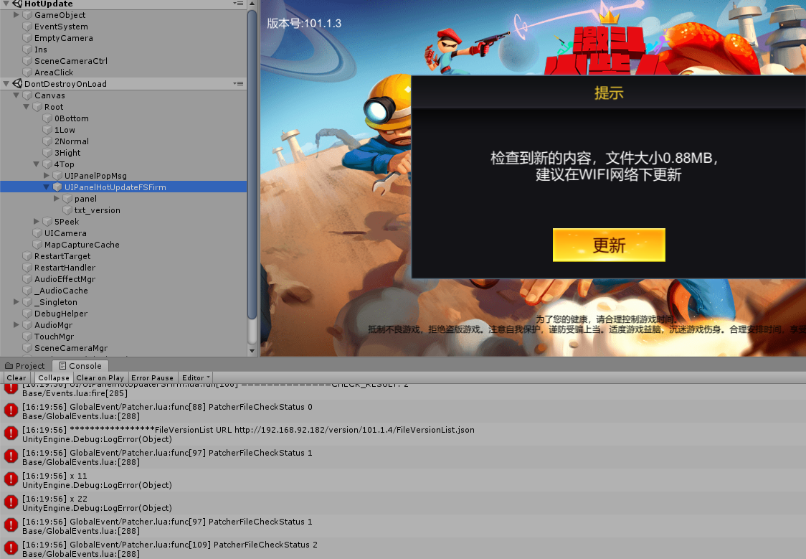

开始更新：

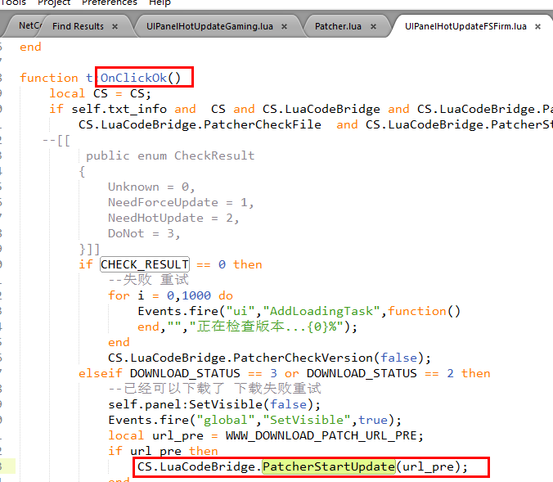



### 检查 版本目录 是否需要清理掉

Patch.CheckVersionFileValidate

### UIPanelHotUpdateFSFirm

### FirstScene

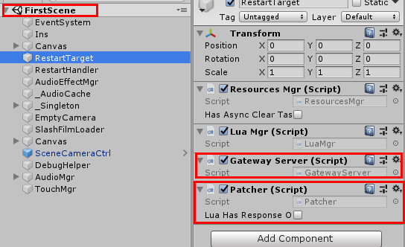

## 打包流程

### 版本流程

#### 补丁工具/---1---BuildPatch_Android Step1 build AssetBundle

TryDeleteDir("AssetBundles");

//SetupABNames();

_InnerBuildAllBundle(BuildTarget.Android);

CopyDir("AssetBundles", "VersionFiles/AssetBundles/Android/AssetBundles");

Ref完整输出AB包

_InnerBuildAllBundle(EditorUserBuildSettings.activeBuildTarget);

===============================================================================

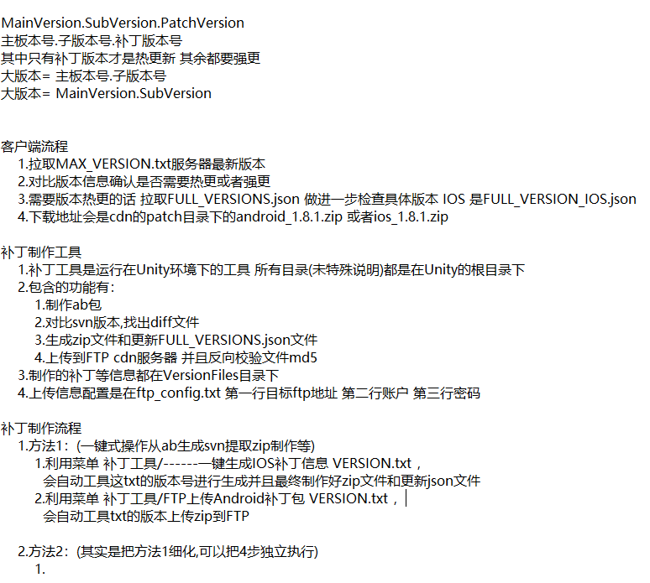

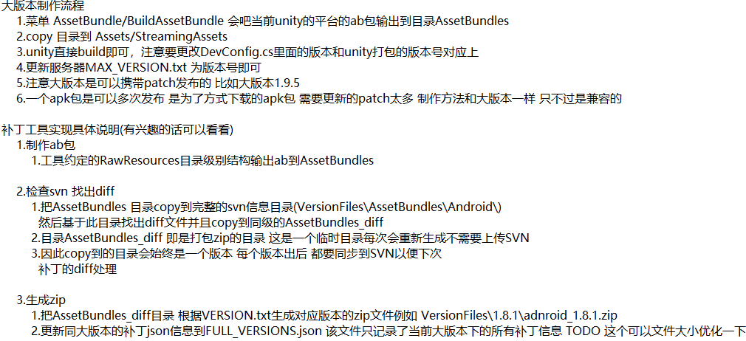

## 文件OR菜单说明

### FFULL_VERSIONS.json

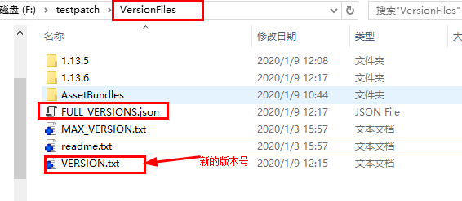





### VersionFiles/VERSION.txt

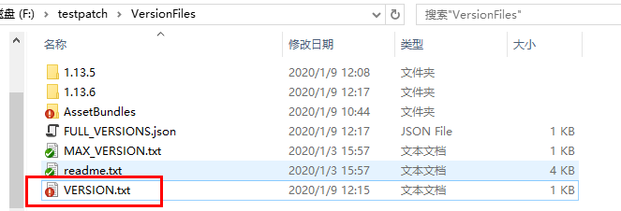

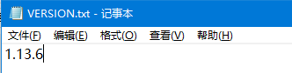

### MAX_VERSION.json

服务器上的版本号文件

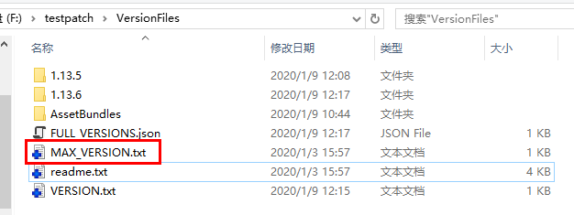

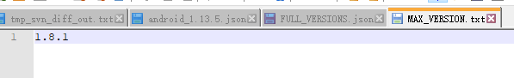

### tmp_svn_diff_out

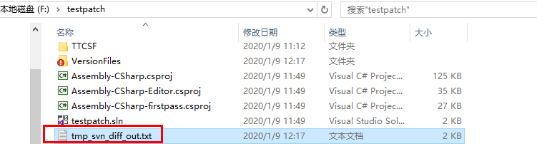

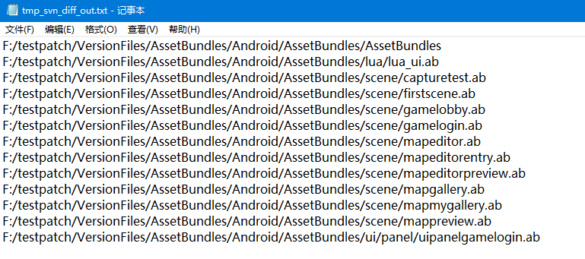

### ftp_config.txt (要自己建)

上传信息配置是在ftp_config.txt 第一行目标ftp地址 第二行账户 第三行密码

### VersionListCache.json

缓存的列表？

会把最新版本的FileVersionList下载下来放在文件VersionListCache.json里

### UIPanelHotUpdateFSFirm

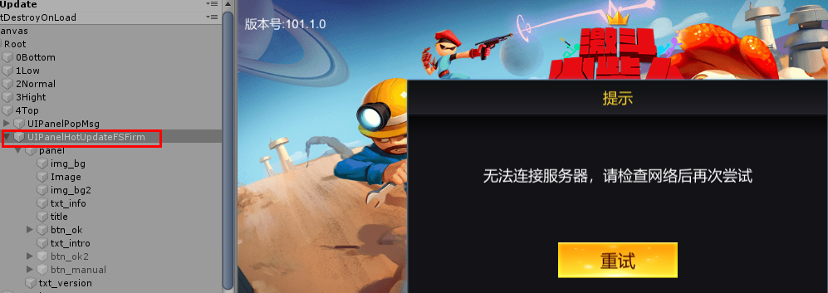

### 补丁工具/FTP Upload

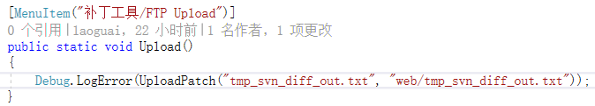

上传SVN差异文件

### 补丁工具/FTP上传Android补丁包 VERSION.txt

以VERSION.txt内容为1.13.6为例:

上传VersionFiles/1.13.6/android_1.13.6.zip 🡪到远程的 patch/android_1.13.6.zip位置

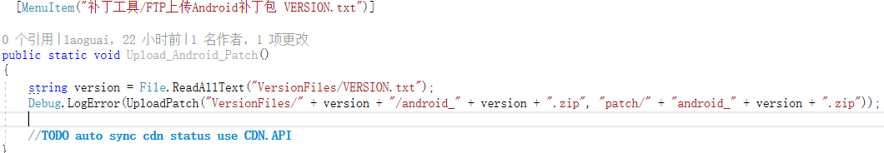

### 补丁工具/FTP上传IOS补丁包 VERSION.txt

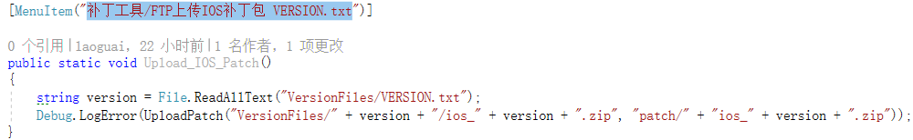

同上传Android补丁包，把android_ 换成ios_

### 补丁工具新（注释？）



生成全部AB包的校验码文件(在根目录),输出FileVersionList，放在Web服务器上，客户单动态去下载放在本地缓存文件VersionListCache：

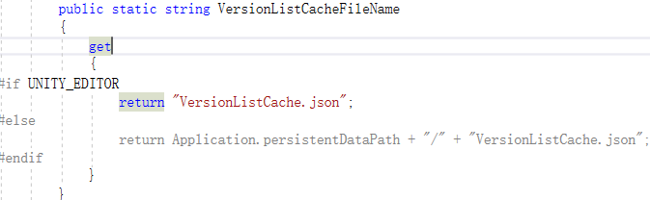



*****生成几个核心AB包验码文件(在resources目录)、并确保StreamAssets目录下有相应的核心文件。

核心文件标志:

file.Contains("/lua/lua")

file.Contains("AssetBundles/AssetBundles")

file.Contains("fsfirm")

file.Contains("/engine/")



生成全部AB包校验码文件(在resources目录)、并把根目录下的AssetBundle目录拷贝到StreamAssets目录？



就是整包排除 skin 和 weapons剩下的ab包生成校验文件并把相应的ab拷贝到

StreamingAssets目录

## 现有流程弊端

步骤多

版本号要手动填

手动SVN处理

# 工具

StickNote

VNote

# Jenkins

## HCR Android Jenkins

Jenkins.war

## HCR_IOS_TRUNK

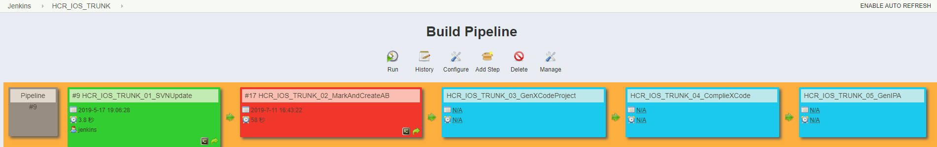

### HCR_IOS_TRUNK_01_SVNUpdate

#!/bin/bash

cd /Users/Shared/Jenkins/hcr/trunk/GiantIOS/Assets/RawResources

svn revert -R ./

cd /Users/Shared/Jenkins/hcr/trunk/GiantIOS

svn up

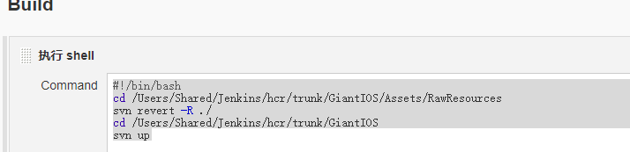

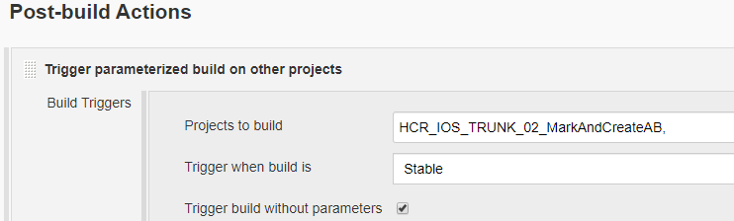

### HCR_IOS_TRUNK_02_MarkAndCreateAB

-projectPath /Users/Shared/Jenkins/hcr/trunk/GiantIOS -quit -batchmode -executeMethod EditorBuild.BuildAssetBundle._BuildAssetBundle

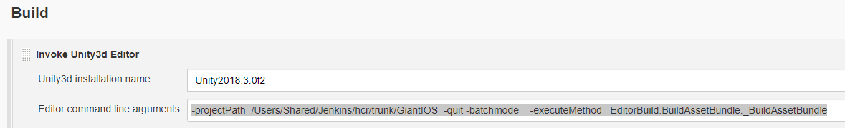

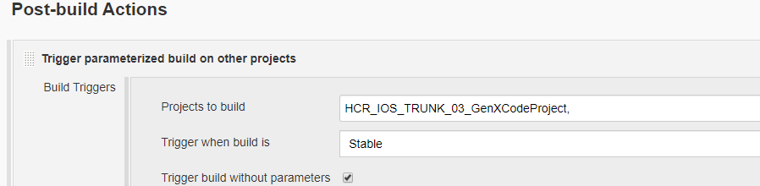

### HCR_IOS_TRUNK_03_GenXCodeProject

-projectPath /Users/Shared/Jenkins/hcr/trunk/GiantIOS -quit -batchmode -executeMethod EditorBuild.RuntimeMaker.OnGenXCodeProject

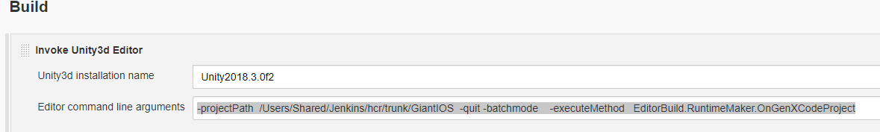

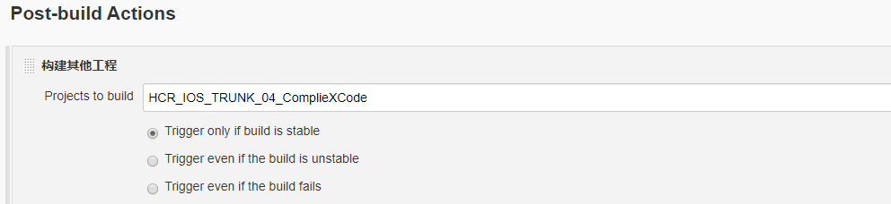

### HCR_IOS_TRUNK_04_ComplieXCode

security unlock-keychain -p "123456@a" "/Users/Shared/Jenkins/Library/Keychains/login.keychain"

#!/bin/bash

projPath=/Users/Shared/Jenkins/hcr/trunk/GiantIOS/proj_ios

xcodebuild -project $projPath/Unity-iPhone.xcodeproj archive -scheme Unity-iPhone -destination generic/platform=iOS PROVISIONING_PROFILE_SPECIFIER=ztzsnewDIS-ALLTOONE CODE_SIGN_IDENTITY="iPhone Distribution: Shanghai Giant Network Technology Co., Ltd." -archivePath $projPath/Unity-iPhone.xcarchive

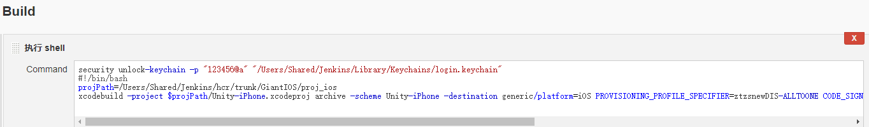

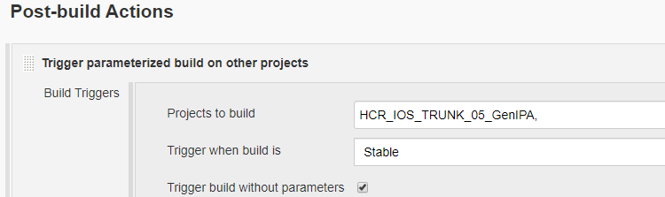

### HCR_IOS_TRUNK_05_GenIPA

#!/bin/bash

projPath=/Users/Shared/Jenkins/hcr/trunk/GiantIOS/proj_ios

xcodebuild -exportArchive -archivePath $projPath/Unity-iPhone.xcarchive -exportPath $projPath/out -exportOptionsPlist $projPath/../build.plist

cp $projPath/out/Unity-iPhone.ipa /Library/WebServer/Documents/jdhcr/ios/jdhcr-$(date +%m%d%H%M%y).ipa

mv $projPath/out/Unity-iPhone.ipa /Library/WebServer/Documents/jdhcr/ios/jdhcr2019.ipa

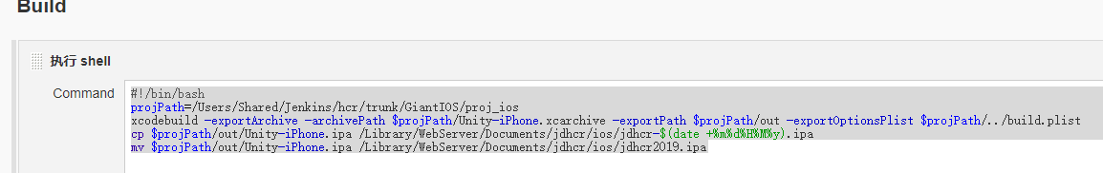

## ios_branch_18.6.0

### ios_branche_01_svnupdate

#!/bin/bash

cd /Users/Shared/Jenkins/hcr/branch/branche_ios_18.6.0/Assets/RawResources

svn revert -R ./

cd /Users/Shared/Jenkins/hcr/branch/branche_ios_18.6.0

svn up

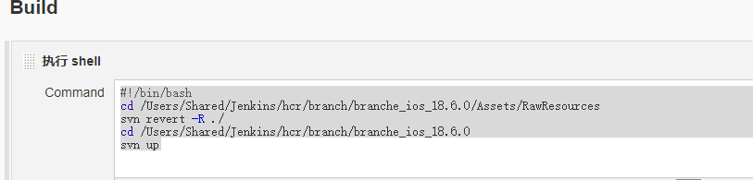

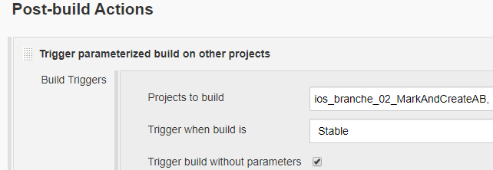

### ios_branche_02_MarkAndCreateAB

-projectPath /Users/Shared/Jenkins/hcr/branch/branche_ios_18.6.0 -quit -batchmode -executeMethod EditorBuild.BuildAssetBundle._BuildAssetBundle

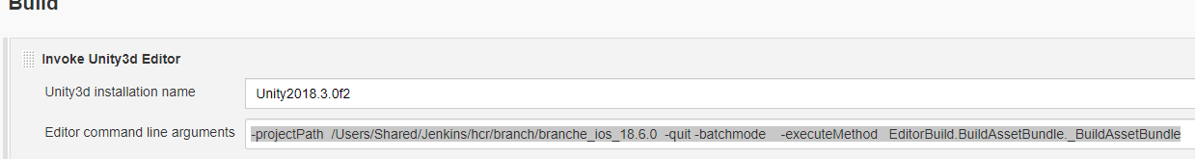

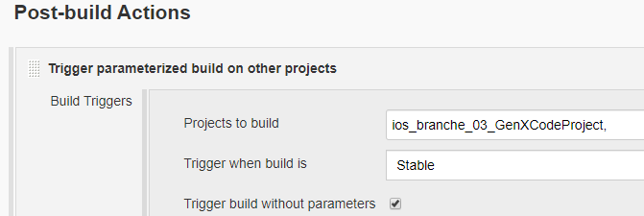

### ios_branche_03_GenXCodeProject

-projectPath /Users/Shared/Jenkins/hcr/branch/branche_ios_18.6.0 -quit -batchmode -executeMethod EditorBuild.RuntimeMaker.OnGenXCodeProjectAppstore

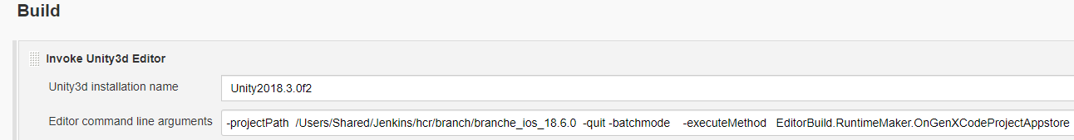

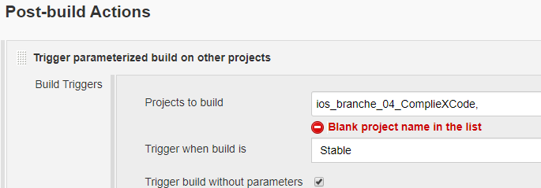

### ios_branche_04_ComplieXCode

security unlock-keychain -p "123456@a" "/Users/Shared/Jenkins/Library/Keychains/login.keychain"

#!/bin/bash

projPath=/Users/Shared/Jenkins/hcr/branch/branche_ios_18.6.0/proj_ios

#xcodebuild -project $projPath/Unity-iPhone.xcodeproj archive -scheme Unity-iPhone -configuration Release -destination generic/platform=iOS PROVISIONING_PROFILE_SPECIFIER=jdhcrDIS CODE_SIGN_IDENTITY="iPhone Distribution: Shanghai Zhengju Information Technology Co., Ltd. (TG93K6XG5H)" -archivePath $projPath/Unity-iPhone.xcarchive

xcodebuild -project $projPath/Unity-iPhone.xcodeproj archive -scheme Unity-iPhone -configuration Release -destination generic/platform=iOS PROVISIONING_PROFILE_SPECIFIER=jdhcrDEV CODE_SIGN_IDENTITY="iPhone Developer: junjie zhang (N86KABWGCZ)" -archivePath $projPath/Unity-iPhone.xcarchive



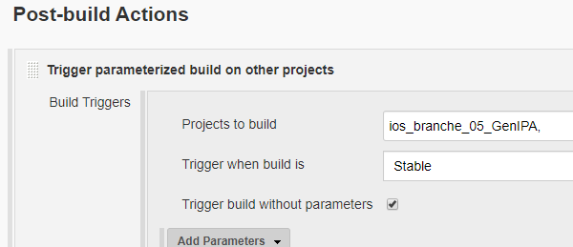

### ios_branche_05_GenIPA

#!/bin/bash

projPath=/Users/Shared/Jenkins/hcr/branch/branche_ios_18.6.0/proj_ios

xcodebuild -exportArchive -archivePath $projPath/Unity-iPhone.xcarchive -exportPath $projPath/out -exportOptionsPlist $projPath/../appstoreDev.plist

cp $projPath/out/Unity-iPhone.ipa /Library/WebServer/Documents/jdhcr/ios/jdhcr-dev-$(date +%m%d%H%M%y).ipa

mv $projPath/out/Unity-iPhone.ipa /Library/WebServer/Documents/jdhcr/ios/jdhcr-dev-2019.ipa

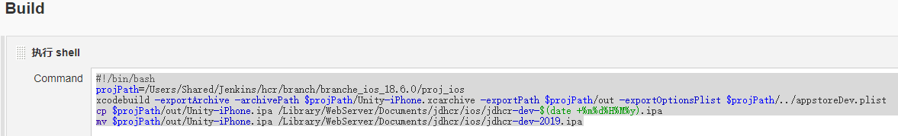

## ios_tmp_dis

### ios_branche_04_CompileXCode_Appstore-dis

security unlock-keychain -p "123456@a" "/Users/Shared/Jenkins/Library/Keychains/login.keychain"

#!/bin/bash

projPath=/Users/Shared/Jenkins/hcr/branch/branche_ios_18.6.0/proj_ios

#disappstoreprofile

#xcodebuild -project $projPath/Unity-iPhone.xcodeproj archive -scheme Unity-iPhone -configuration Release -destination generic/platform=iOS PROVISIONING_PROFILE_SPECIFIER=jdhcrDIS CODE_SIGN_IDENTITY="iPhone Distribution: Shanghai Zhengju Information Technology Co., Ltd. (TG93K6XG5H)" -archivePath $projPath/Unity-iPhone.xcarchive

#devprofile

#xcodebuild -project $projPath/Unity-iPhone.xcodeproj archive -scheme Unity-iPhone -configuration Release -destination generic/platform=iOS PROVISIONING_PROFILE_SPECIFIER=jdhcrDEV CODE_SIGN_IDENTITY="iPhone Developer: junjie zhang (N86KABWGCZ)" -archivePath $projPath/Unity-iPhone.xcarchive

#ad-hoc profile

projPath=/Users/Shared/Jenkins/hcr/branch/branche_ios_18.6.0/proj_ios

xcodebuild -project $projPath/Unity-iPhone.xcodeproj archive -scheme Unity-iPhone -configuration Release -destination generic/platform=iOS PROVISIONING_PROFILE_SPECIFIER=jdhcrADHOCdis CODE_SIGN_IDENTITY="iPhone Distribution: Shanghai Zhengju Information Technology Co., Ltd. (TG93K6XG5H)" -archivePath $projPath/Unity-iPhone.xcarchive

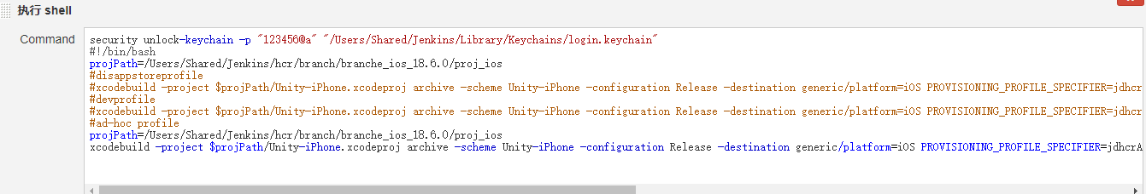

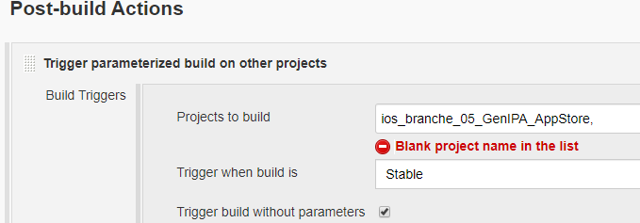

### ios_branche_05_GenIPA_AppStore

#!/bin/bash

projPath=/Users/Shared/Jenkins/hcr/branch/branche_ios_18.6.0/proj_ios

xcodebuild -exportArchive -archivePath $projPath/Unity-iPhone.xcarchive -exportPath $projPath/out -exportOptionsPlist $projPath/../appstoreAdHoc.plist

cp $projPath/out/Unity-iPhone.ipa /Library/WebServer/Documents/jdhcr/ios/jdhcr-dis-$(date +%m%d%H%M%y).ipa

mv $projPath/out/Unity-iPhone.ipa /Library/WebServer/Documents/jdhcr/ios/jdhcr-dis-2019.ipa

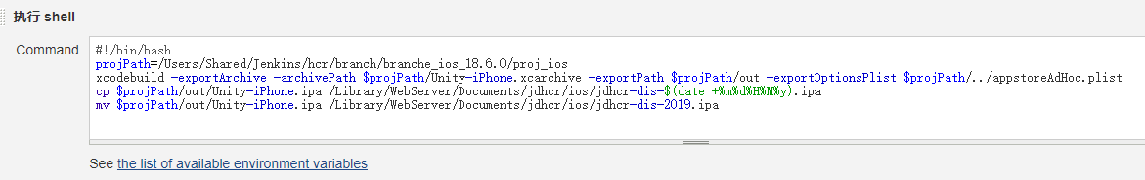

## zttest(all green)

### ztapp_ios_002_complie

security unlock-keychain -p "123456@a" "/Users/Shared/Jenkins/Library/Keychains/login.keychain"

#!/bin/bash

projPath=/Users/Shared/Jenkins/zt/FirClient/branches_jack/branche_reborn

xcodebuild -project $projPath/ztgj/proj.ios_mac/ztgj.xcodeproj archive -scheme ztgjpublish -destination generic/platform=iOS PROVISIONING_PROFILE_SPECIFIER=ztzsnewDIS-ALLTOONE CODE_SIGN_IDENTITY="iPhone Distribution: Shanghai Giant Network Technology Co., Ltd." -archivePath $projPath/Ztgj-iPhone.xcarchive

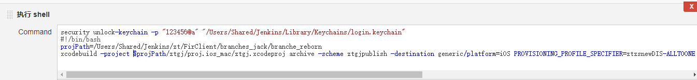

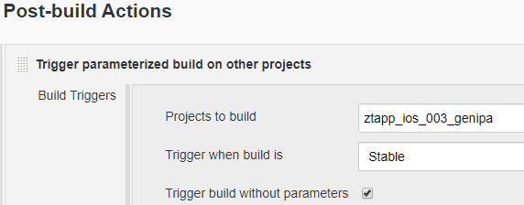

### ztapp_ios_003_genipa

#!/bin/bash

projPath=/Users/Shared/Jenkins/zt/FirClient/branches_jack/branche_reborn

xcodebuild -exportArchive -archivePath $projPath/Ztgj-iPhone.xcarchive -exportPath $projPath/dist -exportOptionsPlist $projPath/exportinfo.plist



# Macpro

# 地编

组合（搭积木）

## 属性编辑

### 类型定义

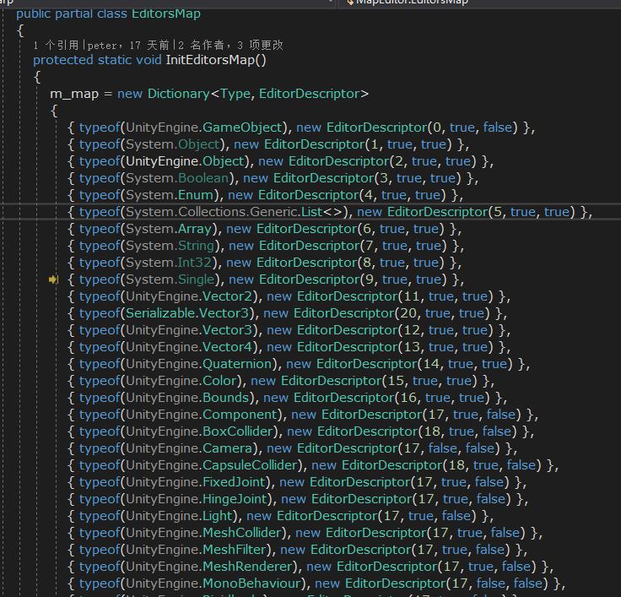

### 编辑原型：

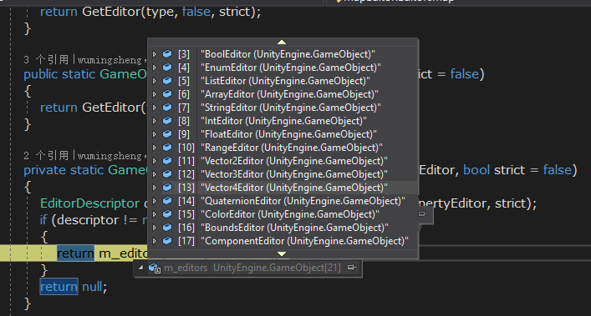

Resource下的MapEditorsMap保存了所有编辑原型

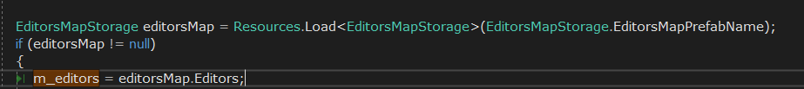

**ComponentEditor**

**//editor:根据模板新创建出的UI, ComponentsPanel:是gameObjectEditor下的专门用来挂组件UI的**

**editor**.transform.SetParent(ComponentsPanel, false);

**editor**.Component = component;

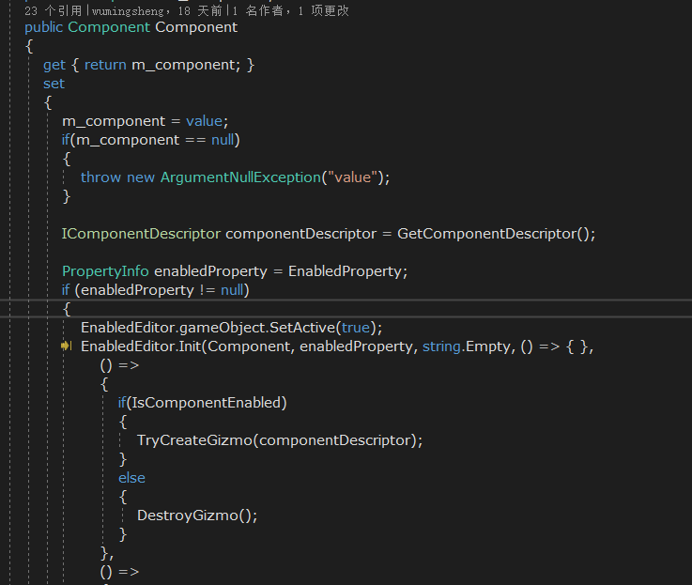

### 组件描述

# Reflection

## 获取属性：

PropertyInfo prop = type.GetProperty("enabled", BindingFlags.Public | BindingFlags.DeclaredOnly | BindingFlags.Instance);

## 属性的类型：

prop.**PropertyType**

## 取得类型的名字：

Component.GetType().Name;

## 取得所有属性

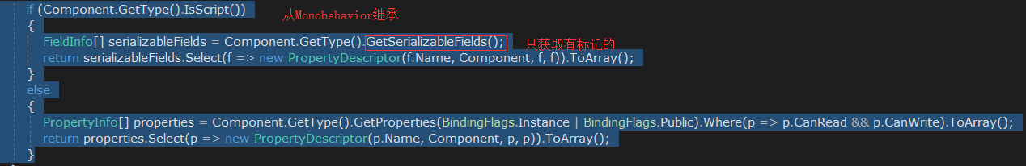

## 判断子类：

type.IsSubclassOf(typeof(MonoBehaviour));

## 判断是PropertyInfo还是FieldInfo

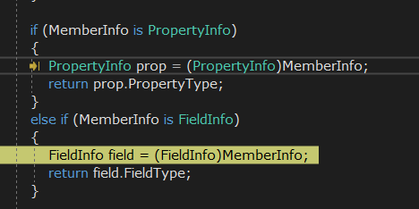

## 根据类型取得所有可以序列号的字段

FieldInfo[] serializableFields = Reflection.**GetSerializableFields**(memberInfo.GetType());

## 根据filed取value

com:实体

field.GetValue(com)

## XXXX

**fi.GetType()**

**和**

**fi.FieldType**

**是两回事**