# 1

## c#-->cpp

### c#:

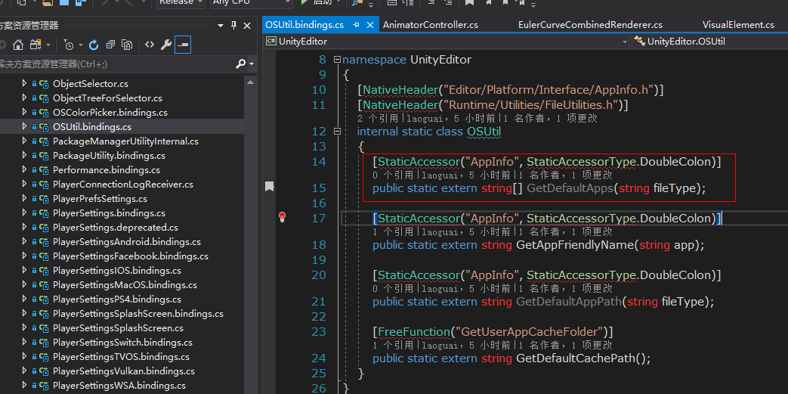

### C++

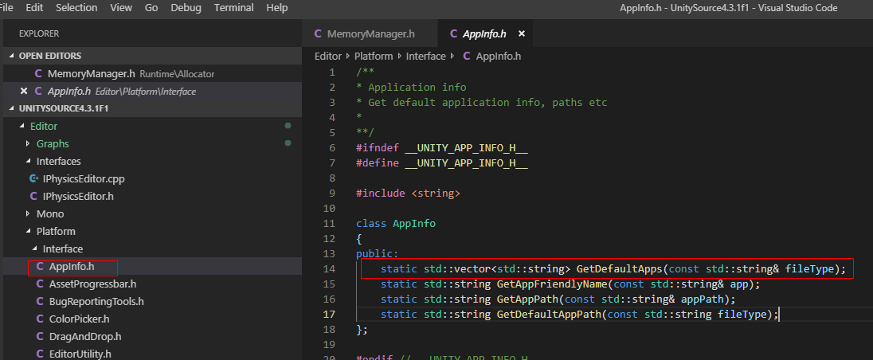

### dd

## cpp用的宏

UNITY_WIN

UNITY_OSX

UNITY_LINUX

__OBJC__(object c?)

## Avatar

# 功能

## 暑假乐翻天

广告位开关：

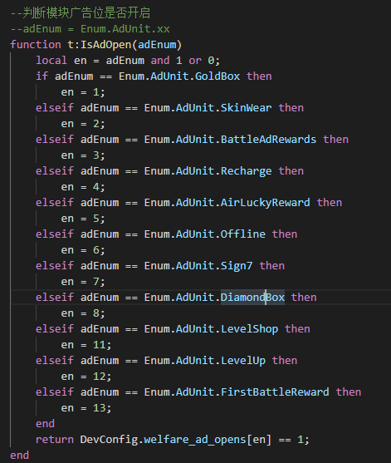

HappyBox_Close

HappyBox_Open

DataMgr.DataPlayerBaseInfo:__Inner_SetCarnivalCoin(tonumber(data.carnival_skin));

Events.fire("data","SyncPlayerBaseInfoCarnivalCoin",self.pb.carnivalcoin);

Events.fire("data","SyncPlayerBaseInfoCarnivalCoinGen",self.pb.carnival_coin_gen);

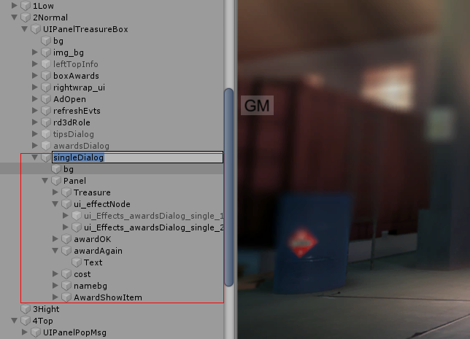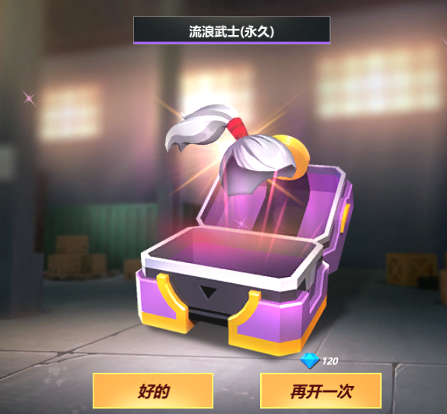

## 抽奖

UIPanelWelfareLottery

UIPanelLotteryGift

UIPanelADBattleOver



## 活动动态

package.loaded[‘test.lua’] = nil

required(‘test.lua’)

--执行一段Lua代码

function t.EvalLuaScript(param ,cb)

if param then

CS.LuaCodeBridge.EvalLuaScript(param);

end

end

## WebView

# 发布

## AdHoc

<https://www.jianshu.com/p/9d525971e10e>

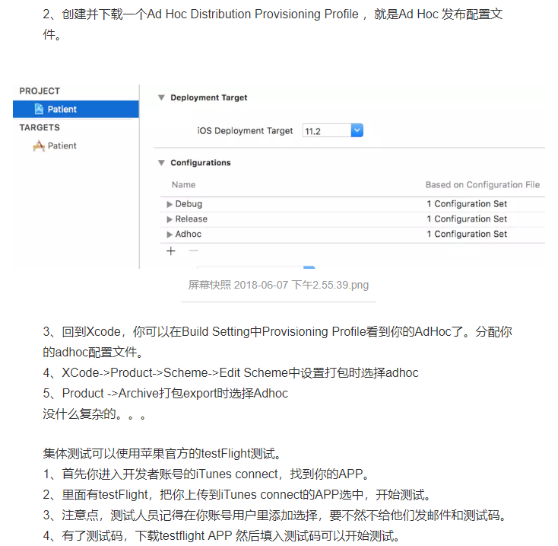

Suggestion: use a compatible library with a minSdk of at most 16,

or increase this project's minSdk version to at least 21,

or use tools:overrideLibrary="com.onevcat.uniwebview" to force usage (may lead to runtime failures)

# 诡异

现拥有<color=#FF6100FF>0</color>把狂欢钥匙

## 按钮显示隐藏影响动画播放

重新隐藏再显示 再调用animatorOK， （不隐藏显示直接调用animator老不受控制）好神奇！