查看虚拟交换机

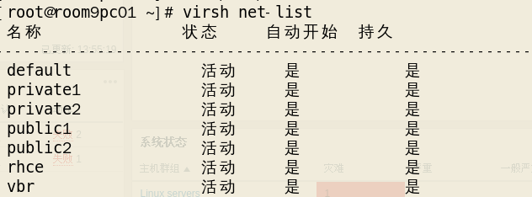

编辑虚拟交换机配置

2019-08-02 14-08-53 的屏幕截图

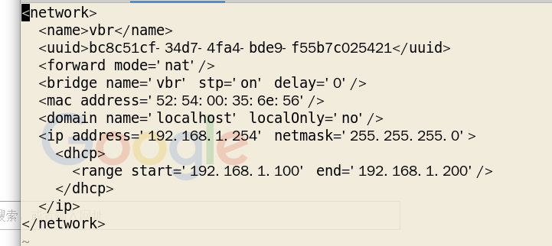

创建并查看镜像文件

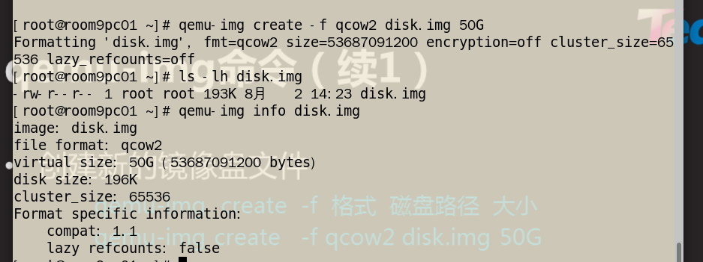

-b **使用后端模板文件**

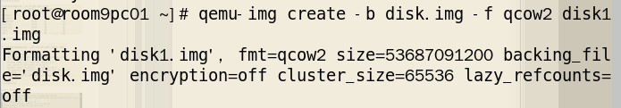

**创建虚拟机**

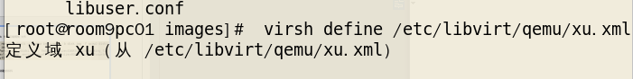

**------------------------------------------------------------------------------------------**

**扩容虚拟机磁盘(真机上操作)**

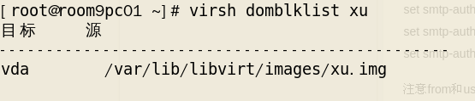

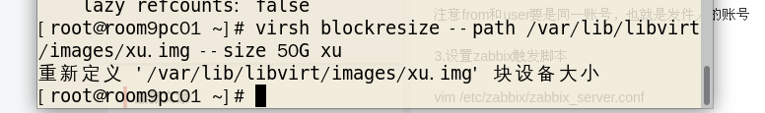

**虚拟机上 ~]# LANG=C**

**~]# growpart /dev/vda 1**

**~]# xfs_growfs /**

**------------------------------------------------------------------------------------------**

**查看虚拟机状态**

**[root@room9pc01 ~]# virsh dominfo first**

**[root@room9pc01 ~]# virsh autostart first**

**域 first标记为自动开始**

查看虚拟机网卡信息

**[root@room9pc01 ~]# virsh domiflist web44**

**接口 类型 源 型号 MAC**

**-------------------------------------------------------**

**vnet8 network private1 virtio 52:54:00:00:ac:d1**

**vnet9 network private2 virtio 52:54:00:0b:05:1b**

**vnet10 network public1 virtio 52:54:00:b5:04:64**

**vnet11 network public2 virtio 52:54:00:85:a3:6f**

**查看虚拟机硬盘信息**

**[root@room9pc01 ~]# virsh domblklist web44**

**目标 源**

**------------------------------------------------**

**vda /var/lib/libvirt/images/tedu_node10.img**

**检测chrony服务是否配置成功**

**[root@nova02 ~]# chronyc sources -v**

**.-- Source mode '^' = server, '=' = peer, '#' = local clock.**

**/ .- Source state '*' = current synced, '+' = combined , '-' = not combined,**

**| / '?' = unreachable, 'x' = time may be in error, '~' = time too variable.**

**|| .- xxxx [ yyyy ] +/- zzzz**

**|| Reachability register (octal) -. | xxxx = adjusted offset,**

**|| Log2(Polling interval) --. | | yyyy = measured offset,**

**|| \ | | zzzz = estimated error.**

**|| | | \**

**MS Name/IP address Stratum Poll Reach LastRx Last sample**

**===============================================================================**

**^* gateway 3 6 17 56 +6708ns[ +30us] +/- 12ms**

**kvm**

**qumu-kvm**

**Libvirt**

**Libvirt-daemon libvert-client libvert-daemon-driver-qemu**

# 部署openstack

nova yum -y install qemu-kvm libvirt-client libvirt-daemon libvirt-daemon-driver-qemu python-setuptools

openstack yum -y install python-setuptools

**[root@nova02 ~]# yum -y install qemu-kvm libvirt-client libvirt-daemon libvirt-daemon-driver-qemu python-setuptools**

**[root@openstack ~]# yum -y install python-setuptools**

**卸载firewall-cmd networkmanager**

**[root@openstack ~]# yum install -y openstack-packstack**

**项目的概念: 隔离的资源,对应一个组织,一个公司,一个用户**

**项目可以有多个用户**

**Openstack user set --password redhat user2(修改密码)**

**[root@openstack ~(keystone_admin)]# openstack user set --password a nsd1904**

**Systemctl restart openstack-nova-computer.service(重启nova服务)**

**[root@nova01 ~]# grep vncserver_proxyclient_address /etc/nova/nova.conf**

**# Deprecated group;name - DEFAULT;vncserver_proxyclient_address**

**#vncserver_proxyclient_address=127.0.0.1**

**vncserver_proxyclient_address=nova01**

**\*nova01 要与/etc/hosts里一致**

# DOCKER

]#man docker-search

]#docker help search

]#docker images //查看docker镜像

**]#docker save docker.io/busybox:latest -o filename.tar //备份镜像**

**]#tar -tvf filename.tar**

**]#docker load -i busybox.tar //恢复镜像**