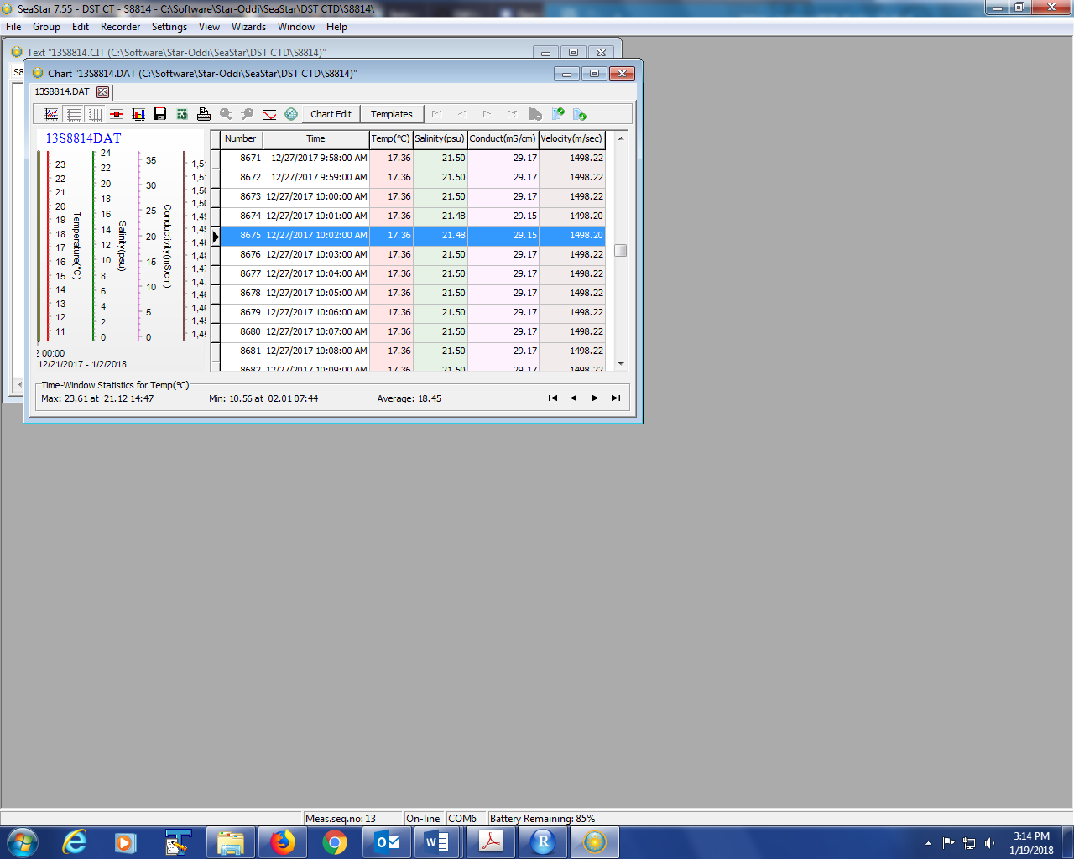

Figure 1.1- Showing how the data looks before Export.

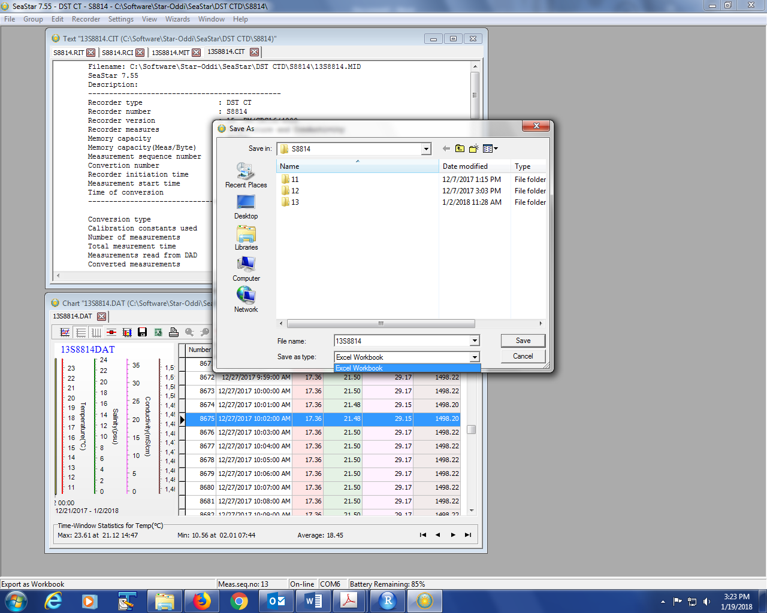

Figure 1.2- Showing that only Workbook can be selected in Export.

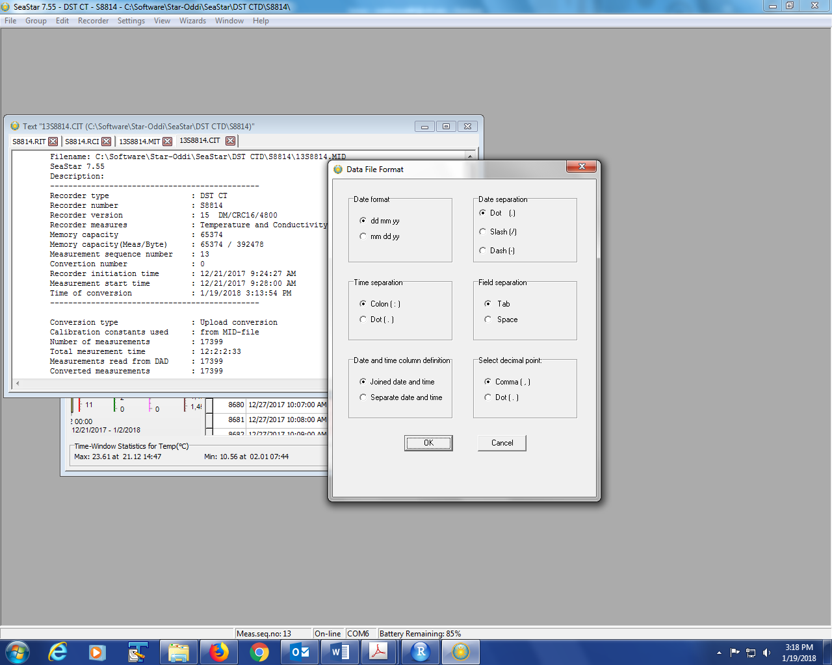

Automatic Settings for the files in SeaStar. Can be changed per download.