Koketso Baruti

student number:  18028607

FInal poe programming 2b

Contents

Requirements of running this app: 3

What is the Budget Web App? 4

How to use the Budget website 4

**1.** **Creating a new user** 4

**2.** **Adding your expenses** 6

**3.** **Adding Your Accommodation Information** 7

5. Logging in 10

**6.** **How to logout:** 12

Budget Web Application User Manual

# Requirements of running this app:

In order to run this app you will need specific software:

* Microsoft Visual studio (Preferably the latest version).
* Microsoft SQL Server Management Studio
* Any browser, preferably Chrome.

In regard to hardware you will need:

Any device that has internet connectivity and runs on either Linux or Windows

# What is the Budget Web App?

The Budget Application is a web application that is compatible with multiple operating systems including Linux. It is a development of the Windows Presentation Form version and has been created to cater to a wider demographic of users.

In order to run this app, one would need a device connected to the internet and an operating system that is either any of the latest versions of Windows e.g.(Windows 7/8/10) or any device running on a Linux operating system.

## How to use the Budget website

### **Creating a new user**

When the website first loads, you will be directed to the login page:

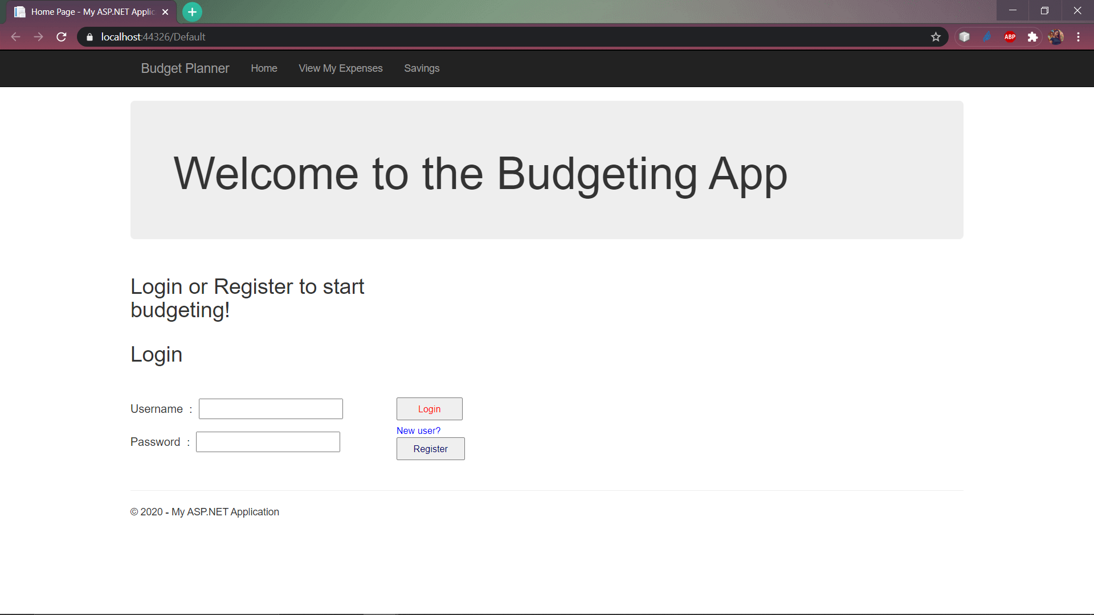

Click on the register button in order to start your registration process: 

After clicking on the ‘Register’ button, you will be led to the registration page where you are **required** to enter your details into the empty textboxes. If you do not enter all the required information, you will not be able to click on ‘Next’ in order to move onto the next stage of registration.

You are also required to enter matching passwords. If you do not enter matching passwords you will not be able to go to the next stage of registration.

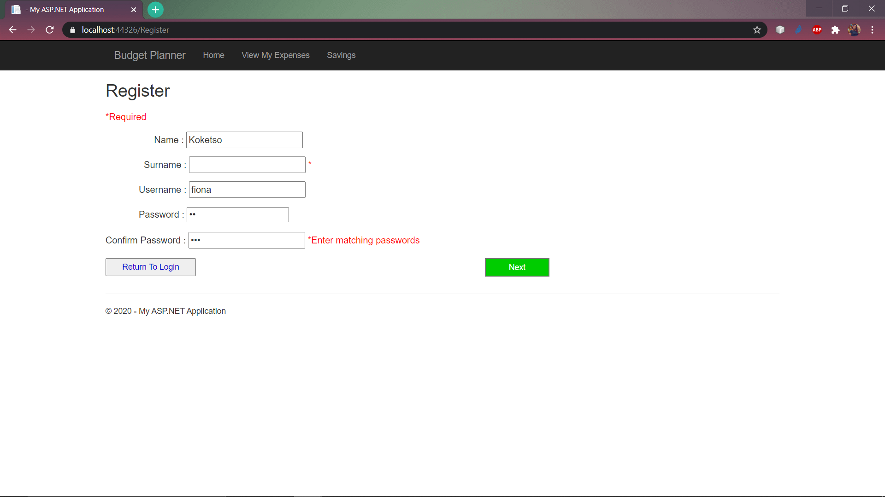

The asterisk (*) symbolizes a required field which has been left empty.

Besides that, make sure to enter a **unique username** as each user is required to have a unique username which can be used to identify them.

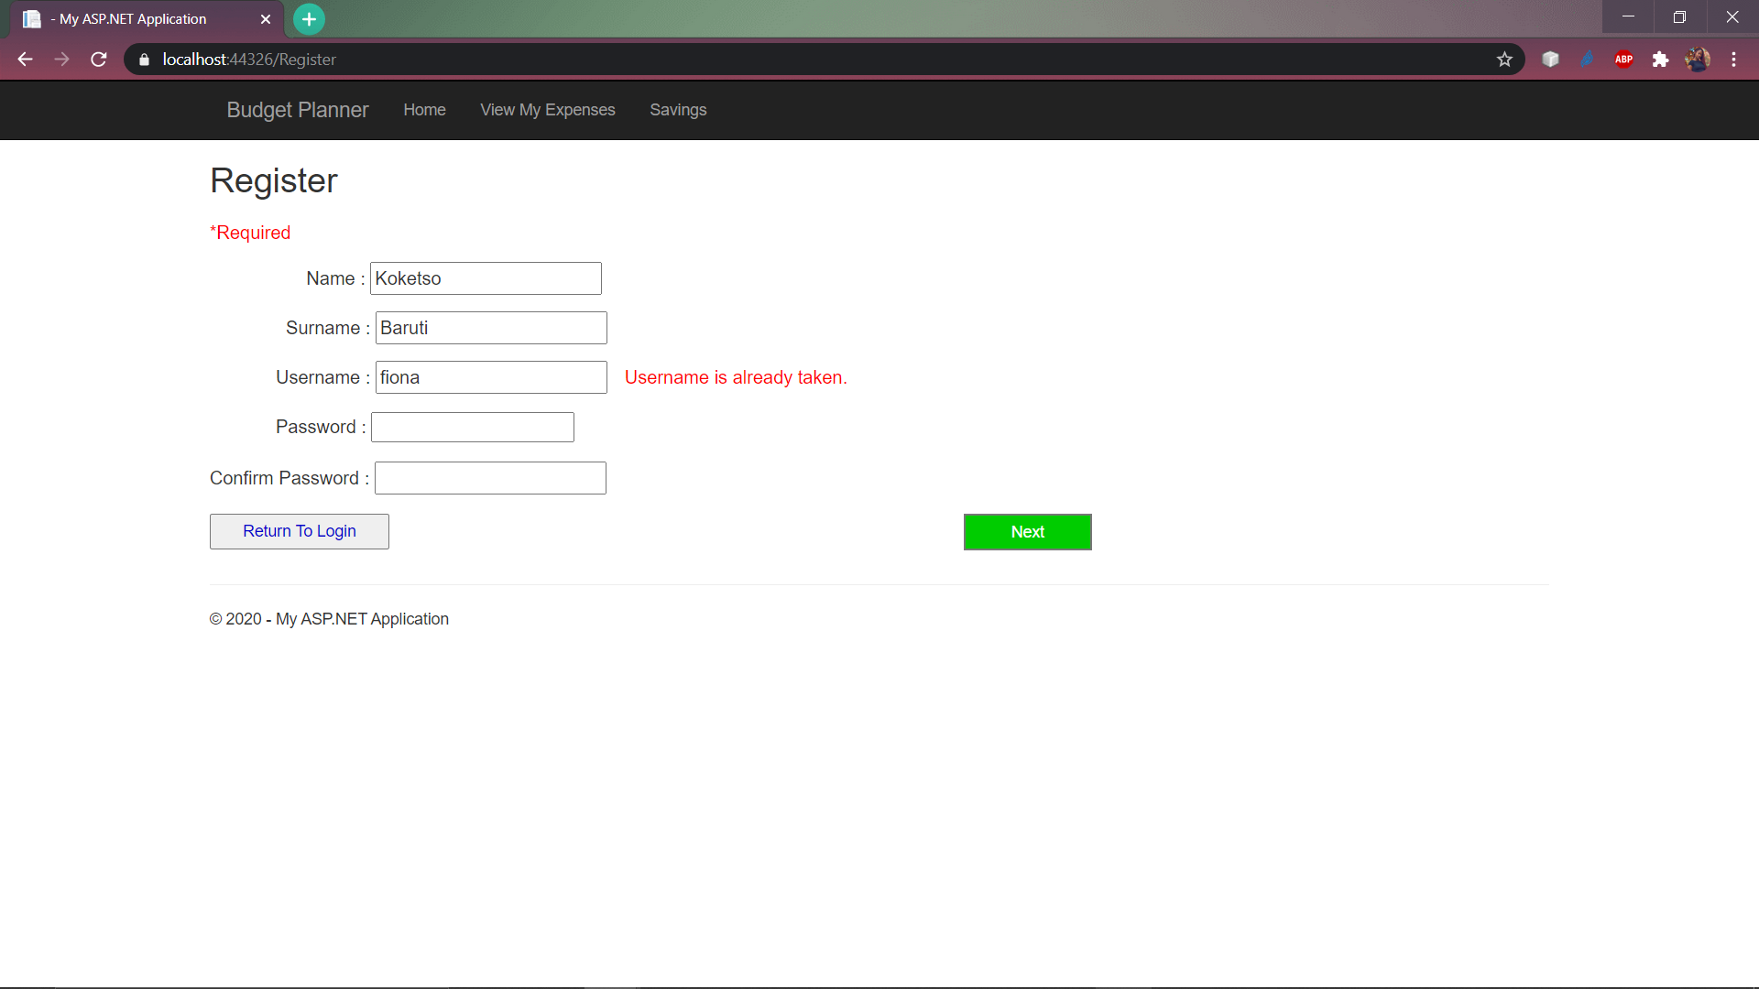

The UI displays an error message if the username is already taken.

If you have entered the correct values in their required spaces, click on ‘Next’ to move onto entering your expenses.

### **Adding your expenses**

After clicking on ‘Next’ , you are led to the ‘Expenses Details’ page where you are required to enter your income details as well as your general expenses:

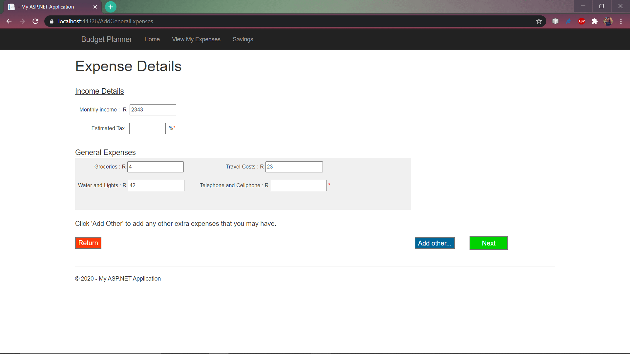

If you have any other expenses which are not listed under general expenses, click on ‘Add Other’ in order to move onto the Other Expenses page.

On the Other Expenses page, you a required to enter the expense you are adding as well as the cost of the expense in **Rands** currency**.** When you have entered the name and the cost of the expense you are adding, click on ‘Add Other Expenses’ to add it to your list of other expenses as well as save it to the database.

**Note:** Make sure your details are correct because there is no way to remove an expense once you have entered it.

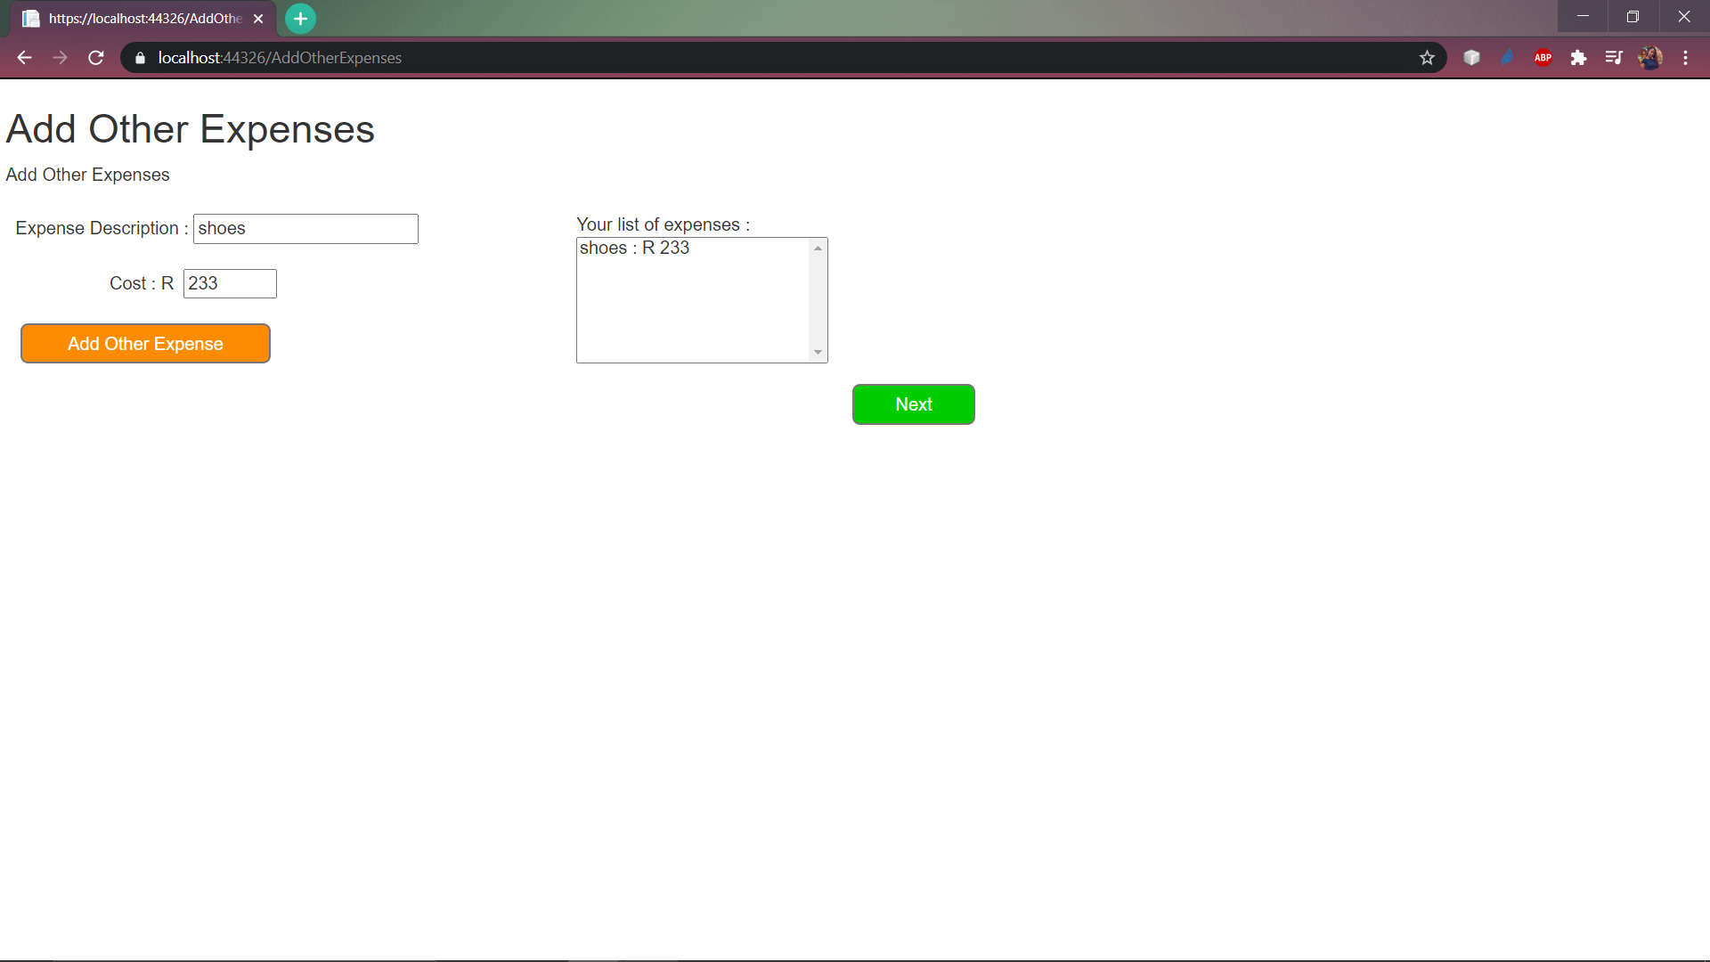

Your list of expenses is entered here when you click ‘Add Other Expenses’.

Click on ‘Next to move onto the next page.

### **Adding Your Accommodation Information**

There are only two options for accommodation. You are required to select whether you will be renting accommodation or buying a house. You can interchangeably click on ‘I want to rent’ to enter your rental information or ‘I want to buy a house’ to select the option of buying a house.

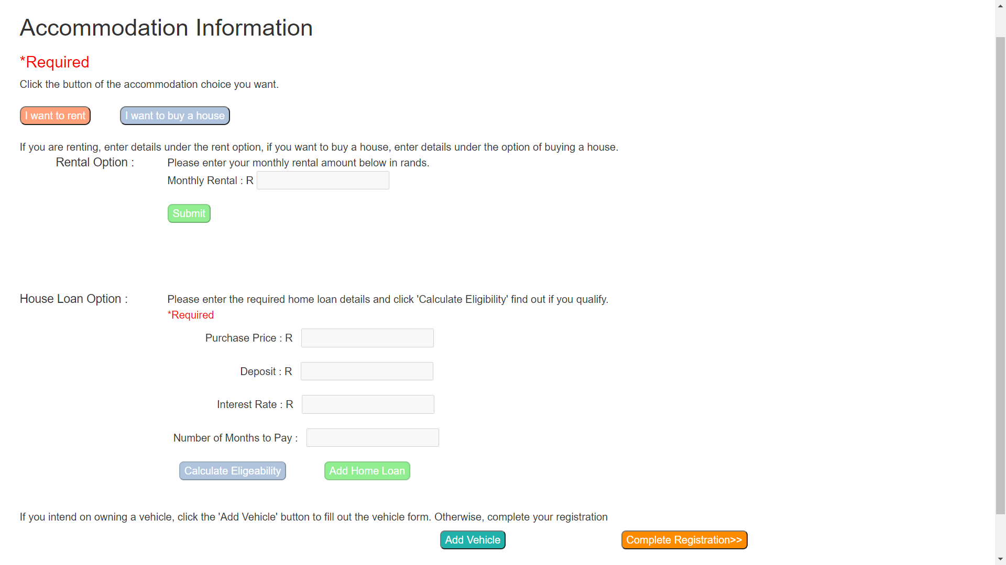

Once you have selected the rental option, enter the rental amount and click on ‘Submit’ to receive a confirmation message.

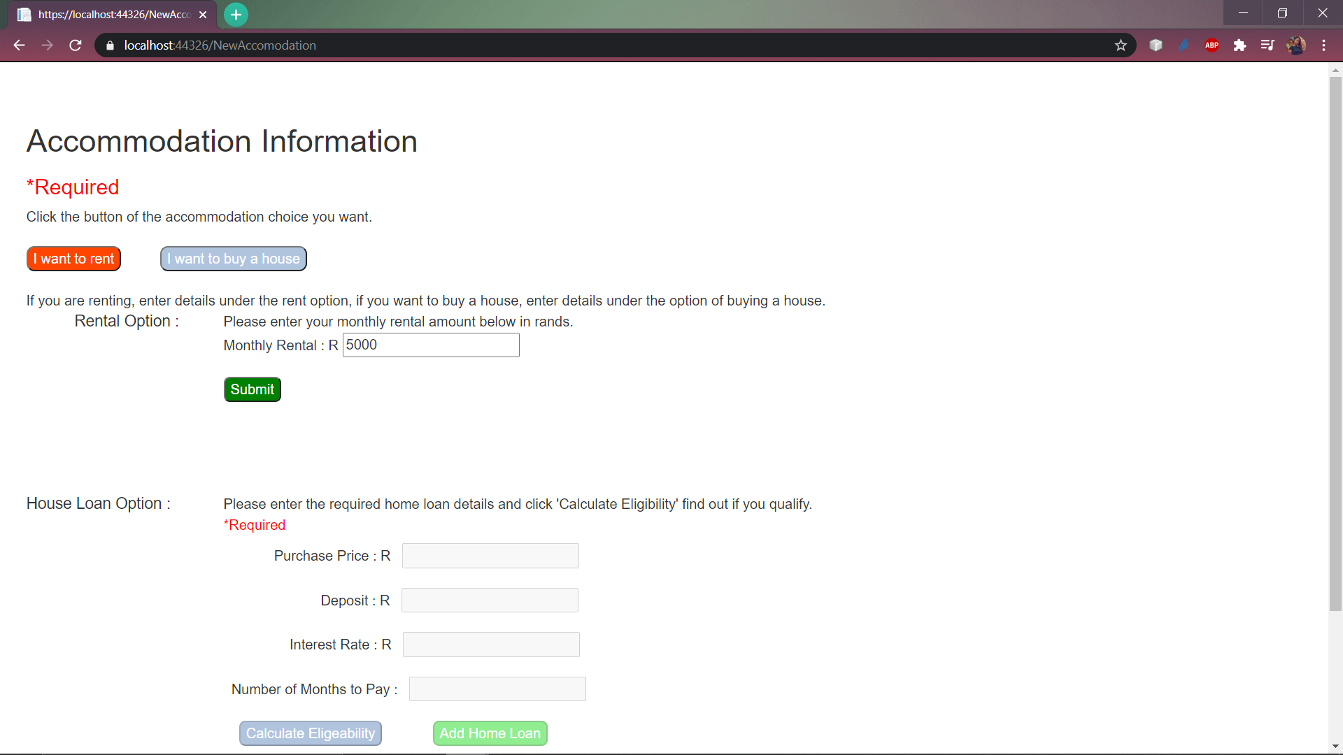

Under the House Option, you should enter all the required values and also make sure that the months to pay are between **240 and 360.** You will get an error message if your value is not within the bounds:

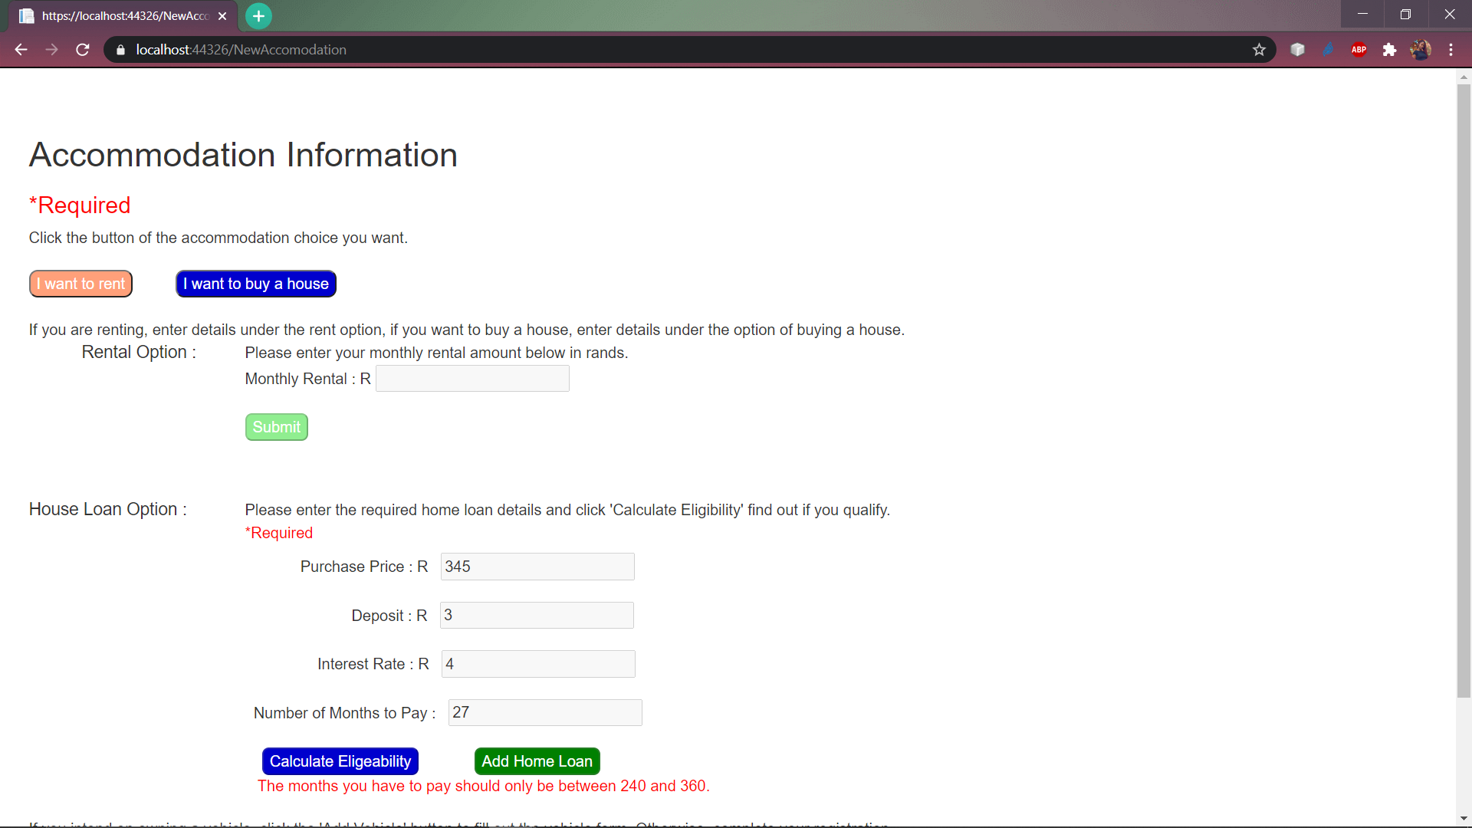 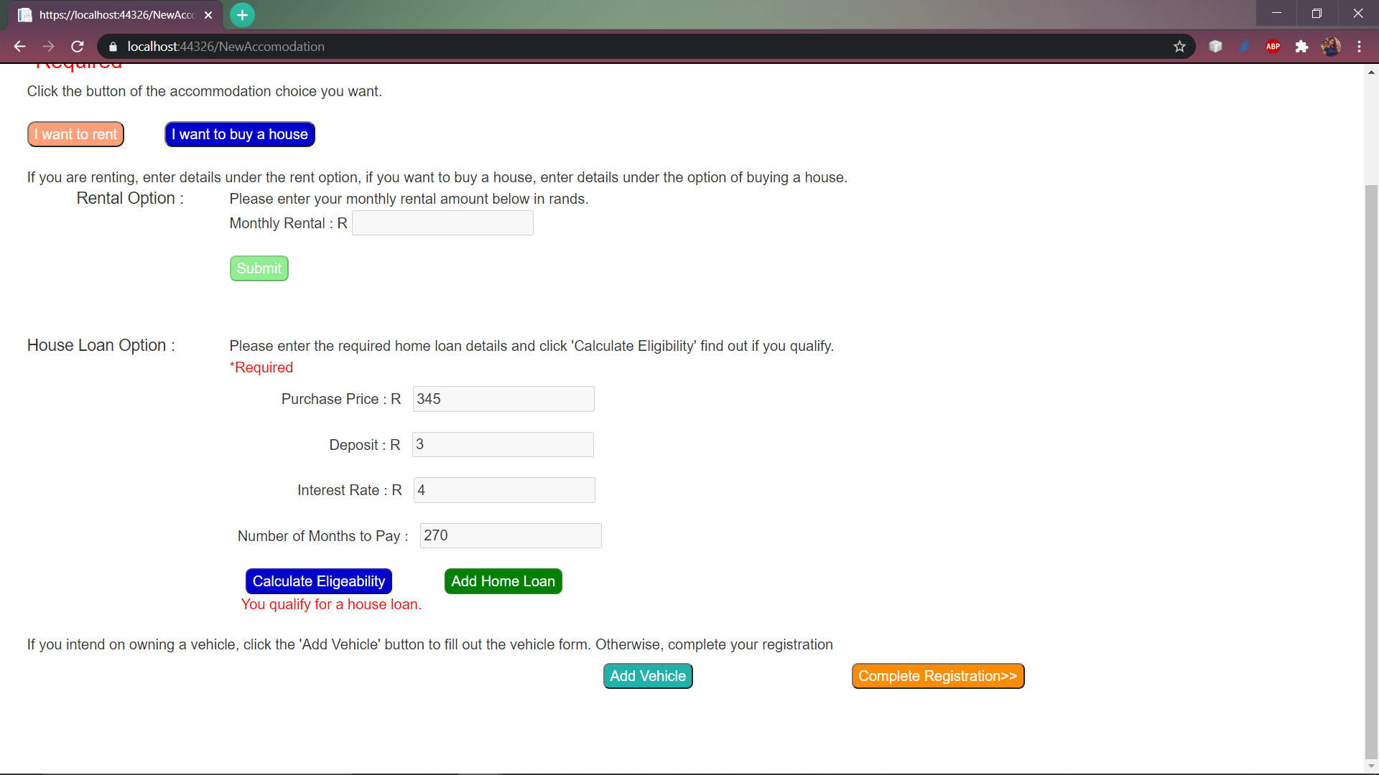

Once you are done entering either your rent or home loan details, click ono ‘Add Home Loan’ or ‘Submit’.

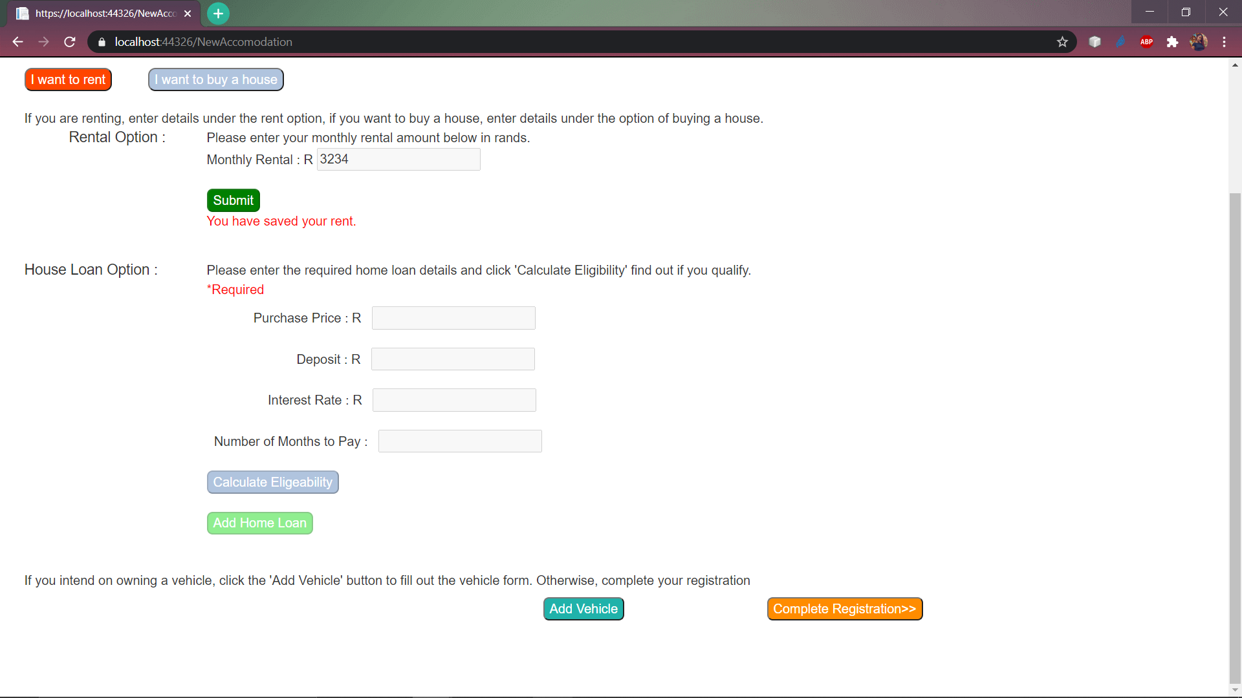

Follow the instruction:

**Note:** Once you select on ‘Complete Registration’ there is no way of adding a vehicle ot your information afterwards.



1. **Adding Your Vehicle Information(optional)**

If you have clicked on the ‘Add vehicle’ option, you will be led to the Vehicle Information page. Enter all the information required of you in the empty boxes. **Do not leave anything blank.**

If you no longer wish to add a vehicle, you can click on the ‘Complete Registration’ button. 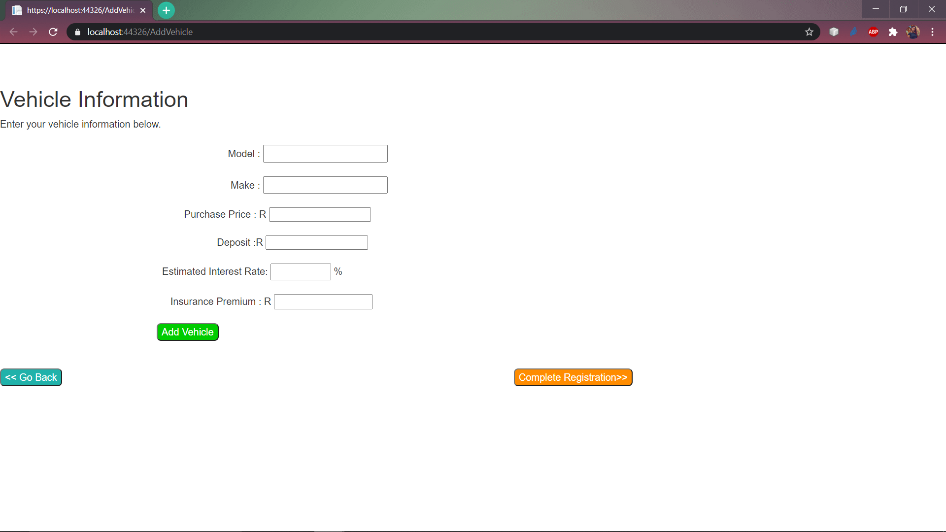

1)

Click on the ‘Add Vehicle’ button to save your vehicle information Expenses’.

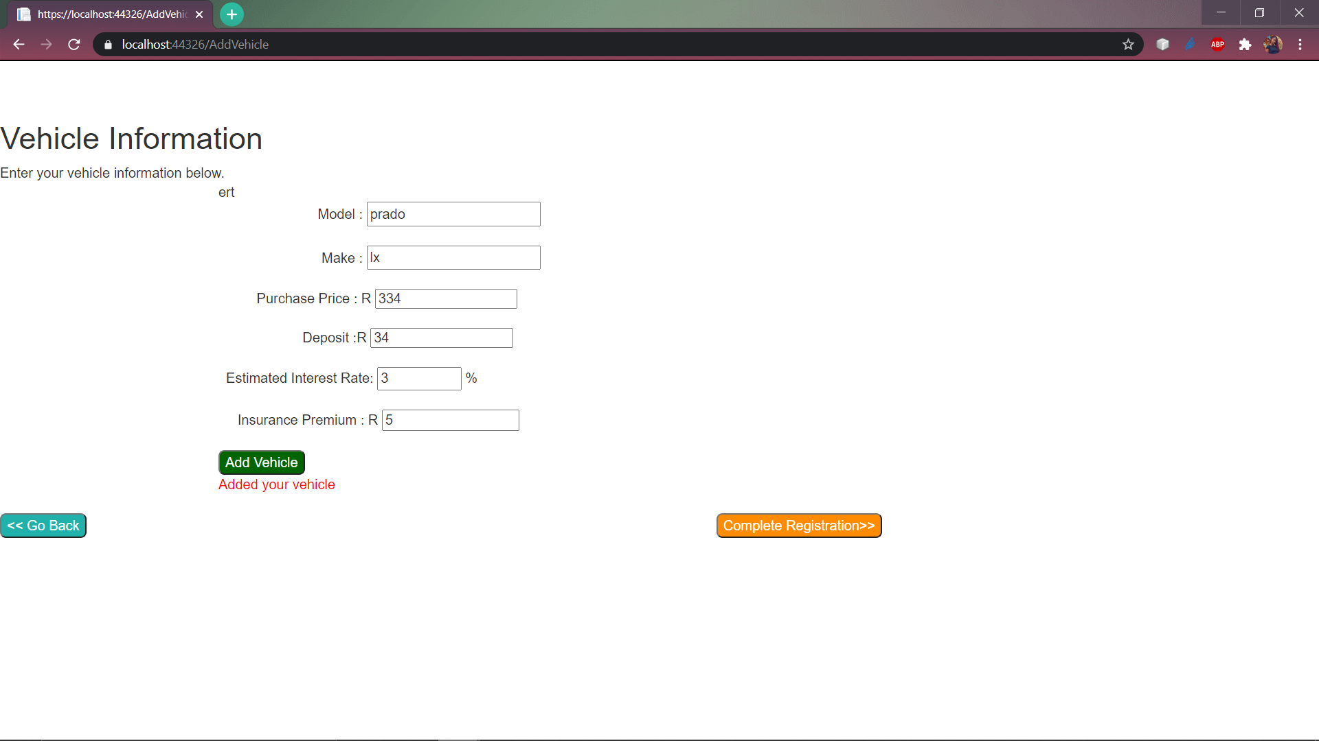

2)

## Logging in

Make sure you enter the correct credentials. Once you have entered your correct details, click on the ‘Login’ button to lead you to the Budget App homepage.

Select the ‘Savings’ menu option on the toolbar to add a savings as well as find out how much you will need to save per month based on the interest you pick.

You must pick out the simple interest or compound interest methods by clicking on any of the two buttons. If you clicked on the ‘Compound Interest’ button, enter the months that are asked of you and enter how many years you want to be saving for.

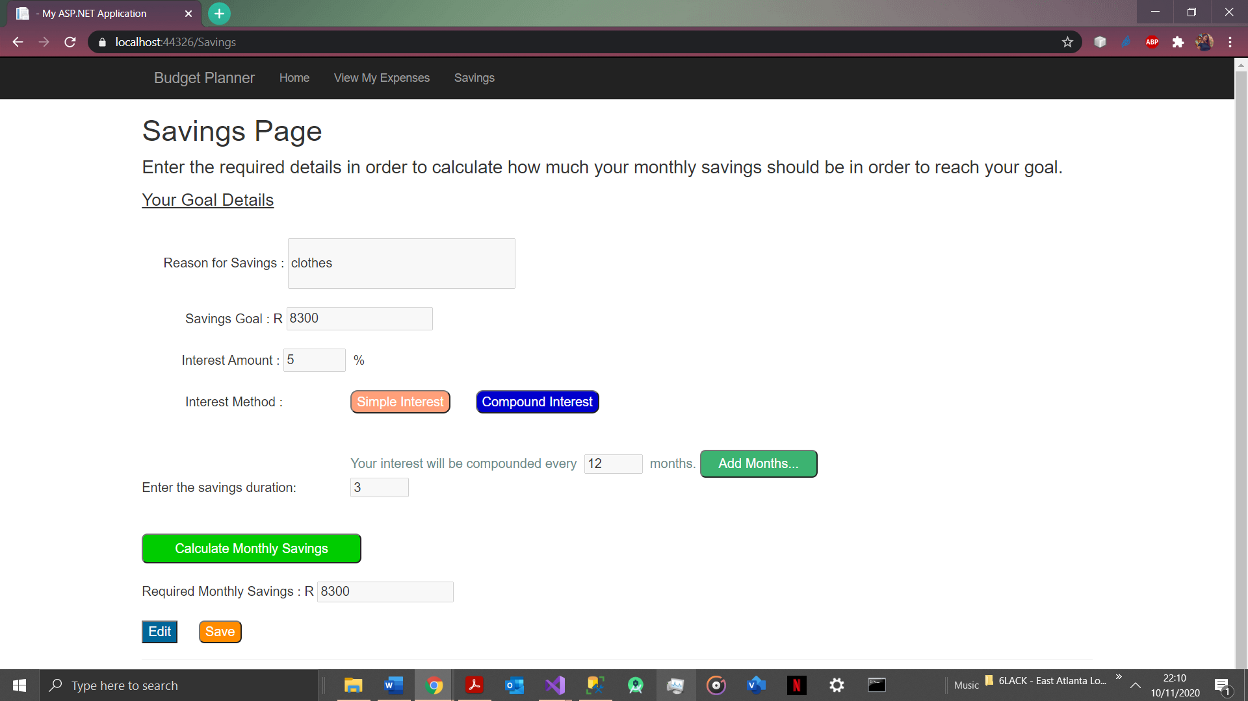

**Make sure to have a reason that is between 5-50 characters long.**

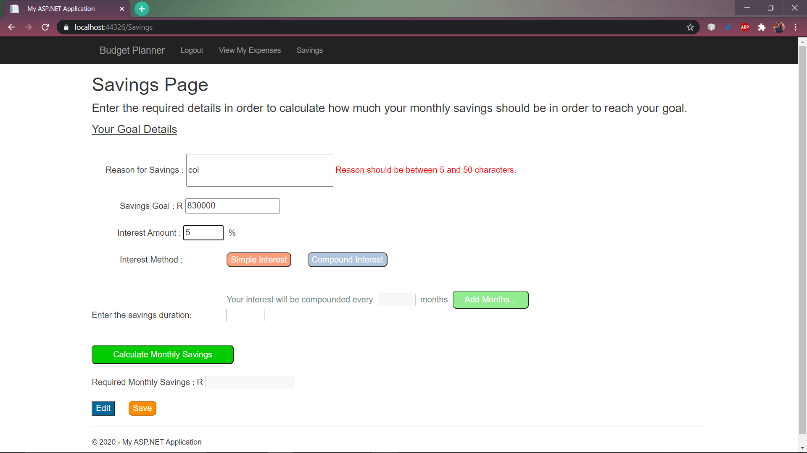

Click on the Calculate Monthly Savings to first get your required monthly savings and then click ‘Save’ to save this information. Click ‘Edit’ to change the details. **You can only do this before saving.**

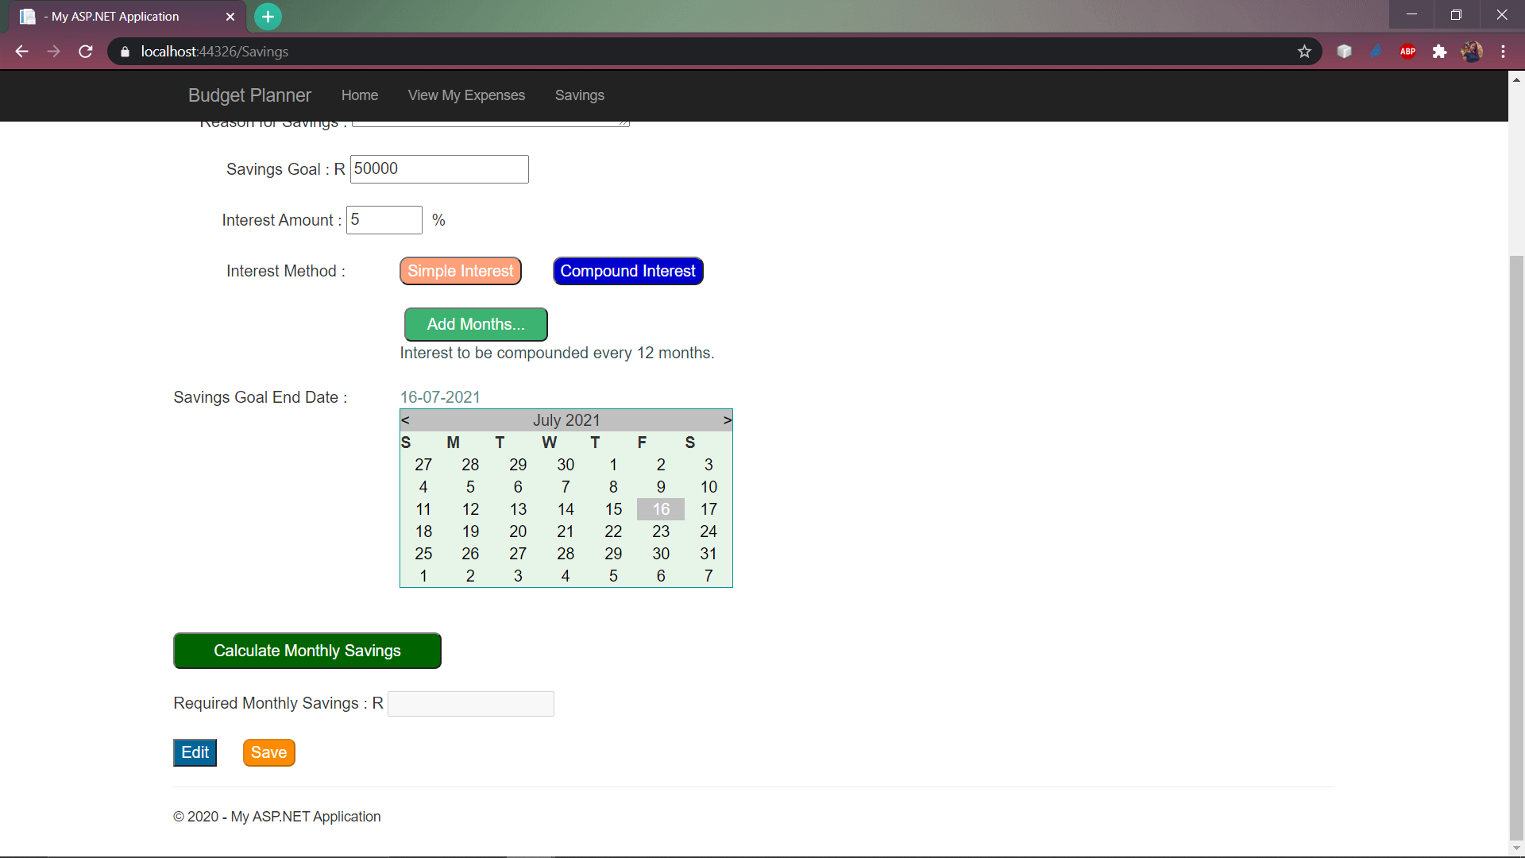

Click on the ‘View My Expenses’ option on the toolbar. Click on the ‘View Home Loan’ button if you had previously added a home loan to your account upon creating your account:

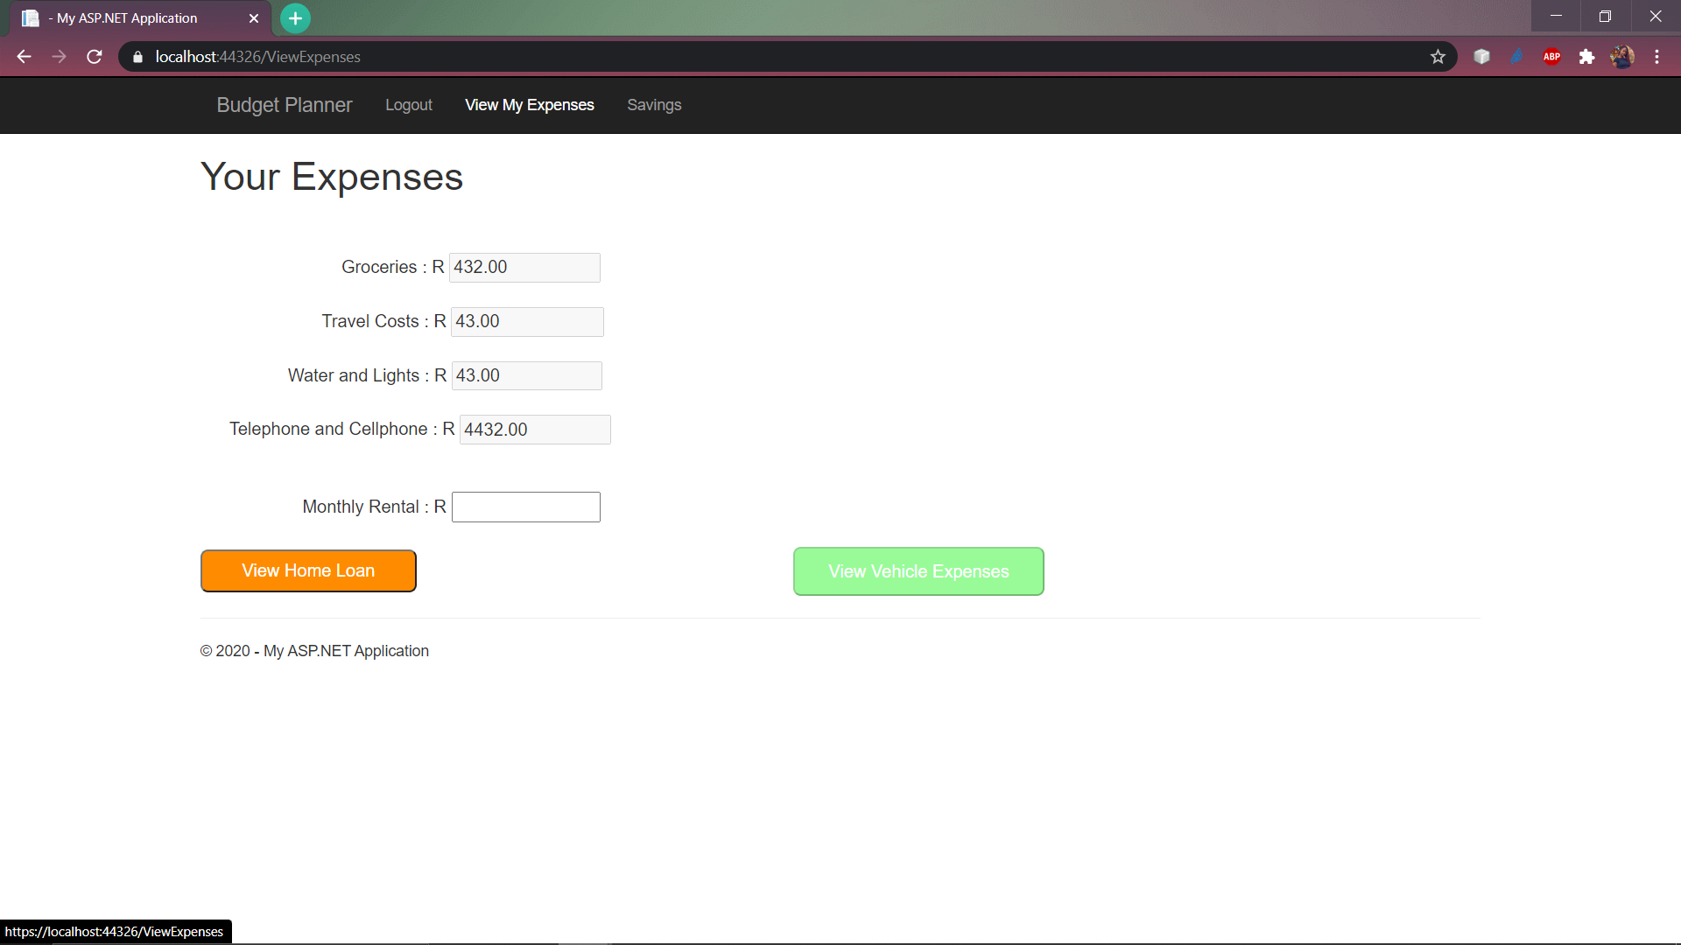

### **How to logout:**

In order to logout, just simply click the logout option on the toolbar.