**Reflection**

**1. Describe your pipeline. As part of the description, explain how you modified the draw_lines() function.**

My pipeline consisted of 5 steps. First, I converted the images to grayscale, then I ....

In order to draw a single line on the left and right lanes, I modified the draw_lines() function by ...

If you'd like to include images to show how the pipeline works, here is how to include an image:

[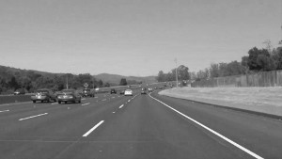](https://github.com/udacity/CarND-LaneLines-P1/blob/master/examples/grayscale.jpg)

**2. Identify potential shortcomings with your current pipeline**

One potential shortcoming would be what would happen when ...

Another shortcoming could be ...

**3. Suggest possible improvements to your pipeline**

A possible improvement would be to ...

Another potential improvement could be to ...