Open SVG File

-Using Command Line Argument
Click Run Configurations

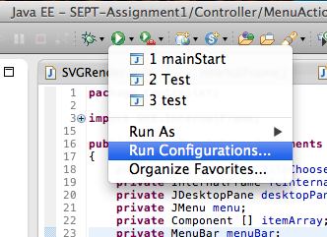
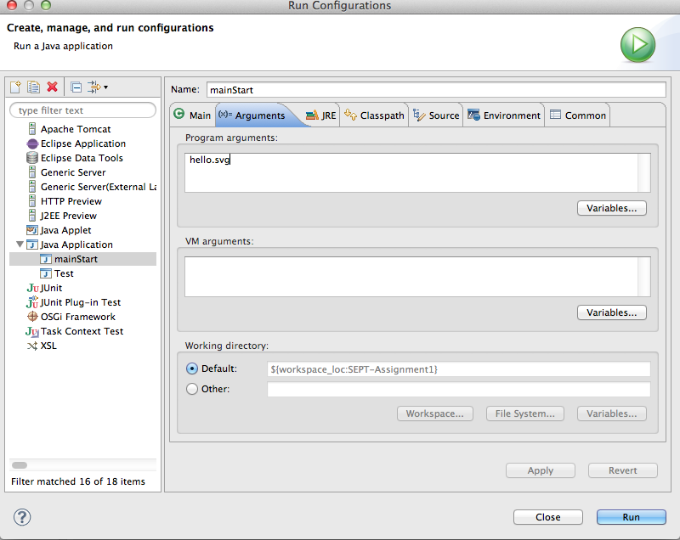
Go to arguments and type the file name at “Program Arguments”

-Using file menu Open

Click Open...

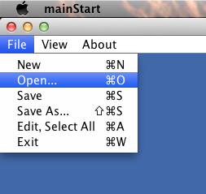
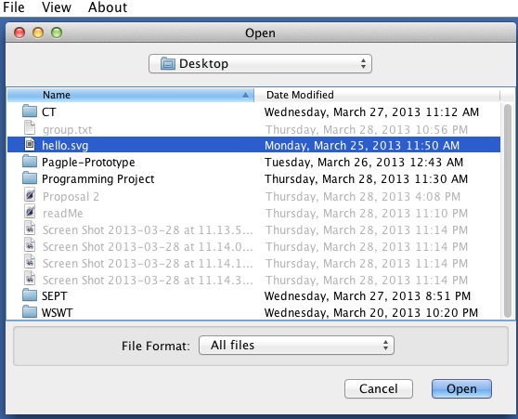

Select SVG file

SVG file is opened

Other Feature(Optional)

-Zoom In and Zoom Out

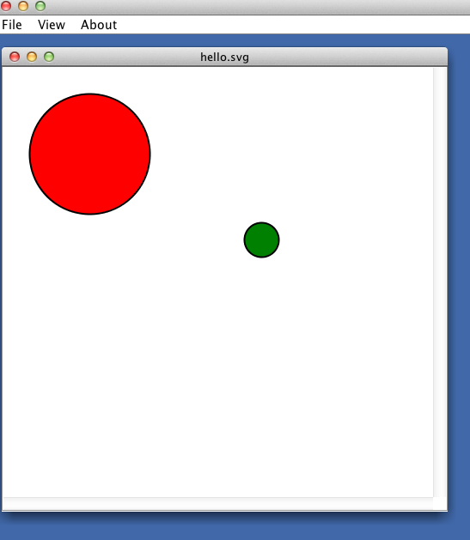
In Mac OS X : press command and “+”or “mouse wheel up” to zoom In and command and “-”or “mouse wheel down” to Zoom Out

In Windows OS : press control and “+”or “mouse wheel up” to zoom In and command and “-”or “mouse wheel down” to Zoom Out

-Panning

Hold on the panel using left mouse click to drag the panel for panning.

