**TEAM NAME:** **Gagnants**

**TEAM MEMBERS:**

HARIPRAKAASH N

KOKILA M

RAMANIARUNSHAKTHI A

**THE PROBLEM STATEMENT:**

**3. Crowdsourced Support Systems (A happy fleet delivers happy experiences)**

Riders who deliver to our homes/ offices etc have a very difficult life. They spend hours on the road, battling traffic, rain, sun, and come what may, they are at our doorstep in time! Can we make their life simpler? Can we build some crowdsourced local intelligence to help delivery partners to navigate their day better through real-time, sharp local knowledge? There are around 4 million delivery people in India- imagine the power of the data that can be generated through this network.

**Side Notes**

* Can real-time intelligence on traffic/roadblocks be generated, that beats Google?
* Can a rider always know which are the best places to park?
* Can a rider be aware of the expected wait time at a pick-up point- it can be a restaurant, a dark store, or a Kirana shop for that matter?
* Can intelligence be built around rain and shared real-time with the rider network?

Use case

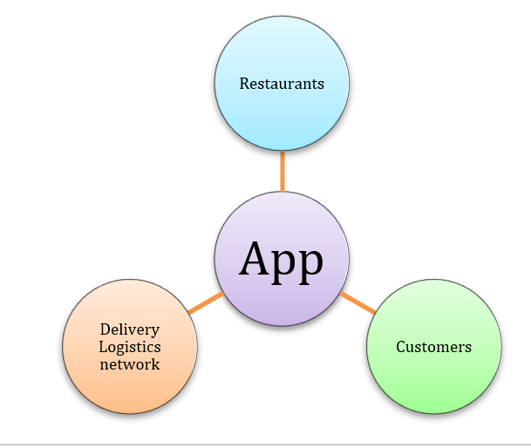

➔ Restaurants

➔ Customers

➔ Delivery Logistics network

Stage 1: Empathize

In this stage, we understand the problem at the deep and ground levels. By some oral allegations and some interview clips of Indian media and articles. Based on our research on this we get the following points,

| S. No | Oral Statements | Reference links |
| --- | --- | --- |
| 1 | 1. “Hungry customers are angry customers”  2. These apps created a lot of jobs for youth  3. That was a lucky moment when the food was packed in Restaurants.  4. I try to make every delivery on time to avoid bad ratings  5. “People see us as the face of the service. We make some mistakes like spillage or late orders for which we take responsibility, but we also get blamed for things beyond our control such as the quality of food.” | <https://chennai.citizenmatters.in/a-day-in-the-life-of-swiggy-delivery-person-7407> |
| 2 | * 30 minute-45 minute deadline to pick up the food from the hotel to the customer * At least 73% of delivery boys attached to online apps have been found driving without helmets, using earphones, over-speeding, and jumping traffic signals. | [Times of India article](https://timesofindia.indiatimes.com/city/chennai/nearly-73-of-online-food-delivery-boys-violate-traffic-rules-survey/articleshow/66339024.cms?from=mdr) |
| 3 | * Assignment Delay: How long before we can find a Delivery Executive who can fulfill this order? * First Mile: How long before they arrive at the Restaurant? * Prep Time: How much time is required for the Restaurant to prepare the food? * Last Mile: How much time is required for the Delivery Executive to reach the customer from the Restaurant? | <https://bytes.swiggy.com/the-swiggy-delivery-challenge-part-one-6a2abb4f82f6> |
| 4 | * Just In Time Assignment (JIT): A way to minimize the time spent by the Delivery Executive at the restaurant waiting for the food to be prepared. * Next Order Assignment (NOA): A way to minimize the time spent by the Delivery Executive waiting to be assigned to the next order and increasing the potential pool of Executives considered for an order. * Batching: A way to increase the efficiency of Delivery Executives by delivering more than one order at a time. | <https://bytes.swiggy.com/the-swiggy-delivery-challenge-part-two-f095930816e3> |

Stage 2: Define—State Your Users' Needs and Problems.

Based on our research we can conclude each problem of ground-level for each use case.

First Use case:: Customer

1. Getting the order delay
2. Hungry becomes angry

Second Use case:: Restaurants :

1. No knowledge of pre-prepared materials
2. Delivery people coming late to take food and rushing us for packages.
3. A sudden increase in the number of orders and sometimes low order.

Third Use case:: A delivery person

1. The lucky moment when the food was packed in Restaurants.
2. They try to make every delivery on time to avoid bad ratings
3. “People see us as the face of the service. We make some mistakes like spillage or late orders for which we take responsibility, but we also get blamed for things beyond our control such as the quality of food.”
4. Unpredictable Rain
5. Finding shortcuts to new places → Not proper address
6. Traffic Violating

Stage 3: Ideate—Challenge Assumptions and Create Ideas.

Pre-existing ideas

AI models that use the data platform to generate time predictions. The optimization algorithm then all the predictions and matches drivers with orders, which the app shows to the customer in real-time. Logistics startup blackbuck users IoT sensors for live vehicle tracking to suggest the best route to drive. A dashcam fitted on every vehicle captures the driver’s images. A technician can detect if a driver is sleepy, looking at his phone, accelerating too much, and the driver will immediately get an alert instructing him to be attentive.

**Our new trends of ideas for each problem**

**Pre Booking :**

Most of the orders are delay due to no knowledge of pre-prepared ingredients. Most of the problems are like this in order to reduce this we created a proof of concepts. This method resolves all the problems in order of delivering food. The customer gets the foods on time, delivery boy will also get good rating and restaurant also get some impression

That first photo represents the combo food. Based on weekly, monthly. Customers can choose their combo pack and also available for diet packs. This pre-order make it easy to the customers just by single step after that order will place and food will delivery on the time (what time the customer mention ) without any hurry burry

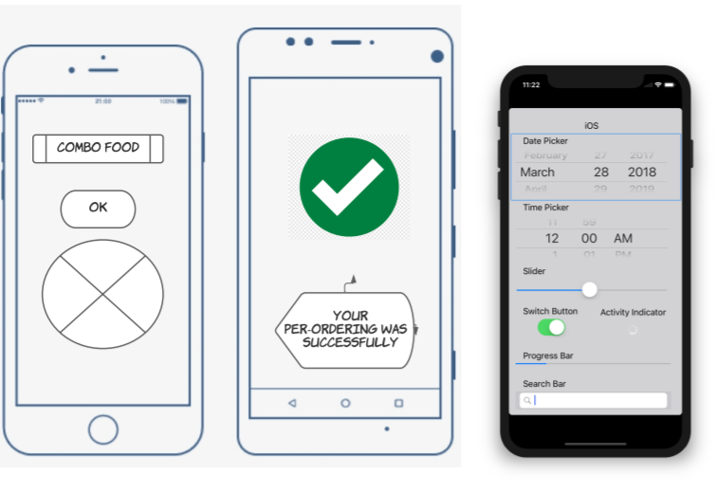

**Smart shortcut API**

Creating a new real-time intelligence system That displays the very shortest distance to reach the customer from the hotel. For this data is collected from same delivery persons.

For example, if the delivery comes from XYZ Street then the delivery person can able to access pre deliveries GPS routes, and based on that our algorithm will provide the shortest distance shows to the delivery man.

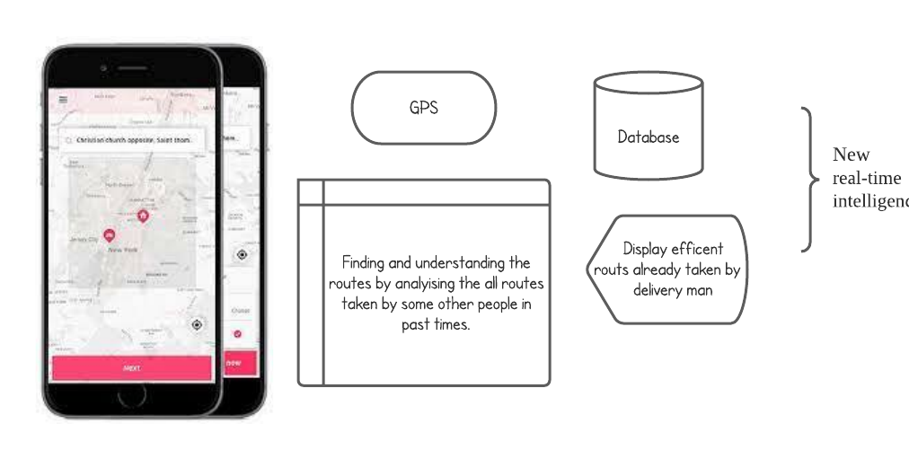

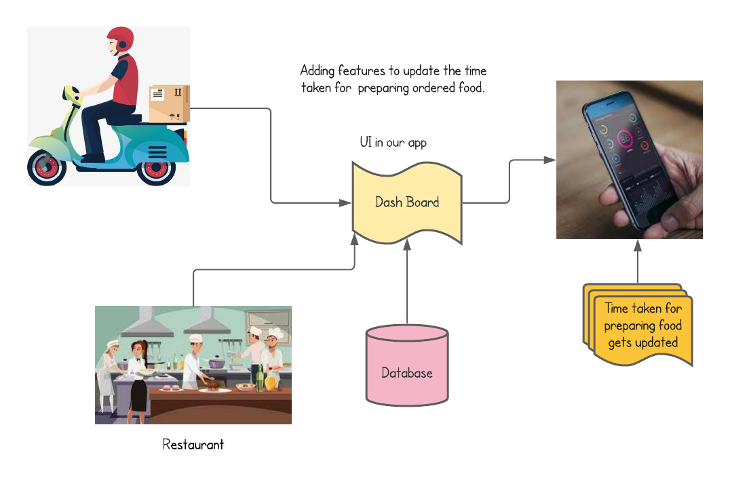

The information about the preparation time of the food can be given by a particular restaurant by adding some options to the application. So that the particular restaurant will give the information about the preparing time of the particular food. So, when the order is placed on particular food then along with the information what type of food is ordered the information about the preparing time of the food will also be sent to the particular delivery boy.