Game Design Document

Fill up the following document

1. Write the title of your project.

Peak of the mountain

1. What is the goal of the game?

The goal is to reach the top of the hill or mountain

1. Write a brief story of your game.

There is boy named john ..who was a best hill climber

..but he hate that now because his father is also a best hill climber

but in recent in a hill climbing race his father died in an accidcent ...after a lot of confusion and pain .john decided to fullfill his fathers dream which is to crack the game .......

1. Which are the playing characters of this game?

* Playing characters are the ones who respond to the user based on the input from the user.
* Cars, monkeys, dinos, wizards, etc., are the playing characters in the game.

|  |  |  |
| --- | --- | --- |
| Number | Character Name | What can this character do? |
| 1 | John | Main role |
| 2 |  |  |
| 3 |  |  |
| 4 |  |  |
| 5 |  |  |
| 6 |  |  |
| 7 |  |  |
| 8 |  |  |

1. Which are the Non-Playing Characters of this game?

* Non-Playing characters are the ones that don't have an action or behavior when the user interacts with the game.
* Hurdles, stones, bananas, coins, etc., are non-playing characters in the game.

|  |  |  |
| --- | --- | --- |
| Number | Character Name | What can this character do? |
| 1 | Vinner | Opponent player |
| 2 | Rock | Opponent player |
| 3 | Don | Opponent player |
| 4 |  |  |
| 5 |  |  |
| 6 |  |  |
| 7 |  |  |
| 8 |  |  |

Draw your imagination of this game. What does this game look like?

* Draw the game either on your computer or on paper.
* Add images of the game scenes to show each of the playing and non-playing characters at least once.

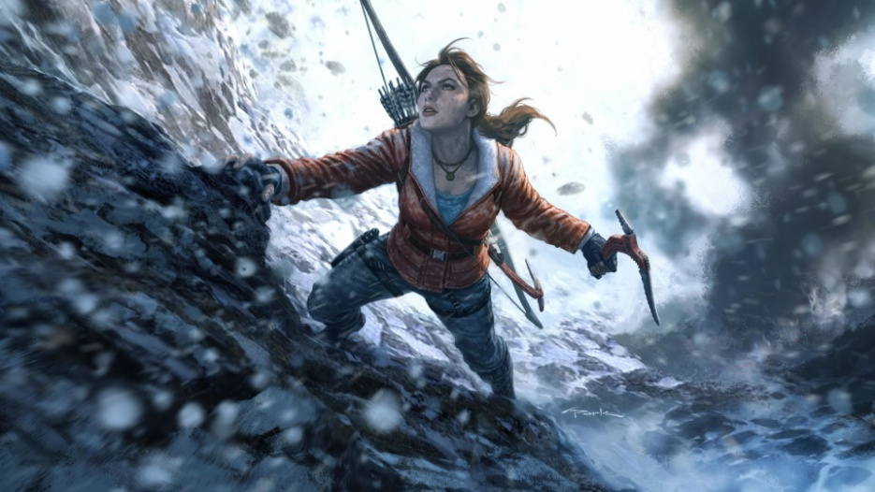

How do you plan to make your game engaging?

the game want to be so enjoyable and advantures and more interserting