Step 1: Open the index.html page in google chrome browser

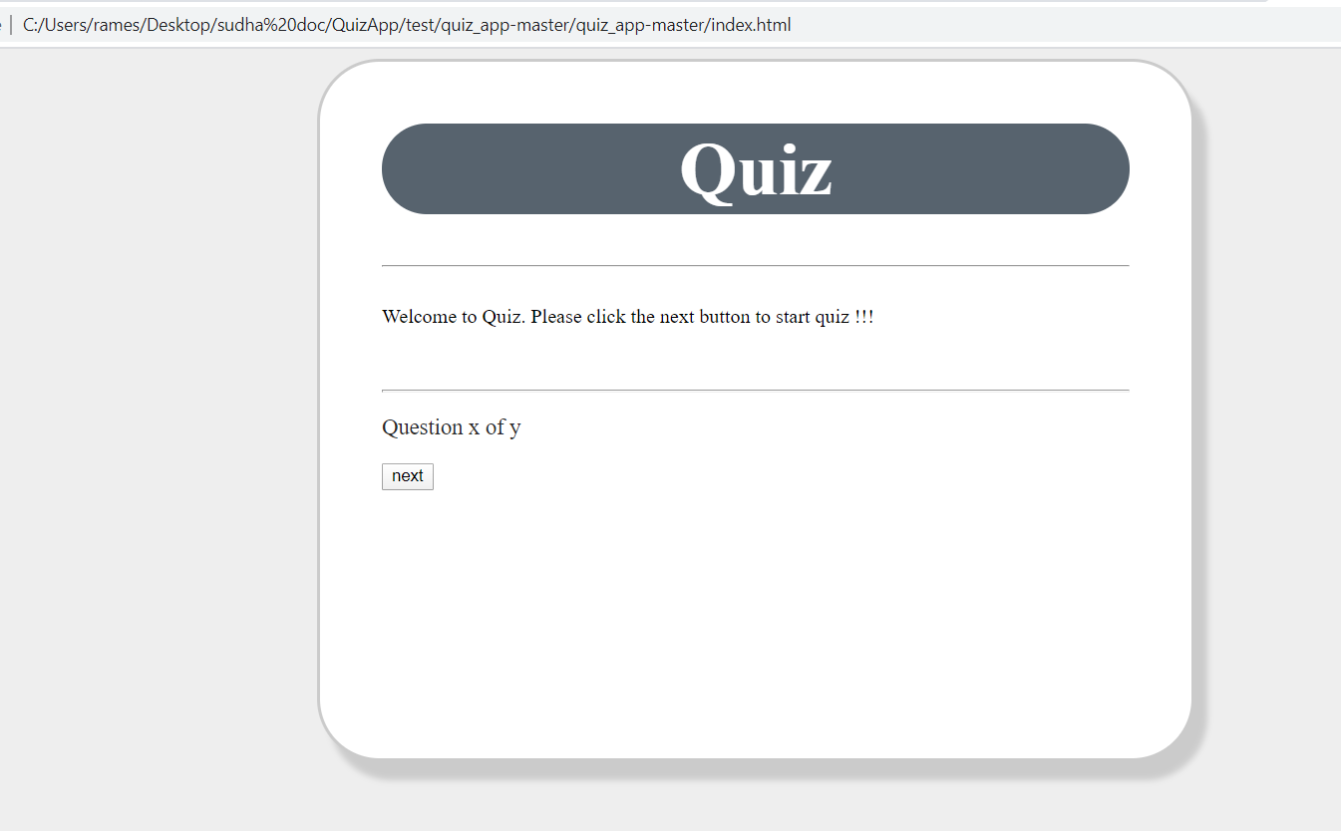

Step 2: Click the next button and it will open the first question

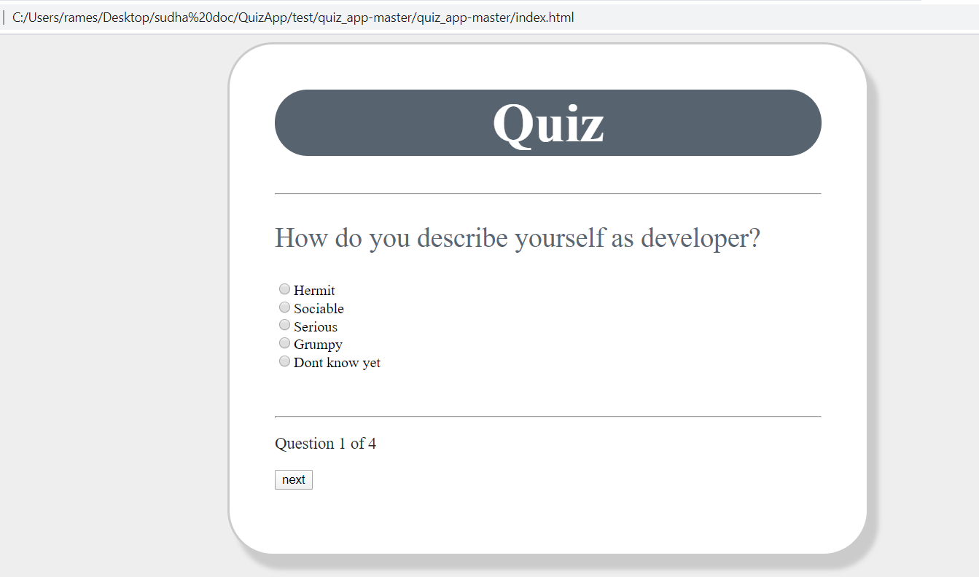

Step 3: Select the appropriate answer (correct answer is Sociable)

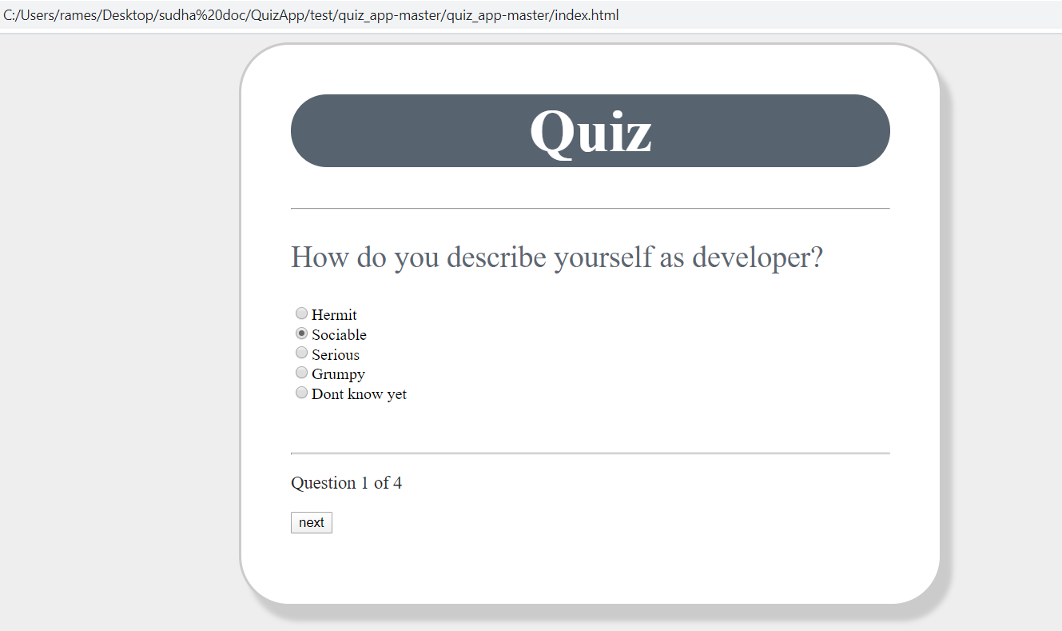

Step 4: Click the next button then next question will open

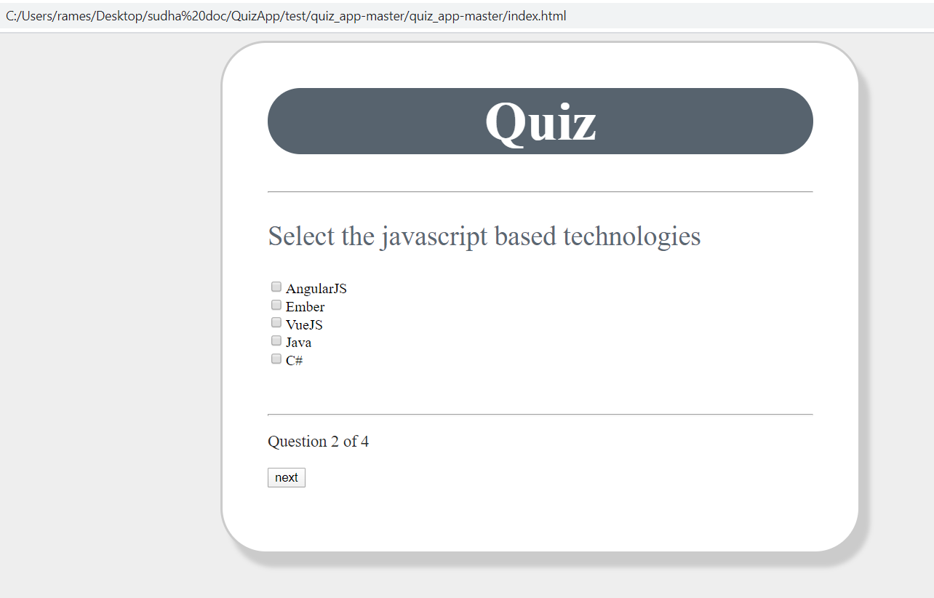

Step 5: Select multiple value from check box option

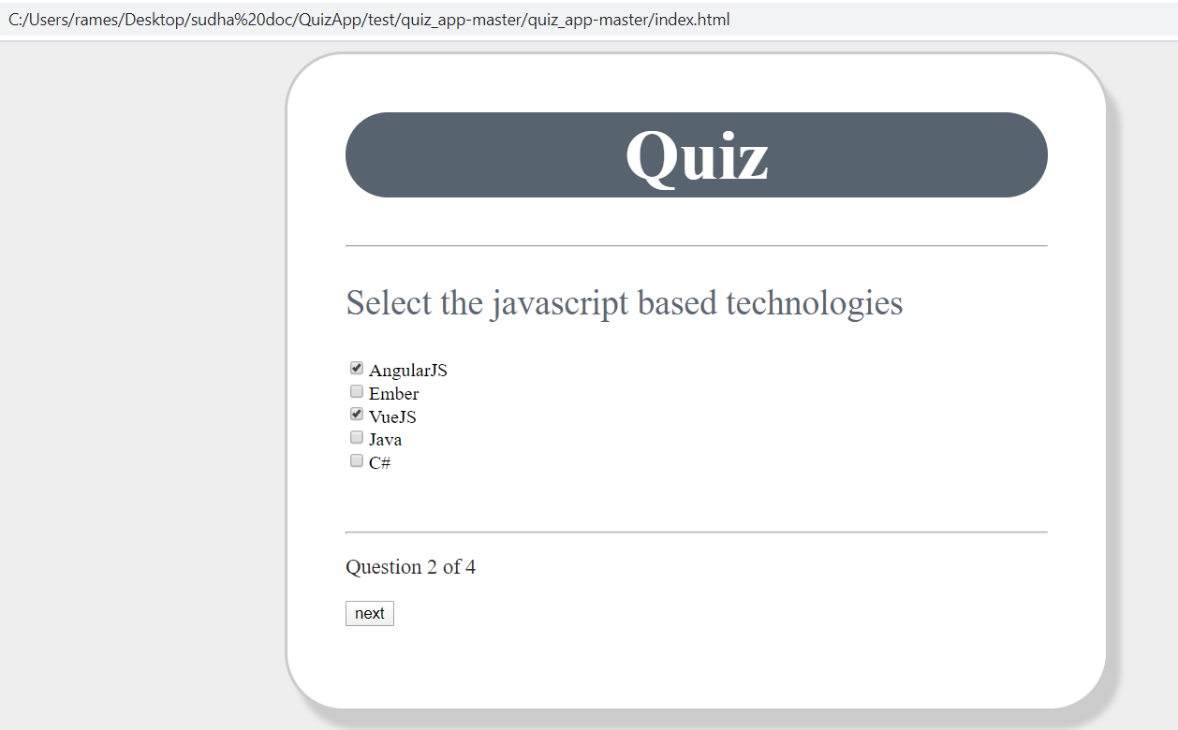

Step 6: click next button and open the next question

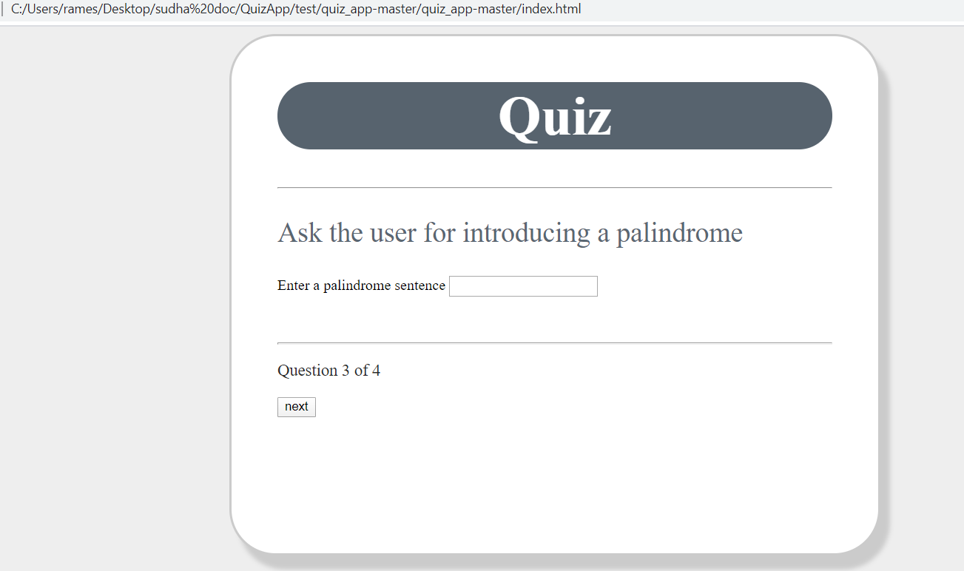

Step 7: Enter palindrome answer and click next button

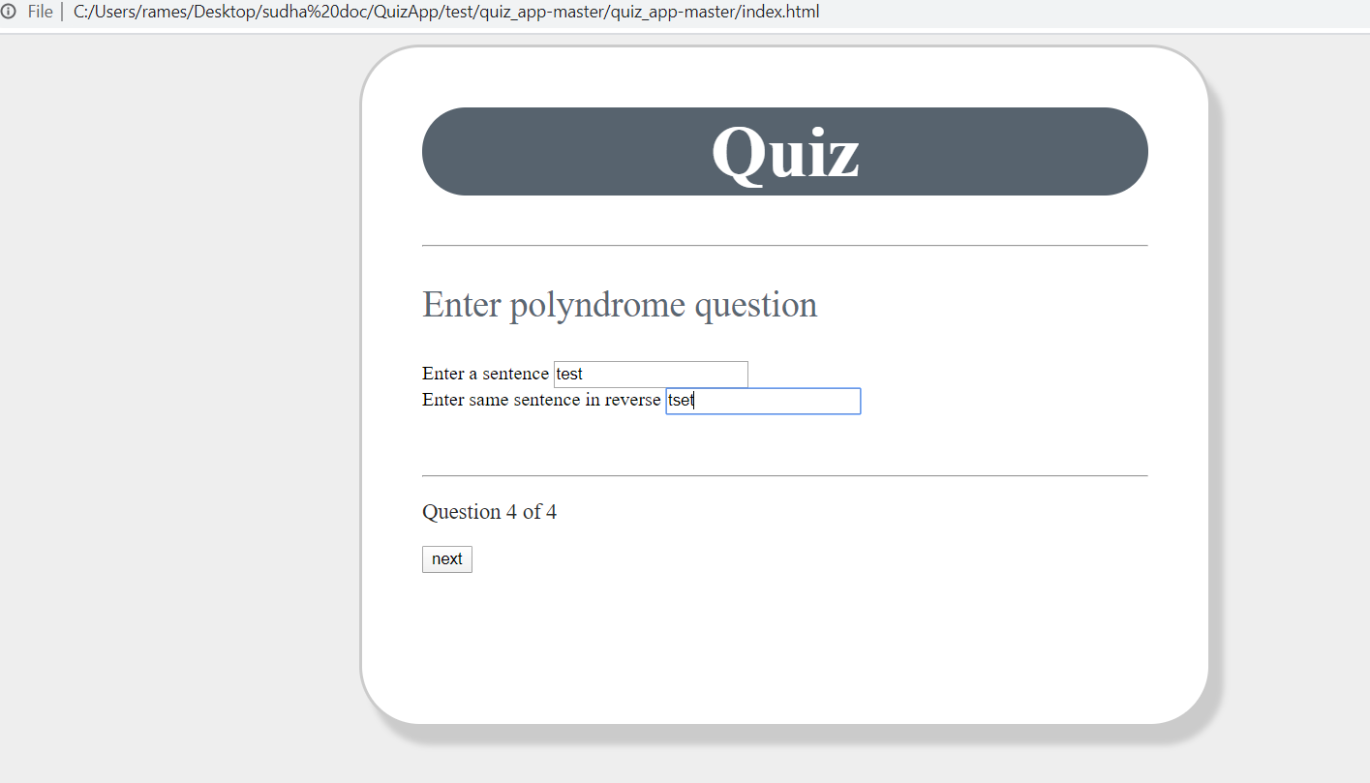

Step 8 : Quiz Result will display

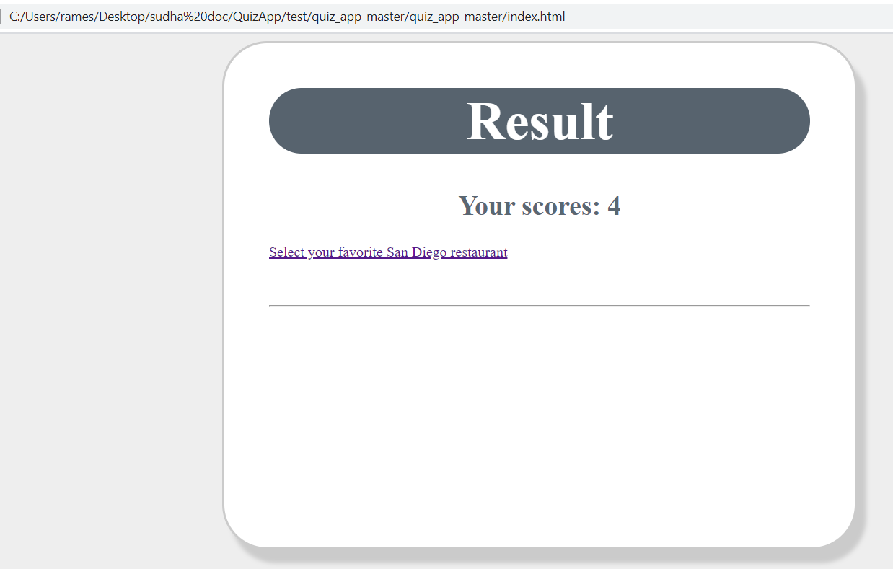

Step 9 : click the select your favorite restaurant link and it will open find restaurant page

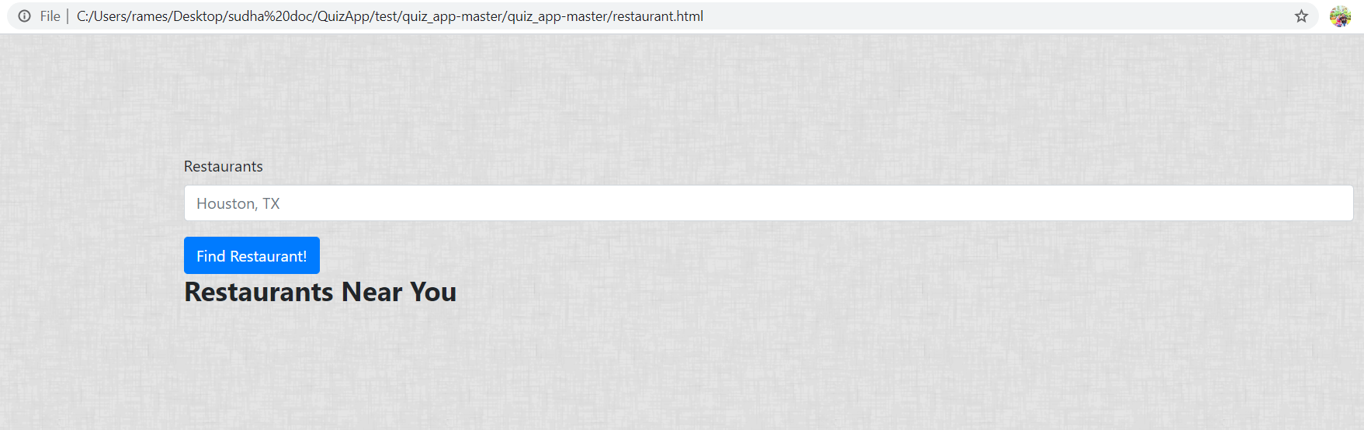

Step 10: Enter city name , State code and click Find Restaurant button

