CURRICULUM VITAE
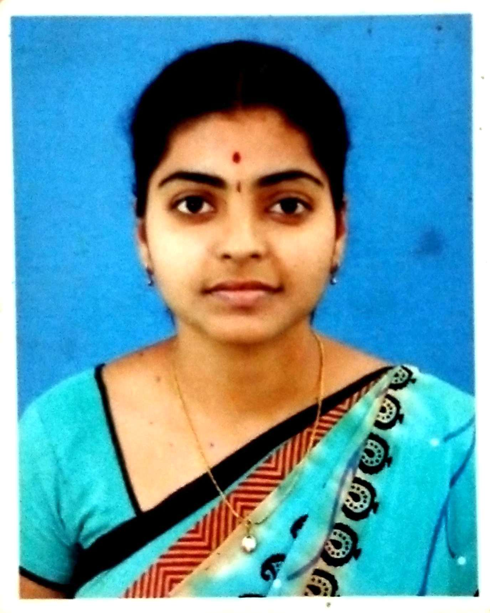

P. KOKILA kohilasairam@gmail.com

Academic Qualification:

Doctorate of Philosophy (PhD), Master of Philosophy in Computer Science (M.Phil), Master of Information Technology (M.Sc., IT) and Bachelor of Computer Application (BCA).

Educational Details:

Course | University/Board | Institution | Year of Passing | Percentage
PhD | Bharathiar University, Coimbatore | Chikkanna Govt Arts college, Tirupur | Thesis submitted | -
M. Phil  (CS) | Bharathiar University, Coimbatore. | P.S.G.R Krishnammal College for Women, Peelamedu | 2010 -2011 | 60 %
M.Sc.,(IT) | Anna University, Coimbatore | Kongu Engineering College, Perundurai | 2008 -2010 | 76 %
BCA | Bharathiar University, Coimbatore | Park’s College Tirupur | 2005-2008 | 69.59 %
Higher Secondary | State Board,  Tamil Nadu | Jaivabai Girls Hr. Sec School, Tiruppur. | 2005 | 60 %
S.S.L.C | State Board,  Tamil Nadu | Jaivabai Girls Hr. Sec school, Tiruppur | 2003 | 65.8 %

Professional Skill Set:

- Operating System : MS Dos, WINDOWS 7,8,10
- Programming Languages : C, C++,
- Database : MS-Access, SQL
- Web Designing tool : HTML, VB Script,

Area of Interest:

- Computer Networks
- Software Project Management
- Natural Language processing
- E-commerce

Projects Undertaken:

Project Title : UPLOAD AND DOWNLOAD METER
Environment : C#, XML
Description : The project is to set the maximum upload and
download Limit for the system

Project Title : INSTANT MESSENGER
Environment : PHP, MS SQL
Description : Instant Messenger developed for LAN environment
Establishes The connection with its peer system and act as Server to send any Response or message to the client Machine.

Project Title : GLOBAL BANKING SYSTEM
Environment : ASP. Net, MS SQL Server-2000
Description : The banking system allows the user to process all bank Transaction through online

Research Undertaken:

M. Phil RESEARCH PROGRAM

Title : Isolated Tamil Digit Speech Recognition using HMM-based
Approaches

Description : The system can recognize Tamil digits and display with
Calculating Accuracy using HMM based acoustic model trainer from CMU, Sphinx Train has been employed

Ph.D RESEARCH PROGRAM

Title : “Enhanced and Integrated Machine Learning Paradigms for Robust Voice Pathology Detection and Discrimination ”

Description: The motive of this research work is to discover voice pathology by designing and developing various machine learning paradigms at different stages.

Paper Published:

- Published a Survey Paper titled “Automatic Speech Recognition: Architecture, Methodologies and Challenges-A Review” in Signal and image Processing International Journal (SIPIJ).

- Presented a Paper titled “Isolated Tamil Digit Speech Recognition Using Template Based and HMM Based Approach” in an International Conference at VIT University (Springer)

- Presented a Paper titled “Isolated Tamil Digit Speech Recognition Using Vector Quantization” in an International Journal of Engineering Research and Technology (IJERT)

- Published a survey paper titled “Perspective Analysis of Voice Disorder Detection using Various Approaches” International Journal of Computer Sciences and Engineering (IJCSE).

- Published a paper titled “Potential feature Extraction using Meyer wavelet Transform and Dimensionality Reduction using sequential forward Feature Selection for Voice Pathology Detection” International Journal of Research in Electronics and Computer Engineering(IJRECE).

- Published a paper titled “Enhanced Audio Signal Noise Removal using Five Level Fuzzy Haar Wavelet Transform” International Journal of Advanced Science and Technology (IJAST).

- Published a paper titled “Uncertainty handling using Improvised Intuitionistic fuzzy ANN based Voice Disorder Detection" International Journal of Recent Technology and Engineering (IJRTE).

- Published a paper titled “An Evolving Model of Voice Disorder Detection using Deep Belief Network “International Journal of Recent Technology and Engineering” (IJRTE).

Conferences, Seminars & Workshops:

- “Research Seminar on Applied Machine Learning” held at PSG College of Technology

- International Conference on “Intelligent Digital Transformation” held at Sri Ramakrishna College of Engineering

- Paper submitted in a National Seminar under topic “ A Survey on Voice Disorder for Identifying Voice Pathology”

- Attended Two Weeks ISTE Workshop on “Database Management System” conducted by ICT (MHRD)

- Faculty Development Programme conducted by Department of Computer Science, Park’s College

- “International Conference on Computational Intelligence” conducted by GR Govindarajulu School of Applied Computer Technology

- “Youth Leadership Programme” conducted by Sri Sathya Sai Seva Organisations, Tamil Nadu

Experiences:

- 18 Months worked as a Assistant Professor of Computer Science in Park’s College, Tirupur

- 6 Months worked as a Teaching Staff in The Quest International school, Tirupur

Personal Details:

Father’s Name : Late. Mr. Padmanaban
Mother’s Name : Mrs.P.Ranganayaki
Gender : Female
Age & DOB : 33 Years (28-06-1987)
Nationality : Indian
Marital status : Married
Mobile : 6385693902

Languages Known:

Tamil – To Read, Write & Speak
English – To Read, Write & Speak
Telugu – To Speak

Personal Skills:
    - Responsible and Considerate.
    - Having good time management skills
    - Very Innovative, dynamic and confident.
    - Having good Communication Skills and Good at Teaching

Extra Curriculars:

- Throw Ball Player
- College Athlete Player
- Volunteering in Sri Sathya Sai Seva Organisations (Educational Wing & Service Wing)

I hereby declare that, the information furnished above is true and correct to the best of my knowledge.

Place: Tirupur Yours Faithfully
Date:

(Kokila.P)

Reference Details:

Dr.G.M.Nasira,M.C.A,M.Phil.,Phd.,
Professor of HOD,Deparment of Computer Application,
Chikkanna Government Arts College,
Tirupur-641 602.
Mob: 8838745870

Dr.P.Balasubramanie , M.Sc, M.Phil., Phd.,
Professor of HOD, Department of CT-PG,
Kongu Engineering Collage,
Perundurai, Erode.
Ph: +91 9443942365

