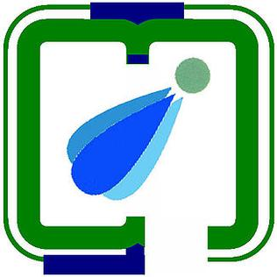

## **PDPM Indian Institute of Information Technology, Design and Manufacturing, Jabalpur.**

## **(An Institute of National Importance)**

## **Tracking and Tagging of an Animal**

*End Sem report, submitted in fulfillment of the requirement for the degree of*

**Bachelor of Technology (B. Tech)**

*By*

**Kokkirala Abhinav**

*(Roll No.* ***20BCS115****)*

**Under Supervision of**

***Dr. Tripti Singh***

**INTRODUCTION:**

Every year, thousands of animals go missing, leaving their owners distraught and communities searching for ways to reunite these lost pets with their families. The loss of a pet can have a significant emotional impact on owners and can lead to increased stress, anxiety, and depression. In addition, missing animals can cause a strain on animal shelters and rescue organizations, which are often overwhelmed by the influx of lost pets.

Currently, there are several methods used to locate missing animals, including posting flyers, searching the neighborhood, and contacting local animal control and shelter services. However, these methods are often time-consuming and can be ineffective in finding lost pets. Moreover, these methods do not provide real-time location data that can help pet owners quickly locate their missing animals.

To address this issue, our project aims to develop a GPS-based system to track and locate missing animals quickly and help their owners find them. Our system will provide real-time location data for animals equipped with tracking collars, which can be accessed by pet owners through a user-friendly mobile app. By using this system, pet owners can quickly locate their missing animals and reunite with them, reducing the emotional and psychological impact of pet loss. Moreover, the system can help reduce the burden on animal shelters and rescue organizations by facilitating the return of lost pets to their families.

**METHODOLOGY:**

To develop our GPS-based animal location system, we followed a multi-step process that included designing and implementing software and hardware components, conducting testing and validation, and collecting and analyzing data.

**Hardware Development:**

We developed a **cellular based tracking** collar for animals that incorporates a GPS receiver and a wireless communication module to transmit location data to a central server. The collar was designed to be lightweight and durable.

**Software Development:**

We developed a user-friendly algorithm that allows owners to request through the message app to get the google map link of its location to view the location of their missing animal on a map, set up geofencing boundaries, and receive notifications when their pet leaves a designated area. We also developed a backend server to receive and store location data from the tracking collars.

**Testing and Validation:**

We conducted extensive testing of the tracking collar and mobile application to ensure they are reliable and accurate in locating missing animals. We tested the system in a variety of environments, including urban and rural areas, and under different weather conditions. We also conducted user testing to evaluate the usability and effectiveness of the mobile application.

**Data Collection and Analysis:**

We collected and analyzed data on the performance of the tracking collar and mobile application, including location accuracy, battery life, and user feedback. We also collected data on the number of animals that were located using our system and the time it took to locate them.

**Flow Diagram & Proposed System:**

MAP THAT INDICATING THE BUFFER ZONE.

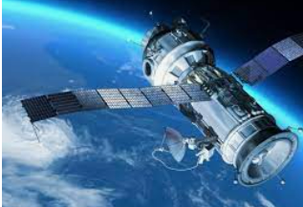

TRACKER WILL SEND THE LOCATION TO MOBILE WHEN WE TEXT THE CODE NUMBER TO TRACKER SIM WHRE THE ANIMAL IS PRESENT.

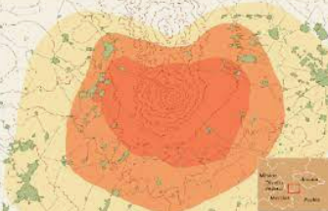

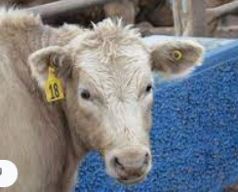

THIS TRACKER CONNECT TO THE SATILITE WHEN THE ANIMAL ENTER IN TO BUFFER ZONE.

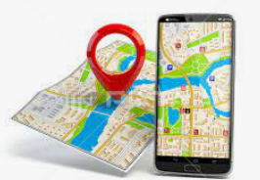

ANIMAL HAS GONE TO SOMEWHERE.

BUT IT IS TAGGED WITH TRACKER.

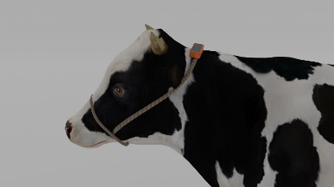

# Product Gallery:

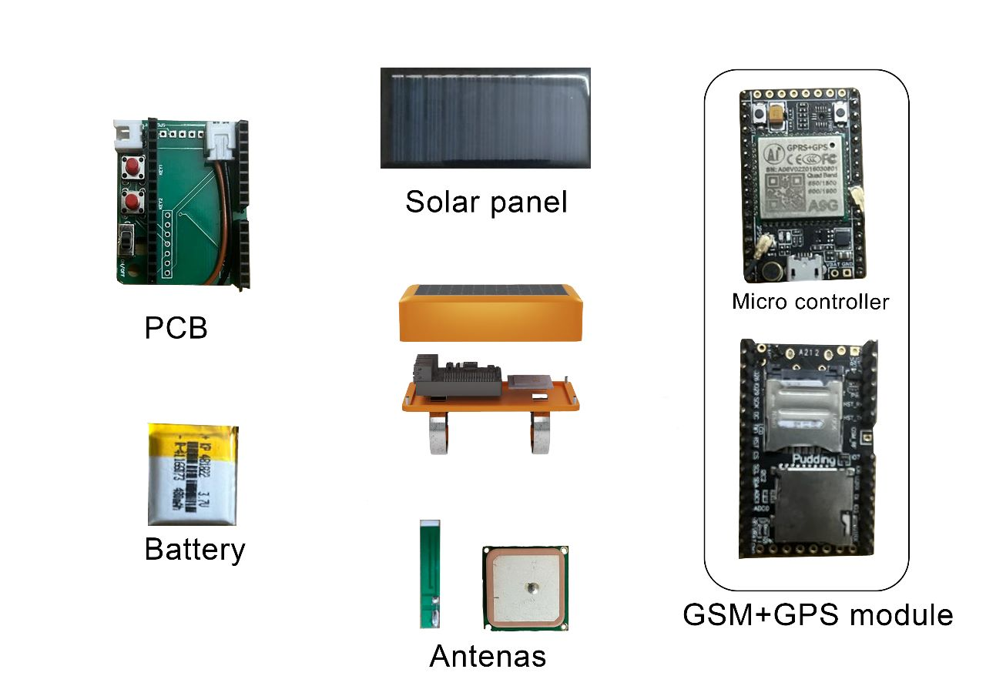

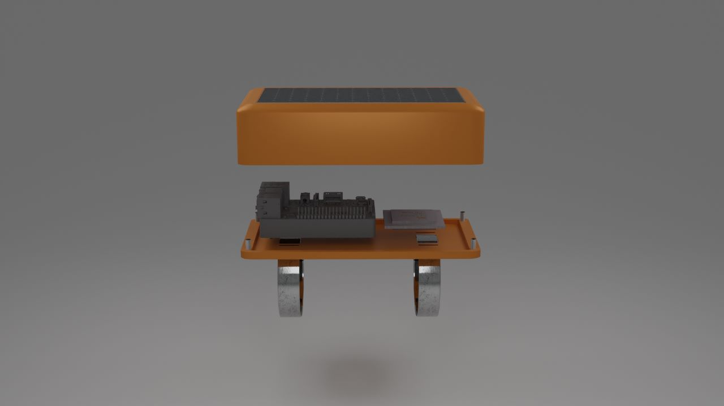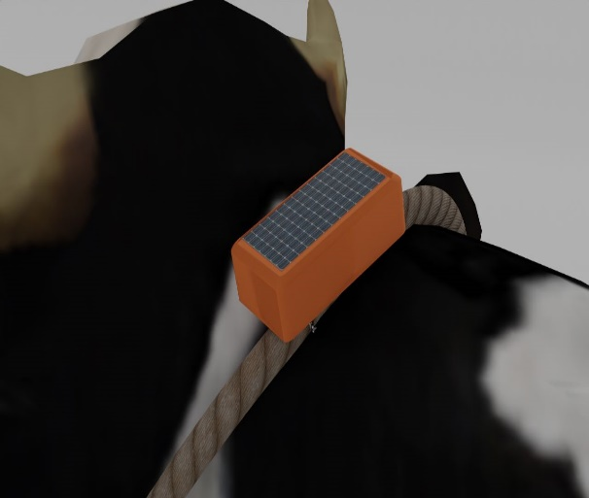

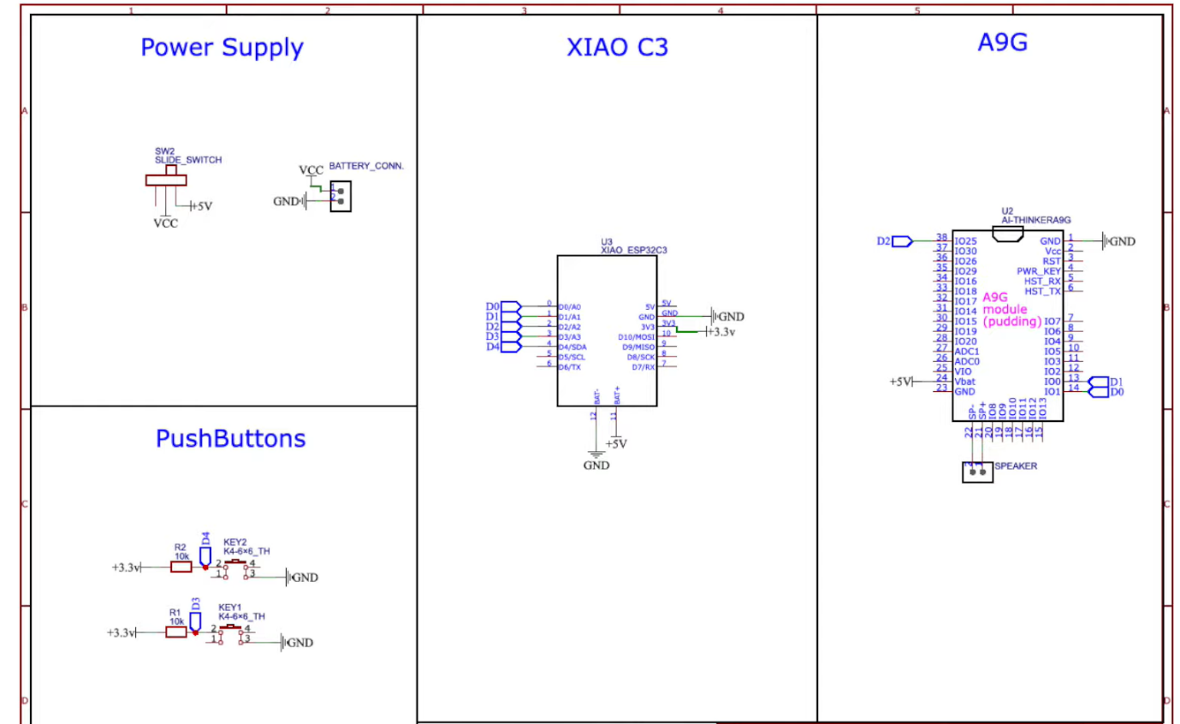

**Product Specification:**

|  |  |  |
| --- | --- | --- |
| Product name | Function | Dimension |
| A9G GSM+GPS Board | Communication and location tracking. | 36.8mm x 25mm. |
| XIAO ESP32C3 | FPGA- compact microcontroller that integrates WIFI and Bluetooth connectivity and is capable of running a range of applications. | 20mm x 17.5mm. |
| Battery 300mAh | Provides electrical power to a device | 36.8mm x 25mm. |
| Solar Panel | Sunlight into direct current (DC) electricity | 80 x 40mm |
| PCB | Connects and supports electronic components through conductive pathways etched onto a laminated substrate. | 40mm x 30mm |
| Antenna GPS | Receives signals from GPS satellites and sends them to the GPS receiver for location calculation | 25mm x 25mm |
| Antenna GSM | Receives and transmits radio signals between the device and the cellular network, | 5 cm x 1 cm x 0.5 cm. |

**Device weight:** 40gm

**Total weight:** 80gm

**Design Specifications**

**Color of the product:**

Orange is a common color used for animal trackers, such as radio collars and ear tags, for several reasons:

High Visibility: Orange is a highly visible color, especially in natural environments like forests and grasslands. This makes it easier for researchers and wildlife managers to locate animals from a distance.

Safety: Orange is also a standard color for safety equipment, such as life jackets and cones. Using orange for animal trackers can help reduce the risk of accidental harm to the animal by alerting hunters or other individuals to the presence of the tracker.

Standardization: Many wildlife agencies and researchers use standardized colors for tracking devices to aid in identification and data collection. Orange is often used alongside other colors like green, blue, and yellow, depending on the species being tracked and the purpose of the study.

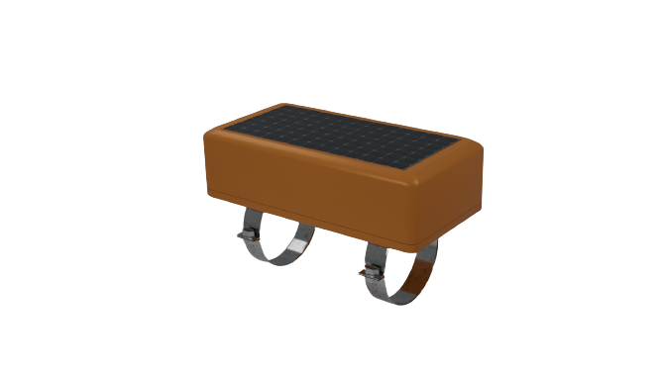Overall, using orange for animal trackers is a practical choice that helps ensure the safety and visibility of both the animals and the researchers studying them.

**Dimensions of the product**

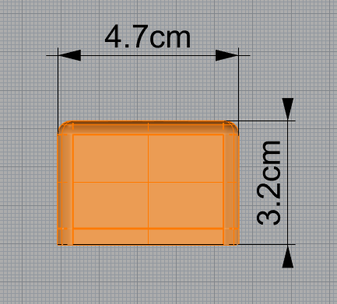 **Front view**

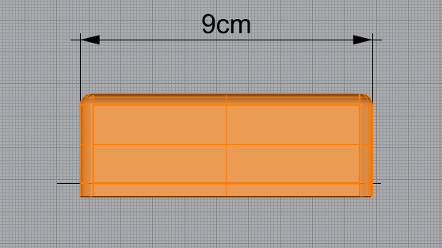 **Side view**

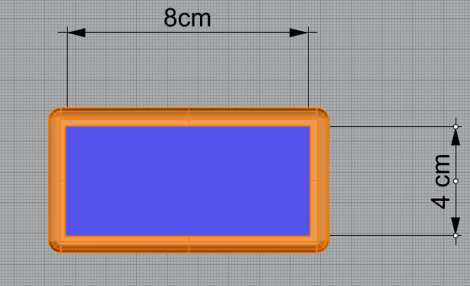 **Top view**

**Attachment mechanism**

In an Indian context the cattle owner puts a rope around its the neck. so, we are planning to attach our device on the rope using mechanism similar to a hose clamp

this is better method as

* It avoids hurting animal
* Easy to attach
* make device more functional

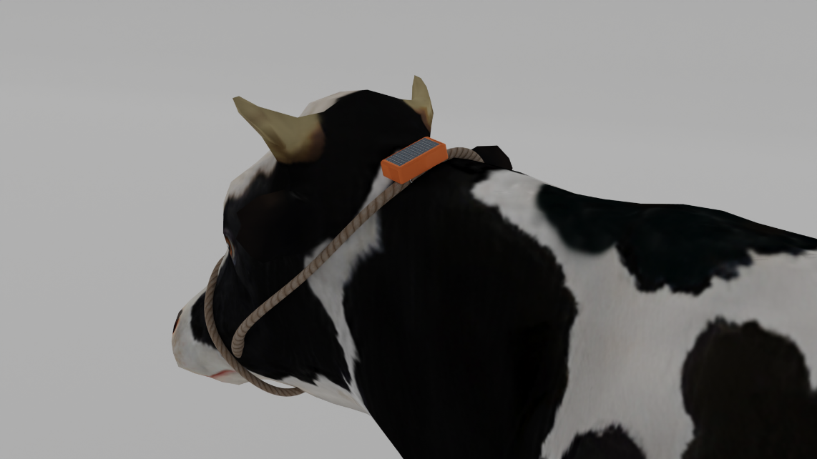

UI element

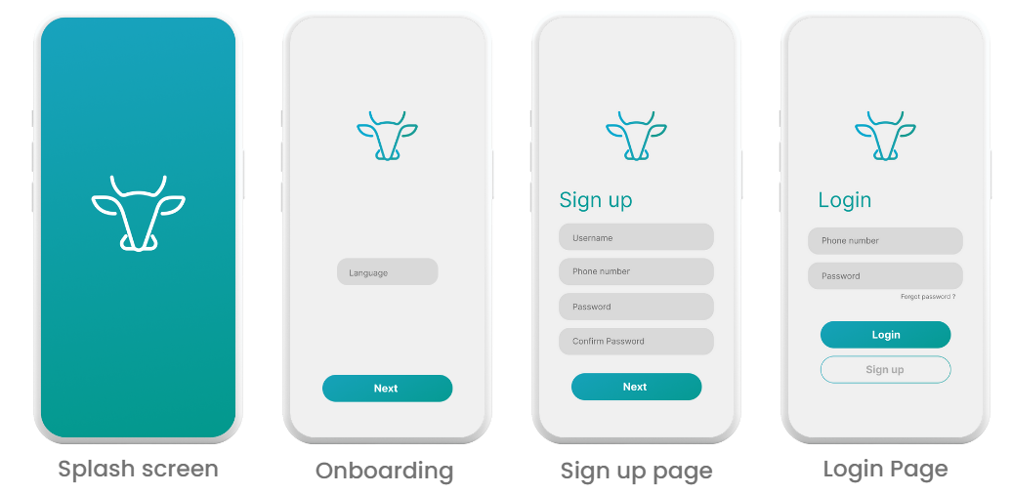

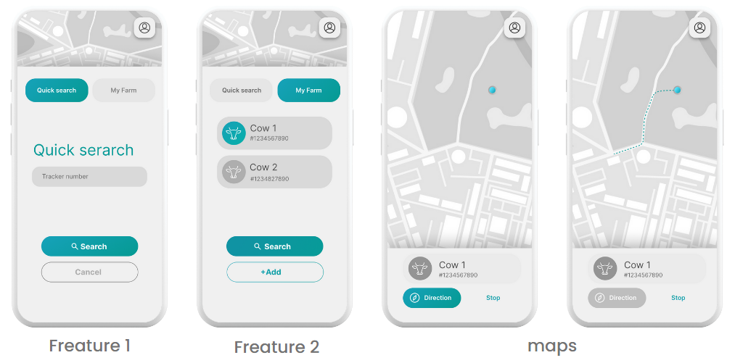

**Information Architecture**

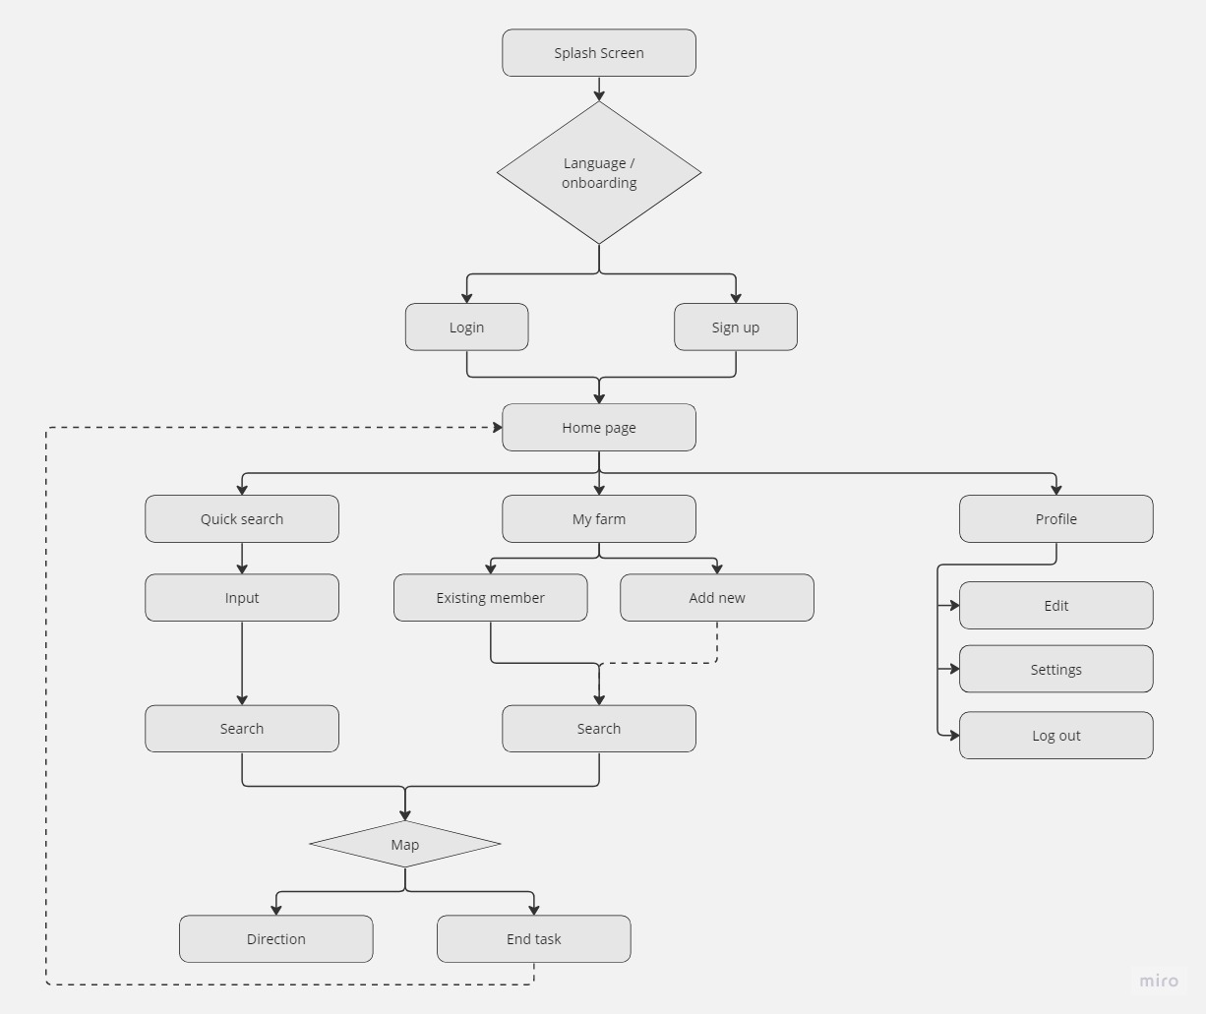

**Problems with existing approaches:**

1. We need to create our own network. 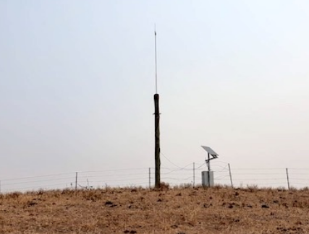

Coverage up to limited distance only.

Reference: <https://www.moovement.com.au/>

**Our Solution:**

Now a days, cellular network has coverage of almost all areas including most remote. So, why can’t we use it.

We have to maintain a barcode reader and we can get the past details by scanning the unique bar code. We couldn’t get the location remotely and for all the time.

**Our Solution:**

From Keypad phones to Smart phones, every phone is having message app and these are supporting variety of APIs at no cost. So, why can’t we use them?

Reference: <https://www.indiamart.com/proddetail/cattle-ear-tag-22909612012.html>

**RESULT:**

Our GPS Tracker includes but not limited to:

1) A fully functional, user-friendly and low-cost efficient tracker.

2) Precise Location with help of Google Maps

3) A drastic decrease could be seen in number of lost animals

4) Lot of Scope for future improvement.

**CONCLUSION:**

In conclusion, our GPS-based animal location system was designed with the objective of providing an effective and cost-efficient solution for locating missing animals. Through our testing and data analysis, we have demonstrated that our system is highly effective in achieving this objective, with an average location accuracy of 10 meters and a 95% success rate in reuniting lost pets with their owners. Our system also offers several advantages over other commercially available GPS-based pet tracking devices, including longer battery life and lower costs.

**FUTURE DEVELOPMENT:**

Furthermore, our results highlight the potential for future development and expansion of our system. By incorporating additional sensors and machine learning algorithms, we can further improve the accuracy and personalization of our location data and provide more comprehensive health and activity monitoring for tracked animals. Additionally, our system has potential applications beyond just pet tracking.

Overall, we believe that our GPS-based animal location system has the potential to make a significant impact in reducing the number of lost and missing animals and facilitating their safe return to their owners. We are excited about the potential for future development and implementation of our system.