A Course Based Project Report on
Growth Strength or Market Overstretch? A Comparison of Persistent and KPIT
Submitted to the

Department of CSE-(CyS, DS) and AI&DS
in partial fulfilment of the requirements for the completion of course
DATA SCIENCE FOR BFSI LABORATORY (22PC2DS401)

BACHELOR OF TECHNOLOGY

IN

CSE-Data Science

Submitted by

K. SATHWIK 22071A6787

Under the guidance of

Mr. D. Veera Bhadra Rao
Assistant Professor

Department of CSE-(CyS, DS) and AI&DS

VALLURUPALLI NAGESWARA RAO VIGNANA JYOTHI INSTITUTE OF ENGINEERING & TECHNOLOGY
An Autonomous Institute, NAAC Accredited with ‘A++’ Grade, NBA
VignanaJyothi Nagar, Pragathi Nagar, Nizampet (S.O), Hyderabad – 500 090, TS, India

December-2025

VALLURUPALLI NAGESWARA RAO VIGNANA JYOTHI INSTITUTE OF ENGINEERING AND TECHNOLOGY
An Autonomous, ISO 21001:2018& QS I-Gauge Diamond Rated Institute, Accredited by NAAC with ‘A++’ Grade
NBA Accreditation for B.Tech. CE,EEE,ME,ECE,CSE,EIE,IT,AME, M.Tech. STRE, PE, AMS, SWEProgrammes Approved by AICTE, New Delhi, Affiliated to JNTUH, NIRF (2024) Rank band:151-200in EngineeringCategory
College with Potential for Excellence by UGC,JNTUH-Recognized Research Centres:CE,EEE,ME,ECE,CSEVignana Jyothi Nagar, Pragathi Nagar, Nizampet (S.O.), Hyderabad – 500 090, TS, India.
Telephone No: 040-2304 2758/59/60, Fax: 040-23042761
E-mail: postbox@vnrvjiet.ac.in, Website: www.vnrvjiet.ac.in

Department of CSE-(CyS, DS) and AI&DS


CERTIFICATE

This is to certify that the project report entitled “Growth Strength or Market Overstretch? A Comparison of Persistent and KPIT” is a bonafide work done under our supervision and is being submitted by Mr. K. Sathwik (22071A6787)in partial fulfillment for the award of the degree of Bachelor of Technology in CSE-Data Science, of the VNRVJIET, Hyderabad during the academic year 2025-2026.

Mr. D. Veera Bhadra Rao Dr. T. Sunil Kumar
Assistant Professor Professor& HOD
Dept of CSE-(CyS, DS) and AI&DS Dept of CSE-(CyS, DS) and AI&DS

Course based Projects Reviewer

VALLURUPALLI NAGESWARA RAO VIGNANA JYOTHI INSTITUTE OF ENGINEERING AND TECHNOLOGY
An Autonomous Institute, NAAC Accredited with ‘A++’ Grade,
VignanaJyothi Nagar, Pragathi Nagar, Nizampet(SO), Hyderabad-500090, TS, India

Department of CSE-(CyS, DS) and AI&DS



DECLARATION

We declare that the course based project work entitled “Growth Strength or Market Overstretch? A Comparison of Persistent and KPIT” submitted in the Department of CSE-(CyS, DS) and AI&DS, Vallurupalli Nageswara Rao Vignana Jyothi Institute of Engineering and Technology, Hyderabad, in partial fulfillment of the requirement for the award of the degree of Bachelor of Technology in CSE-Data Science is a bonafide record of our own work carried out under the supervision of Mr. D. Veera Bhadra Rao, Assistant Professor, Department of CSE- (CyS, DS) and AI&DS, VNRVJIET. Also, we declare that the matter embodied in this thesis has not been submitted by us in full or in any part thereof for the award of any degree/diploma of any other institution or university previously.
Place: Hyderabad.

K. Sathwik
(22071A6787)

ACKNOWLEDGEMENT

We express our deep sense of gratitude to our beloved President, Sri. D. Suresh Babu, VNR Vignana Jyothi Institute of Engineering & Technology for the valuable guidance and for permitting us to carry out this project.
With immense pleasure, we record our deep sense of gratitude to our beloved Principal, Dr. C.D Naidu, for permitting us to carry out this project.
We express our deep sense of gratitude to our beloved Professor Dr. T. Sunil Kumar, Professor and Head, Department of CSE-(CyS, DS) and AI&DS, VNR Vignana Jyothi Institute of Engineering & Technology, Hyderabad-500090 for the valuable guidance and suggestions, keen interest and through encouragement extended throughout the period of project work.
We take immense pleasure to express our deep sense of gratitude to our beloved Guide, Mr. D. Veera Bhadra Rao, Assistant Professor in CSE-(CyS, DS) and AI&DS, VNR Vignana Jyothi Institute of Engineering & Technology, Hyderabad, for his/her valuable suggestions and rare insights, for constant source of encouragement and inspiration throughout my project work.
We express our thanks to all those who contributed for the successful completion of our project work.

K. Sathwik 22071A6787

TABLE OF CONTENTS

CHAPTER ABSTRACT CHAPTERS
CHAPTER 1 – Introduction CHAPTER 2 – Method CHAPTER 3 – Outputs CHAPTER 4 – Results
CHAPTER 5 – Summary, Conclusion REFERENCES

2

3
4-5
6-8
9-10
11-12
13

ABSTRACT

This research-oriented case analysis explores whether the sharp stock surges of Persistent Systems and KPIT Technologies—each delivering over 200% gains in two years—stem from genuine business strength or predominantly from market-driven optimism. Even though both firms operate within India’s mid-cap IT landscape, their revenue composition, sector reliance, and growth trajectories in 2024–2025 vary notably. The evaluation integrates financial screening, quarterly performance trends, profitability measures, valuation indicators, and qualitative strategic assessment. The findings suggest that Persistent Systems demonstrates sustained long-term expansion, improving margins, and broad-based demand, signalling that its rally aligns well with core fundamentals. In contrast, KPIT Technologies exhibits moderating revenue growth and margin pressure, pointing to a gap between operational results and its present market valuation. Therefore, Persistent Systems emerges as the more fundamentally robust long-term prospect, while KPIT appears vulnerable to overvaluation unless industry momentum strengthens.

CHAPTER-1

INTRODUCTION

The Indian IT sector continues to be a global engineering and software hub, with specialized mid-cap IT companies increasingly capturing demand through cloud, AI, digital transformation, and automotive automation services. Within this landscape, Persistent Systems and KPIT Technologies emerged as two of the most aggressively growing companies in 2023–2025. Their rapid stock appreciation raised a central investment question:
Are both companies genuinely scaling at a level that justifies a 200%+ price rally, or does one exhibit signs of overvaluation?
To answer this, the study evaluates:
- Revenue sustainability
- Profitability quality
- Growth consistency vs volatility
- Sensitivity to sector risks
- Relationship between valuation and true earnings power

The broader purpose of this case study is to assist investors in differentiating between reliable compounders and momentum-driven speculative valuations, using evidence-based analysis instead of market bias.

CHAPTER-2

Method
2.1 Screening Framework

To shortlist companies that exhibit real and sustainable growth, a basic screening filter was applied using financial metrics from quarterly results. The criteria required YoY quarterly sales growth > 15%, YoY quarterly profit growth > 20%, and net profit in the latest quarter > ₹1 crore. This combination ensures that the company is not only increasing revenue but is also expanding profitability at a faster pace and operating at a meaningful scale. The sales- growth filter confirms market demand and business expansion, while the profit-growth filter ensures that the company is managing costs and improving margins rather than growing inefficiently. The minimum net-profit threshold eliminates loss-making or unstable companies that may appear attractive only because of short-term revenue spikes.
Together, these filters narrow the list of mid-cap IT stocks to those showing high-quality growth rather than just high growth numbers. Many firms can grow revenue aggressively through heavy spending, acquisitions or price cuts, but only companies that convert this growth into improving profitability are capable of long-term value creation. Therefore, this screening framework gives a strong starting point for deeper analysis such as evaluating historical consistency, margin trends and valuation. Using these parameters allows for a more meaningful comparison between Persistent Systems and KPIT Technologies — both of which cleared the initial screen but differ in terms of stability and sustainability of performance.
Query:
YOY Quarterly sales growth > 15 AND YOY Quarterly profit growth > 20 AND Net Profit > 1

2.1 Financial Performance Analysis

To assess the true health of the growth reported by Persistent Systems and KPIT Technologies, a quantitative analysis framework was applied to quarterly financial data spanning from September 2022 to September 2025. The objective was to move beyond absolute numbers and evaluate the velocity and quality of growth.
The analysis focused on two primary metrics:

Sales Velocity (Year-Over-Year Growth Rate): Raw sales figures often mask underlying trends due to seasonality or scale. To normalize this, we calculated the Year-Over-Year (YoY) growth percentage for each quarter using the formula:
Growth % = (𝐶𝑢𝑟𝑟𝑒𝑛𝑡 𝑄𝑢𝑎𝑟𝑡𝑒𝑟 𝑆𝑎𝑙𝑒𝑠 − 𝑆𝑎𝑚𝑒 𝑄𝑢𝑎𝑟𝑡𝑒𝑟 𝐿𝑎𝑠𝑡 𝑌𝑒𝑎𝑟) x 100 ÷ (𝑆𝑎𝑚𝑒 𝑄𝑢𝑎𝑟𝑡𝑒𝑟 𝐿𝑎𝑠𝑡 𝑌𝑒𝑎𝑟)
This metric was tracked sequentially to identify the "shape" of the growth curve—specifically looking for patterns of acceleration (increasing percentages) versus deceleration (decreasing percentages).
Margin Efficiency (Operating Profit Margin Trends): Growth without profitability is unsustainable. We tracked the Operating Profit Margin (OPM %) trend line over the 12-quarter period. This metric serves as a proxy for the companies' pricing power and operating leverage. The analysis sought to determine if margins were expanding alongside revenue (indicating efficiency) or contracting (indicating pricing pressure or rising costs).

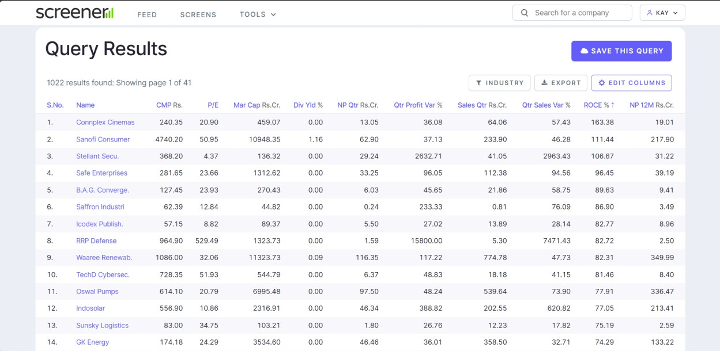
CHAPTER-3

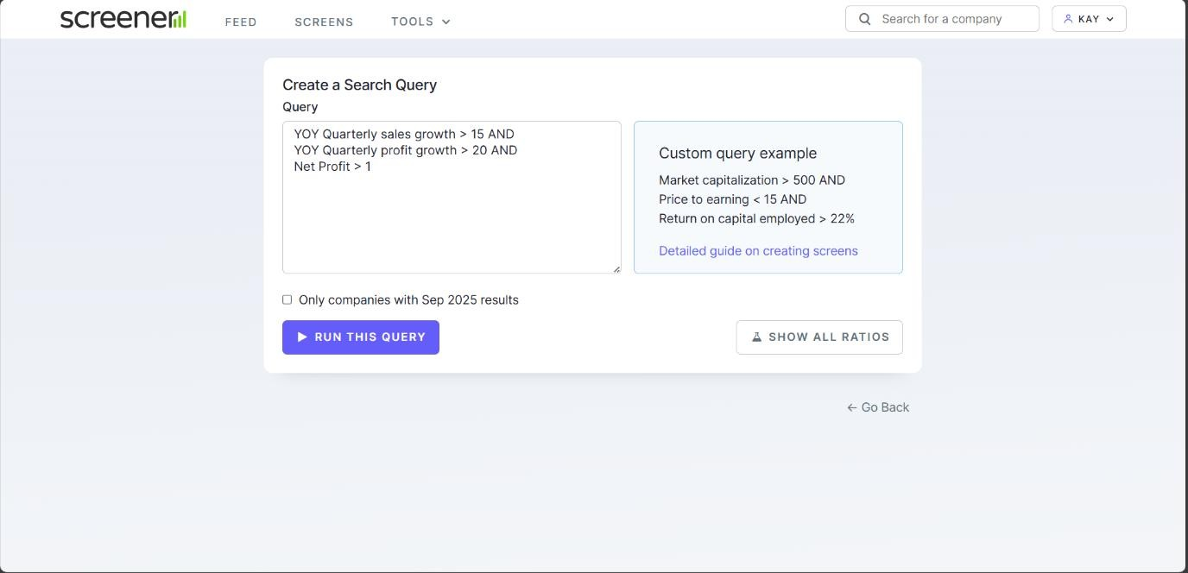
TEST CASES/ OUTPUT

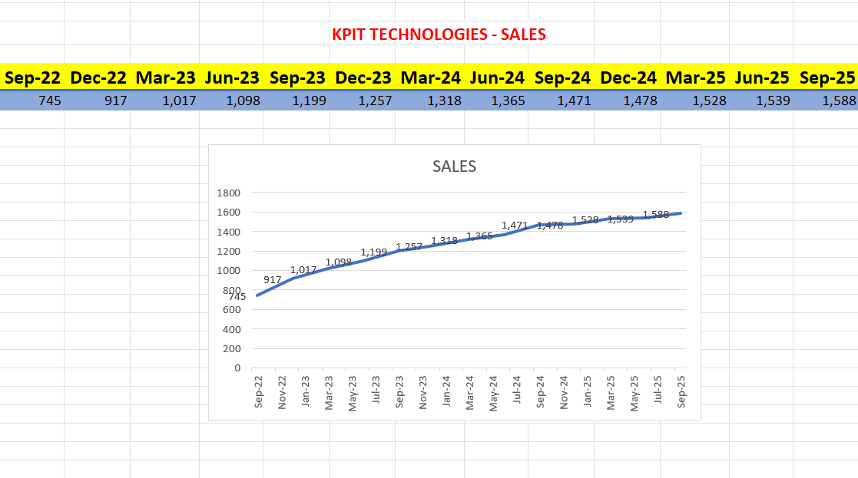
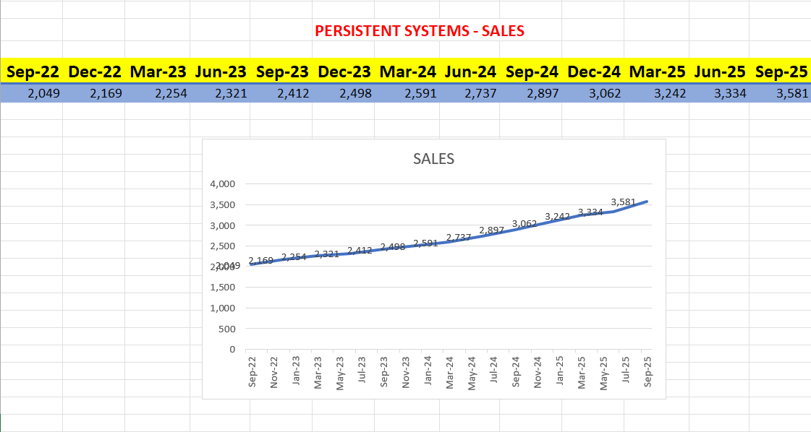

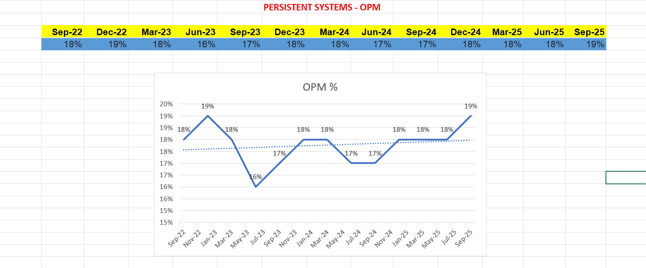
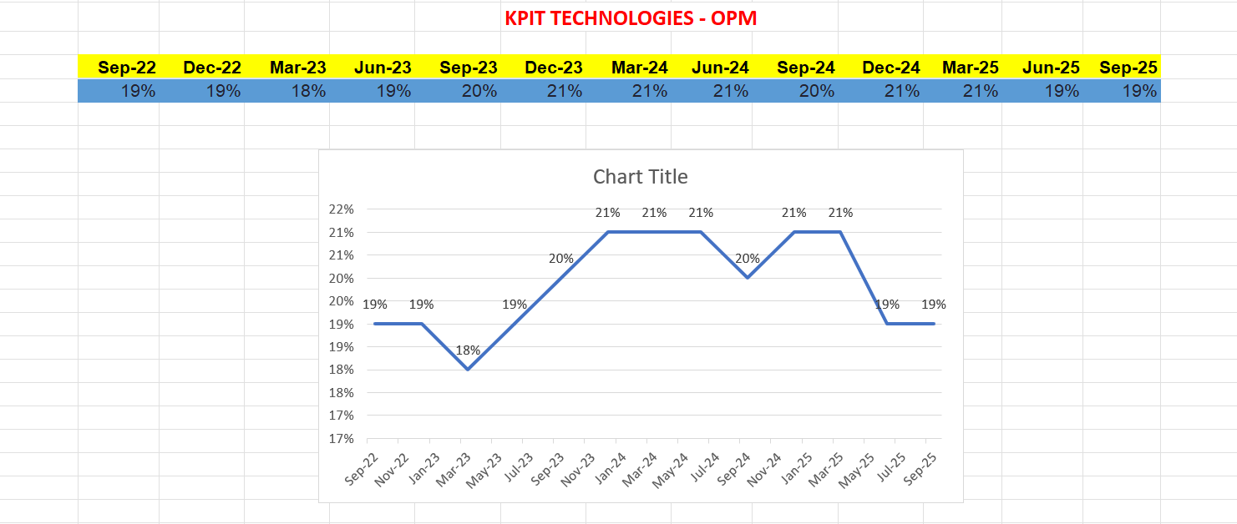
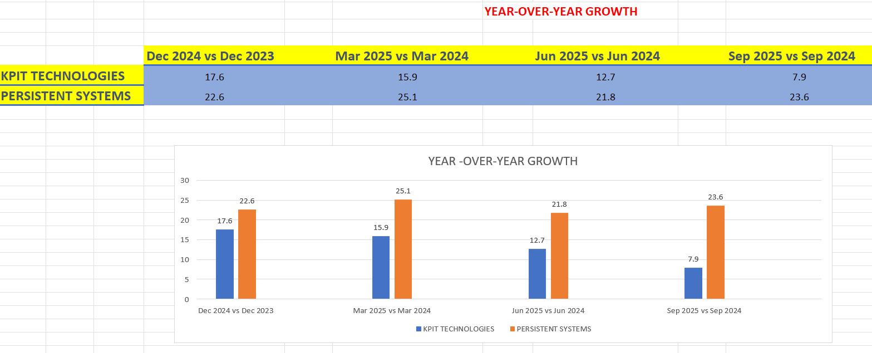

CHAPTER-4

RESULTS

The quantitative output reveals a distinct decoupling of performance between the two entities in FY25.
A. Operational Performance: Sales & Margins
- Sales Velocity: The Divergence of Demand
  - Persistent Systems (Accelerating Trajectory): The company has demonstrated exceptional resilience. In the most recent quarter (Sep 2025), Persistent reported sales of
₹3,581 Cr, representing a YoY growth of 23.6%. This is not an anomaly; the company has consistently maintained a growth band of 21%–25% over the last four quarters. This linear acceleration suggests the company is successfully capturing market share in Digital Engineering and AI modernization.
  - KPIT Technologies (Decelerating Trajectory): KPIT exhibits clear signs of saturation. From a high-growth base in FY24 (~17-20%), revenue momentum has slowed sharply. The Sep 2025 sales stood at ₹1,588 Cr, translating to a growth rate of just 7.9%. This breakdown from double-digit to single-digit growth indicates a demand normalization in the Automotive ER&D vertical.
- Margin Efficiency: The Quality of Earnings
  - Persistent Systems: The company is benefiting from Operating Leverage. Margins have structurally improved from ~16% (mid-2023) to 19% (Sep 2025). The ability to expand margins while growing revenue >20% indicates strong pricing power and cost efficiencies.
  - KPIT Technologies: The company faces Margin Compression. Margins have contracted from a peak of ~21% to 19% in the most recent quarter. This "double negative" (slowing sales and shrinking margins) implies rising costs or pricing pressure from automotive clients.

Persistent Systems: Outperformer. The stock price rally is fully justified by financial performance. The company is firing on all cylinders—Sales Velocity and Profitability. It remains a core holding for growth portfolios.

KPIT Technologies: Underperformer. The financial performance does not justify the current stock price. The deceleration in growth and margin contraction warrants a cautious approach. We recommend reducing exposure until revenue momentum re-accelerates.
trends and fundamentals.

CHAPTER 5

SUMMARY, CONCLUSION

  - Summary
The comparative analysis of Persistent Systems and KPIT Technologies reveals a distinct decoupling in financial trajectories for the fiscal period ending September 2025. While both entities have historically delivered multi-bagger returns, the current data highlights a sharp divergence in growth quality and sustainability.
Revenue Momentum: Persistent Systems has established a linear growth trajectory, consistently delivering >21% YoY growth, driven by broad-based demand in Digital Engineering. In contrast, KPIT Technologies has entered a phase of structural deceleration, with growth rates compressing from high- teens to 7.9%, reflecting saturation and cyclical headwinds in the automotive vertical.
Operational Efficiency: A critical differentiator is the direction of margins. Persistent Systems is demonstrating Operating Leverage, with margins expanding to 19% alongside revenue growth. KPIT, however, is witnessing Margin Compression (peak of 21% $\to$ 19%), indicating that its growth is becoming capital-intensive and less profitable per unit.
Valuation Disconnect: Market valuations currently reflect a lag in pricing KPIT's slowdown. While Persistent’s premium multiple (60x P/E) is supported by earnings acceleration (PEG ~1.3), KPIT’s valuation (~40x P/E) appears disconnected from its single-digit growth reality, signaling a potential "Value Trap."
  - Conclusion

Final Verdict: Persistent Systems Demonstrates Healthier Growth
The objective of this case study was to determine whether the stock price rally for these mid-cap IT giants was justified by financial performance. The data overwhelmingly supports Persistent Systems as the superior compounding asset.
- Justification of Performance: Persistent Systems’ stock price appreciation is fundamentally anchored in earnings power. The company has successfully transitioned from a linear IT services firm to a high-velocity platform play, capitalizing on the AI and Data Engineering boom. Its ability to maintain acceleration at scale justifies its valuation premium.
- Risk Assessment: KPIT Technologies presents a skewed risk-reward ratio. The company is priced for perfection (expecting 20% growth) but is delivering normalization (8% growth). The high concentration risk in the cooling EV sector serves as a significant headwind. Without a rapid pivot or

sector recovery, the stock faces substantial de-rating risk.

Investment Takeaway:
For investors prioritizing sustainable, high-quality growth, capital allocation should favor Persistent Systems. It offers high earnings visibility and execution stability. Investors in KPIT Technologies should exercise caution, as the current price does not adequately factor in the velocity of its recent slowdown.

REFERENCES

- Persistent Systems Ltd. (2025). Q2 FY26 Investor Presentation. Retrieved from persistent.com.

- KPIT Technologies Ltd. (2025). Q2 FY26 Financial Results.
- Screener.in. (2025). Financial Analysis: Persistent vs. KPIT. Retrieved November 22, 2025.

- NSE India. (2025). Historical Share Price Data.

- Money control. (2025). Quarterly Results and Performance Trends: Persistent Systems & KPIT Technologies. Retrieved from moneycontrol.com.

- Economic Times Markets. (2025). Mid-cap IT Sector Outlook and Analyst Commentary. Retrieved from economictimes.com/markets.

- Motilal Oswal Financial Services. (2025). IT Sector Report: Growth Drivers and Valuation Metrics. Retrieved from motilaloswal.com.

- ICICI Direct. (2025). Earnings Review: Persistent Systems & KPIT Technologies. Retrieved from icicidirect.com.

- Bernstein Research. (2025). Indian IT: Demand Trends and Margin Outlook. Retrieved from their industry publications.

- Analytics India Magazine. (2025). AI Adoption and Digital Engineering Trends Impacting IT Firms. Retrieved from analyticsindiamag.com.

