Garbage Classifier

EECS 4422 Computer Vision

Author: Koko Nanahji

Student Number: 215168057

Abstract

This paper describes implementation of a garbage classification tool that can be used to sort garbage in three bin system. This tool is designed to be used as part of augmenting the existing garbage bins into “smart” garbage bins” that could replace the bins that are located on our streets. The algorithm uses classical computer vision method called Histogram of oriented gradients (HoG) to represent each image and uses Support Vector Machine as the classification algorithm. The data used in project consist of mostly real data that was found online, and some additional data was taken specifically for this project.

1. Motivation

Environmental protection has become one of the major concerns of 21st century. One of the main contributors to the pollution and contamination of the environment is insufficiency in waste management systems. Implementing an effective waste management infrastructure can help us clean up our environment and preserve it for future generation. Successful waste management starts from the time that the object makes it to disposal. Therefore, separating waste into proper categories is a crucial part in the overall waste management infrastructure. However, finding the right garbage bin for a specific object can be challenging and learning where each object should be placed can be time consuming. The main motivation behind the project described in this paper is to help ease this process. The garbage classifier application is designed to help categorize disposed items in a three-bin garbage segregation system.

1. Context

The application describe in this paper is designed to be part of the augmentations that needs to be added to the current garbage bins. In order to benefit from this application, a new set of hardware devices need to be added to the current garbage bins. The main job of the added hardware is to capture an image of the object and feed the image to this application. Afterwards, the application classifies the object and returns the ID corresponding to a garbage bin. The added hardware, after receiving the ID of the identified bin, drops the object in the correct bin. Therefore, augmented garbage bins should ease the process of garbage segregation and help us better take care of our environment.

1. Dataset Description

This application is developed for three bin system, where there is one bin for recyclables, another bin for organics and one additional bin for non-recyclable items. Therefore, the dataset to train and test the application contains items that belong to each category. Given time restrictions for this project we chose only a few items that are typically seen in garbage bins and created the dataset accordingly. The dataset contains apple and banana images which belong to the organic category, it also contains images of cans, such as soda cans, tomato soup cans and chowder can as well as juice boxes (both small and large boxes) which all belong to the recyclable category and finally it contains images of (standard) light bulbs in the non-recyclable category. The dataset consists of images that were mostly found on GitHub repositories and some other images that were taken manually to increase the variety of the items in the dataset. One of the major issues with doing this project was disproportionate size of images that can be found on computer vision dataset repositories. As there are many apple and banana images however there are very few images of light bulbs.

1. Method

The garbage classification algorithm described in this paper is based on classical computer vision and machine learning methods. Main reason for using classical methods instead of using newer and more popular techniques such as deep neural networks, was the limited size of the available dataset. Since neural networks are “data hungry”, training a neural network would require large volume of data that was not available, however classical methods can achieve successful results without requiring “too much” data.

The classification method that is used in this application is Support Vector Machine (SVM). The main idea behind Support Vector Machines is to find the hyperplane that has the largest distance to the nearest training data point of any class in input space. Since, in general it is believed that the larger the margin (the distance from the hyperplane to the nearest training data point of any class), the lower the error of the classifier will be in real world data. The reason that Support Vector machines were chosen as the classification method is because the evaluation results showed that, for this specific problem and dataset, Support Vector Machine outperformed the other two algorithm that were originally being considered as the classification method namely, K-Nearest Neighbours algorithm and Multi-class logistic regression.

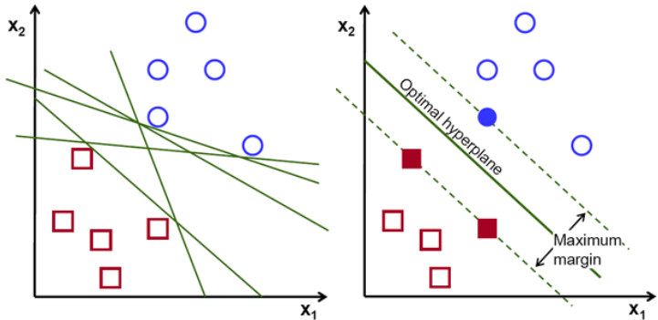The feature vector to describe each image is created by the classical computer vision method called Histogram of Oriented Gradients (HOG) method. Histogram of Oriented Gradients divides the image into small patches and creates a histogram of the oriented gradients for each patch. The combination of these histograms constitutes the feature vector that is used to describe each image. The reason that output of Histogram of Oriented Gradients is used as the feature vector is because it outperformed the other technique that was tried which was using keypoints as the descriptor of each image. However, given the shapes of the items this approach performed poorly and did scale properly even on small set of items.

Figure 1: Shows the hyperplane chosen by Support Vector Machine in this simple example

Given the disproportionate size of data for each category in the dataset, we were only able to use small subset of the images in the categories that had excessively more data than the other categories. For example, as was mentioned before, there are about 1000 images for apples however due to lack of images in the other categories, such as light bulbs, we only used 50 (randomly chosen) images from the apple category to train the classifier.

1. Evaluation Method

The evaluation of the goodness of fit of the model is done based on k-folds cross validation method. Cross validation is used in measuring the prediction accuracy of a predictive model and estimating the performance of the model in real world. The way that k-fold cross validation works is that the original dataset is divided into k equal sized chunks. One of the k chunks is used for testing the model, and the remaining k − 1 chunks are used as the training data. This process is repeated k times, with each of the k subsamples used exactly once as the test data. The combination of the k results is used to produce a single estimation of the accuracy of the model. The main advantage of this method over other methods is that all the available data is used for both training and testing. Therefore, given the limited size of the dataset, cross validation was a reasonable choice for model evaluation.

1. Experimental Results

The results that were found be cross validation showed a reasonable success.

1. Analysis of Results

The results shows us that Hog descriptor with SVM can be a solid alternative for neural networks and have a reasonable performance.

1. Restrictions and Future Work

There are many restrictions on the proposed solution in this paper to garbage classification problem. One of the major issues is the scalability of the items that can be classified. Addition of new objects could cause the application to have bad performance. Sine the approach of this paper is based on Hog descriptors and these descriptors only consider the shape of the object therefore adding new items that have similar shape could cause the classical method to fail for example, pear and light bulb however a CNN would be able to distinguish between these items. Future work to rectify this problem could be to add other features such as color and texture to the feature vector of the images. Another problem with the approach of distinguishing objects based on images could be problematic as some objects look exactly alike but they should be placed in separate bins such as a real apple vs plastic apple as both of these look the same the image alone will not provide enough information to distinguish them. Possible solution could be to add another metric such as the weight of the object into as a predictor in additional to the image of the item.