MALLORN Astronomical Classification Challenge

Overview
This project tackles the MALLORN Astronomical Classification Challenge Kaggle competition. The goal is to identify Tidal Disruption Events (TDEs) — stars torn apart by supermassive black holes — from simulated LSST multi-band light curves constructed from real ZTF observations.
Competition Metric: F1 Score (binary classification, target = 1 for TDE).
Kaggle Profile: jackieveloped

Dataset
Split | Objects | TDE (target=1) | Non-TDE (target=0)
Train | 3,043 | ~64 | ~2,979
Test | 7,135 | Unknown | Unknown

The training set is severely imbalanced (~2% TDE). Non-TDE objects include AGN (Active Galactic Nuclei) and Type II Supernovae (SN II).
Each object has:
- Metadata: redshift (Z, Z_err), extinction (EBV), spectral type (SpecType)
- Light curves: multi-band (u, g, r, i, z, y) time-series photometry split across 20 data files

Data Parsing
The competition data is split into two parts: metadata and light curves.

Metadata
Two CSV files at the top level:
- train_log.csv — 3,043 training objects with columns: object_id, Z, Z_err, EBV, SpecType, split, target
- test_log.csv — 7,135 test objects with the same columns (except target)

Light Curves
Light curve data is distributed across 20 subdirectories (split_01/ to split_20/), each containing train_full_lightcurves.csv and test_full_lightcurves.csv.
Each light curve file has columns: object_id, Time (MJD), Flux, Flux_err, Filter (u/g/r/i/z/y).
Each split file contains ~26K (train) or ~59K (test) observation rows. To reconstruct a complete dataset, all 20 splits must be concatenated.

Methodology

1. Feature Engineering
We extract 190+ features from each object's light curve across several categories:
Global Flux Statistics (16 features)
Mean, std, median, min, max, range, skewness, kurtosis, percentiles (P10, P90), IQR, MAD, fraction above mean, fraction positive flux, inverse-variance weighted mean.
Error & Signal-to-Noise Features (6 features)
Flux error mean/std/median, SNR mean/max/std.
Temporal Features (10 features)
Time span, cadence statistics, flux rate of change statistics, fraction of positive flux rate.
Peak Analysis (7 features)
Peak flux, peak phase, peak time, rise/decline rate, rise/decline duration, rise-to-decline ratio.
Variability Indices (4 features)
Stetson J index, Von Neumann ratio, excess variance, number of peaks.
Per-Filter Features (17 x 6 = 102 features)
For each LSST band (u, g, r, i, z, y): count, mean, std, max, min, range, skewness, kurtosis, SNR, weighted mean, MAD, P10, P90, positive fraction, max rate, mean rate, peak phase, Stetson J.
Color Features (18 features)
Mean and peak flux differences between band pairs, color variability in (g-r) and (r-i).
Cross-Filter Timing (3 features)
Peak delay between bands: (g,r), (r,i), (i,z).
Metadata Interaction Features (8 features)
Flux statistics divided by redshift, Z x EBV, log features, has_z_err indicator.

2. Model Ensemble
We use a 3-model ensemble to maximize prediction diversity:
Model | Type | Key Config
LightGBM | Gradient Boosting | lr=0.02, max_depth=7, 31 leaves, 3000 rounds
XGBoost | Gradient Boosting | lr=0.02, max_depth=7, 3000 rounds
ExtraTrees | Random Forest variant | 500 trees, max_depth=10, balanced class weights

All models use scale_pos_weight (or class_weight="balanced") to handle the severe class imbalance.

3. Cross-Validation
- 5-fold Stratified K-Fold ensures each fold preserves the TDE class ratio
- Each model produces out-of-fold (OOF) predictions used for ensemble optimization
- Early stopping (patience=150 rounds) for LightGBM and XGBoost

4. Ensemble Weight & Threshold Optimization
After cross-validation, we perform a grid search on OOF predictions to find optimal ensemble weights and classification threshold, jointly maximizing the F1 score.

Experiments & Results
We explored multiple approaches, progressively improving the pipeline. All scores are F1 on Kaggle's private/public leaderboard.

Kaggle Submission Results
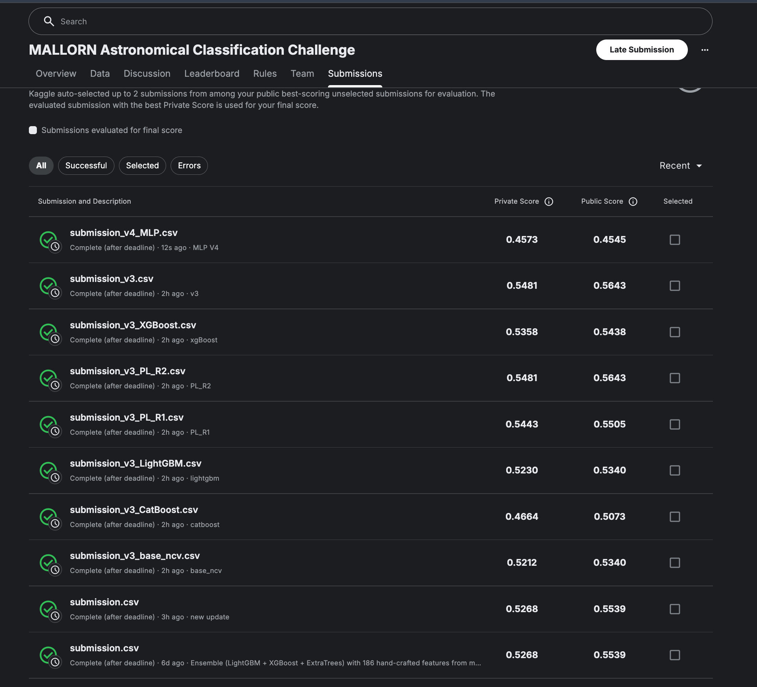

Approach 1: Baseline Ensemble (LightGBM + XGBoost + ExtraTrees)
- Features: ~150 hand-crafted features
- Models: LightGBM, XGBoost, ExtraTrees with 5-fold stratified CV
- Ensemble: Grid search over ensemble weights + threshold optimization on OOF predictions
- No oversampling
Submission | Private Score | Public Score
Ensemble (weight-optimized) | 0.5268 | 0.5539

Approach 2: Enhanced Features + Stacking + SMOTE
- Features: ~267 features — added Bazin function fits, structure function, autocorrelation, flux asymmetry, rolling statistics, Stetson K index
- Models: LightGBM, XGBoost, CatBoost, ExtraTrees, BalancedRandomForest (5-model)
- SMOTE oversampling (k=3) within each CV fold
- Stacking: Logistic Regression meta-learner on base model outputs
- 10-fold CV with nested CV threshold selection
This approach did not yield a clear improvement over Approach 1, likely due to feature noise from the larger feature set and potential overfitting with 5 models on a small TDE sample.

Approach 3: Feature Selection + Optuna Tuning + Pseudo-Labeling
- Features: Top 60 features selected via multi-seed LightGBM importance
- Models: LightGBM, XGBoost, CatBoost (focused 3-model ensemble)
- Optuna: Bayesian hyperparameter tuning: 50 trials per model
- SMOTE (k=3) within 10-fold CV
- Pseudo-Labeling: 2 rounds of self-training on high-confidence test predictions
- Nested CV threshold selection (median from 5-fold inner CV)
Submission | Private Score | Public Score
3-Model Ensemble | 0.5481 | 0.5643
Pseudo-Label Round 2 | 0.5481 | 0.5643
Pseudo-Label Round 1 | 0.5443 | 0.5505
XGBoost (single model) | 0.5358 | 0.5438
LightGBM (single model) | 0.5230 | 0.5340
Base Ensemble (nested CV) | 0.5212 | 0.5340
CatBoost (single model) | 0.4664 | 0.5073

Approach 4: MLP + Multi-Seed Blending
- Features: Same top 60 features as Approach 3, with StandardScaler for MLP
- Models: LightGBM, XGBoost, CatBoost, MLP (2-3 hidden layers)
- Multi-seed blending: Each model trained with 3 seeds x 10-fold CV, predictions averaged
- Optuna tuning for all 4 models (40-50 trials each)
- 2 rounds of pseudo-labeling
Submission | Private Score | Public Score
MLP (single model) | 0.4573 | 0.4545

MLP underperformed tree-based models significantly. Multi-seed blending added training cost without improving over Approach 3.

Summary
Approach | Best Private Score | Key Technique
Baseline Ensemble | 0.5268 | Weight-optimized 3-model ensemble
Enhanced Features + Stacking | ~0.5268 | SMOTE + 5-model stacking
Feature Selection + Optuna + PL | 0.5481 | Feature selection + HPO + pseudo-labeling
MLP + Multi-Seed | 0.4573 | Neural network + multi-seed blending

Best result: F1 = 0.5481 (Private) achieved by the Approach 3 ensemble and its pseudo-labeled variant.

Key Takeaways
- Feature selection > feature quantity: Reducing from 267 to 60 features improved generalization
- Hyperparameter tuning matters: Optuna-tuned models significantly outperformed manually-tuned ones
- Pseudo-labeling helped slightly: Round 2 matched the base ensemble; Round 1 was close
- Tree-based models dominate: XGBoost was the strongest single model; MLP was the weakest
- CatBoost underperformed relative to LightGBM and XGBoost on this task
- Threshold optimization is critical: Optimal threshold was far below 0.5

Dependencies
- Python 3.12
- pandas, numpy, scipy
- scikit-learn
- lightgbm
- xgboost
- matplotlib
- tqdm

Analysis
- Class imbalance is the central challenge: only ~2% of training objects are TDEs. Standard accuracy metrics would be misleading; F1 score focuses on the minority class. Threshold optimization on OOF predictions is essential.
- TDEs have distinctive light curve morphology: rapid flux rise followed by a power-law decline, which differs from the stochastic variability of AGN and the plateau behavior of SN II.
- Multi-band color evolution matters: TDEs show characteristic blue color that evolves over time, captured by cross-filter peak delays and color features.
- Redshift normalization is physically motivated: dividing flux-based features by redshift accounts for distance effects, making features more comparable across objects at different distances.
- Ensemble diversity improves robustness: LightGBM and XGBoost learn similar gradient-boosted patterns but differ in regularization and splitting strategies, while ExtraTrees provides a complementary randomized approach.

