Maxwell Miller-Golub

9/12/2024

DATA 413/613

Homework 1: Bash

Question 1: (10 Points)

What is the difference between shell and bash?

 “Shell” refers to any program that has a command line interface (CLI), but Bash is a particular type of shell that has specific commands and properties.

Question 2: (10 Points) To respond to this question, you need to use terminal/Bash and have a screenshot of your terminal/bash.

1. What is your home directory?

My home directory is “Users/mmg”



1. What files/folders exist in it?

A couple preset folders (and a bunch of files I should probably have better organized elsewhere)

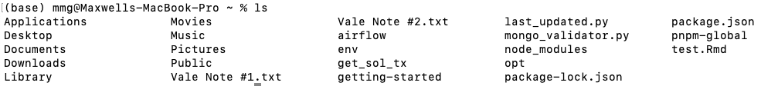

That list gets a lot longer if you select hidden files as well…

Question 3: (10 Points)  To respond to this question, you need to use terminal/Bash and have a screenshot of your terminal/bash.

1. Where does the command `cd../../` take you? Run the command `pwd` and explain the output!

“cd ../..” takes me to the root directory of my system. “Pwd” outputs “/”, which could also be interpreted as “Macintosh HD”

1. What does the command `cd` do? Run the command `pwd` and explain the output!

Question 4: (10 Points)  To respond to this question, you need to use terminal/Bash and have a screenshot of your terminal/bash.

Read the manual page of ls. What does the `a` flag do? What does the `l` flag do?

Inputting “man ls” brought up my systems manual on “ls.” I didn’t see a description for a lowercase “a” flag, but uppercase A returns directory entries that begin with a dot. The “l” flag lists files in “long format”





Question 5: (A and B each have 5 points, and C has 10 points. The total is 20 points.)  To respond to this question, you need to use terminal/Bash and have a screenshot of your terminal/bash.

1. Create a folder within your home directory, which was identified in Question 2, and name it 'temp_bash'.A close-up of a computer code

   Description automatically generated
2. Create a new file using the command `touch` and name it `myfile.txt` inside the new folder `temp_bash` and run `ls` to show that the file is inside the folder.

1. Run the `stat myfile.txt` command and explain the information retrieved from the output.

File: the given file name

Size: number of bytes stored in the file

Filetype: the type of the file

Mode: the permissions granted to users to read, modify, etc on the file

Uid: my user identification number (as the files creator)

Gid: the group identification number of the file. With Uid, these determine who has access to the file

Device: My devices’ number (in hexidecimals)

Inode: the unique file identifier number within my device’s system

Links: the number of hard links of the file. In this case “myfile.txt” is a hard link to the object that it refers to.

Access: datetime of the last time the file was accessed

Modify: datetime of last file modification

Change: datetime when either an attribute of the file or the content of the file was changed

Birth: datetime that file was created

Question 6: (40 Points)  To respond to this question, you need to use terminal/Bash and have a screenshot of your terminal/bash.

1. Use the command `>>`  and add the following line This line is my first line. Now add the following line This line is my second line. Then, run cat myfile.txt to show that the line has been added.

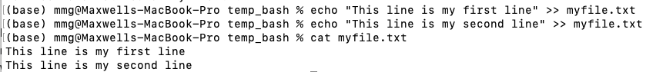

1. Copy the file  myfile.txt to file copy_myfile.txt with the command `cp`



1. Use the command `>`  and add the following line This line is a new line to copy_myfile.txt. Then run cat copy_myfile.txt to show the line is added.
2. Explain the difference between `>` and `>>` based on the result of the Question 6.

 “>” will overwrite a file with the new information you’ve given, but “>>” will append the new information to the end of the file. “>>” is much safer to use because you can append to an empty file without fear of erasing what’s already there.