Evaluation of Three Research Prompts Across 225 Web Dialogues
Local analysis of a browser experiment · 30 September 2026

Summary
Five conditions were tested on 15 distinct web research tasks, with three independent repetitions. All 225 final dialogues were completed using GPT-5.6 Sol High. The data were evaluated from local files; no additional Oracle outputs were included in the analysis.
- Verification First: no confirmed gain. The difference in the formal “criteria plus direct link” indicator is +0.050 [−0.054; +0.171], while required content marker coverage differs by −0.017. Responses are longer and slower.
- Question Horizon: the indicator of substantive coverage of latent aspects increased by +0.111 [+0.037; +0.200], but response length rose from 697 to 2,197 words and time from 67.0 to 148.2 s. Some of the expansion is useful; this indicator does not verify the truth of every claim.
- Clarify Then Investigate: the first turn covered substantially more relevant clarification topics (+0.858 [+0.777; +0.930]); the mean was 10.2 questions. Final required content marker coverage increased by +0.049 [+0.013; +0.090], below the predefined +0.10 threshold.
Conclusion under the frozen protocol: no prompt can yet be credited with a confirmed advantage in producing correct, adequately supported answers. The available numbers are a transparent automated screen; source support for every material claim and the rate of material errors across all 225 responses have not been certified.

Design and Reproducibility
Element | Frozen Condition
Sample | 15 tasks: 4 factual, 4 analytical, 4 practical, 3 ambiguous
Repetitions | 5 conditions × 3 fresh browser sessions per task = 225 dialogues
Conditions | base; verify; horizon; two_turn_base; clarify
Paired comparisons | verify–base; horizon–base; clarify–two_turn_base
Environment | Oracle browser engine; GPT-5.6 Sol; High; Web Search; concurrency 3
Exclusions | The 15-dialogue pilot and earlier API runs are excluded from the final sample

In the two-turn conditions, the first message contained a short, deliberately incomplete request. The second message supplied the same complete details to both conditions. It did not answer each of the 5–15 personalized questions, so the experiment tests clarification behavior and final outcomes under identical facts, but not the full effect of genuine interaction with a user.
Initially, 25 runs failed for technical reasons: 17 Web Search confirmation failures and 8 readiness timeouts. Three further Web Search failures occurred during retries. In total, 28 invalid attempts were excluded; each was replaced with a fresh session under the same conditions. The manifests confirm the model and High setting for all 225 final responses.

What Was Measured
The screen searches final responses for phrases defined by the rubric. The Question Horizon question tree was removed before content scoring.
In two-turn dialogues, first-turn questions were separated from URLs with query parameters, which had initially produced false counts.
For Verification First, an additional indicator multiplies the proportion of required phrases found by the presence of a direct URL from a relevant official domain. This inventories links; it does not prove that a page supports a specific claim. Because of this limitation, it is not equivalent to the preregistered grounded task completion metric.
To estimate uncertainty, the three repetitions of each “task × condition” pair were averaged, then differences were calculated across the 15 tasks. The 95% intervals were obtained from 10,000 task bootstrap resamples. They do not capture errors in the rubric, web sources, or automated phrase recognition.

Main Numerical Results
Condition | Required | Latent | URL | Total words | Time, s
base | 0.968 | 0.830 | 41/45 | 697 | 67.0
verify | 0.951 | 0.822 | 44/45 | 879 | 94.9
horizon | 0.977 | 0.941 | 44/45 | 2,197 | 148.2
two_turn_base | 0.940 | 0.822 | 43/45 | 1,145 | 99.4
clarify | 0.988 | 0.874 | 44/45 | 1,572 | 116.8

The “required” and “latent” proportions measure automated phrase coverage, not human judgments of correctness. “Total words” includes both turns for two-turn conditions. Time includes browser execution; internal reasoning tokens and actual cost were not observed.
Paired comparison | Screening indicator | Difference and 95% interval | Tasks + / = / −
verify / base | phrases + official URL | +0.050 [−0.054; +0.171] | 5 / 6 / 4
horizon / base | latent aspects | +0.111 [+0.037; +0.200] | 6 / 9 / 0
clarify / two_turn_base | first-turn topics | +0.858 [+0.777; +0.930] | 15 / 0 / 0

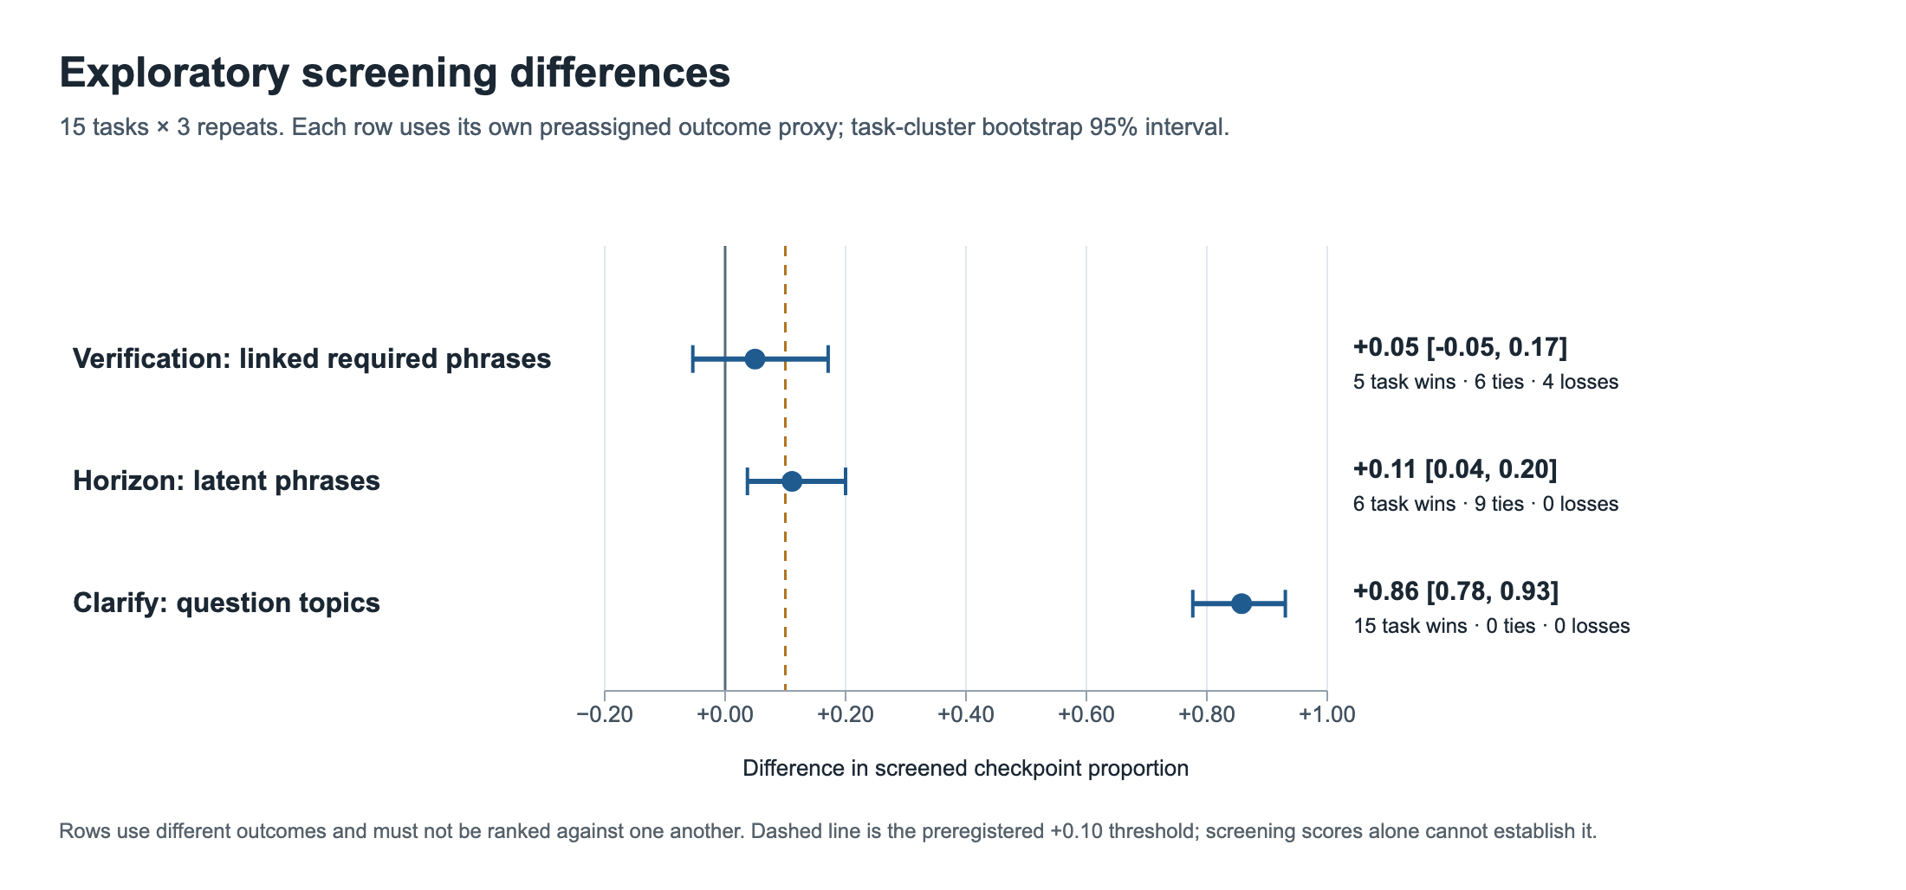
Figure 1. Differences in automated indicators. The rows use different content denominators and do not rank the three prompts.
Sensitivity check for verify: without the URL requirement, the required coverage difference is −0.017 [−0.073; +0.040]. This reverses the sign of the effect and shows how strongly the “phrases + URL” conclusion depends on link exports, especially in P03/P04.

Where the Results Change
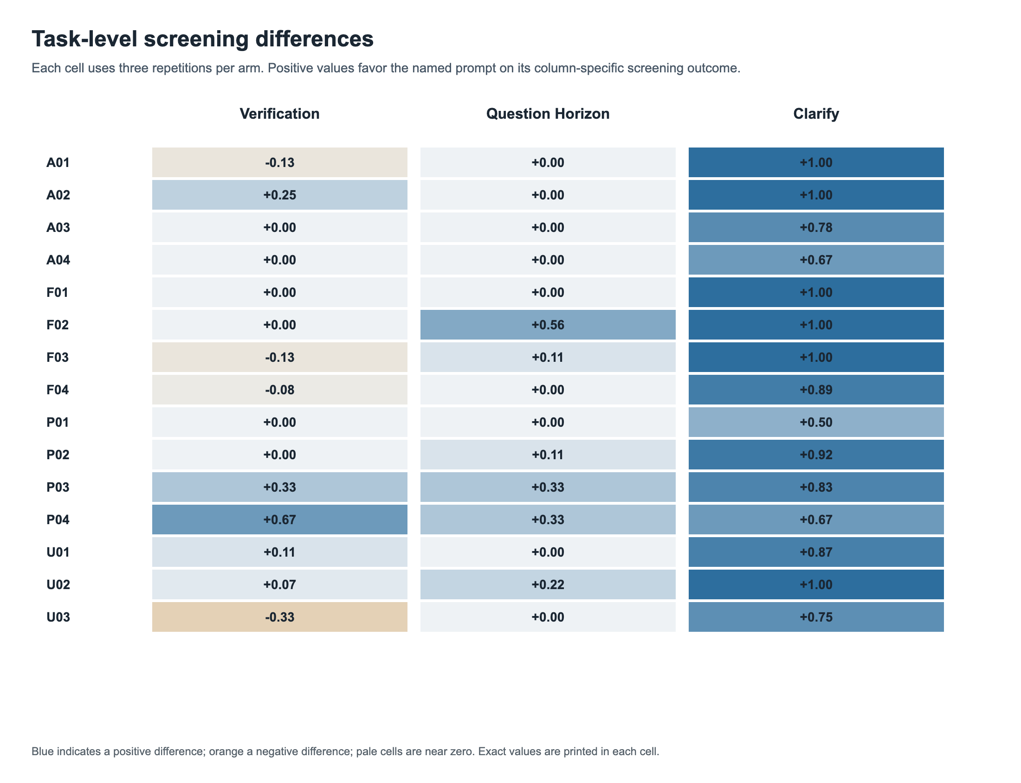
Figure 2. Changes for each of the 15 tasks. The columns show different indicators for the predefined condition pairs.
Question Horizon’s positive effect on latent aspects is concentrated in six tasks, especially F02 (WCAG 2.2 versions), P03 (GitHub Actions trust boundaries), P04 (packaging migration), and U02 (prioritization after an earthquake). The screen detected no difference in nine tasks. This is consistent with broader framing helping where latent dependencies actually exist; no universal gain is evident.
The large positive verify effect in P04 is partly explained by two P04 baseline responses containing only internal citation markers, without direct URLs in the export. Such a file does not allow source verification through a direct link, but it does not prove that the response content itself is incorrect.

The Cost of Additional Structure
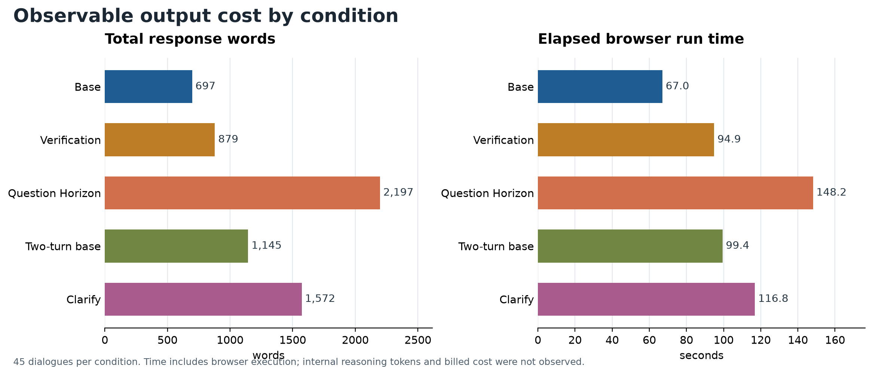
Figure 3. Observed output length and time. The two scales are shown separately; this is not an estimate of financial cost.
Compared with base, verify adds an average of 182 words and 27.9 s, while Question Horizon adds 1,501 words and 81.1 s. Clarify adds 427 words and 17.4 s relative to its two-turn control. Any substantive benefit therefore needs to justify this additional work and burden on the reader.
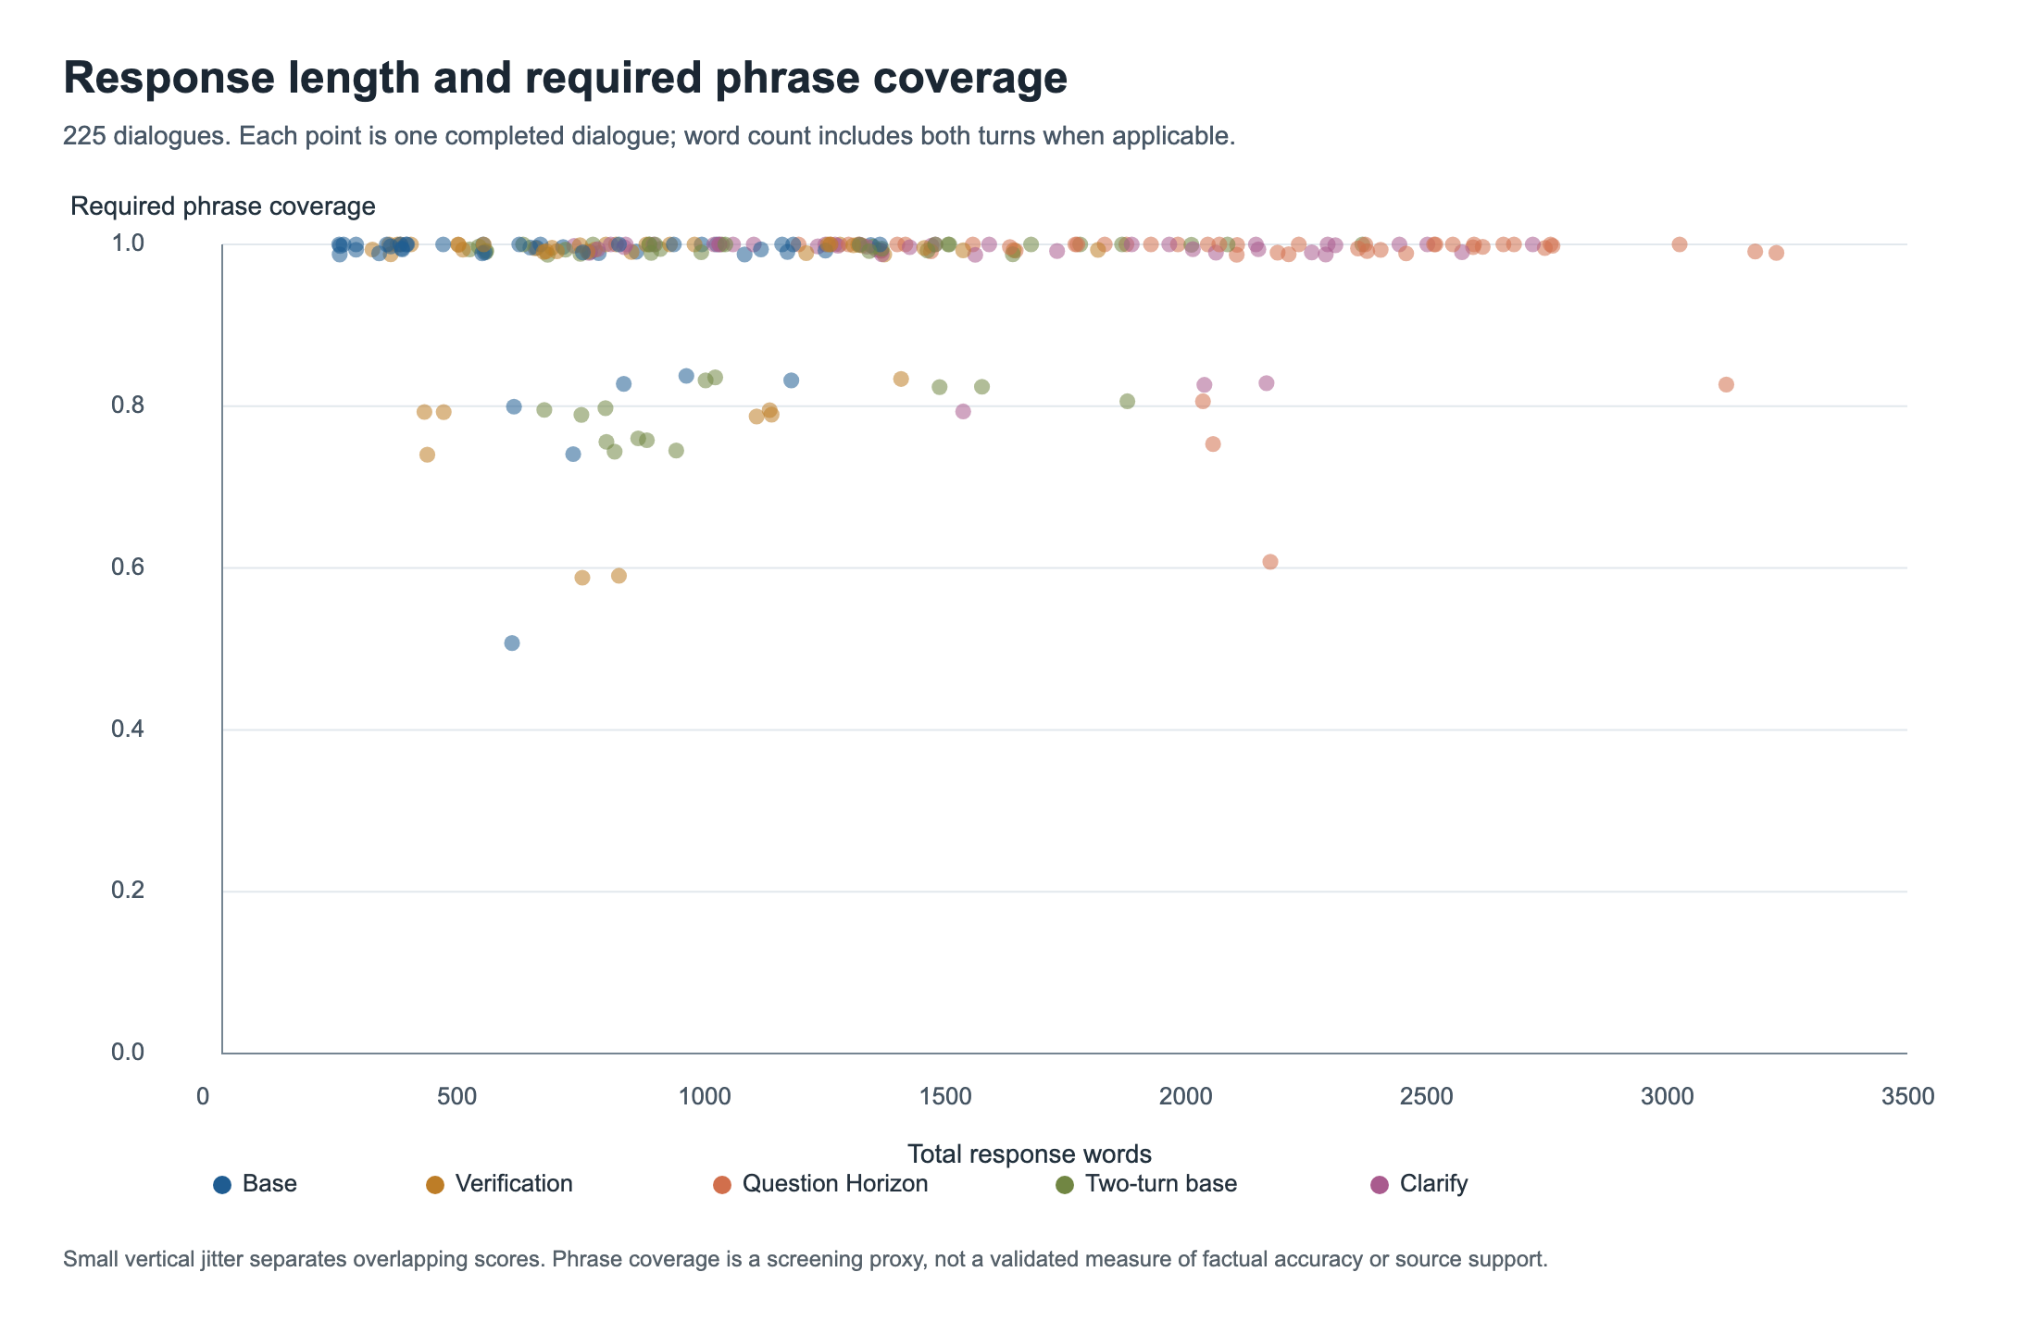
Figure 4. Response length and automatically detected required markers. Clustering near 1.0 shows the indicator’s ceiling; longer responses cannot automatically be considered more accurate.

The First Clarification Turn
Clarify asked a mean of 10.18 questions; 44 of 45 dialogues contained 5–15 questions. The exception, F03, asked four and explicitly explained that a fifth would not materially change the research. The mean for two_turn_base was 0.20: the unmodified model mostly answered the incomplete question immediately. In all 45 clarify dialogues, the first turn contained questions, followed by a second message providing the task details.
First-turn topic screening: 0.952 for clarify versus 0.094 for the two-turn control. The advantage is expected from the instruction format itself; it does not show that every question was necessary. In the simple factual F01 task about three NIST standards, samples asked 11–12 questions about infrastructure, retention periods, and regulation, although the factual error specified in the task could have been corrected without most of those answers. This is a real risk of unnecessary friction. By contrast, F03’s four questions about timeline scope and audience were an appropriate exception.
With the same complete facts in the second message, the difference in final required coverage is only +0.049 [+0.013; +0.090]. This is below the preregistered +0.10 threshold. In practice, 5–15 questions should be allowed only when that many unknowns actually affect the decision, and partial user answers should be handled explicitly.

Audit of Scores and Sources
A separate review covered 45 dialogues (20%): nine from each condition, including random, category-based, atypical, and all nine cases without a direct URL in the final export. The exact list was frozen before the screening rules were corrected and published separately so that later scoring changes could not alter the sample. The review examined the opening of each response, evidence for every criterion, source domain lists, and the full text in disputed passages. Eleven criterion marks were corrected across nine dialogues. For example, a regular expression sometimes incorrectly counted a wheel test as a clean-environment check or failed to recognize an explicit refusal to choose a city based on magnitude alone.
Of the 225 final responses, 216 contain a direct URL from the relevant official source family. Nine retained only internal ChatGPT markers; two of these had URLs in the first turn but not the final turn. A missing URL in an export is a citation reproducibility problem, not an automatic factual error. Neither the number of links nor an official domain guarantees support for a specific claim.
Audit limitations: this was a focused review, not a complete analysis of all material claims in the 225 responses; condition labels in the audit packets were not hidden. This deviates from the frozen requirement for blind evaluation. Accordingly, neither the material error rate nor the full source-grounding measure was calculated, and the rule requiring no increase in errors of 0.05 cannot be applied.

Practical Decision
Prompt | What the Experiment Showed | When to Use It
Verification First | No convincing content gain; responses are longer and slower. | When an explicit verification process matters, but do not expect a proven accuracy advantage from these data.
Question Horizon | Broader coverage of latent aspects in some tasks, at a substantial cost in length and time. | For a complex decision with unknown dependencies; require a concise summary and source verification.
Clarify Then Investigate | Systematically gathers context; the final substantive gain is small given the supplied second message. | When missing facts would actually change the recommendation; allow fewer than five questions for a simple fact-check.

The most defensible conclusion is that Question Horizon shows signs of improving research breadth, Clarify reliably changes first-turn behavior, and Verification First showed no stable substantive improvement in this sample. This is not a ranking of prompt accuracy. Confirmation requires blind semantic evaluation of all control criteria with links to specific claims and independent verification of material errors.

Limits on Generalization
- One model, one reasoning level, one browser tool, and 15 tasks; the results do not automatically generalize to other models or dates.
- The screen has a ceiling near 1.0, is sensitive to wording, and cannot distinguish a correct claim from a mention of a false claim in a negation or quotation.
- Browser run time also depends on search and the UI; it is not pure model time. API cost and hidden tokens were not observed.
- Nine exports with internal markers but no URLs complicate source evaluation and distort the indicator that requires a direct link.
- The second turn in clarify and its control contained the same complete task text, but not answers to every individual question. The cost of asking questions can therefore be estimated, while the maximum potential gain from a real dialogue cannot.

Data and Primary Sources
Reproducible files: evals/BROWSER_WEB_PROTOCOL.md; evals/browser-web-tasks.json; evals/extract_browser_local.py; evals/score_browser_local.py; evals/record_browser_focused_audit.py. Local results: local_records.json, local_score_summary.json, audit_sample.json, and focused_audit.json in the browser-web-local-analysis-20260930 folder. The original browser-web-final-20260929 package contains batch.json, design.json, tasks.json, manifests, and complete chat.md files.
Official reference sources for the tasks: NIST FIPS 203–205 — https://csrc.nist.gov/pubs/fips/203/final ; WCAG 2.2 — https://www.w3.org/TR/WCAG22/ ; NASA OSIRIS-REx — https://science.nasa.gov/mission/osiris-rex/ ; WMO State of the Global Climate 2024 — https://wmo.int/publication-series/state-of-global-climate/state-of-global-climate-2024 ; NOAA 2024 — https://www.ncei.noaa.gov/news/global-climate-202413 ; USGS magnitude/intensity — https://www.usgs.gov/faqs/what-difference-between-magnitude-and-intensity ; GitHub Actions security — https://docs.github.com/en/actions/security-for-github-actions/security-guides/security-hardening-for-github-actions ; PyPA setup.py — https://packaging.python.org/en/latest/discussions/setup-py-deprecated/ .
These sources anchor the rubric; including a URL in an answer is not equivalent to verifying support for a specific claim. Official pages may be updated after the task set freeze date of 29 September 2026.

