Air Alert Burden & Fatigue Analyzer
A reproducible Python mini-project for analyzing the burden of air raid alerts in Ukraine. The main window is 2025-06-22 to 2026-06-21, with all available history used as context.
Analytical benchmark only; not for life-safety decisions. Always follow official alerts and local safety instructions.

Key Findings
The highest total alert burden in the last 12 months is Donetska oblast with 2256.2 alert hours.
The largest nighttime burden is Donetska oblast with 1166.8 night alert hours.
The baseline model is intentionally simple: recent 7-day mean, 30-day mean, and same-weekday history. Its purpose is to create a benchmark for validation, not a safety product.
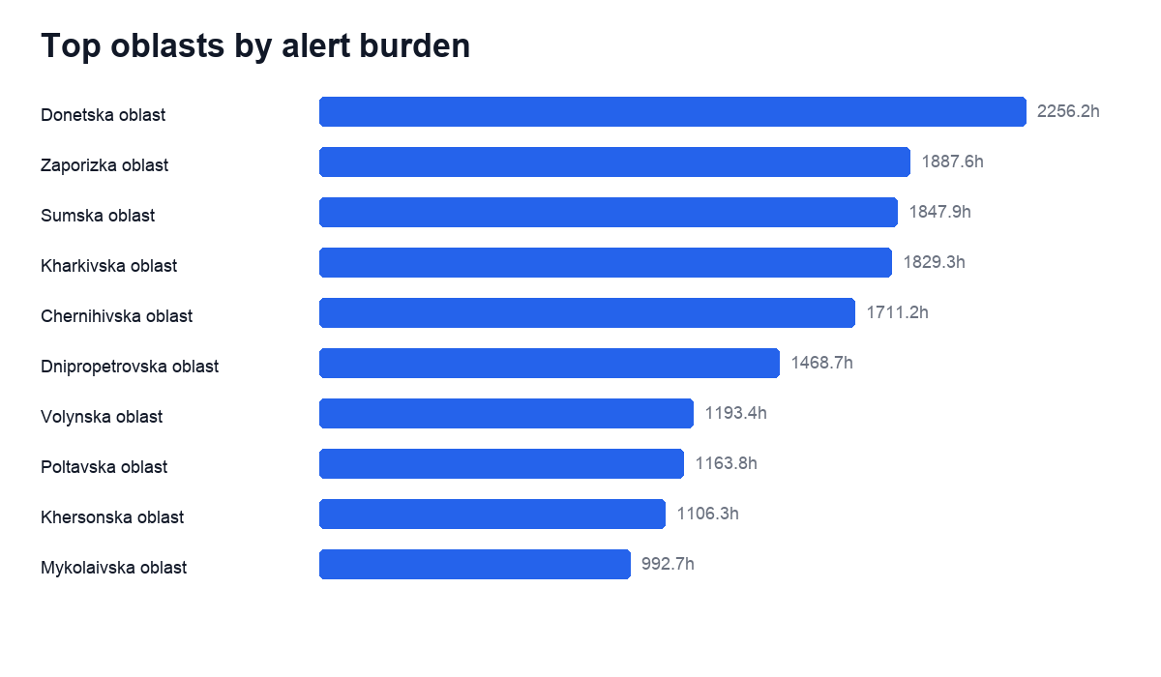
Figure 1. Top oblasts by alert burden.
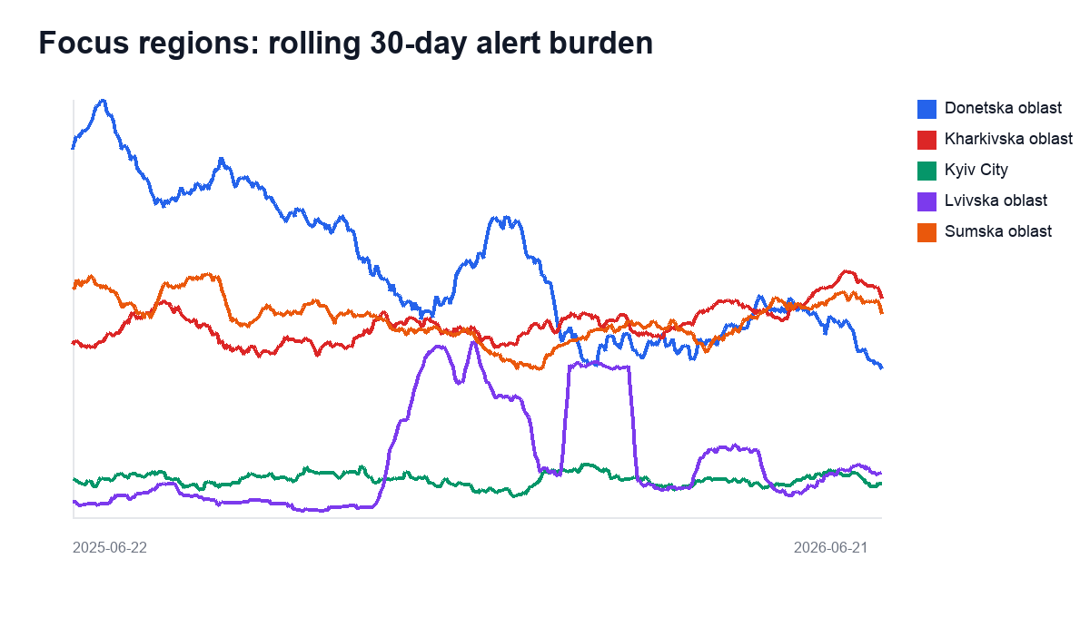
Figure 2. Focus regions, rolling 30-day burden.
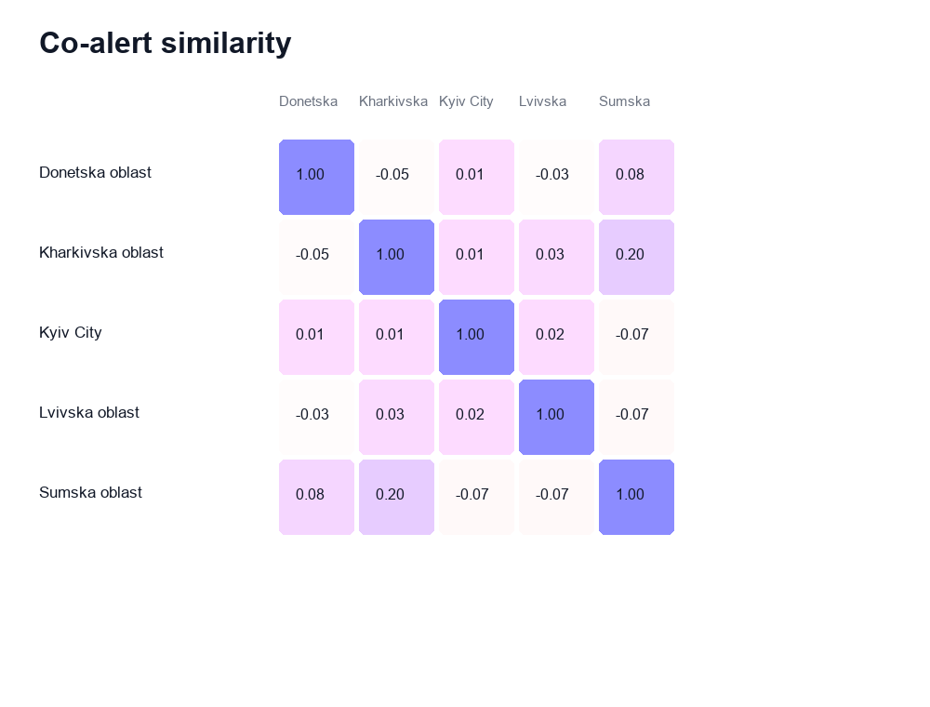
Figure 3. Co-alert similarity among focus regions.
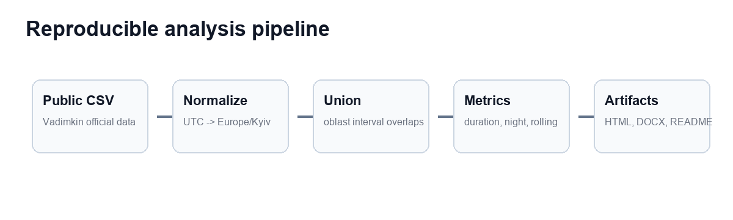
Figure 4. Reproducible analysis pipeline.

Top Regions
oblast | total_alert_hours | total_night_hours | alert_count | night_share
Donetska oblast | 2256.151 | 1166.846 | 1512 | 0.517
Zaporizka oblast | 1887.595 | 804.329 | 2247 | 0.426
Sumska oblast | 1847.911 | 784.896 | 3109 | 0.425
Kharkivska oblast | 1829.346 | 709.158 | 4160 | 0.388
Chernihivska oblast | 1711.249 | 621.223 | 2375 | 0.363
Dnipropetrovska oblast | 1468.659 | 648.802 | 3845 | 0.442
Volynska oblast | 1193.397 | 502.46 | 993 | 0.421
Poltavska oblast | 1163.822 | 482.403 | 1804 | 0.414
Khersonska oblast | 1106.318 | 577.825 | 1849 | 0.522
Mykolaivska oblast | 992.74 | 395.32 | 1873 | 0.398

Baseline Predictions
oblast | target_date | predicted_alert_hours | model
Chernihivska oblast | 2026-06-22 | 5.54 | weighted_recent_weekday_baseline
Kharkivska oblast | 2026-06-22 | 5.29 | weighted_recent_weekday_baseline
Sumska oblast | 2026-06-22 | 5.25 | weighted_recent_weekday_baseline
Dnipropetrovska oblast | 2026-06-22 | 4.33 | weighted_recent_weekday_baseline
Poltavska oblast | 2026-06-22 | 4.13 | weighted_recent_weekday_baseline
Zaporizka oblast | 2026-06-22 | 3.88 | weighted_recent_weekday_baseline
Volynska oblast | 2026-06-22 | 3.78 | weighted_recent_weekday_baseline
Donetska oblast | 2026-06-22 | 3.49 | weighted_recent_weekday_baseline
Mykolaivska oblast | 2026-06-22 | 2.57 | weighted_recent_weekday_baseline
Khersonska oblast | 2026-06-22 | 2.52 | weighted_recent_weekday_baseline

Backtest
oblast | mae_hours | n_test_days
Luhanska oblast | 0 | 1548
Ivano-Frankivska oblast | 0.63 | 1548
Zakarpatska oblast | 0.79 | 1548
Rivnenska oblast | 0.83 | 1548
Lvivska oblast | 0.86 | 1548
Ternopilska oblast | 0.87 | 1548
Khmelnytska oblast | 0.95 | 1548
Kyiv City | 1.04 | 1548
Chernivetska oblast | 1.04 | 1548
Volynska oblast | 1.05 | 1548

Source and Method Ledger
layer | source | status | caveat
Alert history | Vadimkin Ukrainian air raid sirens dataset, volunteer_data_en.csv | reported public-warning events | Volunteer data is oblast-level and starts earlier, but some end times are imputed when marked naive.
Regional aggregation | Derived by this project | calculated | Overlapping records inside the same oblast are unioned to avoid double counting.
Night burden | Derived by this project | calculated | Night is defined as 22:00-07:00 Europe/Kyiv local time.
Baseline forecast | Derived by this project | experimental benchmark | Not a safety recommendation and not a tactical prediction.

Limitations
- Air raid alerts are public-warning events, not direct records of attacks.
- From late 2025, official records become more granular in some places, so oblast aggregation is conservative.
- Night burden is based on time overlap with a fixed local-night window.
- The baseline model is not a life-safety decision tool.

