**COVID-19 DATA ANALYSIS EXECUTIVE SUMMARY**

**A. Introduction**

As the world grapples with the unprecedented challenges posed by the COVID-19 pandemic, this data analysis project aims to shed light on critical aspects of the ongoing health crisis. This executive summary encapsulates the purpose, methodology, and key findings of our comprehensive COVID-19 data analysis.

**IMPLEMENTATION GUIDANCE FOR LOCKDOWN POLICY**

**Section I: Guidance for Lockdown Enforcement**

As part of the measures in place to enforce social distancing and limit the Spread of the SARS-CoV-2, the Federal Government of Nigeria has decided that schools, organizations and businesses in FCT, Lagos and Ogun States will close effective from 30 March 2020 at 23:00h for an initial period of 2 weeks.

● for the period of the lockdown, every person is confined to his or her place of residence, unless strictly for the purpose of performing an essential service, obtaining an essential good or service, or seeking medical care.

● All borders linking the two States and FCT to the rest of the country are shut during the period of the lockdown, except for the transportation of persons on essential duty, food, fuel, manufactured goods or donated relief items. Security agencies should note this.

● Mass gathering is prohibited, except for funeral services as guided by infection prevention and control regulations, for which social distancing rules apply and crowds are limited to not more than 20 persons.

● Movement between and within the affected States and FCT is restricted, except for workers involved in the delivery of authorized essential services, duties, food and goods.

● Retail shops and malls must be closed, except where essential goods are sold. Shops and malls that are open must enforce social distancing and hygiene measures in line with issued guidelines.

● Any business or organization providing essential goods and services must identify the staff who will perform those services.

● Commuter services between cities and States including passenger rail services, bus services, e-hailing services, maritime and air passenger transport are suspended for the period of the lockdown in the affected States.

● Limited transport services are allowed for the movement of workers, services and goods in response to COVID-19 and for the purpose of seeking medical attention or provision of essential services. Transport services available during the lockdown must implement social distancing and hygiene measures.

**Purpose of the Report:** The primary objective of this report is to offer valuable insights into the impact and dynamics of COVID-19, focusing on its effects on public health, the economy, and societal well-being. Through meticulous data analysis, we aim to distill complex information into actionable intelligence, aiding decision-makers in navigating the multifaceted challenges presented by the pandemic.

**Problem Statement and Data Information:** The COVID-19 pandemic has ushered in an era of unparalleled global uncertainty, necessitating a data-driven approach to comprehend its ramifications. We have gathered and analyzed a diverse set of data, encompassing infection rates, Human development Index, economic indicators, and socio-demographic factors, to provide a holistic understanding of the pandemic's impact.

**Reason for Writing the Report:** This report is crafted to serve as a vital resource for executives, stakeholders, and decision-makers. By synthesizing intricate data patterns, we aim to assist our audience in making informed decisions, formulating effective strategies, and implementing targeted interventions in response to the evolving challenges posed by the pandemic.

**Analysis Questions and Conclusions:** The analysis delves into crucial questions surrounding the spread of the virus, economic resilience, and societal adaptation, what states were most affected and why? , how did the pandemic impact GDP and HDI? what is the daily infection rate?, How does recovered cases compare to death cases? What is the role of health system in that? The report's conclusions encapsulate key insights derived from rigorous statistical analyses, offering a nuanced understanding of the current state of affairs.

**B. Body**

* **Data Overview:** obtained data from the John Hopkins repository.
  + - Global Daily Confirmed Cases
    - Global Daily Recovered Cases
    - Global Daily Death Cases -

Performed a web scraping to obtain data from the NCDC website with columns; states, recovered, confirmed, admitted, and death cases. Alternative from Wikipedia (NCDC still the source) due to downtime on NCDC website

Downloaded Human Development index data from Global Data Labs [https://globaldatalab.org/shdi/table/shdi/NGA/](https://colab.research.google.com/corgiredirector?site=https%3A%2F%2Fglobaldatalab.org%2Fshdi%2Ftable%2Fshdi%2FNGA%2F)

Budget data for states including initial and revised budgets for 2020

GDP data with GDP value for four Quarters from 2014 to 2020

Covid external data for states having the following features:

* + - Overall CCVI Index - Overall COVID-19 Community Vulnerability Index
    - Age - Age Index Score

Sub-Factors considered - Old Age

* + - Epidemiological - Epidemiological Index score.

Sub factors considered are: Hypertension, Smoking, Diabetes, Obesity, HIV and other infectious diseases.

* + - Fragility - Fragility Index Score.

Sub factors considered are: Population of concern sites, Food insecurity, Civil Unrest.

* + - Health System - Health System Index Score.

Sub factors considered are: Health Facilities per capita, Access to healthcare systems, Healthcare system performance.

* + - Population Density - Population Density
    - Socio-Economic - Socio-Economic Index Score

Sub-Factors considered are: Access to Information, Education, Poverty, and Unemployment.

* + - Transport Availability - Transport Availability Index Score

Sub-Factors considered are: Access to transportation, Connectivity by road, Crowding in household, improved housing, Sanitation.

* + - Acute IHR - Percentage of people who got infected that are expected to require acute care.

* **Methods:** I downloaded HDI data from Global data labs and imported it into the notebook environment using pandas read_csv method and loaded all external datasets using the same method. Made use of pandas read_csv to read github repository url for data from John Hopkins repository. I made use of Beautiful Soup to scrape NCDC covid data from their website alternatively from wikipedia, requested for the url using urllib request method, read the data using urlopen as a string, the parsed the data using beautiful soup html parser, found all tables, header cells (column names) and rows using find_all method, used for loop to append the data into a list then created a pandas dataframe using the list. I employed a time series approach considering events before the lockdown, during the lockdown and the phases of easing the lock down as per The Presidential COVID-19 Task force policy, viewed basic information of dataframes using pandas info() and head() methods.
* **Analysis:**

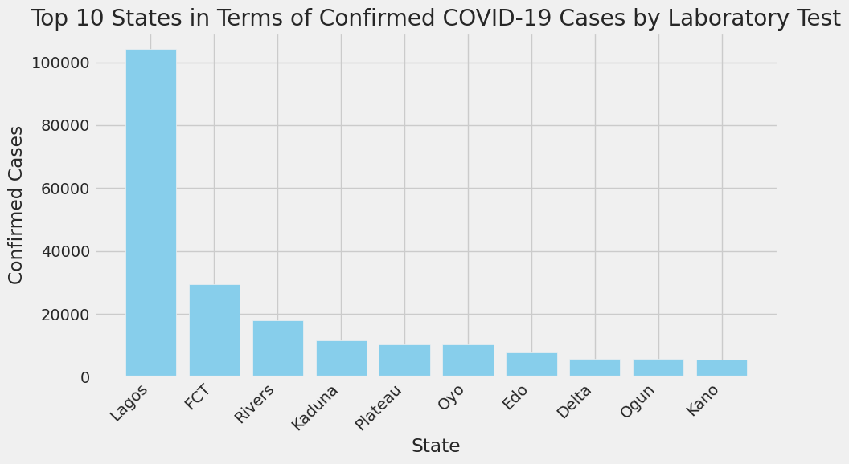

The top ten states in terms of COVID-19 cases confirmed by Laboratory test.

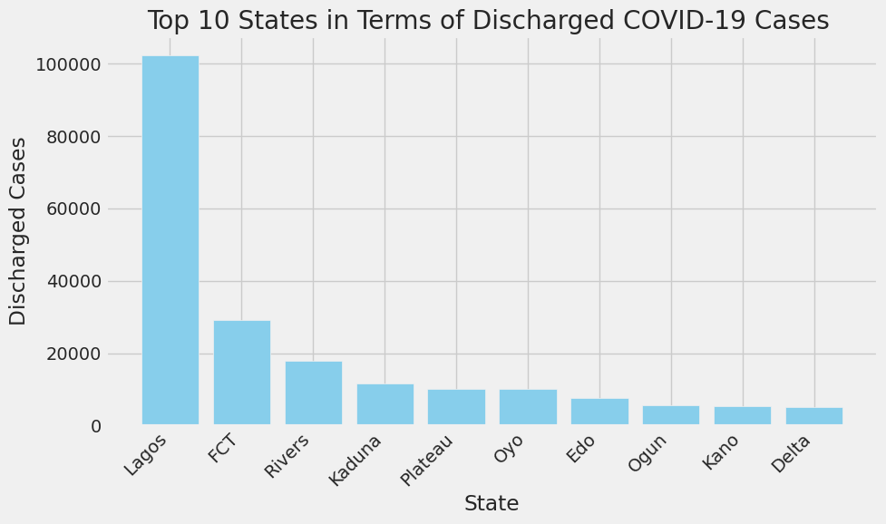

The top 10 states in terms of COVID-19 cases that were discharged

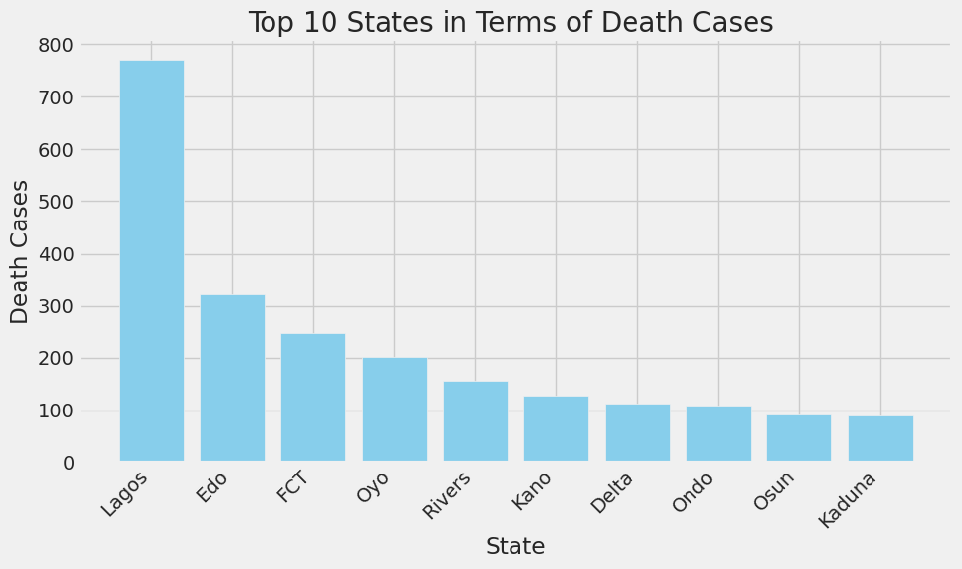

The top ten states in terms of COVID-19 cases that lead to death

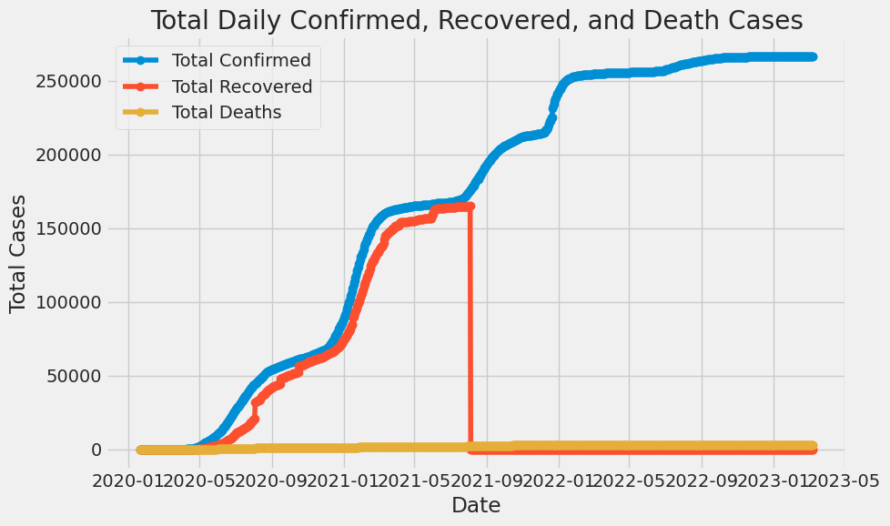

The total Daily confirmed, recovered and death COVID-19 cases

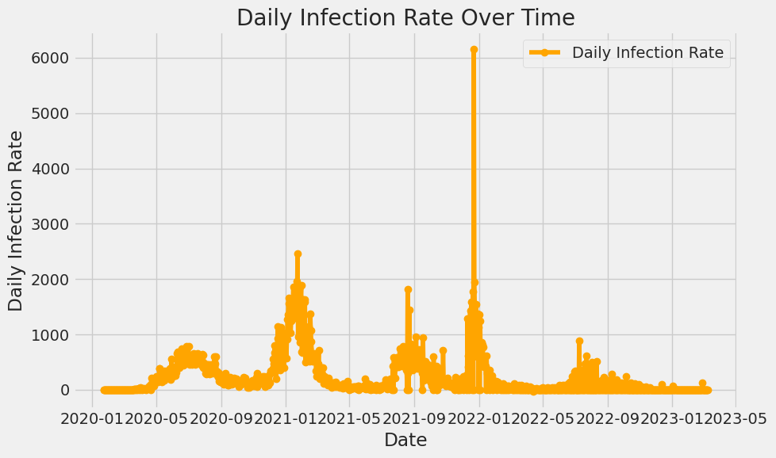

The Daily Infection Rate with respect to time. Maximum Infection Rate: 6158.0 on 2021-12-22 00:00:00

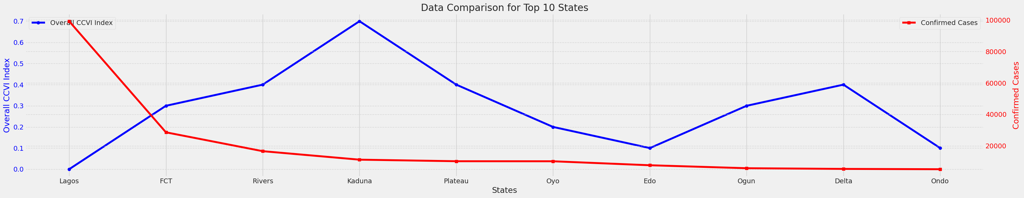

The overall CCVI Index vs top ten states with highest confirmed cases, the higher the index the higher the number of cases

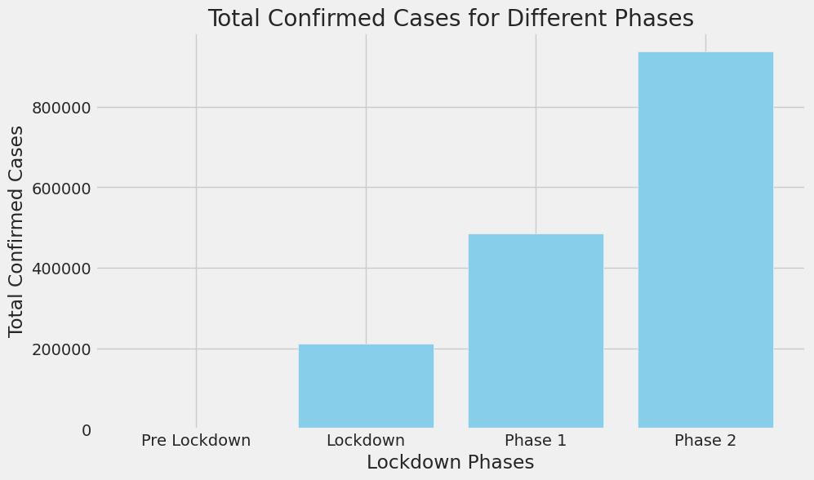

Total confirmed cases for pre lockdown, lockdown and phase 1 and 2 of easing of lockdown restrictions

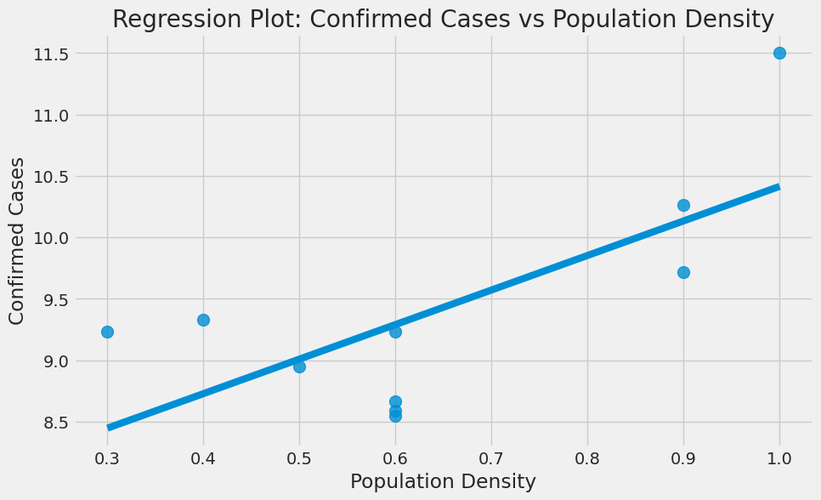

Regression plot to determine relationship between confirmed cases and population density, positive correlation

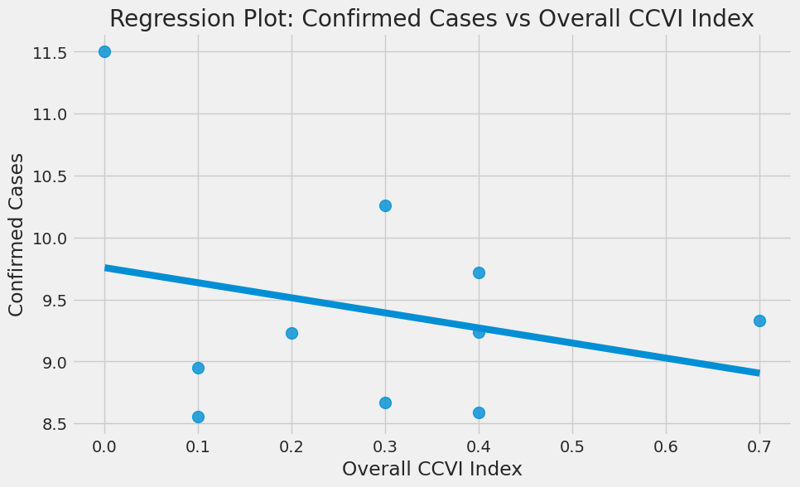

Regression plot to check correlation between confirmed cases and overall CCVI Index and confirmed cases

Regression plot to determine correlation between death cases and Health system, negative correlation

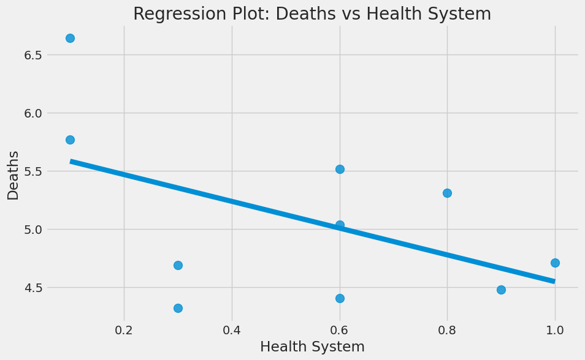

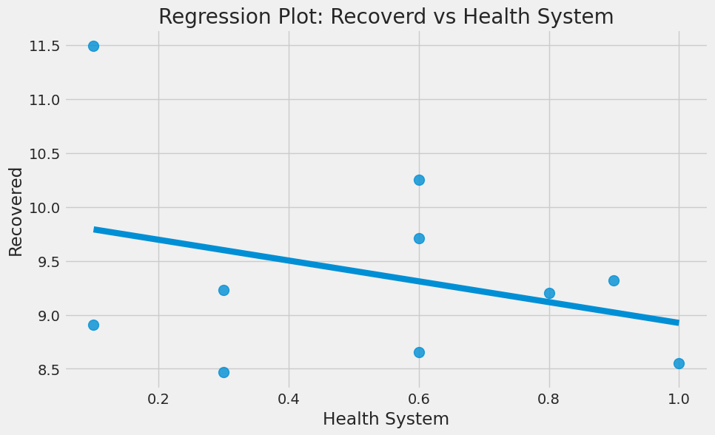

Regression plot to investigate relationship between recovered cases and health system

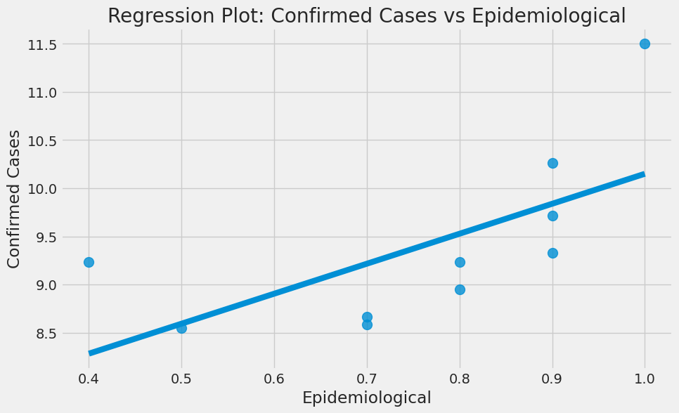

Regression plot to determine correlation between confirmed cases and epidemiological index

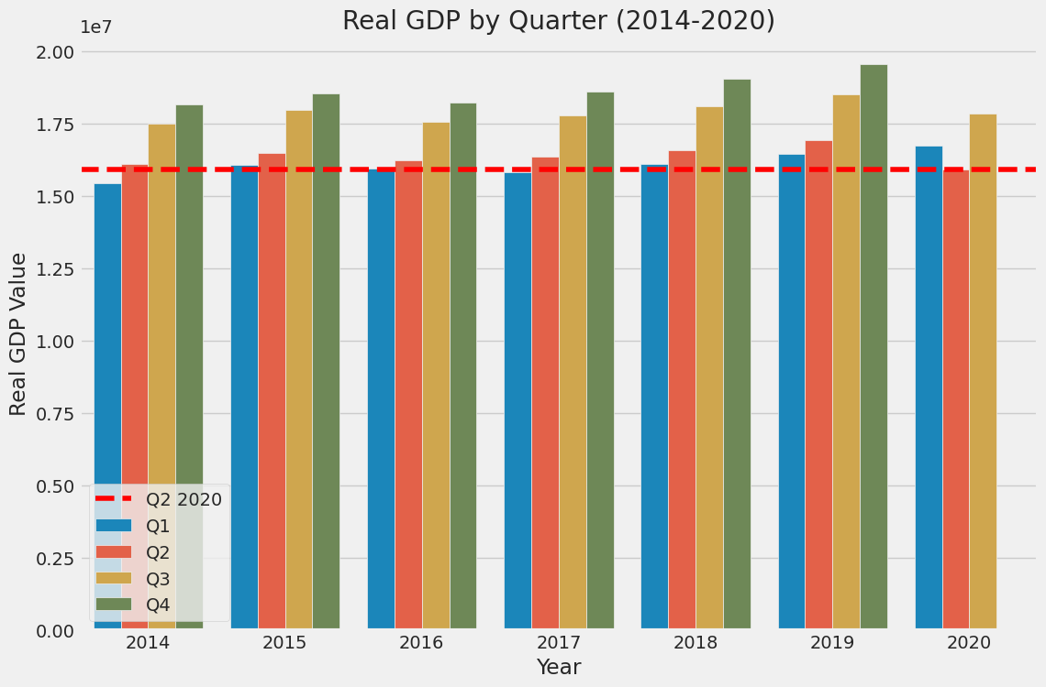

Visualizing GDP data for various years and corresponding quarters, Q2 2020 hit an all-time low

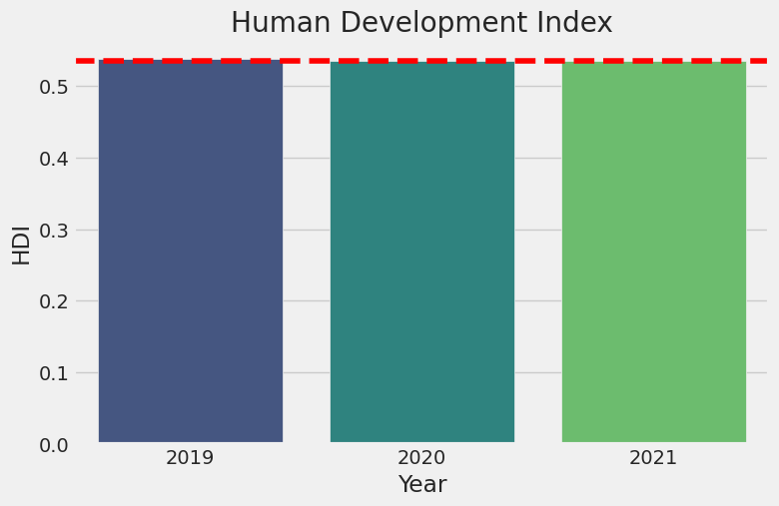

Human development index plot for 2019, 2020, and 2021, HDI decreased by 0.3 in 2020 and gained slightly in 2021

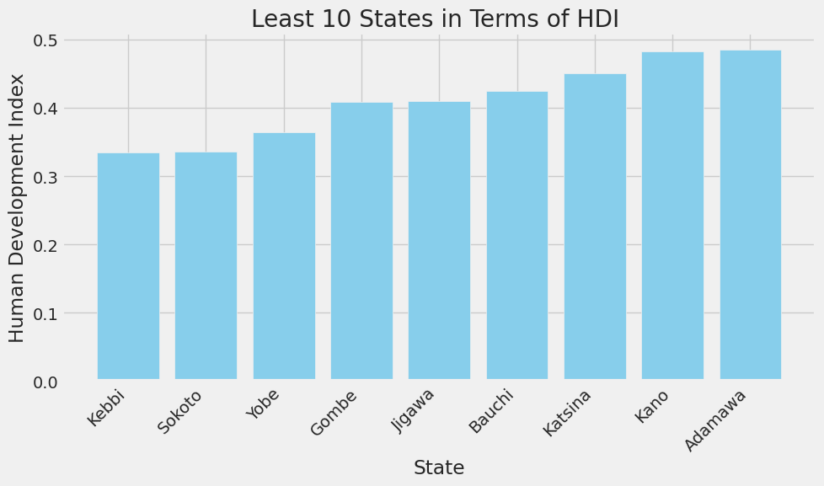

Top ten poorest performing states in terms of HDI

Top ten poorest performing states in terms of health system

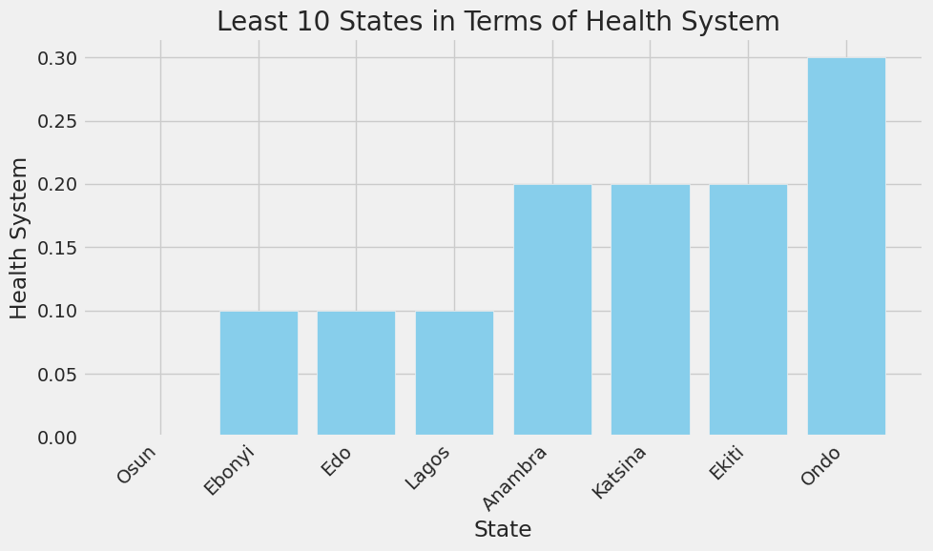

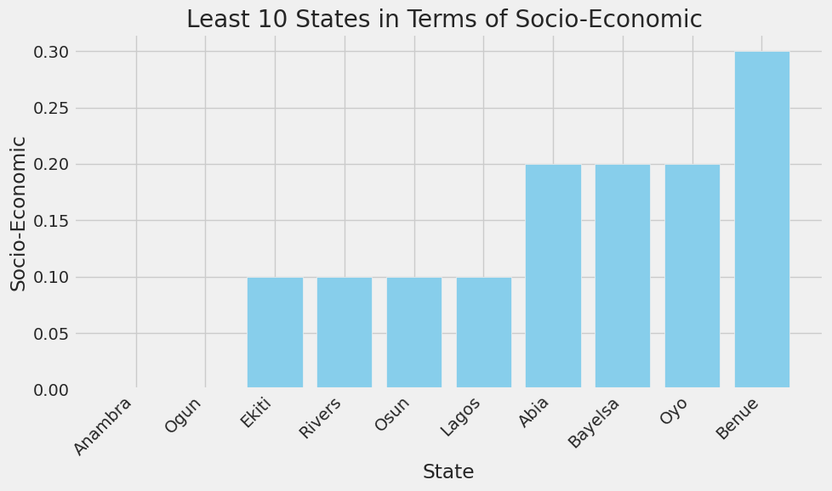

Top ten poorest performing states in terms of Socio-economic factor

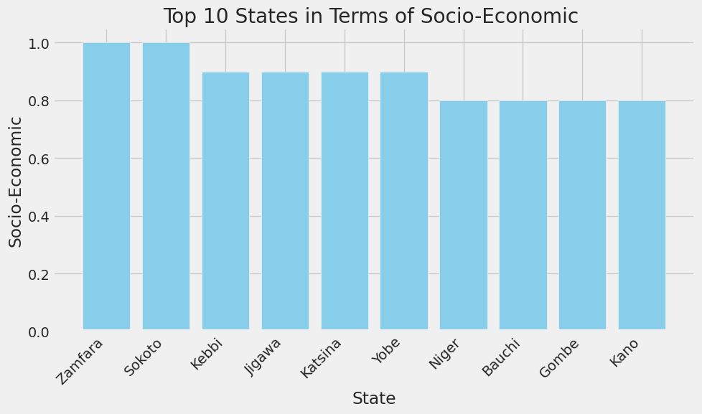

Top ten best performing states in terms of socio-economic factor

* **Results:** The top ten affected states are states with either International airports of a neighboring states to one with such; Lagos, FCT, Rivers, Kaduna, Plateau, Oyo, Edo, Delta, Ogun, Kano. A higher Overall CCVI Index implies more confirmed cases. The total movement restriction starting with Lagos, FCT and Ogun curtailed the daily infection rate. Comparing daily confirmed, death and recovered cases there were more recoveries than deaths. The easing of the lockdown caused a significant increase in the confirmed cases in those periods. The higher the population the more the confirmed cases, the better the health system the lesser the death cases, the higher the epidemiological index the higher the number of confirmed cases. The GDP values for Q2 2020 hit an all-time low for quarter two since 2014, the pandemic affected production and service delivery, The HDI dropped in 2020 indicating human development was affected, the lockdown easing phases helped in minimizing the impact of the pandemic.

During the pre-lockdown phase from 1st January 2020 to 29th march 2020 579 cases were confirmed, during the lockdown from 30th march 2020 to 1st june 2020 211,216 cases were confirmed, during the first phase of easing the lockdown from 2nd june 2020 to 29th june 2020 484,923 cases were confirmed, for the second phase of lockdown ease from 30th june 2020 to 27th july 2020 937,322 cases were confirmed.

The top ten states in terms of socio-economic factors are Zamfara, Sokoto, Kebbi, Jigawa, Katsina, Yobe, Niger, Bauchi, Gombe, Kano.

The least ten states in terms of socio-economic factors are Ananmbra, Ogun, Ekiti, Rivers, Osun, Lagos, Abia, Bayelsa, Oyo, Benue.

The states with the poorest health system are Osun, Ebonyi, Edo, Lagos, Anambra, Katsina, Ekiti, Ondo.

The states with the poorest HDI are Kebbi, Sokoto, Yobe, Gombe, Jigawa, Bauchi, Katsina, Kano, Adamawa.

**C. Conclusions**

* The analysis delves into crucial questions surrounding the spread of the virus, economic resilience, and societal adaptation, what states were most affected and why? , how did the pandemic impact GDP and HDI? What is the daily infection rate? How does recovered cases compare to death cases? What is the role of health system in that?
* The top ten affected states are states with either International airports of a neighboring states to one with such; Lagos, FCT, Rivers, Kaduna, Plateau, Oyo, Edo, Delta, Ogun, Kano Maximum Infection Rate: 6158.0 on 2021-12-22 00:00:00. The total movement restriction starting with Lagos, FCT and Ogun curtailed the daily infection rate, the easing of lockdown restrictions resulted into an increase in confirmed cases but was inevitable to rejig the economy. Comparing daily confirmed, death and recovered cases there were more recoveries than deaths. The higher the population the more the confirmed cases, the better the health system the lesser the death cases, the higher the epidemiological index the higher the number of confirmed cases. The pandemic affected the HDI was 0.535 in 2019, dropped to 0.535 in 2020 and was 0.535 as well in 2021, and GDP in 2020 dropped relative to preceding and successive years. The pandemic policies affect the GDP and HDI but was necessary to contain disease spread, easing of lockdown restrictions helped in limiting damage and providing potential for recovery.
* Least performing states in terms of health system, HDI, and socio-economic factors need to look into their policies, programs and intervention and also budget allocation and spending allocated to those sectors, template from top performing states in those areas can be used to bridge the gap and improve well-being of their citizens.
* Insights into best performing states in terms of health system and socio-economic programs and budget and policy implementation on those sectors would aid in bridging the gap between them and the poor performing states with respect to those factors.
* HDI data downloaded from [https://globaldatalab.org/shdi/table/shdi/NGA/](https://colab.research.google.com/corgiredirector?site=https%3A%2F%2Fglobaldatalab.org%2Fshdi%2Ftable%2Fshdi%2FNGA%2F).
* Automated data collection to keep up with current trends to avoid data and concept drift, better budget breakdown by states for healthcare, Transport and socio-economic programs.

**D. References**

* PTF-COVID-19-Guidance-on-implementation-of-lockdown-policy-FINAL.docx-2